Legal AI Multi-Agent System

Agent Roles
Agent | Role
Planner | Initialises shared state and iteration tracking for retry loops.
Router | Classifies query domain (legal / news / general) using the LLM.
Memory | Retrieves conversation history from the session store.
Retrieval | Searches the ChromaDB vector store for relevant document chunks.
Legal Agent | Specialised EU AI Act expert - generates detailed statutory analysis.
News Agent | Fetches and synthesises recent regulatory news and updates.
General QA | Handles open-ended or cross-domain questions.
Aggregator | Combines all expert outputs into a unified draft response.
Validator | Checks quality, relevance, and factual completeness; triggers retries.
Response | Formats and delivers the final user-facing answer.

Technology Stack
- LangGraph: DAG-based multi-agent workflow orchestration with typed state and reducers.
- FastAPI: REST + Server-Sent Events (SSE) backend for real-time streaming.
- ChromaDB: Local vector store for EU AI Act document embeddings.
- Ollama: Local LLM inference engine (privacy-preserving, no API dependency).
- React + Vite: Modern frontend with six-mode topology selector and live workflow feed.

DAG Architecture
The workflow is modelled as a Directed Acyclic Graph (DAG) compiled by LangGraph. Edges are either static (always executed) or conditional (chosen at runtime based on the query classification and selected execution mode). Parallel branches are supported natively by returning a list of target node names from a conditional edge function. State is shared across all nodes via a typed TypedDict with per-key reducer functions that safely merge concurrent writes.
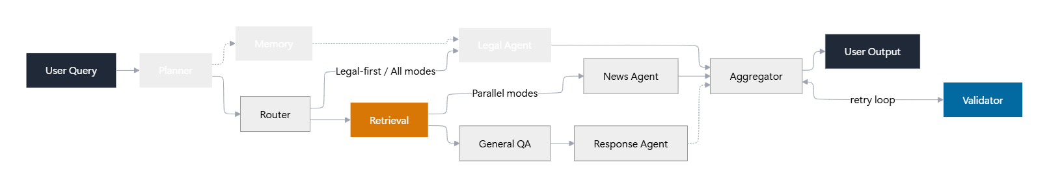
Figure 1 - Full DAG architecture. Parallel expert branches collapse back at the Aggregator.

State Management and Concurrency
Each key in AgentState is annotated with a reducer function that controls how concurrent branch writes are merged. Three custom reducers are defined:
- dict_reducer: dict_reducer - merges agent_outputs and agent_timings dicts (later values overwrite earlier for the same key).
- append_thinking_steps: append_thinking_steps - safely appends thinking log entries from parallel branches, using (step, details) deduplication.
- replace_if_present: replace_if_present - for list fields like chat_history where only the latest value matters.

EU AI Act Regulatory Context
The EU AI Act (Regulation 2024/1689) was published in the Official Journal in August 2024. Unlike static regulatory texts, it has a phased implementation schedule that makes temporal accuracy critical for any compliance assistant. Key effective dates:
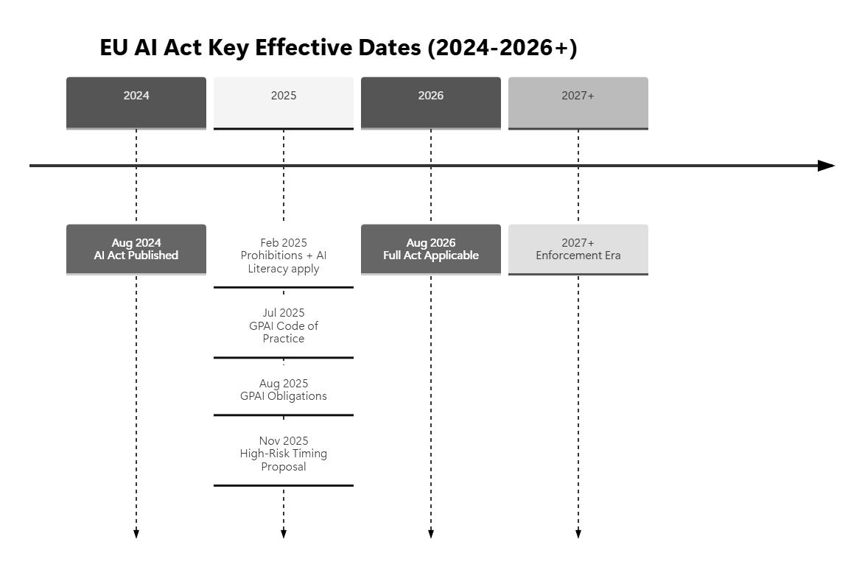
Figure 2 - EU AI Act phased effective dates. A compliance assistant must reason about which obligations are currently active.

Effective Date | Event
Aug 2024 | AI Act published in EU Official Journal.
2 Feb 2025 | Chapter I (definitions), Chapter II (prohibitions), and AI literacy obligations entered into force.
10 Jul 2025 | GPAI Code of Practice published - primary voluntary compliance path for GPAI providers.
2 Aug 2025 | General-Purpose AI (GPAI) obligations started applying.
19 Nov 2025 | Commission proposal to adjust high-risk AI system annex timing.
2 Aug 2026 | Full Act applicable to all remaining categories including high-risk AI systems.

Related Work

DAG and Agentic Workflow Research
- Adaptive Graph of Thoughts (AGoT), Feb 2025 The closest DAG reasoning paper to this system. AGoT recursively decomposes queries into a directed acyclic graph of subproblems and selectively expands only where needed. This is the natural next evolution beyond the fixed pipeline used here.
- Agentic RAG Survey, Jan 2025 Provides a taxonomy of agentic RAG systems around planning, reflection, tool use, and multi-agent collaboration. Maps almost directly onto this system's Planner/Router/Retrieval/Validator architecture.
- LLMCompiler, ICML 2024 Foundational parallel DAG work: models a Planner, Task Fetcher, and Executor for parallel function calling, with documented latency and cost gains. Best precedent for converting this system's single-route flow into a true parallel fan-out/fan-in DAG.
- Graph of Thoughts (GoT), AAAI 2024 Shows that arbitrary graph dependencies (not just chain or tree structures) can improve complex reasoning. Conceptual ancestor of the DAG agent direction.
- RAGCap-Bench, Oct 2025 Argues for benchmarking intermediate agentic RAG capabilities, not only end-to-end accuracy. Directly relevant to evaluating this system's Planner, Router, Validator, and Retrieval stages independently.
- Self-RAG / CRAG Two retrieval-side foundations. Self-RAG adds adaptive retrieve/generate/critique behaviour. CRAG adds a retrieval evaluator with corrective web fallback when initial retrieval is weak. This system's Validator + retry loop closely resembles CRAG's corrective retrieval loop.

Legal RAG Research
- LegalBench-RAG, Aug 2024 Key finding: legal RAG needs precise snippet retrieval, not coarse document-level chunks. Directly challenges this system's current ~1000-char chunk + top-5 vector search setup.
- LexRAG, Feb 2025 First benchmark for multi-turn legal consultation with expert annotation (LexiT toolkit). The Memory Agent in this system is directionally aligned, but not evaluated against multi-turn benchmarks
- LRAGE, Apr 2025 Frames legal RAG quality as a function of corpus, retriever, reranker, LLM backbone, and metrics. Exactly the evaluation framing this project needs as a next step
- Massive Legal Embedding Benchmark (MLEB), Oct 2025 Shows that legal retrieval quality should be tested across jurisdictions, document types, and task types. Implies domain-adapted embeddings matter more than assumed; directly relevant if using a generic embedding model.
- A Reasoning-Focused Legal Retrieval Benchmark, May 2025 Pushes legal retrieval toward real research tasks rather than toy statute lookup. Headline lesson: legal RAG is still genuinely hard.
- Legal RAG Bench, Mar 2026 Probably the single most important 2026 result for this project's roadmap. Primary finding: retrieval quality is the main performance ceiling, and many apparent hallucinations are actually triggered by retrieval failures. Biggest gains are in retrieval, reranking, and source selection -- not in adding more agents.
- Benchmarking Legal RAG: Promise and Limits, Feb 2026 Evidence that custom legal tools can outperform marketed commercial AI assistants. Failures split into retrieval failures and reasoning failures. Good reality check for agentic legal AI.
- Challenges for Generative AI in Legal Reasoning, Jan 2026 RAG and multi-agent systems can help narrow legal tasks, but do not solve the hardest parts: jurisdiction, source hierarchy, ambiguity, burden of proof, and transparent justification. Provides key design constraints.

EU AI Act Benchmarking
- COMPL-AI Framework, updated Feb 2025 Translates the AI Act into measurable technical requirements and builds an Act-centred benchmarking suite for LLMs. The closest paper to this system's actual legal domain. If the assistant is meant to provide compliance support (not just Q&A), COMPL-AI is the strongest existing foundation to build on.
- GPAI Code of Practice, Jul 2025 The Commission's main voluntary compliance path for GPAI obligations. An AI Act assistant built today should incorporate the GPAI Code, Commission Q&A, and effective-date logic rather than relying only on the base regulation PDF.

Original Contributions vs Existing Work

What This System Does That Most Papers Do Not
- Multi-source fusion in one assistant Combines static EU AI Act law, live regulatory news, and general governance knowledge in a single query pipeline. Most papers focus on exactly one of these sources.
- Explicit Validator + retry loop Most legal assistants stop at retrieve-and-generate. This system adds a Validator node that checks quality and factual completeness, and can trigger corrective retrieval or replanning up to a configurable iteration limit.
- Automatic time-sensitive news fetching The News Agent fetches and indexes recent regulatory updates automatically. This is especially important for AI regulation given the AI Act's phased implementation and evolving GPAI guidance.
- Typed state graph with transparent steps The use of a compiled LangGraph StateGraph with Annotated type hints, per-key reducers, and a thinking_log provides better engineering discipline than most ad-hoc 'agent' demos.
- Six selectable execution topologies Dynamically re-wires the agent graph per request. Users can compare sequential, single-route, full-parallel, partial-parallel, and retrieval-only modes - all benchmarked on the same query.
- Local privacy-preserving deployment The system runs entirely on Ollama with no external API calls for inference. This is a real advantage for legal/privacy-sensitive deployment contexts.

Execution Topologies
The six topologies represent different graph wiring strategies. The mode is passed per-request and controls which conditional edges fire in the compiled LangGraph.
Mode | Full Name | Graph Path
all | All Experts - Sequential Chain | Retrieval -> Legal -> News -> General QA -> Aggregator
single [Recommended] | Single Expert - Routed | Retrieval -> [Routed Expert] -> Aggregator
parallel | Parallel Experts - All Concurrent | Retrieval -> Legal || News || General QA -> Aggregator
legal_news_parallel | Parallel Legal & News | Retrieval -> Legal || News -> Aggregator
legal_first | Sequential Legal -> News | Retrieval -> Legal -> News -> Aggregator
verify_only | Retrieval Only (Verify Only) | Retrieval -> Aggregator (no expert agents)

Benchmark Results
All six topologies were executed sequentially against the following compliance query:
"What are the compliance requirements and obligations for high-risk AI systems under the EU AI Act, and are there any recent updates?"
Fetch news was disabled to isolate agent topology performance from network I/O variability.
Mode | Total (s) | Backend (ms) | Steps | Response (chars)
all | 79.07 | 67,524 | 20 | 924
single [BEST] | 46.51 | 45,436 | 16 | 1154
parallel | 71.0 | 69,851 | 20 | 1083
legal_news_parallel | 69.49 | 68,399 | 18 | 946
legal_first | 83.41 | 82,270 | 18 | 968
verify_only | 22.27 | 20,823 | 14 | 548

Visual Comparisons

Backend Latency
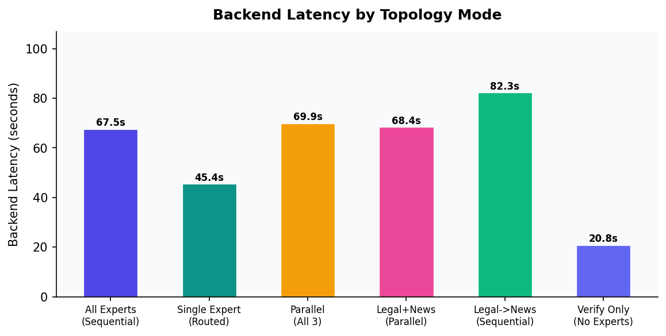
Figure 3 - Backend latency per topology. single mode is 33% faster than all.

Workflow Steps
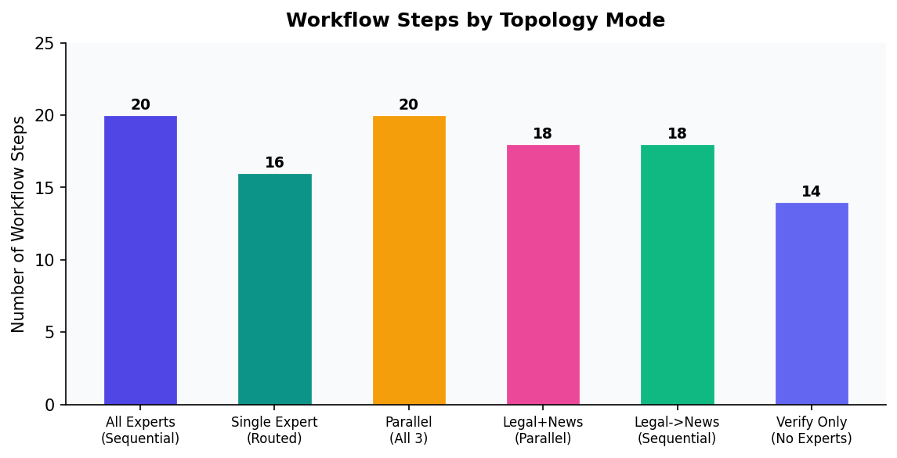
Figure 4 - Number of graph steps executed. Fewer steps = lower orchestration overhead.

Response Length
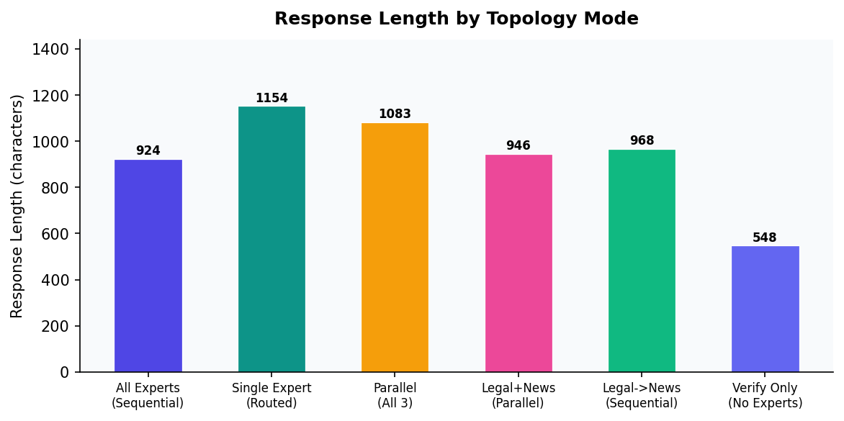
Figure 5 - Response character length. Depth must be balanced against conciseness.

Per-Node Timing Breakdown
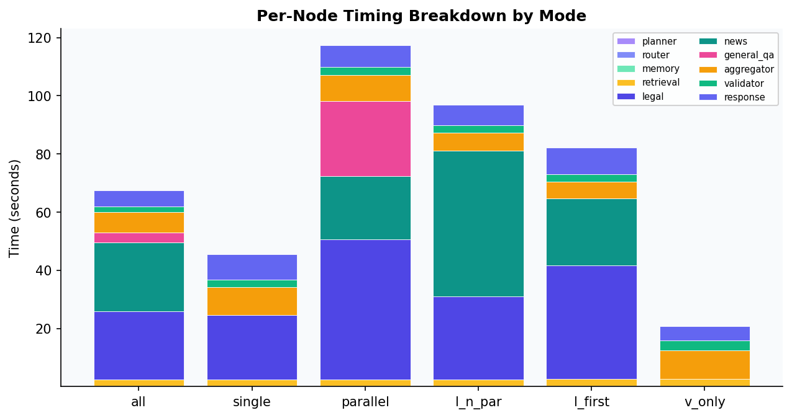
Figure 6 - Stacked timing per agent node by mode. Legal and News dominate total latency.

Multi-Dimensional Radar
Radar axes (normalised 0-1): Speed (inverted latency), Step Efficiency (inverted steps), Response Depth (character length), and Breadth (number of expert branches activated).
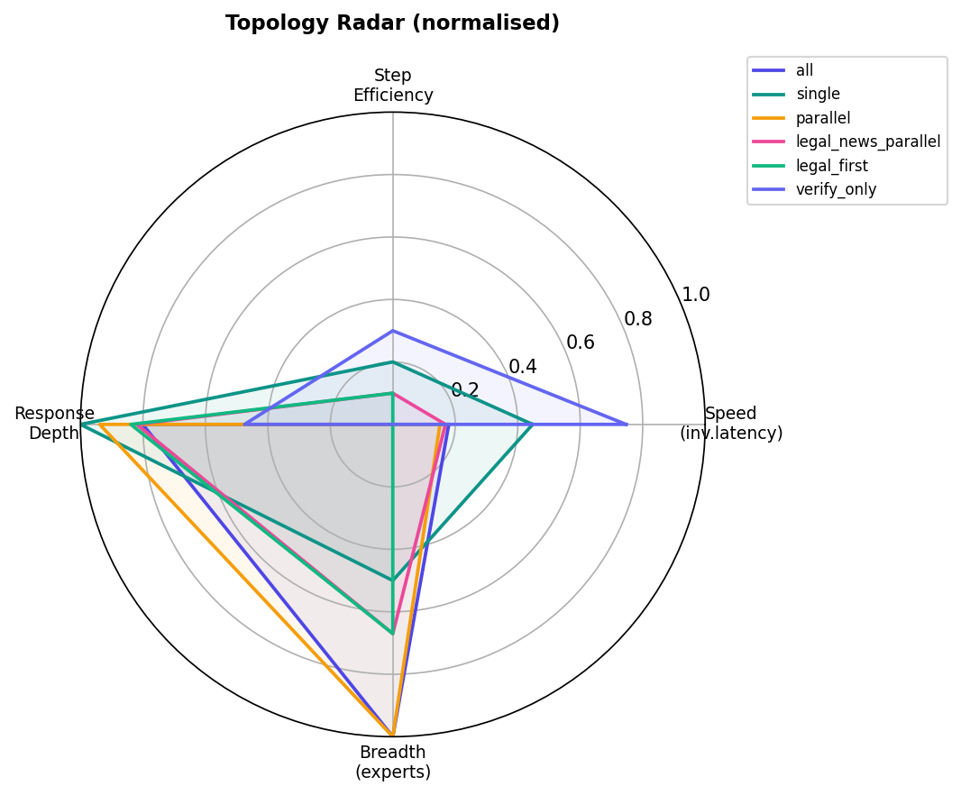
Figure 7 - Radar shows single mode balances speed and depth. verify_only is fast but has zero breadth.

Input / Output Responses
Below are the full responses generated by each topology for the benchmark query.

All Experts - Sequential Chain [all]
Graph path: Retrieval -> Legal -> News -> General QA -> Aggregator
Backend: 67,524 ms | Total: 79.07 s | Steps: 20 | Response: 924 chars
planner | router | memory | retrieval | legal | news | general_qa | aggregator | validator | response
0.0s | 0.3s | 0.0s | 2.1s | 23.4s | 23.7s | 3.5s | 7.0s | 1.9s | 5.6s

Generated Response:
The EU AI Act outlines stringent compliance requirements for high-risk AI systems, including those used in legal services. Key obligations include:
- **Risk Assessment**: Conduct thorough risk assessments to identify potential risks.
- **Conformity Assessments**: Undergo independent third-party evaluations to ensure safety and performance standards are met.
- **Human Oversight**: Prioritize human oversight for critical applications.
- **Technical Documentation**: Maintain detailed records supporting compliance.
Recent updates have provided more guidance on these processes, including clearer procedures for conformity assessments and enhanced enforcement mechanisms through the establishment of an EU AI Observatory.
For the most up-to-date information, refer to official EU documents or regulatory bodies. Ensuring compliance is crucial to maintain safety, transparency, and accountability in high-risk AI systems.

Single Expert - Routed [single]
Graph path: Retrieval -> [Routed Expert] -> Aggregator
Backend: 45,436 ms | Total: 46.51 s | Steps: 16 | Response: 1154 chars
planner | router | memory | retrieval | legal | aggregator | validator | response
0.0s | 0.3s | 0.0s | 2.1s | 22.3s | 9.5s | 2.7s | 8.6s

Generated Response:
Under the EU AI Act, high-risk AI systems must meet several stringent requirements:
- **Risk Assessment**: Providers need to conduct thorough risk assessments before deployment.
- **Technical Documentation**: Detailed documentation is required to show compliance.
- **Human Oversight**: In certain cases, human oversight is necessary.
- **Record-Keeping**: Records must be maintained for at least 10 years post-deployment.
- **Post-Market Monitoring**: Continuous monitoring ensures ongoing compliance.
- **Transparency**: High-risk systems must provide clear information about their functioning.
As of May 2026, there have been no specific updates regarding recent changes to the EU AI Act. Non-compliance can result in significant fines ranging from €250,000 to 6% of annual global turnover.
For more detailed information on specific articles or sections, refer to the official European Commission website.
If you're interested in learning more about how AI is being integrated into legal practices and data management, upcoming events like "AI & Legal Innovation Talks" scheduled for June 17-18, 2026, in London, might provide additional insights.

Parallel Experts - All Concurrent [parallel]
Graph path: Retrieval -> Legal || News || General QA -> Aggregator
Backend: 69,851 ms | Total: 71.0 s | Steps: 20 | Response: 1083 chars
planner | router | memory | retrieval | news | general_qa | legal | aggregator | validator | response
0.0s | 0.3s | 0.0s | 2.1s | 21.8s | 25.7s | 48.2s | 9.0s | 2.8s | 7.5s

Generated Response:
The EU AI Act aims to ensure that high-risk AI systems meet ethical and safety standards. Here are the key compliance requirements:
- **Risk Assessment and Documentation**: High-risk AI systems must undergo thorough risk assessments with detailed documentation covering design, development, testing, deployment, and monitoring.
- **Human Oversight**: Systems should be designed to allow for human intervention when necessary.
- **Technical Documentation and Certificates**: Comprehensive technical documentation and certificates from independent third parties are required.
- **Labeling and Transparency**: Products must clearly indicate they are AI systems and provide information about their capabilities and limitations.
- **Post-Market Monitoring**: Continuous monitoring is essential to ensure ongoing compliance.
As of May 20, 2026, the EU AI Act has not yet been fully implemented but is expected to come into force in May 2024 with a grace period until mid-2025 for compliance. For detailed requirements and the latest updates, consult official EU sources or legal experts.

Parallel Legal & News [legal_news_parallel]
Graph path: Retrieval -> Legal || News -> Aggregator
Backend: 68,399 ms | Total: 69.49 s | Steps: 18 | Response: 946 chars
planner | router | memory | retrieval | legal | news | aggregator | validator | response
0.0s | 0.3s | 0.0s | 2.1s | 28.6s | 50.1s | 6.2s | 2.5s | 7.1s

Generated Response:
The EU AI Act focuses on regulating high-risk AI systems used in critical sectors such as healthcare, construction, transport, and energy. Key compliance requirements include:
- **Conducting Risk Assessments:** Evaluating potential risks associated with the AI system.
- **Technical Documentation:** Preparing detailed documentation to support risk management.
- **Human Oversight:** Ensuring human intervention is available for decision-making processes.
- **Record Keeping:** Maintaining records for 10 years following the deployment of the system.
- **Labeling and Explanation:** Clearly labeling the system with its risk category and providing explanations for outputs.
As of May 2026, the act is still under implementation. Member states are aligning their national laws to comply. Recent updates include ongoing public consultations and guidance documents from the European Commission to assist stakeholders in meeting these requirements.

Sequential Legal -> News [legal_first]
Graph path: Retrieval -> Legal -> News -> Aggregator
Backend: 82,270 ms | Total: 83.41 s | Steps: 18 | Response: 968 chars
planner | router | memory | retrieval | legal | news | aggregator | validator | response
0.0s | 0.3s | 0.0s | 2.3s | 39.2s | 22.9s | 5.9s | 2.5s | 9.2s

Generated Response:
High-risk AI systems under the EU AI Act must meet several stringent compliance requirements:
- **Detailed Risk Assessments:** These must be conducted to identify potential risks.
- **Comprehensive Technical Documentation:** To ensure transparency and accountability.
- **Human Oversight Mechanisms:** To maintain control over system operations.
- **Accuracy and Robustness:** Ensuring reliable performance of the AI system.
- **Data Protection Compliance:** Adherence to EU data protection laws.
- **Traceability:** Maintaining a clear record of how decisions are made by the AI system.
- **Continuous Post-Market Monitoring:** To address any emerging issues post-deployment.
As of May 2026, there have been no significant updates to the act itself. However, ongoing efforts by regulatory bodies continue to support implementation through guidance and best practices.
For precise details, consulting a legal expert specializing in EU AI regulations is recommended.

Retrieval Only (Verify Only) [verify_only]
Graph path: Retrieval -> Aggregator (no expert agents)
Backend: 20,823 ms | Total: 22.27 s | Steps: 14 | Response: 548 chars
planner | router | memory | retrieval | aggregator | validator | response
0.0s | 0.4s | 0.0s | 2.3s | 9.8s | 3.4s | 4.9s

Generated Response:
The EU AI Act outlines strict compliance requirements and obligations for high-risk AI systems, including those used in legal practices. Key obligations include:
- Ensuring data privacy and security
- Maintaining transparency
- Avoiding bias
Recent updates emphasize the importance of ethical considerations and client trust. Law firms must comply with these regulations to mitigate risks and maintain legal standards.
For the latest details, refer to the official EU AI Act documentation or consult a legal expert specializing in AI compliance.

Analysis and Recommendation

Key Observations
- verify_only is fastest (20.8 s) but shallowest. Without expert agents, the system uses only vector-search retrieval. The response is a generic bullet list lacking depth and legal citation. Not enough.
- single achieves the best quality-to-latency ratio (45.4 s). The Router correctly classifies the query as 'legal', activating only the Legal Agent. The response includes record-keeping timelines, fines (EUR 250k to 6% of turnover), and real-world compliance events. 33% faster than the all-sequential mode with minimal quality loss.
- all (sequential) is high quality but slow (67.5 s). Running all three experts adds ~22 s over single with marginal gain for a focused legal query. The extra News and General QA contributions are partially redundant.
- Parallel modes do not accelerate on local single-GPU hardware. The local Ollama server queues LLM inference serially. Python-level concurrency maps to sequential queuing, so parallel and legal_news_parallel ran in ~69-70 s, comparable to all.
- legal_first is the slowest (82.3 s). Chaining Legal -> News sequentially without parallelism incurs full LLM cost for both calls without any latency benefit. Dominated by both parallel and single modes.

Summary Table
Mode | Latency | Steps | Verdict
all | 67.5s | 20 | Good quality, slow -- use for exhaustive queries
single | 45.4s | 16 | [RECOMMENDED] Best speed + quality balance
parallel | 69.9s | 20 | Good quality -- only beneficial with multi-GPU
legal_news_parallel | 68.4s | 18 | Good -- no speed gain on local CPU
legal_first | 82.3s | 18 | Slowest -- limited advantage over 'all'
verify_only | 20.8s | 14 | Fastest -- unsuitable for deep analysis

