Thomas Charbonnet In422 – TP N°1 : SET 1

Exercice n°1 :

1)
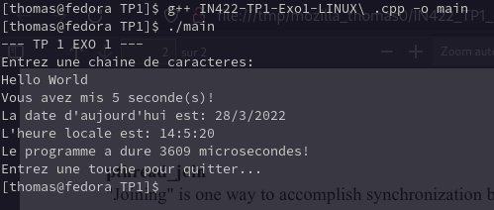
2) The program take take and save a temporay variable on the memory. When we will stop the code, the variable will be lose. But also, it capture the time necesseary for executing the previous action and it print some data with the time.

3) temps système : it’s the time used by the CPU for executing the code
temps local = this is the time used by the human time for making the code

4) No, it’s not normal because

clock_t is the cpu time the number of cpu click

Exercice n°2 :
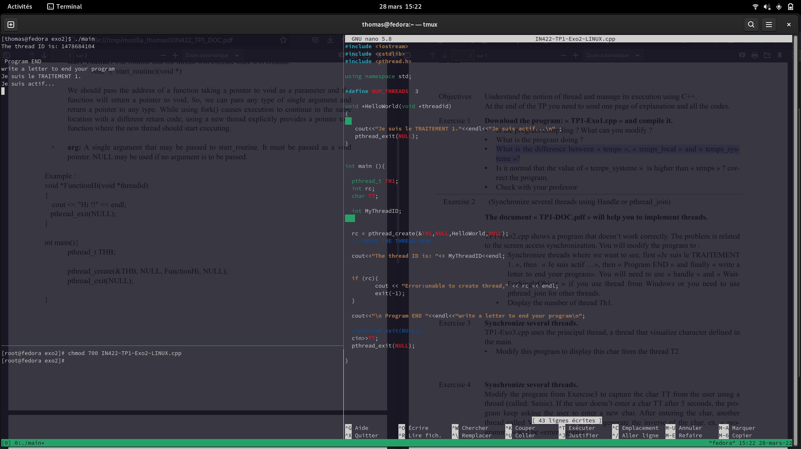

Exercice n°3 :

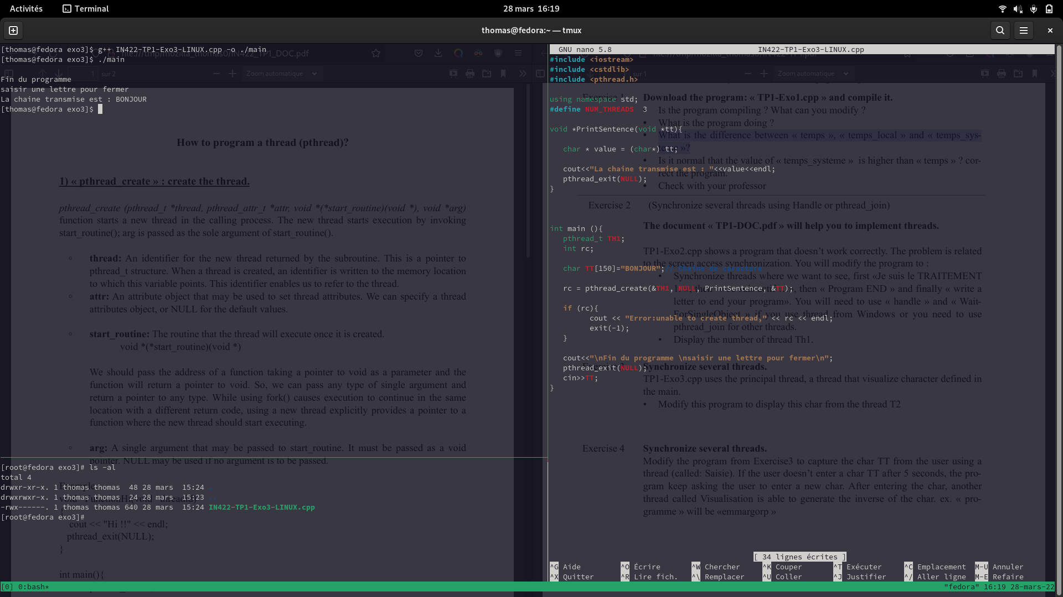
Exercice n°4 :

