Dissertation Submitted for the partial fulfilment of the **B.Sc. as a part of M.Sc. (Integrated) Five Years Program AIML/Data Science** degree to the Department of AIML & Data Science.

**Project Dissertation**

**BRAIN TUMOR CLASSIFICATION (MRI)**

**Submitted to**

By

**Charchil Singh (Roll no. - 29)**

**Semester-VI**

**M.Sc. (Integrated) Five Years Program AIML/Data Science**

Department of AIML & Data Science.

School of Emerging Science and Technology

Gujarat University

**June 2022**

**DECLARATION**

This is to certify that the research work reported in this dissertation entitled “**BRAIN TUMOR CLASSIFICATION”** for the partial fulfilment of B.Sc. as a part of M.Sc. (Integrated) in Artificial Intelligence and Machine Learning/Data Science degree is the result of investigation done by myself.

|  |  |
| --- | --- |
| Place: Ahmedabad | Charchil Singh |
| Date: 10 - June - 2022 | Name of Student |

**ACKNOWLEDGEMENT**

On this occasion of submitting my project work, I would like to thank all the people who have made this possible. The role of the Department of AIML, Gujarat University in shaping my professional capability is very important.

I thank Dr. Ravi Gor, coordinator of the Department of AIML, Data Science & Actuarial Science, for all his support.

Rashmi Madam my mentor has always guided me on the right path and has been a motivating source for innovative project work. This work would have not been possible without her guidance, support, and encouragement. With the help of her guidance, I magnificently overcame the difficulties during my work and learned at each step.

I am heartily and loving thankful to my parents and my friends for their sacrifice, the support & and love which encouraged me to efficiently overcome the difficulties in my pursuit of the project and who always helped me in my work.

Last but not the least, I would not be able to complete the work without the blessings of almighty and would like to thank God for giving me strength and patience to carry out my work with full dedication.

**-CHARCHIL SINGH**

**CONTENT**

Abstract …………………………………………….………………………………………………………..….5

Chapter 1: Introduction ….……………………………………………………………………………….6

1.1: Types of Brain Tumour………………………………………………………………………………7

1.2: Objective…………………………………………………………………………………………………10

Chapter 2: Proposed Model for Prediction

2.1: Project Workflow…………………………………………………………………………………….11

2.2: Data Collection……………………………………………………………………………………….11

2.3: Data Visualization……………………………………………………………………………………12

2.4: Samples of images of dataset …………………………………………………………………13

Chapter 3: Methodology………………………………………………………………………………..14

3.1: Convolutional Neural Network (CNN)……………………………………………………..14

3.2: Transfer Learning…………………………………………………………………………………….15

Chapter 4: Experimental Results

4.1: Results and Evaluation ……………………………………………………………………………16

4.2: Conclusion……………………………………………………………………………………………..19

4.3: References ……………………………………………………………………………………………..21

**ABSRACT**

In recent years, prediction and analysis of human brain tumour have become one of the most challenging issues in healthcare science. Various machine learning algorithms are designed to automate the process of detection of brain tumour. Because of the popularity of computer vision in AI, the classification of tumour in unstructured data set such as brain MRI and its analysis as become an important part of the diagnosis of cancer at an early stage. The correct diagnosis is a very crucial and critical step and depends on the expertise of doctors and radiologists. The deep learning models are getting a lot of popularity in the detection of tumours because its accuracy. In this project, we designed deep learning architectures for detection of tumours in Magnetic Resonance Imaging (MRI) image. In the proposed architecture, firstly, the convolution neural network (CNN) architecture was designed from scratch using Keras library; secondly, the architecture of CNN was tuned by adjusting hyper parameter and increasing number of layers, and finally the transfer learning mechanism was implemented by using weights of EffiecientNet architecture. The performance of all models was evaluated using confusion matrix on validation and the test data set. The result shows that adjusting hyper parameter and transfer learning the accuracy of detection of tumour can be improved. In addition, this deep learning model detects human brain tumours within seconds as compared to other machine learning algorithm.

**Introduction**

Artificial Intelligence in the healthcare domain is used to estimate the power of human cognition to simplify the analysis of complicated medical data by using complex algorithms and decision support systems. As the computing power of medical data is increasing in terms of velocity, volume, and variability, finding meaningful insight from medical data has become a challenging task. Health care data come in structured and unstructured format. The structured data is in the form of textual information containing different features of specific diseases were as unstructured data are in the form of signals and medical images. Because of the popularity of computer vision in AI, the segmentation of tumour in unstructured dataset such as brain MRI and its analysis as become an important part of the diagnosis of cancer at an early stage. The correct diagnosis is a very crucial and critical step and depends on the expertise of doctors and radiologists. In such cases, the computer-aided diagnosis system is used as the second option for diagnosis. The problem with the traditional computer-aided system is of false positive and false negative predictions done, concerning the classification of tumour which can be life-threatening. Also, due to the heterogeneous and diffusive shapes of human organs such a liver, brain, tumour, etc., the segmentation of these organs as become challenging task because a lot of overlapping and low clearance ratio is seen between these organs. The physicians are finding it difficult and thus need a second option to come the conclusion of treatment therapy for patient before any surgical operation decision. So, there is a need to design an algorithm which can process 2D medical images of CT scan devices or MRI efficiently and classify weather given image contains tumour or not. The motivation is to design a robust model using deep learning techniques to improve performance of the proposed model in terms computation processing, overfitting, learning mechanism and accuracy. The most popular framework of deep learning is a convolution neural net- JOURNAL OF CRITICAL REVIEWS ISSN- 2394-5125 VOL 7, ISSUE 04, 2020 1806 work architecture for medical image analysis. The transfer learning mechanism can be used to reduce the cost of high computation to train a classifier for medical images

**Types of Brain Tumour**

**1) Pituitary Tumours**

* This type of tumor occurs in the anterior body of the pituitary gland. This is a pea-sized gland that is located behind the bridge of your nose. It produces hormones that help to regulate the functions of the other endocrine glands. Pituitary tumors can affect the function of the pituitary gland in two different ways:
* Increasing the production of regulatory hormones
* Reducing the production of regulatory hormones

**2) Meningioma Tumours**

* A meningioma is a tumor that arises from the meninges the membranes that surround the brain and spinal cord. Although not technically a brain tumor, it is included in this category because it may compress or squeeze the adjacent brain, nerves and vessels. Meningioma is the most common type of tumor that forms in the head.

**3) Glioma Tumours**

* A type of tumor that occurs in the brain and spinal cord.
* Gliomas can occur in the brain and in various locations in the nervous system, including the brain stem and spinal column.
* Different types of gliomas cause different symptoms. Some include headaches, seizures, irritability, vomiting, visual difficulties and weakness or numbness of the extremities.
* Treatments include surgery, radiation therapy, chemotherapy and targeted molecular therapy.

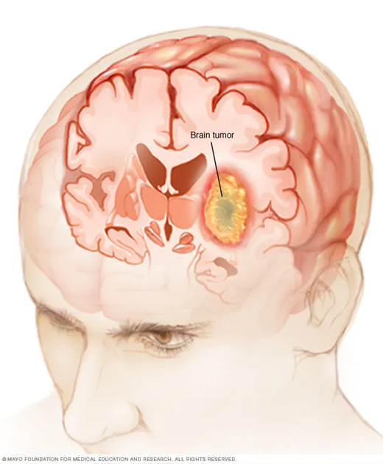

**Objective**

* The classification of tumor in unstructured data set such as brain MRI images and its analysis as become an important part of the diagnosis of cancer at an early stage. The correct diagnosis is a very crucial and critical step and depends on the expertise of doctors and radiologists.
* The deep learning models are getting a lot of popularity in the detection of tumors because its accuracy.

In this project, we have used deep learning algorithms for detection of tumors in Magnetic Resonance Imaging (MRI) image. In the proposed architecture, firstly, the convolution neural network (CNN) algorithm was designed from scratch using Keras library; secondly, the architecture of CNN was tuned by adjusting hyper parameter and increasing number of layers

**PROJECT WORKFLOW**

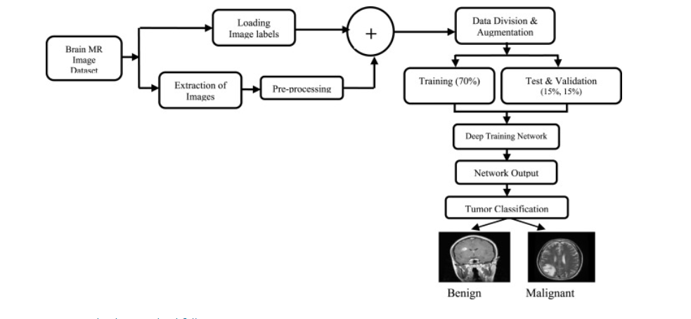

**DATA COLLECTION**

* The dataset has been collected from Kaggle. The original dataset is available at Kaggle which is provided from a Kaggle user named SATRAJ.
* The dataset consists of 3264 MRI images of Brain at different angles.
* These images are resized into 224x224 pixels so that they can be readily used with many pre-trained deep learning models.
* The image in this dataset contains different types of tumours

**DATA VISUALIZATION**

* Here the data distribution is given
* 395 images contain no tumour
* 827 images contain pituitary tumour
* 826 images contain glioma tumour
* 822 images contain meningioma tumour

**SAMPLE IMAGES OF DATASET**

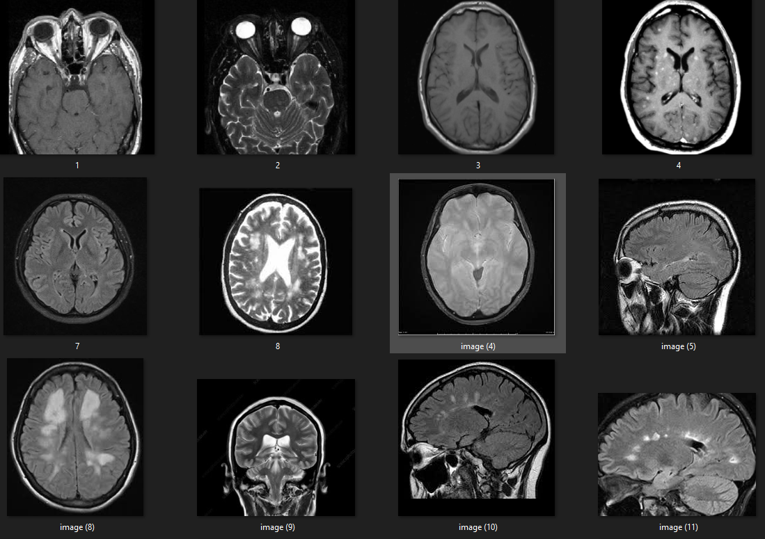

**METHODOLOGY**

### Convolutional Neural Networks

The most used deep learning model among neural networks is CNN model. A typical CNN model consists of two parts: feature extraction and classification. CNN architecture generally includes five main layers: input layer, convolution layer, pooling layer, fully connected layer and classification layer. CNN performs feature extraction and classification through sequentially trainable layers placed one after the other. Feature extraction part of the CNN generally includes the convolutional and pooling layers, whereas the classification part includes the fully connected and classification layers. Although CNNs focus on image classification and accept images as input data in recent years

**Transfer Learning**

* To improve performance of the deep learning model, the transfer learning technique can be used.
* In transfer learning pre-trained models are used to build model instead of designing them from scratch.
* Here we have used EffiecientNet architecture weights for training the model.
* EffiecientNet is a convolutional neural network architecture and scaling method that uniformly scales all dimensions of depth/width/resolution using a compound coefficient

* The picture above shows number of parameters of EfficientNetB1 model and layers used for training the sample size using transfer learning mechanism

**RESULTS**

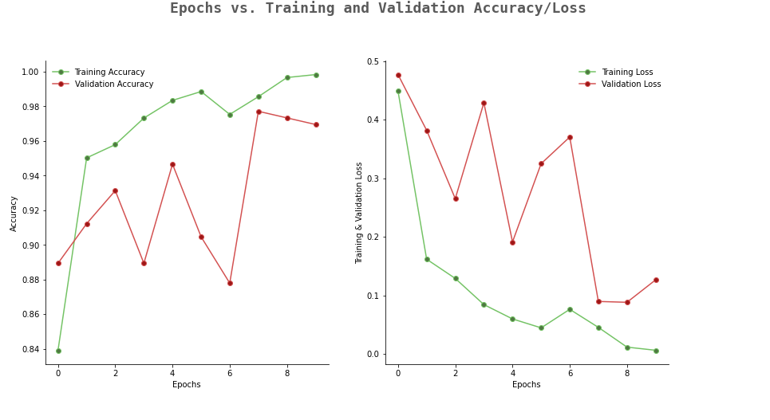

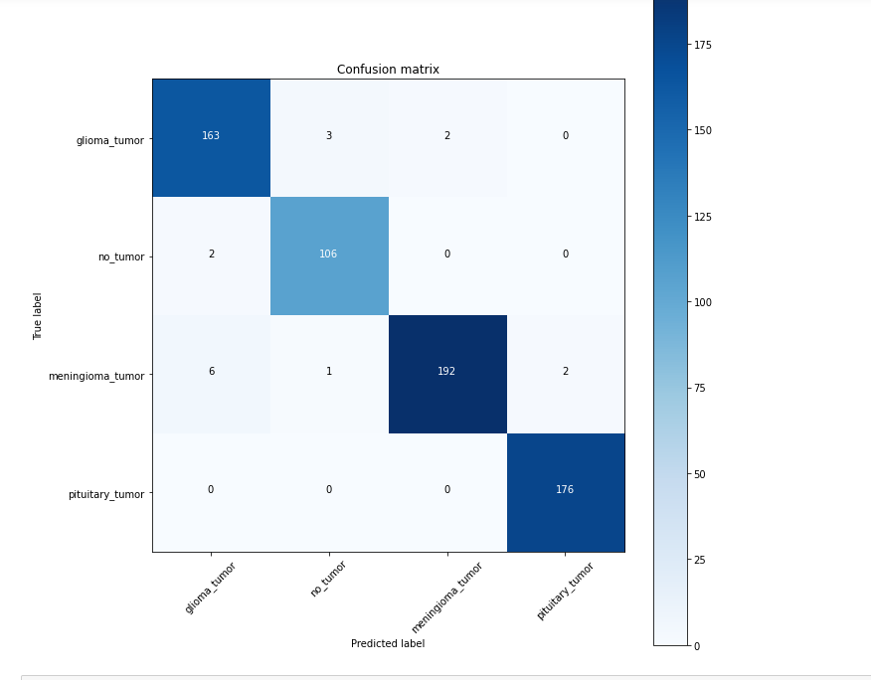

The CNN models are trained, and the performance was recorded. The CNN model architecture shown in figure with adjusted hyper parameter trained for 10 epochs. The max pooling of size 4*4 was applied in two layers to preserve spatial properties of tumours. The trainable parameters are 6,518,308 and non-trainable parameters are 62,055 out of total parameters 6,580,363 in the network. The proposed architecture improves accuracy of CNN architecture shown in figure to 98%. The accuracy and loss plots are shown in figure. From plot is seen that model with hyper parameter adjustment improves the accuracy both in validation and testing dataset. There is slightly peak is seen in loss during training because of small sample of test dataset which can be adjusted by increasing size of dataset, but as epoch increases the loss decreases and it is in line with validation loss

Accuracy or correct rate of classification is the efficiency of appropriate classification to the total number of classification tests. This process of brain tumour classification has been performed on various normal and abnormal MR images, and the accuracy of the CNN classifier is manipulated, using the equation given below:

**CONCLUSION**

In this paper, we have proposed different styles of CNN architectures and compared their performance for brain tumour detection. First, we started with very simple architecture and recorded its accuracy and then the model is tuned by adjusting hyper parameter and increasing number of filters and layers. The results show that adjustment of hyper parameters increases the accuracy of CNN model.

Further model accuracy was increased by using VGG16 has base model and keeping other layers of the model has intact. The use of transfer learning mechanism shows significant improvement in accuracy and F1 score of tumour detection model.

In identification and classification into different types of tumours from brain MRI images, accuracy of nearly 100% was achieved for trained dataset and 95% was achieved for tested dataset. With the above results, we conclude that our proposed method clearly classify the different types of tumour into pituitary, meningioma and glioma tumour, which helps in taking clear diagnosis decisions by clinical experts.

From the observation results, it can be clearly expressed that the detection of brain tumour is fast and accurate when compared to the manual detection carried out by clinical experts

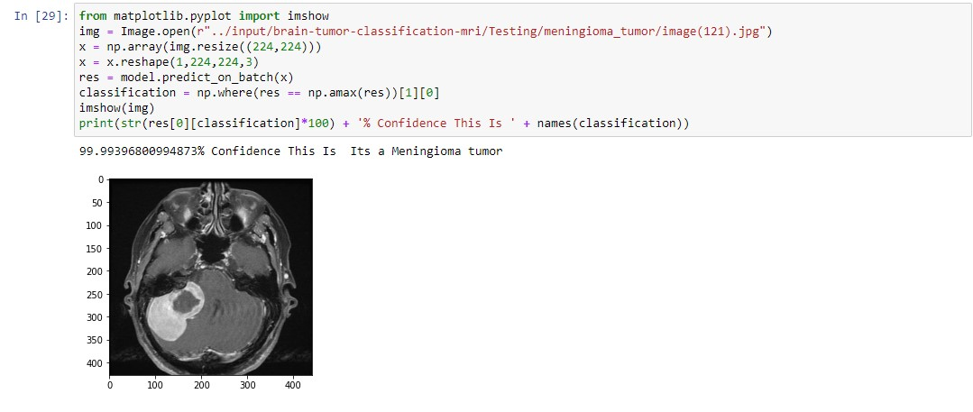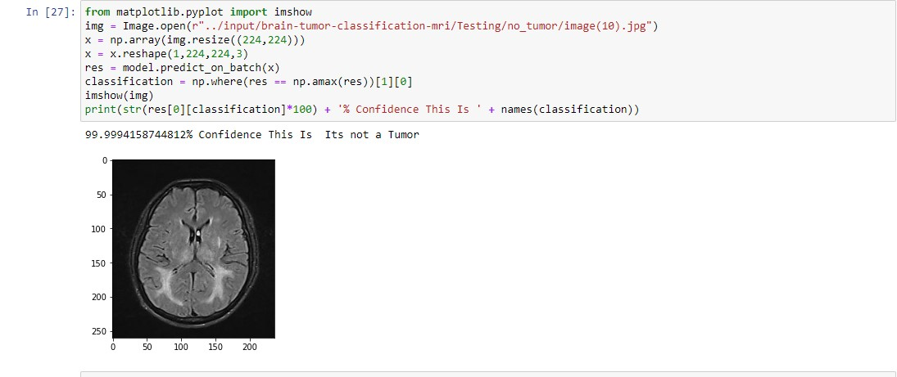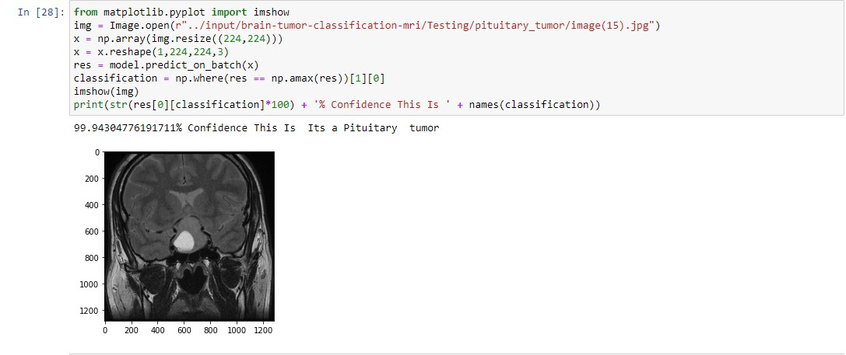

These images show that our model successfully classifies the image of brain tumour into its respective category.

**REFRENCES**

* <https://www.kaggle.com/datasets/sartajbhuvaji/brain-tumor-classification-mri>
* <https://towardsdatascience.com/a-comprehensive-guide-to-convolutional-neural-networks-the-eli5-way-3bd2b1164a53>
* [https://paperswithcode.com/method/efficientnet#:~:text=EfficientNet%20is%20a%20convolutional%20neural,resolution%20using%20a%20compound%20coefficient](https://paperswithcode.com/method/efficientnet).
* <https://braininformatics.springeropen.com/articles/10.1007/s40708-017-0075-5>
* <https://youtu.be/-a7IMhEi4_w>