# 《图像处理导论》

# 第一次作业

学院：计算机科学与工程学院

班级：计算机1606班

姓名：戚子强

学号：20164625

**作业内容：**

对一张图片使用高斯噪声、椒盐噪声，和均值滤波、中值滤波进行处理。

**结果展示：**

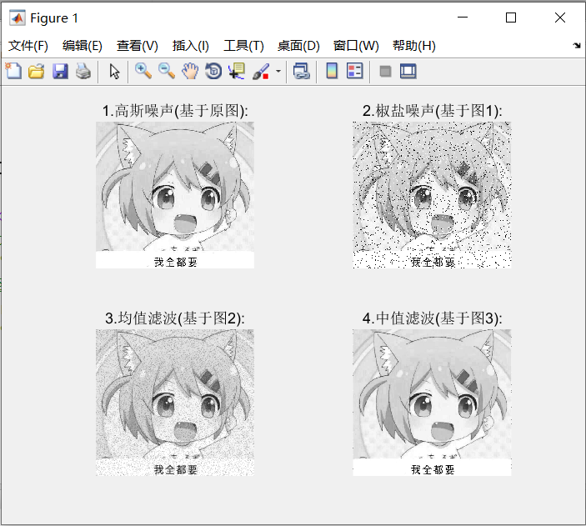

**代码实现：**

Matlab代码如下：

clear;

pic = imread('t3.jpg');

pic1 = rgb2gray(pic);

pic21 = imnoise(pic1,'gaussian',0.01,0);

%目前保持平滑性，仅增加1%扰动，第四个参数为0则不考虑平滑

pic22 = imnoise(pic21,'salt & pepper',0.08);

%第三个参数范围[0,1]，越大噪声越大

%%%%%%%%%%%%%%%%%%%%%%%%%%%%%%%

%均值滤波的实现，也可以使用自带函数filter2(fspecial('average',n);,g)/255;

%%%%%%%%%%%%%%%%%%%%%%%%%%%%%%%

n = 3; %模板大小

template = ones(n);

[height, width] = size(pic22);

x1 = double(pic22);

x2 = x1;

for i = 1:height-n+1

for j = 1:width-n+1

c = x1(i:i+n-1,j:j+n-1).*template;

s = sum(sum(c));

x2(i+(n-1)/2,j+(n-1)/2) = s/(n*n);

end

end

pic23 = uint8(x2);

%%%%%%%%%%%%%%%%%%%%%%%%%%%%%%%

%中值滤波的实现，也可以使用自带函数medfilt2(g,[n2 n2]);

%%%%%%%%%%%%%%%%%%%%%%%%%%%%%%%

[height, width] = size(pic23);

x3 = double(pic23);

x4 = x3;

for i = 1:height-n+1

for j = 1:width-n+1

c = x1(i:i+n-1,j:j+n-1);

e = c(1,:);

for k = 2:n

e = [e, c(k, :)];

end

tmp = median(e);

x4(i+(n-1)/2,j+(n-1)/2) = tmp;

end

end

pic24 = uint8(x4);

figure;

subplot(2,2,1);imshow(pic21);title('1.高斯噪声(基于原图):');

subplot(2,2,2);imshow(pic22);title('2.椒盐噪声(基于图1):');

subplot(2,2,3);imshow(pic23);title('3.均值滤波(基于图2):');

subplot(2,2,4);imshow(pic24);title('4.中值滤波(基于图3):');