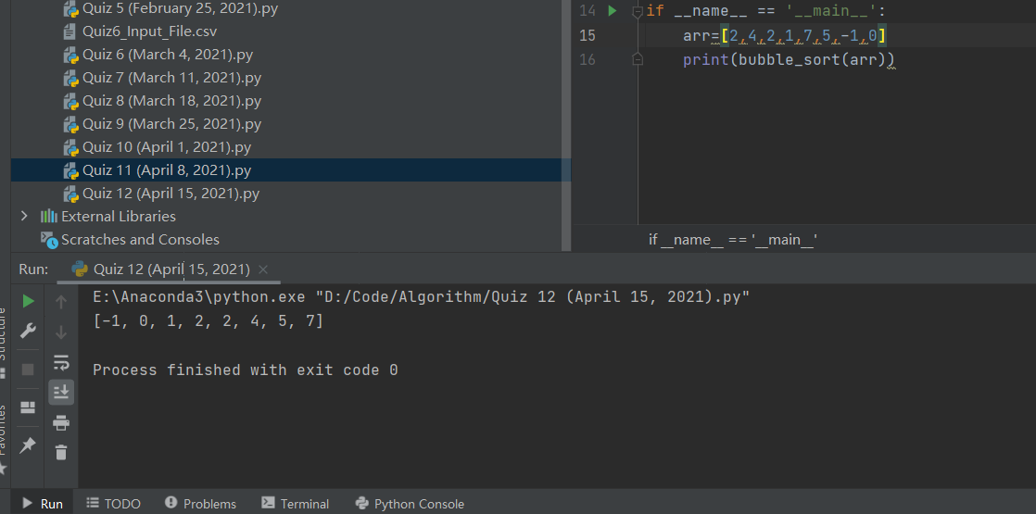

Analysis:

Bubble sort: W(n)=(n-1)(n-1)∈O(n2)

Insertion sort: T(n)=n2/2∈O(n2)

Exchange sort: W(n)= n2/2∈O(n2)

Selection sort: T(n)= n2/2∈O(n2)

So the upper bound of these four sorting algorithms are the same.