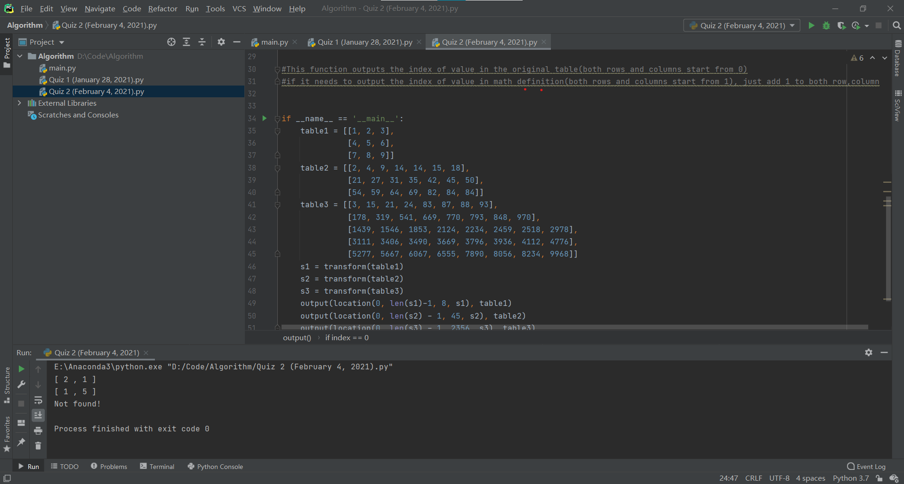

#The output function prints the index of value in the original table (both rows and columns start from 0)

#if it needs to output the index of value in math definition (both rows and columns start from 1), just add 1 to both row, column