Ps: Because the restrictions of my computer hardware, I can only set the maximum of N is about 30. Once I set N above 30, the algorithm 3.1 will take long long time to compute the result. So I set the maximum of K=N/2, time of these two half parts are symmetrical.

Algorithm 3.1:

N=30, K from 0 to 30:

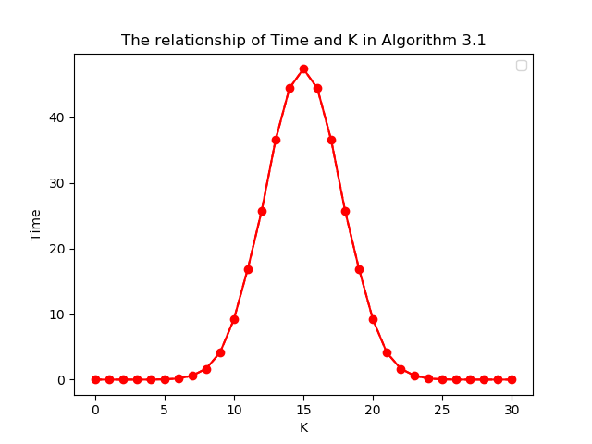

K=20, N from 20-30:

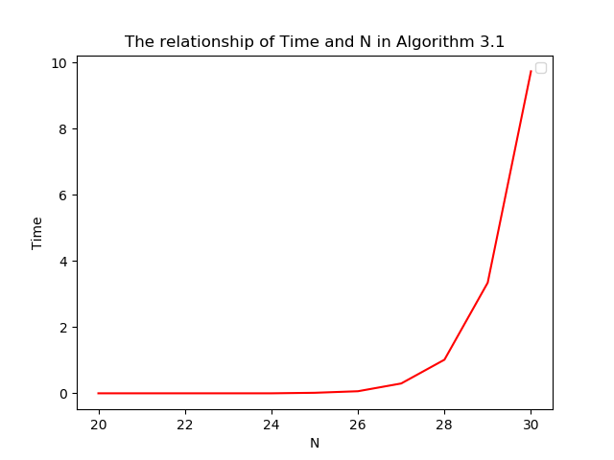

Algorithm 3.2:

N=300, K from 0 to 300:

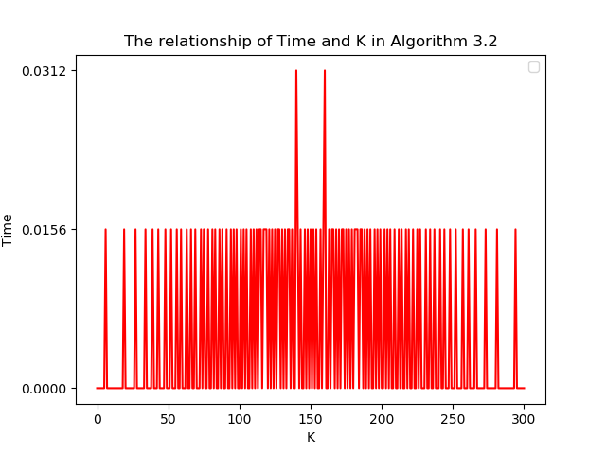

K=150, N from 150-300:

