[A - Reverse string](https://vjudge.net/problem/HackerRank-si-basic-reverse-string" \t "_blank)

//A - Reverse string

#include<bits/stdc++.h>

using namespace std;

int main()

{

string str;

cin>>str;

reverse(str.begin(),str.end());

cout<<str;

}

Abc

//cbA

[B - Odd even index](https://vjudge.net/problem/HackerRank-si-basic-odd-even-index)

 //A - Reverse string

#include<bits/stdc++.h>

using namespace std;

int main()

{

string str;

cin>>str;

for(int i=1;i<str.length();i++)

{

if(i%2!=0)

{

cout<<str[i];

}

}

for(int i=0;i<str.length();i++)

{

if(i%2==0)

{//fgtad5g

cout<<str[i];

}

}

}

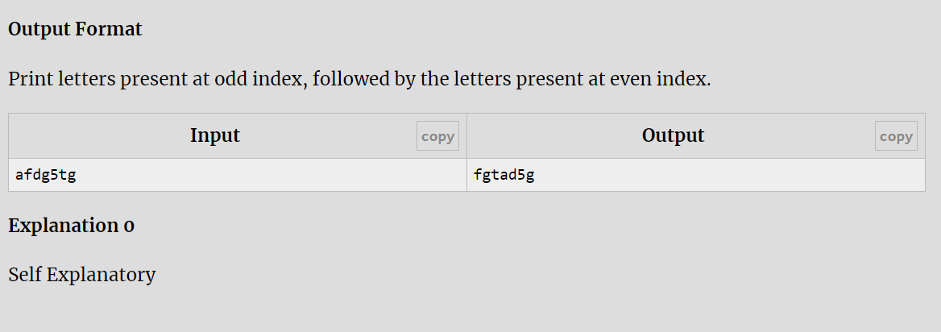

[C - Occurrence of a character](https://vjudge.net/problem/HackerRank-si-basic-occurrence-of-a-character-1)

 //A - Reverse string

#include<bits/stdc++.h>

using namespace std;

int main()

{

string str;

getline(cin,str);

char ch;

cin>>ch;

int count=0;

for(int i=0;i<str.length();i++)

{

if(str[i]==ch)

{

count++;

}

}

cout<<count;

}

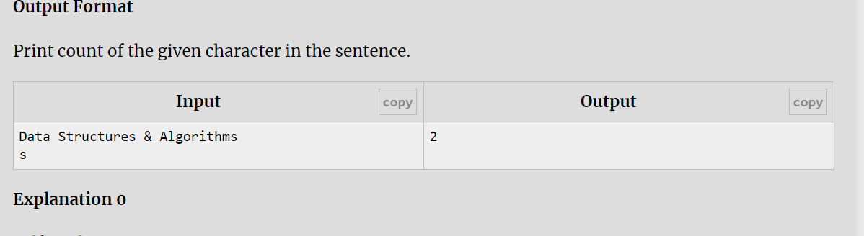

[D - Vowels in a string](https://vjudge.net/problem/HackerRank-si-basic-vowels-in-a-string)

#include<bits/stdc++.h>

using namespace std;

int main()

{

string str;

getline(cin,str);

int count=0;

transform(str.begin(),str.end(),str.begin(),::tolower);

for(int i=0;i<str.length();i++)

{

if(str[i]=='a'||str[i]=='e'||str[i]=='i'||str[i]=='o'||str[i]=='u')

{

count++;

}

}

if(count==str.length())

{

cout<<"Yes";

}

else

{

cout<<"No";

}

}

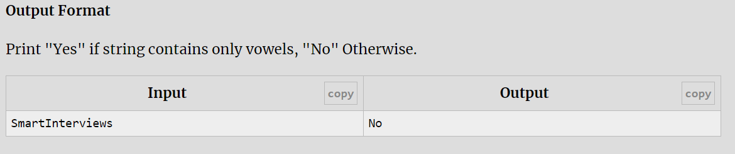

[E - Digits in a string](https://vjudge.net/problem/HackerRank-si-basic-digits-in-a-string)

 #include<bits/stdc++.h>

using namespace std;

int main()

{

string str;

getline(cin,str);

int count=0;

for(int i=0;i<str.length();i++)

{

if(str[i]=='0'||str[i]=='1'||str[i]=='2'||str[i]=='3'||str[i]=='4'||str[i]=='5'||str[i]=='6'||str[i]=='7'||str[i]=='8'||str[i]=='9')

{

count++;

}

}

if(count==str.length())

{

cout<<"Yes";

}

else

{

cout<<"No";

}

}

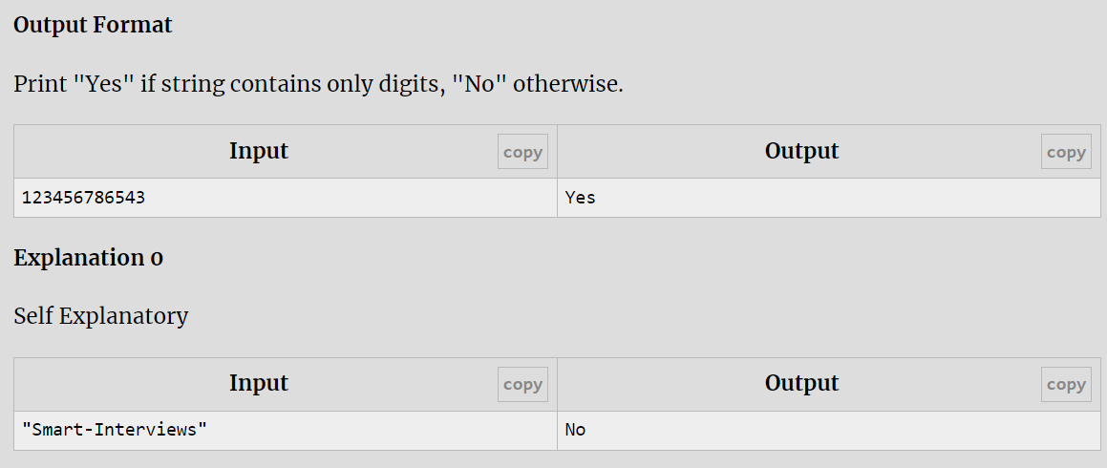

[F - Count vowels and consonants](https://vjudge.net/problem/HackerRank-si-basic-count-vowels-and-consonants)

#include<bits/stdc++.h>

using namespace std;

int main()

{

string str;

getline(cin,str);

int count1=0,count2=0;

transform(str.begin(),str.end(),str.begin(),::tolower);

for(int i=0;i<str.length();i++)

{

if(str[i]=='a'||str[i]=='e'||str[i]=='i'||str[i]=='o'||str[i]=='u')

{

count1++;

}

else

{

count2++;

}

}

cout<<count1<<" "<<count2;

}



[G - Toggle case of characters](https://vjudge.net/problem/HackerRank-si-basic-toggle-case-of-characters)

 #include<bits/stdc++.h>

using namespace std;

int main()

{

string str;

getline(cin,str);

for(int i=0;i<str.length();i++)

{

if(islower(str[i]))

{

str[i]=toupper(str[i]);

}

else

{

str[i]=tolower(str[i]);

}

}

cout<<str;

}

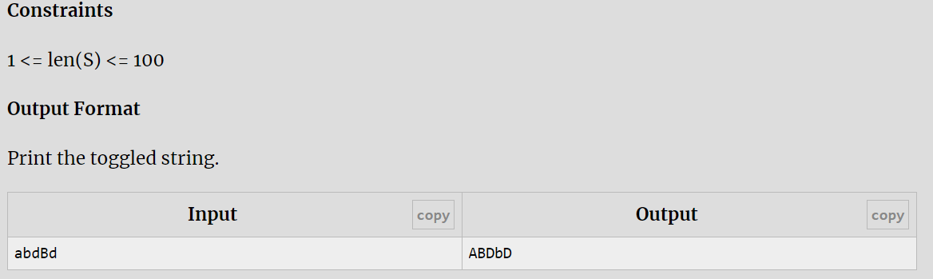

[H - Compress a string](https://vjudge.net/problem/HackerRank-si-basic-compress-a-string)

 #include<bits/stdc++.h>

using namespace std;

int main()

{

string str;

cin>>str;

int count=1;

for(int i=0;i<str.length();i++)

{

if(str[i]==str[i+1])

{

count++;

}

else

{

cout<<str[i]<<count;

count=1;

}

}

}

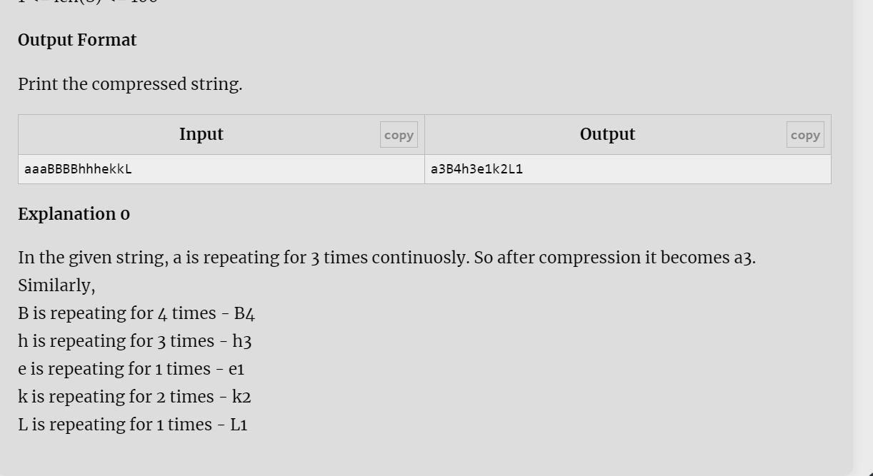

[J - Find First Repeating Character](https://vjudge.net/problem/HackerRank-si-find-first-repeating-character)

#include<bits/stdc++.h>

using namespace std;

int main()

{

int t;

cin>>t;

while(t--)

{

string str;

cin>>str;

char ch='.';

vector<int>count(26);

for(int i=0;i<str.length();i++)

{

count[str[i]-97]++;

}

for(int i=0;i<str.length();i++)

{

if(count[str[i]-97]>1)

{

ch=str[i];

break;

}

}

cout<<ch<<"\n";

}

}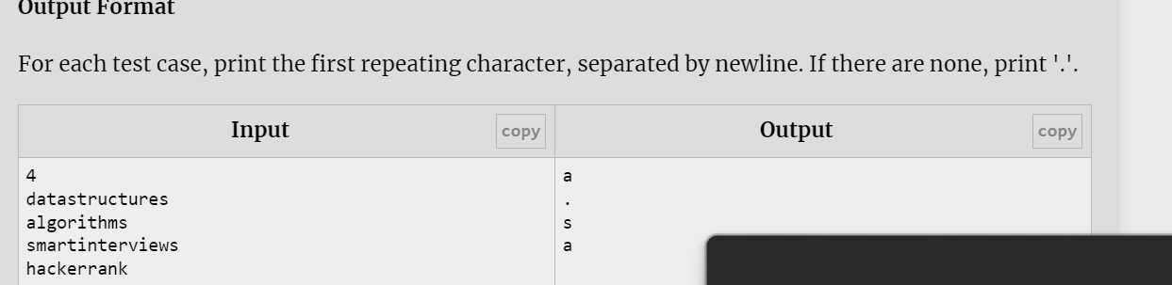

## [K - Words, Vowels and Consonants](https://vjudge.net/problem/HackerRank-si-words-vowels-and-consonants)

#include <iostream>

using namespace std;

int main() {

int t;

cin>>t;

cin.ignore();

while(t--)

{

string str;

getline(cin,str);

int w=0,v=0,c=0;

for(int i=0;i<str.length();i++)

{

if(!(isspace(str[i])) && isspace(str[i+1]))

w++;

if(isalpha(str[i]))

{

str[i]=tolower(str[i]);

if(str[i]=='a'||str[i]=='e'||str[i]=='i'||str[i]=='o'||str[i]=='u')

v++;

else

c++;

}

}

if(str[str.length()-1]==' ')

cout<<w<<" "<<v<<" "<<c<<"\n";

else

cout<<w+1<<" "<<v<<" "<<c<<"\n";

}

}

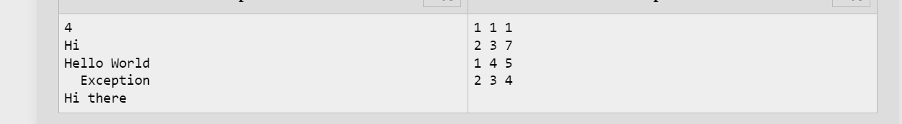

## [L - Anagrams easy](https://vjudge.net/problem/HackerRank-si-check-anagrams)

#include<bits/stdc++.h>

using namespace std;

int main()

{

int t;

cin>>t;

while(t--)

{

string str1,str2;

cin>>str1>>str2;

sort(str1.begin(),str1.end());

sort(str2.begin(),str2.end());

if(str1==str2)

{

cout<<"True"<<"\n";

}

else

{

cout<<"False"<<"\n";

}

}

}

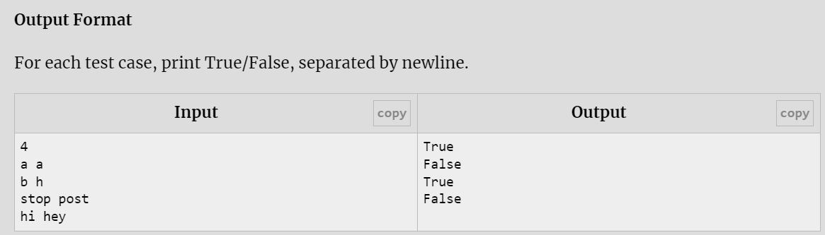

## [M - Pangram](https://vjudge.net/problem/CodeForces-520A)

#include <bits/stdc++.h>

using namespace std;

int main() {

int i,len;

cin>>len;

string str;

cin>>str;

vector<int>count(26);

for(i=0;i<len;i++)

{

str[i]=tolower(str[i]);

count[str[i]-97]++;

}

bool flag = true;

for(int a:count)

{

if(a==0)

{

flag=false;

break;

}

}

if(flag)

{

cout<<"YES";

}

else

{

cout<<"NO";

}

}

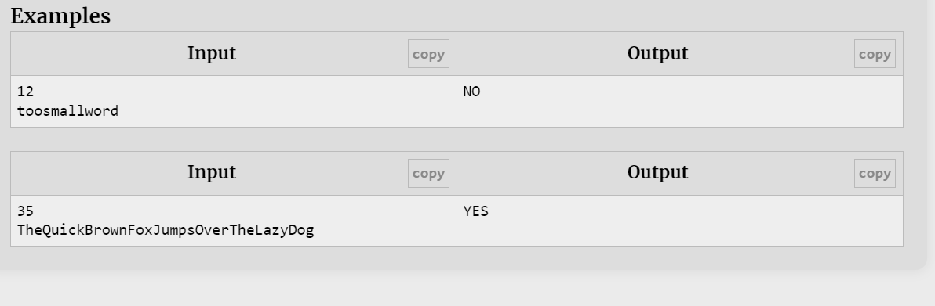

## [N - Way Too Long Words](https://vjudge.net/problem/CodeForces-71A)

#include <bits/stdc++.h>

using namespace std;

int main()

{

string str;

int t,count=0;

cin>>t;

for(int i=0;i<t;i++)

{

cin>>str;

if(str.length()>10)

{

cout<<str[0]<<str.length()-2<<str[str.length()-1]<<endl;

count++;

}

else

{

cout<<str<<"\n";

}

}

}

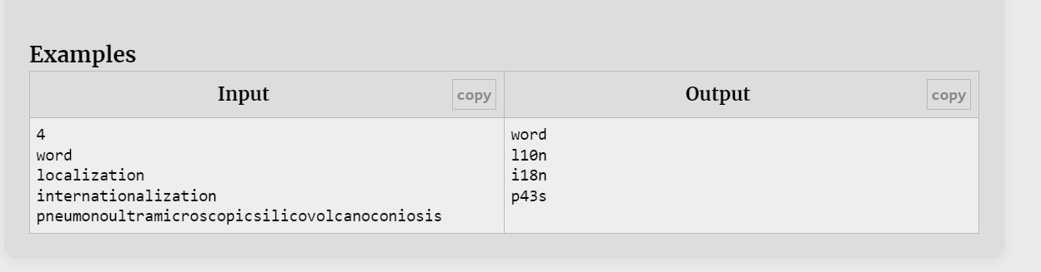

## [O - Love Story](https://vjudge.net/problem/CodeForces-1829A)

 #include<bits/stdc++.h>

using namespace std;

int main()

{

int t;

cin>>t;

while(t--)

{

string str= "codeforces";

string str1;

cin>>str1;

int count=0;

for(int i=0;i<=10;i++)

{

if(str1[i]!=str[i])

{

count++;

}

}

cout<<count<<"\n";

}

}

