PROJECT REPORT ON
HTML REPORT GENERATION OF REQUIRED STANDARD CELLS USING .LIB FILE

BASH PROJECT
IN
PHYSICAL DESIGN
DOMAIN

Submitted by: -

Kajal Pathak
Nikhil Jain
Sarosh

Project Buddy:
Mr. Vashu Yadav

Submitted to: -


PinE Training Academy
ACKNOWLEDGEMENT

It is our pleasure to acknowledge our sense of gratitude to our project guide Mentor Scripting and buddy, Mr. Vashu Yadav, under whom we carried out the project work. Their incisive and objective guidance and timely advice encouraged us with constant flow of energy to continue the work.
This project has taken considerate amount of time and resources and we would like to acknowledge the help of all those who have made the project possible. We would like to thank Mr. Vaibhav Mishra, head of PinE Training Academy for his immense support and guidance.

Date : 12/04/2020
Place : PinE Training Academy, C 56/28th, 3rd Floor, Sector 62,
Noida U.P. 201301 India

ABSTRACT

HTML REPORT GENERATION OF REQUIRED STANDARD CELLS USING .LIB FILE, in our project we have taken the .lib file as input and extracted all the vital information of timing and power of all the required standard cells as per user’s choice and in background a HTML report of the selected cell will be generated automatically and at the end, user can send the HTML report to anyone. In our project we have used BASH scripting to automate the above process.
Our main objective is to make the work of the designer easy and minimize their efforts which can save a lot of time in opening different windows and searching every standard cell separately for their timing and power information.
Three major parts of our project are:
- Checking the .lib for the Required standard cell.
- Fetching information from .lib file and presenting it on the terminal and making the HTML report of the work in the background.
- Sending the HTML report through email if required.

CONTENT

Sr. No. | Topic | Page No.
1 | Introduction | 5
2 | Characterization of Standard Cell Library | 6
3 | Methodology for using HTML | 7
4 | Methodology for using Email | 8
5 | Flow Chart | 9
6 | Output | 12
7 | Applications | 20
8 | Conclusion | 21
9 | Reference | 22
10 | Appendix | 23

INTRODUCTION
Bash (AKA Bourne Again Shell) is a type of interpreter that processes shell commands. A shell interpreter takes commands in plain text format and calls Operating System services to do the directed operation through the shell commands. A shell scripting is writing a program for the shell to execute and a shell script is a file or program that shell will execute.
A Bash script is a plain text file which contains a series of commands. These commands are a mixture of commands of shell and syntax of BASH.
Standard Cell Libraries(.lib) Information are required by almost all the Designers for Chip Design. Standard cell libraries contain primitive cells required for digital design, those particular cell contain the information of capacitance, rise time, fall time, delay table etc.
In standard cell library file, there are mainly 12 categories of cells are present having different drive strength and flavour, which contain timing and power information of each of the pin of every standard cell which is necessary for the designer to fix the timing violations while doing the timing analysis of the design. Reading the particular information of cell which is important for designer is complex or time consuming as this file contain lots of information, so our aim to make this project is reduce the complexity in reading the file, reduced time in searching the cell, in searching the particular information of cell etc.
And we are putting this information in HTML table to read easily and then this file will be sent through the email.

Characterization Of Standard Cell Library

Liberty Timing File (LIB)
- .lib file is basically timing model that contains cell delays, transition, setup and hold time requirements.
- .lib file is an ASCII representation of timing and power parameters associated with any cells in a particular technology node.
- This is basically a timing model file which contains cell delay, cell transition, setup and hold time requirements of a cell.
- These files are provided by gate library vendor or the foundry if they support gate library.
In .lib file following unit attributes are present
- Time unit
- Voltage unit
- Current unit
- Leakage power unit
- Capacitive load unit
- Slew rate: Lower and upper limit values are defined in terms of percentage for both rise and fall time
- Input threshold at rise and fall time
- Output threshold for rise and fall time
For each cell (AND, NAND, INV) following attributes are defined:
- Area of cell
- Leakage power
- Capacitance
- Rise and fall capacitance
- Properties such as capacitance, direction of the pin etc. for each pin (input and output) will be defined. Further different values are characterised in matrix form.
Methodology For Using HTML
HTML is the standard markup language for creating Web pages.
- HTML stands for Hyper Text Markup Language
- HTML describes the structure of a Web page
- HTML consists of a series of elements
- HTML elements tell the browser how to display the content
- HTML elements are represented by tags
- HTML tags label pieces of content such as "heading", "paragraph", "table", and so on
- Browsers do not display the HTML tags, but use them to render the content of the page
HTML Headings
HTML headings are defined with the <h1> to <h6> tags.
<h1> defines the most important heading. <h6> defines the least important heading

HTML Paragraphs
HTML paragraphs are defined with the <p> tag

HTML Lists
The <html> element defines the whole document.
It has a start tag <html> and an end tag </html>.
Inside the <html> element is the <body> element.
The <body> element defines the document body.
It has a start tag <body> and an end tag </body>.

Defining an HTML Table
An HTML table is defined with the <table> tag.
Each table row is defined with the <tr> tag. A table header is defined with the <th> tag. By default, table headings are bold and centred. A table data/cell is defined with the <td> tag

HTML Table - Left-align Headings
By default, table headings are bold and centred.
To left-align the table headings, use the CSS text-align property
- Use the HTML <tr> element to define a table row
- Use the HTML <td> element to define a table data
- Use the HTML <th> element to define a table heading
Methodology for using Email

Email (electronic mail) is the exchange of computer-stored messages by telecommunication. Email messages are usually encoded in American Standard Code for Information Interchange (ASCII) text. However, you can also send non-text files such as graphic images and sound files as attachments sent in binary streams.
Email can be distributed to lists of people, as well as to individuals. A shared distribution list can be managed by using an email reflector. Some mailing lists enable us to subscribe by sending a request to the mailing list administrator. A mailing list that is administered automatically is called a list server. Email is one of the protocols included with the Transport Control Protocol/Internet Protocol (TCP/IP) suite of protocols. A popular protocol for sending email is Simple Mail Transfer Protocol (SMTP), and a popular protocol for receiving it is Post Office Protocol 3 (POP3).
SMTP is the protocol used for sending e-mail over the Internet. Your e-mail client (such as Outlook, Eudora, or Mac OS X Mail) uses SMTP to send a message to the mail server, and the mail server uses SMTP to relay that message to the correct receiving mail server. Basically, SMTP is a set of commands that authenticate and direct the transfer of electronic mail. When configuring the settings for your e-mail program, you usually need to set the SMTP server to your local Internet Service Provider's SMTP settings (i.e. "smtp.yourisp.com").
In our project we have used msmtp, which is a SMTP client. In the default mode, it transmits a mail to an SMTP server which takes care of further delivery. To use this program with our mail user agent (MUA), we create a configuration file with our mail account(s) and tell our MUA to call msmtp instead of /usr/sbin/sendmail.
msmtp Features include:
- Sendmail compatible interface (command line options and exit codes)
- Support for multiple accounts
- TLS/SSL support including client certificates
- Support for Internationalized Domain Names (IDN)
- Many authentication methods
- Fast SMTP implementation using command pipelining
- DSN (Delivery Status Notification) support
- SOCKS proxy support
msmtp runs on a wide variety of platforms. It needs little more than an ANSI C compiler and Berkeley-style sockets. It does not require any additional libraries.
msmtp is free software; you can redistribute it and/or modify it under the terms of the GNU General Public License as published by the Free Software Foundation; either version 3 of the License, or (at your option) any later version.

Flow Of The Project
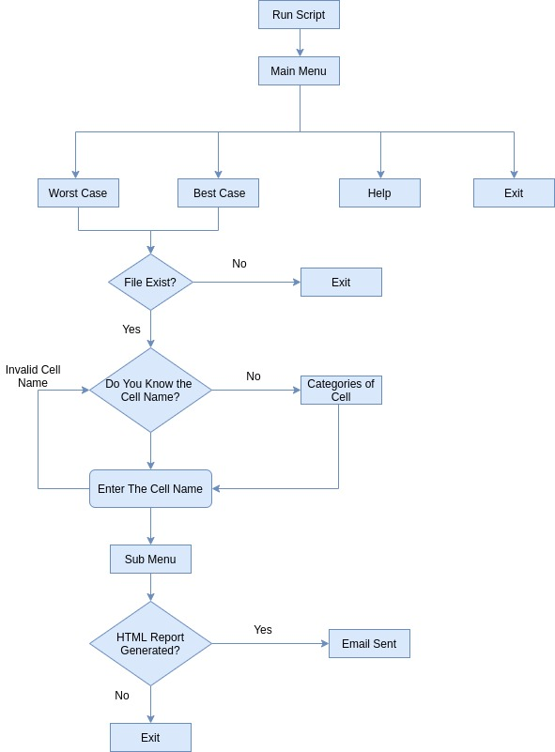

STEP OF PROJECT

- Step 1:

    - After running the script, the main menu containing four options appears:
- Worst case
          - Can be selected while setup violation check using slow.lib
- Best case
- Can be selected while hold violation check using fast.lib
- Help
          - There is a help section for the user to make it easy for the user to guide in the flow of the script and let them understand that how to use the tool efficiently.
- Exit
          - If the user selects Exit the script will exit the main menu without asking for HTML report generation and email.

- Step 2:

    - Checks for the input files i.e. .lib file, that whether the file is present in the current working directory or not.
    - If the input files are not found then the script exits by giving the warning that the required .lib file is not present in the current working directory.
    - If the input file is present then the script proceeds to next step.

- Step 3:

    - The user will be asked that does the name of the standard cell is known or they would like to see the categorised list of all the 477 cells present in the .lib file. So, user can select the required cell from the provided list and can proceed to the cell specifications.

- Step 4:

    - If the user knows the cell name already, they can directly enter it.
    - If the cell name entered is present in the file then only the script will proceed otherwise it will give the warning of invalid cell name and ask the user to enter the cell name again.

- Step 5:

    - After confirming the cell name the user proceed to the specifics of the selected standard cell.
    - A sub-menu in the form of a list will be presented with the following 12 options
for the selected standard cell:

          - Model
          - Units
          - Operating Condition
          - Area
          - Leakage Power
          - Rail connection
          - Pin Information with direction and functionality specifications
          - Timing
          - Internal Power
          - Complete Specification of the selected cell
- Step 6:

    - On the basis of all the information fetched in the step 5 the HTML Report file will be generated by the name “report.html”
    - The Report will also contain the starting, ending and total working time of the script.
- Step 7:

    - The user will be asked that do they want to send the HTML report via email to anyone or not
        - If Yes, then the user will be asked to enter the receiver’s email address or multiple email addresses.
        - After the entered email is confirmed and validated by the script then the email is sent with HTML report as the body of the email.
        - If No, then the script will show the end time and the total run time of the script and will exit.

OUTPUTS
First, we run the script then we check that standard cell library file is present or not if the file is not present then script will exit after generation the warning that the file is not present in the present working directory.
If file exist in current working directory then it will go for further step.
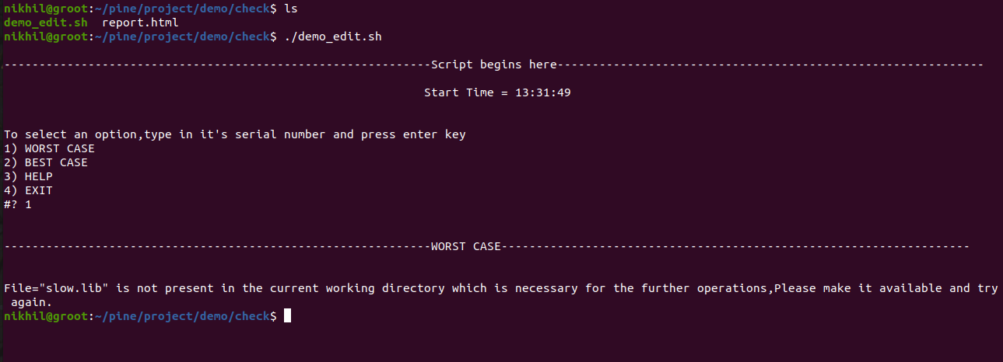
In this step as the file are present in current working directory so it will ask for further option.
In this step we are asking the user that Do you know the Cell Name?
If the user knows the Cell Name then he/she will type (y), if they didn’t know the Cell Name then type (n).
then next prompt will ask to user to Enter the Cell Name in UPPERCASE, here cell name must be in uppercase because all the cells in library file are in uppercase.
Here we are also giving 3 attempts to user to entered the correct cell name if user enter Invalid Cell Name till 3 attempts then prompt will again come and ask the user that Do you know the Cell Name?

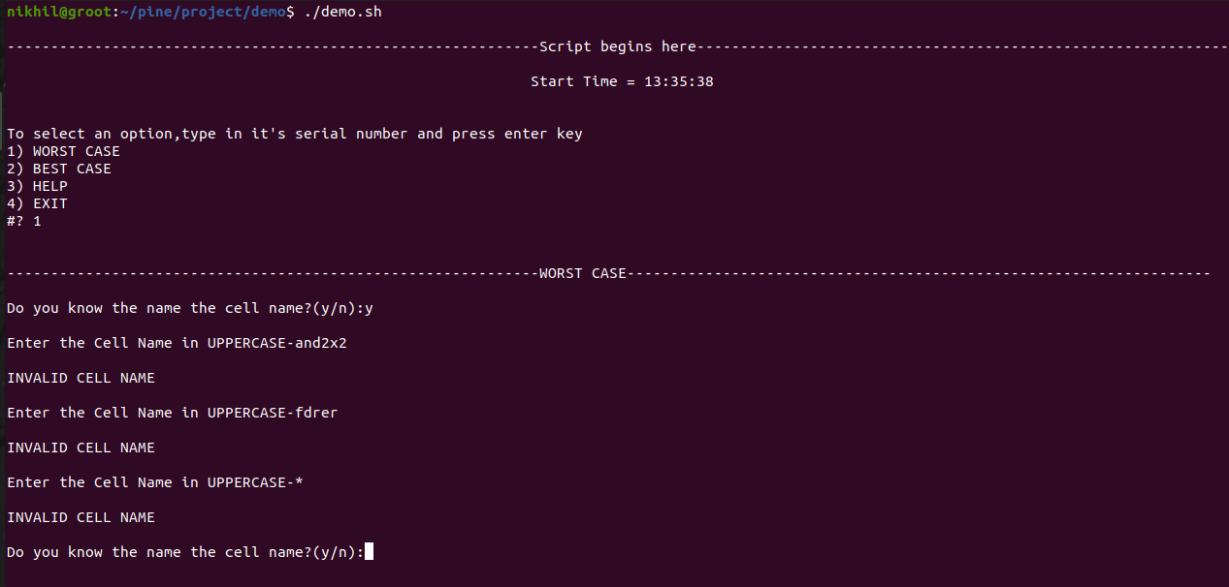
As we know library file contain large number of cells so it is very difficult that the designer knows all the cell name of all category with drive strength so here, we provide the list of cells which user want to see.
If user typed n then the Categories of Cell will open and each category contain the list of all cell of that type with different drive strength.
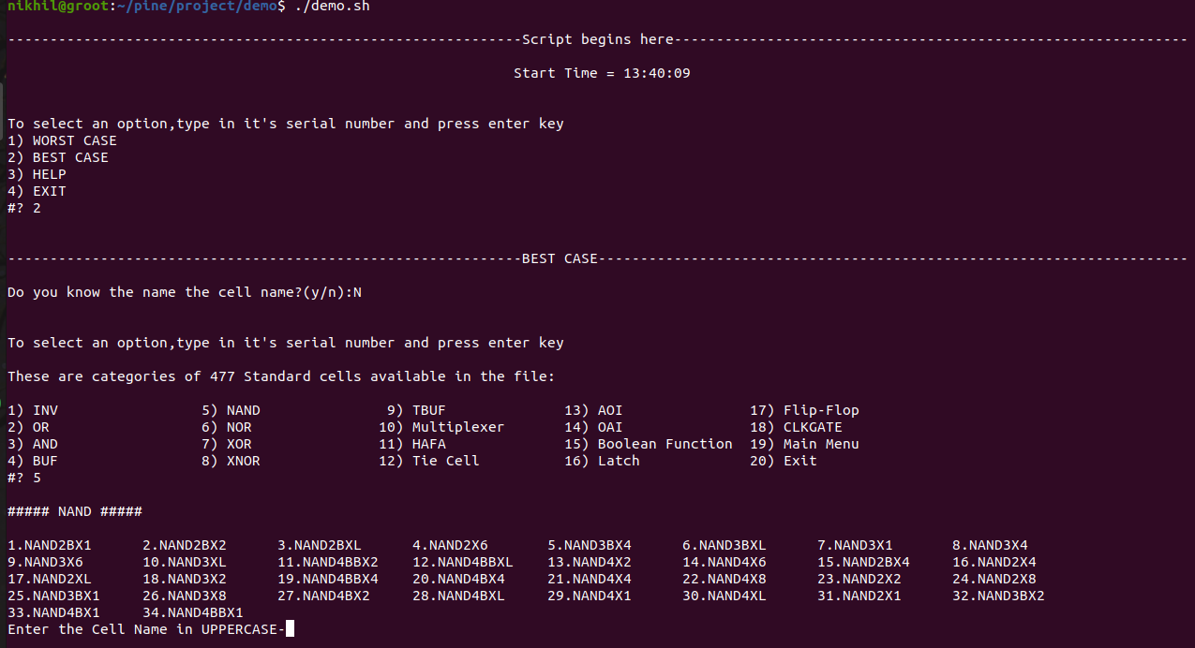
As you can see there are 477 standard cells are present in the file and these 477 cells are divided into 18 categories. As shown below we choose 5th option of NAND Gate and all type of NAND gate with different drive strength will be shown.

After typing the correct cell name, we can get all the information of that cell name to read the information easily we divide the cell information in sub option Model, Units, Operating Condition, Area, Leakage power, Rail Connection, Pin Information, Timing, Internal Power.
here we also give one option that if user want to see complete information of the particular cell the he/she can choose the 10th option to see Complete Information.
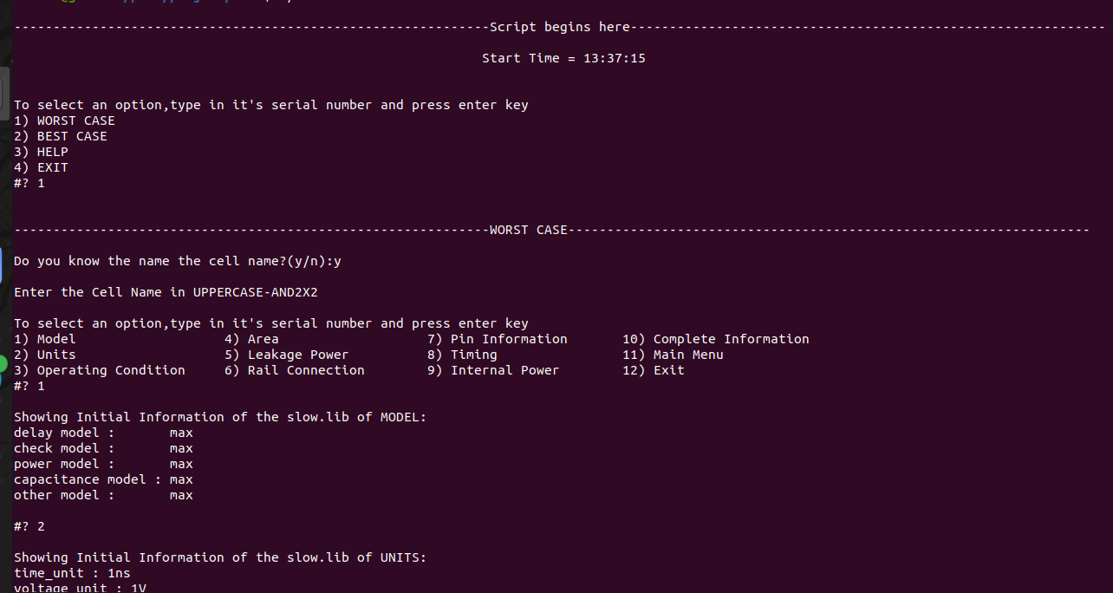
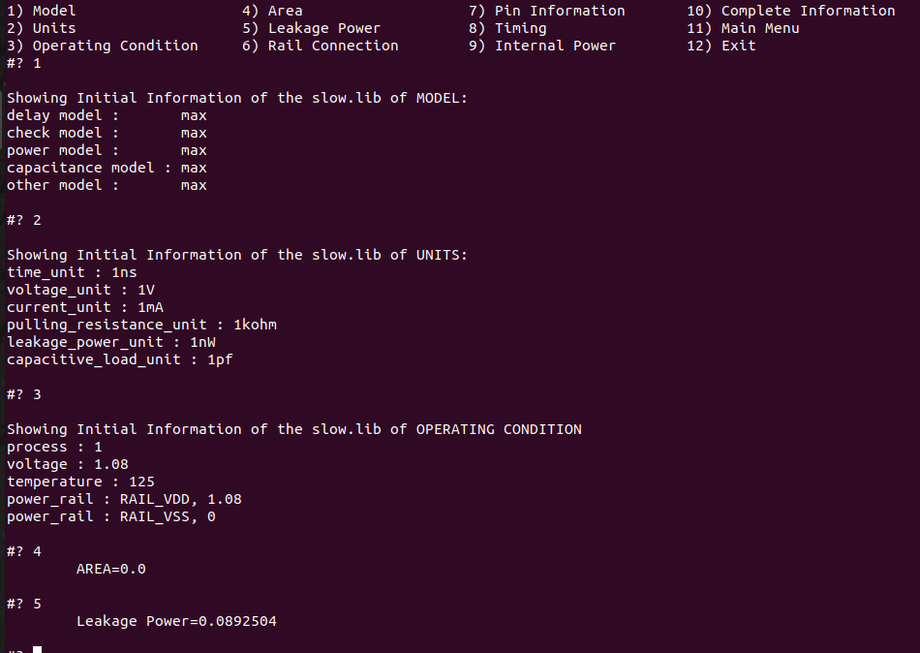

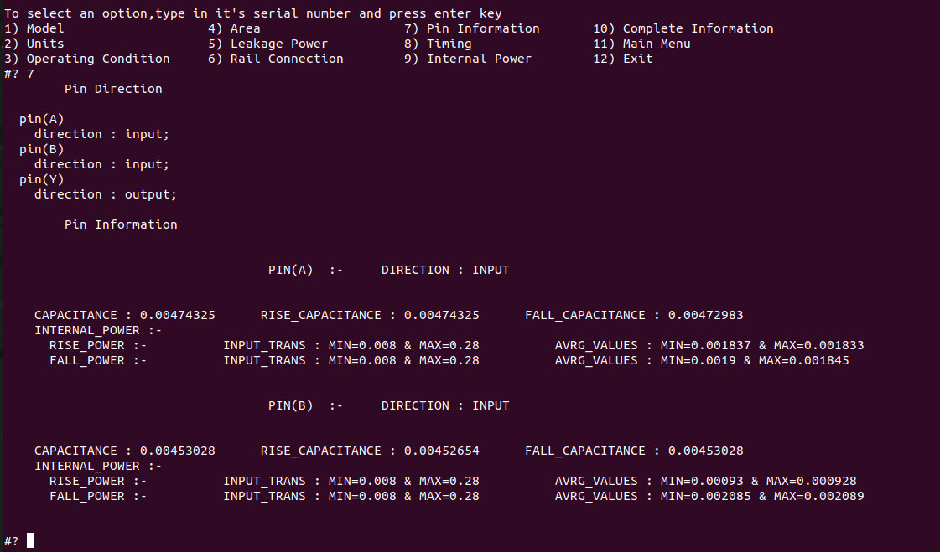

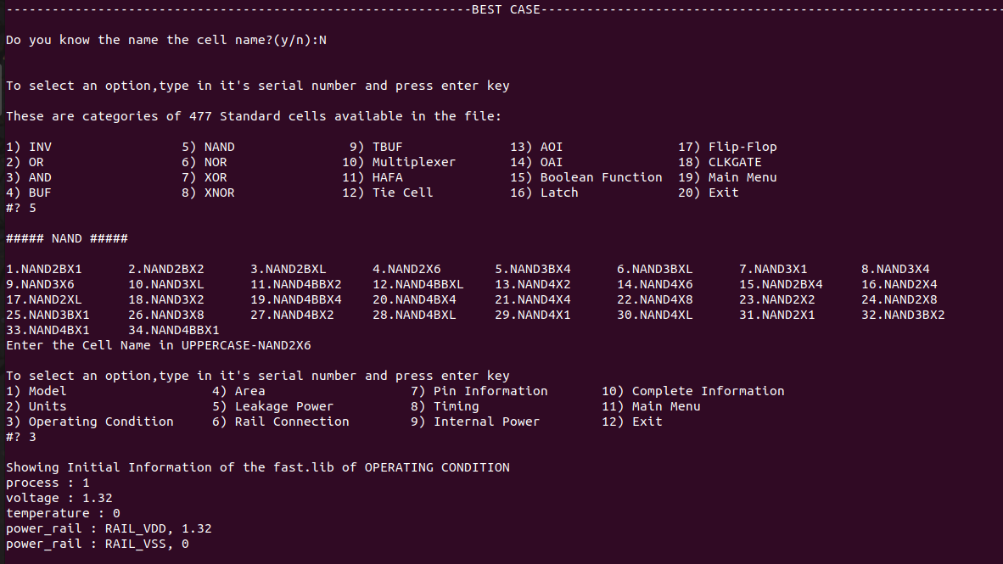


Now, HTML report will be generated and we also give option to send the HTML report through an Email. Prompt will ask user to send the report through email if he/she type y then mail will be send to the recipient mail address which you provided. If he/she type n then script exit here.

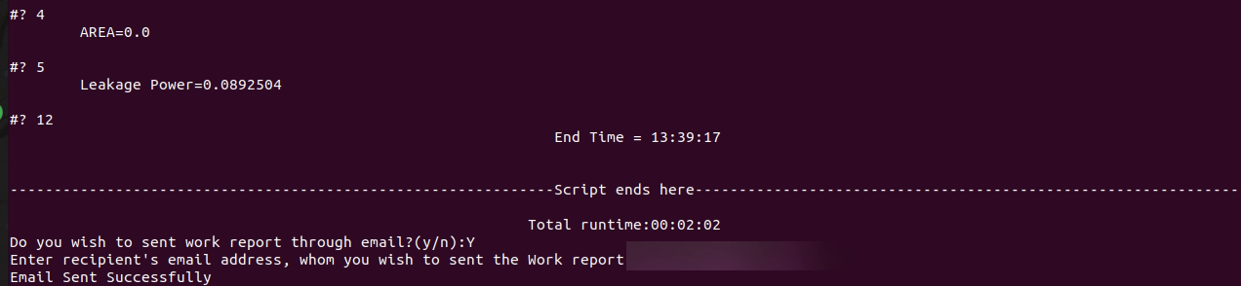
The mail prompt will only come on one condition that the report.html file will be generated if not generated then script exit here.
Report.html file will be generated only when the user see the information of the particular cell.

Here we also provide the HELP option in which we had showed the description of our project and steps of our project on how to run the project.

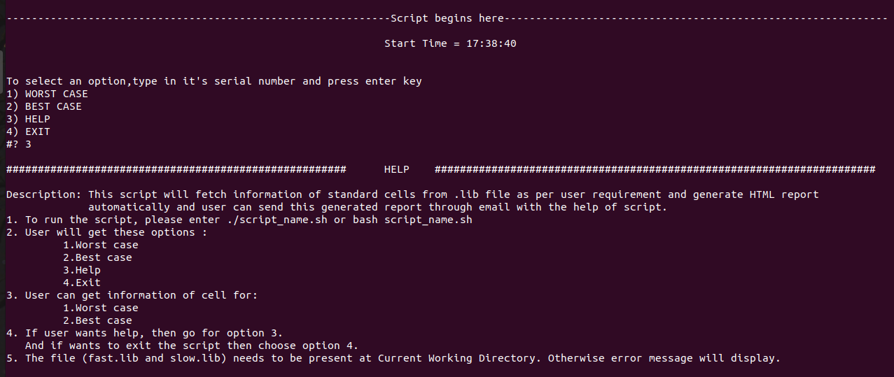
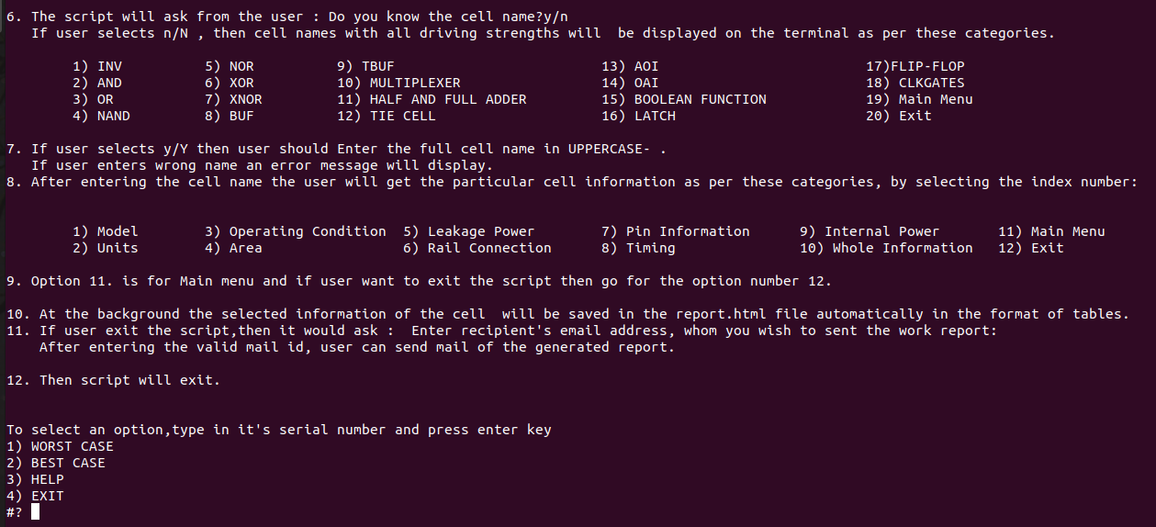

If user run the script by mistake or he/she wants to from the script without reading the information then they can choose 4th option exit from the script.
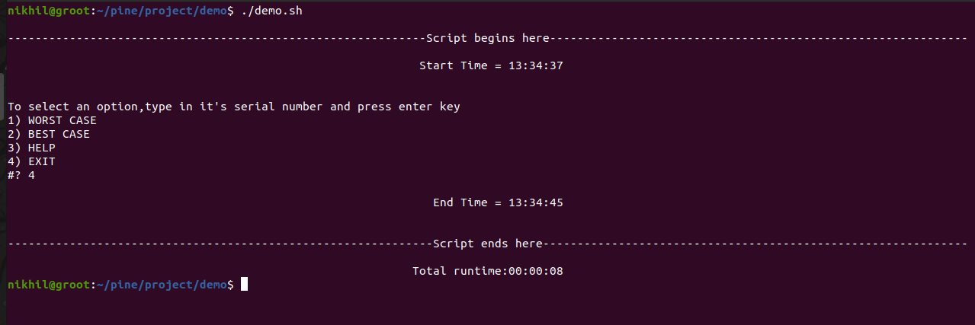
APPLICATIONS
- To obtain the starting, ending and the total working time of the user on the script.
- To obtain the minimum and maximum values of the timing and power of the selected standard cell from the lookup table in an instant.
- Enables the user to obtain the specifications of the desired Standard cell without opening and searching the file each and every time.
- To generate the HTML report in the background while working on the shell.
- To send work report form terminal via email.
- To send the tabular HTML data in the body of email.
- To check that the entered email is in the valid format or not.
- To obtain the list of all the standard cells present in the .lib file.
- To make it easy to understand specifications of each standard cell from the report file which is in a proper tabular form.
- To check whether a Standard cell is present in the .lib file or not.

CONCLUSION
This project used BASH Scripting to extract the specifications of each and every cell, one at a time, from the liberty timing file and generate the HTML report of all the results and output fetched on the terminal and email it via terminal to one or many receivers. The script consists of some important commands, such as egrep, sed, awk, read, date, mail, select were used along with the features of functions, conditional statements, loops, variable initialization etc.
The script first checks the existence of the input .lib file and takes action accordingly. If it exits then proceeds further else gets terminated.
The script asks the user to enter the cell name and will only proceed if the name entered is present in the .lib file.
The script fetches all the information of the selected standard cell and further the information is used to generate the HTML report.
The script after sends the HTML report to the receiver’s email address with the HTML report as the body of the mail.

REFERENCE
- “J. Bhasker ,Rakesh Chadha” Static Timing Analysis for Nanometer Designs
- TSMC 0.18μm Process 1.8-Volt SAGE-X TM Standard Cell Library Databook “Artisan Components”Standard Cell Library File Specification http://www.signoffsemi.com/lef-def-lib/
- Design And Characterization Of A Standard Cell Library For The Freepdk45 Process By Naresh Anne Andhra University Visakhapatnam, India 2008
- For email setup: https://vitux.com/how-to-use-gmail-from-the-ubuntu-terminal-to-send-emails/
- For HTML table creation, colour code: https://www.w3schools.com/html/

APPENDIX

Script:

#!/bin/bash

Help(){
echo "###################################################### HELP ######################################################################"
echo

printf "Description: This script will fetch information of standard cells from .lib file as per user requirement and generate HTML report\n automatically and user can send this generated report through email with the help of script.\n"

echo "1. To run the script, please enter ./main.sh or bash main.sh"

echo "2. User will get these options :"
printf "%s\t 1.Worst case\n"
printf "%s\t 2.Best case\n"
printf "%s\t 3.Help\n"
printf "%s\t 4.Exit\n"

echo "3. User can get information of cell for:"
printf "%s\t 1.Worst case\n "
printf "%s\t 2.Best case\n"
echo "4. If user wants help, then go for option 3. "
echo " And if wants to exit the script then choose option 4. "

echo "5. The file (fast.lib and slow.lib) needs to be present at working directory. Otherwise error message will display."
echo
echo "6. The script will ask from the user : Do you know the cell name?y/n"
echo " If user selects n/N , then cell names with all driving strengths will be displayed on the terminal as per these categories."
echo "

1. BASIC GATES(INV,AND,OR,NAND,NOR,XOR,XNOR,BUF,TBUF)
2. MULTIPLEXER
3. HAFA
4. TIE CELL
5. AOI
6. OAI
7. BOOLEAN FUNCTION
8. LATCH
9. FLIP-FLOP
10.CLKGATES "
echo
echo "7. If user selects y/Y then user should Enter the full cell name in UPPERCASE- ."
echo " If user enters wrong name an error message will display."
echo "8. After entering the cell name the user will get the particular cell information as per these categories, by selecting the index number:"
echo "

1) Model 3) Operating Condition 5) Leakage Power 7) Pin Information 9) Internal Power 11) Previous Menu

2) Units 4) Area 6) Rail Connection 8) Timing 10) Whole Information 12) Exit
"

echo " suboptions are there in the timing information, user can select that option according to the requirement, through index number."

echo "9. Option 11. is for Main menu and if user want to exit the script then go for the option number 12. "
echo

echo "10. At the background the selected information of the cell will be saved in the report.html file automatically in the format of tables."
echo "11. If user exit the script,then it would ask : Enter recipient's email address, whom you wish to sent the work report:"
echo " After entering the valid mail id, user can send mail of the generated report. "

echo
echo "12. Then script will exit. "
echo
}

model() {
#MODEL_WITH_HTML_REPORT_GENERATION
echo -e "\nShowing Initial Information of the $filename of MODEL: "
echo "<table border="5" bordercolorlight="#b9dcff" bordercolordark="#006fdd" width="290">
<tr>
<th bgcolor="#bfbfbf" ><center>Model</center></th>
</tr>" >> report.html

while read line ;do
if [[ $line =~ ' model' ]];then
#if any line contains the specified REGEX then it will be printed
echo "$line"
echo "<tr>
<td>$line</td>
</tr>" >> report.html
fi
done < $filename #"$filename" contains the name of the input .lib file
echo "</table>" >> report.html
}
units() {
#UNIT_WITH_HTML_REPORT_GENERATION
echo -e "\nShowing Initial Information of the $filename of UNITS: "
echo "<table border="5" bordercolorlight="#b9dcff" bordercolordark="#006fdd" width="290">
<tr>
<th bgcolor="#bfbfbf" ><center>Units</center></th>
</tr>" >> report.html

while read line ;do
if [[ $line =~ '_unit' ]]; then
echo $line
echo "<tr>
<td>$line</td>
</tr>" >> report.html
fi
done <<< $(sed 's/[;),]//g;s/"//g;s/(/: /' $filename) #"$filename" contains the name of the input .lib file
#if any line contains the specified REGEX then it will be feeded as input to while loop
echo "</table>" >> report.html
}
operating_condition() {
#OPERATING_CONDITION_WITH_HTML_REPORT_GENERATION
echo -e "\nShowing Initial Information of the $filename of OPERATING CONDITION"
echo "<table border="5" bordercolorlight="#b9dcff" bordercolordark="#006fdd" width="290">
<tr>
<th bgcolor="#bfbfbf" ><center>Operating Condition</center></th>
</tr>" >> report.html

while read line ; do
echo "$line"
echo "<tr>
<td>$line</td>
</tr>" >> report.html
done <<< $(cat $filename | egrep -A 5 operating_conditions | head -6 | tail -5 | sed 's/[;)]//g;s/(/ :/')
#if any line contains the specified REGEX then it will be feeded as input to while loop
echo "</table>" >> report.html
}
area(){
#AREA_WITH_HTML_REPORT_GENERATION
area=$(echo "$cell_information" | egrep 'area'| awk '{print $3}' | sed 's/;//')
echo -e "\tAREA=$area\n"
echo "<table border="5" bordercolorlight="#b9dcff" bordercolordark="#006fdd" width="290">
<tr>
<th bgcolor="#bfbfbf" ><center>Area of $cell_name</center></th>
</tr>
<tr>
<td>$area</td>
</tr>
</table>" >> report.html
}
leakage_power(){
#LEAKAGE_POWER_WITH_HTML_REPORT_GENERATION
leakage_power=$(echo "$cell_information" | egrep 'leakage' | awk '{print $3}' | sed 's/;//')
echo -e "\tLeakage Power=$leakage_power\n"
echo "<table border="5" bordercolorlight="#b9dcff" bordercolordark="#006fdd" width="290">
<tr>
<th bgcolor="#bfbfbf" ><center>Leakage Power of $cell_name</center></th>
</tr>
<tr>
<td>$leakage_power</td>
</tr>
</table>" >> report.html
}
rail(){
#RAIL_CONNECTION_WITH_HTML_REPORT_GENERATION
rail=$(echo "$cell_information" | egrep 'rail' | awk '{print $2 $3}')
echo -e "\tRail Connection=$rail\n"
echo "<table border="5" bordercolorlight="#b9dcff" bordercolordark="#006fdd" width="290">
<tr>
<th bgcolor="#bfbfbf" ><center>Rail Connection of $cell_name</center></th>
</tr>
<tr>
<td>$rail</td>
</tr>
</table>" >> report.html
}
pin(){
#PIN_INFORMATION
pin_direction=$( echo "$cell_information"| sed -rn '/pin\(.+\)\s+\{$/{N;p}'| sed -r 's/[{}]//g')
#PIN_DIRECTION
echo -e "\tPin Direction\n\n$pin_direction\n"
#PIN_TIMING
echo -e "\tPin Information\n\n"
sed -nr "/$cell_name/,/^}/p" $filename | sed -rn '/pin\(.+\)/N;/input/,/: output/p' | sed -rn '/pin\(.+\)/N;/output/d;p' | sed 's/index_1/INPUT_TRANS/;s/index_2/OUTPUT_CAP/;s/\\//g;s/\;//;s/,/ /g;s/\"/ /g' | awk '{print $0}/INPUT_TRANS|OUTPUT_CAP/{print " "$1" : " "MIN="$3 " & MAX="$9}' | sed -r '/INPUT_TRANS \(| OUTPUT_CAP \(/d;s/\(.+template.+\)//' | awk '{print $0}/values \( [0-9]/{print " "$1" : " "MIN="$3 " & MAX="$9}' | sed -r '/values\s+\(\s+[0-9]/d' | sed -r '/values \(/{N;N;N;N;N;N;N;s/\n/ /g}' | awk '{print $0}/values \(/{print " AVRG_VALUES : MIN="$3 " & MAX="$51}' | sed -r '/values \(/d;s/values/ANRG_VALUES/;/_power \{/{N;N;N;s/\n/ /g};/capacitance/{N;N;s/\n/ /g};/related_pin/{N;s/\n/ /g};/_constraint/{N;N;s/\n/ /g};/when :/{N;s/\n/ /};/pin\(.+\)/{N;s/\n/ /};s/\(\)//;s/\{/:-/g;s/\}/ /g;s/values :/AVRG_VALUES :/;s/pin\(.+\)/ \U&/;/direction/{N;s/\n/\n\n/};s/[a-Z]+_*.* :/\U&/g;s/INPUT_SIGNAL_LEVEL : RAIL_VDD//'

}
timing(){
#OPERATING_CONDITION
res=$(echo "$cell_information" | sed -n "/timing/,/}/p")
echo "$res"
}
internal_power(){
res=$(echo "$cell_information" | sed -n "/internal_power/,/}/p")
echo "$res"
}
file_check(){
check_file=$(ls| egrep "$filename")
if [[ ! $check_file =~ '.' ]];then
{
echo -e "\nFile=\"$filename\" is not present in the current working directory which is necessary for the further operations,Please make it available and try again."
exit
}
fi
}
email(){ #it will ask the user to enter the recipient's email address

read -p "Enter recipient's email address, whom you wish to sent the Work report:" email_id
#"email_id" stores the user input of recipient's email address
confirm=$(echo $email_id | egrep '[A-Za-z0-9._-]+@[A-Za-z0-9._-]+\.[A-Za-z.]+'| wc -L)
#"confirm" varible will be "0" if the email id entered by the user is invalid
if [[ $confirm -ne 0 ]];then
{
#if valid email address is given the email will be sent
mail -s "$(echo -e "Work report\nContent-Type: text/html")" $email_id < report.html
echo "Email Sent Successfully"
exit
}
else
{
#if valid email address is not given the email will not be sent
echo "You have entered an invalid Email address, Please check the email and try again"
email
}
fi

}
choice(){ #it will ask the user does he/she wants to send the work report through email or not
end_time
while :
do
read -p "Do you wish to sent work report through email?(y/n):" choose

case $choose in

"y" | "Y" ) #If "yes", Script will exit after sending the email
email
;;

"N" | "n") #If "no", Script will exit without sending the email
exit
;;
*) #If invalid input is given, Script ask again for yes/no
echo "You have entered an invalid input, Please try again"
choice

;;
esac
done
}
no(){
#ALL_CELL_LIST_WITH_DRIVE_STRENGTH

total_cell_count=$(egrep -o '^cell\s\(.+\)' $filename | awk '{print $2}' | sed 's/[()]//g' | wc -l)
echo -e "\nTo select an option,type in it's serial number and press enter key\n"
echo "These are categories of $total_cell_count Standard cells available in the file:"
echo

select answer4 in "INV" "OR" "AND" "BUF" "NAND" "NOR" "XOR" "XNOR" "TBUF" "Multiplexer" "HAFA" "Tie Cell" "AOI" "OAI" "Boolean Function" "Latch" "Flip-Flop" "CLKGATE" "Main Menu" "Exit";do

case $answer4 in

"INV") #INV
echo -e "\n##### INV #####\n"
awk 'BEGIN{i=0}/cell \(INV.+\)/{i++;printf i"."" ";print $2}' $filename | sed 's/[()]//g' | column -x
break
;;

"OR") #OR
echo -e "\n##### OR #####-\n"
awk 'BEGIN{i=0}/cell \(OR.+\)/{i++;printf i"." " ";print $2}' $filename | sed 's/[()]//g' | column -x
break
;;

"AND") #AND
echo -e "\n##### AND #####\n"
awk 'BEGIN{i=0}/cell \(AND.+\)/{i++;printf i"." " ";print $2}' $filename | sed 's/[()]//g' | column -x
break
;;

"BUF") #BUF
echo -e "\n##### BUF #####\n"
awk 'BEGIN{i=0}/cell \(BUF.+\)/{i++;printf i".";print $2}' $filename | sed 's/[()]//g' | column -x
break
;;

"NAND") #NAND
echo -e "\n##### NAND #####\n"
awk 'BEGIN{i=0}/cell \(NAND.+\)/{i++;printf i".";print $2}' $filename | sed 's/[()]//g' | column -x
break
;;

"NOR") #NOR
echo -e "\n##### NOR #####\n"
awk 'BEGIN{i=0}/cell \(NOR.+\)/{i++;printf i".";print $2}' $filename | sed 's/[()]//g' | column -x
break
;;

"XOR") #XOR
echo -e "\n##### XOR #####\n"
awk 'BEGIN{i=0}/cell \(XOR.+\)/{i++;printf i".";print $2}' $filename | sed 's/[()]//g' | column -x
break
;;

"XNOR") #XNOR
echo -e "\n##### XNOR #####\n"
awk 'BEGIN{i=0}/cell \(XNOR.+\)/{i++;printf i".";print $2}' $filename | sed 's/[()]//g' | column -x
break
;;

"TBUF") #TBUF
echo -e "\n##### TBUF #####\n"
awk 'BEGIN{i=0}/cell \(TBUF.+\)/{i++;printf i".";print $2}' $filename | sed 's/[()]//g' | column -x
break
;;

"Multiplexer") #MULTIPLEXER
echo -e "\n##### MULTIPLEXER #####\n"
awk 'BEGIN{i=0}/cell \(.?MX.+\)/{i++;printf i".";print $2}' $filename | sed 's/[()]//g' | column -x
break
;;

"HAFA") #HALF_ADDER_FULL_ADDER
echo -e "\n##### HAFA #####\n"
awk 'BEGIN{i=0}/cell \(ADD.+\)/{i++;printf i"." " ";print $2}' $filename | sed 's/[()]//g' | column -x
break
;;

"Tie Cell") #TIE_CELL
echo -e "\n##### TIE CELL #####\n"
awk 'BEGIN{i=0}/cell \(TIE.+\)/{i++;printf i"." " ";print $2}' $filename | sed 's/[()]//g' | column -x
break
;;

"AOI") #AOI
echo -e "\n##### AOI #####\n"
awk 'BEGIN{i=0}/cell \(AO.+\)/{i++;printf i"." " ";print $2}' $filename | sed 's/[()]//g' | column -x
break
;;

"OAI") #OAI
echo -e "\n##### OAI #####\n"
awk 'BEGIN{i=0}/cell \(OA.+\)/{i++;printf i"." " ";print $2}' $filename | sed 's/[()]//g' | column -x
break
;;
"Boolean Function") #BOOLEAN_FUNCTION
echo -e "\n##### BOOLEAN FUNCTION #####\n"
awk 'BEGIN{i=0}/cell \(DLY.+\)/{i++;printf i"." " ";print $2}' $filename | sed 's/[()]//g' | column -x
break
;;

"Latch") #LATCH
echo -e "\n##### LATCH #####\n"
awk 'BEGIN{i=0}/cell \(TLAT.+\)/{i++;printf i"." " ";print $2}' $filename | sed 's/[()]//g' | column -x
break
;;

"Flip-Flop") #FLIP-FLOP
echo -e "\n##### FLIP-FLOP #####\n"
awk 'BEGIN{i=0}/cell \(.*FF.+\)/{i++;printf i"." " ";print $2}' $filename | sed 's/[()]//g' | column -x
break
;;

"CLKGATE") #CLKGATE
echo -e "\n##### CLKGATE #####\n"
awk 'BEGIN{i=0}/cell \(CLK.+\)/{i++;printf i"." " ";print $2}' $filename | sed 's/[()]//g' | column -x
break
;;

"Main Menu") #Main menu
main_menu
;;

"Exit") end_time
exit
;;

*) echo "Invalid input,Please Select only from the list below and retry"
no
;;
esac
done
}
check_cell_name_correct(){ #HERE_WHILE_LOOP_RUN_FOR_3_TIMES_AFTER_THIS_IT_WILL_GO_BACK_TO_THE_READ_CELL_INFORMATION()
#HERE_WHILE_LOOP_GIVES_3_CHANCE_TO_ENTER_THE_CELL_NAME
let i=1
while [ $i -lt 4 ];do
read -p "Enter the Cell Name in UPPERCASE-" cell_name
cell_list=$(egrep -o '^cell\s\(.+\)' $filename | awk '{print $2}' | sed 's/[()]//g')
cell_count=$(echo "$cell_list" | egrep -w "$cell_name" | wc -l)

if [[ $cell_count -ne 0 ]]; then
{
sub_menu
break
}
else
{
echo -e "\t\nINVALID CELL NAME\n"
}
fi
let i=i+1
done
read_cell_information
}
read_cell_information(){
read -p "Do you know the name the cell name?(y/n):" answer3
echo
while :
do
case "$answer3" in

"y" | "Y") check_cell_name_correct
;;

"n" | "N") no
check_cell_name_correct
;;

*) echo "Invalid choice, please select either \"y\" or \"n\" only"
read -p "Do you know the name the cell name?(y/n):" answer3
echo
;;
esac
done
}
sub_menu(){
cell_information=$(sed -n "/cell ($cell_name)/,/^}/p" $filename)

echo -e "\nTo select an option,type in it's serial number and press enter key"
select answer2 in "Model" "Units" "Operating Condition" "Area" "Leakage Power" "Rail Connection" "Pin Information" "Timing" "Internal Power" "Complete Information" "Main Menu" "Exit";do

case $answer2 in

"Model") model
echo
;;

"Units") units
echo
;;

"Operating Condition") operating_condition
echo
;;

"Area") area
;;

"Leakage Power") leakage_power
;;

"Rail Connection") rail
;;

"Pin Information") pin
;;

"Timing") timing
;;

"Internal Power") internal_power
;;

"Complete Information") echo "$cell_information"
;;

"Main Menu") main_menu
;;

"Exit") #EMAIL_ONLY_SENT_IF_THESE_REGEX_FOUND_IN_REPORT.HTML_FILE
sent=$(cat $"report.html"|egrep -w 'Model|Units|Operating Condition|Area|Leakage Power|Rail Connection'| wc -l)
if [[ $sent -ne 0 ]];then
{
choice
}
else
{
end_time
exit
}
fi
;;

*) echo "Invalid input,Please Select only from the list below and retry"
sub_menu
;;
esac
done
}

printf "\n%s\n\n" "---------------------------------------------------------Script begins here---------------------------------------------"

#TO_REMOVE_THE_PREVIOUS_INFORMATION_FROM_REPORT.HTML_FILE
clear_previous_info=$(cat report.html > report.html)

#TO_DISPLAY_THE_START_TIME_AND_DATE
time=$(date +"%T")
DATE=$(date +%d/%b/%Y)
printf "%81s\n\n" "Start Time = "$time
start=$(date +%s)
echo "<!DOCTYPE html>
<html>
<head>
<title>.lib_Report</title>
</head>
<body>
<table width="290" >
<tr>
<td bgcolor="lightblue"><h4>Date- $DATE </h4><h4>Starting Time $time</h4></td>
</tr>" >> report.html

main_menu(){
echo -e "\nTo select an option,type in it's serial number and press enter key"

select answer1 in "WORST CASE" "BEST CASE" "HELP" "EXIT"; do
echo

case $answer1 in
#WORST_CASE_OPTION_1
"WORST CASE") printf "\n%s\n\n" "-------------------------------------------------------------WORST CASE---------------------------------------------------"

#TO_SHOW_WORST_CASE_ON_HTML_WEBPAGE
echo "<table width="290" >
<tr>
<td bgcolor="#cc9900"><b><center>WORST CASE</center></b></td>
</tr>
</table>" >> report.html

filename=slow.lib
file_check
read_cell_information
;;

#BEST_CASE_OPTION_2
"BEST CASE") printf "\n%s\n\n" "-------------------------------------------------------------BEST CASE----------------------------------------------------------------------"

#TO_SHOW_BEST_CASE_ON_HTML_WEBPAGE
echo "<br>
<table width="290" >
<tr>
<td bgcolor="#cc9900"><b><center>BEST CASE</center></b></td>
</tr>
</table>
" >> report.html

filename=fast.lib
file_check
read_cell_information
;;

#HELP_OPTION_3
"HELP") Help
main_menu
;;

#EXIT_OPTION_4
"EXIT") end_time
exit
;;

*) echo "Invalid input,Please Select only from the list below and retry"
main_menu
;;
esac
done
}

end_time(){
time="$(date +"%T")"
printf "%81s\n\n" "End Time = "$time
end=$(date +%s)
dt=$(echo "$end - $start" | bc)
dd=$(echo "$dt/86400" | bc)
dt2=$(echo "$dt-86400*$dd" | bc)
dh=$(echo "$dt2/3600" | bc)
dt3=$(echo "$dt2-3600*$dh" | bc)
dm=$(echo "$dt3/60" | bc)
ds=$(echo "$dt3-60*$dm" | bc)
printf "\n%s\n\n" "--------------------------------------------------------------Script ends here--------------------------------------------------------------"
printf "%73s" "Total runtime:"
printf "%02d:%02d:%02d\n" $dh $dm $ds
echo "<table width="290" >
<tr>
<td bgcolor="lightblue"><h4>End Time $time</h4><h4>Run Time "$dh:$dm:$ds"</h4></td>
</tr>
</table>
</body>
</html>" >> report.html
}

main_menu

