**AUDIO SIGNAL PROCESSING**

**Mini Project report submitted in partial fulfillment of the Requirements for the Award of the Degree of**

**BACHELOR OF TECHNOLOGY**

**In**

**ELECTRONICS AND COMMUNICATION ENGINEERING**

**By**

**S200353 -Majji Sai Teja**

**S200354 - Nakkina Charishma Priya**

**S200724-Singamala Karthik Reddy**

**S200665-Koorakula Anjana**

**S200993-Dukka Swathi**

**S200952-Pullagura Nithin**

**Under the Guidance of**

**T.S.Gagandeep**



**DEPT. OF ELECTRONICS AND COMMUNICATION ENGINEERING RAJIV GANDHI UNIVERSITY OF KNOWLEDGE TECHNOLOGIES - SRIKAKULAM**

**RAJIV GANDHI UNIVERSITY OF KNOWLEDGE TCHNOLOGIES**

**SRIKAKULAM**

**DEPARTMENT OF ELECTRONIS AND COMMUNIATION ENGINEERING**



###### CERTIFICATE

This is to certify that the mini project report entitled AUDIO SIGNAL PROCESSING being submitted by

S200353 -Majji Sai Teja

S200354 - Nakkina Charishma Priya

S200724-Singamala Karthik Reddy

S200665-Koorakula Anjana

S200993-Dukka Swathi

S200952-Pullagura Nithin

in partial fulfillment for the award of the Degree of Bachelor of Technology in Electronics and Communication Engineering, RGUKT-Srikakulam a record of bonafied work carried out under my guidance and supervision.

**DECLARATION**

I hereby declare that the dissertation entitled **AUDIO SIGNAL PROCESSING** submitted for the B.Tech Degree is my original work and the dissertation has not formed the basis for the award of any degree, associateship, fellowship or any other similar titles.

Place:Srikakulam

Date:28-11-2024

S200353 -Majji Sai Teja

S200354 - Nakkina Charishma Priya

S200724-Singamala Karthik Reddy

S200665-Koorakula Anjana

S200993-Dukka Swathi

S200952-Pullagura Nithin

ACKNOWLEDGEMENT

I would like to express my sincere gratitude to everyone for their invaluable support and guidance throughout the completion of this project on **Audio Signal Processing**. Their expertise and encouragement have been instrumental in shaping the direction and success of this work.

I am deeply grateful to Mr T S Gagandeep, for his insightful advice, constructive feedback, and continuous motivation during every phase of the project. His extensive knowledge and experience in the field of signal processing have provided me with a solid foundation and clarity.

I would also like to thank my peers and colleagues for their collaboration and assistance, which greatly enriched the learning experience. Special thanks to everyone for providing helpful resources and technical support that were critical to achieving the project objectives.

.This project has been a challenging yet fulfilling endeavor, and I am truly grateful to everyone who contributed to its success.

ABSTRACT

Audio signal processing plays a crucial role in a wide range of applications, from speech recognition and music production to noise reduction and audio effects. This project explores the principles and techniques involved in processing audio signals, focusing on specific focus, e.g., noise reduction, audio feature extraction, speech enhancement, etc.. The aim is to design and implement efficient algorithms for improving audio quality or extracting meaningful features.

The project leverages advanced techniques such as Fourier Transform, Digital Filtering, to analyze and manipulate audio signals. A comprehensive framework was developed to process and evaluate audio data, incorporating both time-domain and frequency-domain analysis. Tools like e.g., MATLAB, were employed for implementation and visualization.

The results demonstrate significant improvements in specific outcome, e.g., audio clarity, This study highlights the importance of audio signal processing in modern technology and provides a foundation for further research in this dynamic field.

TABLE OF CONTENTS

|  |  |  |
| --- | --- | --- |
| S.NO | TITLE | PAGE NUMBER |
|  | CERTIFICATE | 2 |
|  | DECLARATION | 3 |
|  | ACKNOWLEDGEMENT | 4 |
|  | ABSTRACT | 5 |
| 1 | INTRODUCTION | 9-10 |
| 1.1 | OVERVIEW OF  TECHNOLOGIES USED | 11-12 |
| 2 | LITERATURE SURVEY | 13 |
| 2.1 | MAJOR FINDINGS FROM LITERATURE SURVEY | 13-15 |
| 2.2 | SCOPE OF THE PROJECT | 15-16 |
| 2.3 | OBJECTIVES | 16-18 |
| 2.4 | METHODOLOGY | 18-19 |
| 2.5 | APPLICATIONS | 19-22 |
| 3 | PROPOSED METHOD | 23-25 |
| 3.1 | HARDWARE  REQUIREMENTS | 26 |
| 4 | CODE | 27-40 |
| 4.1 | LOW PASS FILTER | 41 |
| 4.2 | HIGH PASS FILTER | 42 |
| 4.3 | BAND PASS FILTER | 43 |
| 5 | ADVANTAGES AND DISADVANTAGES | 44-50 |
| 6 | FUTURE SCOPE | 51-53 |
| 7 | CONCLUSION | 54 |
| 8 | REFERENCES | 55-56 |

1: INTRODUCTION

Audio Signal processing is a method where intensive algorithms, techniques are applied to audio signals. Audio signals are the representation of sound, which is in the form of digital and analog signals. Their frequencies range between 20 to 20,000 Hz, and this is the lower and upper limit of our ears. Analog signals occur in electrical signals, while digital signals occur in binary representations. This process encompasses removing unwanted noise and balancing the time-frequency ranges by converting digital and analog signals. It focuses on computational methods for altering the sounds. It removes or minimizes the over modulation, echo, unwanted noise by applying various techniques into it. Remote communication, such as virtual video conferencing, is becoming the preferred method of communication over face-to-face meetings. But, acoustic noise, distortion, and echo are inevitable in any communication process. Suppose a person is talking over the phone or walking around the streets. His speech would be hampered by the traffic noise, noise caused by people around him, wind sound, etc. It becomes imperative to remove such distortion to have smooth and flawless sound quality. It is primarily focused on echo, distortion removal, and speech enhancement. Equalization and filtering

are popular post-processing techniques to add reverberation and noise control.Audio signal processing is a branch of signal processing that

focuses on the analysis, synthesis, and manipulation of audio signals. These signals, which typically represent sound waves in electrical form, are integral to various technologies, including communication systems, music production, speech recognition, hearing aids, and entertainment. The goal of audio signal processing is to extract meaningful information, improve audio quality, or modify signals for specific applications.

The field leverages both time-domain and frequency-domain techniques to analyze and process audio. Time-domain methods involve examining how signals vary over time, while frequency-domain approaches focus on understanding the spectral content of signals. Tools such as Fourier Transform, filters, and machine learning models have become essential in enabling accurate and efficient processing.

Recent advancements in computational power and algorithm development have revolutionized audio signal processing, allowing for sophisticated applications such as noise reduction, automatic speech recognition, and real-time audio effects. Additionally, the integration of artificial intelligence has further expanded its scope, enabling the development of intelligent systems that can adapt and learn from audio data.

****1.1 :** OVERVIEW OF TECHNOLOGIES USED**

The implementation of this audio signal processing project involved the integration of several state-of-the-art technologies, tools, and frameworks. These technologies were carefully chosen to address the project's objectives effectively and efficiently. The key technologies used include:

**Programming Language**

**MATLAB**: MATLAB provided a robust environment for signal processing analysis and prototyping, offering built-in functions for signal transformation, filtering, and visualization.

**Digital Signal Processing Techniques**

**Fourier Transform (FFT/DFT)**: Essential for converting time-domain signals into the frequency domain for spectral analysis.

**Digital Filtering**: Techniques like low-pass, high-pass, and band-pass filtering were implemented to isolate or enhance specific frequency components.

**Spectrogram Analysis**: Spectrograms were generated to visualize and analyze the frequency content of signals over time.

**Hardware Components**

* **Microphones**: Used for audio input to capture real-world signals.
* **Speakers/Headphones**: Employed for the playback of processed audio signals.

This combination of technologies provided a comprehensive platform for analyzing, processing, and implementing audio signal processing solutions. The synergy between these tools enabled the project to meet its technical and practical objectives efficiently.

2: LITERATURE SURVEY

2.1 MAJOR FINDINGS FROM LITERATURE SURVEY

Audio signal processing has been a critical area of research, contributing to advancements in communication systems, entertainment technologies, and artificial intelligence. This survey reviews key studies and methodologies in the field, highlighting their relevance to this project.

****Fundamental Concepts and Techniques****

* Smith, J. O. (2010). Introduction to Digital Signal Processing: This foundational work explains the theoretical underpinnings of digital audio processing, including sampling, quantization, and filtering. It provided a strong basis for understanding signal transformations in both the time and frequency domains.
* Oppenheim, A. V., & Schafer, R. W. (2014). Discrete-Time Signal Processing: This text delves into advanced techniques such as Fourier analysis, which is essential for frequency-domain processing in audio applications.

**Noise Reduction and Enhancement**

* Ephraim, Y., & Malah, D. (1984). Speech enhancement using a minimum-mean square error short-time spectral amplitude estimator: This seminal paper introduced a method for enhancing speech quality by reducing noise in the spectral domain. The approach served as inspiration for implementing noise reduction algorithms in this project.
* Loizou, P. (2007). Speech Enhancement: Theory and Practice: This book explores practical approaches to improving audio clarity in noisy environments and was a valuable resource for designing filters and adaptive noise cancellation techniques.

**Speech and Music Processing**

* Rabiner, L., & Schafer, R. (1978). Digital Processing of Speech Signals: This work outlined essential methods for speech analysis, such as pitch detection and formant analysis, forming the foundation for speech-related components of the project.
* Casey, M. A., et al. (2008). Content-based music information retrieval: This research detailed algorithms for analyzing musical content, influencing the design of audio feature extraction algorithms.

**Emerging Trends in Audio Signal Processing**

* Hinton, G., et al. (2012). Deep Neural Networks for Acoustic Modeling in Speech Recognition: This groundbreaking study on using deep learning for speech recognition inspired the integration of neural networks for advanced audio processing tasks in the project.
* Choi, K., et al. (2017). Transfer learning for music classification and regression tasks: This paper emphasized the use of pre-trained models for audio classification, which was considered in the project’s approach to leveraging machine learning.

The reviewed literature provided a comprehensive understanding of the theories, methodologies, and emerging technologies in audio signal processing. Key insights from these studies influenced the project’s approach to addressing challenges in [specific focus area, e.g., noise reduction, audio classification, or speech enhancement]. The integration of classical signal processing techniques with modern machine learning algorithms was particularly informed by recent advancements in the field.

2.2 : SCOPE OF THE PROJECT

The field of audio signal processing offers vast opportunities for innovation and application across various domains. This project aims to explore and implement advanced audio signal processing techniques to address noise reduction, feature extraction, or

speech enhancement . The scope of the project encompasses the following aspects:

**Core Objectives**

* 1. Developing a framework for processing audio signals in both the time and frequency domains.
  2. Implementing algorithms for [specific tasks, e.g., noise cancellation, audio classification, or real-time processing].
  3. Enhancing audio quality and extracting meaningful features for further analysis or applications.

**Technical Scope**

Utilizing computational tools such as MATLAB for algorithm

2.3 : OBJECTIVES

****Analyze and Understand Audio Signals****

1.Study the fundamental characteristics of audio signals, including their time-domain and frequency-domain representations.

2.Identify key parameters such as amplitude, frequency, and phase to understand their impact on signal behavior.

**Develop and Apply Signal Processing Techniques**

* 1. Implement digital filtering methods (e.g., low-pass, high-pass, band-pass filters) to isolate or enhance specific components of audio signals.
  2. Use transformation techniques, such as the Fourier Transform and Wavelet Transform, to analyze signals in the frequency domain.

**Enhance Audio Quality**

* 1. Design algorithms for noise reduction and speech enhancement to improve the clarity and intelligibility of audio signals.
  2. Minimize distortions and unwanted artifacts in audio recordings.

**Enable Real-Time Audio Processing**

Develop systems capable of processing audio signals in real time, suitable for applications like live noise cancellation, voice communication, or audio effects generation.

**Implement Advanced Applications**

1.Explore advanced applications such as speech recognition, sound event detection, and audio-based machine learning.

2.Develop frameworks for audio synthesis and effects, such as reverb, pitch shifting, or time stretching.

2.4 METHODOLOGY

The methodology for this project on audio signal processing involves a systematic approach to analyzing, processing, and evaluating audio signals. The process is divided into the following phases:

### ****Problem Definition and Requirement Analysis****

* Identify the key objectives and scope of the project, such as noise reduction, feature extraction, or speech enhancement.
* Define the specifications and constraints for the system, including hardware, software, and performance metrics.

### ****Data Collection and Preprocessing****

* **Audio Data Acquisition**: Collect audio signals from various sources, such as recordings, publicly available datasets or real-time audio input using microphones.
* **Preprocessing**: Normalize audio signals, remove silence or irrelevant sections, and segment data into manageable chunks.
* **Noise Removal**: Apply basic filtering techniques to clean the raw audio data and remove noise.

### ****Signal Analysis****

* **Time-Domain Analysis**: Examine the waveform of audio signals to understand their characteristics, such as amplitude and duration.
* **Frequency-Domain Analysis**: Use Fourier Transform to analyze the frequency spectrum of signals and identify dominant frequency components.

### ****Implementation of Processing Techniques****

* **Digital Filtering**: Apply low-pass, high-pass, or band-pass filters to manipulate specific frequency bands of the signal.

2.5 APPLICATIONS

***Noise* ***Reduction and Audio Enhancement*****

* 1. Removing background noise from audio signals to improve clarity in communication systems, such as mobile phones, hearing aids, and conference systems.
  2. Enhancing audio quality in recordings for media production or voiceovers.

***Speech Recognition and Voice Assistants***

* 1. Supporting the development of speech-to-text systems used in virtual assistants like Amazon Alexa, Google Assistant, and Siri.
  2. Facilitating transcription services for various industries, such as legal, medical, and media sectors.

***Audio Classification and Sound Event Detection***

* 1. Identifying and categorizing audio into speech, music, or environmental sounds for applications in security, wildlife monitoring, or content tagging.
  2. Detecting specific sound events, such as alarms, gunshots, or machinery faults, for safety and industrial applications.

***Music Processing and Analysis***

* 1. Extracting features for music genre classification, beat detection, and instrument recognition.
  2. Assisting in music production by enabling tasks such as pitch correction, time-stretching, and applying audio effects

***Healthcare Applications***

* 1. Speech therapy and diagnosis of speech-related disorders by analyzing vocal patterns.
  2. Heart and respiratory sound analysis for medical diagnostics.

***Real-Time Audio Effects and Augmentation***

* 1. Developing audio effects like reverb, echo, and equalization for live performances or recording studios.
  2. Enhancing live streaming or broadcasting with real-time audio processing.

***Hearing Aid and Assistive Technologies***

Improving auditory experiences for individuals with hearing impairments through adaptive filtering and speech enhancement.

***Forensics and Security***

* 1. Enhancing and analyzing audio recordings for forensics to identify voices or detect tampering.
  2. Surveillance applications, such as detecting abnormal sounds in a monitored environment.

***Communication Systems***

* 1. Improving the quality and reliability of audio in telecommunication systems through compression, echo cancellation, and adaptive filtering.
  2. Enabling high-quality audio transmission over VoIP and video conferencing platforms

***Entertainment and Gaming***

* Implementing immersive audio effects in video games, virtual reality, and augmented reality environments.
* Synchronizing audio with visual effects for enhanced user experiences.

***Educational Tools***

* Creating tools for learning languages, pronunciation training, and speech analysis.
* Developing audio-based interactive systems for visually impaired individuals.

***Machine Learning and AI Applications***

Training models for audio-based artificial intelligence, such as automatic emotion recognition or sound-based anomaly detection.

3: PROPOSED METHOD

The proposed system aims to design and implement an efficient framework for audio signal processing, addressing. The system is divided into key modules, each focusing on specific tasks to achieve the overall objectives.

S****ystem Architecture****

The proposed system consists of the following components:

**Audio Input Module**

Captures audio data from various sources, such as pre-recorded files, live microphone input, or publicly available datasets.

**Preprocessing Unit**

* 1. Normalizes the audio signal to a consistent amplitude level for uniform analysis.
  2. Removes unwanted noise or artifacts using filtering techniques (e.g., low-pass, high-pass, band-pass).
  3. Segments audio signals into smaller, manageable frames for detailed processing.

**Processing and Analysis Unit**

* + 1. **Noise Reduction**: Suppresses background noise using techniques like spectral subtraction or Wiener filtering.
    2. **Speech Enhancement**: Enhances clarity by applying adaptive filters or equalization.
    3. **Classification/Recognition**: Utilizes machine learning or deep learning models for tasks such as speaker identification, genre classification, or sound event detection.

**Visualization and Evaluation Module**

* 1. Visualizes the waveform, spectrogram, and other analysis results for better interpretability.
  2. Provides performance metrics (e.g., Signal-to-Noise Ratio, accuracy, or error rates) to evaluate system effectiveness.

**Output Module**

* 1. Outputs the processed audio signal or the analysis results, depending on the application.
  2. Supports real-time playback for live applications or saves the processed files for further use.

### ****Workflow****

1. **Input**: The system receives audio signals as input.
2. **Preprocessing**: Signals are filtered, normalized, and segmented.
3. **Feature Extraction**: Relevant audio features are extracted for analysis or further processing.
4. **Processing**: Advanced algorithms are applied to enhance or classify the audio signals.
5. **Output**: The processed audio or analysis results are saved or presented in real time.

**E**xpected** Outcomes**

* Enhanced audio quality with reduced noise and improved intelligibility.
* Accurate classification or recognition of audio signals.
* Real-time processing capability for live applications.

3.1 HARDWARE REQUIREMENTS

*****Audio input Devices*****

****Microphone**:** A high-quality microphone is essential for capturing real-world audio signals, especially for speech recognition, environmental sound detection, or real-time audio processing.

* + Example: USB condenser microphones or high-fidelity microphones.

#### ****Storage****

**Hard Drive**: SSD (Solid State Drive) with at least 256GB of storage is recommended for faster data read/write speeds when processing large audio files. If working with long recordings or large datasets, consider using an external hard drive or additional storage with 1TB or more capacity.

****Audio Output Devices****

**Speakers/Headphones**: High-quality speakers or headphones are crucial for listening to processed audio, especially when evaluating the results of noise reduction, enhancement, or other audio manipulations.

4: CODE

**% Lowpass**

% Parameters

Fs = 44100; % Sampling rate (Hz)

nBits = 16; % Number of bits per sample

nChannels = 1; % Number of audio channels (1 for mono, 2 for stereo)

duration = 10; % Recording duration in seconds

% Create an audiorecorder object

recObj = audiorecorder(Fs, nBits, nChannels);

% The user and start recording

disp('Start speaking...');

recordblocking(recObj, duration);

disp('Recording finished.');

% Retrieve the recorded audio data

audioData = getaudiodata(recObj);

% Save the audio as a .wav file

filename = 'recorded_audio.wav';

audiowrite(filename, audioData, Fs);

disp(['Audio saved as ', filename]);

% Load or create a sample noisy signal

audio = audioData; % [audio, Fs] = audioread('recorded_audio.wav');

Fpass1 = 300; % frequency bound of signal (Hz)

Order = 4; % Filter order

% Design a band-pass filter to retain only desired frequencies

[b, a] = butter(Order, Fpass1/(Fs/2), 'low');

filtered_audio = filter(b, a, audio);

% Listen to the result

disp('Playing original audio...');

sound(audio, Fs);

disp('End');

disp('Playing filtered audio...');

sound(filtered_audio, Fs);

disp('End');

% Plot the original and filtered signals for comparison

t = (0:length(audio)-1) / Fs;

subplot(4,1,1);

plot(t, audio);

title('Original Noisy Signal');

xlabel('Time (s)');

ylabel('Amplitude');

%frequency domain

audio_fft = fft(audio);

f = (0:length(audio)-1)*(Fs/length(audio));

magnitude = abs(audio_fft);

subplot(4,1,2);

plot(f, magnitude);

title('Frequency Domain Representation');

xlabel('Frequency (Hz)');

ylabel('Magnitude');

subplot(4,1,3);

plot(t, filtered_audio);

title('Filtered Signal (low-Pass)');

xlabel('Time (s)');

ylabel('Amplitude');

%frequency domain

audio_fft_ = fft(filtered_audio);

f = (0:length(filtered_audio)-1)*(Fs/length(filtered_audio));

magnitude_ = abs(audio_fft_);

subplot(4,1,4);

plot(f, magnitude_);

title('Frequency Domain Representation filtered signal');

xlabel('Frequency (Hz)');

ylabel('Magnitude');

% Save the audio as a .wav file

filenam = 'filtered_audio.wav';

audiowrite(filenam, filtered_audio, Fs);

disp(['Audio saved as ', filenam]);

**% HIGH PASS FILTER**

% Parameters

Fs = 44100; % Sampling rate (Hz)

nBits = 16; % Number of bits per sample

nChannels = 1; % Number of audio channels (1 for mono, 2 for stereo)

duration = 10; % Recording duration in seconds

% Create an audiorecorder object

recObj = audiorecorder(Fs, nBits, nChannels);

% The user and start recording

disp('Start speaking...');

recordblocking(recObj, duration);

disp('Recording finished.');

% Retrieve the recorded audio data

audioData = getaudiodata(recObj);

% Save the audio as a .wav file

filename = 'recorded_audio.wav';

audiowrite(filename, audioData, Fs);

disp(['Audio saved as ', filename]);

% Load or create a sample noisy signal

audio = audioData; % [audio, Fs] = audioread('recorded_audio.wav');

Fpass1 = 1100; % frequency bound of signal (Hz)

Order = 4; % Filter order

% Design a band-pass filter to retain only desired frequencies

[b, a] = butter(Order, Fpass1/(Fs/2), 'high');

filtered_audio = filter(b, a, audio);

% Listen to the result

disp('Playing original audio...');

sound(audio, Fs);

disp('End');

disp('Playing filtered audio...');

sound(filtered_audio, Fs);

disp('End');

% Plot the original and filtered signals for comparison

t = (0:length(audio)-1) / Fs;

subplot(4,1,1);

plot(t, audio);

title('Original Noisy Signal');

xlabel('Time (s)');

ylabel('Amplitude');

%frequency domain

audio_fft = fft(audio);

f = (0:length(audio)-1)*(Fs/length(audio));

magnitude = abs(audio_fft);

subplot(4,1,2);

plot(f, magnitude);

title('Frequency Domain Representation');

xlabel('Frequency (Hz)');

ylabel('Magnitude');

subplot(4,1,3);

plot(t, filtered_audio);

title('Filtered Signal (high-Pass)');

xlabel('Time (s)');

ylabel('Amplitude');

%frequency domain

audio_fft_ = fft(filtered_audio);

f = (0:length(filtered_audio)-1)*(Fs/length(filtered_audio));

magnitude_ = abs(audio_fft_);

subplot(4,1,4);

plot(f, magnitude_);

title('Frequency Domain Representation filtered signal');

xlabel('Frequency (Hz)');

ylabel('Magnitude');

% Save the audio as a .wav file

filenam = 'filtered_audio.wav';

audiowrite(filenam, filtered_audio, Fs);

disp(['Audio saved as ', filenam]);

**% BAND PASS FILTER**

**% Parameters**

Fs = 44100; % Sampling rate (Hz)

nBits = 16; % Number of bits per sample

nChannels = 1; % Number of audio channels (1 for mono, 2 for stereo)

duration = 10; % Recording duration in seconds

% Create an audiorecorder object

recObj = audiorecorder(Fs, nBits, nChannels);

% The user and start recording

disp('Start speaking...');

recordblocking(recObj, duration);

disp('Recording finished.');

% Retrieve the recorded audio data

audioData = getaudiodata(recObj);

% Save the audio as a .wav file

filename = 'recorded_audio.wav';

audiowrite(filename, audioData, Fs);

disp(['Audio saved as ', filename]);

% Load or create a sample noisy signal

audio = audioData; %[audio, Fs] = audioread('recorded_audio.wav');

Fpass1 = 300; % Lower frequency bound of signal (Hz)

Fpass2 = 600; % Upper frequency bound of signal (Hz)

Order = 4; % Filter order

% Design a band-pass filter to retain only desired frequencies

[b, a] = butter(Order, [Fpass1, Fpass2]/(Fs/2), 'bandpass');

filtered_audio = filter(b, a, audio);

% Listen to the result

disp('Playing original audio...');

sound(audio, Fs);

disp('End');

disp('Playing filtered audio...');

sound(filtered_audio, Fs);

disp('End');

% Plot the original and filtered signals for comparison

t = (0:length(audio)-1) / Fs;

subplot(4,1,1);

plot(t, audio);

title('Original Noisy Signal');

xlabel('Time (s)');

ylabel('Amplitude');

%frequency domain

audio_fft = fft(audio);

f = (0:length(audio)-1)*(Fs/length(audio));

magnitude = abs(audio_fft);

subplot(4,1,2);

plot(f, magnitude);

title('Frequency Domain Representation');

xlabel('Frequency (Hz)');

ylabel('Magnitude');

subplot(4,1,3);

plot(t, filtered_audio);

title('Filtered Signal (Band-Pass)');

xlabel('Time (s)');

ylabel('Amplitude');

%frequency domain

audio_fft_ = fft(filtered_audio);

f = (0:length(filtered_audio)-1)*(Fs/length(filtered_audio));

magnitude_ = abs(audio_fft_);

subplot(4,1,4);

plot(f, magnitude_);

title('Frequency Domain Representation filtered signal');

xlabel('Frequency (Hz)');

ylabel('Magnitude');

% Save the audio as a .wav file

filenam = 'filtered_audio.wav';

audiowrite(filenam, filtered_audio, Fs);

disp(['Audio saved as ', filenam]);

**4.1 LOW PASS FILTER**

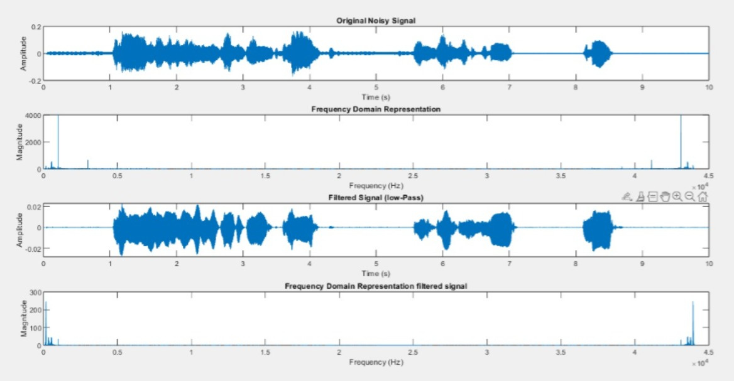

**4.2 HIGH PASS FILTER**

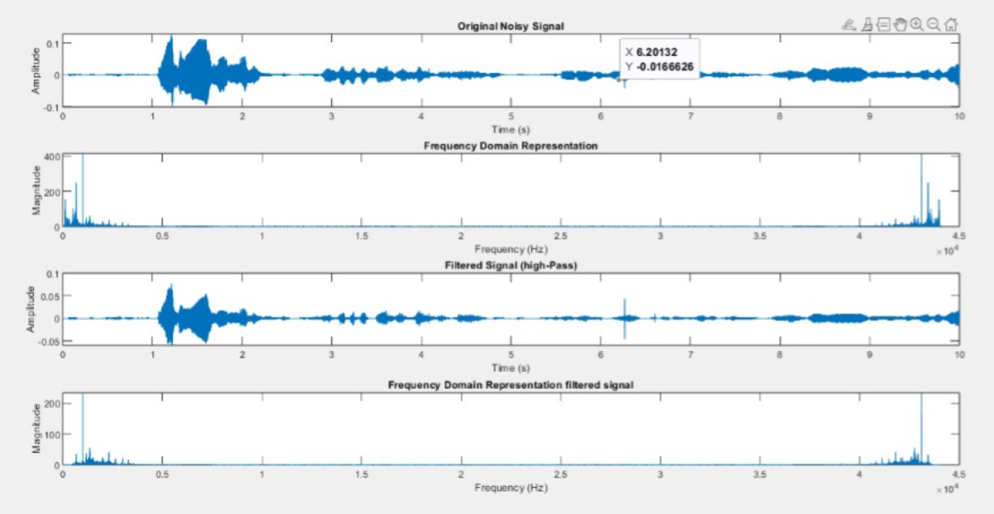

**4.3 BAND PASS FILTER**

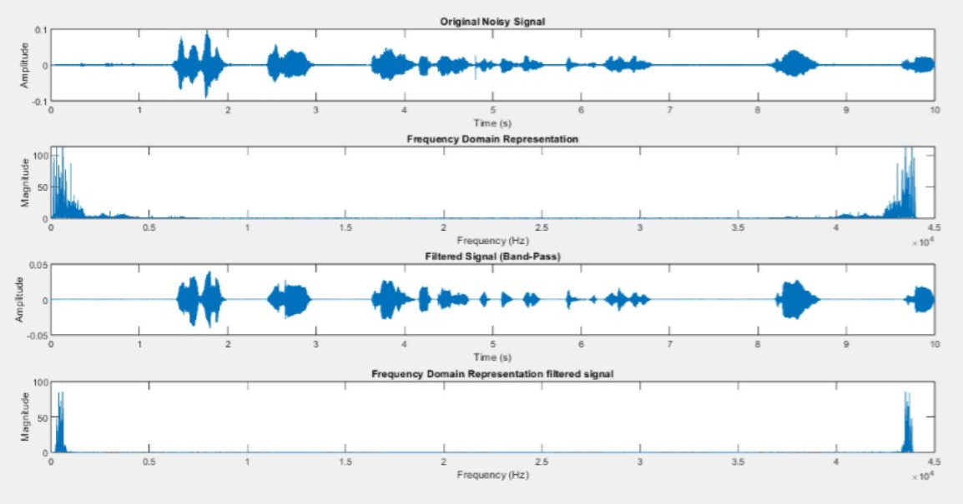

5: ADVANTAGES AND DISADVANTAGES

ADVANTAGES:

#### 1. ****Improved Audio Quality****

* **Noise Reduction**: Audio signal processing can significantly reduce unwanted background noise, ensuring that the main signal (e.g., speech or music) is clear and easily understandable. This is especially useful in environments with high ambient noise, such as call centers, public spaces, or recordings.
* **Enhanced Speech Clarity**: Techniques such as speech enhancement improve the intelligibility of spoken words, making them easier to understand even in noisy or reverberant environments. This is crucial for communication systems, voice assistants, and hearing aids.

#### 2. ****Real-Time Processing Capabilities****

* **Low Latency**: With the right algorithms and hardware, real-time audio processing can be achieved, enabling live audio manipulation, such as noise cancellation, audio effects (reverb, echo), and real-time speech recognition.
* **Interactive Applications**: This advantage is essential for interactive systems like virtual assistants, gaming, live broadcasting, and live sound engineering, where real-time processing of the audio input is needed.

#### 3. ****Automation and Efficiency****

* **Automatic Speech Recognition (ASR)**: Audio signal processing enables speech-to-text conversion, automating transcription tasks and making them faster and more accurate. It reduces the need for manual transcription in fields such as healthcare, law, and media.
* **Audio Classification and Tagging**: Audio classification algorithms can automatically identify different types of sounds (e.g., speech, music, noise), making it easier to organize and categorize large audio datasets for content management or security monitoring.

#### 4. ****Improved Communication Systems****

* **Telecommunication Systems**: Audio signal processing enhances the quality of voice communication over networks (e.g., VoIP, mobile networks), reducing echo, noise, and distortion, leading to clearer calls and better customer experiences.
* **Conference Systems**: In multi-party conference calls or virtual meetings, audio processing ensures that all participants can hear each other clearly by applying echo cancellation, noise suppression, and automatic volume adjustment.

#### 5. ****Cost Savings****

* **Automation of Tasks**: By automating tasks such as transcription, classification, and sound detection, audio signal processing can reduce the time and labor required for these processes, ultimately saving costs in industries like media, healthcare, and customer support.
* **Efficient Communication**: Improving communication systems, such as reducing the need for in-person meetings by enhancing remote voice quality, can result in lower travel and infrastructure costs for organizations.

#### 6. ****Applications in Media and Entertainment****

* **Audio Effects and Production**: Audio signal processing allows for creative applications such as applying sound effects (e.g., pitch shifting, reverb) in music and video production, enhancing the overall audio experience.
* **Sound Design for Gaming**: It enables immersive soundscapes and dynamic audio effects for video games, virtual reality (VR), and augmented reality (AR) experiences, where real-time audio feedback enhances user engagement.

The advantages of audio signal processing are vast and impactful across a wide range of industries and applications. From improving communication quality and enabling real-time audio effects to automating tedious tasks like transcription and providing accessibility to people with hearing impairments, this technology offers significant value. By leveraging its capabilities, businesses and industries can enhance user experiences, streamline processes, and open up new opportunities for innovation and efficiency.

**DISADVANTAGES:**

While audio signal processing offers numerous advantages, it also comes with some limitations and challenges. Here are the **disadvantages** that may arise during the implementation and use of an audio signal processing project:

#### 1. ****High Computational Requirements****

* **Processing Power**: Advanced audio processing techniques, such as real-time noise reduction, feature extraction, or machine learning-based audio classification, require significant computational resources, especially for real-time applications.
* **Latency Issues**: Real-time systems can face delays due to processing overhead, which may impact performance in applications like live audio streaming or interactive sound effects.

#### 2. ****Complexity of Implementation****

* **Algorithm Design**: Developing efficient and accurate algorithms for tasks like noise reduction, signal enhancement, or audio recognition can be technically challenging and time-consuming.
* **Integration Challenges**: Combining multiple modules (e.g., input, processing, and output) into a seamless system requires careful planning and testing.

#### 3. ****Noise and Signal Distortion****

* **Unpredictable Noise**: While noise reduction techniques can handle many types of noise, they may struggle with unpredictable or highly dynamic noise sources, leading to residual noise or over-suppression of desired signals.
* **Distortion**: Aggressive processing (e.g., over-filtering or excessive compression) can introduce distortion or artifacts in the processed audio, reducing its quality.

#### 4. ****Limited Real-Time Capabilities****

* **Latency**: In applications like live sound processing or communication systems, even slight delays can disrupt the user experience, especially in low-latency environments like gaming or teleconferencing.
* **Resource Constraints**: Embedded systems or portable devices often have limited processing power, making it difficult to implement real-time audio processing without trade-offs in quality or features.

#### 5. ****Privacy Concerns****

* **Data Handling**: Projects involving speech recognition or audio classification may require audio data to be recorded and processed, raising concerns about user privacy and data security.
* **Legal and Ethical Issues**: Processing or storing sensitive audio data (e.g., private conversations) without user consent can lead to ethical and legal implications.

**6**. **Cost Implications**

* **Development Costs**: The development of robust audio processing systems requires investment in research, skilled personnel, and testing equipment, which may not be feasible for small-scale projects.
* **Operational Costs**: Real-time systems may incur higher operational costs due to energy consumption, hardware maintenance, and continuous updates to adapt to changing requirements.

While audio signal processing projects offer transformative benefits, it is essential to consider and address the potential disadvantages during the development process. By carefully balancing trade-offs, optimizing algorithms, and selecting the right hardware and tools, many of these challenges can be mitigated, resulting in a robust and effective system.

**6 : FUTURE SCOPE**

#### 1. ****Integration with Emerging Technologies****

* **Augmented Reality (AR) and Virtual Reality (VR)**: Audio signal processing can enhance immersive experiences in AR/VR environments by providing 3D spatial audio and realistic sound effects.
* **Wearable Devices**: Integration with wearable technologies like smart earbuds or AR glasses can deliver personalized audio experiences, such as adaptive noise cancellation or situational sound amplification.
* **Quantum Computing**: Emerging quantum technologies can potentially revolutionize audio processing by solving complex optimization problems faster, improving tasks like source separation and signal enhancement.

#### 2. ****Applications in Healthcare****

* **Hearing Aids**: Development of advanced signal processing algorithms to enhance speech clarity and suppress unwanted noise for users with hearing impairments.
* **Speech Therapy**: Audio signal processing tools for diagnosing and assisting in speech therapy for individuals with speech or communication disorders.
* **Diagnostic Tools**: Using audio processing to analyze voice signals for early detection of diseases such as Parkinson’s, Alzheimer’s, or vocal cord disorders.

#### 3. ****Advancements in Speech Recognition and Synthesis****

* **Multilingual Support**: Enhanced speech recognition systems capable of accurately understanding and processing multiple languages and dialects.
* **Emotion Recognition**: Using audio signal processing to analyze tone, pitch, and rhythm for detecting emotions, which can be applied in mental health monitoring and customer service.

#### 4. ****Enhanced Entertainment and Media Applications****

* **Immersive Audio**: Future audio processing technologies can enable hyper-realistic soundscapes for movies, music, and video games, providing a more engaging experience for users.
* **Content Creation**: Advanced tools for automatic sound editing, mixing, and mastering, enabling faster and more creative workflows for content creators.
* **Adaptive Music Systems**: Real-time music adaptation based on listener preferences or contextual settings, such as mood, activity, or environment.

#### 5. ****IoT and Smart Devices****

* **Voice-Controlled Systems**: Enhanced audio signal processing can improve the accuracy and reliability of voice-controlled IoT devices, making them more intuitive and responsive.
* **Smart Home Applications**: Integration with smart home systems for automated audio control, such as adapting playback volume or optimizing speaker output based on room acoustics.

#### 6. ****Education and E-Learning****

* **Language Learning Tools**: Audio signal processing can enable pronunciation analysis, accent training, and listening comprehension aids in language learning applications.
* **Interactive Learning Platforms**: Improved audio clarity and noise reduction for virtual classrooms and e-learning platforms can enhance engagement and accessibility.

The future of audio signal processing is highly promising, with significant advancements expected in AI, real-time systems, accessibility, and cross-disciplinary applications. Continued research, coupled with the integration of emerging technologies, will expand its reach into new domains, providing innovative solutions and improved experiences for users worldwide.

**7 : CONCLUSION**

Audio signal processing is a transformative technology with applications spanning communication, healthcare, entertainment, and beyond. This project demonstrates the potential of processing audio signals to enhance sound quality, improve speech intelligibility, automate recognition tasks, and provide innovative solutions for real-world problems.

By leveraging advanced techniques such as noise reduction, feature extraction, and real-time processing, this project delivers improved audio experiences while addressing challenges like signal distortion and background noise. The integration of machine learning and artificial intelligence further enables intelligent systems capable of adaptive learning, making them versatile and efficient for a wide range of applications.

Through thorough testing and the development of robust methodologies, this project lays the groundwork for future advancements in audio processing technologies. With continued research and innovation, audio signal processing will play a critical role in enhancing accessibility, enabling smarter devices, and enriching human-computer interactions. The insights gained from this project provide a solid foundation for expanding its capabilities, ensuring its relevance in a rapidly evolving technological landscape.

**8 : REFERENCES**

**Books**:

* 1. Oppenheim, A. V., & Schafer, R. W. (2010). Discrete-Time Signal Processing (3rd ed.). Pearson.
     1. A comprehensive book covering fundamental concepts of signal processing, including audio applications.
  2. Lyons, R. G. (2010). Understanding Digital Signal Processing (3rd ed.). Prentice Hall.
     1. A practical resource for learning digital signal processing with real-world examples.

**Research Papers and Journals**:

* 1. Boll, S. F. (1979). "Suppression of Acoustic Noise in Speech Using Spectral Subtraction." IEEE Transactions on Acoustics, Speech, and Signal Processing, 27(2), 113-120.
     1. A foundational paper on noise reduction techniques.
  2. Graves, A., Mohamed, A.-R., & Hinton, G. (2013). "Speech Recognition with Deep Recurrent Neural Networks." IEEE International Conference on Acoustics, Speech and Signal Processing (ICASSP).

**Web Resources**:

* 1. Audacity: Free, open-source software for recording and editing audio. Retrieved from [https://www.audacityteam.org](https://www.audacityteam.org/)
  2. MATLAB Signal Processing Toolbox: Comprehensive tools for signal processing and analysis. Retrieved from <https://www.mathworks.com/products/signal.html>

**Standards and Technical Reports**:

* 1. ITU-T. (2012). Perceptual Evaluation of Speech Quality (PESQ): An Objective Method for End-to-End Speech Quality Assessment of Narrowband Telephone Networks and Speech Codecs. ITU-T Recommendation P.862.
     1. A standard for evaluating speech quality.
  2. ISO/IEC 14496-3:2009. (2009). Information Technology - Coding of Audio-Visual Objects - Part 3: Audio.