SIMATS ENGINEERING
CO2_AT3 Error Analysis Task
COURSE NAME: Software Testing COURSE CODE: CSA37
NAME: M.S.Charishma
REG.NO:192311393

COURSE OUTCOME COVERED

CO2: Design effective test cases using black-box, white-box testing techniques and to control methods flow.
Assessment Tool Weightage: 20%
Sl. No | Questions | Bloom’s Level
1 | A tester designs test cases for an online shopping system using equivalence partitioning but incorrectly groups input ranges (e.g., valid and invalid inputs mixed in one class). Additionally, boundary values are not considered. Analyze the given test design and identify all errors in equivalence class partitioning and boundary value analysis. Examine the root causes of these mistakes with proper reasoning. Propose corrected test cases with proper classification and boundary coverage. Justify how your corrections improve defect detection effectiveness. | 3
2 | A QA engineer performs random testing on a banking application and claims high coverage without using any structured techniques. Critical defects in transaction limits and boundary conditions are missed. Evaluate the testing approach and identify errors in strategy and coverage assumptions. Analyze the root causes behind missing critical defects. Suggest appropriate black box testing techniques to correct the approach. Justify how these techniques ensure better test adequacy and reliability. | 3
3 | A developer performs white box testing but creates an incomplete control flow graph, missing decision nodes and loops, resulting in poor path coverage. Analyze the errors in the control flow graph and path testing approach. Identify the root causes for inadequate test coverage. Propose corrections by constructing a proper control flow representation and identifying all independent paths. Justify how improved path testing ensures better coverage and defect detection. | 5
4 | A testing team reports 100% statement coverage for a module but fails to detect logical errors in conditional statements. Evaluate the adequacy of the testing performed and identify gaps in coverage criteria. Analyze why statement coverage alone was insufficient. Recommend improved white box testing strategies such as branch or path coverage. Justify how the revised approach enhances overall test effectiveness and error detection. | 5
5 | A tester uses Equivalence Class Partitioning for an age-validation field (0-100) but defines only two classes: Negative numbers and Positive numbers. Analyze the errors in this partitioning strategy. Identify why this fails to account for valid vs. invalid age limits and the absence of Boundary Value Analysis. Propose a corrected set of partitions and justify how they ensure more robust input validation. | 3
6 | A developer claims full Condition Coverage for a complex `if(A && B
7 | A QA team applies Decision Table Testing for a discount system but misses several combinations of "Premium Member" and "Coupon Applied," leading to price calculation errors. Analyze the errors in the construction of the decision table. Identify why the current approach is incomplete. Propose a revised, exhaustive decision table and justify its effectiveness in preventing production defects. | 3
8 | During unit testing of a looping structure, a tester checks only the first and last iterations (n=1 and n=max). Defects occurring at n=0 and n=max+1 are missed. Evaluate the errors in this Loop Testing strategy. Analyze the root causes behind these omissions. Recommend a corrected approach for testing simple and nested loops, and justify how it ensures path integrity. | 5
9 | An engineer utilizes Error Guessing as the primary testing technique for a safety-critical braking system, ignoring structured black box methods. Identify the errors in relying solely on ad-hoc techniques for high-risk modules. Analyze the impact on test adequacy. Suggest a combination of BVA and State Transition Testing to fix the strategy, justifying the increased safety assurance. | 5
10 | A tester designs a Control Flow Graph (CFG) for a module but fails to represent the "else" branches of multiple nested if statements, leading to 100% statement coverage but 0% branch coverage on error paths. Analyze the errors in graph construction. Identify the root causes for the missing nodes. Propose a corrected CFG and independent paths to ensure branch adequacy. | 5

Code of Conduct:

I __M.S.Charishma__ (Name / Reg No) certify that this submission is my original work and that I have adhered to the guidelines specified for this assessment.
I understand that any violation of academic integrity rules will result in disciplinary action.

Signature of the student: M.S.Charishma

RUBRICS FOR CALCULATION:

Criteria | Weightage | Level 4 (Exemplary) | Level 3 (Proficient) | Level 2 (Developing) | Level 1 (Beginning)
Error Identification | 20% | Accurately identifies all errors with clear understanding of issues | Identifies most errors with minor omissions | Identifies limited errors; some are missed | Fails to identify key errors
Root Cause Analysis | 30% | Clearly explains underlying causes with strong technical reasoning | Explains causes with moderate clarity | Partial explanation; weak reasoning | Unable to identify causes of errors
Correction & Justification | 25% | Provides correct solutions with strong justification and logic | Provides correct corrections with some justification | Corrections are partially correct or weakly justified | Incorrect or no corrections provided
Application of Concepts | 15% | Effectively applies relevant concepts to analyze and resolve errors | Applies concepts with minor errors | Limited application; requires guidance | Unable to apply concepts
Clarity & Presentation | 10% | Presents analysis clearly, logically, and systematically | Generally clear with minor issues | Lacks clarity or proper structure | Poor presentation and difficult to understand

ANSWERS
1. Equivalence Partitioning and Boundary Value Analysis
Errors: Valid and invalid values have been mixed in the same equivalence class, so one test may not represent the whole class. Boundary values have also been omitted, even though defects commonly occur at the edges of input ranges.
Correction: For an online shopping quantity field, use separate classes such as valid quantity (1 to available stock), zero, negative quantity, and quantity greater than available stock. For a price field, separate valid non-negative prices from negative or non-numeric values. Test values just below, at, and just above each boundary. For example, if quantity must be 1–10, test 0, 1, 2, 9, 10, and 11.
Justification: ECP reduces redundant tests by selecting representatives from each class, while BVA targets edge-related defects. Together they provide systematic and efficient coverage.
2. Random Testing in a Banking Application
The main error is assuming that many randomly generated tests automatically mean high coverage. Random testing may rarely select exact transaction limits, invalid amounts, or combinations involving account balance and transfer limits.
Correction: Identify input partitions for amount, balance, account status, and daily transfer total. Apply ECP and BVA to test values below, at, and above minimum and maximum limits. Include valid transfers, zero and negative amounts, insufficient balance, exceeded daily limit, and invalid account details. Use random testing additionally to explore unexpected combinations, not as the only method.
Justification: Structured tests make coverage measurable and ensure critical boundaries are deliberately exercised. Combining them with random tests improves reliability.
3. Incomplete Control Flow Graph and Path Testing
Errors: The CFG omits decision nodes and loops, so some branches and repeated executions are not represented. As a result, the team cannot reliably identify independent paths or measure path coverage.
Correction: Draw a node for each processing step and decision, and arrows for every possible control transfer, including true/false branches and loop-back edges. Identify independent paths using the CFG and calculate cyclomatic complexity with V(G) = E − N + 2P (for one connected component, V(G) = E − N + 2). Design at least one test for each independent path and test loop zero, one, and multiple iterations where applicable.
The following sketch illustrates a basic decision CFG; the actual graph must be adapted to the program logic.
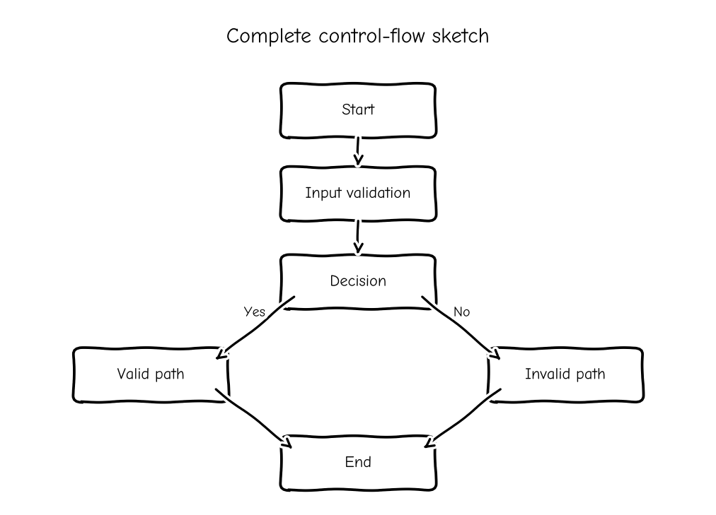

4. Why 100% Statement Coverage Is Not Enough
Statement coverage confirms that each statement has executed at least once, but it does not guarantee that both outcomes of every decision have been tested. A test may execute the main action while never taking an error or false branch.
Correction: Add branch coverage by testing each decision as both true and false. Then use condition coverage for individual Boolean conditions and basis-path testing for independent paths. For example, for if (balance >= amount), test both sufficient and insufficient balance. For compound conditions, vary each condition so its effect on the decision is observed.
Justification: Branch and path testing expose logic errors that statement coverage can miss and improve confidence in error handling.
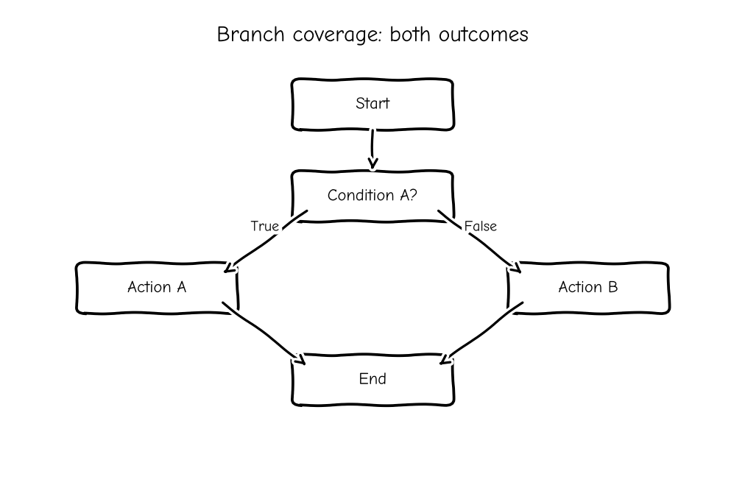
5. Correct ECP for Age Validation (0–100)
The two classes “negative” and “positive” are incomplete because they do not distinguish the valid range from values above the maximum, and they incorrectly treat all positive values as valid.
Correct partitions: (1) age below 0 – invalid; (2) age from 0 through 100 – valid; (3) age above 100 – invalid; (4) non-numeric or blank input – invalid if the application requires a numeric age.
Boundary tests: −1, 0, 1, 99, 100, and 101. Also test blank text, letters, and decimal values if the field rules require whole-number ages.
Justification: These partitions represent distinct expected behaviours, while boundary tests focus on the points most likely to reveal comparison and validation errors.
6. Condition Coverage for a Compound IF Statement
The supplied question is incomplete in the source document: it ends at “if(A && B”. Based on this visible expression, condition coverage requires each atomic condition A and B to evaluate to both True and False at least once.
Example test set for A && B:
• A=True, B=True → decision True.
• A=True, B=False → decision False.
• A=False, B=True → decision False.
• A=False, B=False → decision False.
The four combinations make the condition outcomes explicit. Depending on the programming language's short-circuit evaluation, B may not be evaluated when A is False; the test design should account for this. Condition coverage alone does not necessarily guarantee full decision or MC/DC coverage, so additional tests may be required by the safety or quality standard.
7. Incomplete Decision Table for a Discount System
The likely error is failing to test all combinations of Premium Member and Coupon Applied. With two Boolean conditions, there are four combinations, and each should have an expected result.
Test cases:
1. Premium = Yes, Coupon = Yes: apply the documented premium-and-coupon rule, including any cap or restriction.
2. Premium = Yes, Coupon = No: apply premium discount only.
3. Premium = No, Coupon = Yes: apply coupon discount only if eligible.
4. Premium = No, Coupon = No: no discount.
Before execution, define the business rule for whether discounts can be combined, the order of calculation, and the maximum discount. Verify the final price and ensure it cannot become negative. The complete table prevents missed combinations and makes expected outcomes reviewable.
8. Loop Testing Strategy
Testing only n=1 and n=max misses important boundaries. A loop may fail when it executes zero times (n=0), at the first iteration, during typical repetition, or just beyond the allowed maximum (n=max+1).
Correction: Test 0, 1, 2, a typical value, max−1, max, and max+1 where these values are meaningful and safe. For nested loops, first vary one loop while holding the others at minimum values; then test combinations and boundary interactions. Check loop termination, counter updates, and array/index limits.
Justification: Boundary-focused loop testing helps reveal off-by-one errors, incorrect termination conditions, and infinite loops.
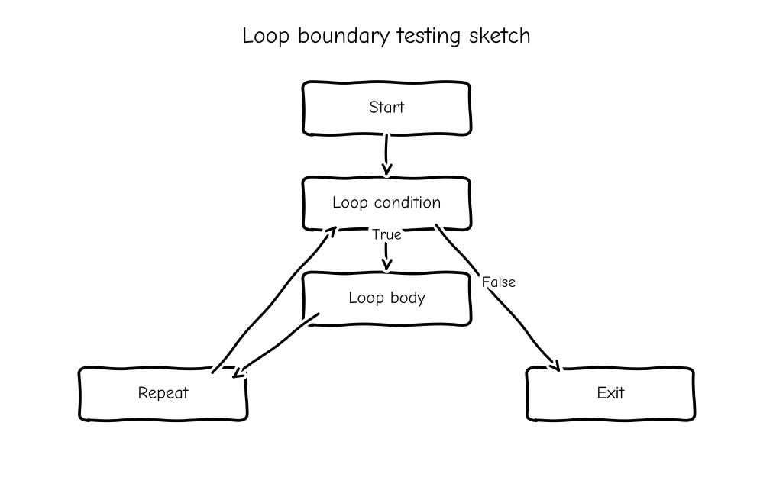
9. Error Guessing in a Safety-Critical Braking System
Relying only on Error Guessing is inadequate because it depends on individual experience and may omit uncommon but dangerous situations. It does not provide measurable coverage of input boundaries or dynamic system states.
Correction: Use BVA for speed, braking distance, sensor readings, and pressure thresholds, testing just below, at, and above specified limits. Use State Transition Testing for states such as normal driving, brake requested, braking active, ABS active, sensor fault, and safe fallback. Test legal and illegal transitions, including sensor failure while braking. Retain Error Guessing as a supplementary technique.
Justification: Combining structured boundary tests with state-based scenarios improves traceability and safety assurance.
10. CFG Missing Else Branches
Errors: Omitting else branches makes the CFG incomplete. Tests can execute every statement on the main route while never exercising false outcomes or error-handling paths; therefore, 100% statement coverage can coexist with poor branch coverage.
Correction: Add a decision node for every if condition and represent both True and False edges. For nested decisions, include all relevant combinations and ensure each terminal path reaches the correct exit. The sketch below shows an example with explicit else branches. For the real module, create the graph from its actual source logic, list independent paths, and create tests for each branch and critical path.
Justification: A complete CFG exposes omitted routes and supports measurable branch and basis-path coverage.
