1. Implement and demonstrate the FIND-S algorithm for finding the most specific hypothesis based on a given set of training data samples.
Problem 1: EnjoySport Training Dataset

Aim
To implement FIND-S and find the most specific hypothesis for the EnjoySport training examples.

Training Data
Sky | AirTemp | Humidity | Wind | Water | Forecast | Label
Sunny | Warm | Normal | Strong | Warm | Same | Yes
Sunny | Warm | High | Strong | Warm | Same | Yes
Rainy | Cold | High | Strong | Warm | Change | No
Sunny | Warm | High | Strong | Cool | Change | Yes

Procedure
- Start with the most specific hypothesis: [Ø, Ø, Ø, Ø, Ø, Ø].
- Read the training examples one by one.
- If an example is positive, compare each attribute with the current hypothesis.
- If an attribute differs, replace that hypothesis attribute with '?'; if it matches, keep it unchanged.
- Ignore negative examples and display the final hypothesis.

Coding (Python)
def find_s(data, number_of_attributes):
hypothesis = ["Ø"] * number_of_attributes

for example in data:
attributes = example[:-1]
label = example[-1]

if label == "Yes":
if hypothesis == ["Ø"] * number_of_attributes:
hypothesis = list(attributes)
else:
for i in range(number_of_attributes):
if hypothesis[i] != attributes[i]:
hypothesis[i] = "?"

return hypothesis

training_data = [['Sunny', 'Warm', 'Normal', 'Strong', 'Warm', 'Same', 'Yes'], ['Sunny', 'Warm', 'High', 'Strong', 'Warm', 'Same', 'Yes'], ['Rainy', 'Cold', 'High', 'Strong', 'Warm', 'Change', 'No'], ['Sunny', 'Warm', 'High', 'Strong', 'Cool', 'Change', 'Yes']]
result = find_s(training_data, 6)
print("Most specific hypothesis:", result)

Input
The training data entered in the program is:
[['Sunny', 'Warm', 'Normal', 'Strong', 'Warm', 'Same', 'Yes'], ['Sunny', 'Warm', 'High', 'Strong', 'Warm', 'Same', 'Yes'], ['Rainy', 'Cold', 'High', 'Strong', 'Warm', 'Change', 'No'], ['Sunny', 'Warm', 'High', 'Strong', 'Cool', 'Change', 'Yes']]

Output
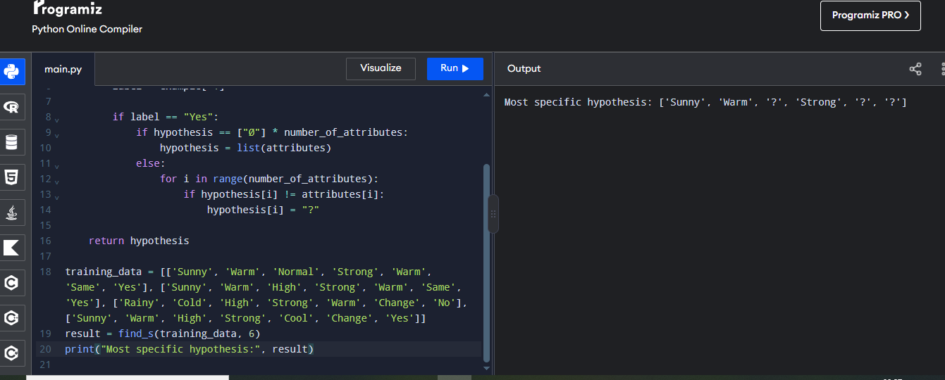

Problem 2: Play Tennis

Aim
To determine the most specific hypothesis for deciding whether conditions are suitable to play tennis.

Training Data
Outlook | Temperature | Humidity | Wind | Label
Sunny | Hot | High | Weak | No
Sunny | Hot | High | Strong | No
Overcast | Hot | High | Weak | Yes
Rain | Mild | High | Weak | Yes
Sunny | Cool | Normal | Weak | No
Overcast | Cool | Normal | Strong | Yes

Procedure
- Initialize every hypothesis attribute to Ø.
- Process the weather examples in the given order.
- Use only examples labelled Yes to update the hypothesis.
- Keep matching attribute values and replace differing values with '?'.
- Print the final hypothesis after all examples are processed.

Coding (Python)

def find_s(data, number_of_attributes):
hypothesis = ["Ø"] * number_of_attributes
for example in data:
attributes = example[:-1]
label = example[-1]

if label == "Yes":

if hypothesis == ["Ø"] * number_of_attributes:

hypothesis = list(attributes)

else:

for i in range(number_of_attributes):

if hypothesis[i] != attributes[i]:

hypothesis[i] = "?"

return hypothesis

training_data = [

['Sunny', 'Warm', 'Normal', 'Strong', 'Yes'],

['Sunny', 'Warm', 'High', 'Strong', 'Yes'],

['Rainy', 'Cold', 'High', 'Weak', 'No'],

['Sunny', 'Warm', 'High', 'Weak', 'Yes']

]

result = find_s(training_data, 4)

print("Most specific hypothesis:", result)

Input

Sky Temperature Humidity Wind Play

Sunny Warm Normal Strong Yes

Sunny Warm High Strong Yes

Rainy Cold High Weak No

Sunny Warm High Weak Yes

Output
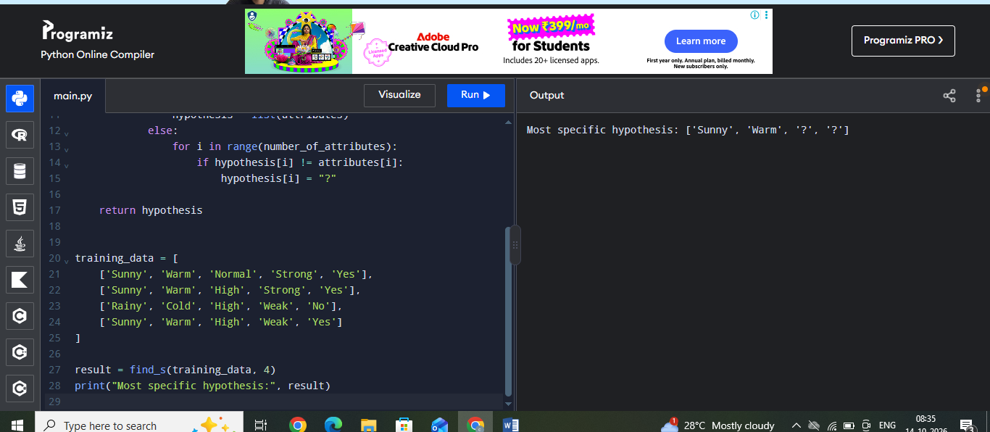
Problem 3: Student Pass Prediction

Aim
To apply FIND-S to positive training samples describing when a student passes an examination.

Training Data
StudyHours | Attendance | Assignments | Preparation | Label
High | Good | Complete | Ready | Yes
High | Good | Complete | Ready | Yes
Medium | Good | Complete | Ready | Yes
Low | Poor | Incomplete | NotReady | No

Procedure
- Represent each sample using study hours, attendance, assignment completion and preparation.
- Initialize the hypothesis with Ø for all four attributes.
- Read each sample and update the hypothesis only for Pass = Yes.
- Generalize an attribute to '?' when positive samples have different values.
- Display the resulting hypothesis.

Coding (Python)
def find_s(data, number_of_attributes):
hypothesis = ["Ø"] * number_of_attributes
for example in data:
attributes = example[:-1]
label = example[-1]
if label == "Yes":
if hypothesis == ["Ø"] * number_of_attributes:
hypothesis = list(attributes)
else:
for i in range(number_of_attributes):
if hypothesis[i] != attributes[i]:
hypothesis[i] = "?"
return hypothesis
training_data = [['High', 'Good', 'Complete', 'Ready', 'Yes'], ['High', 'Good', 'Complete', 'Ready', 'Yes'], ['Medium', 'Good', 'Complete', 'Ready', 'Yes'], ['Low', 'Poor', 'Incomplete', 'NotReady', 'No']]
result = find_s(training_data, 4)
print("Most specific hypothesis:", result)

Input
The training data entered in the program is:
[['High', 'Good', 'Complete', 'Ready', 'Yes'], ['High', 'Good', 'Complete', 'Ready', 'Yes'], ['Medium', 'Good', 'Complete', 'Ready', 'Yes'], ['Low', 'Poor', 'Incomplete', 'NotReady', 'No']]

Output
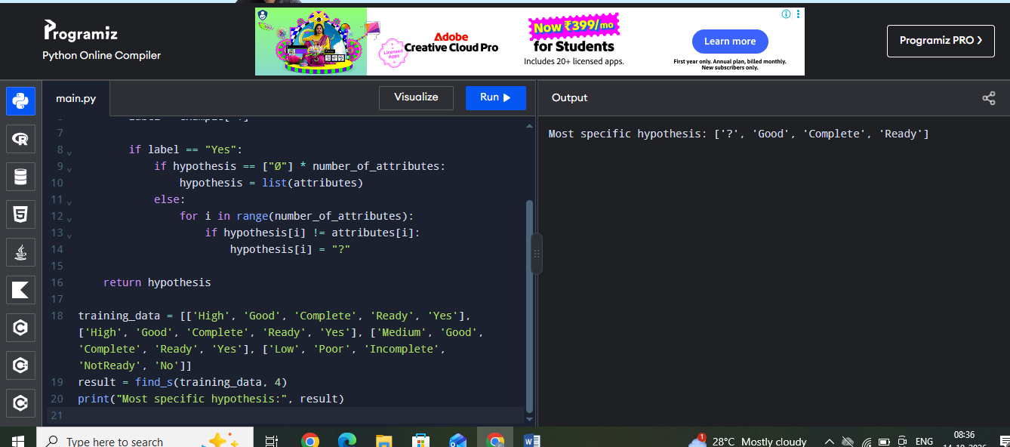

Problem 4: Laptop Recommendation

Aim
To find the most specific hypothesis for positive examples of laptop configurations accepted by a user.

Training Data
Processor | RAM | Storage | Battery | Label
i5 | 8GB | 512GB SSD | Long | Yes
i5 | 8GB | 512GB SSD | Long | Yes
i7 | 16GB | 1TB SSD | Long | Yes
i3 | 4GB | 256GB SSD | Short | No

Procedure
- Use processor, RAM, storage and battery as the attributes.
- Initialize the hypothesis to [Ø, Ø, Ø, Ø].
- Scan the training records from top to bottom.
- For each Yes record, retain common values and replace inconsistent attributes with '?'.
- Ignore No records and print the final hypothesis.

Coding (Python)
def find_s(data, number_of_attributes):
hypothesis = ["Ø"] * number_of_attributes
for example in data:
attributes = example[:-1]
label = example[-1]
if label == "Yes":
if hypothesis == ["Ø"] * number_of_attributes:
hypothesis = list(attributes)
else:
for i in range(number_of_attributes):
if hypothesis[i] != attributes[i]:
hypothesis[i] = "?"
return hypothesis
training_data = [['i5', '8GB', '512GB SSD', 'Long', 'Yes'], ['i5', '8GB', '512GB SSD', 'Long', 'Yes'], ['i7', '16GB', '1TB SSD', 'Long', 'Yes'], ['i3', '4GB', '256GB SSD', 'Short', 'No']]
result = find_s(training_data, 4)
print("Most specific hypothesis:", result)

Input
The training data entered in the program is:
[['i5', '8GB', '512GB SSD', 'Long', 'Yes'], ['i5', '8GB', '512GB SSD', 'Long', 'Yes'], ['i7', '16GB', '1TB SSD', 'Long', 'Yes'], ['i3', '4GB', '256GB SSD', 'Short', 'No']]

Output
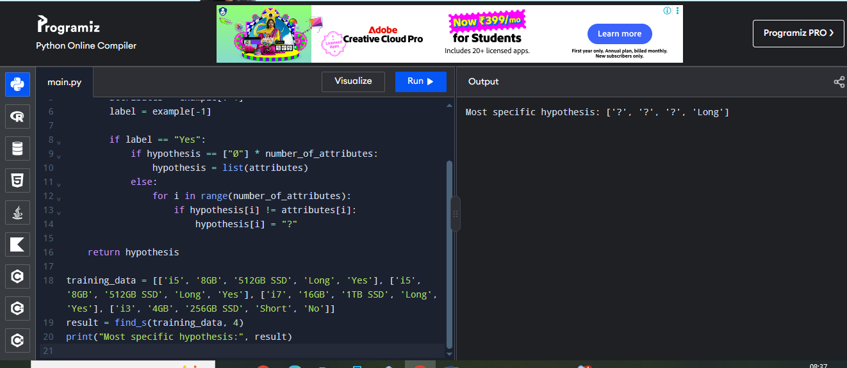

Problem 5: Fruit Classification

Aim
To demonstrate FIND-S using positive examples of a preferred fruit based on colour, size, taste and texture.

Training Data
Colour | Size | Taste | Texture | Label
Yellow | Medium | Sweet | Soft | Yes
Yellow | Medium | Sweet | Soft | Yes
Red | Small | Sweet | Soft | Yes
Green | Large | Sour | Hard | No
Yellow | Large | Sweet | Soft | Yes

Procedure
- Create a training set with four descriptive attributes and a Preferred label.
- Begin with the most specific hypothesis [Ø, Ø, Ø, Ø].
- Process each training sample in sequence.
- Update the hypothesis using positive examples only; differing values become '?'.
- Print the final hypothesis and compare it with the expected result.

Coding (Python)
def find_s(data, number_of_attributes):
hypothesis = ["Ø"] * number_of_attributes
for example in data:
attributes = example[:-1]
label = example[-1]
if label == "Yes":
if hypothesis == ["Ø"] * number_of_attributes:
hypothesis = list(attributes)
else:
for i in range(number_of_attributes):
if hypothesis[i] != attributes[i]:
hypothesis[i] = "?"
return hypothesis
training_data = [['Yellow', 'Medium', 'Sweet', 'Soft', 'Yes'], ['Yellow', 'Medium', 'Sweet', 'Soft', 'Yes'], ['Red', 'Small', 'Sweet', 'Soft', 'Yes'], ['Green', 'Large', 'Sour', 'Hard', 'No'], ['Yellow', 'Large', 'Sweet', 'Soft', 'Yes']]
result = find_s(training_data, 4)
print("Most specific hypothesis:", result)

Input
The training data entered in the program is:
[['Yellow', 'Medium', 'Sweet', 'Soft', 'Yes'], ['Yellow', 'Medium', 'Sweet', 'Soft', 'Yes'], ['Red', 'Small', 'Sweet', 'Soft', 'Yes'], ['Green', 'Large', 'Sour', 'Hard', 'No'], ['Yellow', 'Large', 'Sweet', 'Soft', 'Yes']]

Output
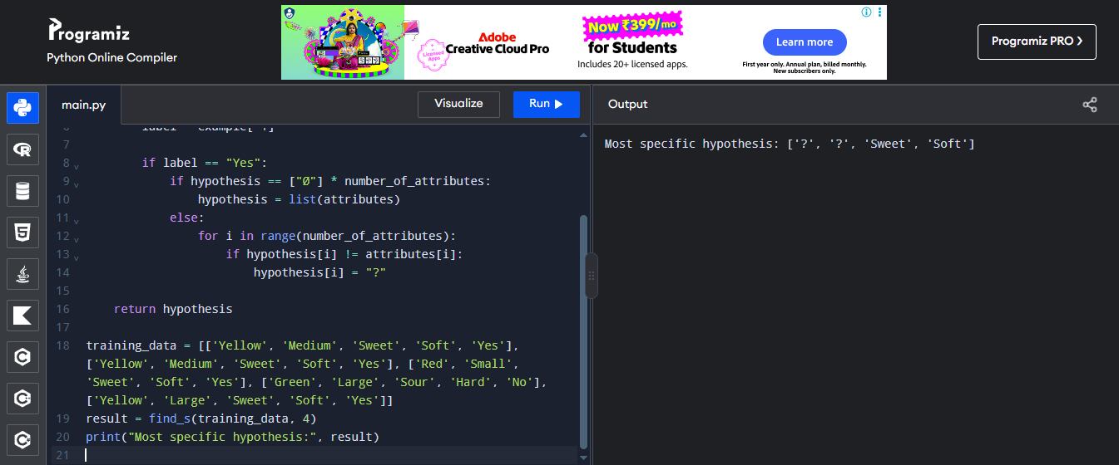

2. For a given set of training data examples stored in a .CSV file, implement and demonstrate the Candidate-Elimination algorithm in Python to output a description of the set of all hypotheses consistent with the training examples.
Problem 1: Weather Prediction

Aim
To implement the Candidate-Elimination algorithm using training examples stored in a CSV file and identify the version space with its specific and general boundaries.

Training Data
Outlook | Temperature | Wind | Label
Sunny | Warm | Strong | Yes
Sunny | Cold | Strong | Yes
Rainy | Warm | Weak | No
Sunny | Warm | Weak | Yes

Procedure
- Create a CSV file named training.csv with the attribute names and training examples.
- Read the CSV file using Python’s csv module.
- Generate the possible hypotheses using the observed attribute values and the wildcard ?.
- Keep only the hypotheses that correctly classify every positive and negative training example.
- Display the version space, the specific boundary S and the general boundary G.

Coding (Python)
import csv
from itertools import product

def candidate_elimination(filename):
with open(filename, newline="") as file:
rows = list(csv.reader(file))
attributes = rows[0][:-1]
data = rows[1:]
domains = [sorted(set(row[i] for row in data)) for i in range(len(attributes))]

hypotheses = list(product(*[domain + ["?"] for domain in domains]))
version_space = []
for h in hypotheses:
if all((row[-1] == "Yes") == all(
h[i] == "?" or h[i] == row[i]
for i in range(len(attributes))) for row in data):
version_space.append(h)

def more_general(h1, h2):
return all(a == "?" or a == b for a, b in zip(h1, h2))

S = [h for h in version_space if not any(
h != other and more_general(h, other) for other in version_space)]
G = [h for h in version_space if not any(
h != other and more_general(other, h) for other in version_space)]

print("Version Space:", version_space)
print("Specific Boundary S:", S)
print("General Boundary G:", G)

candidate_elimination("training.csv")

Input
Outlook,Temperature,Wind,Label
Sunny,Warm,Strong,Yes
Sunny,Cold,Strong,Yes
Rainy,Warm,Weak,No
Sunny,Warm,Weak,Yes

Output
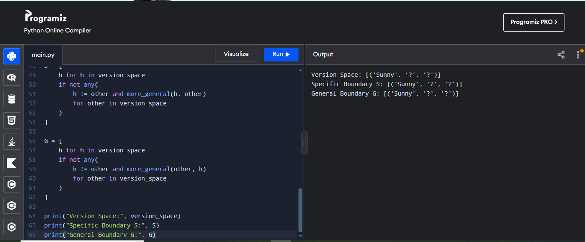

Problem 2: Student Pass Prediction

Aim
To implement the Candidate-Elimination algorithm using training examples stored in a CSV file and identify the version space with its specific and general boundaries.

Training Data
Study | Attendance | Assignment | Label
High | Good | Complete | Yes
High | Poor | Complete | No
Medium | Good | Complete | Yes
Low | Poor | Incomplete | No

Procedure
- Create a CSV file named training.csv with the attribute names and training examples.
- Read the CSV file using Python’s csv module.
- Generate the possible hypotheses using the observed attribute values and the wildcard ?.
- Keep only the hypotheses that correctly classify every positive and negative training example.
- Display the version space, the specific boundary S and the general boundary G.

Coding (Python)
import csv
from itertools import product
from io import StringIO
data = """Study,Attendance,Assignment,Label
High,Good,Complete,Yes
High,Poor,Complete,No
Medium,Good,Complete,Yes
Low,Poor,Incomplete,No"""
rows = list(csv.reader(StringIO(data)))
attributes = rows[0][:-1]
data = rows[1:]
domains = [
sorted(set(row[i] for row in data))
for i in range(len(attributes))
]
hypotheses = list(product(
*[domain + ["?"] for domain in domains]
))
version_space = []
for h in hypotheses:
valid = True
for row in data:
match = all(
h[i] == "?" or h[i] == row[i]
for i in range(len(attributes))
)

if (row[-1] == "Yes") != match:
valid = False
break

if valid:
version_space.append(h)
def more_general(h1, h2):
return all(
a == "?" or a == b
for a, b in zip(h1, h2)
)
S = [
h for h in version_space
if not any(
h != other and more_general(h, other)
for other in version_space
)
]
G = [
h for h in version_space
if not any(
h != other and more_general(other, h)
for other in version_space
)
]
print("Version Space:", version_space)
print("Specific Boundary S:", S)
print("General Boundary G:", G)

Input
Study,Attendance,Assignment,Label
High,Good,Complete,Yes
High,Poor,Complete,No
Medium,Good,Complete,Yes
Low,Poor,Incomplete,No

Output
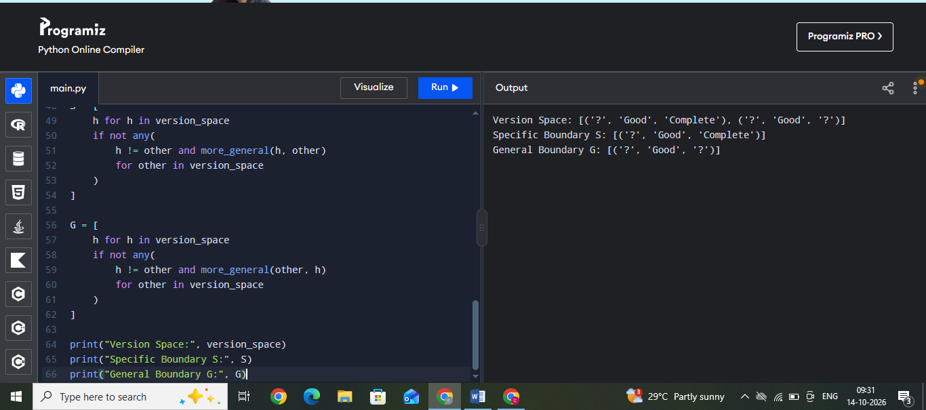
Problem 3: Laptop Recommendation

Aim
To implement the Candidate-Elimination algorithm using training examples stored in a CSV file and identify the version space with its specific and general boundaries.

Training Data
Processor | RAM | Battery | Label
i5 | 8GB | Long | Yes
i5 | 16GB | Long | Yes
i7 | 8GB | Long | Yes
i3 | 4GB | Short | No

Procedure
- Create a CSV file named training.csv with the attribute names and training examples.
- Read the CSV file using Python’s csv module.
- Generate the possible hypotheses using the observed attribute values and the wildcard ?.
- Keep only the hypotheses that correctly classify every positive and negative training example.
- Display the version space, the specific boundary S and the general boundary G.

Coding (Python)
import csv
from itertools import product
from io import StringIO
data = """Processor,RAM,Battery,Label
i5,8GB,Long,Yes
i5,16GB,Long,Yes
i7,8GB,Long,Yes
i3,4GB,Short,No"""
rows = list(csv.reader(StringIO(data)))
attributes = rows[0][:-1]
data = rows[1:]
domains = [
sorted(set(row[i] for row in data))
for i in range(len(attributes))
]
hypotheses = list(product(
*[domain + ["?"] for domain in domains]
))
version_space = []
for h in hypotheses:
valid = True
for row in data:
match = all(
h[i] == "?" or h[i] == row[i]
for i in range(len(attributes))
)

if (row[-1] == "Yes") != match:
valid = False
break

if valid:
version_space.append(h)
def more_general(h1, h2):
return all(
a == "?" or a == b
for a, b in zip(h1, h2)
)
S = [
h for h in version_space
if not any(
h != other and more_general(h, other)
for other in version_space
)
]
G = [
h for h in version_space
if not any(
h != other and more_general(other, h)
for other in version_space
)
]
print("Version Space:", version_space)
print("Specific Boundary S:", S)
print("General Boundary G:", G)

Input
Processor,RAM,Battery,Label
i5,8GB,Long,Yes
i5,16GB,Long,Yes
i7,8GB,Long,Yes
i3,4GB,Short,No
Output
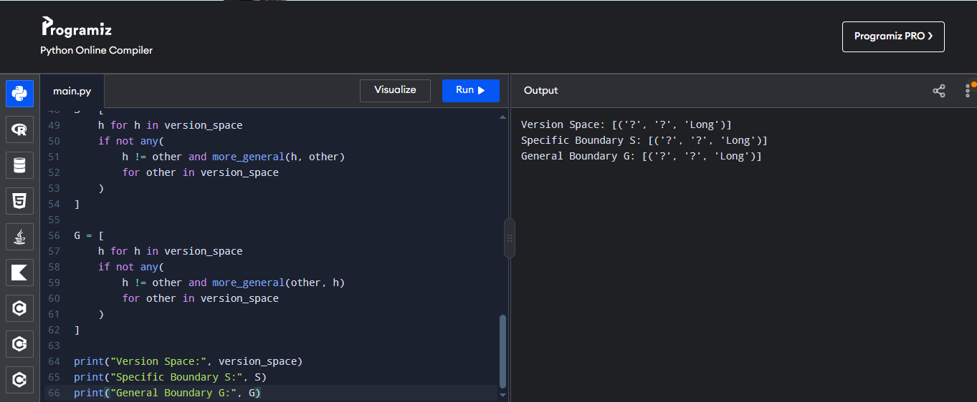

Problem 4: Fruit Classification

Aim
To implement the Candidate-Elimination algorithm using training examples stored in a CSV file and identify the version space with its specific and general boundaries.

Training Data
Colour | Size | Taste | Label
Yellow | Medium | Sweet | Yes
Red | Small | Sweet | Yes
Green | Large | Sour | No
Yellow | Large | Sweet | Yes

Procedure
- Create a CSV file named training.csv with the attribute names and training examples.
- Read the CSV file using Python’s csv module.
- Generate the possible hypotheses using the observed attribute values and the wildcard ?.
- Keep only the hypotheses that correctly classify every positive and negative training example.
- Display the version space, the specific boundary S and the general boundary G.

Coding (Python)
import csv
from itertools import product
from io import StringIO
data = """Colour,Size,Taste,Label
Yellow,Medium,Sweet,Yes
Red,Small,Sweet,Yes
Green,Large,Sour,No
Yellow,Large,Sweet,Yes"""
rows = list(csv.reader(StringIO(data)))
attributes = rows[0][:-1]
data = rows[1:]
domains = [
sorted(set(row[i] for row in data))
for i in range(len(attributes))
]
hypotheses = list(product(
*[domain + ["?"] for domain in domains]
))
version_space = []
for h in hypotheses:
valid = True
for row in data:
match = all(
h[i] == "?" or h[i] == row[i]
for i in range(len(attributes))
)

if (row[-1] == "Yes") != match:
valid = False
break

if valid:
version_space.append(h)
def more_general(h1, h2):
return all(
a == "?" or a == b
for a, b in zip(h1, h2)
)
S = [
h for h in version_space
if not any(
h != other and more_general(h, other)
for other in version_space
)
]
G = [
h for h in version_space
if not any(
h != other and more_general(other, h)
for other in version_space
)
]
print("Version Space:", version_space)
print("Specific Boundary S:", S)
print("General Boundary G:", G)

Input
Colour,Size,Taste,Label
Yellow,Medium,Sweet,Yes
Red,Small,Sweet,Yes
Green,Large,Sour,No
Yellow,Large,Sweet,Yes

Output
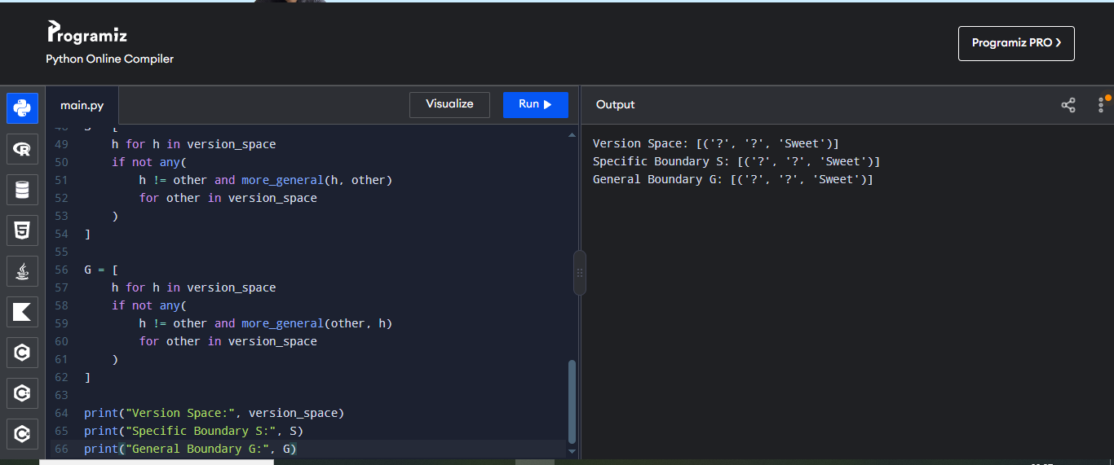
Problem 5: EnjoySport Dataset

Aim
To implement the Candidate-Elimination algorithm using training examples stored in a CSV file and identify the version space with its specific and general boundaries.

Training Data
Sky | AirTemp | Wind | Label
Sunny | Warm | Strong | Yes
Sunny | Cold | Strong | Yes
Rainy | Cold | Weak | No
Sunny | Warm | Weak | Yes

Procedure
- Create a CSV file named training.csv with the attribute names and training examples.
- Read the CSV file using Python’s csv module.
- Generate the possible hypotheses using the observed attribute values and the wildcard ?.
- Keep only the hypotheses that correctly classify every positive and negative training example.
- Display the version space, the specific boundary S and the general boundary G.

Coding (Python)

import csv
import io
from itertools import product

def candidate_elimination():
csv_data = """Sky,AirTemp,Humidity,Wind,Water,Forecast,EnjoySport
Sunny,Warm,Normal,Strong,Warm,Same,Yes
Sunny,Warm,High,Strong,Warm,Same,Yes
Rainy,Cold,High,Strong,Warm,Change,No
Sunny,Warm,High,Strong,Cool,Change,Yes"""

rows = list(csv.reader(io.StringIO(csv_data)))
attributes = rows[0][:-1]
data = rows[1:]

domains = [
sorted(set(row[i] for row in data))
for i in range(len(attributes))
]

hypotheses = list(
product(*[domain + ["?"] for domain in domains])
)

version_space = []

for h in hypotheses:
consistent = True

for row in data:
prediction = all(
h[i] == "?" or h[i] == row[i]
for i in range(len(attributes))
)

actual = row[-1] == "Yes"

if prediction != actual:
consistent = False
break

if consistent:
version_space.append(h)

def more_general(h1, h2):
return all(
a == "?" or a == b
for a, b in zip(h1, h2)
)

S = [
h for h in version_space
if not any(
h != other and more_general(other, h)
for other in version_space
)
]

G = [
h for h in version_space
if not any(
h != other and more_general(h, other)
for other in version_space
)
]

print("Attributes:", attributes)
print("\nVersion Space:")
for h in version_space:
print(h)

print("\nSpecific Boundary S:")
for h in S:
print(h)

print("\nGeneral Boundary G:")
for h in G:
print(h)

candidate_elimination()

Input
Sky,AirTemp,Wind,Label
Sunny,Warm,Strong,Yes
Sunny,Cold,Strong,Yes
Rainy,Cold,Weak,No
Sunny,Warm,Weak,Yes

Output
