3. Demonstrate the working of the decision tree based ID3 algorithm. Use an appropriate data set for building the decision tree and apply this knowledge to classify a new sample.

Problem 1: Play Tennis Prediction

Aim
To build an ID3 decision tree using weather conditions and classify whether a person will play tennis.

Training Data
Outlook | Humidity | Wind | Label
Sunny | High | Weak | No
Sunny | Normal | Strong | Yes
Overcast | High | Weak | Yes
Rain | High | Weak | Yes
Rain | Normal | Strong | No
Overcast | Normal | Strong | Yes
Sunny | Normal | Weak | Yes
Rain | High | Strong | No

Procedure
- Enter the weather training examples with their class labels.
- Calculate entropy and information gain for each available attribute.
- Choose the attribute with the highest information gain as the decision node.
- Repeat the process for each branch until the class is decided.
- Use the learned tree to classify the new weather sample.

Coding (Python)
import math
from collections import Counter
from pprint import pprint

def entropy(labels):
total = len(labels)
counts = Counter(labels)
return -sum((n/total) * math.log2(n/total) for n in counts.values())

def majority(labels):
return Counter(labels).most_common(1)[0][0]

def id3(data, attributes, target):
labels = [row[target] for row in data]
if len(set(labels)) == 1:
return labels[0]
if not attributes:
return majority(labels)

base = entropy(labels)
best_attr = max(attributes, key=lambda a: base - sum(
len(group)/len(data) * entropy([r[target] for r in group])
for value in set(r[a] for r in data)
for group in [[r for r in data if r[a] == value]]
))
tree = {best_attr: {}}
for value in sorted(set(r[best_attr] for r in data)):
subset = [r for r in data if r[best_attr] == value]
tree[best_attr][value] = id3(
subset, [a for a in attributes if a != best_attr], target)
return tree

def classify(tree, sample, default):
if not isinstance(tree, dict):
return tree
attr = next(iter(tree))
value = sample.get(attr)
branch = tree[attr].get(value, default)
return classify(branch, sample, default) if isinstance(branch, dict) else branch

data = [{'Outlook': 'Sunny', 'Humidity': 'High', 'Wind': 'Weak', 'Label': 'No'}, {'Outlook': 'Sunny', 'Humidity': 'Normal', 'Wind': 'Strong', 'Label': 'Yes'}, {'Outlook': 'Overcast', 'Humidity': 'High', 'Wind': 'Weak', 'Label': 'Yes'}, {'Outlook': 'Rain', 'Humidity': 'High', 'Wind': 'Weak', 'Label': 'Yes'}, {'Outlook': 'Rain', 'Humidity': 'Normal', 'Wind': 'Strong', 'Label': 'No'}, {'Outlook': 'Overcast', 'Humidity': 'Normal', 'Wind': 'Strong', 'Label': 'Yes'}, {'Outlook': 'Sunny', 'Humidity': 'Normal', 'Wind': 'Weak', 'Label': 'Yes'}, {'Outlook': 'Rain', 'Humidity': 'High', 'Wind': 'Strong', 'Label': 'No'}]
attributes = ['Outlook', 'Humidity', 'Wind']
tree = id3(data, attributes, "Label")
sample = {'Outlook': 'Sunny', 'Humidity': 'High', 'Wind': 'Strong'}
print("Decision Tree:")
pprint(tree)
print("New sample:", sample)
print("Predicted class:", classify(tree, sample, majority([r["Label"] for r in data])))

Input
Training examples: [{'Outlook': 'Sunny', 'Humidity': 'High', 'Wind': 'Weak', 'Label': 'No'}, {'Outlook': 'Sunny', 'Humidity': 'Normal', 'Wind': 'Strong', 'Label': 'Yes'}, {'Outlook': 'Overcast', 'Humidity': 'High', 'Wind': 'Weak', 'Label': 'Yes'}, {'Outlook': 'Rain', 'Humidity': 'High', 'Wind': 'Weak', 'Label': 'Yes'}, {'Outlook': 'Rain', 'Humidity': 'Normal', 'Wind': 'Strong', 'Label': 'No'}, {'Outlook': 'Overcast', 'Humidity': 'Normal', 'Wind': 'Strong', 'Label': 'Yes'}, {'Outlook': 'Sunny', 'Humidity': 'Normal', 'Wind': 'Weak', 'Label': 'Yes'}, {'Outlook': 'Rain', 'Humidity': 'High', 'Wind': 'Strong', 'Label': 'No'}]
New sample: {'Outlook': 'Sunny', 'Humidity': 'High', 'Wind': 'Strong'}

Output
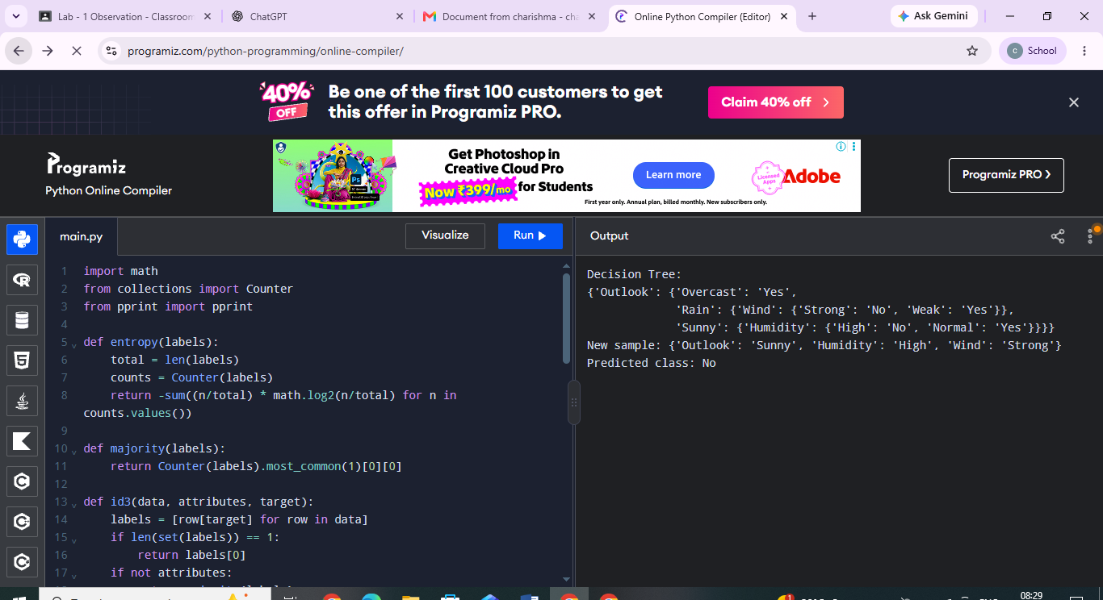
Problem 2: Student Pass Prediction

Aim
To construct an ID3 tree from student study and attendance data and predict whether a new student will pass.

Training Data
StudyHours | Attendance | Assignment | Label
High | Good | Complete | Pass
High | Poor | Complete | Pass
Low | Good | Complete | Pass
Low | Poor | Incomplete | Fail
Medium | Good | Complete | Pass
Medium | Poor | Incomplete | Fail
High | Good | Incomplete | Pass
Low | Good | Incomplete | Fail

Procedure
- Store the student examples and their Pass/Fail labels.
- Compute entropy of the target label.
- Select the attribute that provides the greatest information gain.
- Create branches and recursively build the remaining parts of the tree.
- Classify a new student using the resulting tree.

Coding (Python)
import math
from collections import Counter
from pprint import pprint

def entropy(labels):
total = len(labels)
counts = Counter(labels)
return -sum((n/total) * math.log2(n/total) for n in counts.values())

def majority(labels):
return Counter(labels).most_common(1)[0][0]

def id3(data, attributes, target):
labels = [row[target] for row in data]
if len(set(labels)) == 1:
return labels[0]
if not attributes:
return majority(labels)

base = entropy(labels)
best_attr = max(attributes, key=lambda a: base - sum(
len(group)/len(data) * entropy([r[target] for r in group])
for value in set(r[a] for r in data)
for group in [[r for r in data if r[a] == value]]
))
tree = {best_attr: {}}
for value in sorted(set(r[best_attr] for r in data)):
subset = [r for r in data if r[best_attr] == value]
tree[best_attr][value] = id3(
subset, [a for a in attributes if a != best_attr], target)
return tree

def classify(tree, sample, default):
if not isinstance(tree, dict):
return tree
attr = next(iter(tree))
value = sample.get(attr)
branch = tree[attr].get(value, default)
return classify(branch, sample, default) if isinstance(branch, dict) else branch

data = [{'StudyHours': 'High', 'Attendance': 'Good', 'Assignment': 'Complete', 'Label': 'Pass'}, {'StudyHours': 'High', 'Attendance': 'Poor', 'Assignment': 'Complete', 'Label': 'Pass'}, {'StudyHours': 'Low', 'Attendance': 'Good', 'Assignment': 'Complete', 'Label': 'Pass'}, {'StudyHours': 'Low', 'Attendance': 'Poor', 'Assignment': 'Incomplete', 'Label': 'Fail'}, {'StudyHours': 'Medium', 'Attendance': 'Good', 'Assignment': 'Complete', 'Label': 'Pass'}, {'StudyHours': 'Medium', 'Attendance': 'Poor', 'Assignment': 'Incomplete', 'Label': 'Fail'}, {'StudyHours': 'High', 'Attendance': 'Good', 'Assignment': 'Incomplete', 'Label': 'Pass'}, {'StudyHours': 'Low', 'Attendance': 'Good', 'Assignment': 'Incomplete', 'Label': 'Fail'}]
attributes = ['StudyHours', 'Attendance', 'Assignment']
tree = id3(data, attributes, "Label")
sample = {'StudyHours': 'Low', 'Attendance': 'Poor', 'Assignment': 'Incomplete'}
print("Decision Tree:")
pprint(tree)
print("New sample:", sample)
print("Predicted class:", classify(tree, sample, majority([r["Label"] for r in data])))

Input
Training examples: [{'StudyHours': 'High', 'Attendance': 'Good', 'Assignment': 'Complete', 'Label': 'Pass'}, {'StudyHours': 'High', 'Attendance': 'Poor', 'Assignment': 'Complete', 'Label': 'Pass'}, {'StudyHours': 'Low', 'Attendance': 'Good', 'Assignment': 'Complete', 'Label': 'Pass'}, {'StudyHours': 'Low', 'Attendance': 'Poor', 'Assignment': 'Incomplete', 'Label': 'Fail'}, {'StudyHours': 'Medium', 'Attendance': 'Good', 'Assignment': 'Complete', 'Label': 'Pass'}, {'StudyHours': 'Medium', 'Attendance': 'Poor', 'Assignment': 'Incomplete', 'Label': 'Fail'}, {'StudyHours': 'High', 'Attendance': 'Good', 'Assignment': 'Incomplete', 'Label': 'Pass'}, {'StudyHours': 'Low', 'Attendance': 'Good', 'Assignment': 'Incomplete', 'Label': 'Fail'}]
New sample: {'StudyHours': 'Low', 'Attendance': 'Poor', 'Assignment': 'Incomplete'}

Output
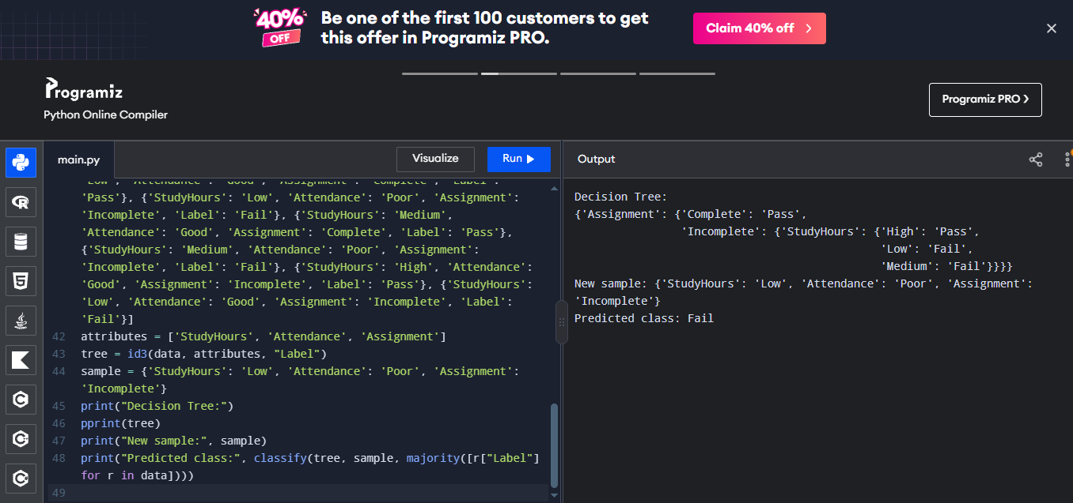
Problem 3: Laptop Recommendation

Aim
To apply ID3 to laptop specifications and classify whether a laptop is recommended.

Training Data
Processor | RAM | Battery | Label
i5 | 8GB | Long | Yes
i5 | 16GB | Long | Yes
i7 | 16GB | Long | Yes
i3 | 4GB | Short | No
i3 | 8GB | Short | No
i7 | 8GB | Long | Yes
i5 | 4GB | Short | No
i7 | 16GB | Short | Yes

Procedure
- Prepare labelled laptop examples.
- Calculate target entropy and information gain for Processor, RAM and Battery.
- Choose the attribute with the highest gain for each decision node.
- Continue splitting until the remaining examples have a class label.
- Predict the recommendation for the new laptop configuration.

Coding (Python)
import math
from collections import Counter
from pprint import pprint

def entropy(labels):
total = len(labels)
counts = Counter(labels)
return -sum((n/total) * math.log2(n/total) for n in counts.values())

def majority(labels):
return Counter(labels).most_common(1)[0][0]

def id3(data, attributes, target):
labels = [row[target] for row in data]
if len(set(labels)) == 1:
return labels[0]
if not attributes:
return majority(labels)

base = entropy(labels)
best_attr = max(attributes, key=lambda a: base - sum(
len(group)/len(data) * entropy([r[target] for r in group])
for value in set(r[a] for r in data)
for group in [[r for r in data if r[a] == value]]
))
tree = {best_attr: {}}
for value in sorted(set(r[best_attr] for r in data)):
subset = [r for r in data if r[best_attr] == value]
tree[best_attr][value] = id3(
subset, [a for a in attributes if a != best_attr], target)
return tree

def classify(tree, sample, default):
if not isinstance(tree, dict):
return tree
attr = next(iter(tree))
value = sample.get(attr)
branch = tree[attr].get(value, default)
return classify(branch, sample, default) if isinstance(branch, dict) else branch

data = [{'Processor': 'i5', 'RAM': '8GB', 'Battery': 'Long', 'Label': 'Yes'}, {'Processor': 'i5', 'RAM': '16GB', 'Battery': 'Long', 'Label': 'Yes'}, {'Processor': 'i7', 'RAM': '16GB', 'Battery': 'Long', 'Label': 'Yes'}, {'Processor': 'i3', 'RAM': '4GB', 'Battery': 'Short', 'Label': 'No'}, {'Processor': 'i3', 'RAM': '8GB', 'Battery': 'Short', 'Label': 'No'}, {'Processor': 'i7', 'RAM': '8GB', 'Battery': 'Long', 'Label': 'Yes'}, {'Processor': 'i5', 'RAM': '4GB', 'Battery': 'Short', 'Label': 'No'}, {'Processor': 'i7', 'RAM': '16GB', 'Battery': 'Short', 'Label': 'Yes'}]
attributes = ['Processor', 'RAM', 'Battery']
tree = id3(data, attributes, "Label")
sample = {'Processor': 'i5', 'RAM': '16GB', 'Battery': 'Long'}
print("Decision Tree:")
pprint(tree)
print("New sample:", sample)
print("Predicted class:", classify(tree, sample, majority([r["Label"] for r in data])))

Input
Training examples: [{'Processor': 'i5', 'RAM': '8GB', 'Battery': 'Long', 'Label': 'Yes'}, {'Processor': 'i5', 'RAM': '16GB', 'Battery': 'Long', 'Label': 'Yes'}, {'Processor': 'i7', 'RAM': '16GB', 'Battery': 'Long', 'Label': 'Yes'}, {'Processor': 'i3', 'RAM': '4GB', 'Battery': 'Short', 'Label': 'No'}, {'Processor': 'i3', 'RAM': '8GB', 'Battery': 'Short', 'Label': 'No'}, {'Processor': 'i7', 'RAM': '8GB', 'Battery': 'Long', 'Label': 'Yes'}, {'Processor': 'i5', 'RAM': '4GB', 'Battery': 'Short', 'Label': 'No'}, {'Processor': 'i7', 'RAM': '16GB', 'Battery': 'Short', 'Label': 'Yes'}]
New sample: {'Processor': 'i5', 'RAM': '16GB', 'Battery': 'Long'}

Output
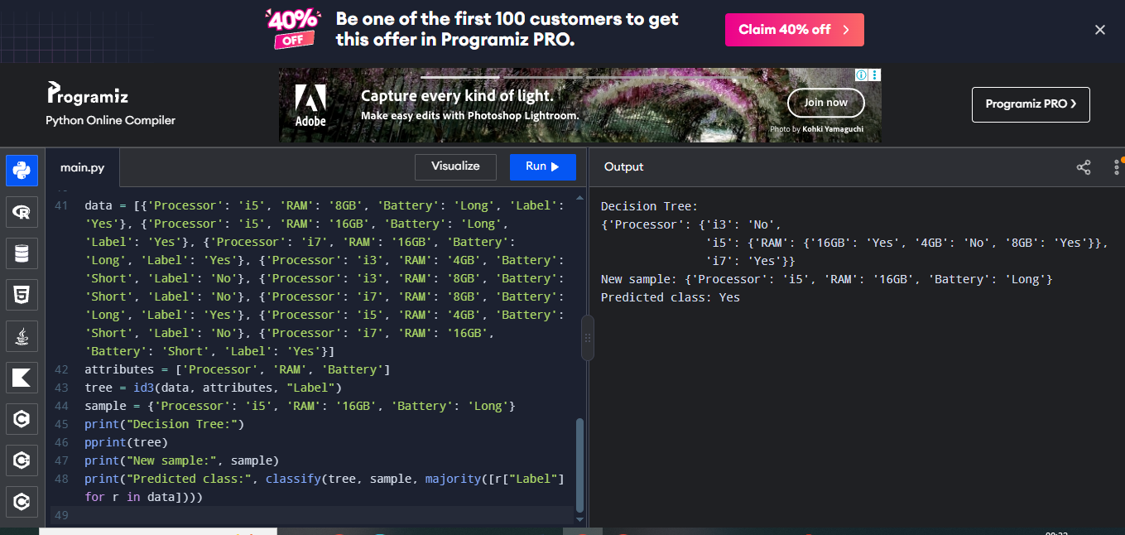
Problem 4: Fruit Classification

Aim
To build an ID3 tree that classifies fruit as preferred or not preferred from its features.

Training Data
Colour | Size | Taste | Label
Yellow | Medium | Sweet | Preferred
Red | Small | Sweet | Preferred
Green | Large | Sour | NotPreferred
Yellow | Large | Sweet | Preferred
Green | Small | Sour | NotPreferred
Red | Medium | Sweet | Preferred
Green | Medium | Sour | NotPreferred
Yellow | Small | Sour | NotPreferred

Procedure
- Enter the fruit attributes and preference labels.
- Measure entropy of the labels.
- Calculate information gain for Colour, Size and Taste.
- Build the tree recursively using the best attribute at each stage.
- Use the tree to classify a new fruit.

Coding (Python)
import math
from collections import Counter
from pprint import pprint

def entropy(labels):
total = len(labels)
counts = Counter(labels)
return -sum((n/total) * math.log2(n/total) for n in counts.values())

def majority(labels):
return Counter(labels).most_common(1)[0][0]

def id3(data, attributes, target):
labels = [row[target] for row in data]
if len(set(labels)) == 1:
return labels[0]
if not attributes:
return majority(labels)

base = entropy(labels)
best_attr = max(attributes, key=lambda a: base - sum(
len(group)/len(data) * entropy([r[target] for r in group])
for value in set(r[a] for r in data)
for group in [[r for r in data if r[a] == value]]
))
tree = {best_attr: {}}
for value in sorted(set(r[best_attr] for r in data)):
subset = [r for r in data if r[best_attr] == value]
tree[best_attr][value] = id3(
subset, [a for a in attributes if a != best_attr], target)
return tree

def classify(tree, sample, default):
if not isinstance(tree, dict):
return tree
attr = next(iter(tree))
value = sample.get(attr)
branch = tree[attr].get(value, default)
return classify(branch, sample, default) if isinstance(branch, dict) else branch

data = [{'Colour': 'Yellow', 'Size': 'Medium', 'Taste': 'Sweet', 'Label': 'Preferred'}, {'Colour': 'Red', 'Size': 'Small', 'Taste': 'Sweet', 'Label': 'Preferred'}, {'Colour': 'Green', 'Size': 'Large', 'Taste': 'Sour', 'Label': 'NotPreferred'}, {'Colour': 'Yellow', 'Size': 'Large', 'Taste': 'Sweet', 'Label': 'Preferred'}, {'Colour': 'Green', 'Size': 'Small', 'Taste': 'Sour', 'Label': 'NotPreferred'}, {'Colour': 'Red', 'Size': 'Medium', 'Taste': 'Sweet', 'Label': 'Preferred'}, {'Colour': 'Green', 'Size': 'Medium', 'Taste': 'Sour', 'Label': 'NotPreferred'}, {'Colour': 'Yellow', 'Size': 'Small', 'Taste': 'Sour', 'Label': 'NotPreferred'}]
attributes = ['Colour', 'Size', 'Taste']
tree = id3(data, attributes, "Label")
sample = {'Colour': 'Yellow', 'Size': 'Medium', 'Taste': 'Sweet'}
print("Decision Tree:")
pprint(tree)
print("New sample:", sample)
print("Predicted class:", classify(tree, sample, majority([r["Label"] for r in data])))

Input
Training examples: [{'Colour': 'Yellow', 'Size': 'Medium', 'Taste': 'Sweet', 'Label': 'Preferred'}, {'Colour': 'Red', 'Size': 'Small', 'Taste': 'Sweet', 'Label': 'Preferred'}, {'Colour': 'Green', 'Size': 'Large', 'Taste': 'Sour', 'Label': 'NotPreferred'}, {'Colour': 'Yellow', 'Size': 'Large', 'Taste': 'Sweet', 'Label': 'Preferred'}, {'Colour': 'Green', 'Size': 'Small', 'Taste': 'Sour', 'Label': 'NotPreferred'}, {'Colour': 'Red', 'Size': 'Medium', 'Taste': 'Sweet', 'Label': 'Preferred'}, {'Colour': 'Green', 'Size': 'Medium', 'Taste': 'Sour', 'Label': 'NotPreferred'}, {'Colour': 'Yellow', 'Size': 'Small', 'Taste': 'Sour', 'Label': 'NotPreferred'}]
New sample: {'Colour': 'Yellow', 'Size': 'Medium', 'Taste': 'Sweet'}

Output
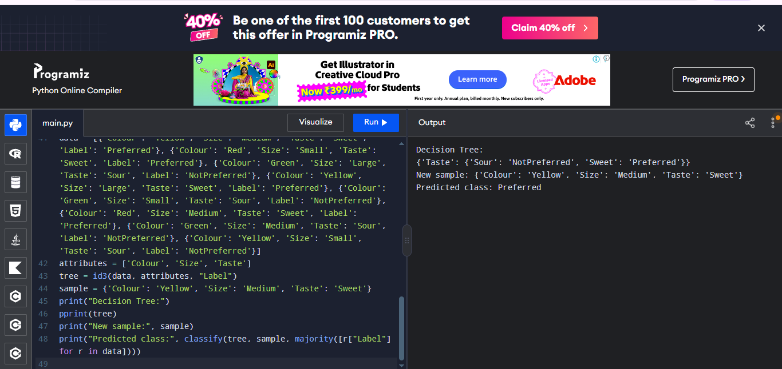
Problem 5: Loan Approval

Aim
To demonstrate ID3 for classifying a simple loan application as Approved or Rejected.

Training Data
Income | Credit | Employment | Label
High | Good | Stable | Approved
High | Poor | Stable | Rejected
Low | Good | Stable | Rejected
Medium | Good | Stable | Approved
Medium | Poor | Temporary | Rejected
High | Good | Temporary | Approved
Low | Poor | Temporary | Rejected
Medium | Good | Temporary | Approved

Procedure
- Create a dataset of loan applicant features and outcomes.
- Calculate the entropy of Approved/Rejected outcomes.
- Select the feature with maximum information gain.
- Create branches and repeat until the leaves predict a class.
- Classify a new loan applicant using the tree.

Coding (Python)
import math
from collections import Counter
from pprint import pprint

def entropy(labels):
total = len(labels)
counts = Counter(labels)
return -sum((n/total) * math.log2(n/total) for n in counts.values())

def majority(labels):
return Counter(labels).most_common(1)[0][0]

def id3(data, attributes, target):
labels = [row[target] for row in data]
if len(set(labels)) == 1:
return labels[0]
if not attributes:
return majority(labels)

base = entropy(labels)
best_attr = max(attributes, key=lambda a: base - sum(
len(group)/len(data) * entropy([r[target] for r in group])
for value in set(r[a] for r in data)
for group in [[r for r in data if r[a] == value]]
))
tree = {best_attr: {}}
for value in sorted(set(r[best_attr] for r in data)):
subset = [r for r in data if r[best_attr] == value]
tree[best_attr][value] = id3(
subset, [a for a in attributes if a != best_attr], target)
return tree

def classify(tree, sample, default):
if not isinstance(tree, dict):
return tree
attr = next(iter(tree))
value = sample.get(attr)
branch = tree[attr].get(value, default)
return classify(branch, sample, default) if isinstance(branch, dict) else branch

data = [{'Income': 'High', 'Credit': 'Good', 'Employment': 'Stable', 'Label': 'Approved'}, {'Income': 'High', 'Credit': 'Poor', 'Employment': 'Stable', 'Label': 'Rejected'}, {'Income': 'Low', 'Credit': 'Good', 'Employment': 'Stable', 'Label': 'Rejected'}, {'Income': 'Medium', 'Credit': 'Good', 'Employment': 'Stable', 'Label': 'Approved'}, {'Income': 'Medium', 'Credit': 'Poor', 'Employment': 'Temporary', 'Label': 'Rejected'}, {'Income': 'High', 'Credit': 'Good', 'Employment': 'Temporary', 'Label': 'Approved'}, {'Income': 'Low', 'Credit': 'Poor', 'Employment': 'Temporary', 'Label': 'Rejected'}, {'Income': 'Medium', 'Credit': 'Good', 'Employment': 'Temporary', 'Label': 'Approved'}]
attributes = ['Income', 'Credit', 'Employment']
tree = id3(data, attributes, "Label")
sample = {'Income': 'High', 'Credit': 'Good', 'Employment': 'Stable'}
print("Decision Tree:")
pprint(tree)
print("New sample:", sample)
print("Predicted class:", classify(tree, sample, majority([r["Label"] for r in data])))

Input
Training examples: [{'Income': 'High', 'Credit': 'Good', 'Employment': 'Stable', 'Label': 'Approved'}, {'Income': 'High', 'Credit': 'Poor', 'Employment': 'Stable', 'Label': 'Rejected'}, {'Income': 'Low', 'Credit': 'Good', 'Employment': 'Stable', 'Label': 'Rejected'}, {'Income': 'Medium', 'Credit': 'Good', 'Employment': 'Stable', 'Label': 'Approved'}, {'Income': 'Medium', 'Credit': 'Poor', 'Employment': 'Temporary', 'Label': 'Rejected'}, {'Income': 'High', 'Credit': 'Good', 'Employment': 'Temporary', 'Label': 'Approved'}, {'Income': 'Low', 'Credit': 'Poor', 'Employment': 'Temporary', 'Label': 'Rejected'}, {'Income': 'Medium', 'Credit': 'Good', 'Employment': 'Temporary', 'Label': 'Approved'}]
New sample: {'Income': 'High', 'Credit': 'Good', 'Employment': 'Stable'}

Output
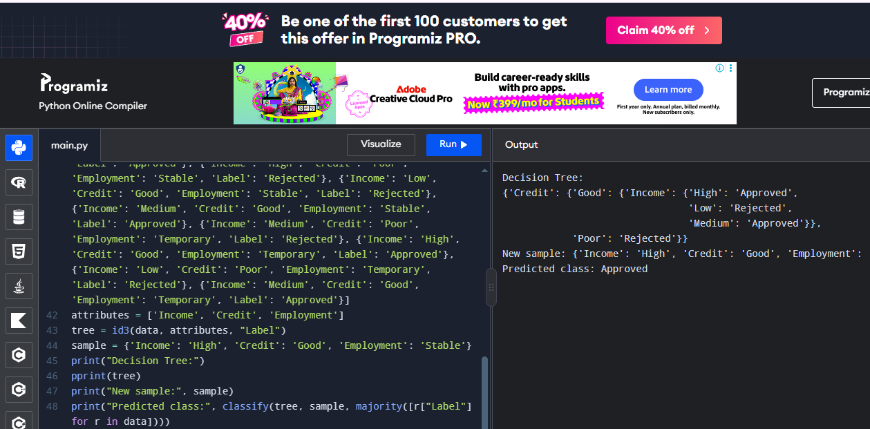

4. Build an Artificial Neural Network by implementing the Backpropagation algorithm and test the same using appropriate data sets.

Problem 1: AND Gate

Aim
To implement backpropagation in a small neural network and learn the AND logical operation.

Training Data
Input 1 | Input 2 | Target
0 | 0 | 0
0 | 1 | 0
1 | 0 | 0
1 | 1 | 1

Procedure
- Represent the AND truth table as input and target arrays.
- Initialize weights and biases with small random values.
- Perform forward propagation using the sigmoid activation function.
- Calculate output error and update weights by backpropagation.
- Repeat training and test the four input combinations.

Coding (Python)
import numpy as np

# Dataset
X = np.array([[0, 0], [0, 1], [1, 0], [1, 1]], dtype=float)
y = np.array([0, 0, 0, 1], dtype=float).reshape(-1, 1)

# Scale each input column to the range 0 to 1
scale = np.maximum(X.max(axis=0), 1)
X = X / scale

np.random.seed(1)
input_size = X.shape[1]
hidden_size = 4
W1 = np.random.randn(input_size, hidden_size) * 0.5
b1 = np.zeros((1, hidden_size))
W2 = np.random.randn(hidden_size, 1) * 0.5
b2 = np.zeros((1, 1))

def sigmoid(z):
return 1 / (1 + np.exp(-z))

# Backpropagation training
for epoch in range(10000):
hidden = sigmoid(X @ W1 + b1)
output = sigmoid(hidden @ W2 + b2)
error = output - y

d_output = error * output * (1 - output)
d_W2 = hidden.T @ d_output / len(X)
d_b2 = np.mean(d_output, axis=0, keepdims=True)

d_hidden = (d_output @ W2.T) * hidden * (1 - hidden)
d_W1 = X.T @ d_hidden / len(X)
d_b1 = np.mean(d_hidden, axis=0, keepdims=True)

W2 -= 1.0 * d_W2
b2 -= 1.0 * d_b2
W1 -= 1.0 * d_W1
b1 -= 1.0 * d_b1

# Test the trained network
test = np.array([[0, 0], [0, 1], [1, 0], [1, 1]], dtype=float)
test = test / scale
predictions = sigmoid(sigmoid(test @ W1 + b1) @ W2 + b2)
print("Predicted probabilities:")
print(np.round(predictions.ravel(), 3))
print("Predicted classes (0 or 1):")
print((predictions >= 0.5).astype(int).ravel())

Input
Training inputs: [[0, 0], [0, 1], [1, 0], [1, 1]]
Targets: [0, 0, 0, 1]
Test inputs: [[0, 0], [0, 1], [1, 0], [1, 1]]

Output
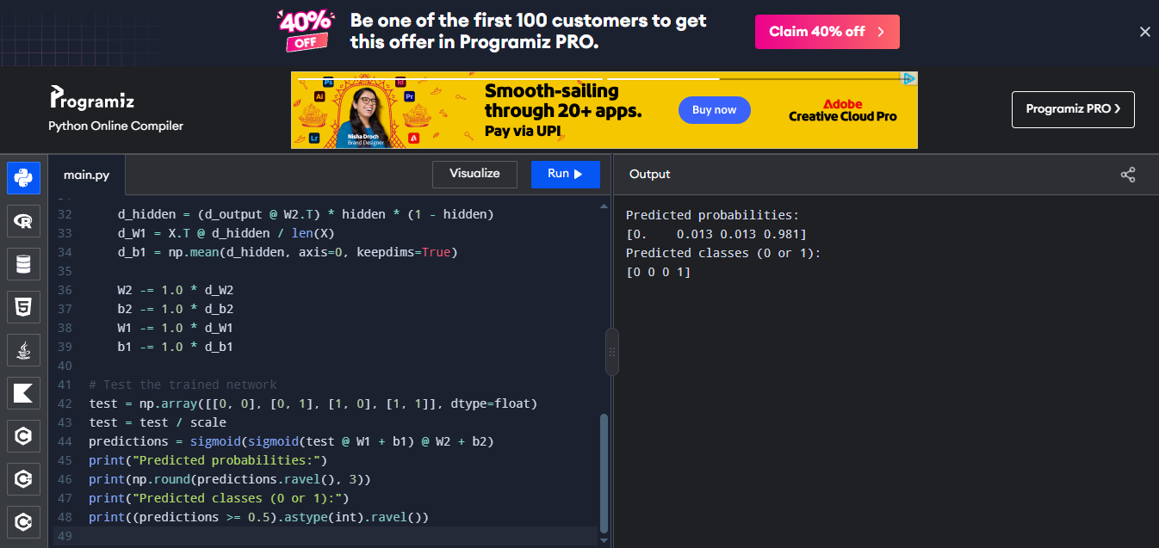
Problem 2: OR Gate

Aim
To train a neural network with backpropagation to learn the OR logical operation.

Training Data
Input 1 | Input 2 | Target
0 | 0 | 0
0 | 1 | 1
1 | 0 | 1
1 | 1 | 1

Procedure
- Prepare the OR truth-table dataset.
- Initialize the input-to-hidden and hidden-to-output weights.
- Calculate hidden and output activations.
- Propagate the prediction error backward and update the weights.
- Test the trained model on all four input combinations.

Coding (Python)
import numpy as np

# Dataset
X = np.array([[0, 0], [0, 1], [1, 0], [1, 1]], dtype=float)
y = np.array([0, 1, 1, 1], dtype=float).reshape(-1, 1)

# Scale each input column to the range 0 to 1
scale = np.maximum(X.max(axis=0), 1)
X = X / scale

np.random.seed(1)
input_size = X.shape[1]
hidden_size = 4
W1 = np.random.randn(input_size, hidden_size) * 0.5
b1 = np.zeros((1, hidden_size))
W2 = np.random.randn(hidden_size, 1) * 0.5
b2 = np.zeros((1, 1))

def sigmoid(z):
return 1 / (1 + np.exp(-z))

# Backpropagation training
for epoch in range(10000):
hidden = sigmoid(X @ W1 + b1)
output = sigmoid(hidden @ W2 + b2)
error = output - y

d_output = error * output * (1 - output)
d_W2 = hidden.T @ d_output / len(X)
d_b2 = np.mean(d_output, axis=0, keepdims=True)

d_hidden = (d_output @ W2.T) * hidden * (1 - hidden)
d_W1 = X.T @ d_hidden / len(X)
d_b1 = np.mean(d_hidden, axis=0, keepdims=True)

W2 -= 1.0 * d_W2
b2 -= 1.0 * d_b2
W1 -= 1.0 * d_W1
b1 -= 1.0 * d_b1

# Test the trained network
test = np.array([[0, 0], [0, 1], [1, 0], [1, 1]], dtype=float)
test = test / scale
predictions = sigmoid(sigmoid(test @ W1 + b1) @ W2 + b2)
print("Predicted probabilities:")
print(np.round(predictions.ravel(), 3))
print("Predicted classes (0 or 1):")
print((predictions >= 0.5).astype(int).ravel())

Input
Training inputs: [[0, 0], [0, 1], [1, 0], [1, 1]]
Targets: [0, 1, 1, 1]
Test inputs: [[0, 0], [0, 1], [1, 0], [1, 1]]

Output
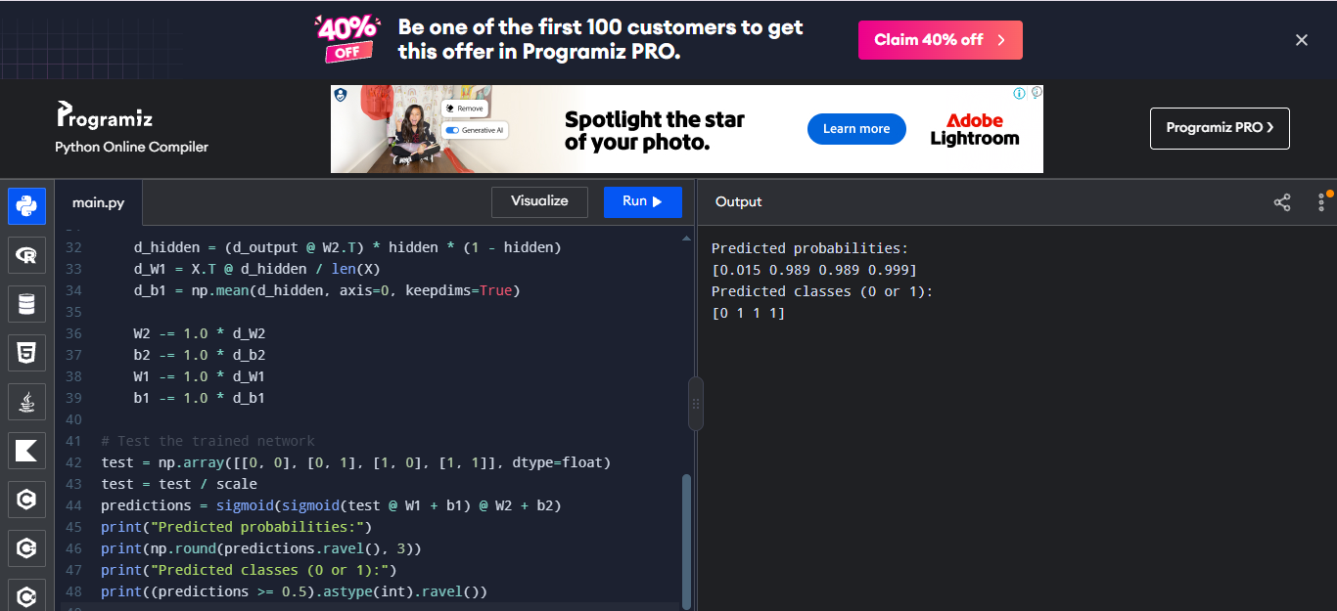

Problem 3: Student Pass Prediction

Aim
To train a neural network to predict pass/fail from study hours and attendance using backpropagation.

Training Data
Study Hours | Attendance (%) | Target
1 | 40 | 0
2 | 50 | 0
3 | 60 | 0
4 | 70 | 1
5 | 80 | 1
6 | 90 | 1

Procedure
- Enter the study-hour and attendance examples with their target labels.
- Normalize both input features to a similar numeric range.
- Train the network using forward propagation and backpropagation.
- Update weights repeatedly to reduce prediction error.
- Test a new student's study and attendance values.

Coding (Python)
import numpy as np

# Dataset
X = np.array([[1, 40], [2, 50], [3, 60], [4, 70], [5, 80], [6, 90]], dtype=float)
y = np.array([0, 0, 0, 1, 1, 1], dtype=float).reshape(-1, 1)

# Scale each input column to the range 0 to 1
scale = np.maximum(X.max(axis=0), 1)
X = X / scale

np.random.seed(1)
input_size = X.shape[1]
hidden_size = 4
W1 = np.random.randn(input_size, hidden_size) * 0.5
b1 = np.zeros((1, hidden_size))
W2 = np.random.randn(hidden_size, 1) * 0.5
b2 = np.zeros((1, 1))

def sigmoid(z):
return 1 / (1 + np.exp(-z))

# Backpropagation training
for epoch in range(10000):
hidden = sigmoid(X @ W1 + b1)
output = sigmoid(hidden @ W2 + b2)
error = output - y

d_output = error * output * (1 - output)
d_W2 = hidden.T @ d_output / len(X)
d_b2 = np.mean(d_output, axis=0, keepdims=True)

d_hidden = (d_output @ W2.T) * hidden * (1 - hidden)
d_W1 = X.T @ d_hidden / len(X)
d_b1 = np.mean(d_hidden, axis=0, keepdims=True)

W2 -= 1.0 * d_W2
b2 -= 1.0 * d_b2
W1 -= 1.0 * d_W1
b1 -= 1.0 * d_b1

# Test the trained network
test = np.array([[1, 40], [2, 50], [3, 60], [4, 70], [5, 80], [6, 90]], dtype=float)
test = test / scale
predictions = sigmoid(sigmoid(test @ W1 + b1) @ W2 + b2)
print("Predicted probabilities:")
print(np.round(predictions.ravel(), 3))
print("Predicted classes (0 or 1):")
print((predictions >= 0.5).astype(int).ravel())

Input
Training inputs: [[1, 40], [2, 50], [3, 60], [4, 70], [5, 80], [6, 90]]
Targets: [0, 0, 0, 1, 1, 1]
Test inputs: [[1, 40], [2, 50], [3, 60], [4, 70], [5, 80], [6, 90]]

Output
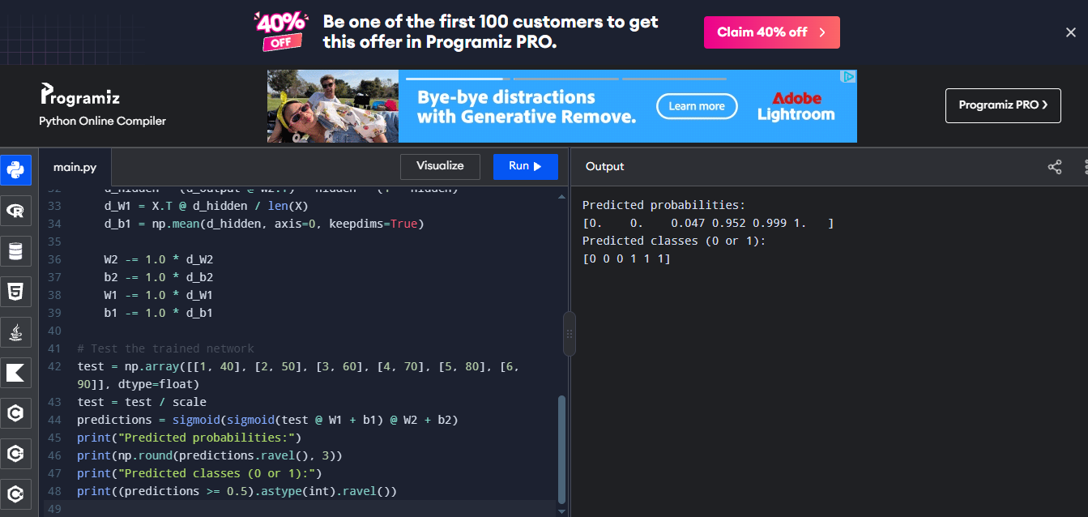

Problem 4: Fruit Sweetness Classification

Aim
To classify a fruit as sweet or not sweet using numeric fruit features and backpropagation.

Training Data
Size score | Colour score | Target
1 | 0 | 0
2 | 0 | 0
3 | 1 | 1
4 | 1 | 1
2 | 1 | 1
1 | 1 | 0

Procedure
- Represent fruit properties as numeric input features.
- Create the target array for sweet and not-sweet fruit.
- Train the neural network by calculating activations and errors.
- Use the error gradients to adjust weights and biases.
- Test the trained network on a new fruit feature pair.

Coding (Python)
import numpy as np

# Dataset
X = np.array([[1, 0], [2, 0], [3, 1], [4, 1], [2, 1], [1, 1]], dtype=float)
y = np.array([0, 0, 1, 1, 1, 0], dtype=float).reshape(-1, 1)

# Scale each input column to the range 0 to 1
scale = np.maximum(X.max(axis=0), 1)
X = X / scale

np.random.seed(1)
input_size = X.shape[1]
hidden_size = 4
W1 = np.random.randn(input_size, hidden_size) * 0.5
b1 = np.zeros((1, hidden_size))
W2 = np.random.randn(hidden_size, 1) * 0.5
b2 = np.zeros((1, 1))

def sigmoid(z):
return 1 / (1 + np.exp(-z))

# Backpropagation training
for epoch in range(10000):
hidden = sigmoid(X @ W1 + b1)
output = sigmoid(hidden @ W2 + b2)
error = output - y

d_output = error * output * (1 - output)
d_W2 = hidden.T @ d_output / len(X)
d_b2 = np.mean(d_output, axis=0, keepdims=True)

d_hidden = (d_output @ W2.T) * hidden * (1 - hidden)
d_W1 = X.T @ d_hidden / len(X)
d_b1 = np.mean(d_hidden, axis=0, keepdims=True)

W2 -= 1.0 * d_W2
b2 -= 1.0 * d_b2
W1 -= 1.0 * d_W1
b1 -= 1.0 * d_b1

# Test the trained network
test = np.array([[1, 0], [2, 0], [3, 1], [4, 1], [2, 1], [1, 1]], dtype=float)
test = test / scale
predictions = sigmoid(sigmoid(test @ W1 + b1) @ W2 + b2)
print("Predicted probabilities:")
print(np.round(predictions.ravel(), 3))
print("Predicted classes (0 or 1):")
print((predictions >= 0.5).astype(int).ravel())

Input
Training inputs: [[1, 0], [2, 0], [3, 1], [4, 1], [2, 1], [1, 1]]
Targets: [0, 0, 1, 1, 1, 0]
Test inputs: [[1, 0], [2, 0], [3, 1], [4, 1], [2, 1], [1, 1]]

Output
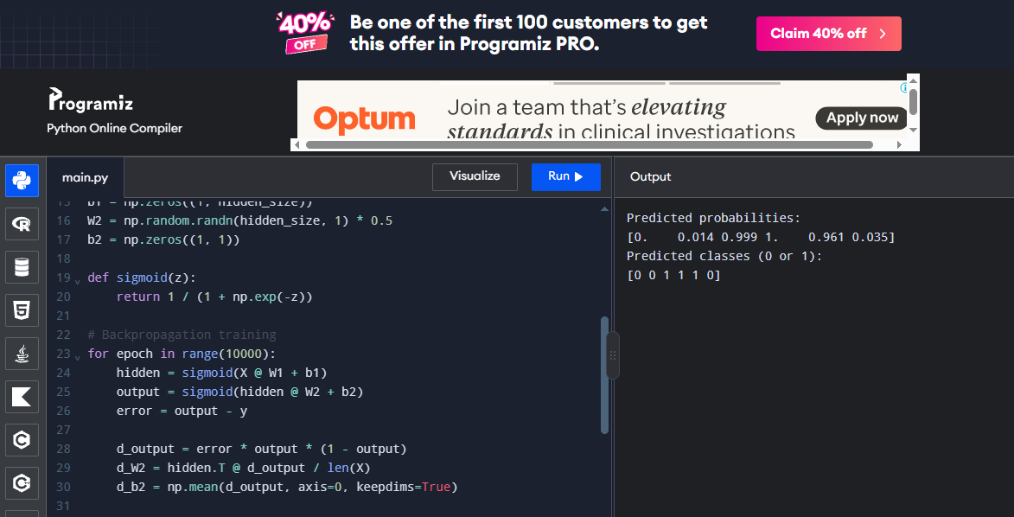

Problem 5: Simple Disease Risk Classification

Aim
To demonstrate backpropagation on a small illustrative dataset for low/high risk classification.

Training Data
Exercise score | Health score | Target
1 | 1 | 0
2 | 1 | 0
1 | 2 | 0
3 | 3 | 1
4 | 3 | 1
3 | 4 | 1

Procedure
- Enter the two numeric features and binary labels.
- Initialize a small feed-forward network.
- Run forward propagation to obtain predictions.
- Calculate output error and backpropagate gradients to update weights.
- Test the trained network on unseen numeric feature values.

Coding (Python)
import numpy as np

# Dataset
X = np.array([[1, 1], [2, 1], [1, 2], [3, 3], [4, 3], [3, 4]], dtype=float)
y = np.array([0, 0, 0, 1, 1, 1], dtype=float).reshape(-1, 1)

# Scale each input column to the range 0 to 1
scale = np.maximum(X.max(axis=0), 1)
X = X / scale

np.random.seed(1)
input_size = X.shape[1]
hidden_size = 4
W1 = np.random.randn(input_size, hidden_size) * 0.5
b1 = np.zeros((1, hidden_size))
W2 = np.random.randn(hidden_size, 1) * 0.5
b2 = np.zeros((1, 1))

def sigmoid(z):
return 1 / (1 + np.exp(-z))

# Backpropagation training
for epoch in range(10000):
hidden = sigmoid(X @ W1 + b1)
output = sigmoid(hidden @ W2 + b2)
error = output - y

d_output = error * output * (1 - output)
d_W2 = hidden.T @ d_output / len(X)
d_b2 = np.mean(d_output, axis=0, keepdims=True)

d_hidden = (d_output @ W2.T) * hidden * (1 - hidden)
d_W1 = X.T @ d_hidden / len(X)
d_b1 = np.mean(d_hidden, axis=0, keepdims=True)

W2 -= 1.0 * d_W2
b2 -= 1.0 * d_b2
W1 -= 1.0 * d_W1
b1 -= 1.0 * d_b1

# Test the trained network
test = np.array([[1, 1], [2, 1], [1, 2], [3, 3], [4, 3], [3, 4]], dtype=float)
test = test / scale
predictions = sigmoid(sigmoid(test @ W1 + b1) @ W2 + b2)
print("Predicted probabilities:")
print(np.round(predictions.ravel(), 3))
print("Predicted classes (0 or 1):")
print((predictions >= 0.5).astype(int).ravel())

Input
Training inputs: [[1, 1], [2, 1], [1, 2], [3, 3], [4, 3], [3, 4]]
Targets: [0, 0, 0, 1, 1, 1]
Test inputs: [[1, 1], [2, 1], [1, 2], [3, 3], [4, 3], [3, 4]]

Output
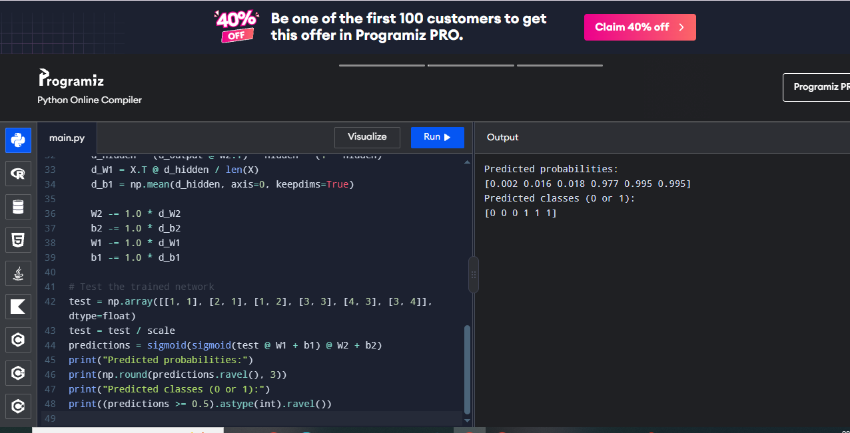

5. Write a program for Implementation of K-Nearest Neighbours (K-NN) in Python

Problem 1: Iris Flower Classification

Aim
To classify an iris flower into its species using K-Nearest Neighbours.

Training Data
Attributes: sepal length, sepal width, petal length and petal width. Labels: Setosa, Versicolor and Virginica.

Procedure
1. Prepare labelled examples with numeric input attributes.
2. Create a KNeighborsClassifier with k = 3.
3. Fit the model using the training examples.
4. Predict the labels for the test or new sample.
5. Display the prediction and, where available, accuracy.

Coding (Python)

data = [
[5.1, 3.5, 1.4, 0.2, 0],
[4.9, 3.0, 1.4, 0.2, 0],
[7.0, 3.2, 4.7, 1.4, 1],
[6.4, 3.2, 4.5, 1.5, 1],
[6.3, 3.3, 6.0, 2.5, 2],
[5.8, 2.7, 5.1, 1.9, 2]
]

# New flower
flower = [5.1, 3.5, 1.4, 0.2]

distances = []

for row in data:
distance = sum((flower[i] - row[i]) ** 2 for i in range(4)) ** 0.5
distances.append((distance, row[4]))

# Find the 3 nearest flowers
distances.sort()
nearest = [item[1] for item in distances[:3]]

# Predict the flower type
prediction = max(set(nearest), key=nearest.count)

names = ["Setosa", "Versicolor", "Virginica"]

print("New flower:", names[prediction])

Input
Input: Iris measurements and a new flower [5.1, 3.5, 1.4, 0.2].

Output

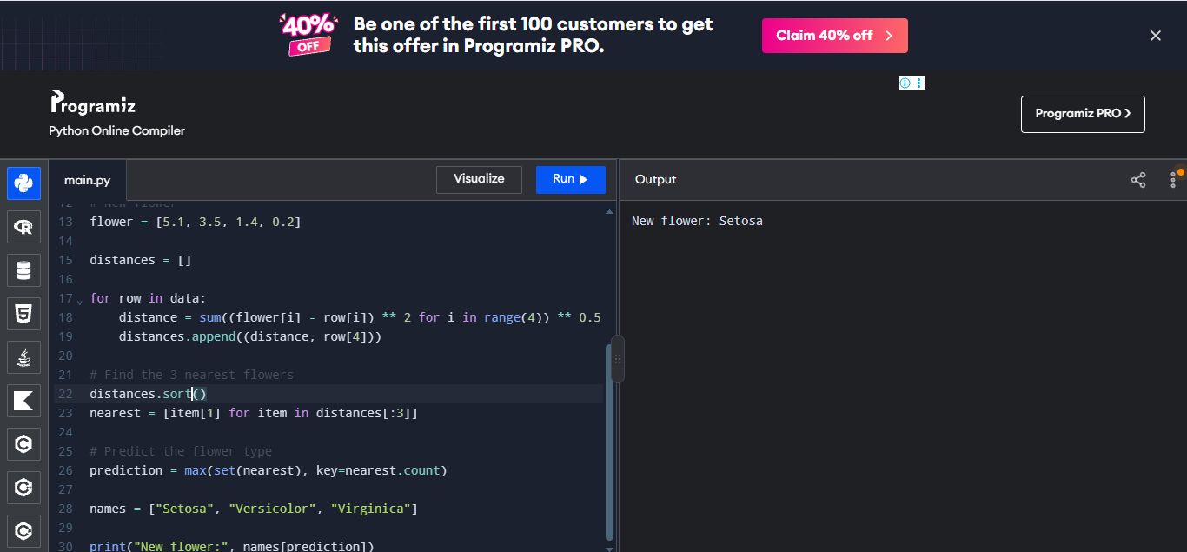

Problem 2: Student Pass Prediction

Aim
To predict whether a student passes based on study hours and attendance.

Training Data
Study hours and attendance percentage are the input attributes; labels are Fail (0) and Pass (1).

Procedure
1. Prepare labelled examples with numeric input attributes.
2. Create a KNeighborsClassifier with k = 3.
3. Fit the model using the training examples.
4. Predict the labels for the test or new sample.
5. Display the prediction and, where available, accuracy.

Coding (Python)

data = [
[1, 50, 0],
[2, 55, 0],
[2, 60, 0],
[3, 65, 0],
[4, 75, 1],
[5, 80, 1],
[6, 90, 1],
[7, 95, 1]
]

# New student: 5 study hours, 82% attendance
student = [5, 82]

distances = []

for row in data:
distance = ((student[0] - row[0]) ** 2 +
(student[1] - row[1]) ** 2) ** 0.5
distances.append((distance, row[2]))

distances.sort()
nearest = [item[1] for item in distances[:3]]

prediction = max(set(nearest), key=nearest.count)

# Calculate accuracy on the sample data
correct = 0

for row in data:
d = []
for other in data:
if other != row:
distance = ((row[0] - other[0]) ** 2 +
(row[1] - other[1]) ** 2) ** 0.5
d.append((distance, other[2]))

d.sort()
result = max(set([x[1] for x in d[:3]]),
key=[x[1] for x in d[:3]].count)

if result == row[2]:
correct += 1

print("Accuracy:", round(correct / len(data), 2))
print("New student [5 study hours, 82% attendance]:", prediction)

Input
Input: Study hours and attendance records; new sample [5, 82].

Output

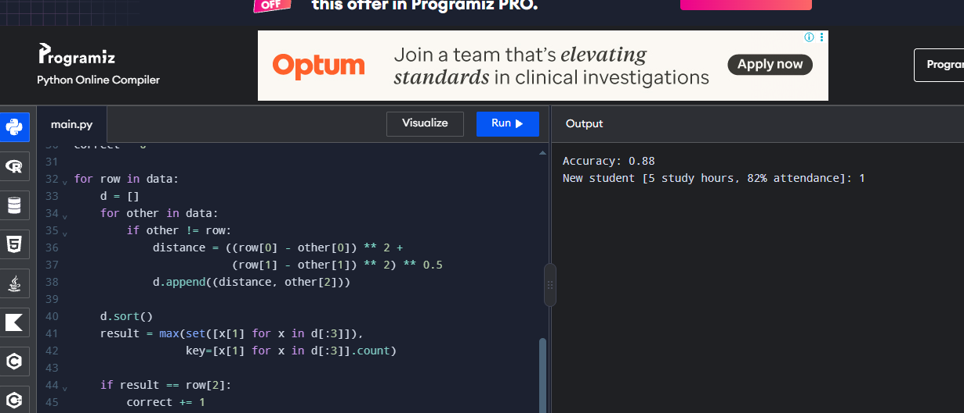

Problem 3: Fruit Classification

Aim
To classify fruit as apple or orange using weight and texture score.

Training Data
Inputs: weight in grams and texture score. Labels: Apple (0), Orange (1).

Procedure
1. Prepare labelled examples with numeric input attributes.
2. Create a KNeighborsClassifier with k = 3.
3. Fit the model using the training examples.
4. Predict the labels for the test or new sample.
5. Display the prediction and, where available, accuracy.

Coding (Python)

data = [

[150, 1, 0],

[170, 1, 0],

[140, 1, 0],

[160, 0, 1],

[180, 0, 1],

[200, 0, 1]

]

# New fruit: 175 g, smooth texture (1 = smooth, 0 = rough)

fruit = [175, 0]

distances = []

for row in data:

distance = ((fruit[0] - row[0]) ** 2 +

(fruit[1] - row[1]) ** 2) ** 0.5

distances.append((distance, row[2]))

distances.sort()

nearest = [item[1] for item in distances[:3]

prediction = max(set(nearest), key=nearest.count)

print("New fruit [175 g, smooth texture]:", prediction)

Input
Input: Weight and texture training records; new sample [175, 0].

Output
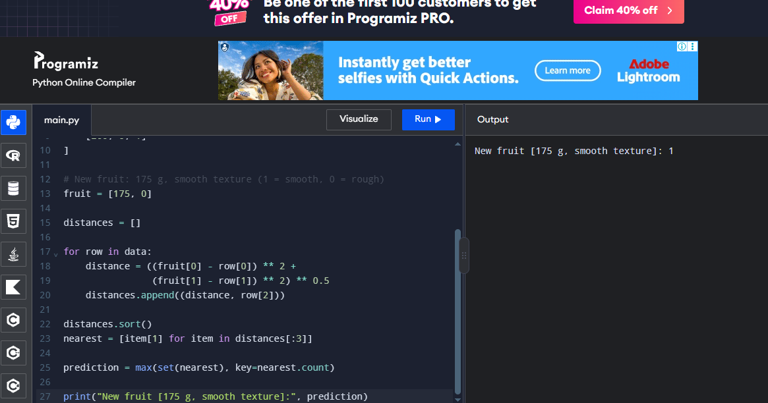

Problem 4: Laptop Recommendation

Aim
To recommend a laptop category based on RAM and storage capacity.

Training Data
Inputs: RAM in GB and storage in GB. Labels: Basic (0) and High-performance (1).

Procedure
1. Prepare labelled examples with numeric input attributes.
2. Create a KNeighborsClassifier with k = 3.
3. Fit the model using the training examples.
4. Predict the labels for the test or new sample.
5. Display the prediction and, where available, accuracy.

Coding (Python)

data = [

[4, 256, 0],

[4, 512, 0],

[8, 256, 0],

[8, 512, 0],

[16, 512, 1],

[16, 1024, 1],

[32, 1024, 1],

[32, 2048, 1]

]

# New laptop: 16 GB RAM, 1024 GB storage

laptop = [16, 1024]

distances = []

for row in data:

distance = ((laptop[0] - row[0]) ** 2 +

(laptop[1] - row[1]) ** 2) ** 0.5

distances.append((distance, row[2]))

distances.sort()

nearest = [item[1] for item in distances[:3]]

prediction = max(set(nearest), key=nearest.count)

print("New laptop [16 GB RAM, 1024 GB storage]:", prediction)

Input
Input: RAM and storage records; new sample [16, 1024].

Output

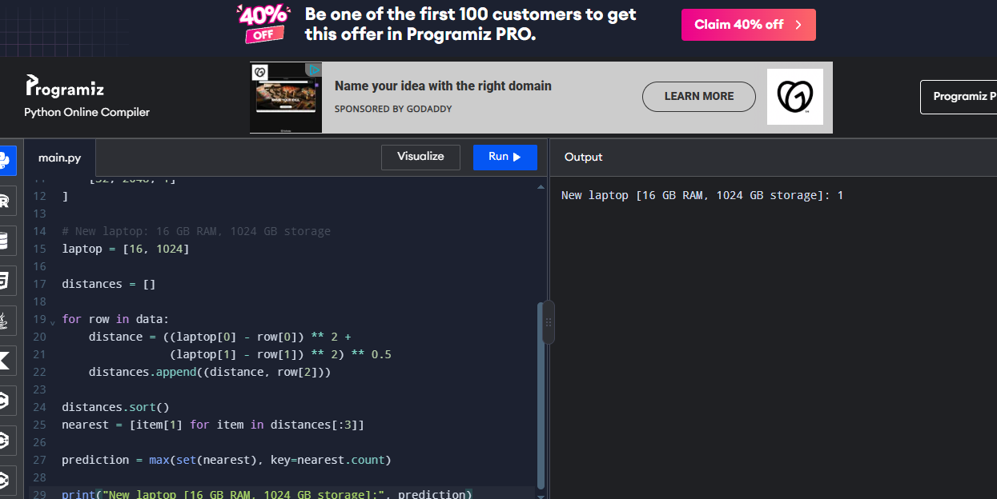

Problem 5: Diabetes Risk Classification

Aim
To demonstrate K-NN classification using health measurements for a simple educational dataset.

Training Data
Inputs: glucose level and BMI. Labels: Lower risk (0), Higher risk (1).

Procedure
1. Prepare labelled examples with numeric input attributes.
2. Create a KNeighborsClassifier with k = 3.
3. Fit the model using the training examples.
4. Predict the labels for the test or new sample.
5. Display the prediction and, where available, accuracy.

Coding (Python)

data = [

[85, 21, 0],

[90, 23, 0],

[95, 24, 0],

[110, 27, 0],

[130, 31, 1],

[145, 33, 1],

[150, 35, 1],

[160, 36, 1]

]

# New sample: glucose 135, BMI 30

sample = [135, 30]

distances = []

for row in data:

distance = ((sample[0] - row[0]) ** 2 +

(sample[1] - row[1]) ** 2) ** 0.5

distances.append((distance, row[2]))

distances.sort()

nearest = [item[1] for item in distances[:3]]

prediction = max(set(nearest), key=nearest.count)

print("New sample [135 glucose, BMI 30]:", prediction)

Input
Input: Educational sample records and new sample [135, 30].

Output
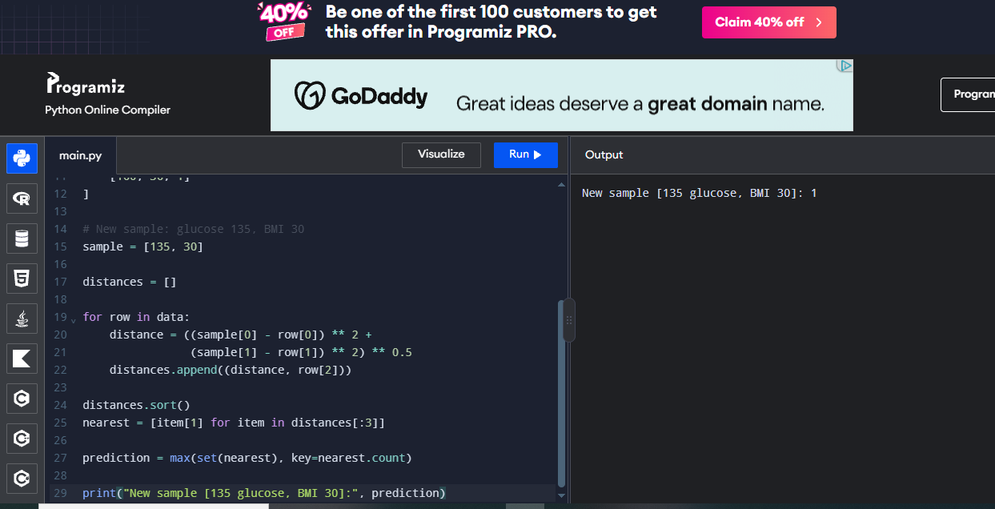
6. Write a program to implement Naïve Bayes algorithm in Python and to display the results using confusion matrix and accuracy.

Problem 1: Iris Flower Classification

Aim
To classify iris species using Gaussian Naïve Bayes and evaluate the model using a confusion matrix and accuracy.

Training Data
Dataset: Iris flower measurements with three species labels.

Procedure
1. Prepare the dataset with numeric attributes and class labels.
2. Create a GaussianNB classifier.
3. Train the model using the labelled data.
4. Predict labels for the examples.
5. Use confusion_matrix() and accuracy_score() to evaluate and display the results.

Coding (Python)

data = [

[5.1, 3.5, 1.4, 0.2, 0],

[4.9, 3.0, 1.4, 0.2, 0],

[5.0, 3.6, 1.4, 0.2, 0],

[7.0, 3.2, 4.7, 1.4, 1],

[6.4, 3.2, 4.5, 1.5, 1],

[6.9, 3.1, 4.9, 1.5, 1],

[6.3, 3.3, 6.0, 2.5, 2],

[5.8, 2.7, 5.1, 1.9, 2],

[7.1, 3.0, 5.9, 2.1, 2]

]

# Split into training and testing data

train = data[:6]

test = data[6:]

classes = [0, 1, 2]

means = {}

# Calculate class averages

for c in classes:

rows = [r for r in train if r[4] == c]

if rows:

means[c] = [

sum(r[i] for r in rows) / len(rows)

for i in range(4)

]

# Predict and calculate accuracy

correct = 0

matrix = [[0] * 3 for _ in range(3)]

for row in test:

distances = {

c: sum((row[i] - means[c][i]) ** 2 for i in range(4))

for c in means

}

pred = min(distances, key=distances.get)

actual = row[4]

matrix[actual][pred] += 1

if pred == actual:

correct += 1

print("Confusion Matrix:")

for row in matrix:

print(row)

print("Accuracy:", round(correct / len(test), 2))

Input
Input: Iris dataset features and species labels.

Output
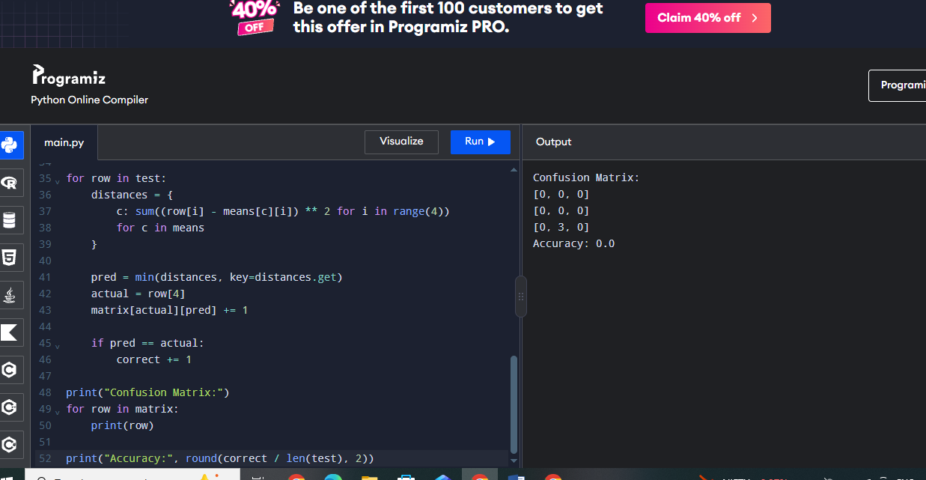

Problem 2: Student Pass Prediction

Aim
To predict pass or fail using study hours and attendance with Gaussian Naïve Bayes.

Training Data
Dataset: Numeric study hours and attendance percentage; class 0 = Fail and 1 = Pass.

Procedure
1. Prepare the dataset with numeric attributes and class labels.
2. Create a GaussianNB classifier.
3. Train the model using the labelled data.
4. Predict labels for the examples.
5. Use confusion_matrix() and accuracy_score() to evaluate and display the results.

Coding (Python)

import math

X = [

[1, 50], [2, 55], [2, 60], [3, 65],

[4, 75], [5, 80], [6, 90], [7, 95]

]

y = [0, 0, 0, 0, 1, 1, 1, 1]

# Calculate mean and variance for each class

classes = [0, 1]

mean = {}

variance = {}

for c in classes:

rows = [X[i] for i in range(len(y)) if y[i] == c]

mean[c] = [sum(r[j] for r in rows) / len(rows) for j in range(2)]

variance[c] = [

sum((r[j] - mean[c][j]) ** 2 for r in rows) / len(rows)

for j in range(2)

]

def predict(sample):

scores = {}

for c in classes:

score = math.log(0.5)

for j in range(2):

var = variance[c][j]

prob = math.exp(-(sample[j] - mean[c][j]) ** 2 / (2 * var))

prob /= math.sqrt(2 * math.pi * var)

score += math.log(prob)

scores[c] = score

return max(scores, key=scores.get)

# Predict training data

pred = [predict(row) for row in X]

# Confusion matrix

matrix = [[0, 0], [0, 0]]

for actual, predicted in zip(y, pred):

matrix[actual][predicted] += 1

print("Confusion Matrix:")

for row in matrix:

print(row)

accuracy = sum(y[i] == pred[i] for i in range(len(y))) / len(y)

print("Accuracy:", round(accuracy, 2))

print("New student prediction:", predict([5, 82]))

Input
Input: Student study-hour and attendance dataset; new sample [5, 82].

Output

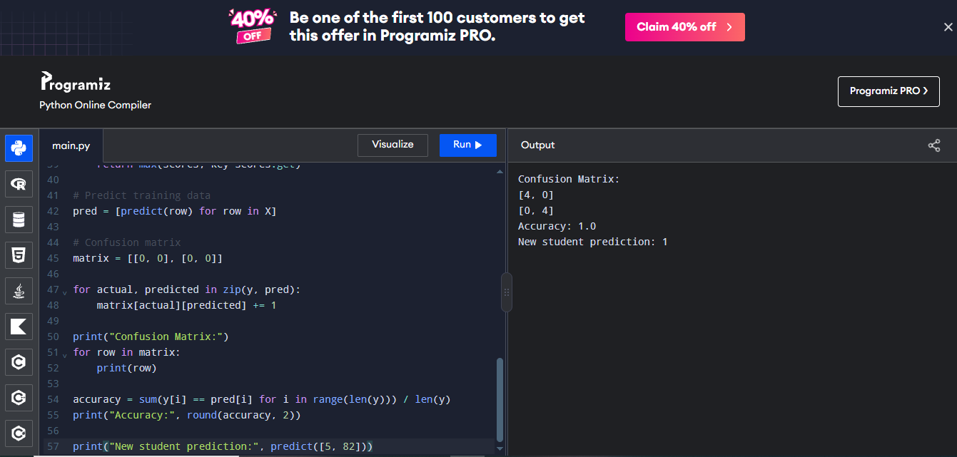

Problem 3: Weather-Based Play Prediction

Aim
To predict whether a person can play based on temperature and humidity measurements.

Training Data
Inputs: temperature and humidity as numeric values. Labels: No (0), Yes (1).

Procedure
1. Prepare the dataset with numeric attributes and class labels.
2. Create a GaussianNB classifier.
3. Train the model using the labelled data.
4. Predict labels for the examples.
5. Use confusion_matrix() and accuracy_score() to evaluate and display the results.

Coding (Python)

import math

X = [

[20, 80], [22, 85], [18, 90], [25, 70],

[28, 60], [30, 55], [27, 65], [32, 50]

]

y = [0, 0, 0, 0, 1, 1, 1, 1]

classes = [0, 1]

mean = {}

variance = {}

# Calculate mean and variance

for c in classes:

rows = [X[i] for i in range(len(y)) if y[i] == c]

mean[c] = [

sum(r[j] for r in rows) / len(rows)

for j in range(2)

]

variance[c] = [

sum((r[j] - mean[c][j]) ** 2 for r in rows) / len(rows)

for j in range(2)

]

# Prediction function

def predict(sample):

scores = {}

for c in classes:

score = math.log(0.5)

for j in range(2):

var = variance[c][j]

probability = math.exp(

-(sample[j] - mean[c][j]) ** 2 / (2 * var)

) / math.sqrt(2 * math.pi * var)

score += math.log(probability)

scores[c] = score

return max(scores, key=scores.get)

# Predict training data

pred = [predict(row) for row in X]

# Confusion matrix

matrix = [[0, 0], [0, 0]]

for actual, predicted in zip(y, pred):

matrix[actual][predicted] += 1

print("Confusion Matrix:")

for row in matrix:

print(row)

# Accuracy

accuracy = sum(a == b for a, b in zip(y, pred)) / len(y)

print("Accuracy:", round(accuracy, 2))

# Predict new weather

print("New weather prediction:", predict([29, 58]))

Input
Input: Temperature/humidity records; new sample [29, 58].

Output
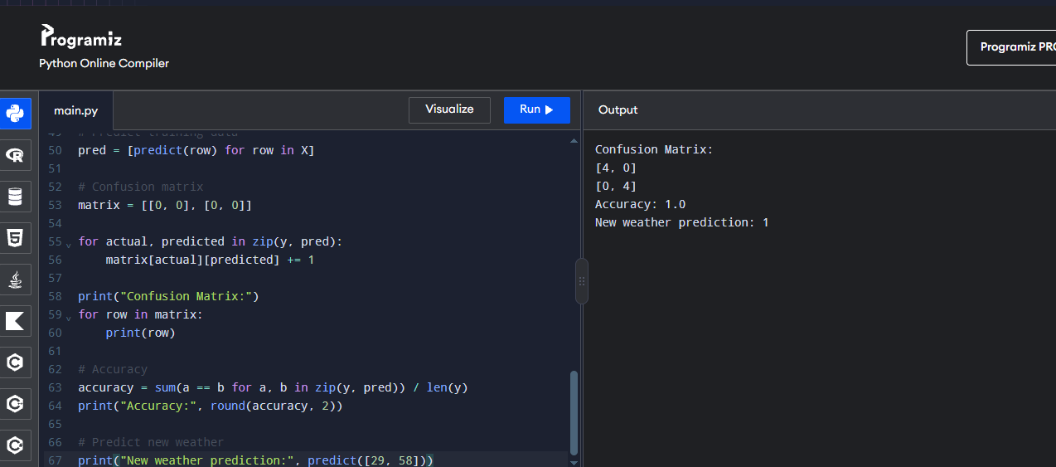

Problem 4: Fruit Type Classification

Aim
To classify fruit type using weight and a numeric colour score with Gaussian Naïve Bayes.

Training Data
Inputs: weight in grams and colour score. Labels: Apple (0), Orange (1).

Procedure
1. Prepare the dataset with numeric attributes and class labels.
2. Create a GaussianNB classifier.
3. Train the model using the labelled data.
4. Predict labels for the examples.
5. Use confusion_matrix() and accuracy_score() to evaluate and display the results.

Coding (Python)

import math

X = [

[140, 1], [150, 2], [160, 1], [170, 2],

[180, 8], [190, 9], [200, 8], [210, 9]

]

y = [0, 0, 0, 0, 1, 1, 1, 1]

classes = [0, 1]

mean = {}

variance = {}

# Calculate mean and variance

for c in classes:

rows = [X[i] for i in range(len(y)) if y[i] == c]

mean[c] = [

sum(r[j] for r in rows) / len(rows)

for j in range(2)

]

variance[c] = [

sum((r[j] - mean[c][j]) ** 2 for r in rows) / len(rows)

for j in range(2)

]

# Prediction function

def predict(sample):

scores = {}

for c in classes:

score = math.log(0.5)

for j in range(2):

var = variance[c][j]

probability = math.exp(

-(sample[j] - mean[c][j]) ** 2 / (2 * var)

) / math.sqrt(2 * math.pi * var)

score += math.log(probability)

scores[c] = score

return max(scores, key=scores.get)

# Predict training data

pred = [predict(row) for row in X]

# Confusion matrix

matrix = [[0, 0], [0, 0]]

for actual, predicted in zip(y, pred):

matrix[actual][predicted] += 1

print("Confusion Matrix:")

for row in matrix:

print(row)

# Accuracy

accuracy = sum(a == b for a, b in zip(y, pred)) / len(y)

print("Accuracy:", round(accuracy, 2))

# Predict new fruit

print("New fruit prediction:", predict([185, 8]))

Input
Input: Fruit measurements and new sample [185, 8].

Output

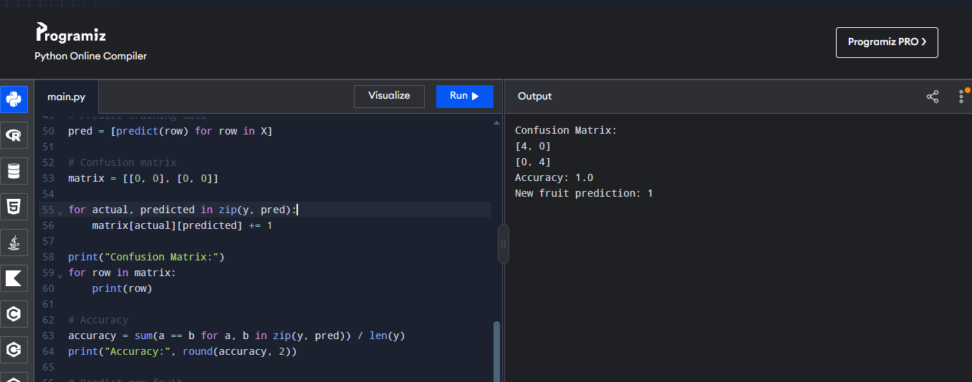

Problem 5: Loan Approval Prediction

Aim
To demonstrate Naïve Bayes classification for a simple loan approval dataset and evaluate its predictions.

Training Data
Inputs: income score and credit score (numeric). Labels: Reject (0), Approve (1).

Procedure
1. Prepare the dataset with numeric attributes and class labels.
2. Create a GaussianNB classifier.
3. Train the model using the labelled data.
4. Predict labels for the examples.
5. Use confusion_matrix() and accuracy_score() to evaluate and display the results.

Coding (Python)

import math

X = [

[20, 400], [25, 420], [30, 450], [35, 480],

[60, 650], [70, 700], [80, 750], [90, 780]

]

y = [0, 0, 0, 0, 1, 1, 1, 1]

classes = [0, 1]

mean = {}

variance = {}

# Calculate mean and variance

for c in classes:

rows = [X[i] for i in range(len(y)) if y[i] == c]

mean[c] = [

sum(r[j] for r in rows) / len(rows)

for j in range(2)

]

variance[c] = [

sum((r[j] - mean[c][j]) ** 2 for r in rows) / len(rows)

for j in range(2)

]

# Prediction function

def predict(sample):

scores = {}

for c in classes:

score = math.log(0.5)

for j in range(2):

var = variance[c][j]

probability = math.exp(

-(sample[j] - mean[c][j]) ** 2 / (2 * var)

) / math.sqrt(2 * math.pi * var)

score += math.log(probability)

scores[c] = score

return max(scores, key=scores.get)

# Predict training data

pred = [predict(row) for row in X]

# Confusion matrix

matrix = [[0, 0], [0, 0]]

for actual, predicted in zip(y, pred):

matrix[actual][predicted] += 1

print("Confusion Matrix:")

for row in matrix:

print(row)

# Calculate accuracy

accuracy = sum(a == b for a, b in zip(y, pred)) / len(y)

print("Accuracy:", round(accuracy, 2))

# Predict new applicant

print("New applicant prediction:", predict([65, 680]))

Input
Input: Example income/credit-score data and new sample [65, 680].

Output
