**1. In the below elements which of them are values or an expression? eg:- values can be integer or string and expressions will be mathematical operators.**

**\***

**'hello'**

**-87.8**

**-**

**/**

**6**

**Ans:** Expressions: *, -, /, +

Values: ’hello’, -87.8, 6

**2. What is the difference between string and variable?**

**Ans:** A variable is actually the name of the location in the primary memory of your computer. A variable can store everything from strings to numbers. A string is the values inside the single or double quotes.

X = ”hello”

Here, X is variable and “hello” is string.

**3. Describe three different data types.**

**Ans:** Int data type: this data type is used to represent positive or negative whole numbers (integral values) eg:4521

Float data type: this data type is used to represent decimal values like point values eg:2.51

Complex data type: this data type is used to represent complex values like A+Bi, where A is real part and Bi is imaginary part.eg:1+2i

**4. What is an expression made up of? What do all expressions do?**

**Ans:** An expression is made up of values, variables, mathematical operators that is used to evaluate or produce other values or the results.eg: 4+5=9

**5. This assignment statements, like spam = 10. What is the difference between an expression and a statement?**

**Ans:** An expression is made up of values, variables, mathematical operators and statement is like a command that python interpreter executes like print.

Eg: 3+4*2, is expression

X=’welcome to python programming’ ,is a statement

**6. After running the following code, what does the variable bacon contain?**

**bacon = 22**

**bacon + 1**

**Ans:** After the running the code, the variable bacon contains the value 23

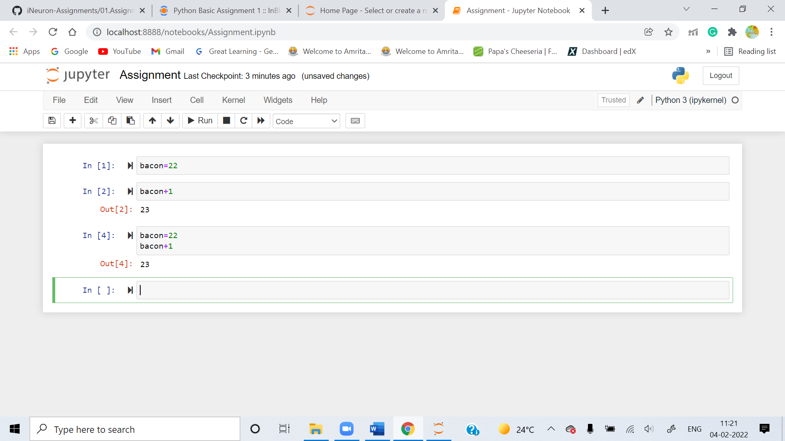

**7. What should the values of the following two terms be?**

**'spam' + 'spamspam'**

**'spam' * 3**

**Ans:** The values of the two terms will be same

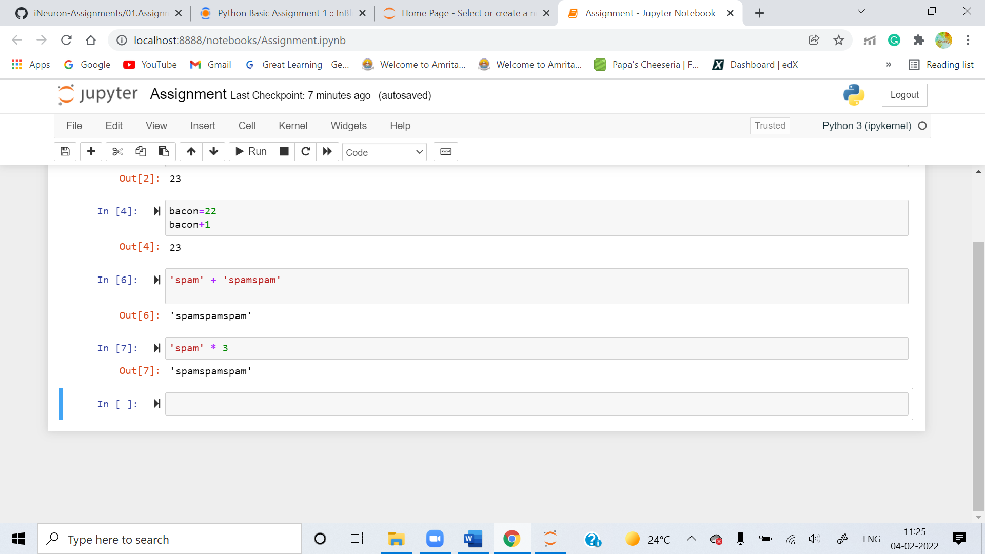

**8. Why is eggs a valid variable name while 100 is invalid?**

**Ans:** Because variable names cannot begin with a number, it can only begin with letters or underscore. Variable is also case-sensitive.

Therefore, egg=”hi” (Valid)

100=”hi”(Invalid)

**9. What three functions can be used to get the integer, floating-point number, or string version of a value?**

**Ans:** The int(), float() and str() are the functions used to get integer, floating-point number, or string version of a value.

**10. Why does this expression cause an error? How can you fix it?**

**'I have eaten ' + 99 + ' burritos.'**

**Ans:** The cause of an error is that 99 is an integer it cannot be concatenated with strings, we need to do typecasting i.e., ‘I have eaten ‘ + str(99) + ’burritos.’