1. What is the result of the code, and explain?

**>>> X = 'iNeuron'**

**>>> def func():**

**print(X)**

**>>> func()**

**Ans:** 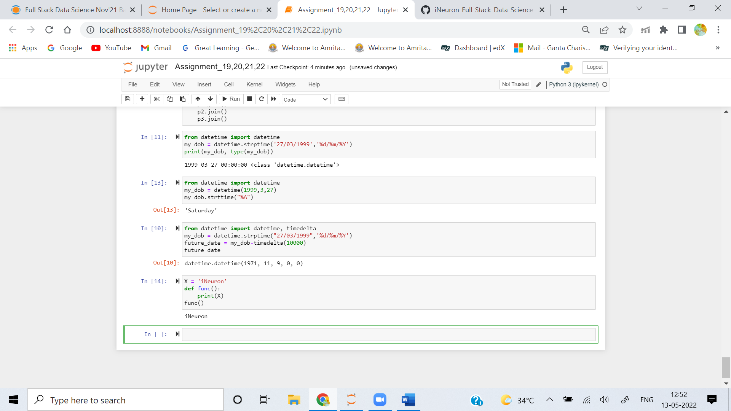

The Result of this code is iNeuron, it's because the function intially looks for the variable X in its local scope,But since there is no local variable X, its returns the value of global variable x ie iNeuron

**2. What is the result of the code, and explain?**

**>>> X = 'iNeuron'**

**>>> def func():**

**X = 'NI!'**

**>>> func()**

**>>> print(X)**

**Ans:**

The Result of this cide is NI!, because the function initially looks for the variable X in its local scope if X is not available then it checks for variable X in the global scope, Since here the X is present in the local scope. it prints the value NI!

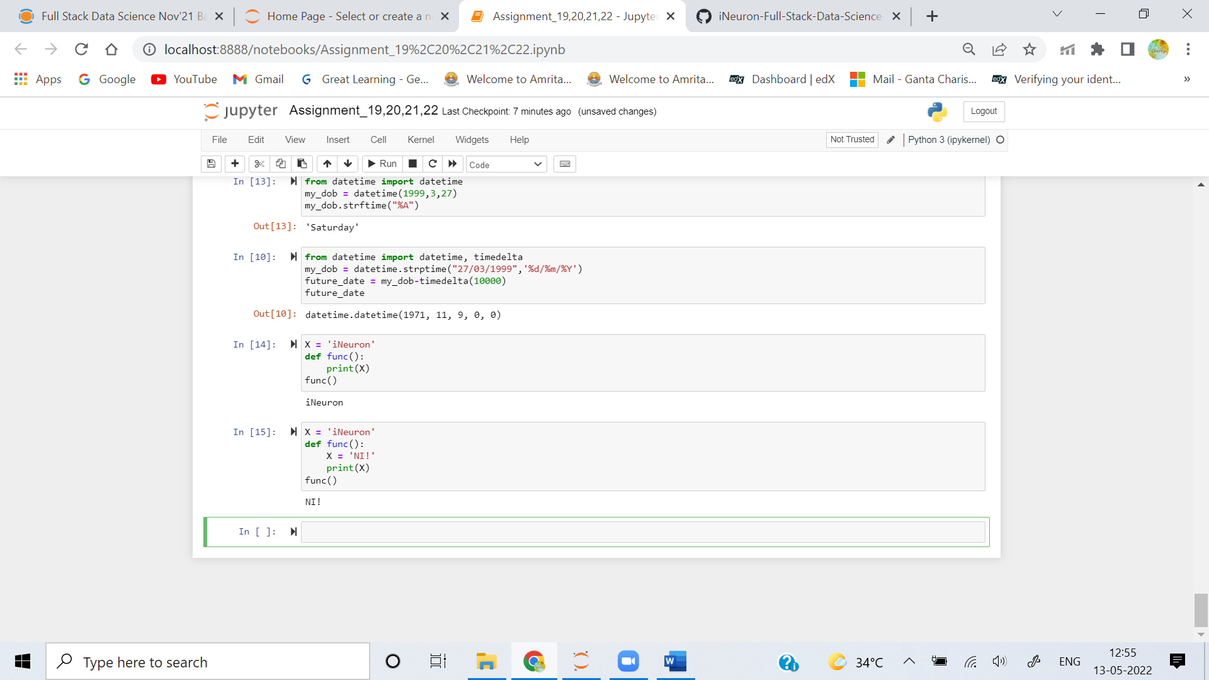

**3. What does this code print, and why?**

**>>> X = 'iNeuron'**

**>>> def func():**

**X = 'NI'**

**print(X)**

**>>> func()**

**>>> print(X)**

**Ans:**

The output of the code is NI and iNeuron. X=NI is in the local scope of the function func() hence

the function prints the x value as NI. X = 'iNeuron' is in the global scope. hence print(X) prints output as iNeuron

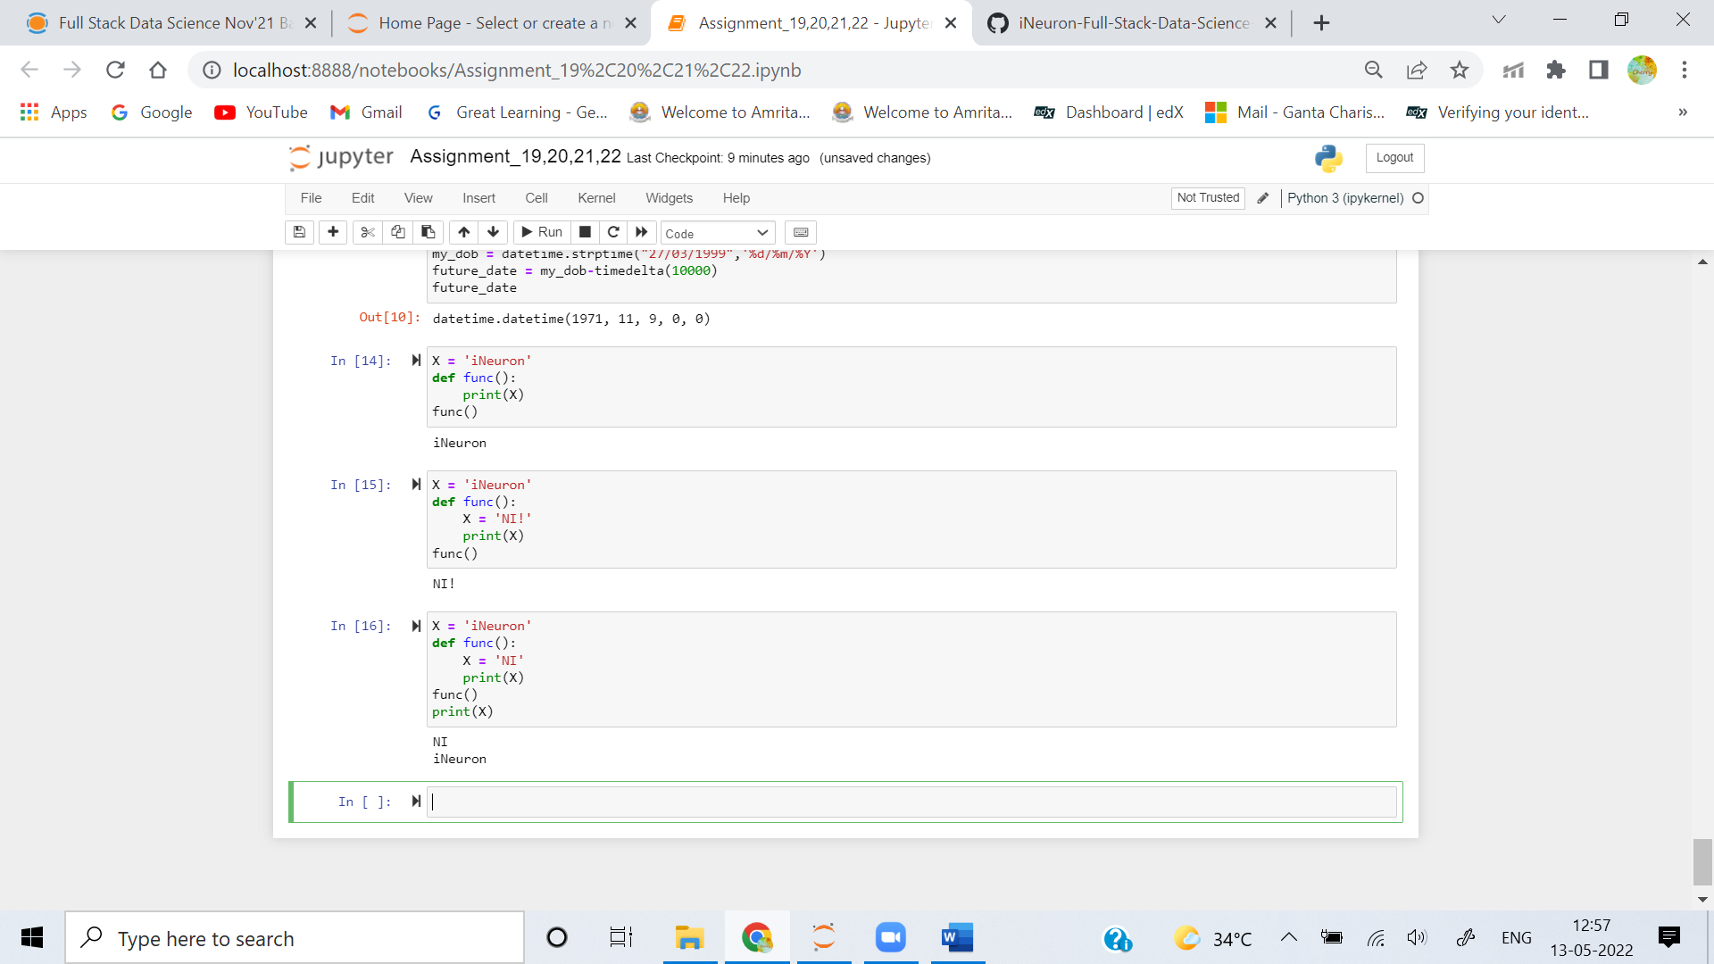

**4. What output does this code produce? Why?**

**>>> X = 'iNeuron'**

**>>> def func():**

**global X**

**X = 'NI'**

**>>> func()**

**>>> print(X)**

**Ans:** 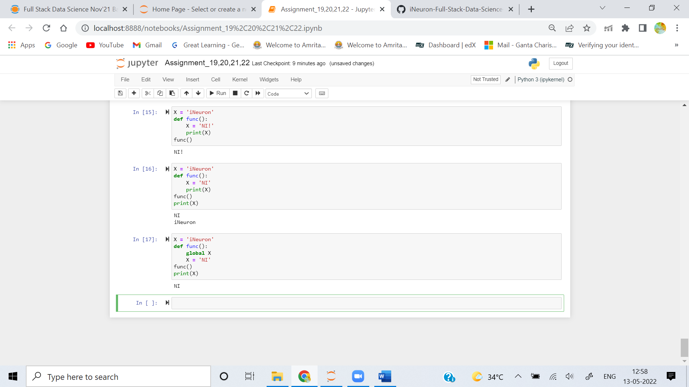

The output of the code is NI. the global keyword allows a variable to be accessible in the current scope. since we are using global keyword inside the function func it directly access the variable in X in global scope. and changes its value to NI. hence the output of the code is NI

**5. What about this code—what’s the output, and why?**

**>>> X = 'iNeuron'**

**>>> def func():**

**X = 'NI'**

**def nested():**

**print(X)**

**nested()**

**>>> func()**

**>>> X**

**Ans:** The output of the code is NI. the reason for this output is if a function wants to access a

variable, if its not available in its localscope. it looks for the variable in its global scope. similarly here also function nested looks for variable X in its global scope. hence the output of the code is NI

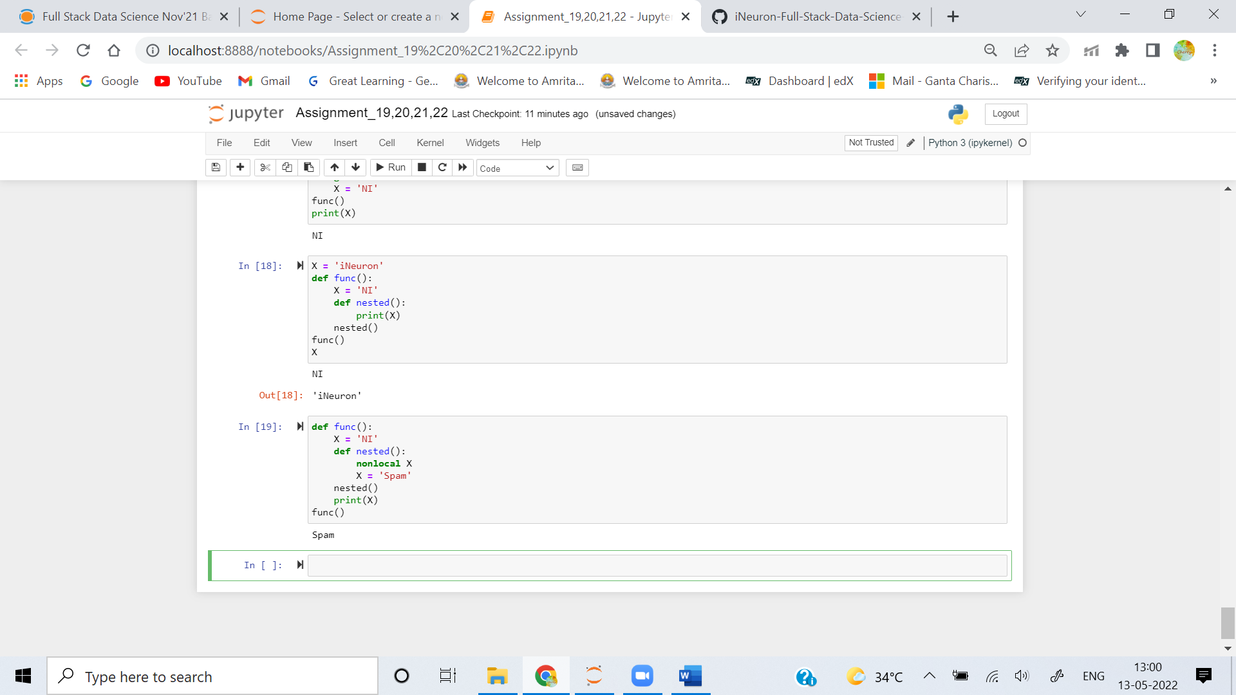

**6. How about this code: what is its output in Python 3, and explain?**

**>>> def func():**

**X = 'NI'**

**def nested():**

**nonlocal X**

**X = 'Spam'**

**nested()**

**print(X)**

**>>> func()**

**Ans:** The output of the code is Spam. nonlocal keyword in python is used to declare a variable as not local.Hence the statement X = "Spam" is modified in the global scope. hence the output of print(X) statement is Spam

