**1. What is the result of the code, and why?**

**>>> def func(a, b=6, c=8):**

**print(a, b, c)**

**>>> func(1, 2)**

**Ans:** The result of the above code is 1 2 8. its because the function uses the default value of c ie 8 which is provided at the time of declaration.

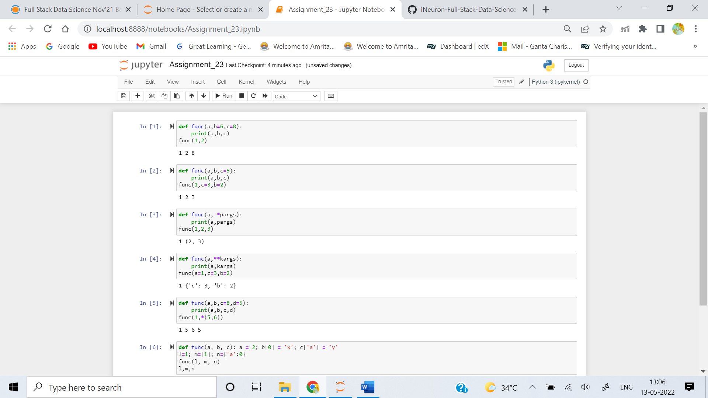

**2. What is the result of this code, and why?**

**>>> def func(a, b, c=5):**

**print(a, b, c)**

**>>> func(1, c=3, b=2)**

**Ans:** The result of the above code is 1 2 3. it is because the function will use default values only when a value for a argument is not provided and if argument name is mentioned while doing a function call, the order of arguments is also ignored by the python interpreter



**3. How about this code: what is its result, and why?**

**>>> def func(a, *pargs):**

**print(a, pargs)**

**>>> func(1, 2, 3)**

**Ans:** The result of the code is 1 (2,3). *pargs stands for variable length arguments. this format is used when we are not sure about the no of arguments to be passed to a function. all the values under this argument will be stored in a tuple.



**4. What does this code print, and why?**

**>>> def func(a, **kargs):**

**print(a, kargs)**

**>>> func(a=1, c=3, b=2)**

**Ans:** The result of the above code is 1 {'c': 3, 'b': 2}. **args stands for variable length keyword arguments. this format is used when we want pass key value pairs as input to a function. All these key value pairs will be stored in a dictionary



**5. What gets printed by this, and explain?**

**>>> def func(a, b, c=8, d=5): print(a, b, c, d)**

**>>> func(1, *(5, 6))**

**Ans:** The output of the above is 1 5 6 5. This reason for this function not throwing an error is because, this function expects 4 arguments. the value for a is provided explicitly whereas for arguments b and c, the function will expand the *(5,6) and consider the value of b as 5 and value of c as 6. since the default value of d is provided in function declaration d value will be 5. However it is recommended to use the feature of positional arguments at the end.



**6. what is the result of this, and explain?**

**>>> def func(a, b, c): a = 2; b[0] = 'x'; c['a'] = 'y'**

**>>> l=1; m=[1]; n={'a':0}**

**>>> func(l, m, n)**

**>>> l, m, n**

**Ans:** The output of above code is 1, ['x'], {'a': 'y'}.

1. Eventhough Python gives importance to indentation. its provides a facility to declare an entire function in one single line. where statements in a function body are sepereated by ;
2. When l,m,n are provided as inputs to the function. its modifies the values of l,m,n and sets the value of l=2 ,m=['x'] and n={'a':'y'}

