**1. What is the relationship between def statements and lambda expressions ?**

**Ans:** def statement is used to create a normal function. where as lamba expressions are used to create Anonymous functions. which can be assigned to a variable and can be called using the variable later in function.

Lambda's body is a single expression and not a block of statements like def statement. The lambda expression's body is similar to what we'd put in a def body's return statement. We simply type the result as an expression instead of explicitly returning it. Because it is limited to an expression, a lambda is less general than a def statement.

**2. What is the benefit of lambda?**

**Ans:** The following are some of the benefits of lambda expressions:

1. Can be used to create Nameless/Anonymous functions inside some complex functions if we are planning to use it only once.
2. Moderate to small functions can be created in a single line
3. Fuctions created using lambda expressions can be assigned to a variable and can be used by simply calling the variable

**3. Compare and contrast map, filter, and reduce.**

**Ans:** The differences between map, filter and reduce are:

1. map(): The map() function is a type of higher-order. This function takes another function as a parameter along with a sequence of iterables and returns an output after applying the function to each iterable present in the sequence.
2. filter(): The filter() function is used to create an output list consisting of values for which the function returns true.
3. reduce(): The reduce() function, as the name describes, applies a given function to the iterables and returns a single value

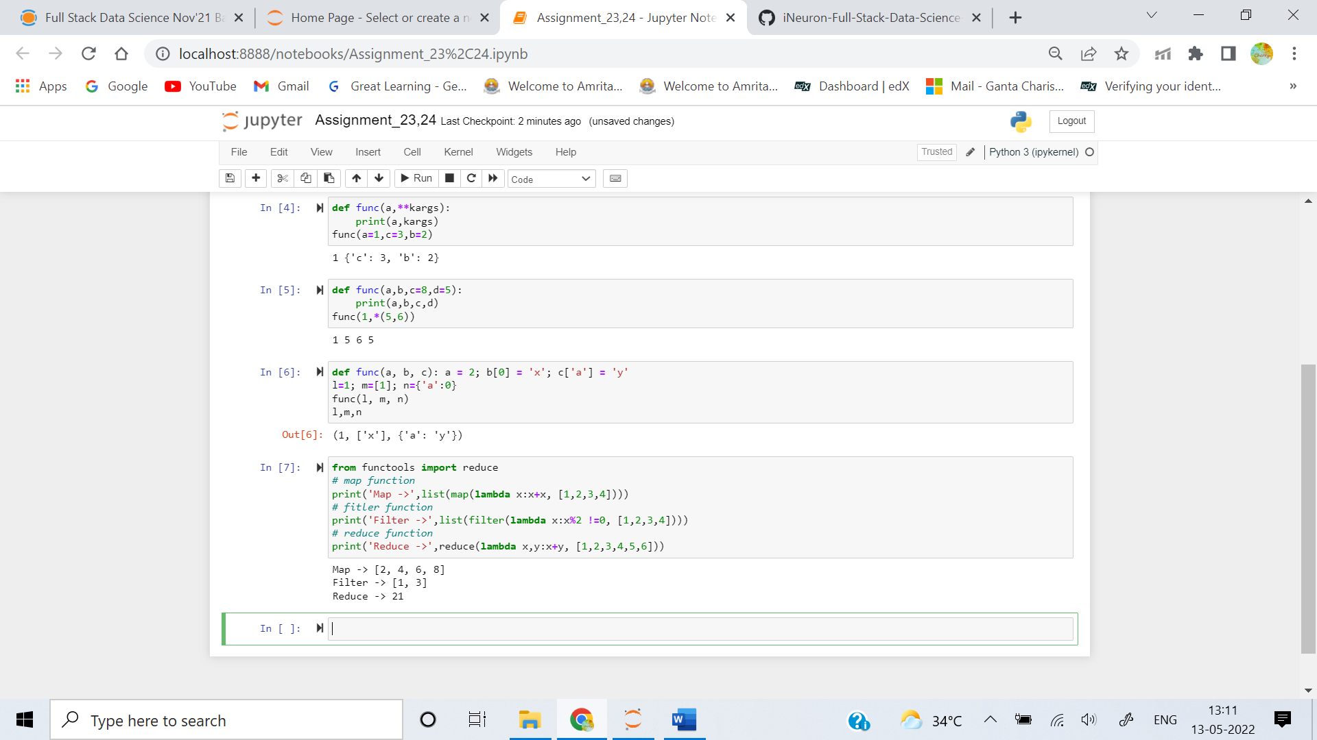

**4. What are function annotations, and how are they used?**

**Ans:** Function annotations provide a way of associating various parts of a function with arbitrary pythoncexpressions at compile time.  
Annotations of simple parameters def func(x: expression, y: expression = 20):  
Whereas the annotations for excess parameters are as − def func (**args: expression, **kwargs: expression):

**5. What are recursive functions, and how are they used?**

**Ans:** A recursive function is a function that calls itself during its execution. The process may repeat several times, outputting the result and the end of each iteration.

**6. What are some general design guidelines for coding functions?**

**Ans:**  Some of the general design guidelines for coding functions are:

1. Always use a docstring to explain the functionality of the function
2. avoid using or limited use of global variables
3. Proper Identation to increase the code readability
4. try to follow a naming convention for function names (pascalCase or camelCase) and stick with the same convention throughout the application.
5. Avoid using digits while choosing a variable name
6. try to use a name for the function which conveys the purpose of the function
7. Local variables should be named using camelCase format (ex: localVariable) whereas Global variables names should be using PascalCase (ex:GlobalVariable).
8. Constant should be represented in allcaps (ex:CONSTANT).

**7. Name three or more ways that functions can communicate results to a caller.**

**Ans:** Some of the ways in which a function can communicate with the calling function is:

1. print
2. return
3. yield