1. **What does an empty dictionary's code look like?**

**Ans:** An empty dictionary is often represented by two empty curly brackets  
d = {} or d = dict()

1. **What is the value of a dictionary value with the key 'foo' and the value 42?**

**Ans:{‘foo’:42}**

1. **What is the most significant distinction between a dictionary and a list?**

**Ans:** Dictionaries are represented by {} where as listed are represented by []  
The Items stored in a dictionary are Unordered , while the items in a list are ordered

1. **What happens if you try to access spam['foo'] if spam is {'bar': 100}?**

**Ans:** we will get a keyError KeyError: 'foo'

1. **If a dictionary is stored in spam, what is the difference between the expressions 'cat' in spam and 'cat' in spam.keys()?**

**Ans:** There is no difference . The operator checks whether a value exits as a key in the dictionary or not

1. **If a dictionary is stored in spam, what is the difference between the expressions 'cat' in spam and 'cat' in spam.values()?**

**Ans:** 'cat' in spam checks whether there is a 'cat' key in the dictionary, while 'cat' in spam.values() checks whether there is a value 'cat' for one of the keys in spam.

**7. What is a shortcut for the following code?**

**if 'color' not in spam:**

**spam['color'] = 'black'**

**Ans: spam.setdefault(‘color’, ‘black’)**

**8.How do you "pretty print" dictionary values using which module and function?**

**Ans:** we can pretty print a dictionary using three functions

1. [Use pprint() to Pretty Print a Dictionary in Python](https://www.delftstack.com/howto/python/python-pretty-print-dictionary/#use-pprint-to-pretty-print-a-dictionary-in-python)

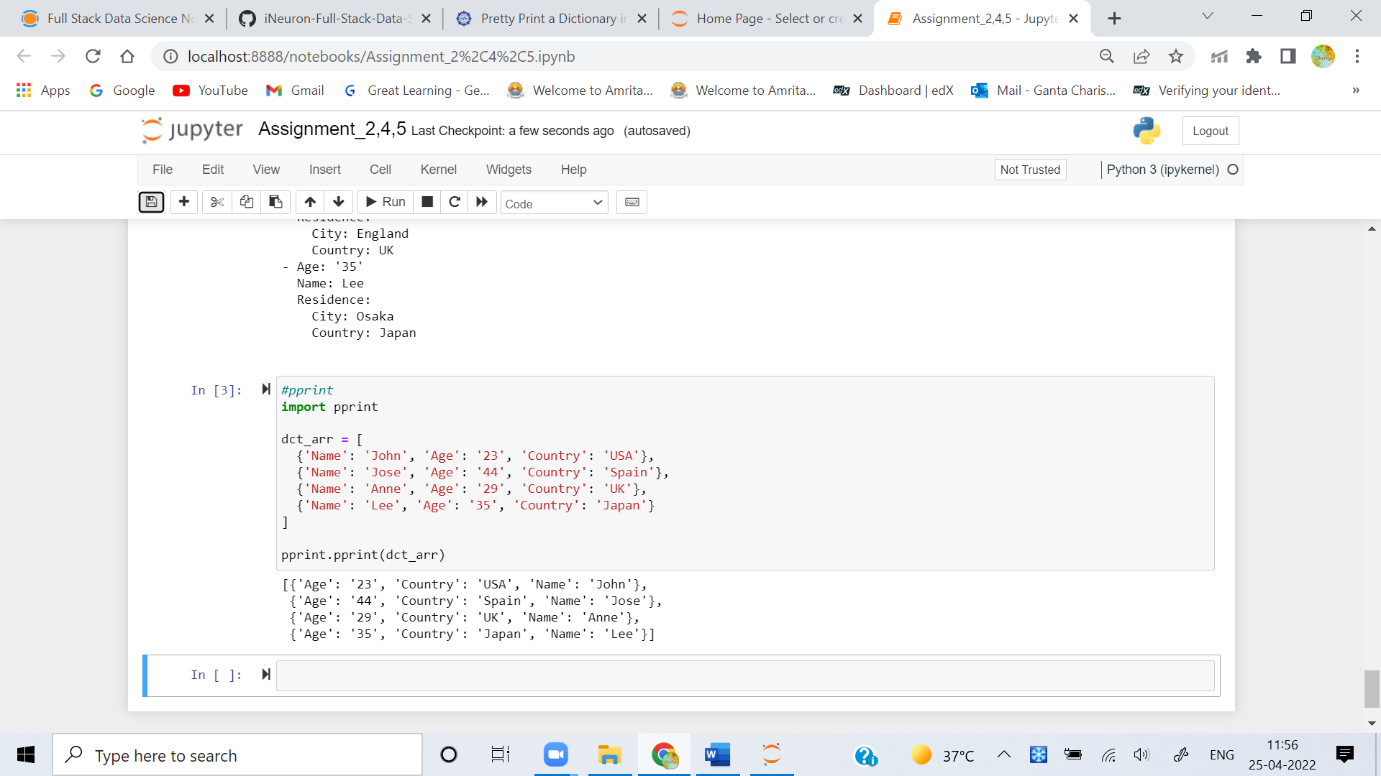

1. [Use json.dumps() to Pretty Print a Dictionary in Python](https://www.delftstack.com/howto/python/python-pretty-print-dictionary/#use-json.dumps-to-pretty-print-a-dictionary-in-python)

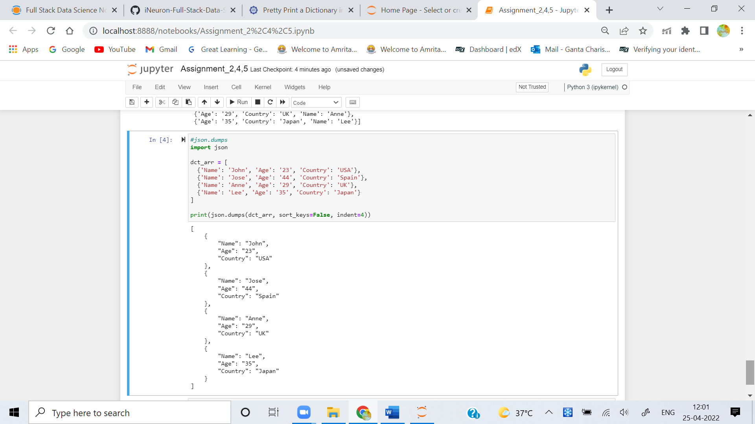

1. [Use yaml.dump() to Pretty Print a Dictionary in Python](https://www.delftstack.com/howto/python/python-pretty-print-dictionary/#use-yaml.dump-to-pretty-print-a-dictionary-in-python)

