Manually segment ‘multitube’-data

AIM: Several ex-vivo (skull-stripped) animal brains were acquired simultaneously in one image. Segment them manually to later perform template registration for each animal
=====================================================================================================
steps:
1. Manual segment images → draw masks
2. Split datasets using the multitube masks

Prerequisite
ANT GUI is started, project is loaded.
Example:
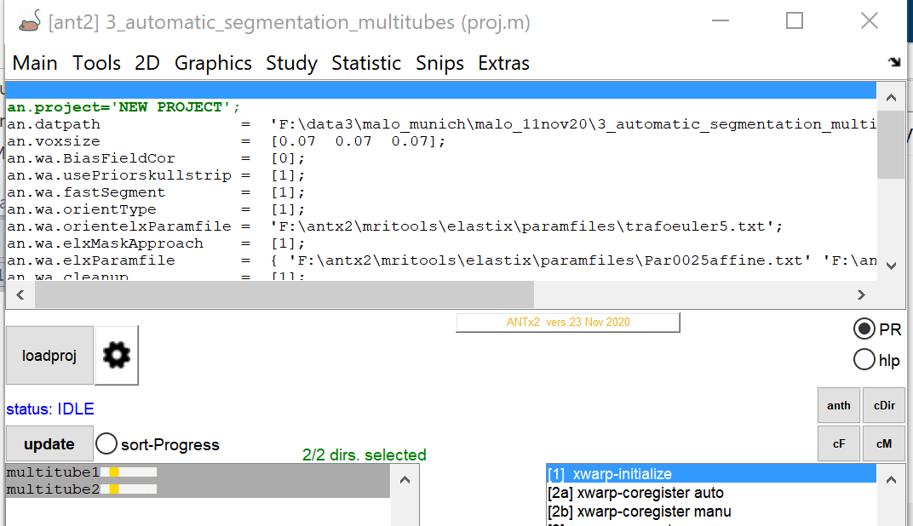
This example contains two datasets in the dat-folder: ‘multitube1’ and ‘multitube2’.
The folders ‘multitube1’ and ‘multitube2’ contain a t2-weighted image which is named ‘t0.nii’. Here I renamed the images to ‘t0.nii’ (via: ANT GUI: Tools/rename) to later use the ‘t2.nii’ filename for the segmented single animal images for template registration. The ‘t0.nii’ of ‘multitube2’ is a rotated copy of the ‘t0.nii’ of multitube1’.
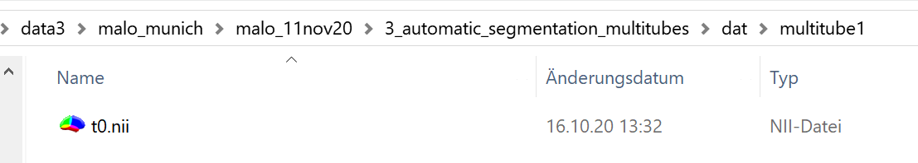
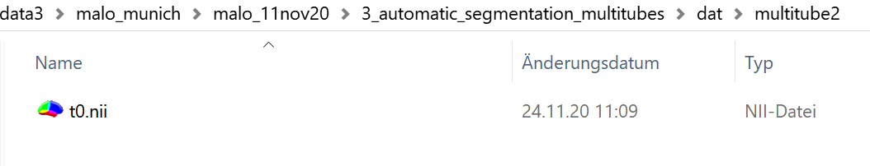
Fig: contents of the folders ‘multitube1’ and ‘multitube2’.
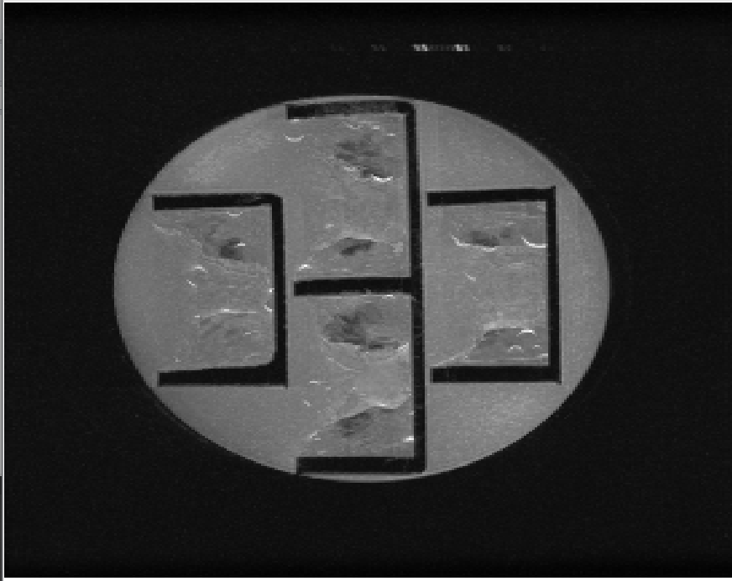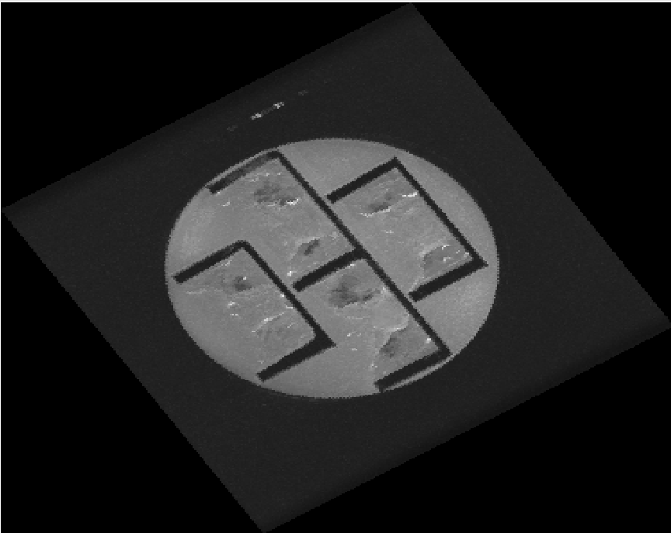
Fig: ‘t0.nii’ of ‘multitube1’ (left) and rotated version ‘t0.nii’ of ‘multitube2’ (right)

1. Manual segment images → draw masks
Select the mouse folders for manual segmentation from the left listbox. Here I selected the two mouse folders.
Go to: ANT GUI: Tools/[1b] segment tube manually)
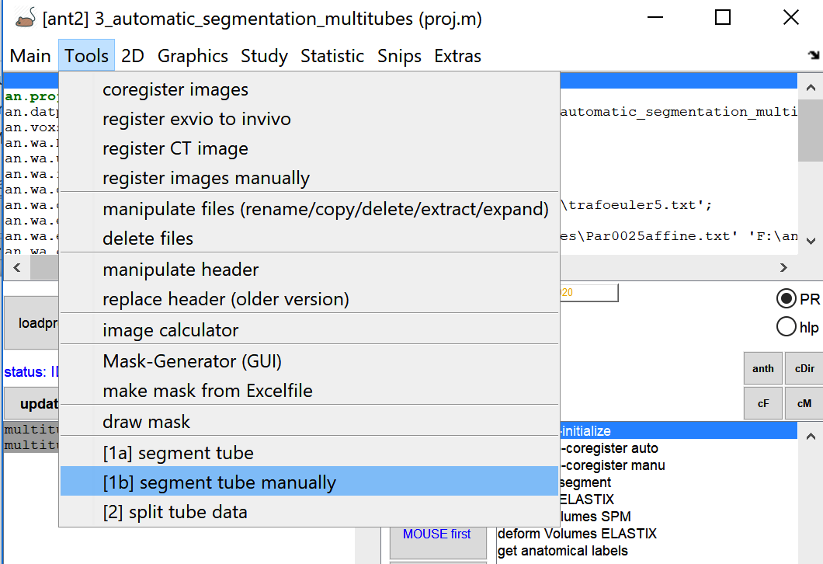

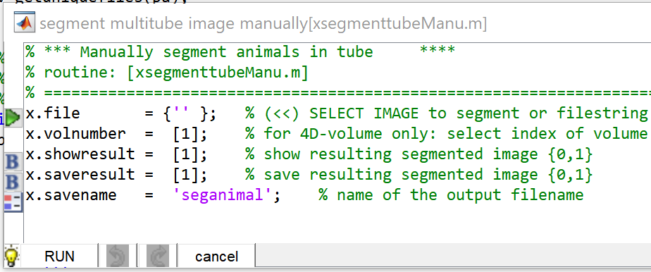
Click green icon left to ‘file’ and select the respective image (‘t0.nii’) to segment.
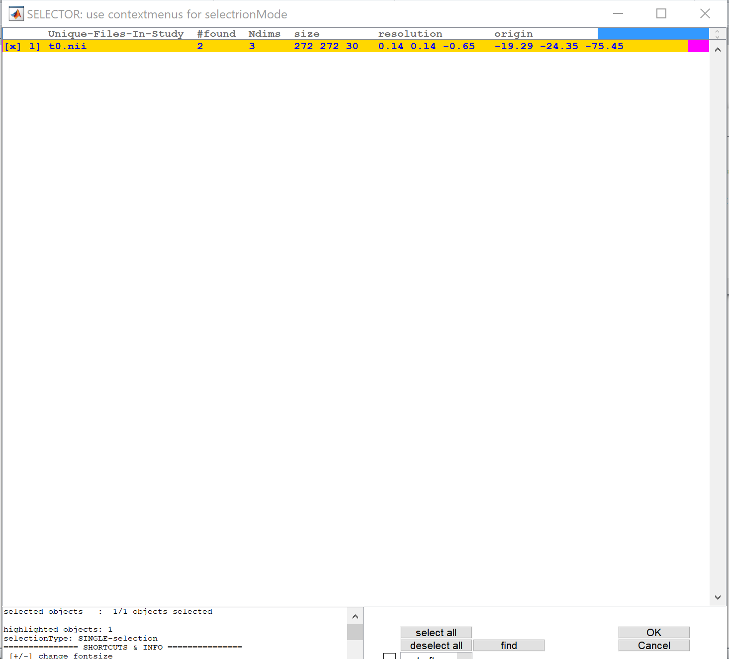
Hit [OK].
The parameter window now looks as follows:
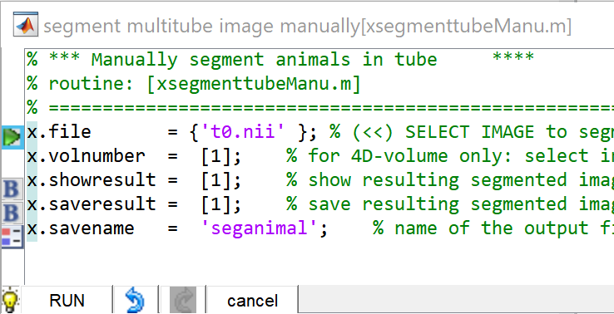
Hit [RUN].

Dataset: ‘multitube1’
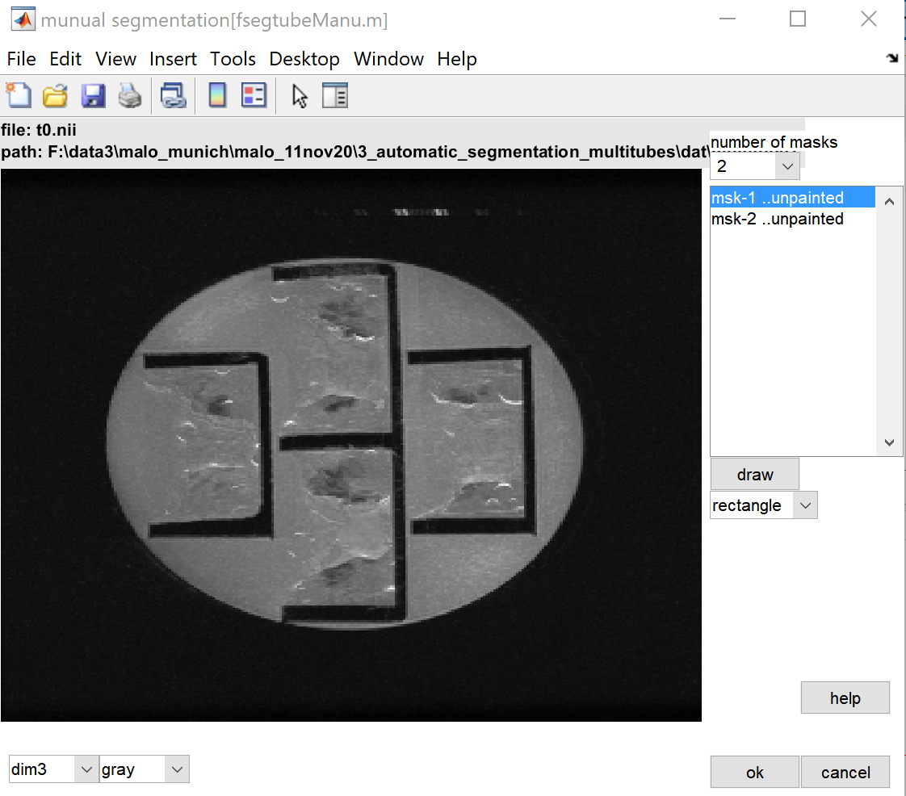
‘t0.nii’ of ‘multitube1’: First,check the optimal orientation for manual drawing via [dim] pull-down menu. The orientation [dim3] is fine. Here we have 4 animals, therefore select [4] in the [number of masks] pull-down menu. This will change the number of masked to be drawn in the right listbox.
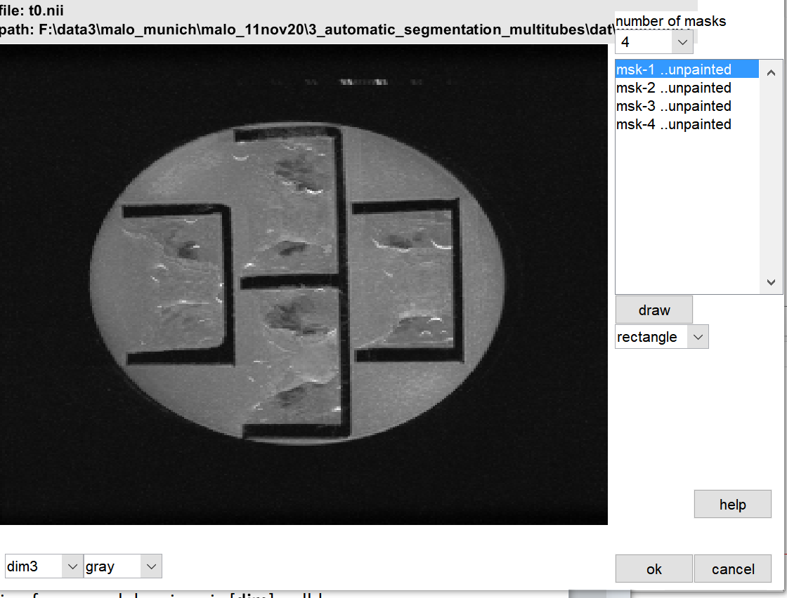
Now, select the first item (mask1) from right listbox. Select ‘rectangle’ from the drawing pull-down menu as drawing tool. Hit [draw] to draw the mask. Draw a rectangle onto the 1st animal data (best way: start clockwise).
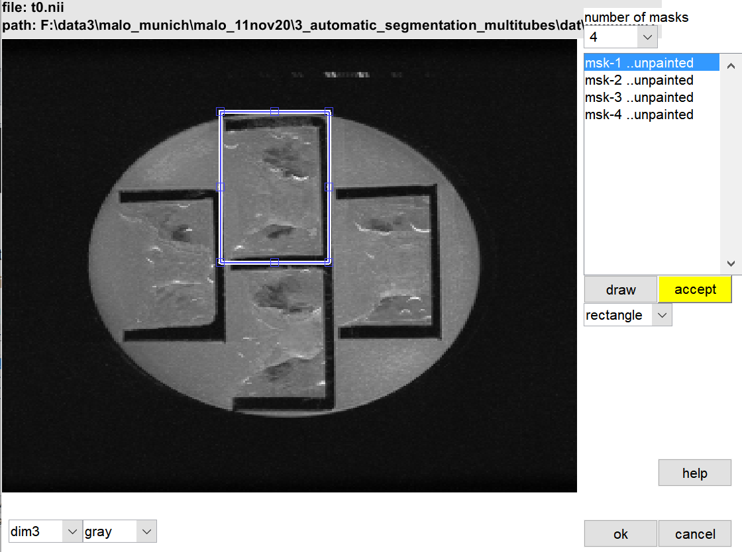
After drawing, you can change the size and the location of the rectangle. When drawing, the [accept]-button appears. Hit [accept]-button for 1st mask when the rectangle is well positioned.
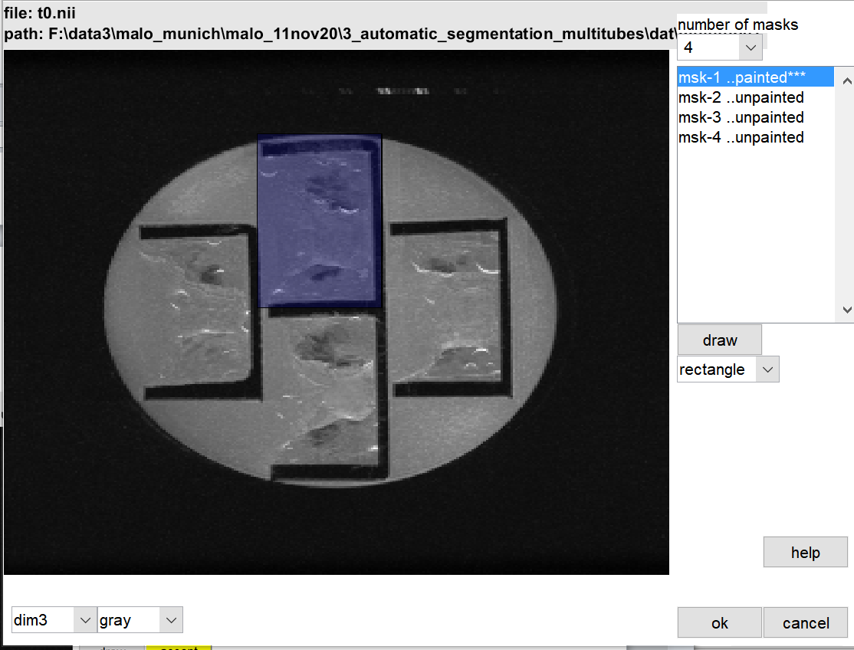
If the result is not satisfying just draw the mask again (via [draw]-button).To delete all masks select ‘delete all masks’ from listbox’s right context-menu. 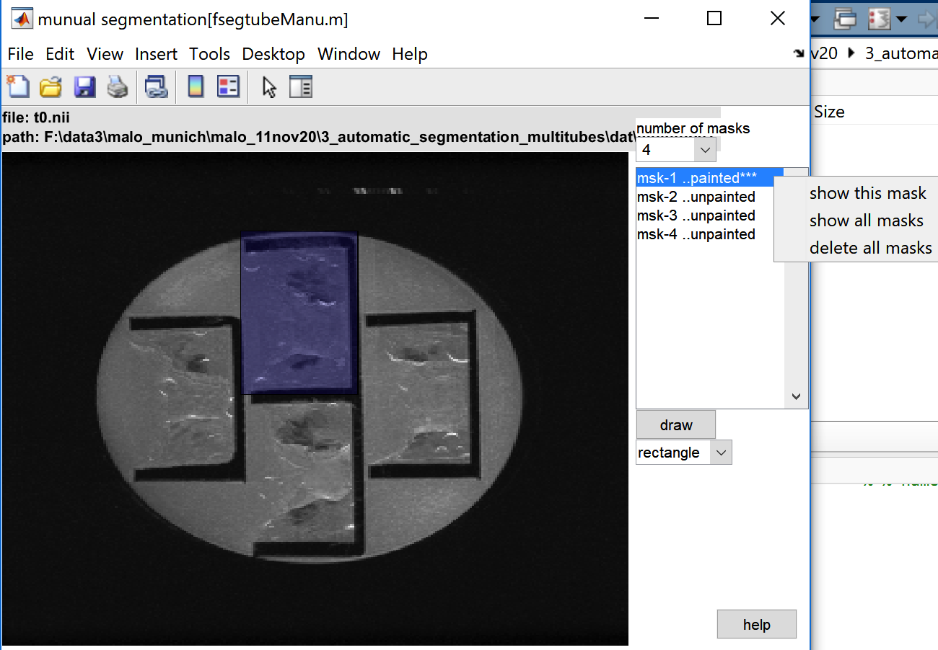
Draw the 2nd mask: select the 2nd item (mask2) from right listbox. Hit [draw]. Now draw a rectangle onto the 2nd animal data (best way: follow clockwise orientation). When finished click [accept]-button.
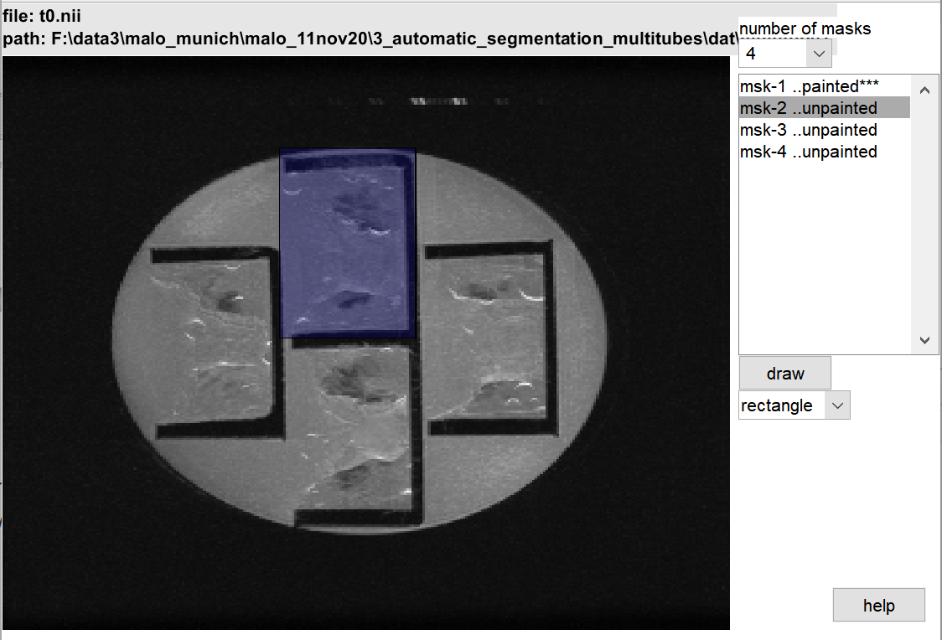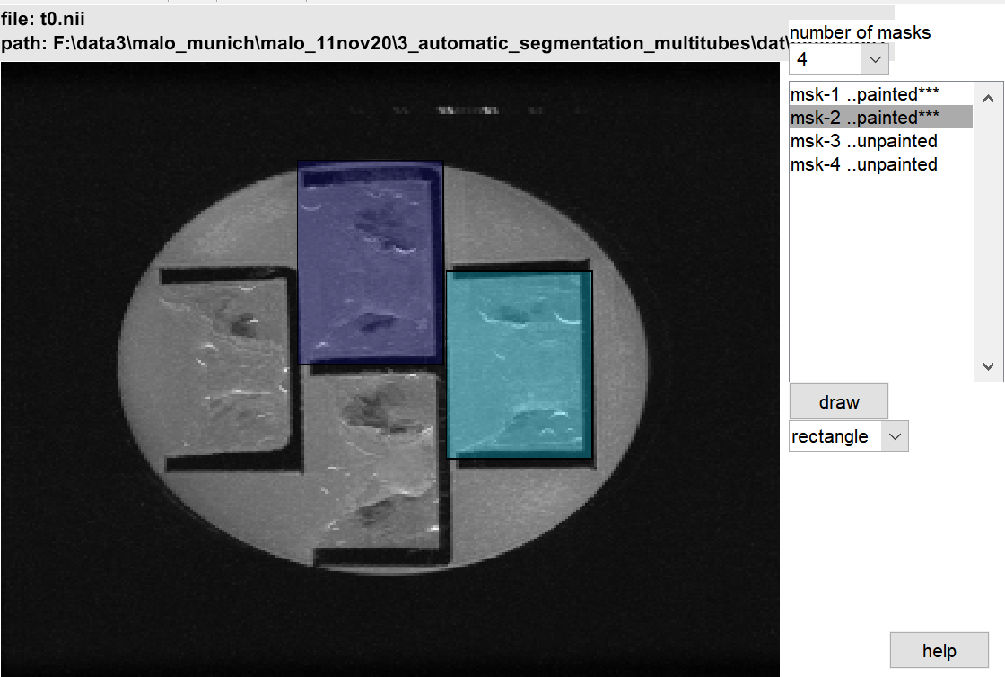
Do this steps for 3rd and 4th animal data:
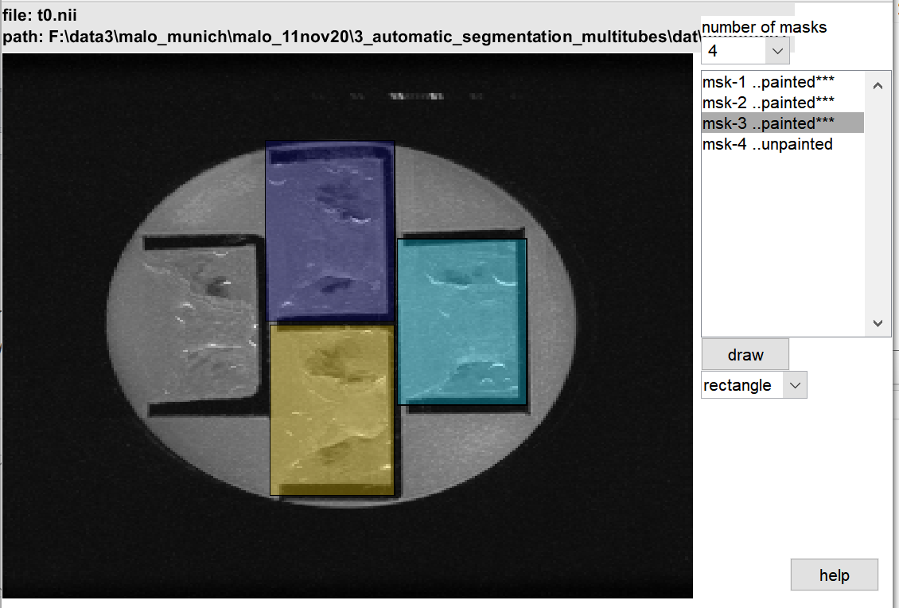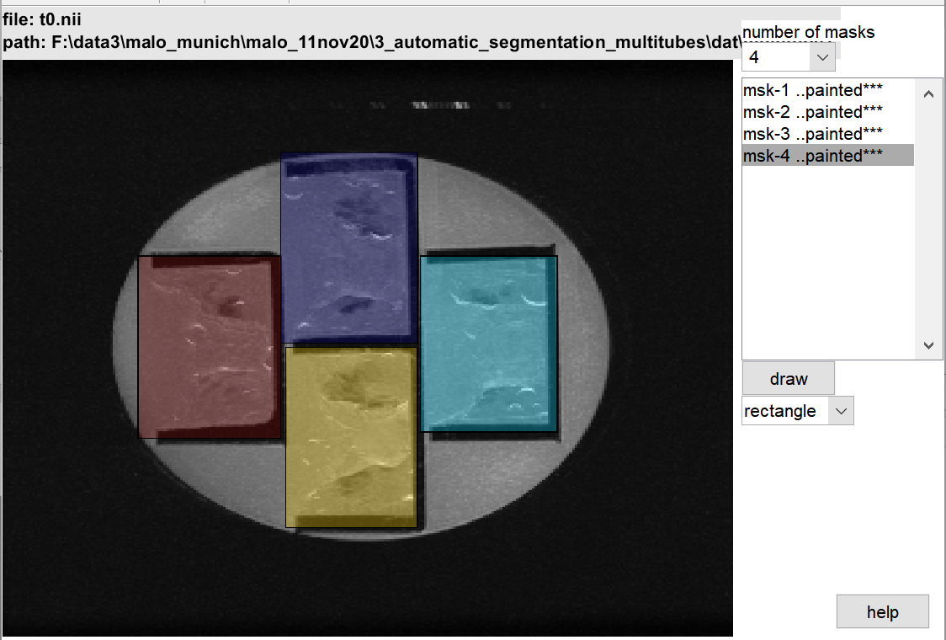
Where is the mask? Just click on an item (mask-Number) in the right listbox and the respective mask will shortly flicker.
When finished hit [OK]. Hit [cancel] to cancel the segmentation of this data set. If you have selected only one animal data set the segmentation for this data set is finished. Here we have selected two data sets from the ANT GUI –left listbox, thus the next data (‘multitube2’) will be opened…
Dataset: ‘multitube2’
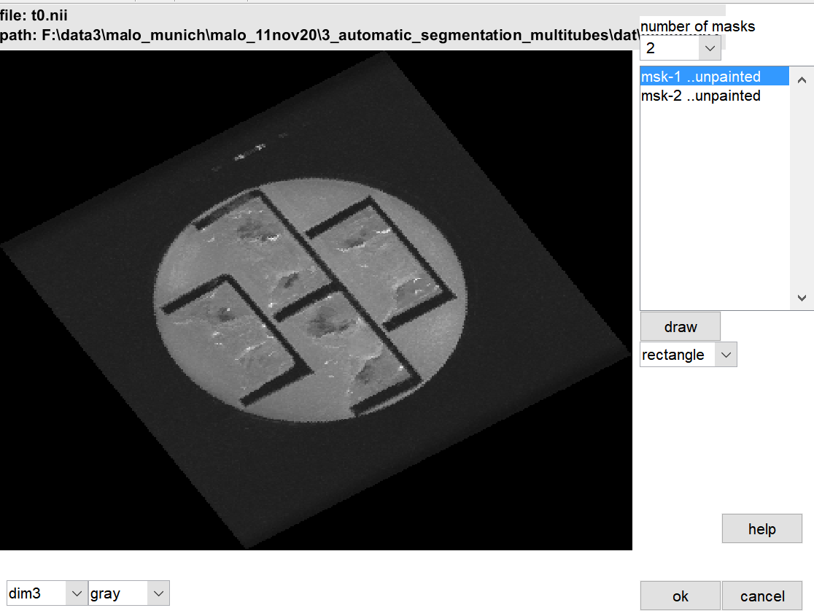
As for multitube1, first check the optimal orientation via [dim] pull-down menu. Count the number of animals to segment and select the number of masks to draw from the ‘number of masks’ pull-down menu. Here the image is rotated thus drawing a rectangle is not optimal. Here we choose the ‘freehand’ drawing tool from the pull-down menu. Now, select the first item (mask1) from right listbox. As drawing tool select ‘freehand’ from the drawing pull-down menu. Hit [draw]. Now draw a mask onto the 1st animal data (best way: start clockwise). When finished hit [accept] button. If the result is not satisfying just draw the mask again (via [draw]-button). Next select the 2nd item from right listbox and draw the mask…hit [accept] when done. Do the steps for all masks.
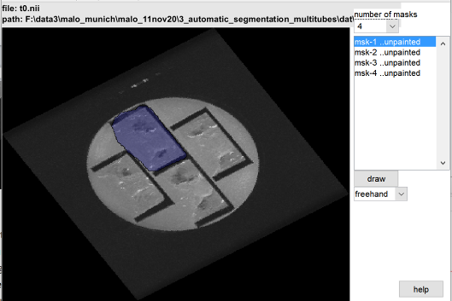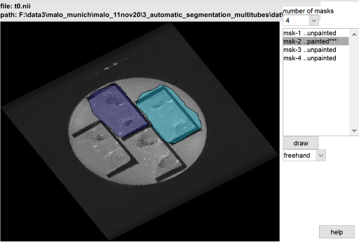
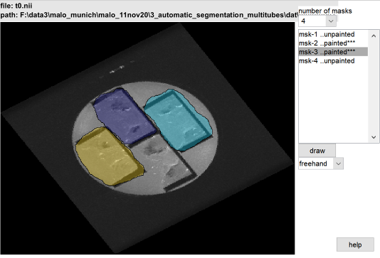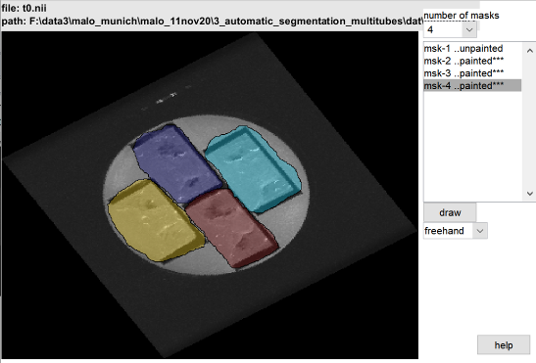
Hit [OK]-when finished.
Note: this segmentation works only when the volume is not rotated in the ‚hidden dimension‘, because the drawn masks are used over all slice of the hidden dimension (here ‘dim-3’ is the hidden dimension).
When done, the respective folders contain two new files:
seganimal.jpg: a screenshot of the overlay of ‘t0.nii’ and the new mask ‘seganimal.nii’
seganimal.nii: the multitube mask. The in-mask voxels contain integers 1,2,3,4 for the masks1,2,3,4, respectively.
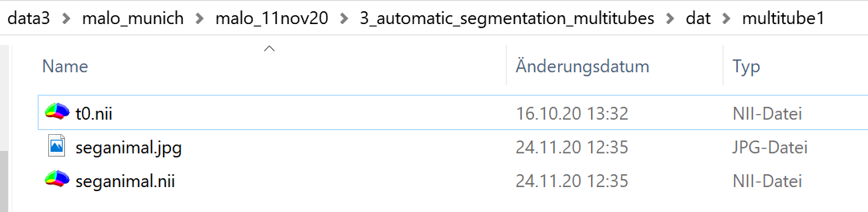
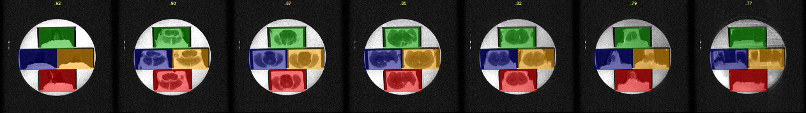
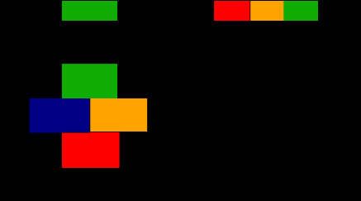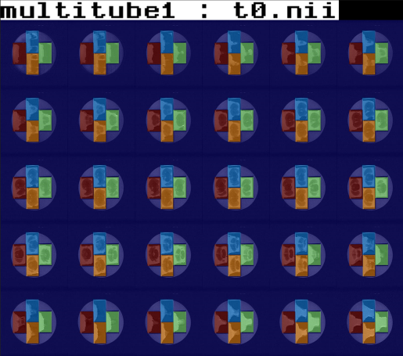
FIG: LEFT: The mask ‘seganimal.nii’ (displayed via MRicron), RIGHT: a screenshot of the overlay of ‘t0.nii’ and the new mask ‘seganimal.nii’ . TOP: overlay of ‘t0.nii’ with ‘seganimal.nii’ (displayed via MRicron).

BATCH
When finished click [ant]-button from the ANT gui to obtain the batch.
% % #g FUNCTION: [xsegmenttubeManu.m]
% % #b info : #b manually segment several animals from the same image /tube
% % =====================================================
z=[];
z.file = { 't0.nii' }; % % (<<) SELECT IMAGE to segment or filestring with wildcards
z.volnumber = [1]; % % for 4D-volume only: select index of volume in 4th dimension (default: 1)
z.showresult = [1]; % % show resulting segmented image {0,1}
z.saveresult = [1]; % % save resulting segmented image {0,1}
z.savename = 'seganimal'; % % name of the output filename
xsegmenttubeManu(1,z); % % run function ( the ‘1’ says to open the GuI)

2. Split datasets using the multitube masks
Select the animal folders from the left listbox (here I selected the two data sets).
Got to: ANT MENU: Tools/[2] split tube data
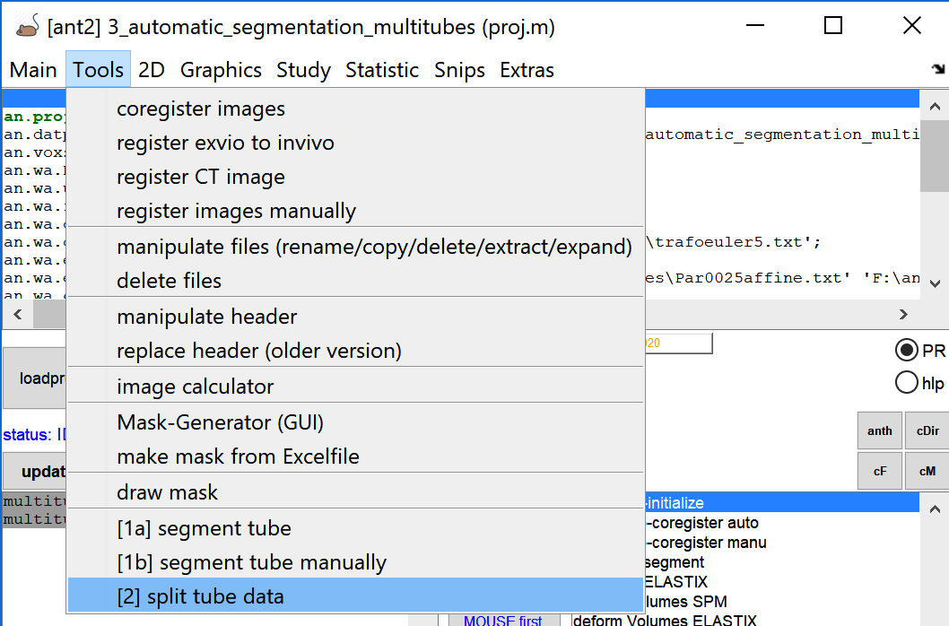
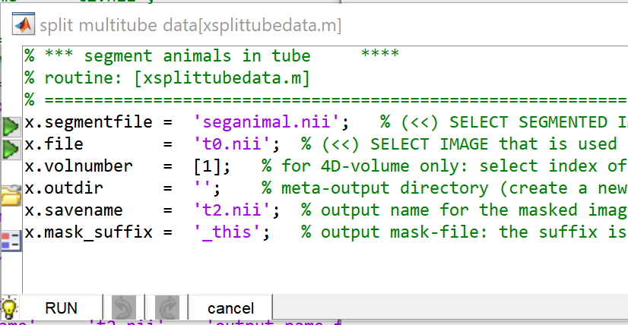
Do the following steps:
x.outdir: click left icon and select the destination path. Here I selected the ‘dat’-folder. I.e. the single animal data will co-exist in the same ‘dat’-folder as the original multitube data. Later, when registering the data be careful when selecting the single-animal data from the left ANT GUI listbox. Note that template registration of the original multitube data (‘t0.nii’) does not work!).
If x.outdir remains empty, the single animal data will be saved in the current directory (so be careful!). Otherwise select another output folder and process (atlas registration) the single animals in this new folder ( In this case you have to create a new project etc..).
x.savename: check if the output filename is ‘t2.nii’ because this file ‘t2.nii’ is used for template registration.
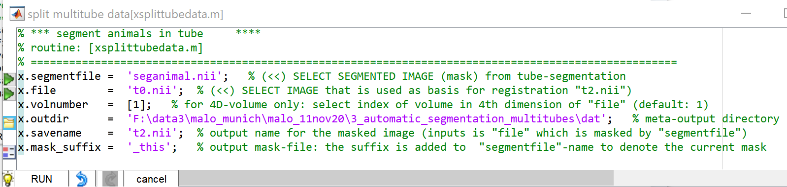

Hit [RUN].
When done hit the ‘UPDATE’-Button of the ANT GUI. (Remember here the output main folder for tube splitting was set to the project’s dat-folder). Each of the single animal-folder ‘xxx_number’ now contains a ‘t2.nii’ with size of the original t0.nii but outer-mask voxel values are set to ‘0’.
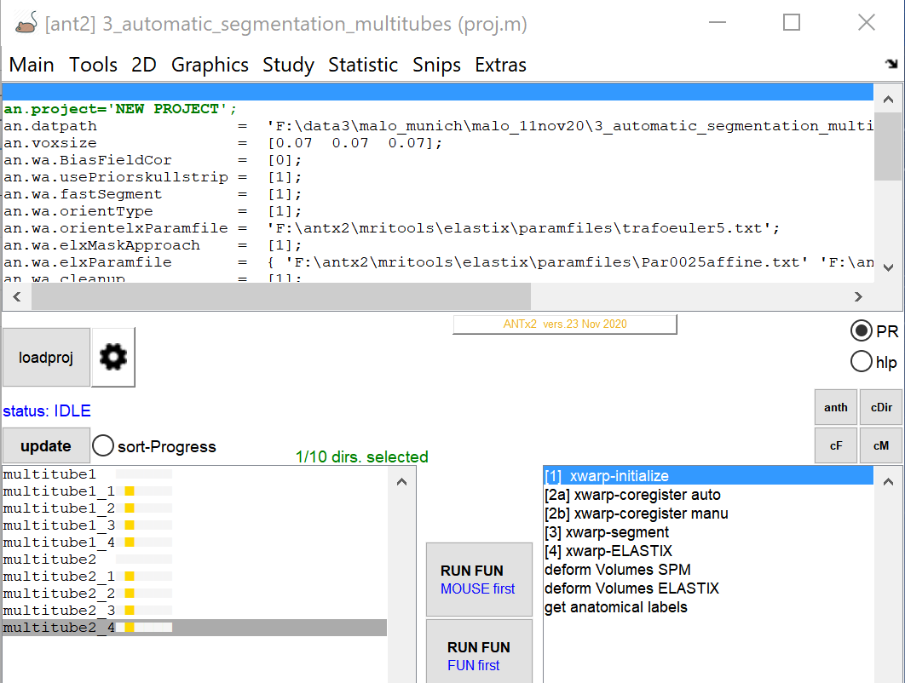
Now you could proceed with the template registration of the splitted multitube data (multitube1_1
multitube1_2, multitube1_3,multitube1_4, multitube2_1,multitube2_2,multitube2_3,multitube2_4).
Again the template registration does not work when using the original multitube data (multitube1 and multitube2)!

BATCH
When finished click [ant]-button from the ANT gui to obtain the batch.

% % =====================================================
% % #g FUNCTION: [xsplittubedata.m]
% % #b info : #b split data-sets based on tube-segementation
% % =====================================================
z=[];
z.segmentfile = 'seganimal.nii'; % % (<<) SELECT SEGMENTED IMAGE (mask) from tube-segmentation
z.file = 't0.nii'; % % (<<) SELECT IMAGE that is used as basis for registration "t2.nii")
z.volnumber = [1]; % % for 4D-volume only: select index of volume in 4th dimension of "file" (default: 1)
z.outdir = 'F:\data3\malo_munich\malo_11nov20\3_automatic_segmentation_multitubes\dat'; % % meta-output directory z.savename = 't2.nii'; % % output name for the masked image (inputs is "file" which is masked by "segmentfile")
z.mask_suffix = '_this'; % % output mask-file: the suffix is added to "segmentfile"-name to denote the current mask
xsplittubedata(1,z); % % run function ( the ‘1’ says to open the GuI)

How to Proceed?
→ see ANT-MENU: EXTRAS/documentation (docs) and the check the following docs:
‘tutorial_orientation_and_manucoreg.doc’
‘tutorial_atlasRegistration.doc’

