Tutorial: Orientation Type and Manual registration
=====================================================================================================
This tutorial covers the following topics:
- Determine the orientation of the animal brain
- Template registration
- Manual coregistration

Contents
Prerequisites
Data example
1) Renaming files
2) Examine Image Orientation (Panel selection)
3) Examine Image Orientation via 3-Point-Selection
4) Registration to Template – PART-1: Initialization + Auto Coregistration
5) Examine Automatic (rigid) Coregistration
6) Adding an Animal with a Different Orientation
7) Registration to Template – PART-2: Manual Coregistration
8) Registration to Template – PART-3: Segmentation and Nonlinear Registration
9) Check Template Registration
=====================================================================================================

Prerequisites
- ANTx GUI is open; a project is defined and loaded
- The ‘dat’ folder contains animal data (Nifti-files, converted for instance via bruker2nifti conversion)
- Each animal folder contains a t2w-image with name ‘t2.nii’

Data Example
In this tutorial the data of two animals will be used. Bruker-data have been converted to Nifti-files in a previous step (not shown here, but can be done via MENU: Main/import Bruker data). At the starting point the ‘dat’-folder contains two folders: ‘Gz20_0629_1’ (mouse-1) and ‘Gz20_0629_2’ (mouse-2), each with following files:
“1-TriPilot-FOV5cm_1.nii”
“2-Pilot-FOV25cm_1.nii”
“ApoE-psf-3D-BOLD-Br_1.nii”
“4-RARE8-Sag_1.nii”
“5-RARE8-Trans_1.nii”

1) Renaming Files
→ The structural image with the filename ‘t2.nii’ is used as source image for image registration. Each of the animal’s folder within the ‘dat’-folder must contain a ‘t2.nii’-file to perform image registration to the template. In most cases an existing file has to be renamed (or copied & renamed) to ‘t2.nii’. The animal-listbox (left in the ANT GUI) will show if the respective animal folder contains a file ‘t2.nii’ (otherwise click the ‘update’-button)

Do the following steps to rename files:
(1) Inspect the data and identify a structural image that can be used as source image for image registration (This file will be later named ‘t2.nii’). Open an animal folder and inspect all Nifty-files (visualization e.g. via MRIcron). In most cases the file-name is similar for all other animals.
(2) Rename files: Either manually or do it for all selected animals in one step: Select all/one/several animals from the animal-listbox (left). Then go to MENU: Tools/manipulate files. In the new window, type “t2.nii” in the “new name” column next to the file that should be used as source image (here: “5-RARE8-Trans_1.nii”). Type a colon-sign (“:”) into the “extract column” (or insert “c” or “copy” which is doing the same). This will make a copy of “5-RARE8-Trans_1.nii” image with file name “t2.nii”. If the “extract column” is empty the original file (“5-RARE8-Trans_1.nii”) will be renamed (so no file copy is used). Hit [OK]-button to rename the files.

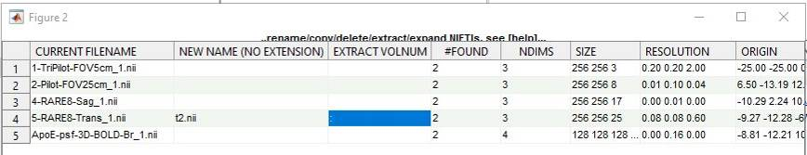
Figure: The image “5-RARE8-Trans_1.nii”) is found in two folders. This file will be copied and named ‘t2.nii’. The colon-sign indicates to use a copy of the file.

Now, the left animal-listbox indicates (yellow box) that the animal folders contain the file ‘t2.nii’ (otherwise hit the ‘update’-button).

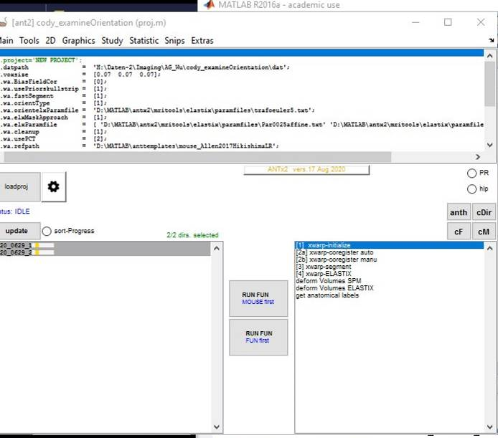 | Figure: The left listbox indicates that a ‘t2.nii’-file exist (yellow box) in each of the animal folders.  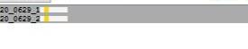

2) Examine Image Orientation (Panel selection)
→ This step is important: Image registration is strongly dependent on the orientation of the source image. In a standard study all animals will be positioned in a similar way in the MR-bore. Thus, if the orientation is known for one animal, it can be used for all other animals of the study. Here, ‘orientation’ means the choice of the three rotation angles (yaw, pitch, roll in radians) such that the source (‘t2.nii’) and target image (the template: ‘AVGT.nii’) are positioned in a similar way (The translation parameters x, y and z are not relevant): In other words, the left/right, anterior/posterior and superior/inferior direction has to be similar or roughly similar for the source and target image. Again, there has to be a match w.r.t to the orientation. However, there is no need to be super precise.

Do the following steps to examine the orientation:
(1) Check the uniformness of orientation across animals: Here we want to find out whether the orientation of ‘t2.nii’ is roughly similar across all animal folders (hopefully!). For this, select some/all animals from the left listbox. From the context-menu select “check registration via gui”.

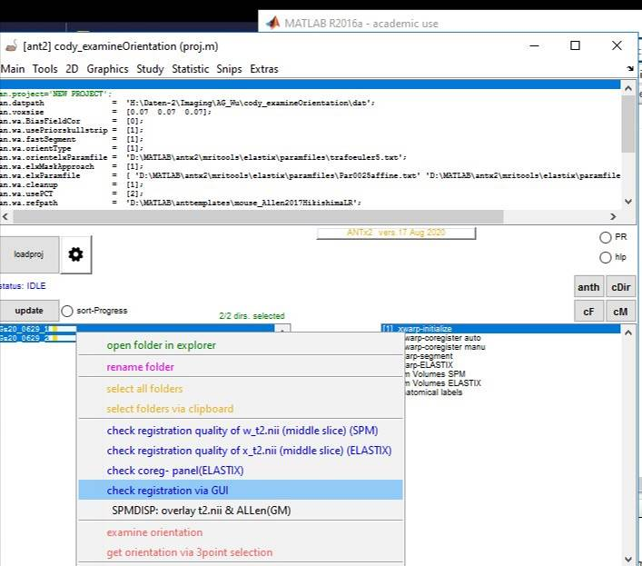 | Figure: Context-menu of the left listbox…select “check registration via gui”.

IN the new window select the ‘t2.nii’ image from the pull-down menu and inspect the orientation. To inspect all other animal click onto the grey box below the slice panels (or use left/right arrow keys to inspect the other selected animals). Here we conclude that orientation across animals is roughly similar.
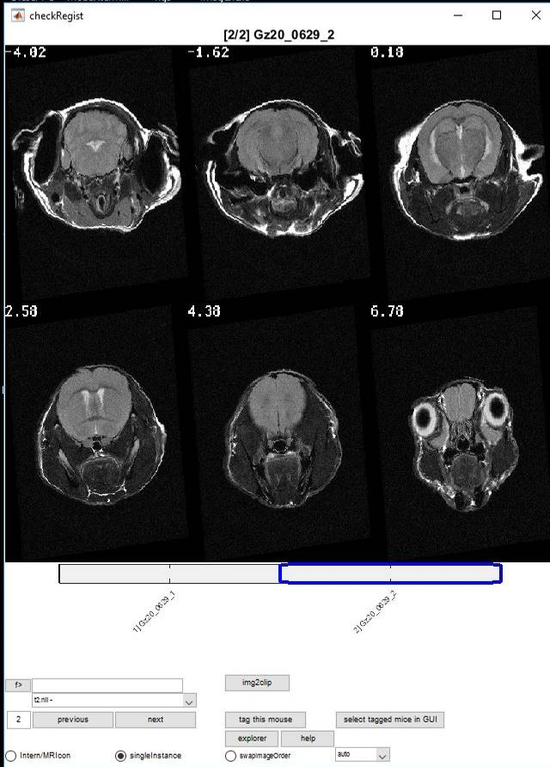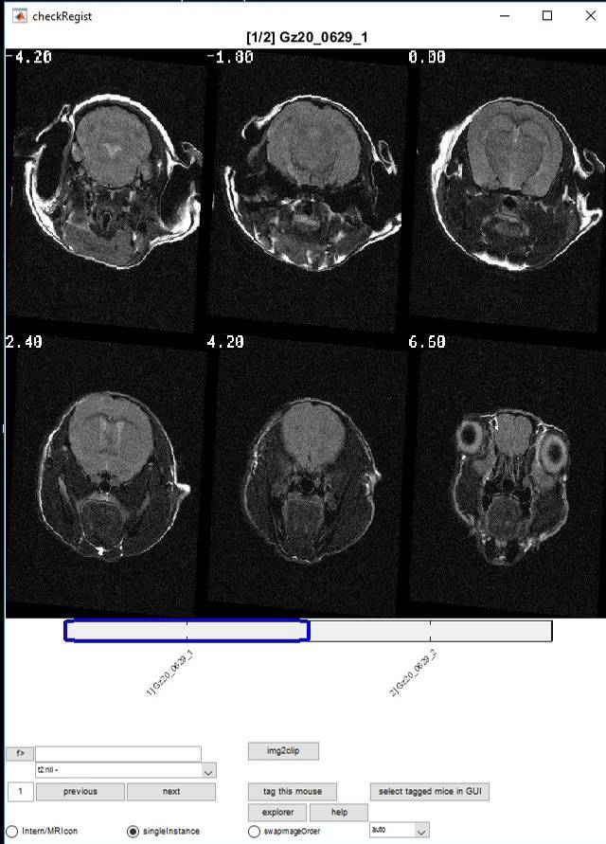 | Figure: The two selected animals show a similar orientation.

(2) Create a “templates folder”: The template was defined in the project-file. However, we now need to import the “template”-folder with the requested voxel-resolution for this study (The templates-folder is than located in the study folder). To do this, select from MENU: Main/create study templates. Note that this step is important for the next ‘examine orientation’-step (otherwise you have to select the target image (the template’s ‘AVGT.nii’) manually.

(3a) Examine orientation: Select one animal from the left listbox. From the context menu select “examine orientation”.

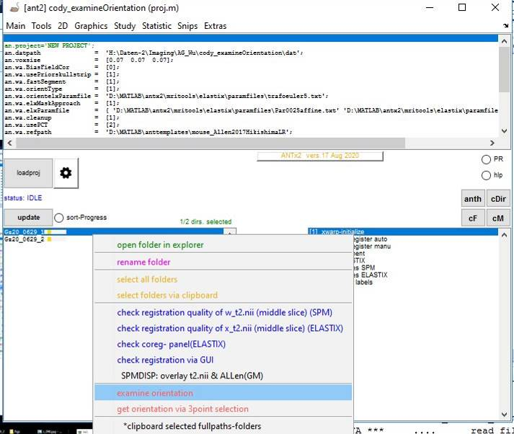 | Figure: Context-menu of the left listbox…select “examine orientation” to inspect the orientation of the 1st animal.

The “examine orientation”-window depict the same ‘t2.nii’ image with different predefined orientations on the left side and the reference/target image (‘AVGT.nii’) on the right side. The task is to select (via radio-control) one of the left panel orientations that is similar to the orientation of the target image. Here I selected panel number 5. Hit ‘OK’ button.

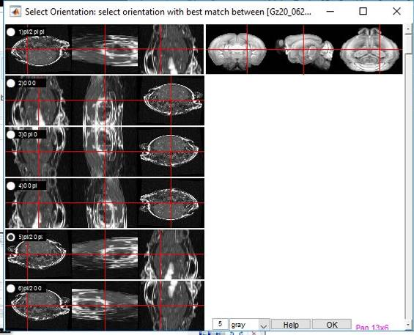 | Figure: Different orientations of the source image (t2.nii, left side) and the target image (‘AVGT.nii’, right side).  Select one of the left panels that show a similar orientation as the target image.

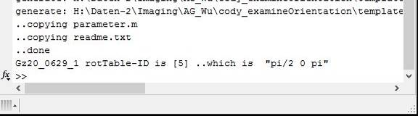 | Figure: When clicking ‘OK’, the orientation type is displayed in square brackets (‘[5]’) in the command window.

Important: When clicking on the ‘OK’ button the selected rotation type (the numeric value in square brackets) is displayed in the command window (here the orientation type is ‘5’).
To use the selected orientation type for template registration, open the ‘settings’ window by selecting the gearwheel-icon from the ANT main window and set the parameter x.wa.orientationType to 5. Note that the value of the orientation type is numeric (This numeric value refers to three rotation angles)!

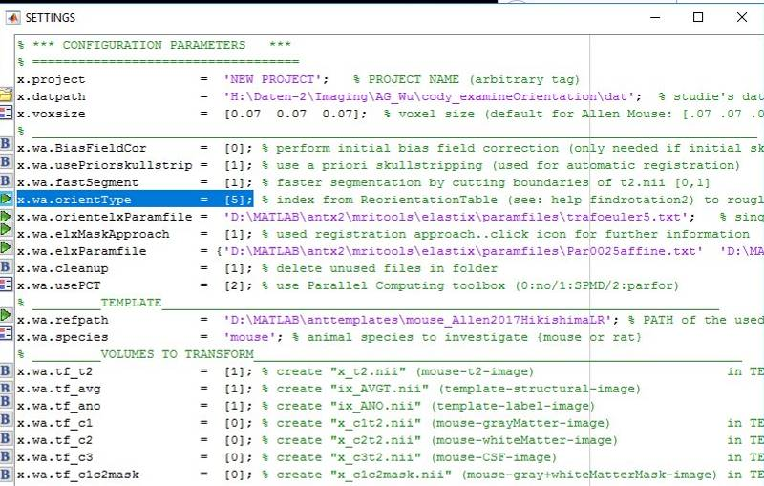 | Figure: In the setting file (aka project file, default is ‘proj.m’) the orientation type is set to 5 (numeric value).

Hit ‘OK’, and if asked update (overwrite) the settings file.

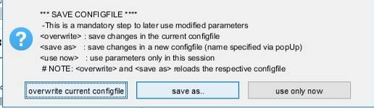 | Figure: The settings file will be updated with the new orientation type.

3) Examine Image Orientation via 3-Point-Selection

Note, ‘examine via 3-point-selection’ is an alternative (!) for ‘examine Image orientation (Panel selection)’ and can be used in cases were the orientation is not determinable via the panel-selection method of predefined orientation types. Scenarios: ‘t2.nii’ image is of low-contrast or small field of view.
To examine the orientation via 3-point selection select “get orientation via 3 point selection” from the context menu.

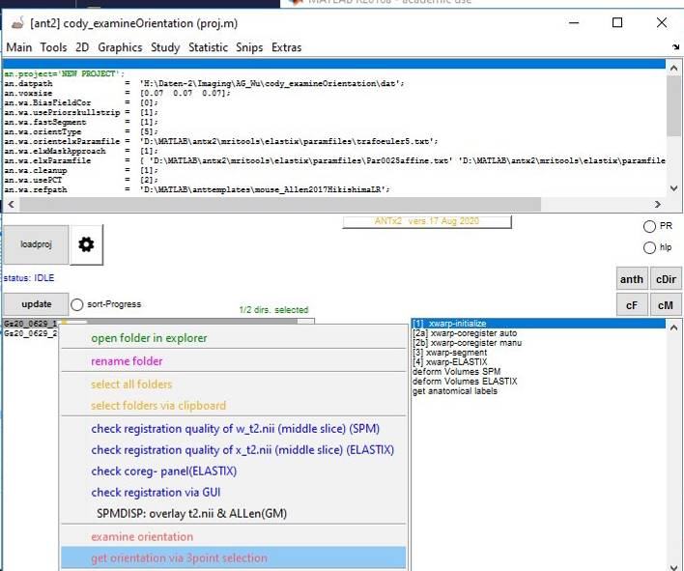 | Figure: The context-menu of the left listbox was select. Select “get orientation via 3 point selection” to determine the orientation of the 1st animal.

In the 3-point selection window you will have to define 3 points in the source (left) and target (right) image, respectively.
First, select the coronar view in both images by inspecting the ‘dim1’/‘dim2’/‘dim3’-buttons of both images.

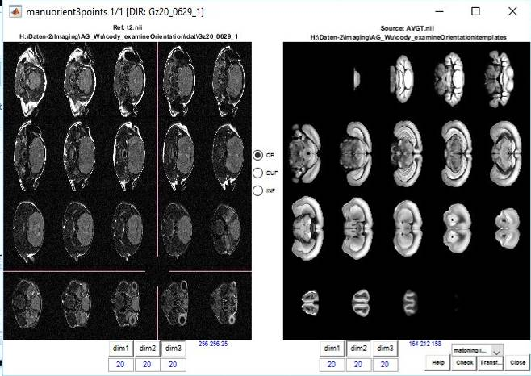 | Figure: Coronal slice view of the source and target image. Use the dim-1/2/3 buttons to change the slice direction.

Next click ‘OB’-radio control and mouse click onto the respective position of the olfactory bulb. You have to do this in both images. The points can be roughly defined. There is no need to be very precise. Points can be re-positioned by clicking on another position of the image.
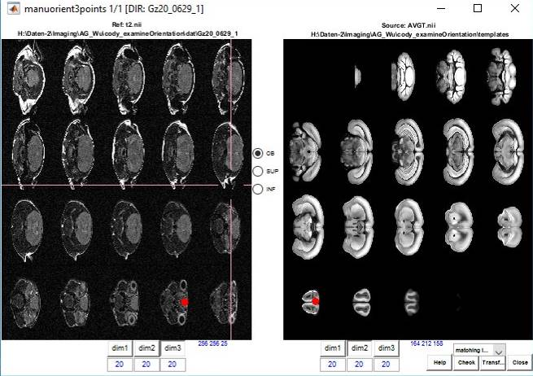 | Figure: The olfactory bulb was tagged (red dot) in the respective slice of both images.

Next click ‘SUP’-radio control and set a green point at the superior brain boundary in the middle slice of both images. The points can be roughly set; there is no need to be very precise.

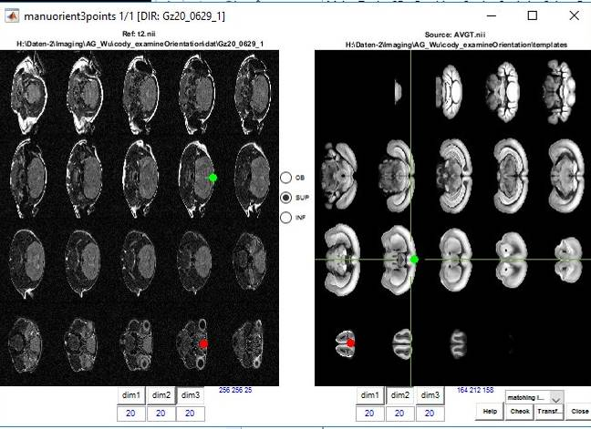 | Figure: The superior brain boundary in the middle slice was tagged (green dot) in both images.

Next click ‘INF’-radio control and make a blue point at the inferior brain boundary in the middle slice. You may use the same slice as for the superior point. The points can be roughly set; there is no need to be very precise.

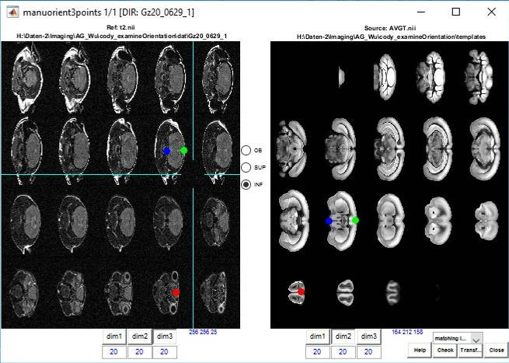 | Figure: The inferior brain boundary in the middle slice was tagged (blue dot) in both images.

To visualize the reorientation select the ‘check’-button (panel window will pop up).

IMPORTANT: The panel window is just for visualization, check only the first left panel (source) and compare it with the right panel. There is no need to select a radio-control here! Alternatively, you can visualize the matching between the source with assumed reorientation (based on the point-selection) and the target using MRIcron. For this select ‘MRIcron’ from the pull-down menu and hit ‘check’ button. If the result is not ok, you have to reposition the points, but remember precision is not very important here.

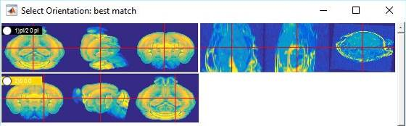 | Figure: The first panel on the left side depicts the orientation of the source image after defining corresponding points (olfactory. bulb, superior and inferior brain boundary) in the source and target image. Now, both images show a similar orientation.

IMPORTANT: Clicking on the ‘check’-button also displays the orientation in the command window. Note that now rotation is defined by three values (angles in radians). The translation-values are of no interest.

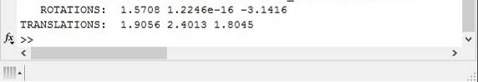 | Figure: Resulting from the point assignment, three rotations are displayed in the command window when clicking on the ‘check’-button.

If you want to use the three rotation values for template registration you have to change the “orientType” parameter in the settings file. For this, select the gearwheel icon from the ANT main window. IMPORTANT: Paste the three rotations next to x.wa.orientType and declare the variable as string (i.e. use single quotation signs), see below Figure! Hit ‘OK’ and save the configuration/settings file.

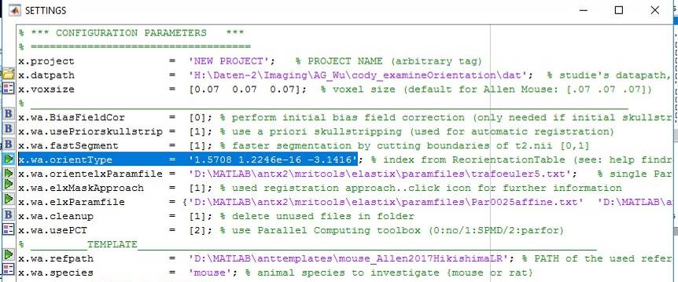 | Figure: The settings file. The three rotation angles were copied from the command window and assigned as string argument for the orient type (x.wa.orientType).

4) Registration to Template – PART-1: Initialization + Auto Coregistration
→ The following steps assume:
1) A project file (settings file/config file) is defined and loaded:
This file contains:
a) Definition of the voxel-size of the template (x.voxsize).
b) The path of the template (x.wa.refpath) is set.
c) The data path (‘…/dat’ in variable x.datpath) is defined.
d) The orientation type is defined (x.wa.orientType; see above).
2) The ‘dat’-folder contains subfolders, each folder is associated with one animal. These animal folders contain a structural image ‘t2.nii’.
3) The template (path associated in the project file: x.wa.refpath ) is already downloaded from google drive (see MENU: Extras/get templates from Google drive) and stored on the local or network drive.
Best option: Create a folder ‘anttemplates’. Insert the downloaded template folder into the ‘anttemplates’ folder and put the ‘anttemplates’ folder at the same hierarchical level as the ANTx-toolbox (example: ‘f:\antx2’ and ‘f:\ anttemplates’; and ‘anttemplates’ contain one or more template folders)

→ The template registration includes the following step:
'[1] xwarp-initialize':
-copy template set, fast skull stripping (used for coregistration and faster version of tissue segmentation)
'[2a] xwarp-coregister auto':
- automatic rigid body registration
'[2b] xwarp-coregister manu':
-optional, manual registration (useful if [2b] fails)
'[3] xwarp-segment' :
-segmentation of tissue compartments (step [2] is important for success of [3])
'[4] xwarp-ELASTIX' :
-affine+nonlinear (b-spline) registration, estimation of the forward and backward transformation parameters.
- parameters can be later used to transform images from native to standard (aka template) space and vice versa

Do the following steps for template registration:
(1) Select the animal for template-registrations from the left listbox.
(2) Select the following processing steps from the right listbox: '[1] xwarp-initialize'; '[2a] xwarp-coregister auto'; '[2b] xwarp-coregister manu'; '[3] xwarp-segment'; '[4] xwarp-ELASTIX'.
IMPORTANT: If both, [2a] and [2b] are selected, [2b] will not be executed (i.e. only the automatic registration is performed). Thus selection of [1], [2a], [3] & [4] is similar to [1], [2a], [2b], [3] & [4].

IMPORTANT: In this tutorial I will select only the first two steps ('[1] xwarp-initialize’ & '[2a] xwarp-coregister auto'), because in the next section I want to add an animal with a different orientation compared to the other animals.

NORMALLY, I would perform the following steps:
- select all animals and run the steps [1], [2a], [3] & [4]
- inspect the template-registration for all animals (via html-progress report & “check registration via gui” context menu)
- select the animals with failed registration (This can be done in the “check registration via gui” window: There, use “tag
this mouse”-button and “select tagged mice in GUI”-button to finally have the animals with deficient registration
selected in left listbox).
- perform manual coregistration ([2b]) for animals with failed registration
- re-run [3] & [4] for animals with failed registration

(3) <Optional> To see the html-progress report during execution of these steps select ‘PR’-radio control from the ANT gui.
(4) Use either the lower (nonparallel processing) or upper (parallel processing) ‘RUN FUN’-button.
IMPORTANT: The upper ‘RUN FUN’-button needs the parallel processing toolbox. Also, the manual coregistration ('[2b] xwarp-coregister manu') will fail during parallel processing (no figure/gui handling during parallel processing).

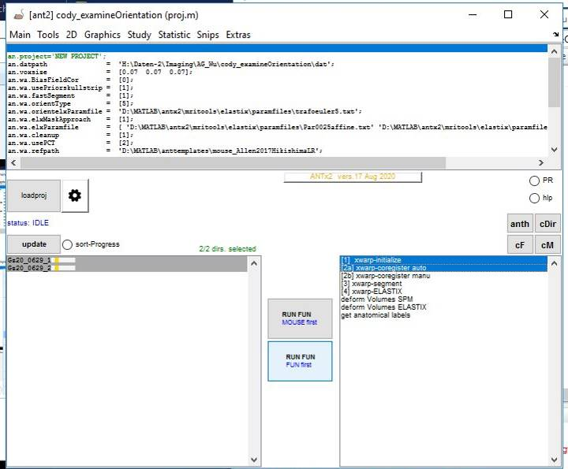 | Figure: Initialization and automatic coregistration has been selected.

Here I executed only the first two steps. Note that I forgot to select the ‘PR’-radio control, thus the html-progress report did not open in the web browser when hitting the ‘RUN FUN’-button. To obtain the html-progress reports during processing double-click on the ‘summary.html’ (located in the study folder).
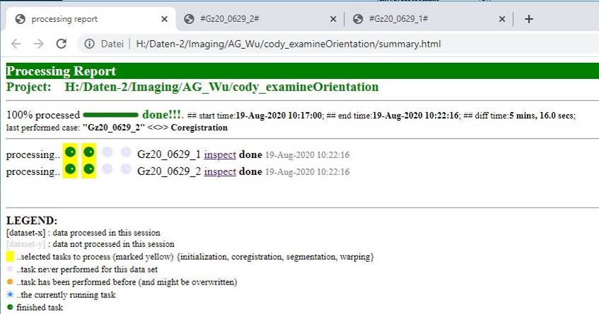 | Figure: Html progress report. The main page shows all animals of the study and indicates the status of each processing step. To examine the result of the executed steps click on the ‘inspect’-link of the respective animal.

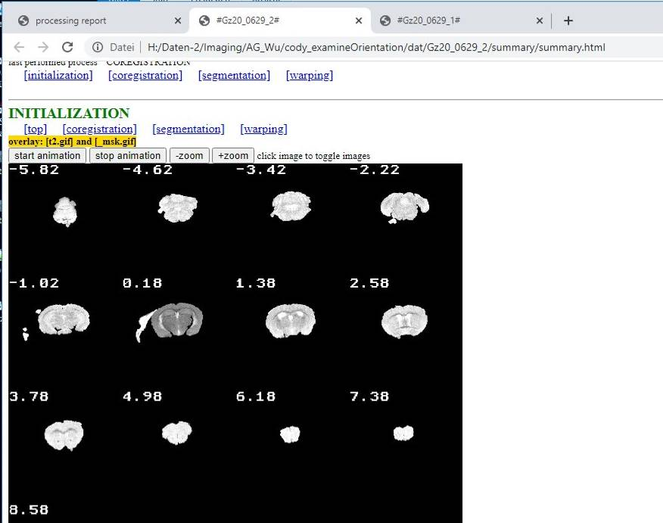 | Figure: Progress report, result of one animal for the '[1] xwarp-initialize’-step. Although tissue outside the brain was declared as ‘brain’ (2nd slice in row-2) the skull stripping sufficient for subsequent automatic coregistration. To visualize the overlay click onto the image in the web browser, or run the animation (toggle between ’t2.nii’ image and skull stripped image).

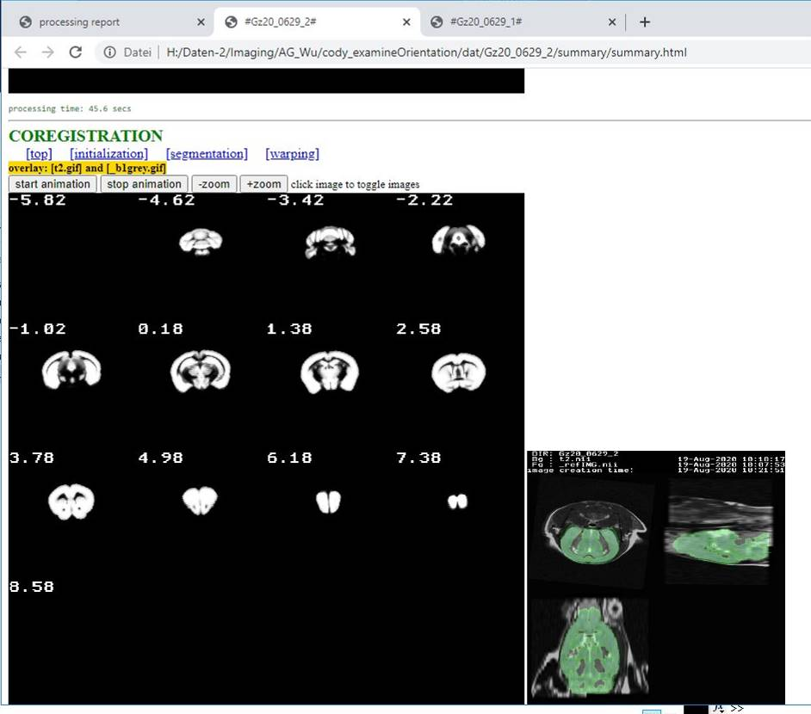 | Figure: Progress report, result of one animal for the '[2a] xwarp-coregister auto'-step. To visualize the coregistration click onto the left image in the web browser, or run the animation (toggle between ’t2.nii’ image and the template ‘AVGT.nii’). The rigid registration is ok.

5) Examine Automatic (rigid) Coregistration
→ Optional step. We want to inspect whether the automatic registration worked for the two animals.

Do the following steps:
(1) Select the animals from the left listbox.
(2) From the context-menu select “check registration via gui”.

In the new window, from the pull-down menu, select ‘t2.nii - \rigid\_bestRot.nii’ to visualize the rigid registration. Use arrow-keys to inspect the other animal(s). Click onto the image to switch between foreground (the templates grey matter image) and background image (‘t2.nii’).

Shortcuts of “check registration via gui” window
[#] change number of displayed slices
[-] change orientation {sagittal, coronal, axial}
[.] fuse images (toggle between two different fusion modes)
[f] flip up/down image
[n] change color of BG image
[m] change color of FG image
[left arrow/right arrow] - go to next/previous animal

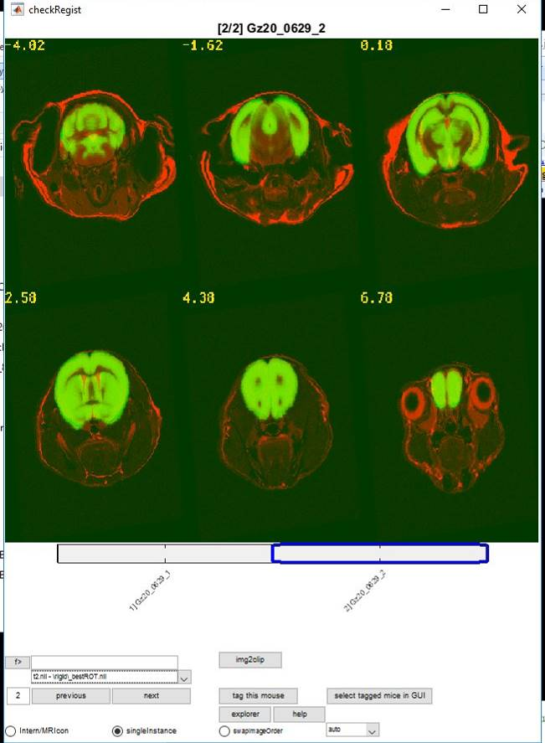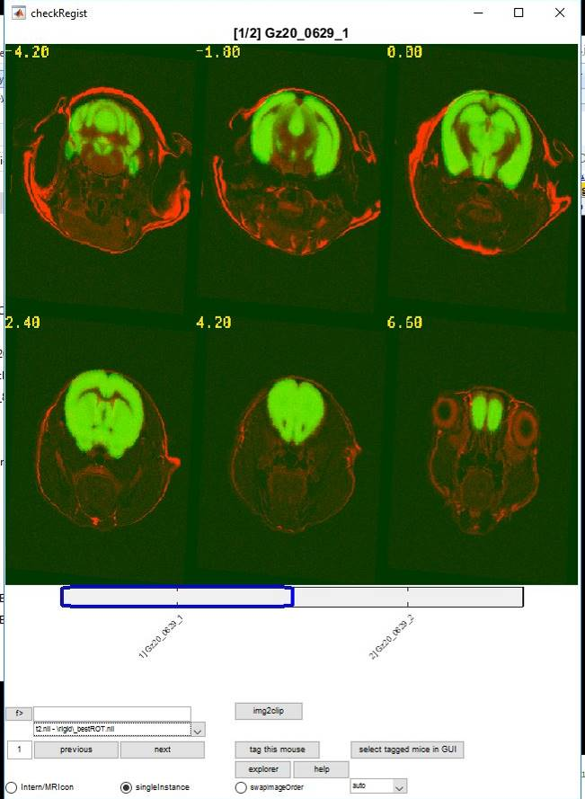 | Figure: The overlays show that the automatic rigid registration worked for the two animals.

6) Adding an Animal with a Different Orientation
→ The aim of this section is to simulate a scenario with failed automatic coregistration. The reasons of failed automatic registration, besides of erroneous positioning of a single animal, are multifaceted (pathological model with side effects, MR-related issues). The scenario is that we assume that the automatic coregistration worked well for most of the animals in the study, but failed in a view cases.

Here I did the following steps to set up the scenario:
- Created a new animal folder in the ‘dat’-folder (‘Gz20_0629_2_badOrientation’).
- In ‘Gz20_0629_2_badOrientation’-folder copied ‘t2.nii’ from animal ‘Gz20_0629_2’ (2nd animal in the previous sections).
- In ‘Gz20_0629_2_badOrientation’-folder made a 2nd copy of ‘t2.nii’ and named it ‘t2.orig’.
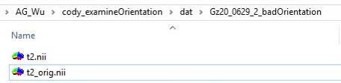 | Figure: Folder content of the new ill-posed animal (‘Gz20_0629_2_badOrientation’)

- Hit ‘update’-button of ANT GUI and select ‘Gz20_0629_2_badOrientation’ from left animal listbox.
- Select MENU: ‘Tools/register images manually’. Here we want to reorient the animal.

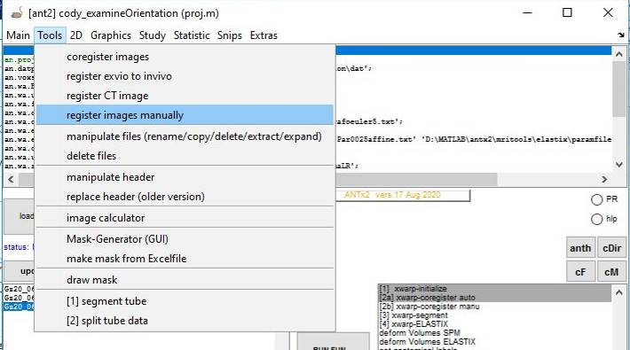 | Figure: select ‘Tools/register images manually’ from MENU.

In the ‘xcoremanu’ window hit left icon for x.target and x.source and select ‘t2.orig.nii’ and ‘t2.nii’, respectively.
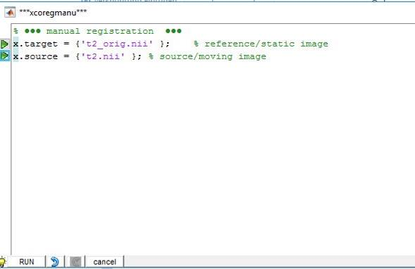 | Figure: ‘t2.orig.nii’ (a copy of ‘t2.nii’) and ‘t2.nii’ were selected as target and source image.
Hit ‘RUN’-button.

In the new graphics window, I entered arbitrary values in the translation and rotation edit fields (right, forward, up, pitch, roll, yaw). This resulted in a repositioning of ‘t2.nii’ compared to ‘t2_orig.nii’.
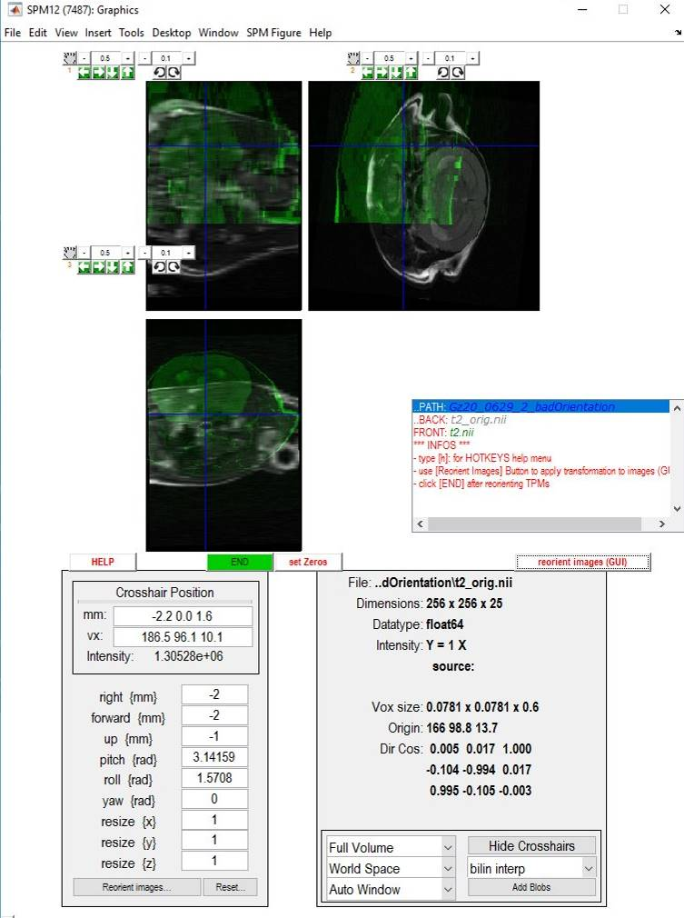 | Figure: Changes in the edit fields for translation and rotation parameters leads to an arbitrarily oriented ‘t2.nii’ image.

To apply these changes to the ‘t2.nii’ image, i.e. make changes of the translation and rotation parameters in the image header, select ‘reorient images (GUI)’-button.
From the new selection window, select ‘t2.nii’-image from the right list (Note, the ‘t2.nii’-image will disappear in the right listbox when selected and reappear in the lower listbox) and click ‘Done’.

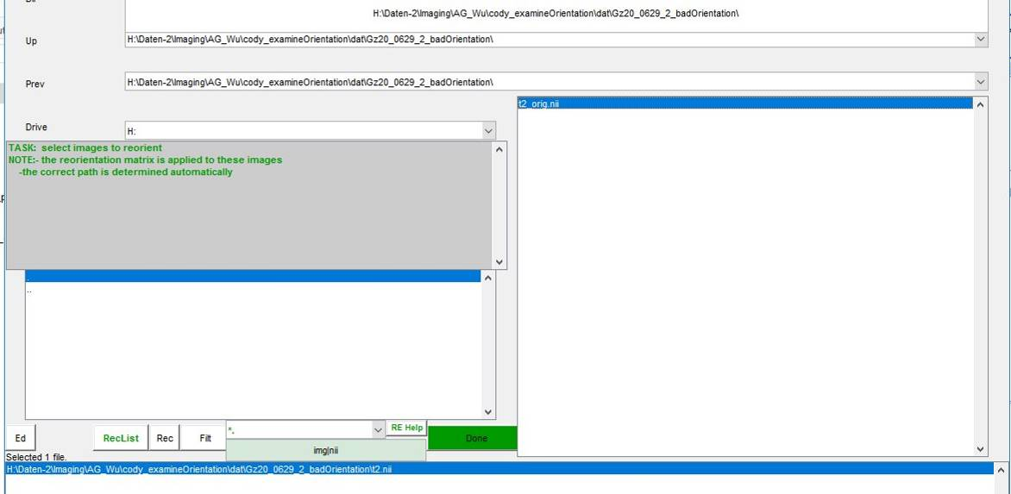 | Figure: ‘t2.nii’ was selected for reorientation. This step will change the translation and rotation parameters in the image header.

In the SPM12 graphic window select ‘END’.
Now we have created an ill-posed example: The ‘t2.nii’ image of ‘Gz20_0629_2_badOrientation’ is ill-posed compared to all other animals of this study (see Figure below).

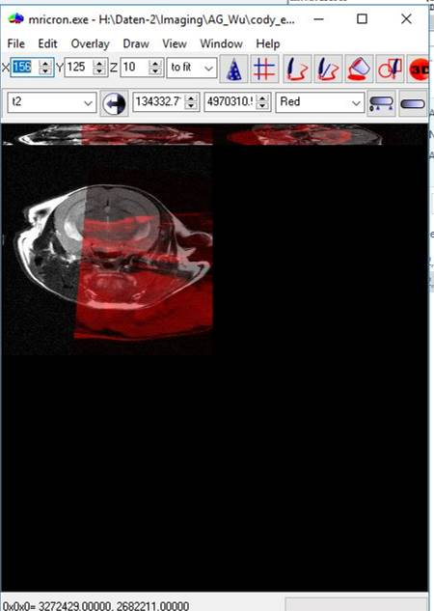 | Figure: The ill-posed t2-nii of animal ‘Gz20_0629_2_badOrientation’ visualized using MRIcron. Inspection can be also made via context-menu: “check registration via gui”.

If '[1] xwarp-initialize' & '[2a] xwarp-coregister auto' is performed for ‘Gz20_0629_2_badOrientation’ the rigid body registration will fail (Fig. below).
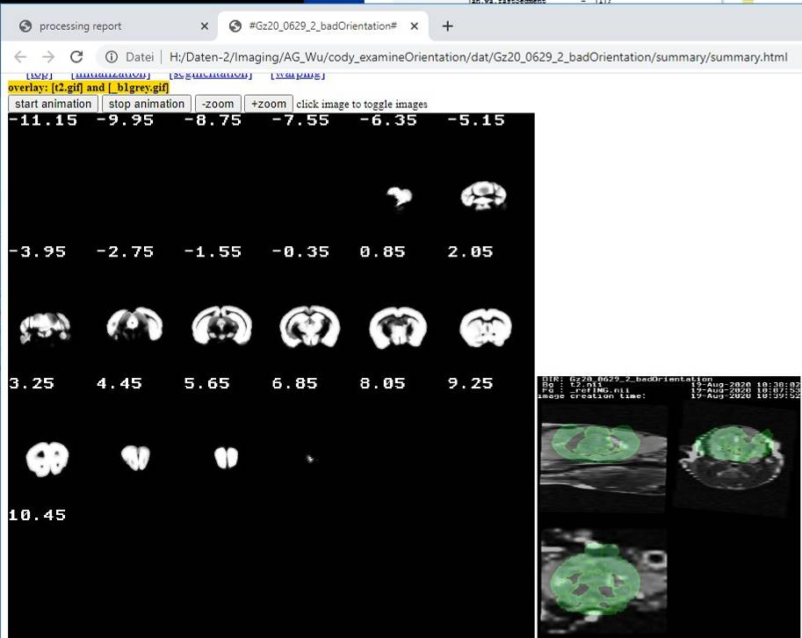 | Figure: Automatic rigid registration failed (right image) for ‘Gz20_0629_2_badOrientation’.

→→ Solution-1: examine orientation Type for ill-posed animal
→ This is one possibility. Draw-back: you have to deal with 2 or more project-files.
→ Not used in this tutorial.

Do the following steps:
(1) Select the ill-posed animal (left listbox) use ‘examine orientation’ or ‘get orientation via 3 point selection’.
(2) Update the orientation type in the setting menu (gearwheel icon) and save this project-file using another file name (+reload it).
(3) Re-run '[1] xwarp-initialize' & '[2a] xwarp-coregister auto' for this specific animal only!

→→ Solution-2: manual coregistration
→ See next section.

7) Registration to Template – PART-2: Manual Coregistration
→ This is another possibility. Draw-back: manually tune translation & rotation parameters to obtain matching source and target images.
→ There are advantages to run all steps for all animals (steps: [1], [2a], [3] & [4])…than tag the cases with failed registration and execute [2b] xwarp-coregister manu’ for those animal with failed registration. Finally run [3] & [4] for the failed cases.
→ Another option is to run only steps [1], [2a] (relatively fast) over all animals, than run [2b] over the bad cases, and finally run [3] & [4] (time consuming steps) over all animals

→ Sometimes you have to be a little patient when opening and closing the manual coregistration GUI!

Do the following steps:
(1) Select the ill-posed animal(s) from the left listbox.
(2) Select [2b] xwarp-coregister manu’ from the right listbox.
(3) Hit lower ‘RUN FUN’ button (IMPORTANT: the upper ‘RUN FUN’ button is for parallel-processing which does not support GUI-interactions).

The SPM12 graphics window will pop up with an overlay of ‘t2.nii’ image and the template ‘AVGT.nii’ image. If you click into one of the three orthogonal panels the template will disappear for a short moment (This is a way to compare the registration of the two images). You can see that both images not registered. The mouse click also updates the three overlays w.r.t the clicked position.

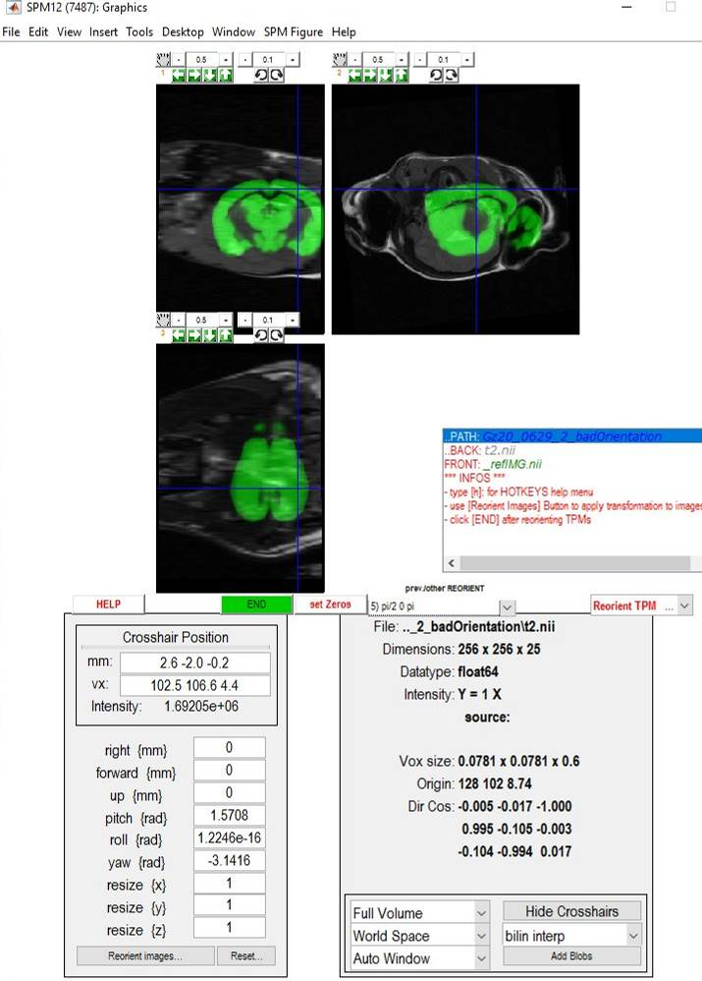 | Figure: The SPM12 graphics window shows the ill-posed ‘t2.nii’ image.

From the pull-down menu (below the overlays) select one of the predefined orientation types and check whether at least the orientation of target and source images matches. Inspect all other orientation types from the pull-down menu (once the pull-down has the focus: use up/down arrow keys to change the orientation type).
Previous rigid registration attempts also appear in the pull-down menu. Use one of the available orientation types or orientation types estimated from previous registrations to constrain the variability in rotation and translation parameters.

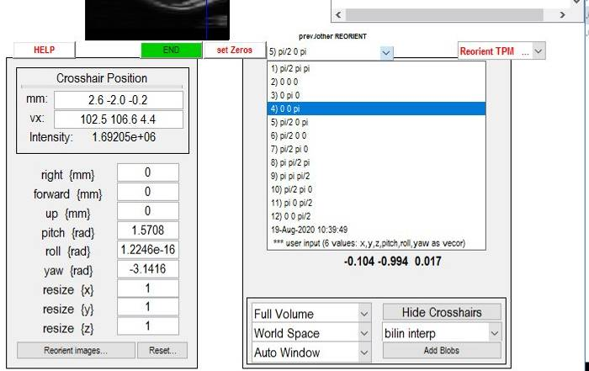 | Figure: Check the orientation types or reorientations from previous registration attempts from the pull-down menu. Use the orientation which shows the smallest deviation in the orientation between source and target image.

In this example I select ’11) pi 0 pi/2’ from the pull-down menu, because both images in the 1st panel depict coronal slices.

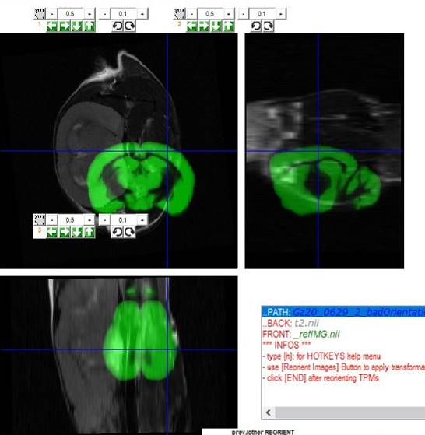 | Figure: The orientation type 11 (‘pi 0 pi/2’) was chosen from the pull-down menu, because at least the 1st panel shows coronal slices in both images.

Manual Coregistration: Edit fields, panel icons and shortcuts
The aim is to register both images manually. For this you may use:
1) Edit fields: right, forward, up, pitch, roll and yaw. These edit fields will be also updated when using the respective shortcuts or icons (from icon panels on top of the overlay panels). Drawback: changing the values via edit controls is really painstaking.
2) icon panels: Each overlay panel is associated with the respective translation (←,→,up/down arrow) and rotation (clock & anticlockwise) icons, the step-size for translation & rotation (edit fields) and a hand-icon to reposition the icon panel.
3) shortcuts:
‘up’/’down’ arrow keys - move fg-image (green) up/down (best observed in 1st and 2rd panel)
‘left’/’right’ arrow keys - move fg-image (green) left/right (best observed in 1st and 3rd panel)
shift+‘up’/’down’ arrow keys - move fg-image (green) inward/outward (best observed in 2nd and 3rd panel)
‘p’ and shift+‘p’ - change pitch-rotation .. clock & anticlockwise
‘r’ and shift+‘r’ - change roll-rotation .. clock & anticlockwise
‘y’ and shift+‘y’ - change yaw-rotation .. clock & anticlockwise

→ The edit fields will be updated each time the translation and rotation icons or shortcuts will be activated
Other shortcuts
+/- - increase/decrease the transparency of the foreground image (green)
# - show/hide red contour plot of the foreground image (green)
space - toggle step-size of translation and rotation (two states: large vs. small step-size)
F1 - change step-size of translation and rotation via GUI
F2, F3, F4 - different toggles to show/hide the foreground/background-image

Use shift+’r’/’r’ shortcuts or clock & anticlockwise icons from panel 1 to adjust the rotation in the first panel

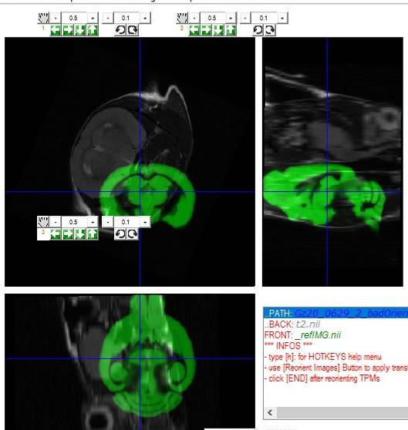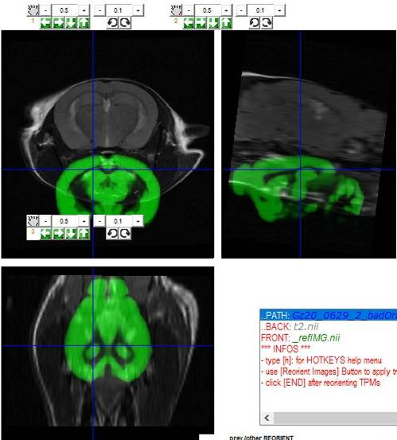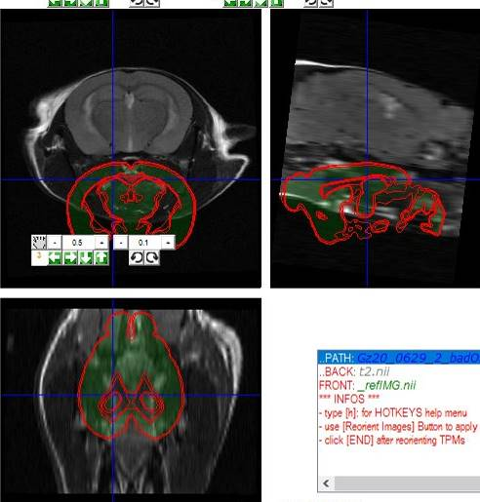
Figure: Shift+’r’/’r’ shortcuts or clock & anticlockwise icons from panel 1 can be used to adjust the roll-rotation parameter The rotation along the rolling axis seems to be fine in the middle figure. The right figure shows the contour option and increased transparency of the foreground image.

Use shift+’up’/’down’ shortcuts or up & down icons from panel 1 to minimize the up-down translational deviance

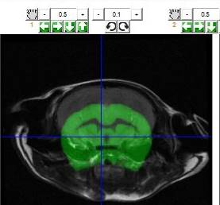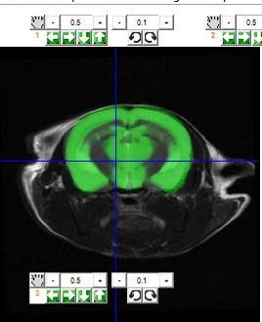 | Figure: shift+’up’/’down’ shortcuts or up & down icons from panel 1 can be used to minimise the translational deviance.

Adjust all other rotation and translation parameters via icons or shortcuts. Select different coronal sections (olf. bulb vs. cerebellum) and inspect the coregistration results. Sometimes you have to re-adjust the parameters (change angle → shift position → change angle → shift position etc.).

The figure below shows the final manual registration result.

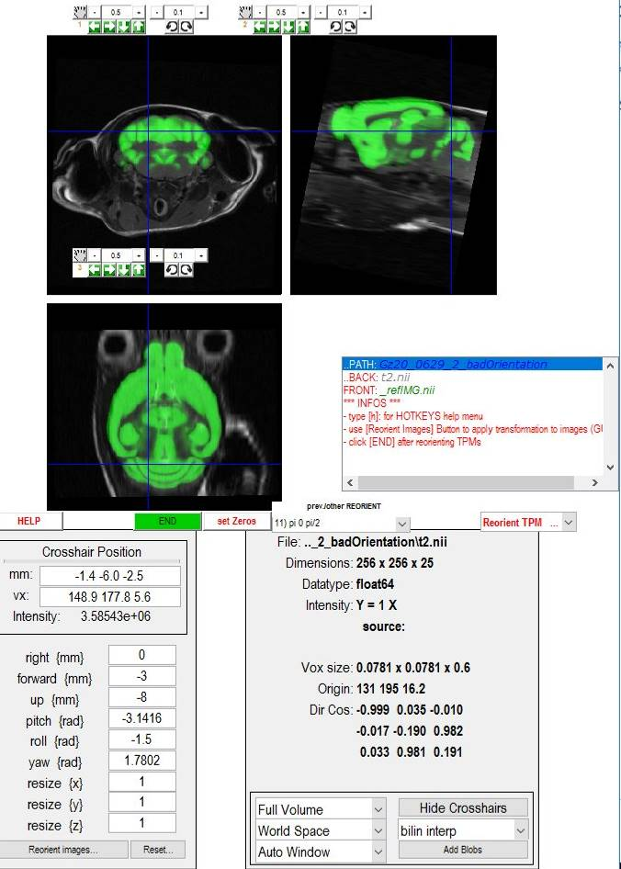 | Figure: Manual coregistration. The final result.  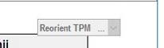  Figure: The ‘Reorient TPM’ button was clicked, rotation and translation parameters have been stored, the control becomes grey to indicate this status.

Next, select ‘Reorient TPM’-from the pull-down (don’t forget this!!). This step is important, because it saves the estimated rotation and translation parameters. When clicked, the ‘Reorient TPM’ pull-down becomes disabled (grey color), indicating a the changes status.

Finally hit the ‘END’-key.

8) Registration to Template – PART-3: Segmentation and Nonlinear Registration

Do the following steps:
- select all animals (n=3 here) from the left listbox
- select '[3] xwarp-segment' & '[4] xwarp-ELASTIX' from the right listbox
-hit one of the ‘RUN FUN’-buttons
-optional: inspect html-progress report

9) Check Template Registration
- Select all animals from the left listbox and use “check registration via gui” from the context-menu select.
- Select ‘x_t2.nii – AVGT.nii’ from the pull-down menu. Examine all animals.
Here we observe that the template registration was successful for all cases.

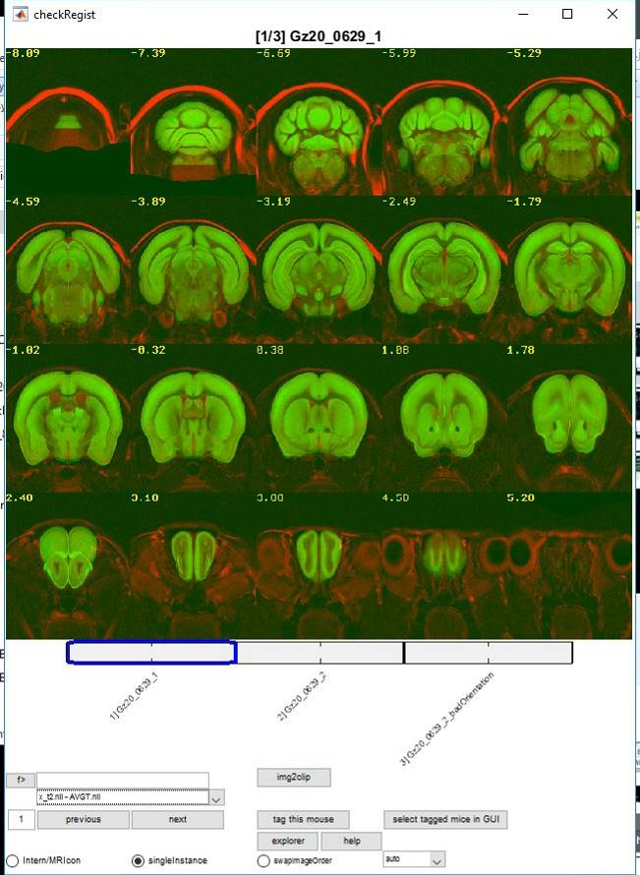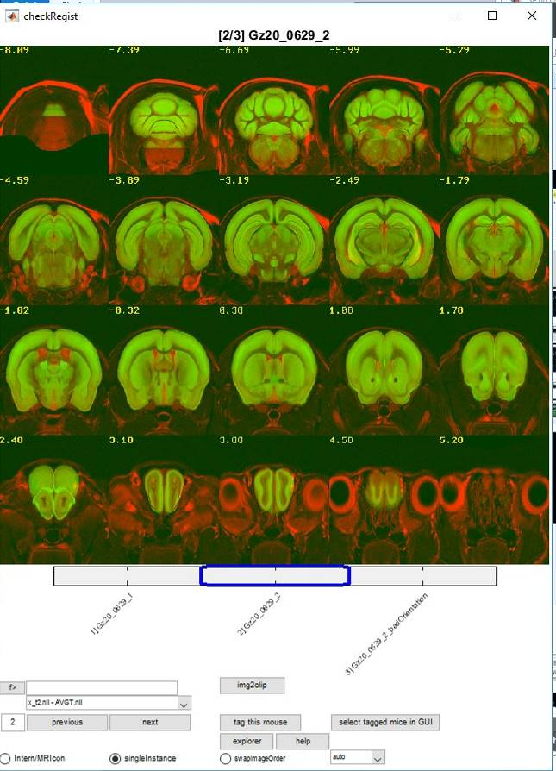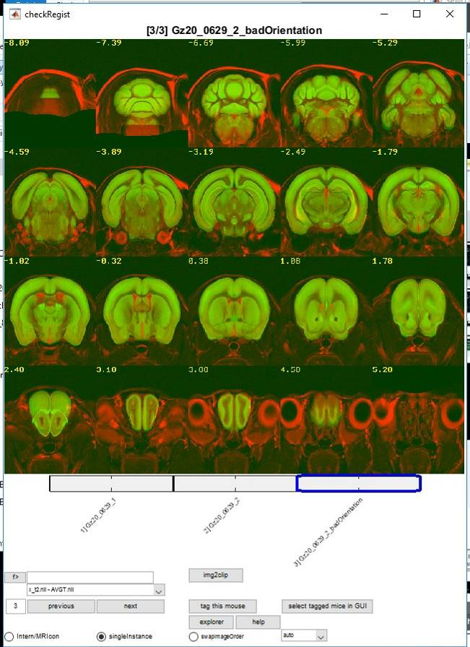
Figure: The template registration was successful for all cases. The latter case (‘Gz20_0629_2_badOrientation’) was manually registered before performing the image segmentation and non-linear registration steps.

