Tutorial: Convert Dicom Images
=====================================================================================================
Prerequisites
- ANTx is installed, Matlab is running.
- a template (AVGT.nii/ANO.nii etc) is downloaded

Data Example
Here we have a folder with subfolders. The hierarchical lowest folders contain Dicom images (a single structural image, same modality). The below graph depicts the folder tree. In this example we work in the directory ‘F:\DATA2\DICOMSAMPLE’, i.e. this folder contains a dicom folder with dicom. Note also that ‘F:\DATA2\DICOMSAMPLE’ will be the study folder, i.e. will contain the ’dat’-folder with animal folders.

F:\DATA2\DICOMSAMPLE
└───Dicoms-raw
├───Sham
│ └───7 days
│ ├───T1 ### Dicoms here
│ └───T2 ### Dicoms here
└───TBI
└───7 days
├───T1 ### Dicoms here
└───T2 ### Dicoms here

1) Prerequisites
Change Matlab’s working directory to the ANTx-directory: example: cd('F:\antx2')
Type: ‘antlink’ to temporally set the paths of the tbx.
2) Change Matlab’s working directory to the Study Directory
cd('F:\data2\dicomSample')
3) Start ANT GUI
Type ‘ant’
4) Make project
From ANT menu select: ‘Main/New Project’
In the settings-window: Select the icon left to ‘x.wa.refpath’ and select the reference template. Here, I selected the template ‘mouse_Allen2017HikishimaLR’ (This template was previously downloaded from the googleDrive-repo is stored in the ‘anttemplates’-folder. This folder is located at the same hierarchical level as the ANT tbx and therefore can be easy chose via UI). Hit ‘OK’-Btn and follow instructions, i.e.: save the project-file: It is preferred to save the project-file (an m-file) in the studies folder) and load project…yes, load it now.
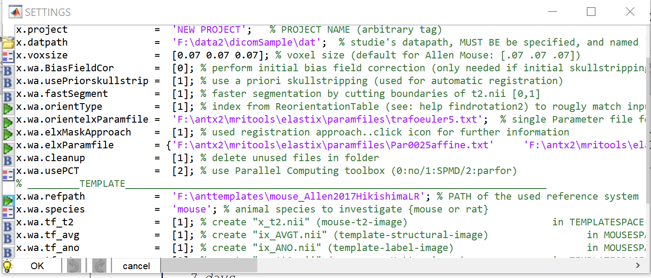

5) Convert Dicom Files
→ Step-4 (Make project) is not necessary to do the dicom conversion.
From ANT menu select: ‘Main/Convert dicom to nifti’
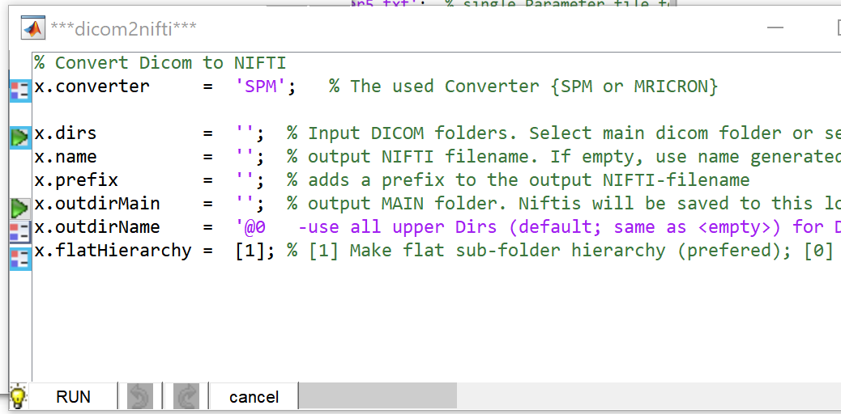

Select Icon left to ‘x.dirs’ to select the folder(s) containing the dicom files. In the selection window click ‘Dicoms-raw’ in the left panel (left image) to see the content of this folder in the right panel (middle image). From the right panel select ‘Sham’ and ‘TBI’. These folders contain the dicom-images. After selection, these folders, disappear in the right panel and appear in the lower panel. Hit ‘Done’.
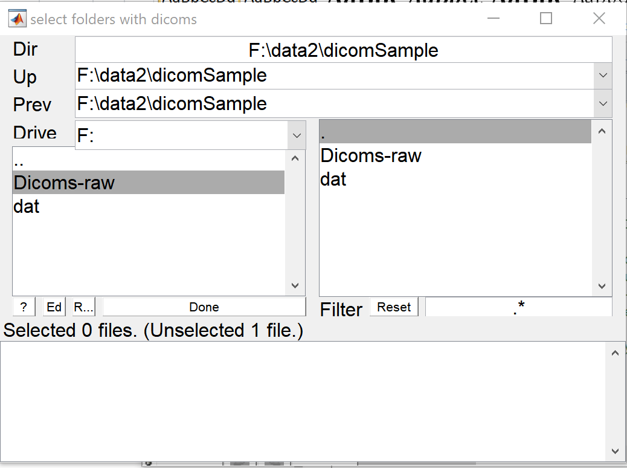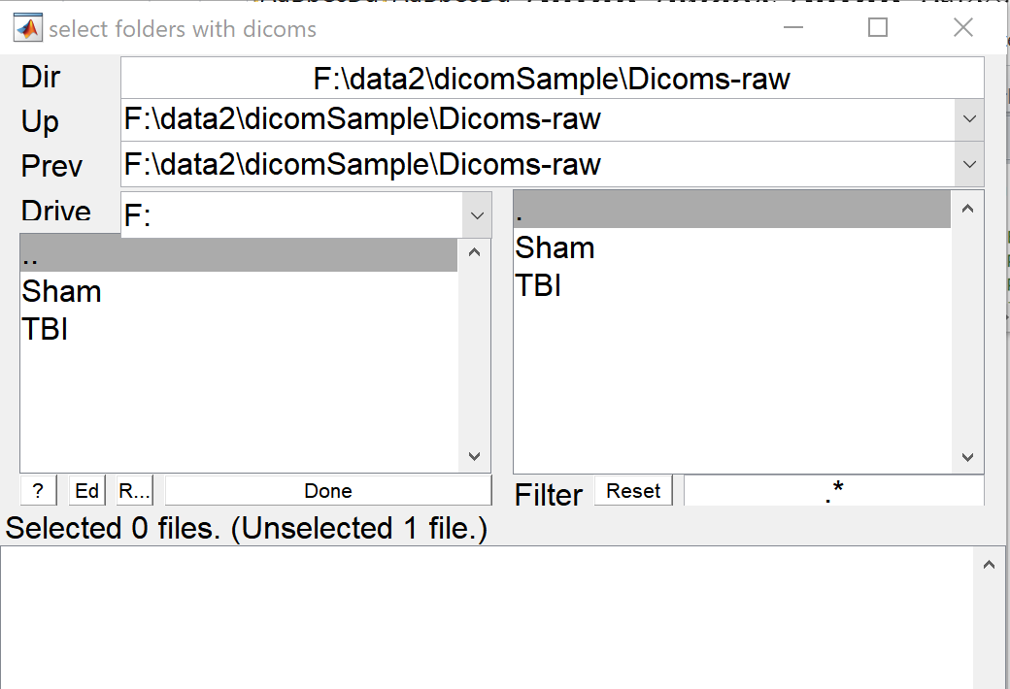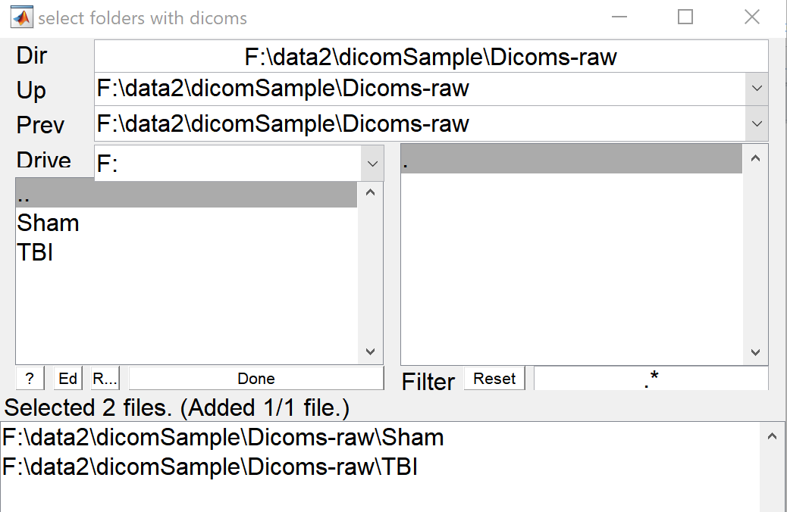

Here, the dicom images have the same modality and will be used for template registration. In this case we can give the resulting Nifti files a proper name (otherwise the Nifti filename is generated based on internal dicom fields).
To rename the Nifti files we use the ‘x.name’ field and rename the resulting files: (x.name = 't2.nii'). The filename ‘t2.nii’ is chosen because the follow-up template registration expects a source file (structural image/t2w-image) with the name ‘t2.nii’.
To select the main output directory, select icon next to ‘x. outdirMain’ field. Because an ANT project is already loaded and the dicoms should be converted in a flat hierarchy (x.flatHierarchy is set to [1] → so no nesting of output-folders), we can use the projects-‘dat’-folder as main output directory. This ‘dat’-folder was created when the project-file was created (→ see image of “step-4) Make project)”). Otherwise it is preferred to select another folder (i.e. an empty folder) to control the output of the dicom conversion.
The ‘x. outdirName’ field is not changed here. Basically this field defines the name of the folder that contains the converted Nifti files. The default is to detect the dicoms and use all upper directory names to construct a folder name for the resulting Nifti-file. You can change the names afterwards as well. See bulb-icon for more information.
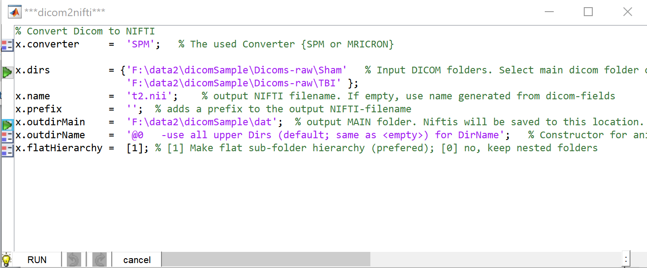

Hit ‘RUN’-BTN. Now, the dicoms will be converted. Matlab Command Comand window shows the converted icons as hyperlink (click link to open the respective folder).
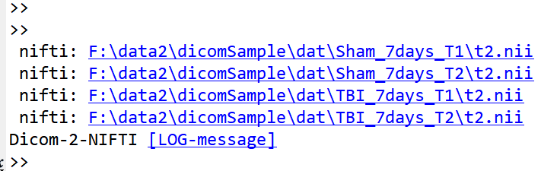
You can also click the [LOG-message] to inspect the list of input-dicom-folders and output-Nifti-files.
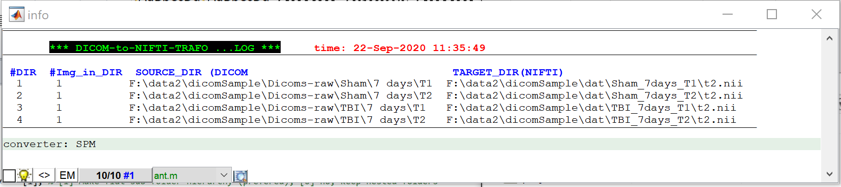

Here, the resulting Nifti-files are stored in our ‘dat’-folder. Although the animal folder names are strange, we can work with them. Otherwise rename the folders (see *)

F:\DATA2\DICOMSAMPLE
├───Dicoms-raw
│ ├───Sham
│ │ └───7 days
│ │ ├───T1 ## Dicoms here ##
│ │ └───T2 ## Dicoms here ##
│ └───TBI
│ └───7 days
│ ├───T1 ## Dicoms here ##
│ └───T2 ## Dicoms here ##
└───dat
├───Sham_7days_T1 ## NIFTI here ##
├───Sham_7days_T2 ## NIFTI here ##
├───TBI_7days_T1 ## NIFTI here ##
└───TBI_7days_T2 ## NIFTI here ##

Now, the left animal-listbox indicates (yellow box) that the animal folders contain the file ‘t2.nii’ (otherwise hit the ‘update’-button).
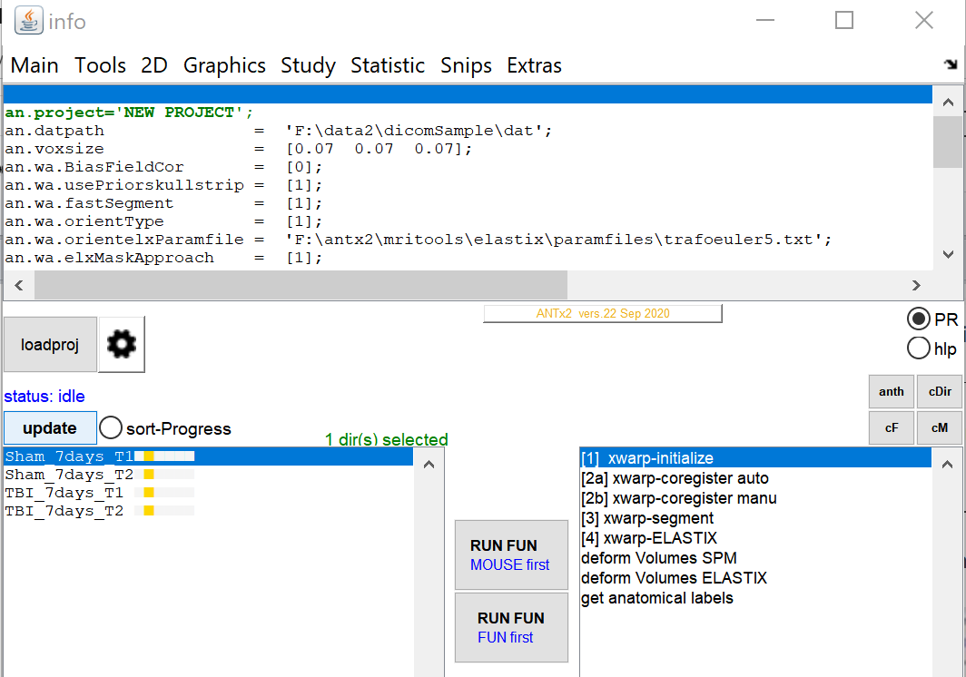
The left listbox indicates that a ‘t2.nii’-file exist (yellow box) in each of the animal folders.
** To rename a folder, select the folder and open context-menu of the left listbox (animal-listbox) and select ‘rename folder’.

