BrukerImport

=====================================================================================================
This tutorial shows how to import Bruker data:

Set Matlab’s current to antx2-TBX
Example: cd('F:\antx2')

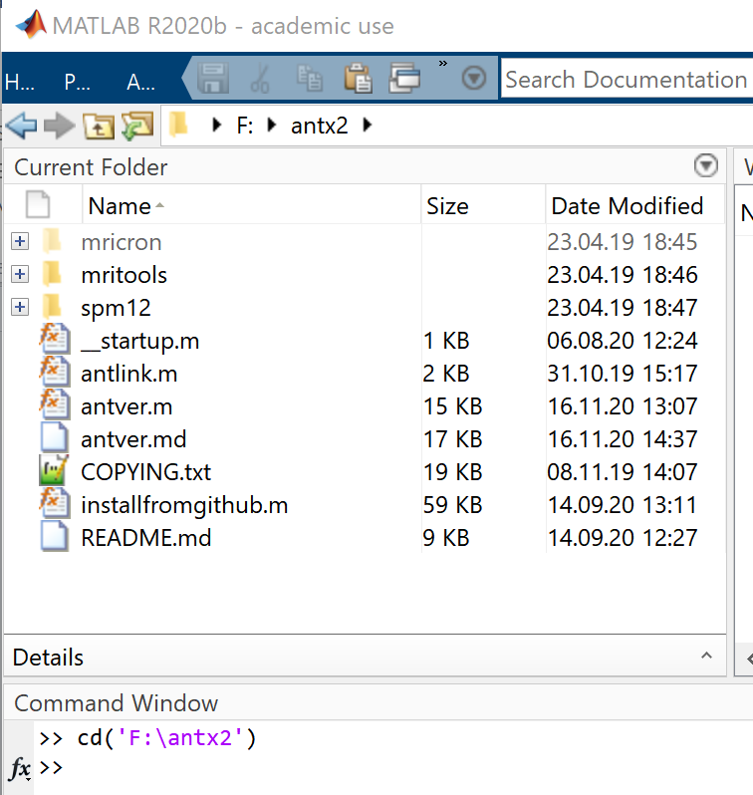

Type ‘antlink’ to temporary set the antx2'-paths
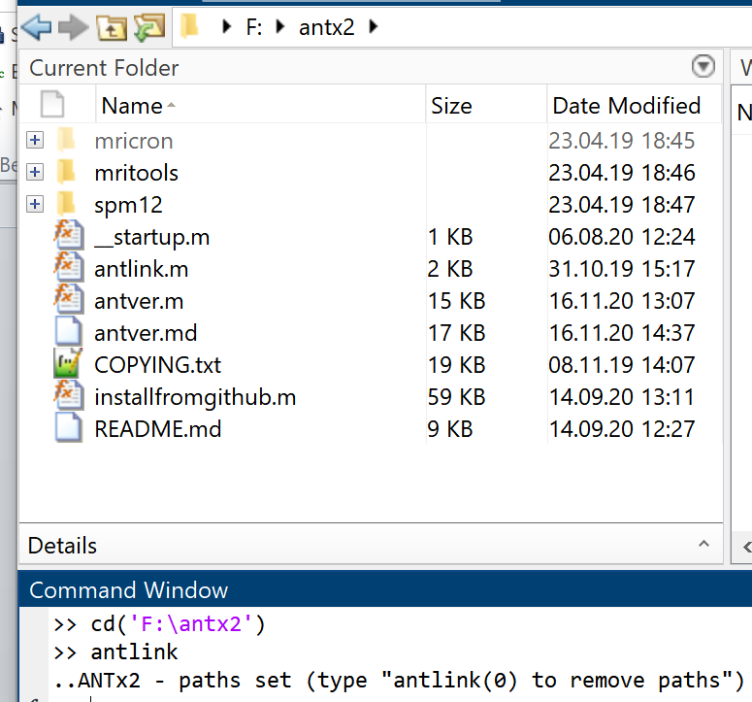

Go to project-folder
Example >> cd('F:\data3\tomislav_brukerImportIssue')
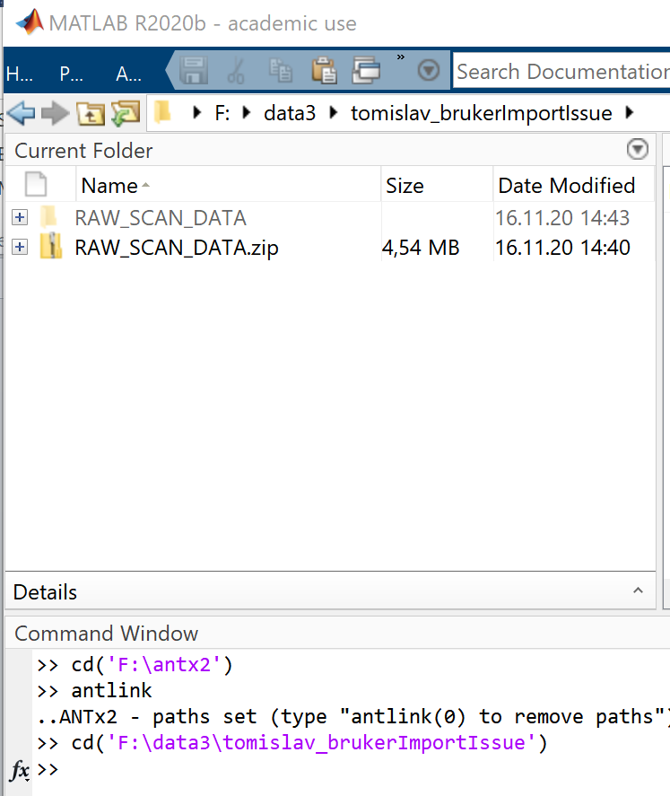

NOTE: I just created a folder ‘tomislav_brukerImportIssue’. This folder contain a folder with the unzipped raw-bruker data (‘RAW_SCAN_DATA’)

Start the GUI:
Type ‘ant’
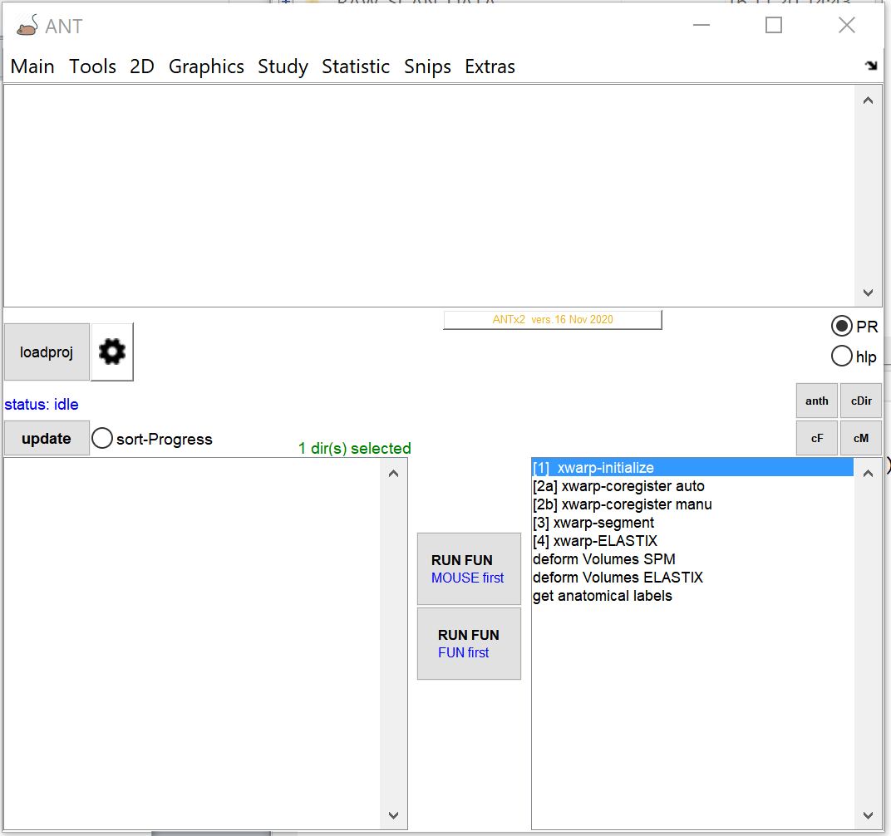

CREATE NEW PROJECT:
From ANT-menu: select Main/New Project
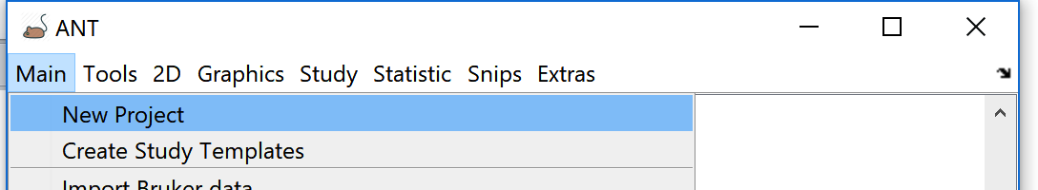

In the parameter window define the reference system (templates). This is important. The reference system defines the animal-related space and Atlas
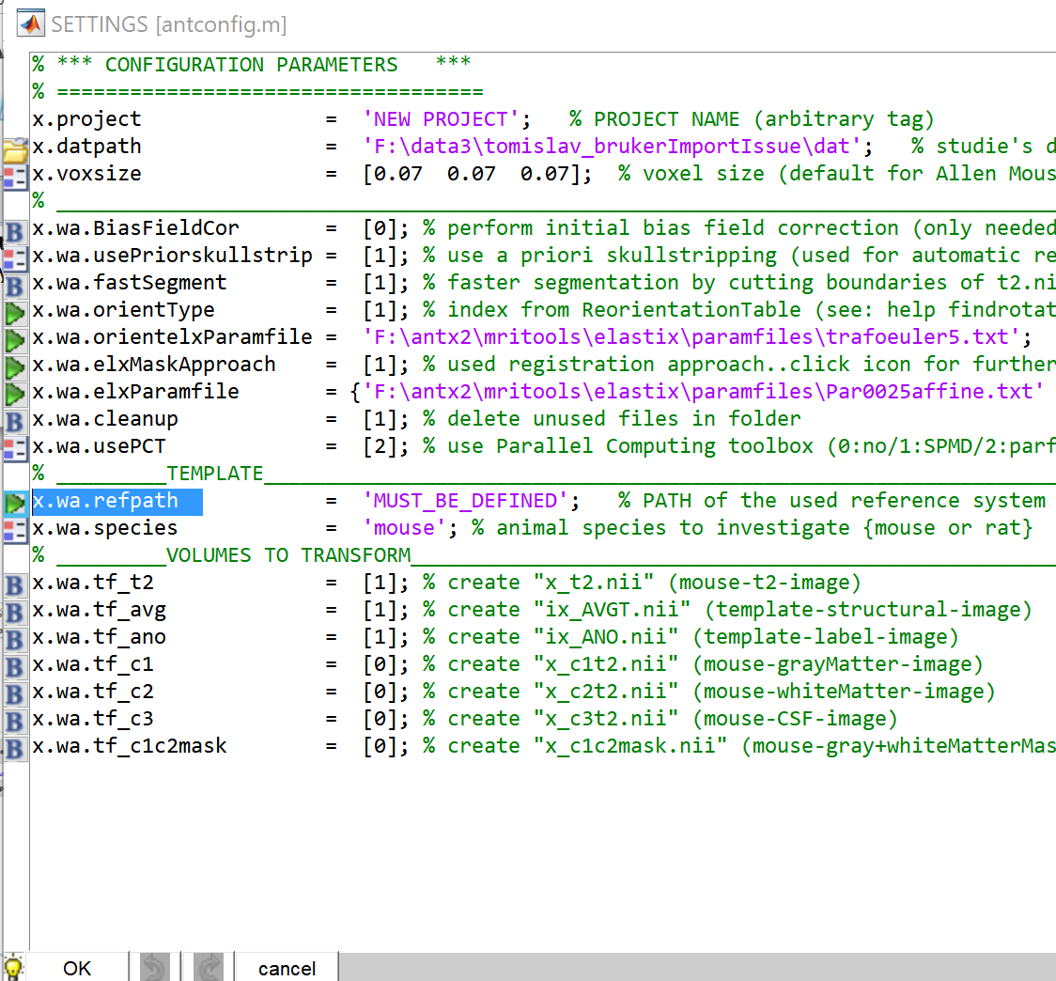
For this, select the green icon left to the ‘refpath’-parameter.

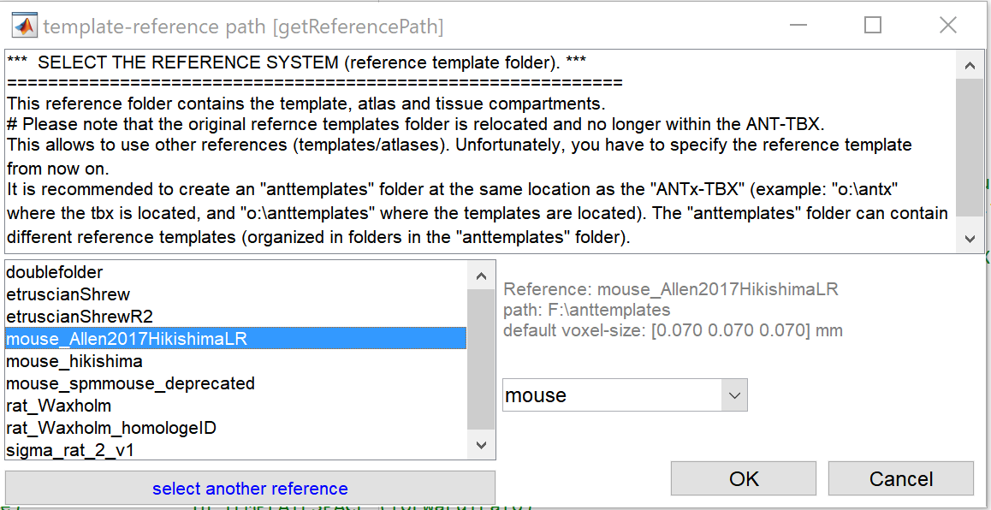
Select the reference system from left listbox. Here, I selected the Allen Mouse atlas with Hikishima TPMs (highlighted). Hit [OK]. Note that the left listbox contains only templates that have been already downloaded (To download the templates use either ANT-Menu: EXTRAS/ get templates from googledrive or EXTRAS/ download templates).

The parameter window should now look as follows:
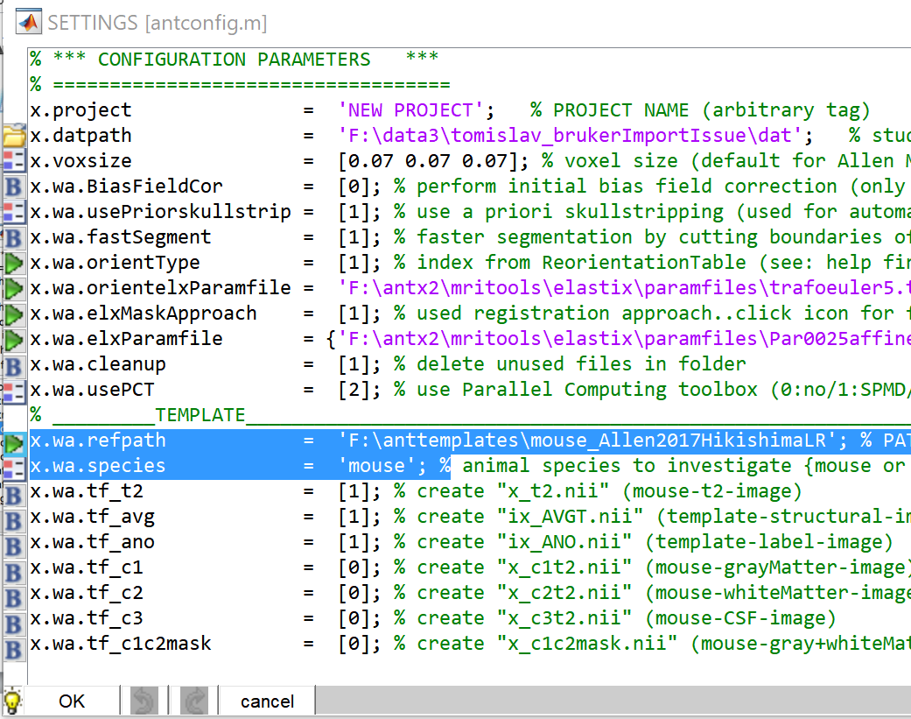

I.E: the reference system and the animal species are defined. Hit [OK].
When hitting [OK], the user is prompted to save the project-file name (the project file is just a Matlab m-file with parameter settings).
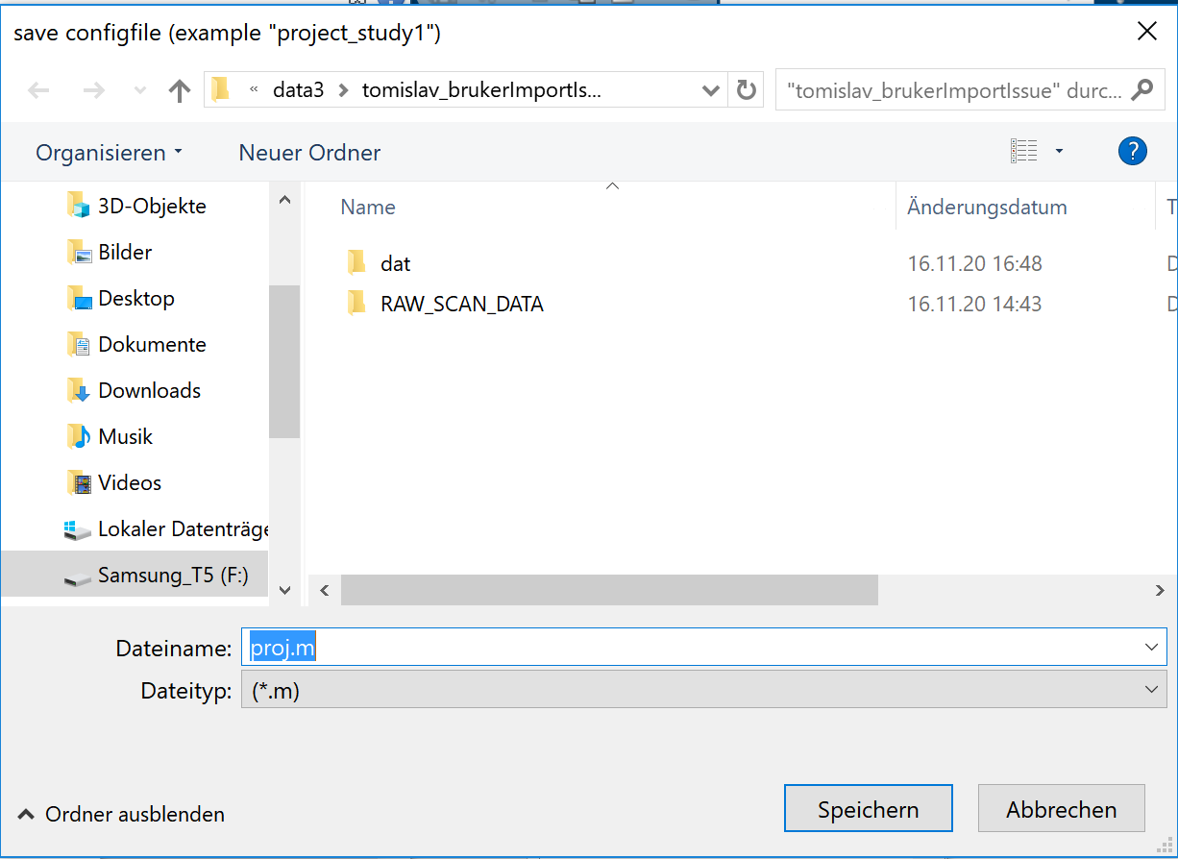
Please save this file in the study folder. (Example: F:\data3\tomislav_brukerImportIssue). Hit [SAVE] (german: ‘Speichern’). If so, another window pops up and ask whether to load the project.
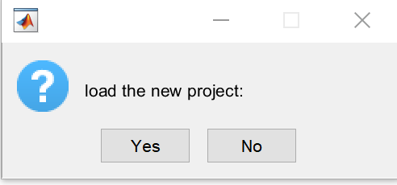
Hit [YES].
NOTE: In the next session just open the ANT GUI and select [loadproj]-button from the main GUI to load the studie’s project file (aka parameter file).

The Study-folder “tomislav_brukerImportIssue” now contains:
RAW_SCAN_DAT : Folder with Bruker-raw data (btw. The data can be stored somewhere else … it’s more convenient for now)
Dat: Folder, that is created when setup a new project. Later this folder will contain the data for all animals
proj.m : parameter file (project file).

BRUKER IMPORT

Go to ANT-MENU: Main/import Bruker data
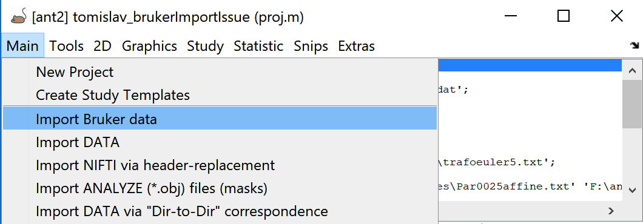

In the Selection window select the Bruker raw data “RAW_SCAN_DATA” from the right listbox
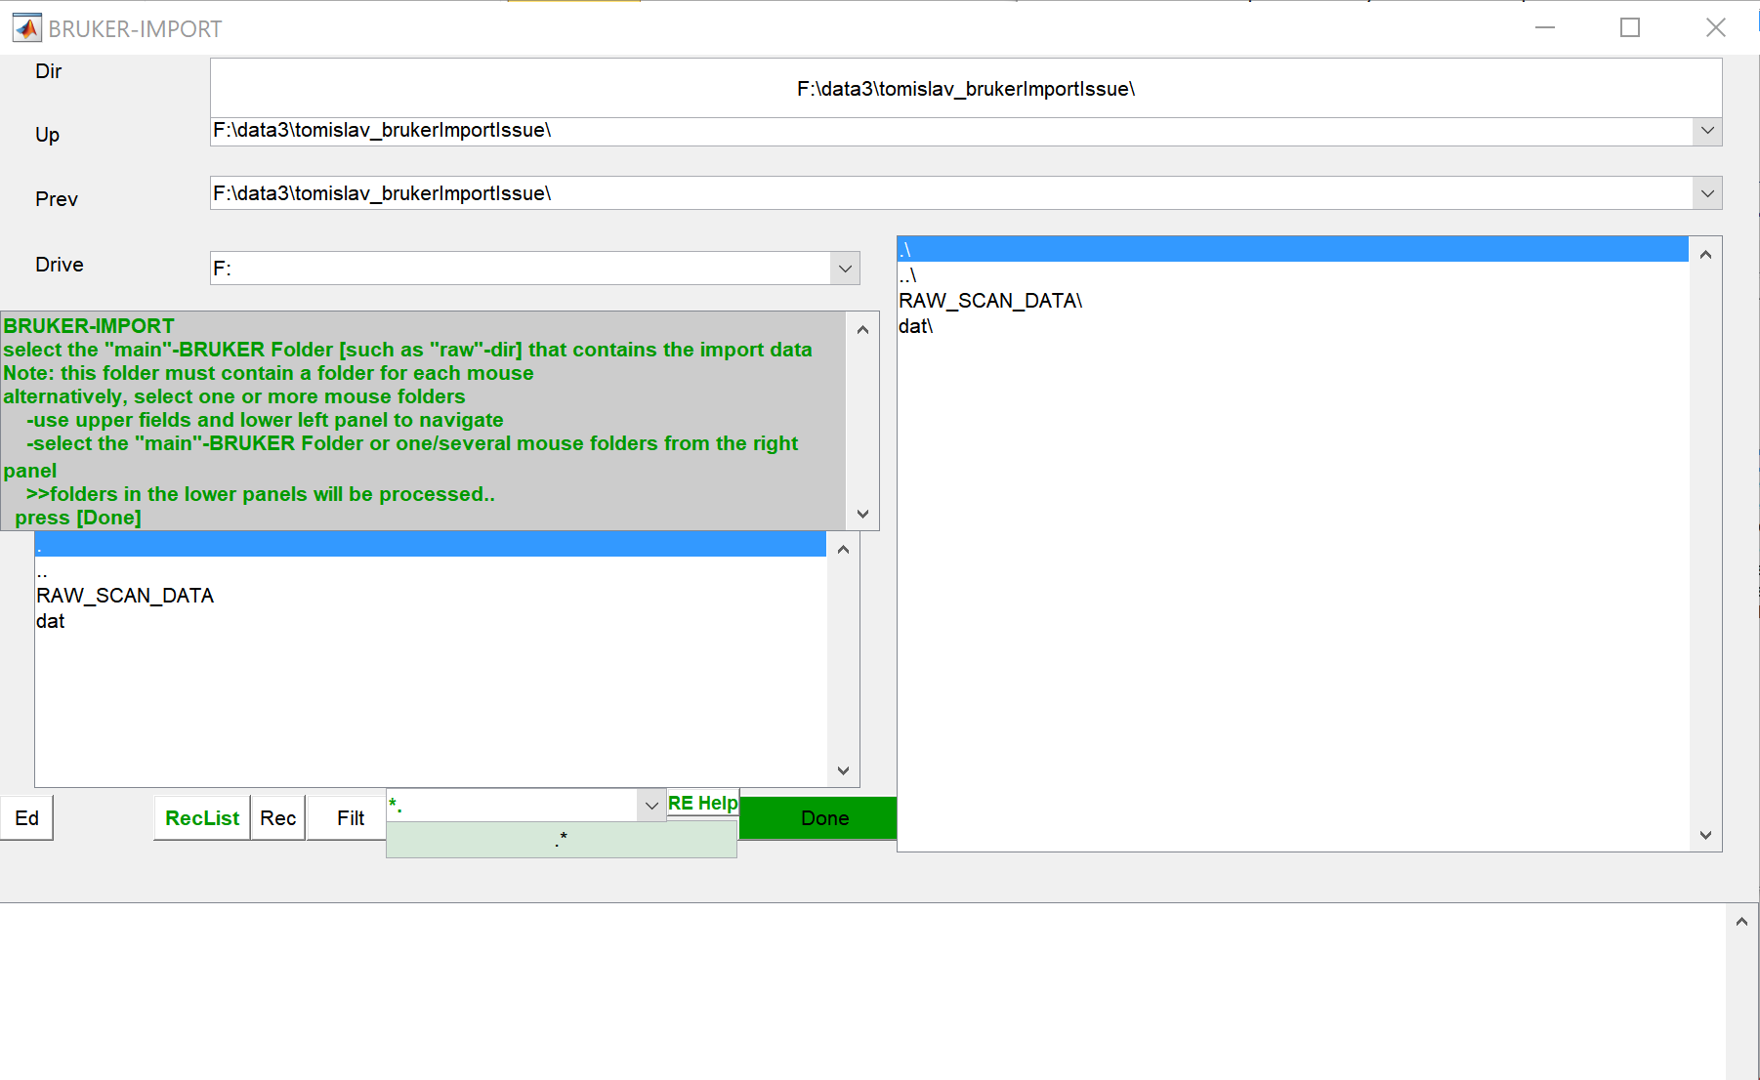
NOTE: The item(s) disappear(s) and reappear(s) in the lower listbox when selecting from the right listbox.
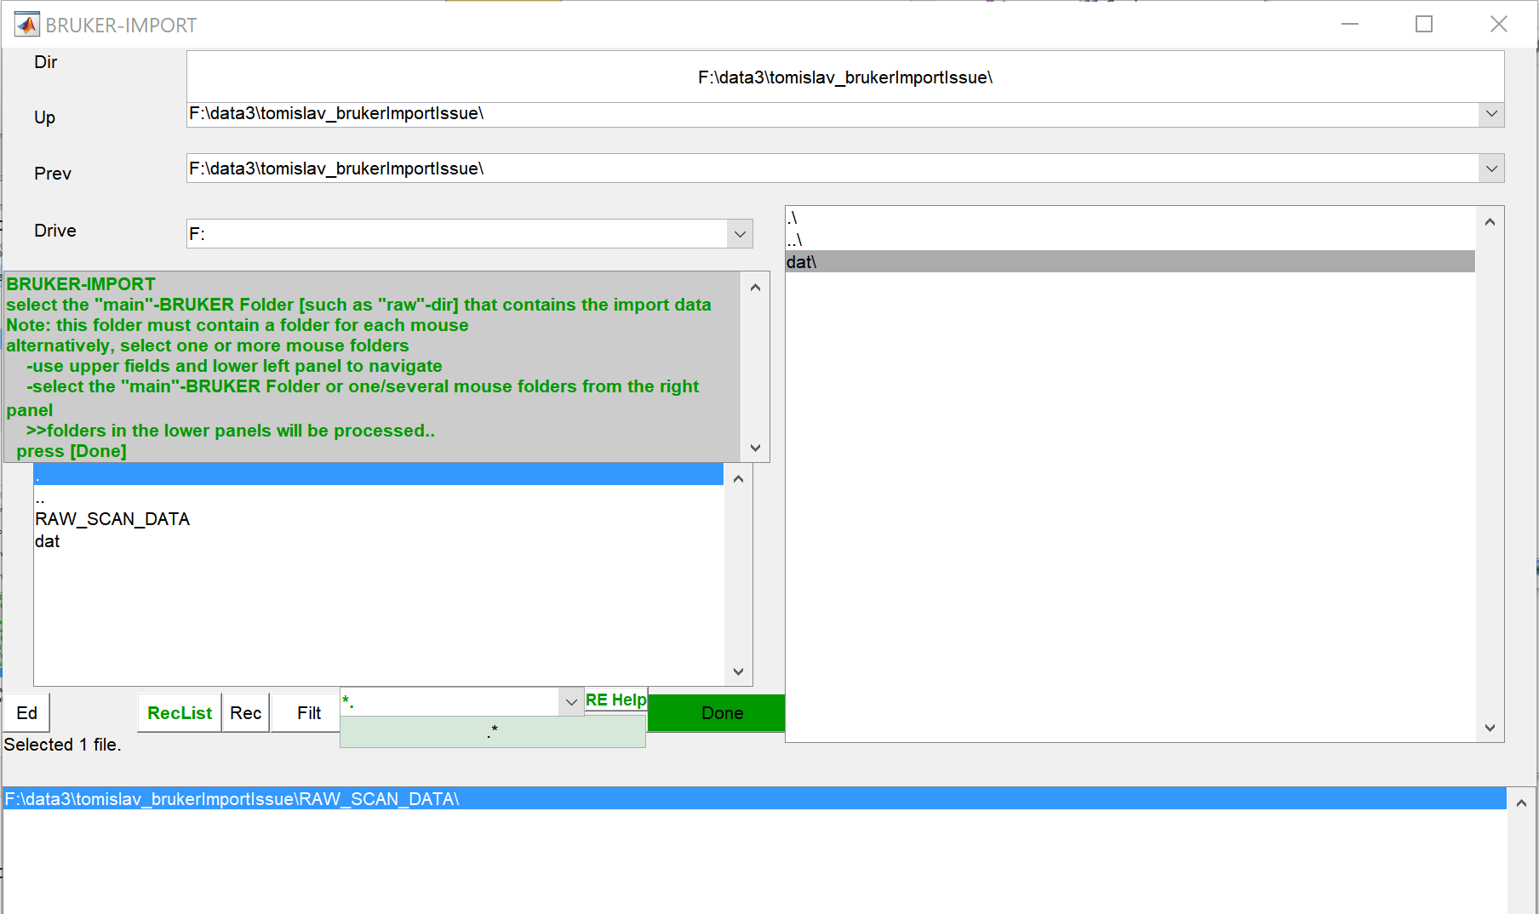
Hit [Done].

The Bruker-File selection window lists all available Bruker data.
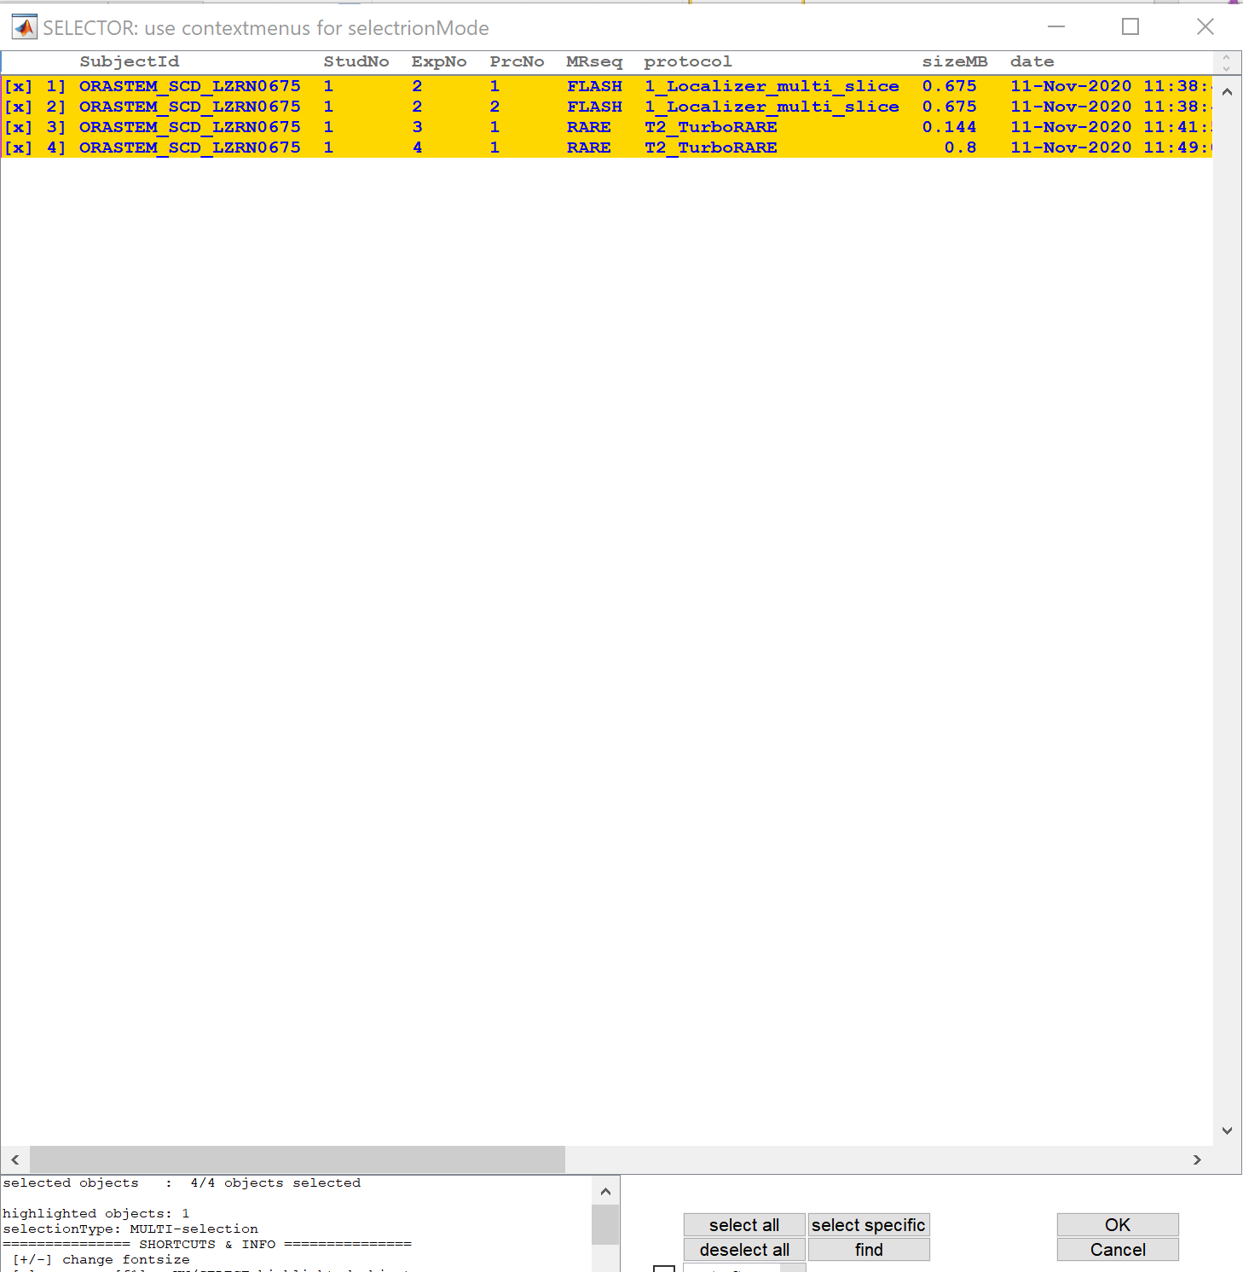

Select the files you want to convert. Here I selected all files. Hit [OK].

Now the Bruker-parameter window pops up. This window shows all available and changeable parameters:
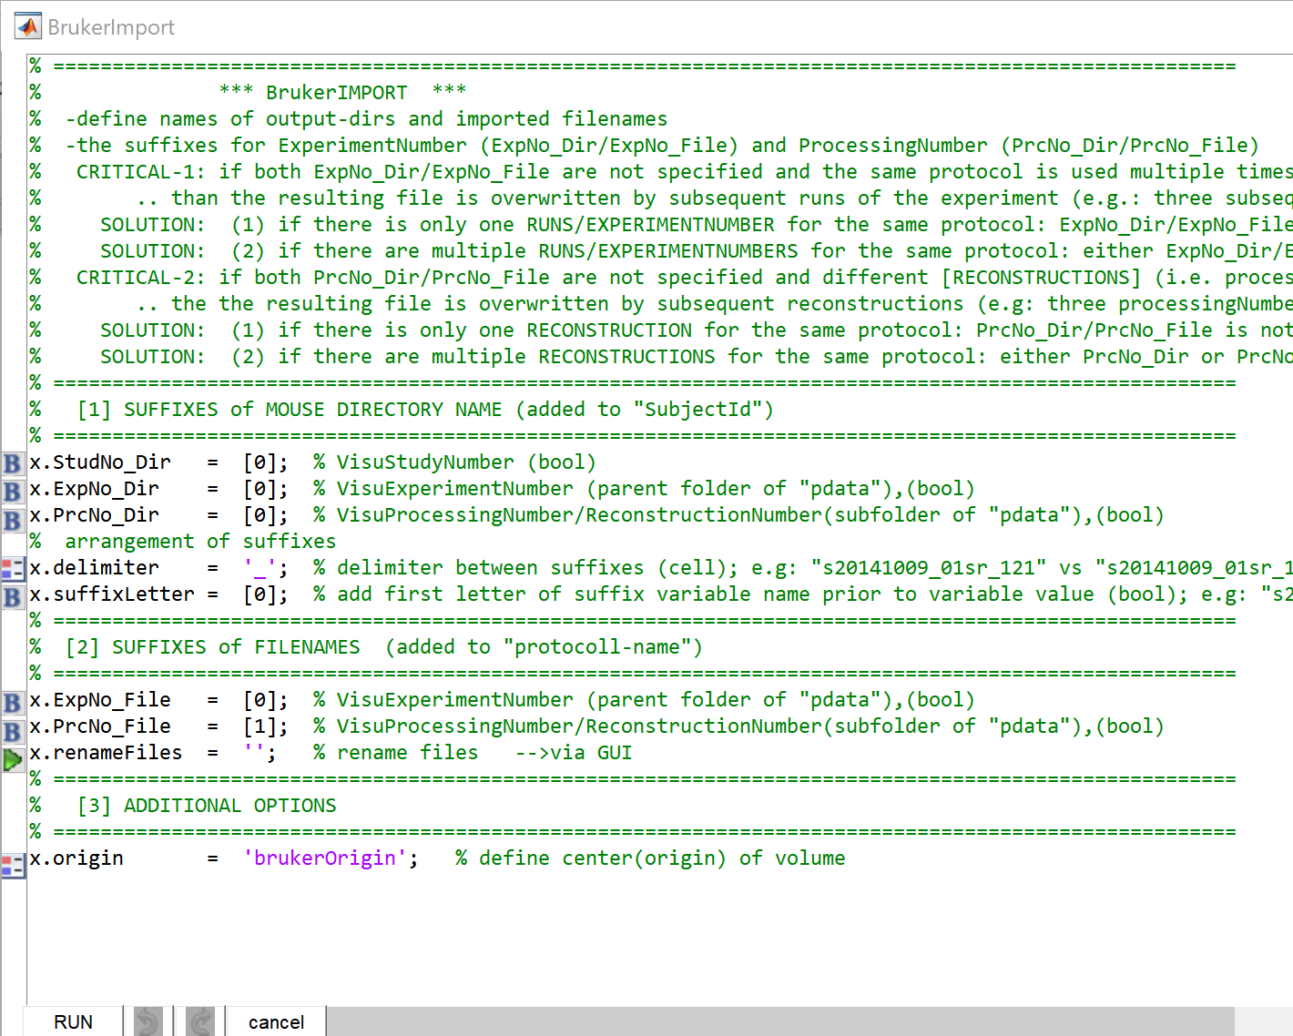
Here, use the default parameter setting. Hit [RUN].
At this step, all selected Bruker files should be converted to NIFTI-files and stored in the study’s ‘dat’-folder.
The main gui shows a new folder (i.a. one animal) in the left list-box. Here data of only one animal were converted.
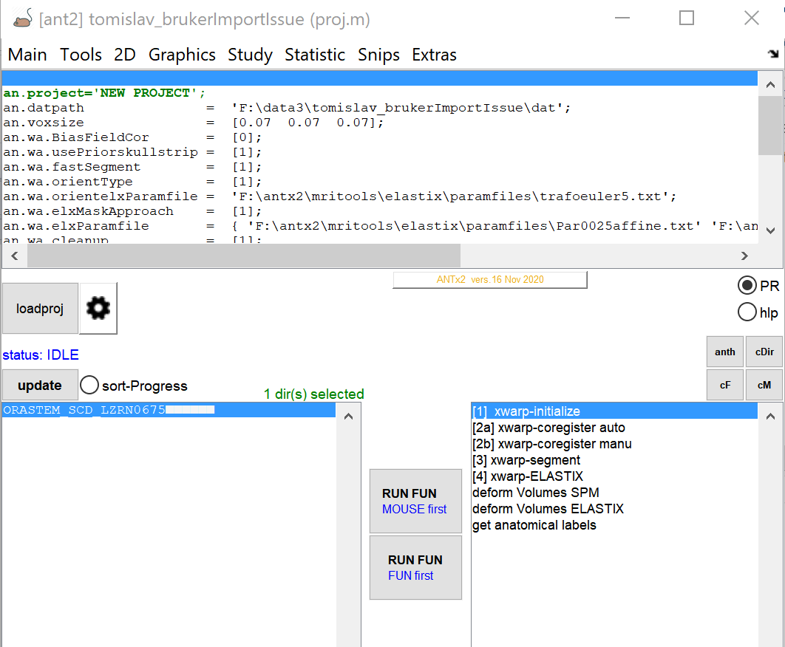

The animal folder ‘ORASTEM_SCD_LZRN0675’ was created in the ‘dat’-folder and contains the following files:
“1_Localizer_multi_slice_1.nii”
“1_Localizer_multi_slice_2.nii”
“T2_TurboRARE_1.nii”

IMPORTANT:
In fact, 4 Bruker files were selected in the Bruker file-selection window (see above),. However, only 3 files were converted. This issue arises if Bruker files have identical “VisuProcessingNumber or ReconstructionNumbers for different scans (happens for instance if the MR sequence was repeated). Here, the “T2_TurboRARE” protocols were repeated (2x). After conversion of the 1st “T2_TurboRARE” file the 2nd “T2_TurboRARE” file overwrites the 1st one. To obtain all files you have to set the Experiment-Number in the Bruker-Parameter window to [1]. (i.e : x.ExpNo_File = [1] ).

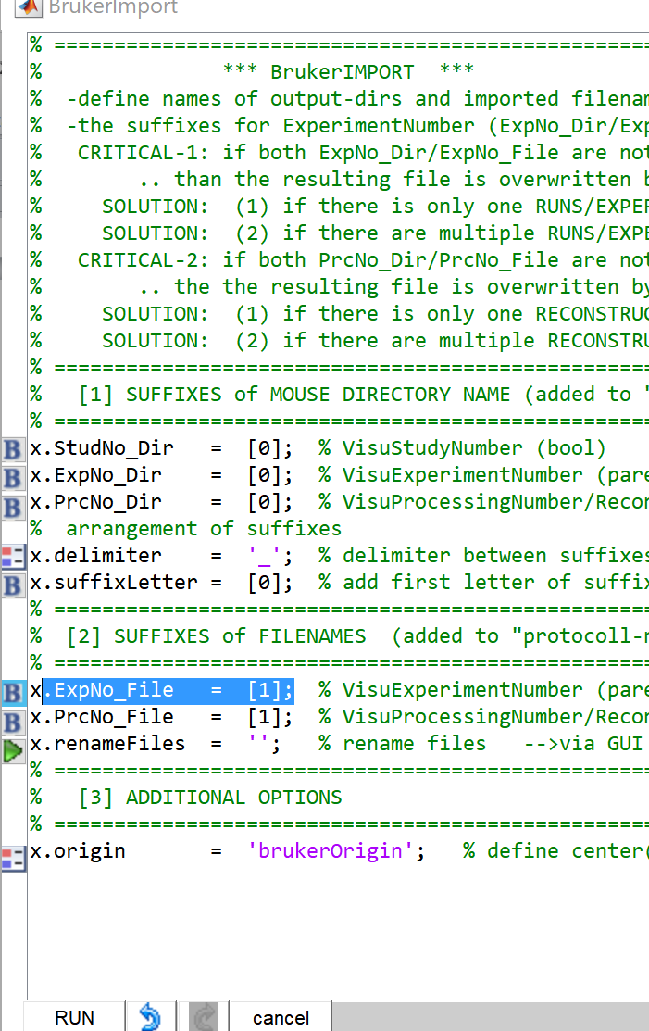

This option adds the experiment number to the converted Nifti filename and prevents overwriting scans with the same protocol name.

Now the animal folder ‘ORASTEM_SCD_LZRN0675’ in the ‘dat’-folder contains the following files:
'1_Localizer_multi_slice_2_1.nii'
'1_Localizer_multi_slice_2_2.nii'
'T2_TurboRARE_3_1.nii'
'T2_TurboRARE_4_1.nii'

Filename construction: “protocolName+ExperimentNumber+ExperimentNumber

For other information
→ ANT-MENU: EXTRAS/documentation (docs)
What could be read next?: “tutorial_orientation_and_manucoreg.doc”

