**Tutorial mask-based parameter extraction**

**from images in native space**

**Scenario:**

A mask was generated for each animal in native space. The mask contains two ROIs: ROI-1 with ID-1 (value is 1) and ROI-2 with ID-2 (value is 2).

For a specific image in native space, we want to extract basic parameters such as mean/min/max/number of voxels and volume for each ROI of the mask.

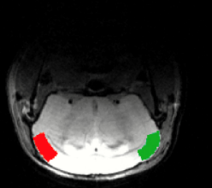Example: t2.nii-image overlayed with the mask 'EMS.nii', both images in Native space. The mask contains two ROIs.

**Content**

**1) Prerequisite**

**2) Steps to perform the parameter extraction**

2.1) **Readout-file selection**

2.2) **Mask-file selection**

2.3) **Select a filename-prefix for resulting excel-file**

**3) The output: Excel-file**

**4) Batch**

**1) Prerequisite**

For all animals the mask file (here: 'EMS.nii’) and the readout-file for parameter-extraction (here: ‘rc_rCBV.nii’) exist. Mask-file and readout-file should meet the following criteria:

- share same space (here: native space)

- In register to each other

- Ideally same voxel-size and identical header-matrix

**2) Steps to perform the parameter extraction**

-Select all animals from the left animal list box

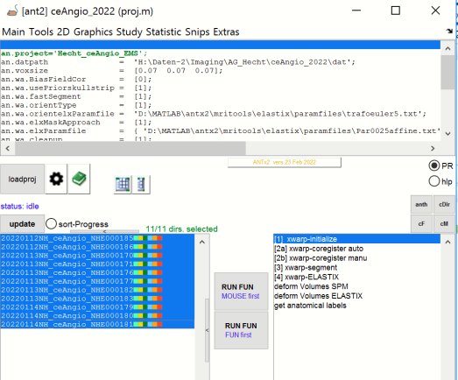

-go to MENU: **Statistic**/obtain parameter from masks

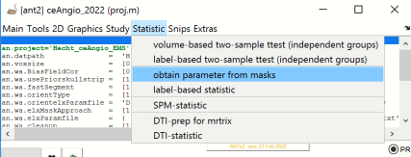

-this opens the parameter-GUI

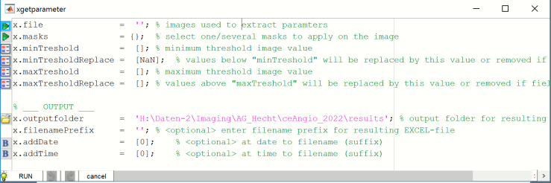

Now do the following steps:

2.1) **Readout-file selection**

- select green icon left to the **x.file**-parameter

- from the file-section window select “**rc_rCBV.nii**” 🡪 hit [OK].

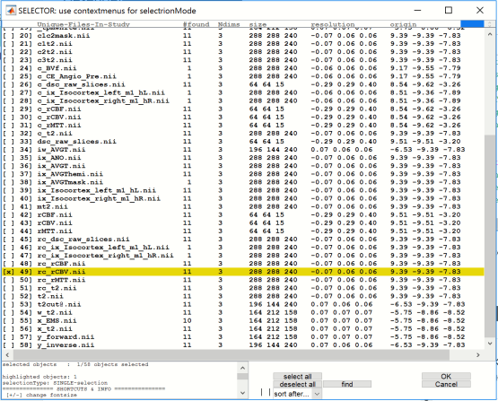

2.2) **Mask-file selection**

- select green icon left to the **x.masks**-parameter …this opens a dialog…

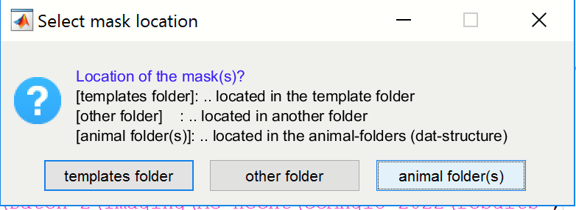

-select [animal folder(s)] from the question-dialog

Reason: In this example each animal has it’s own mask (native space), stored in the respective animal-folder (within the “dat”-folder).

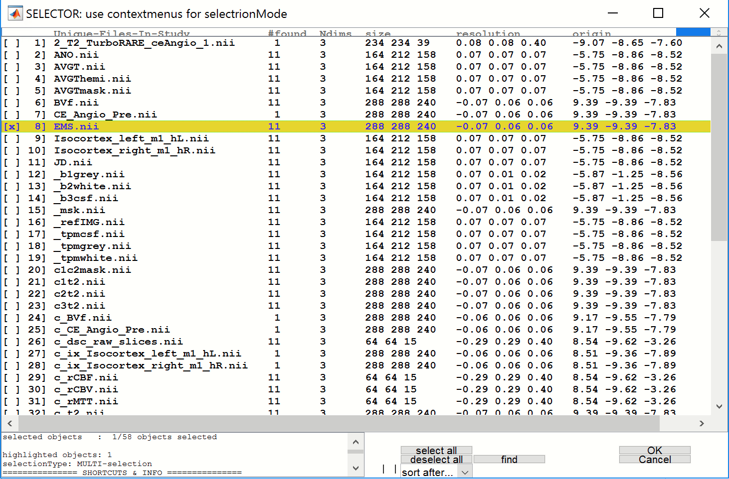

- from the file-section window select the “**EMS.nii**”-file 🡪 hit [OK].

**Remember**: the “EMS.nii”-file is a mask-file containing 2 ROIs.

**Important-1: selection of multiple masks possible here**

You can also select more than one mask-image in this step. The numeric-Ids (values) in each mask-file do not interfere with the numeric ids of other selected masks during read-out and creation of the excel-file.

**Example:** Theoretical scenario: You have 2 masks:

-Mask1: “mask-1.nii” with 4 ROIs and respective ids: 1,2,3,4 and

-Mask2: “mask-2.nii” with 3 ROIs and respective ids: 1,2,3

🡪 You can select the two mask “mask-1.nii” and “mask-2.nii” in one step here

🡪 The resulting excel-file will contain the mask-file name and the respective ID of the two masks.

Example in the output-file:

mask-1__ID_1 .. with parameter extraction here

mask-1__ID_2 .. with parameter extraction here

mask-1__ID_3 .. with parameter extraction here

mask-1__ID_4 .. with parameter extraction here

mask-2__ID_1 .. with parameter extraction here

mask-2__ID_2 .. with parameter extraction here

mask-2__ID_3 .. with parameter extraction here

**Important-2: A text-file with specific labels can be used in combination with the mask**

If a text-file with IDs and label is provided, the labels will be used in the resulting excel-file

To following is mandatory when using a text-file:

- text-file must have the same name as the mask-file

🡪 example: for “**EMS.nii**” the text-file would by “EMS.txt”

- text-file and mask-file must be in the same folder

🡪 in this example both files would be in the animal folders

- the text-file contains: the id (value) and the label for each ROI in the mask (row-wise)

🡪 for example, for this tutorial the text-file would contain:

1 L_somat_Cortex

2 R_somat_Cortex

2.3) **Select a filename-prefix for resulting excel-file**

- for the parameter: **filenamePrefix** type an arbitrary string that is used as prefix in the resulting filename. Here, I used ‘EMS_rc_rCBV’ ( here a combination of mask- and readout-filename) as prefix

The parameter window should now look as follows:

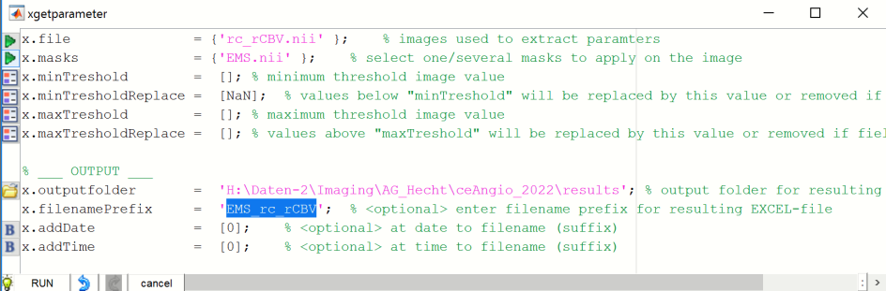

**Optional Settings**

1) minTreshold: set a min-threshold for the readout-image …, in this case: values below this values will by replace by the value defined by minTresholdReplace (here NAN-values).

The latter can be changed via “minTresholdReplace”-parameter.

🡪 example: minTreshold =3 and minTresholdReplace=3: In this case values below 3 will be replaced by the value 3

2) maxTreshold/TresholdReplace: …same logic …

3) outputfolder: change output-folder …default: “results”-folder in the study-folder

4) addDate & addTime : add date & time to the filename of the new excel-file

-finally hit [RUN]

**3. The output: Excel-file**

-When the parameter “outputfolder” is not changed the resulting excel-file will be stored in the “**results**”-folder of the current study (aka project).

-Here the name of the **Excel-file** is “**res_EMS_rc_rCBV_maskParameter.xlsx**” (“res”+filenamePrefix + “_maskParameter.xlsx”)

-T**he Excel-file contains the following sheets:**

'info' basic information: date/mask-name/animals/ missing animals (due to missing files)

'frequencyMsk' : number of voxels for each ROI (real ROI-size , readout-image independent,

true size of the ROI)

'volMsk' : volume of the ROI (real ROI-size , readout-image independent,

true size of the ROI)

'frequency' : number of voxels for each ROI (readout-image dependent,

NaN/threshold dependent🡪thus can be smaller than 'frequencyMsk')

'vol' : volume of the ROI (readout-image dependent (Nan-values!))

NaN/threshold dependent🡪thus can be smaller than 'volMsk')

'mean' : mean intensity value of readout-image within ROI

'std' : standard deviation over intensities of readout-image within ROI

'median' : median intensity value of readout-image within ROI

'integrDens' : product of number voxels and mean intensity of readout-image within ROI

'min' : min intensity value of readout-image within ROI

'max' : max intensity value of readout-image within ROI

**- The parameter-sheets have the following structure:**

-ROWS: …ROI-MASK , i.e., each row represents the parameter readout for a specific ROI

-COLUMNS:…ANIMALS, i.e. each column contains the data of one animal

Example: mean-parameter (sheet: “mean”): Here we have two ROIs from one mask-image (represented in rows) and a number of animals (columns).

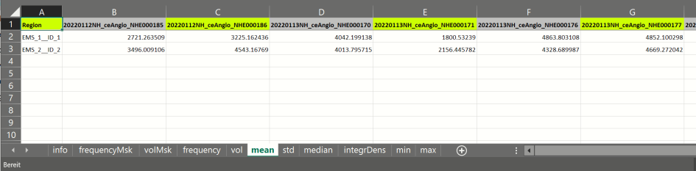

**4. Batch**

-type **anth** to obtain the code… alternatively you could type: **uhelp(anth)** or hit the [anth]-button from the ANT-GUI.

- you can than copy and modify the code

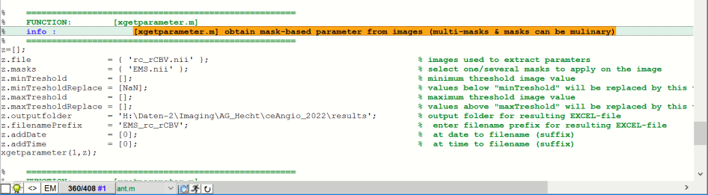

Here is the code to rerun the task:

% % =====================================================

% % #g FUNCTION: [xgetparameter.m]

% % #b obtain mask-based parameter from images (multi-masks & masks can be mulinary)

% % =====================================================

z=[];

z.file = { 'rc_rCBV.nii' }; % % images used to extract paramters

z.masks = { 'EMS.nii' }; % % select one/several masks to apply on the image

z.minTreshold = [0]; % % minimum threshold image value

z.minTresholdReplace = [NaN]; % % values below "minTreshold" will be replaced by this value or removed if field is empty

z.maxTreshold = []; % % maximum threshold image value

z.maxTresholdReplace = []; % % values above "maxTreshold" will be replaced by this value or removed if field is empty

z.outputfolder = 'H:\Daten-2\Imaging\AG_Hecht\ceAngio_2022\results'; % % output folder for resulting EXCEL-file

z.filenamePrefix = '_test'; % % <optional> enter filename prefix for resulting EXCEL-file

z.addDate = [1]; % % <optional> at date to filename (suffix)

z.addTime = [1]; % % <optional> at time to filename (suffix)

xgetparameter(1,z);