# **MPM-toolbox**

## **AIMS**

MPM-functions to run the hMRI-toolbox for rodent data (mouse/rat), i.e. for quantitative MRI.

For hMRI-toolbox see

<https://www.cbs.mpg.de/abteilungen/neurophysik/software/hmri-toolbox>

**I) Working with Preprocessing steps .. Working with ANTx**

## **Preprocessing using ANTx2**

-start Matlab

-add ANTx-path via hyperlink or go to ANTx-folder and type “antlink” (this will set the paths of ANTx2)

-add MPM-path via hyperlink or go to mpm-folder and type “mpmlink” (this will set the paths of mpm)

Set Matlab’s current working dir to the studies folder

My current study-folder is F:\data8_MPM\MPM_agBrandt3. This folder contains the subfolder ‘raw’ with two raw data-sets (Bruker format).

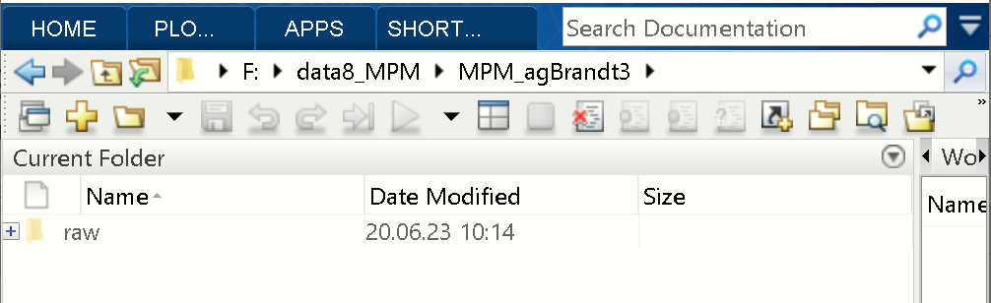

Type “ant” in Matlab command window to open the ANT-gui.

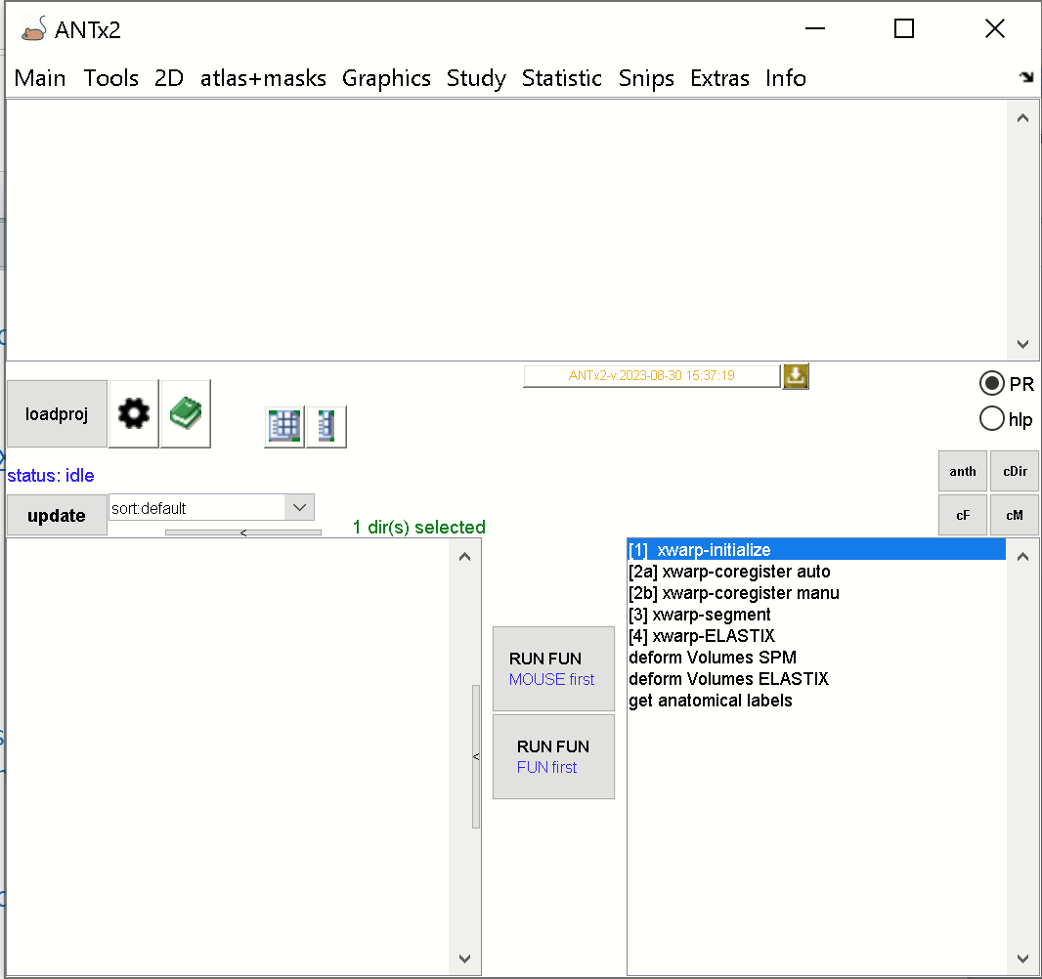

Now, create a new project by selecting Main/New project.

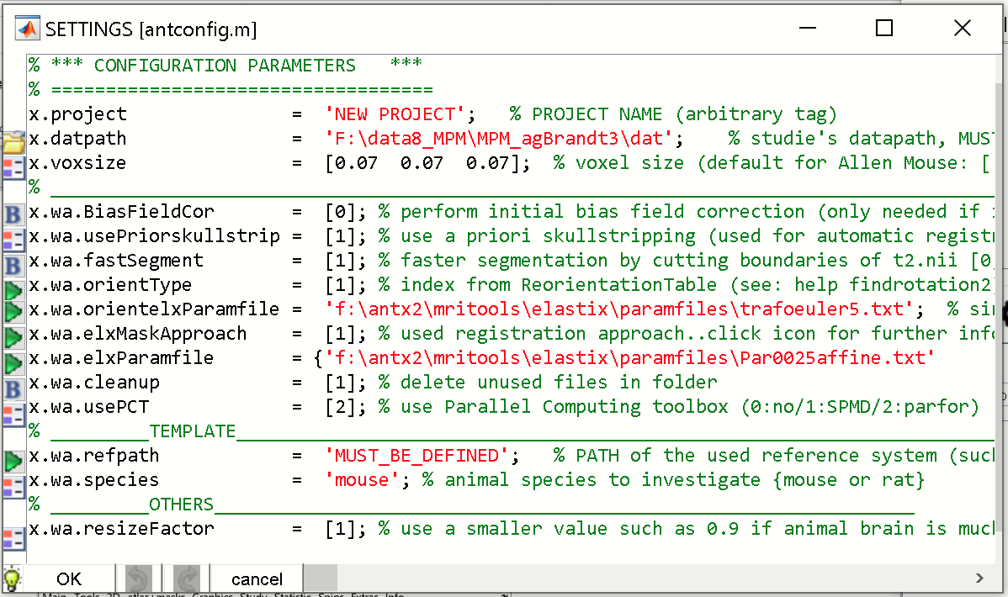

Here you have to specify the reference template. For this, select green icon left to “x.wa.refpath”:

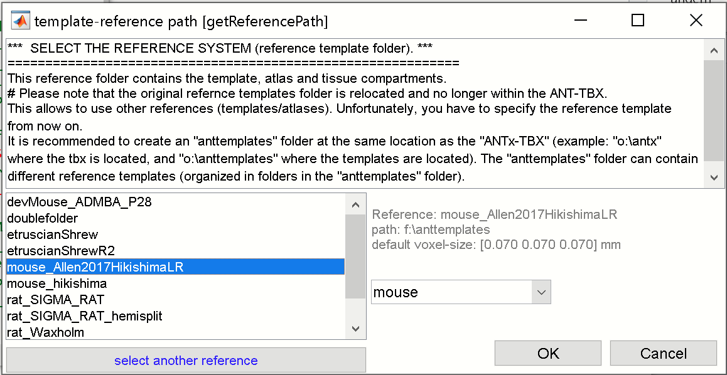

From the template GUI/left listbox select the “mouse Allen2017HikishimaLR”-template. Hit [OK]-button.

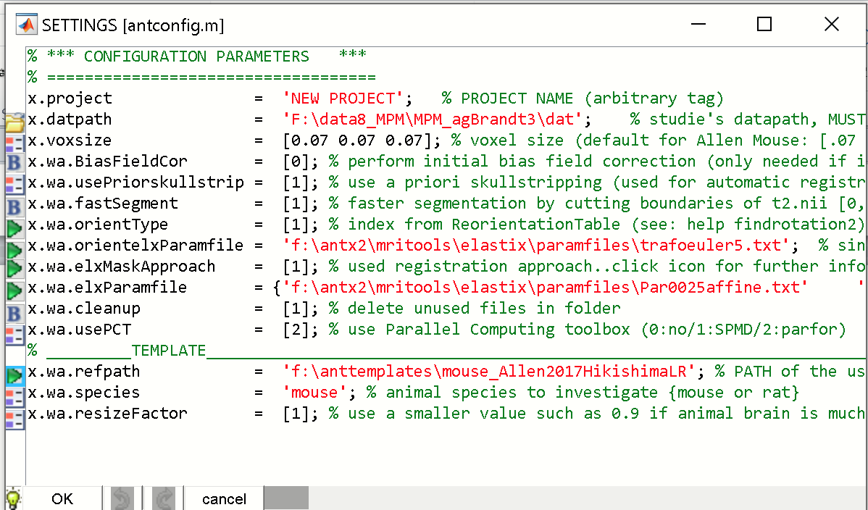

Next, set the following parameters:

x.wa.usePriorskullstrip = 3

x.wa.orientType = 11

The parameter settings should know look as follows:

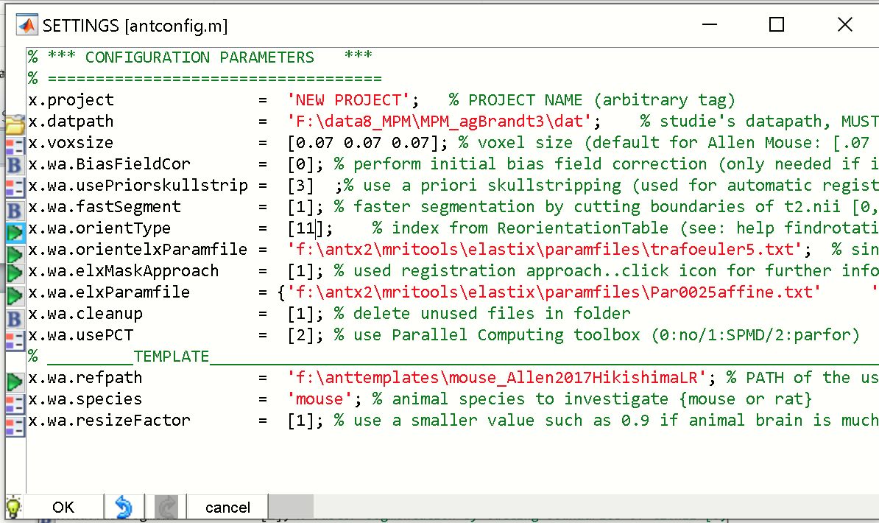

These two parameters .## REASON ##

Hit [OK]-button.

When asked, save the project-file for instance as “proj.m” in the study-folder (here the study folder is F:\data8_MPM\MPM_agBrandt3). When asked to load the project-file (“proj.m”) click [yes]-button.

Now the project-file is defined and loaded into ANTx2-GUI.

**IMPORT BRUKER DATA**

We next have to import the Bruker data from the raw-folder.

For this click MAIN/Import Bruker data. From the ANT-GUI.

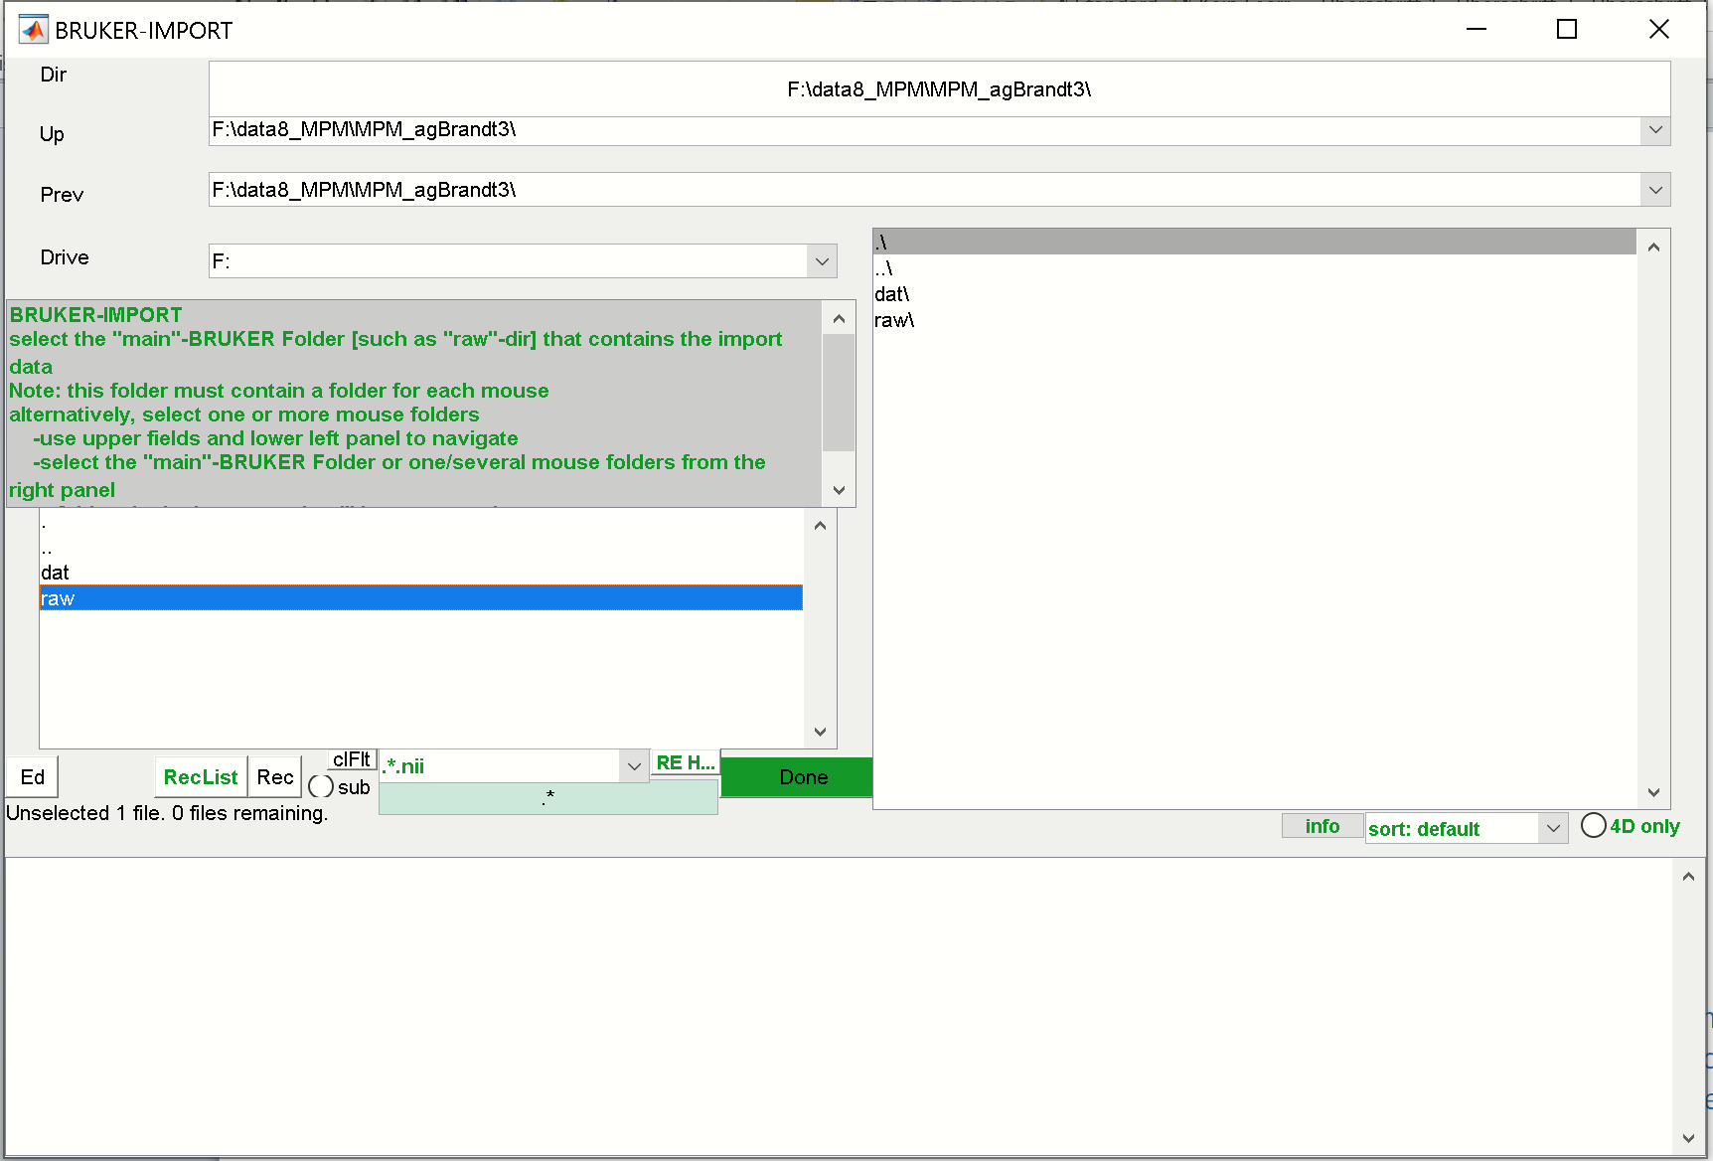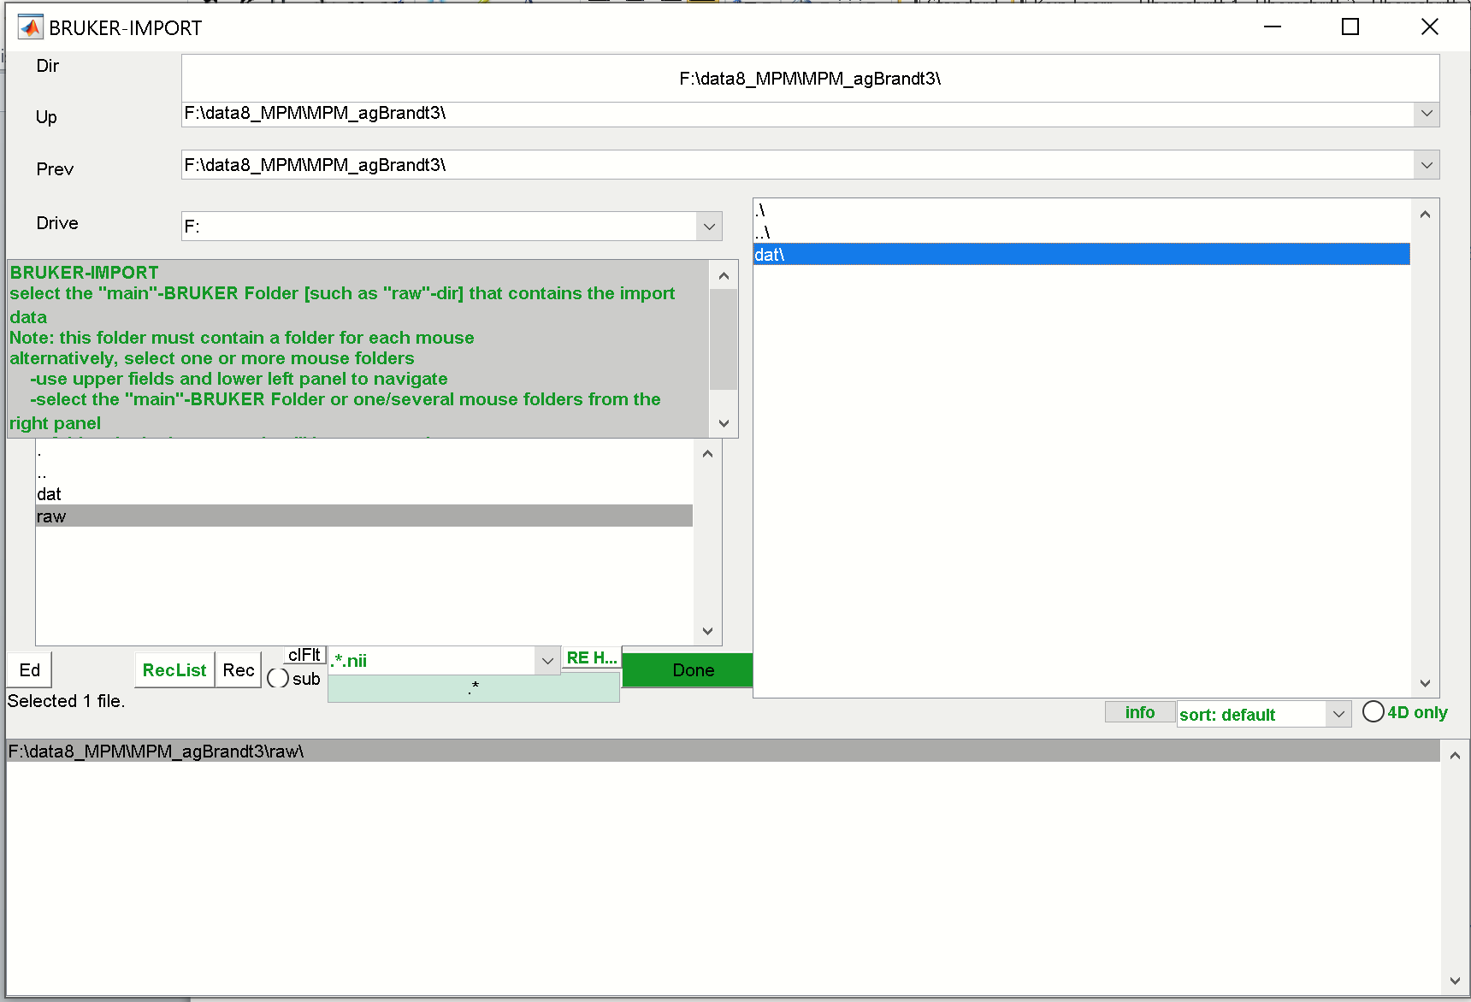

In the Bruker-Import GUI select the “raw”-folder from the right listbox. If selected, this folder will disappear and reappear in the lower listbox. Hit [Done]-button.

The next GUI displays all available files found in in the “raw”-folder

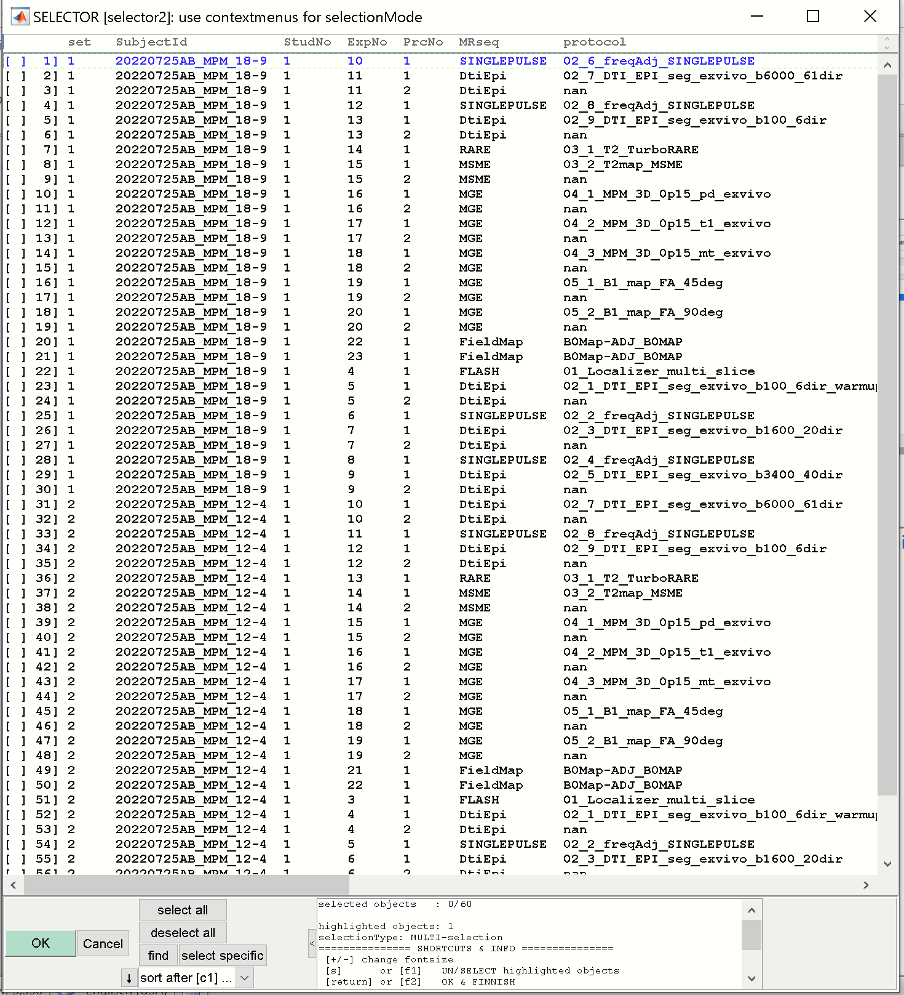

Here we have two datasets (see column “set”). And we select the turborare-file and the PD, T1 and MT for each data set.

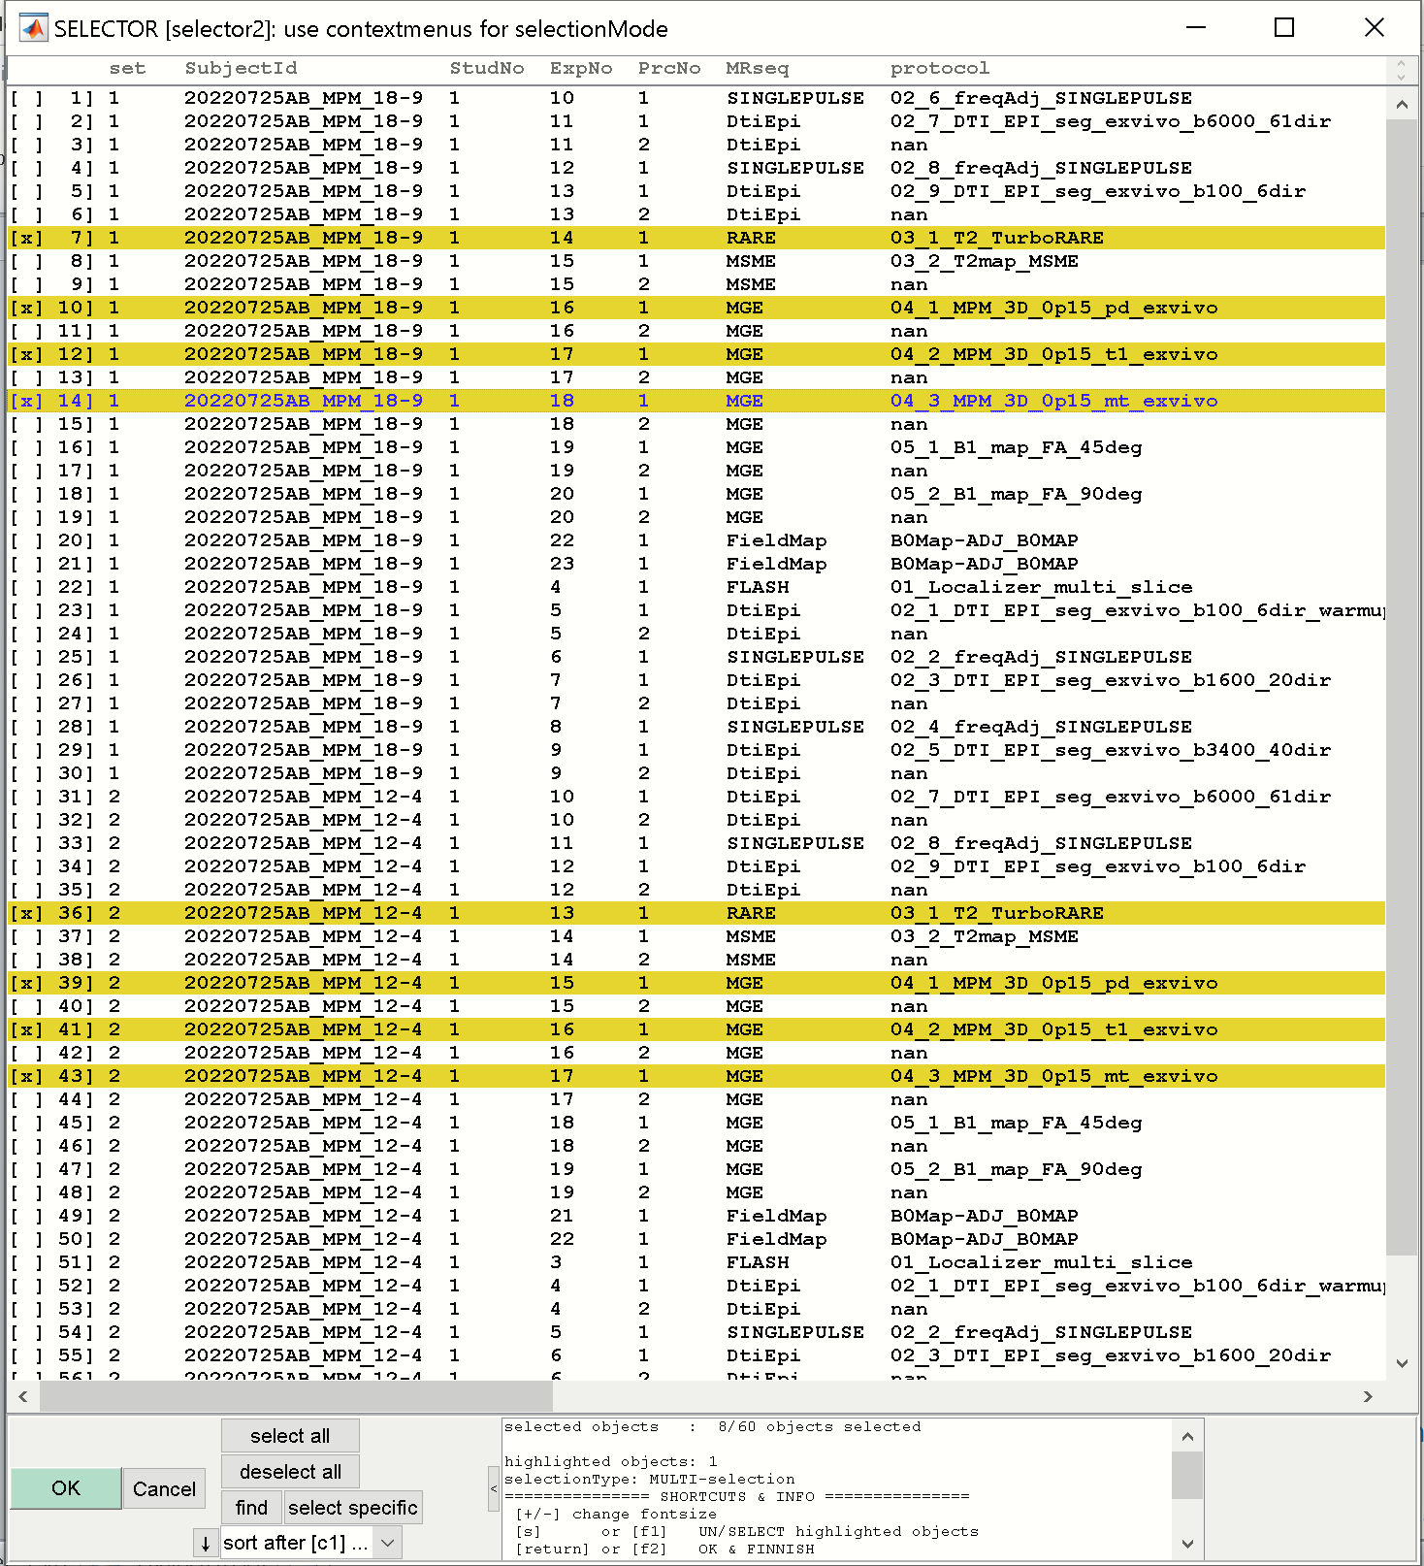

Hit [OK]-button to import these files.

Next the Parameter-file for the Bruker-import appears:

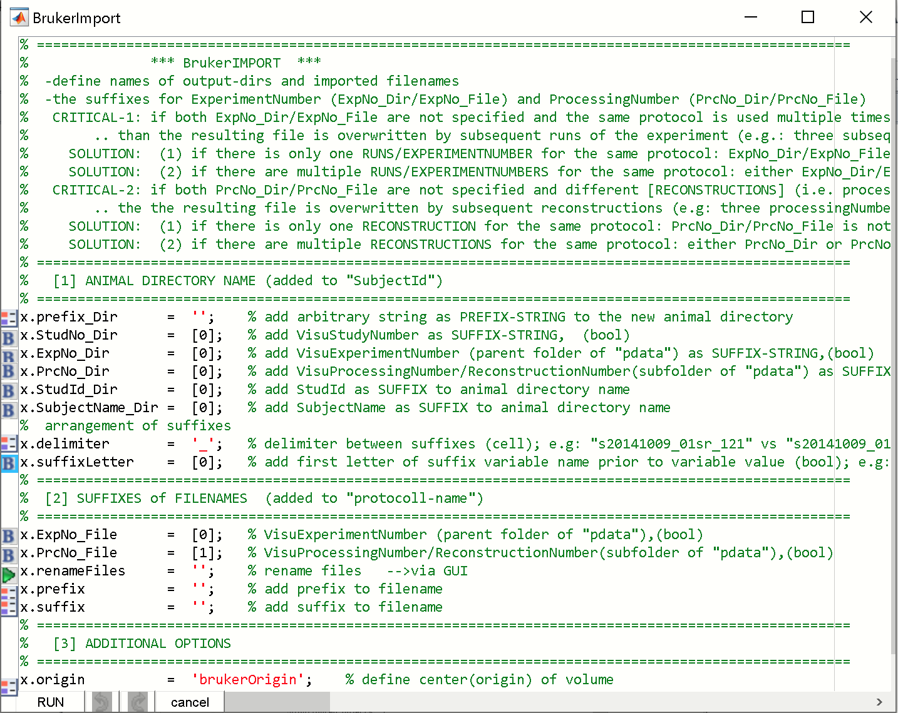

Do nothing here. Hit [RUN]-button

Now, data from two animals were imported (“20220725AB_MPM_12-4” & “20220725AB_MPM_18-9”) as seen in the left listbox (ANTx GUI.)

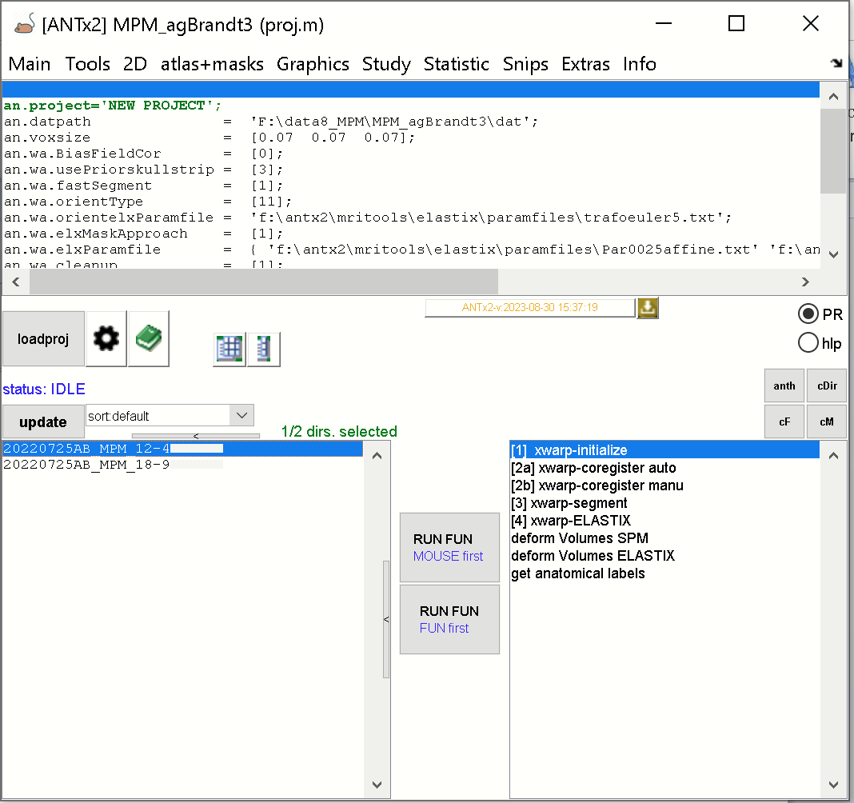

The data of each animal is stored in the “dat”-folde in the current study-folder:

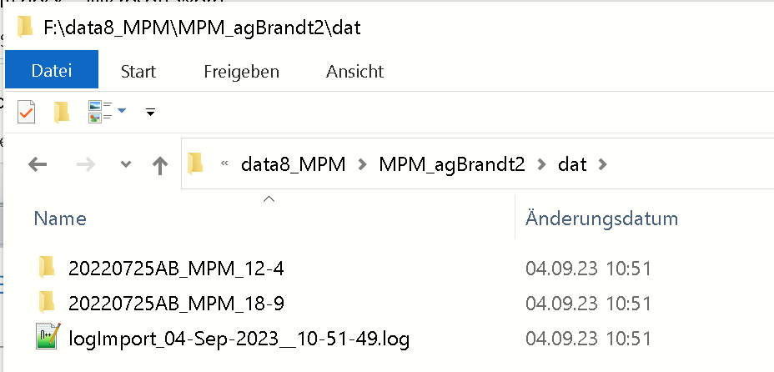

And each animal-folder contains the turborare, the PD, the T1 and MT in NIFTI-format (see fig below):

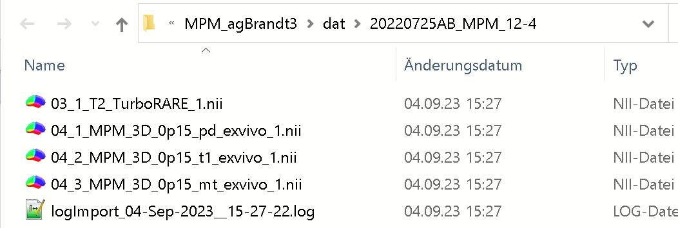

**Starting MPM-GUI**

Set the path of the MPM-wrapper functions now, if not done before (see above).

Type “mpm” in Matlab’s command window to start the mpm-GUI

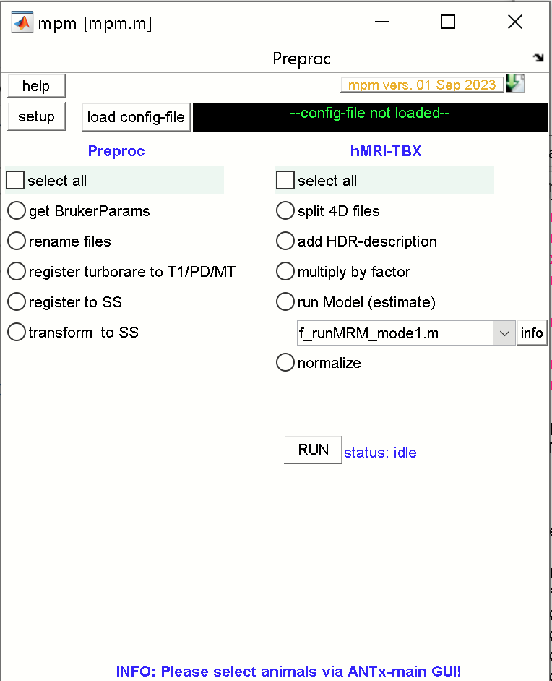

**Configure mpm-setup and parameter files**

Next hit the [setup]-button (this has to be done only once per study).

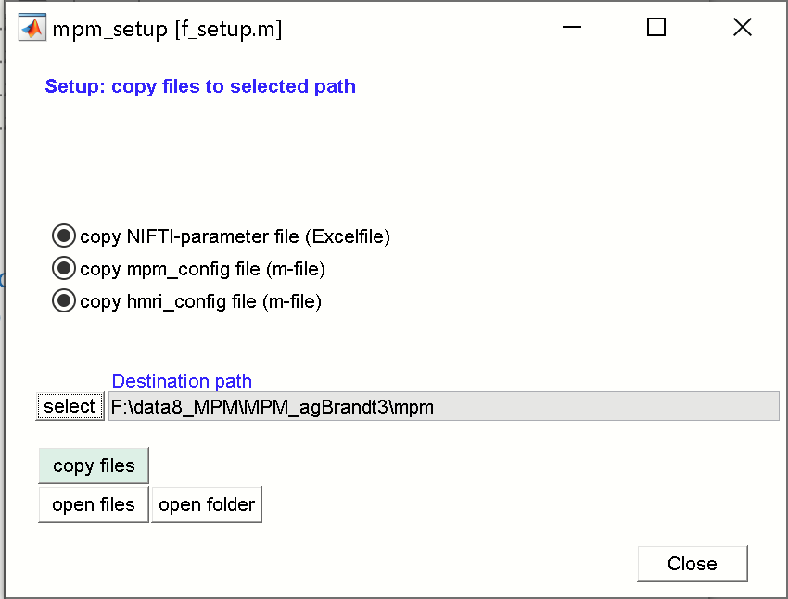

IN the mpm_setup GUI, check that all “copy”-radios are checked. Next, select the destination path by clicking the [select]-button. Here select the current study-folder (my folder is “MPM_agBrandt3”). In most cases an “mpm”-folder is added to the path. Next hit [copy files] to cype these three files to the new “mpm”-folder within the current study folder. When done hit [close]-button to close the mpm_setup GUI.

The new “mpm”-folder within the current study folder will now contain 3 files, which have to be modified to run the MPM-wrapper functions. The names of the three files are fixed:

1) “mpm_NIFTIparameters.xlsx”

2) “mpm_config.m”

3) “hmri_local_defaults_mouse.m”

**1) “mpm_NIFTIparameters.xlsx”**

The excelfile looks as follows:

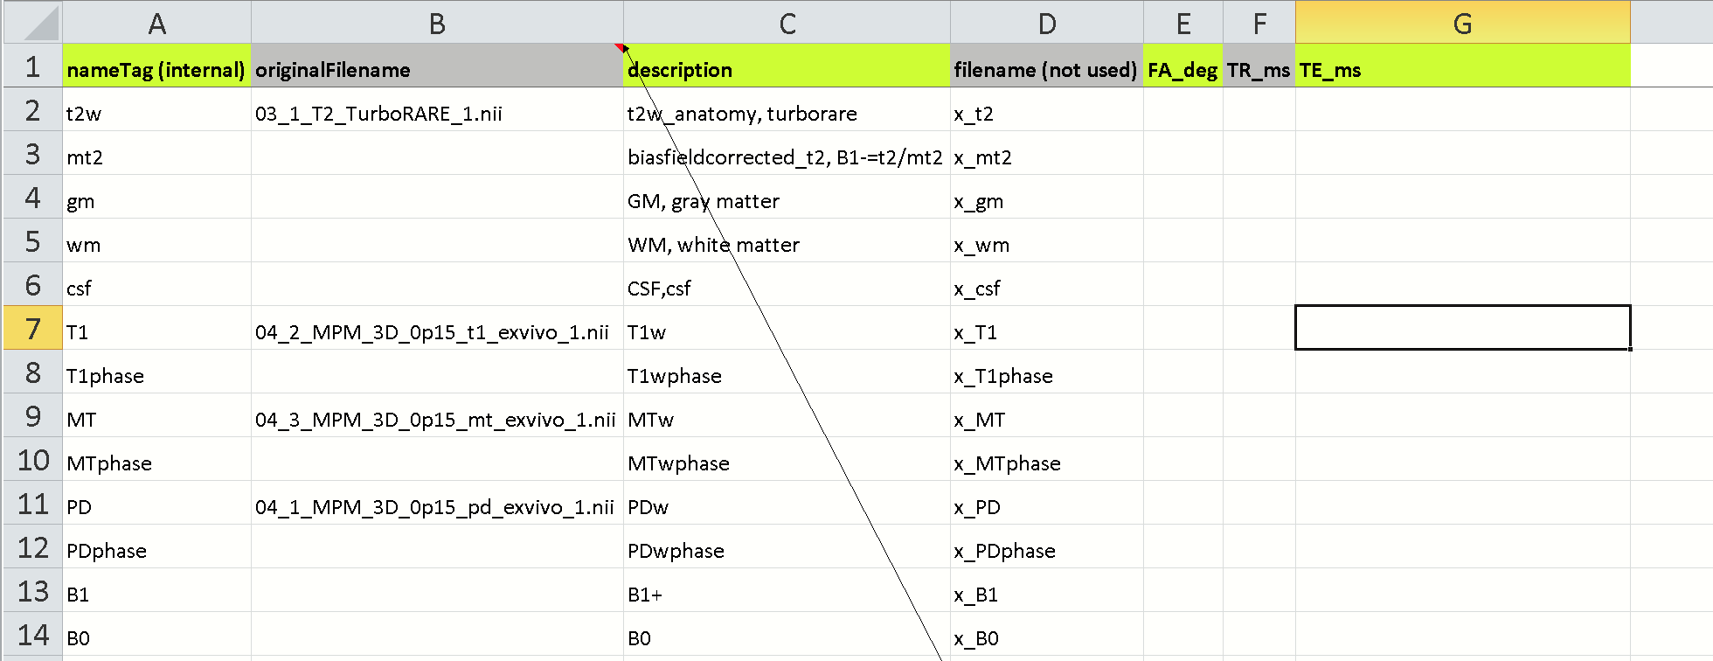

Please enter the original NIFTI-filenames in the 2 column (original Filename). For the current study I inserted the names of:

-turborare (‘03_1_T2_TurboRARE_1.nii’)

-T1 (‘04_2_MPM_3D_0p15_t1_exvivo_1.nii‘)

-MT (‘04_3_MPM_3D_0p15_mt_exvivo_1.nii’) and

-PD (‘04_1_MPM_3D_0p15_pd_exvivo_1.nii’).

The correctness of the NIFTI-filenames in column-2 is important. The excelfile will later contain important parameters needed for the hMRI-TBX (extracted from the Bruker raw data).

**🡪 Please close the excel-document when finished, because parameters will be successively written into this file.**

**2) “mpm_config.m”**

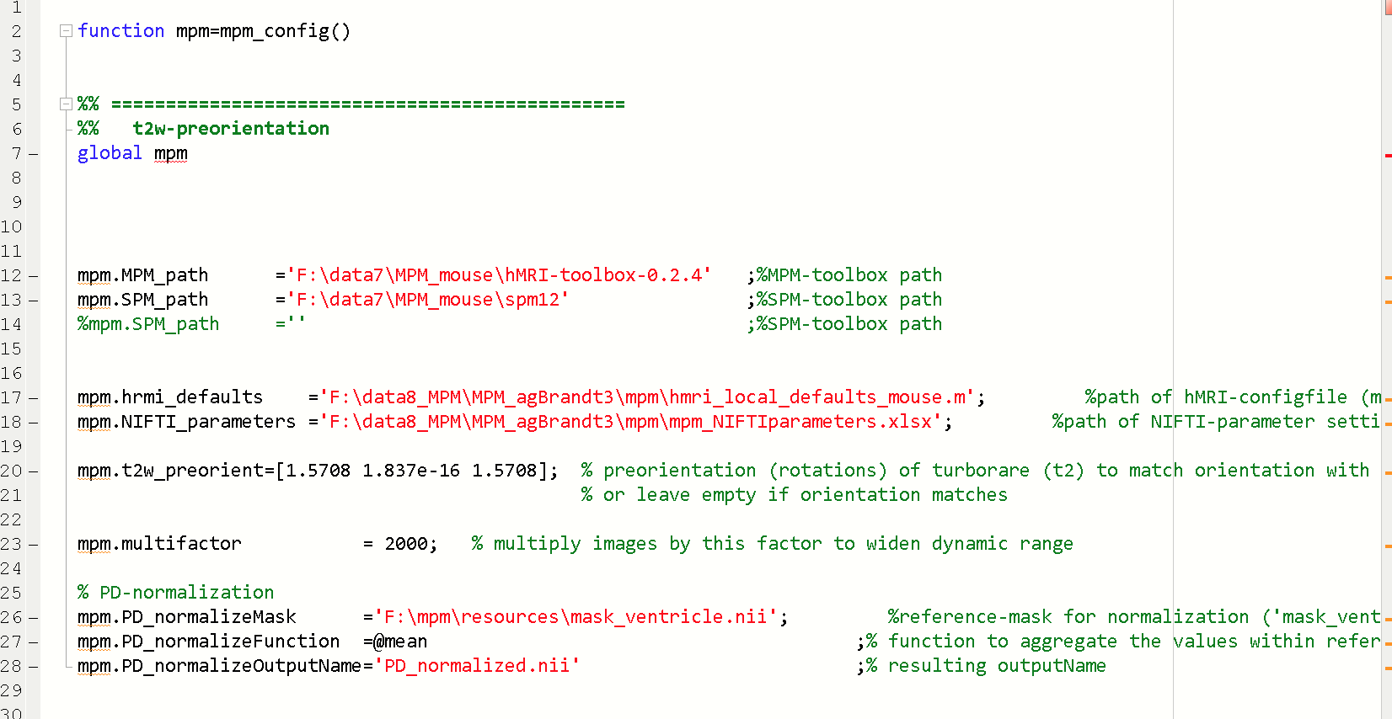

The mpm_config.m file contains parameters that have to be adjusted:

**mpm.MPM_path** ='F:\data7\MPM_mouse\hMRI-toolbox-0.2.4' ;%MPM-toolbox path

-please specify the path of the hMRI-toolbox-0.2.4

**mpm.SPM_path** ='F:\data7\MPM_mouse\spm12' ;%SPM-toolbox path

-please specify the path of SPM12.

-If SPM12 from the ANTx2-toolbox is used, keep this field empty (mpm.SPM_path ='';)

The **mpm.hrmi_defaults** and **mpm.NIFTI_parameters** should be already defined (after the mpm-setup), and link to the files “hmri_local_defaults_mouse.m” and “mpm_NIFTIparameters.xlsx”:

mpm.hrmi_defaults ='F:\data8_MPM\MPM_agBrandt3\mpm\hmri_local_defaults_mouse.m'; %path of hMRI-configfile (m-file)

mpm.NIFTI_parameters ='F:\data8_MPM\MPM_agBrandt3\mpm\mpm_NIFTIparameters.xlsx'; %path of NIFTI-parameter settings (excelfile)

The **mpm.t2w_preorient** variable defines the rough orientation of the turborare-image (used for registration) to match the orientation of PD/T1/MT.

mpm.t2w_preorient=[1.5708 0 1.5708]; % preorientation (rotations) of turborare (t2) to match orientation with PD/T1/MT-images

The **mpm.multifactor** is set to 2000. This factor is multiplied to the PD/T1/MT-image values to increase the dynamic range.mpm.multifactor = 2000; % multiply images by this factor to widen dynamic range

**PD-normalization**

For normalization of the PD-image an reference image is necessary that represents a mask of the CSF/ventricles. A ventricle mask exist in the mpm-toolbox and the path is defined in **mpm.PD_normalizeMask**.

mpm.PD_normalizeMask ='F:\mpm\resources\mask_ventricle.nii'; %reference-mask for normalization ('mask_ventricle.nii' or

'mask_water.nii' or use your own mask)

mpm.PD_normalizeFunction =@mean ;% function to aggregate the values within reference-mask

mpm.PD_normalizeOutputName='PD_normalized.nii' ;% resulting outputName

The **mpm.PD_normalizeFunction** defines how to aggregate the values within the reference mask (here as mean over values within the mask). The output name of the normalized PD-file is defined in **mpm.PD_normalizeOutputName.**

**3) “hmri_local_defaults_mouse.m”**

This m-file contains parameters for the hmri-toolbox.

Important here is that the parameter hmri_def.TPM links to the path of the tissue compartments (contained in the mpm-toolbox):

**hmri_def.TPM**='F:\mpm\resources\mouseTPM_mod.nii';

**LOAD AND RUN THE MPM-PIPELINE**

First select those animals from the ANTx-toolbox (left listbox) that should be processed. Here I selected all animals.

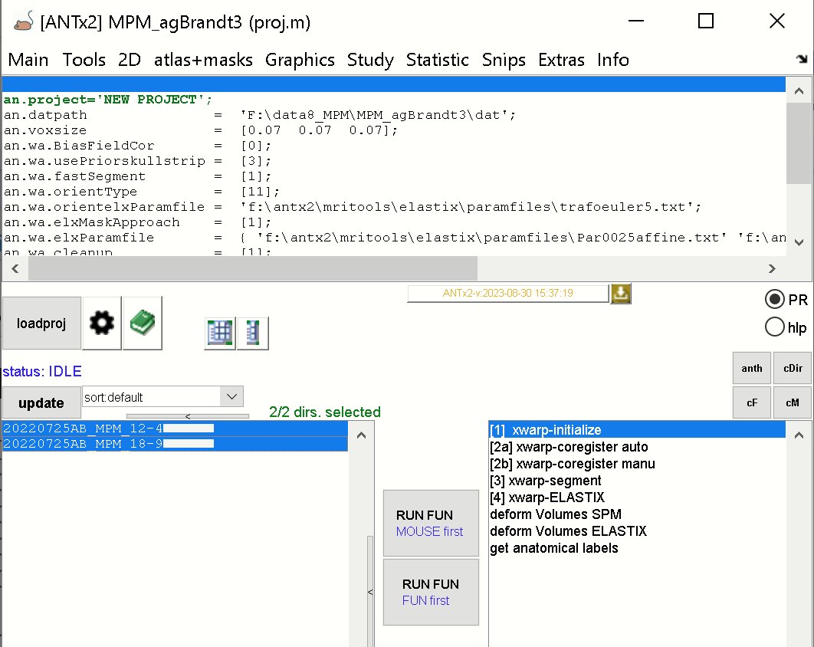

If the mpm-GUI is not open, type “mpm” to open the mpm-GUI.

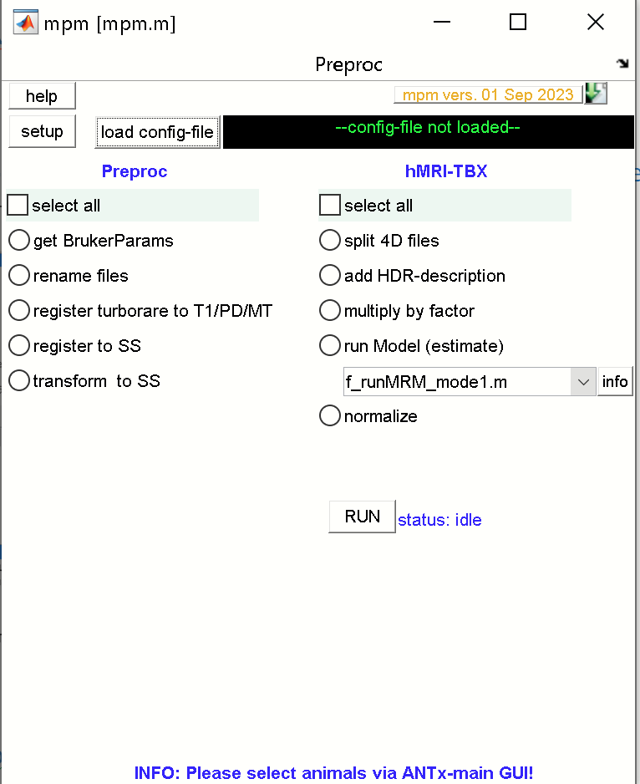

Now, load the mpm-configfile by clicking the [load config-file]-button, and select the “mpm_configfile.m” from the studies mpm-folder.

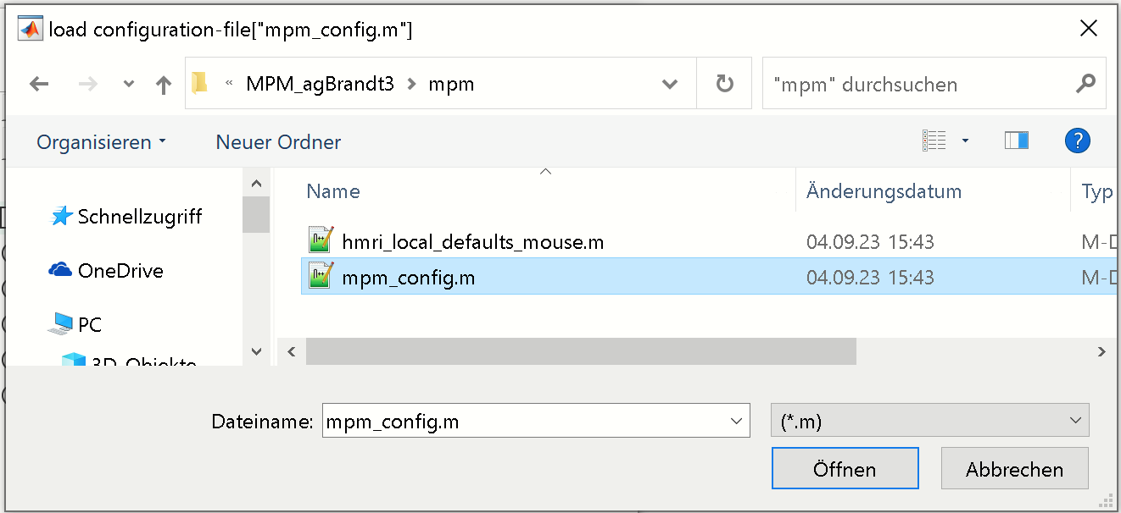

Hit [open/OK](“öffnen”)-button.

When done, the green message right to the [load config-file]-button should display the mpm_config-file

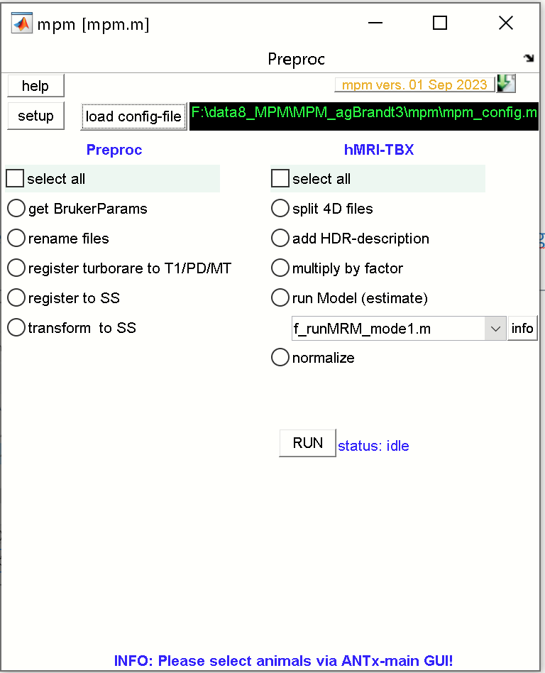

Select all tasks from the preproc-pipeline (left) and the hMRI-pipeline (right).

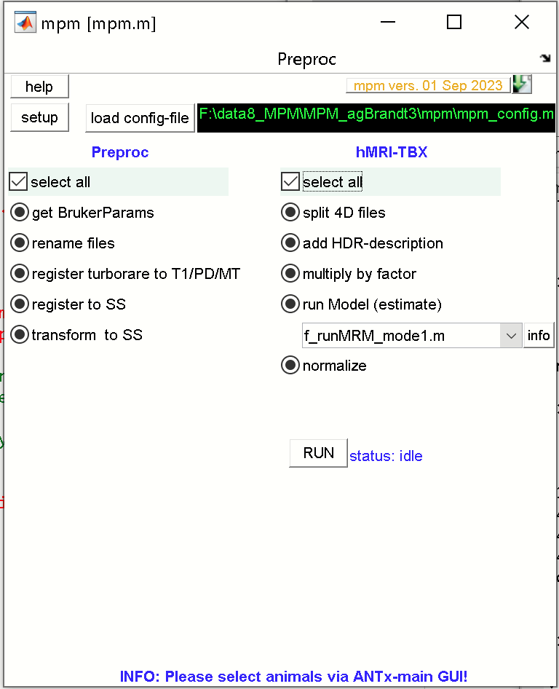

Now, hit [RUN] from the mpm-GUI to start processing for all animals selected from the ANTx-GUI.

When processing is finished, each animal folder will contain a PD-normalized image “PD_normalized.nii” and a subfolder (“Results”) with resulting NIFTI-files.

**PREPROC-Processing steps (ANTx is mandatory for the following preprocessing steps)**

All steps must be processed sequentially in that order

**1) get BrukerParams:** This step is done after importing the Bruker raw-data and specifying the NIFTI-files in column-2 of the excelfile (‘mpm_NIFTIparameters.xlsx’). Based on the Bruker-import and the filenames in the excelfile (‘mpm_NIFTIparameters.xlsx’), the Parameters flip-angle, TR and TE for T1, MT and PD are extracted and written in the respective columns of the excelfile (columns: FA_deg, TR_ms,TE_ms).

**2) rename files**: In the next step, the NIFTI-files (with names defined in column-2 of the excel-file) are copied and the copies renamed to fixed names, defined in column-1 of the excelfile (‘mpm_NIFTIparameters.xlsx’).

Specifically, local copies of the following files are created and new names are given to the copies of the following files:

'03_1_T2_TurboRARE_1.nii' --> 't2w.nii'

'04_2_MPM_3D_0p15_t1_exvivo_1.nii' -->'T1.nii'

'MT 04_3_MPM_3D_0p15_mt_exvivo_1.nii'-->'MT.nii'

'PD 04_1_MPM_3D_0p15_pd_exvivo_1.nii'-->'PD.nii'

**3) register turborare to T1/PD/MT:** In this step the, the turborare-image is rigidly registered to T1/PD/MT.

Here it is assumed that T1/PD/MT are in register towards each other. On the other hand, T1/PD/MT are not in register with the turborare image ('t2w.nii') which is later used for registration with the reference/template (here Allen mouse brain, here we call the space standard-space). Thus, 't2w.nii' must be registered to T1/PD/MT.

If the orientation is completely different between 't2w.nii' and T1/PD/MT there is the option to add a pre-orientation (3 rotation angles). This pre-orientation has to be defined in the mpm.t2w_preorient-variable (for this study it is: [1.5708 0 1.5708] in the ‘mpm_config.m’-file.

The resulting output file will be in register with T1/PD/MT and is named is ‘t2.nii’.

**4) register to SS:** Next, the ‘t2.nii’-image (i.e. the aligned turborare image) is registered to standard space (SS; i.e. the Allen mouse brain template/atlas). When done, a new file is created (‘x_t2.nii’) which represents the ‘t2.nii’-image in standard space.

**5) transform to SS**: Based on the previous step, the estimated transformation-parameters (rigid+affine+nonlinar) are used to transform the following files from native space to standard space (SS):

‘T1.nii‘, ‘MT.nii‘ , ‘PD.nii‘ to **‘x_T1.nii‘, ‘x_MT.nii‘ , ‘x_PD.nii**‘, respectively.

Aside this, the previous step (here SPM’s Unified Approach is used) created a biasfield-corrected ‘t2.nii’-image (‘mt2.nii’) which is also transformed to standard-space **(‘x_mt2.nii’)**

**hMRI-Processing steps (with/without ANTx)**

**6) split 4D files:** Here the 4D-volumes **‘x_T1.nii‘, ‘x_MT.nii‘ , ‘x_PD.nii‘** are split into 3D-volumes (x_T1_00001.nii, x_T1_00002.nii…etc.; x_MT1_00001.nii, x_MT1_00002.nii…etc.; x_PD1_00001.nii, x_PD1_00002.nii…etc.)

**7) add HDR-description:** The parameters flip-angle, TR and TE for T1, MT and PD (which were previously written to the Excelfile (‘mpm_NIFTIparameters.xlsx’, **see get BrukerParams** ) are written to the header of x_T1,x_MT and x_PD images.

**8) multiply by factor**: In the next step a factor is multiplied to the values of the of x_T1,x_MT and x_PD images to increase the dynamic range. Note that the factor is defined in the “mpm_config.m”-file (mpm.multifactor = 2000).

The factor is also stored in the header of the images to allow to rerun this step and prevent multiple, sequential multiplications of the same image with several factors.

**9) run Model (estimate):** Currently there is only one hMRI-implementation available 'f_runMRM_mode1.m'. Hit the info-button for more information.

Basically all images have to be in standard space (SS). The following inputs are used:

[**RF**]: 'x_t2.nii' and 'x_mt2.nii'

'x_t2.nii' - is the t2-weighted image in SS

'x_mt2.nii' - is the bias-corrected t2-weighted image in SS ('mt2.nii' is generated using SPM's Unified Approach)

[**B1-Bias correction**]: #r - B1-bias correction is not used here. I.e. the input is 'noB1'

[**raw_mpm**]: PD, MT and T1 data in SS are used, i.e. multiple 3D-volumes for each modality is used:

'x_PD_00001.nii' , 'x_PD_00002.nii' , 'x_PD_00003.nii' ...etc.

'x_MT_00001.nii' , 'x_MT_00002.nii' , 'x_MT_00003.nii' ...etc.

'x_T1_00001.nii' , 'x_T1_00002.nii' , 'x_T1_00003.nii' ...etc.

**10) normalize:** This step creates a normalizes PD-image ‘PD_normalized.nii’. For this step, a reference-mask has to be provided. The path of the reference mask (NIFTI-file) is specified in mpm_config.m-file (variable: ‘mpm.PD_normalizeMask’). The ventricle-mask ('mask_ventricle.nii', located in the mpm-tbx) is configured as the default reference mask.

Note: If another mask is used as reference mask, it must have the following properties:

-binary 3D NIFTI-image, with values equal to ‘1’ referring to reference-regions such as ventricles

-mask must be in standard space (SS), i.e. in register with the template, x_t2.nii etc.

-same voxel-size as x, _t2.nii, x_T1,x_MT and x_PD images.

**II) Working without the Preprocessing steps/Working without ANTx**

The following workflow works without ANTx-TBX and can be used when the following files exist in standard space:

x_MT.nii : 4D MT-volume in standard-space

x_T1.nii : 4D T1-volume in standard-space

x_PD.nii : 4D PD-volume in standard-space

x_t2.nii : turborare in standard-space

x_mt2.nii : bias-corrected turborare in standard-space (created for example using SPM’s unified Approach)

For example: The following study-folder “**F:\data8_MPM\MPM_agBrandt4_noANTx”** contains a ‘dat’-folder with the animal-folders: ‘20220725AB_MPM_12-4’ and ‘20220725AB_MPM_18-9’. Each of the animal folders contain the following files: x_MT.nii, x_T1.nii, x_PD.nii , x_t2.nii and x_mt2.nii.

**SET MPM-PATH**

-add MPM-path via hyperlink or go to mpm-folder and type “mpmlink” (this will set the paths of mpm)

-in Matlab command window type ‘mpm’ to open the mpm-GUI.

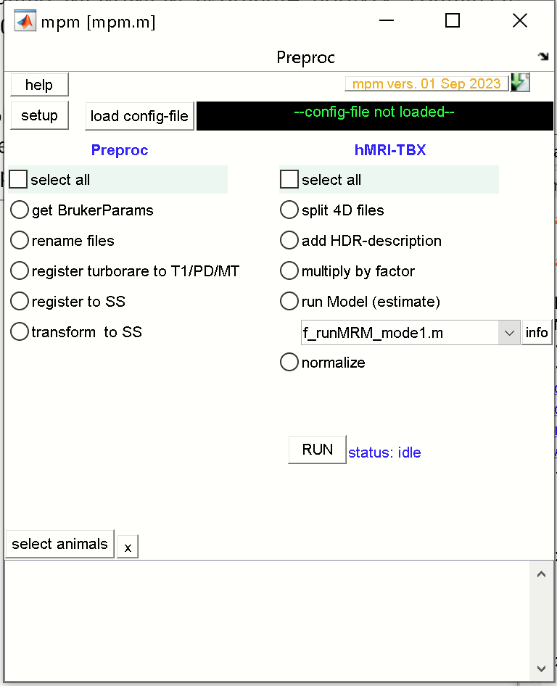

- Set Matlab’s current working Dir to the studies folder: Here: ‘F:\data8_MPM\MPM_agBrandt4_noANTx’.

**SETUP and configuration**

Hit the [setup]-button from the mpm-GUI.

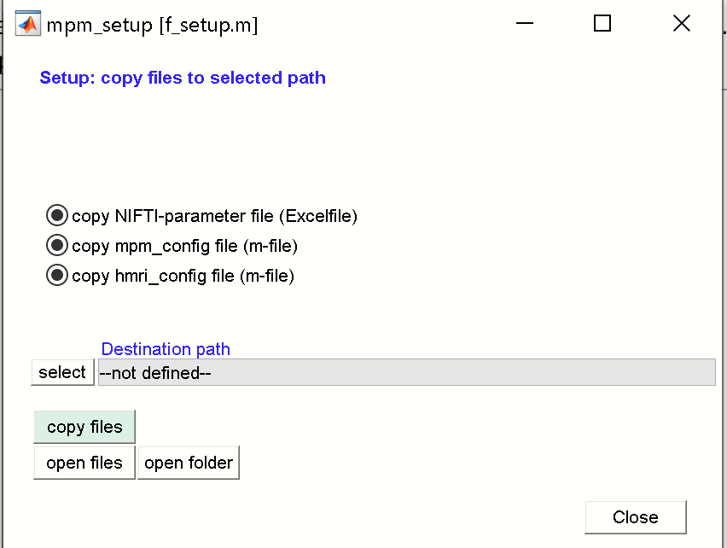

Hit the [select]-button to set the destination path and select the study-folder

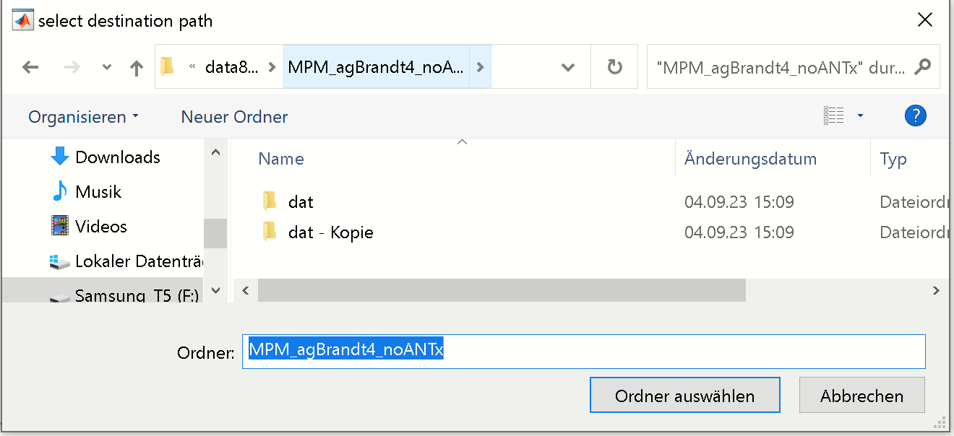

Hit [select]/[ordner auswählen].

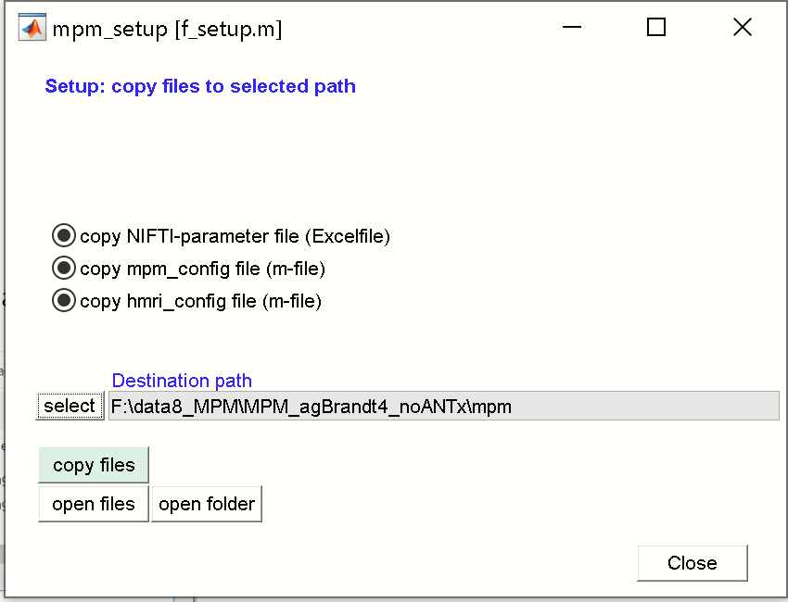

Hit the [copy files]-button to copy 3 documents to the studies/mpm-folder. Hit [close]-button to close the GUI. The study folder should now contain a folder ‘mpm’ with the following documents:

-‘mpm_NIFTIparameters.xlsx’

-‘mpm_config.m’

-‘hmri_local_defaults_mouse.m’

**1) ‘mpm_NIFTIparameters.xlsx’**

The Excel-file looks as follows:

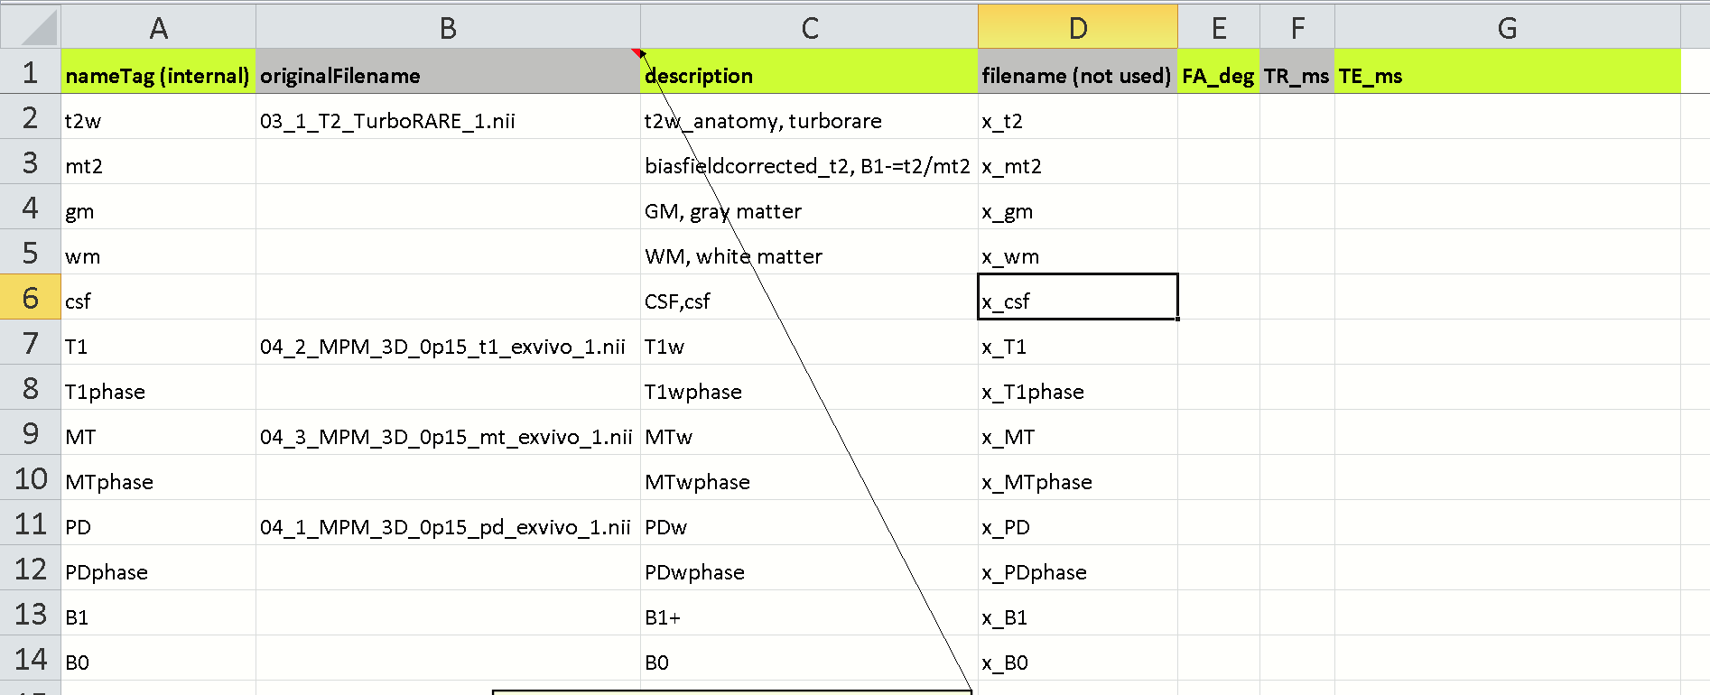

The 4th column specifies the file-names in standard space. Please do not change the names, rather change the names of the files in the ‘dat’-folder. Next add the parameters (flip angle, TR and TE) manually.

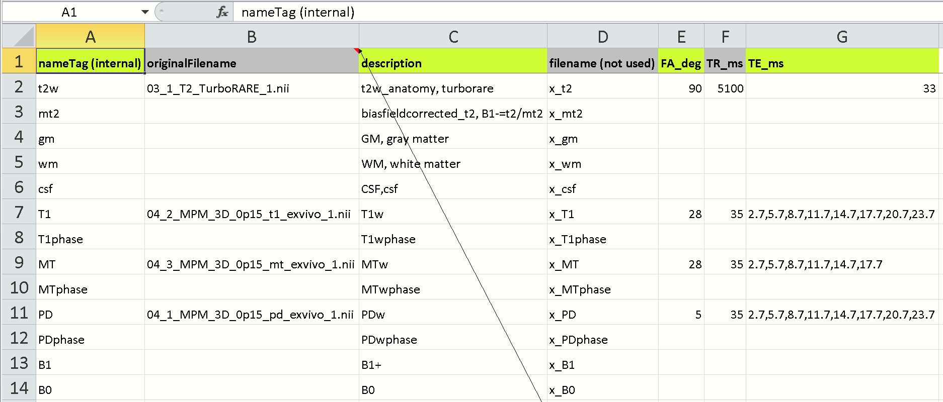

Save and close the excel-file.

**2) ‘mpm_config’**

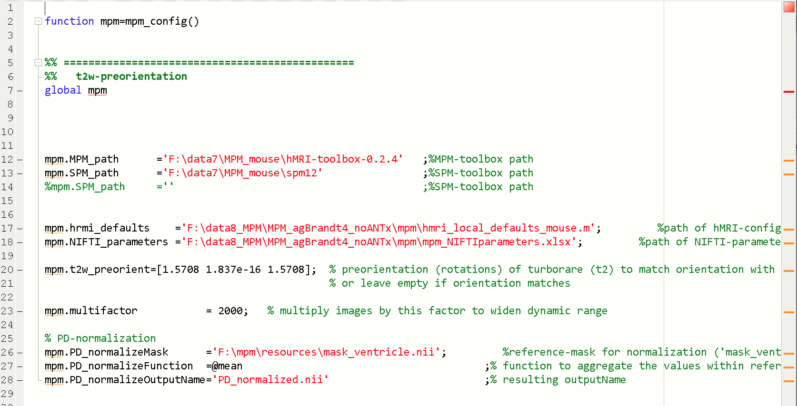

The mpm_config.m file contains parameters that have to be adjusted:

**mpm.MPM_path** ='F:\data7\MPM_mouse\hMRI-toolbox-0.2.4' ;%MPM-toolbox path

-please specify the path of the hMRI-toolbox-0.2.4

**mpm.SPM_path** ='F:\data7\MPM_mouse\spm12' ;%SPM-toolbox path

-please specify the path of SPM12.

The **mpm.hrmi_defaults** and **mpm.NIFTI_parameters** should be already defined (after the mpm-setup), and link to the files “hmri_local_defaults_mouse.m” and “mpm_NIFTIparameters.xlsx”:

mpm.hrmi_defaults ='F:\data8_MPM\MPM_agBrandt4_noANTx\mpm\hmri_local_defaults_mouse.m'; %path of hMRI-configfile (m-file)

mpm.NIFTI_parameters ='F:\data8_MPM\ MPM_agBrandt4_noANTx\mpm\mpm_NIFTIparameters.xlsx'; %path of NIFTI-parameter settings (excelfile)

The **mpm.t2w_preorient** variable defines the rough orientation of the turborare-image (used for registration) to match the orientation of PD/T1/MT.

mpm.t2w_preorient=[1.5708 0 1.5708]; % preorientation (rotations) of turborare (t2) to match orientation with PD/T1/MT-images. **HERE, the images are already in Standard space, so there is no need to change/modify this variable.**

The **mpm.multifactor** is set to 2000. This factor is multiplied to the PD/T1/MT-image values to increase the dynamic range.mpm.multifactor = 2000; % multiply images by this factor to widen dynamic range

**PD-normalization**

For normalization of the PD-image a reference image is necessary that represents a mask of the CSF/ventricles. A ventricle mask exists in the mpm-toolbox and the path is defined in **mpm.PD_normalizeMask**.

mpm.PD_normalizeMask ='F:\mpm\resources\mask_ventricle.nii'; %reference-mask for normalization ('mask_ventricle.nii' or

'mask_water.nii' or use your own mask)

mpm.PD_normalizeFunction =@mean ;% function to aggregate the values within reference-mask

mpm.PD_normalizeOutputName='PD_normalized.nii' ;% resulting outputName

The **mpm.PD_normalizeFunction** defines how to aggregate the values within the reference mask (here as mean over values within the mask). The output name of the normalized PD-file is defined in **mpm.PD_normalizeOutputName.**

**3) “hmri_local_defaults_mouse.m”**

This m-file contains parameters for the hmri-toolbox.

Important here is that the parameter hmri_def.TPM links to the path of the tissue compartments (contained in the mpm-toolbox):

**hmri_def.TPM**='F:\mpm\resources\mouseTPM_mod.nii';

**Loading the config-file**

In the mpm-gui hit the [load config-file]-button and select the ‘mpm_config.m’-file. Hit [open]/[öffnen] to load the configuration.

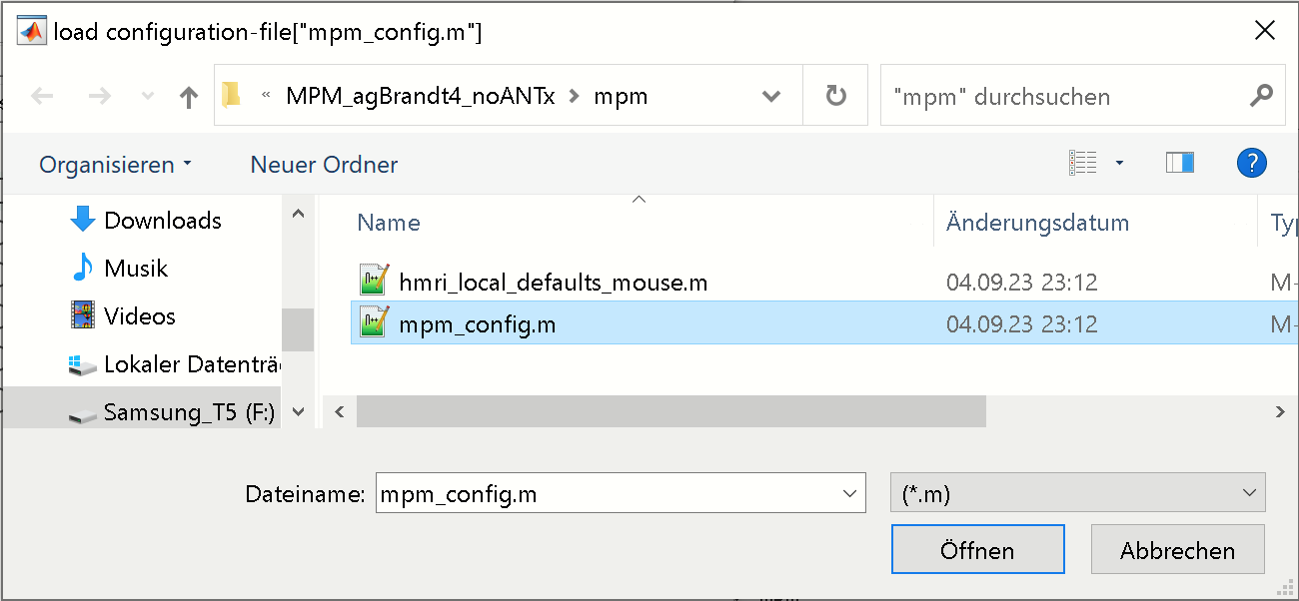

When done, the mpm-GUI should display the path of the config-file right to the [load config-file] button.

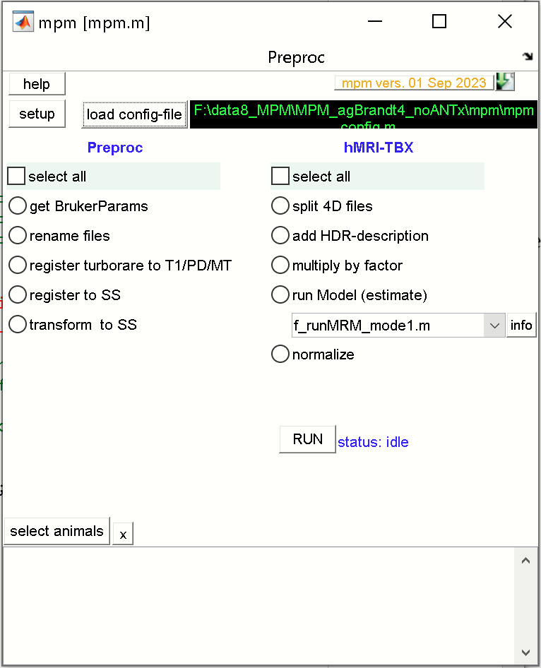

**Select animals for processing**

From mpm-GUI hit the [select animals] button. In the animal-selection GUI navigate to the studies ‘dat’-folder (left listbox). Now select the two animals from the right listbox

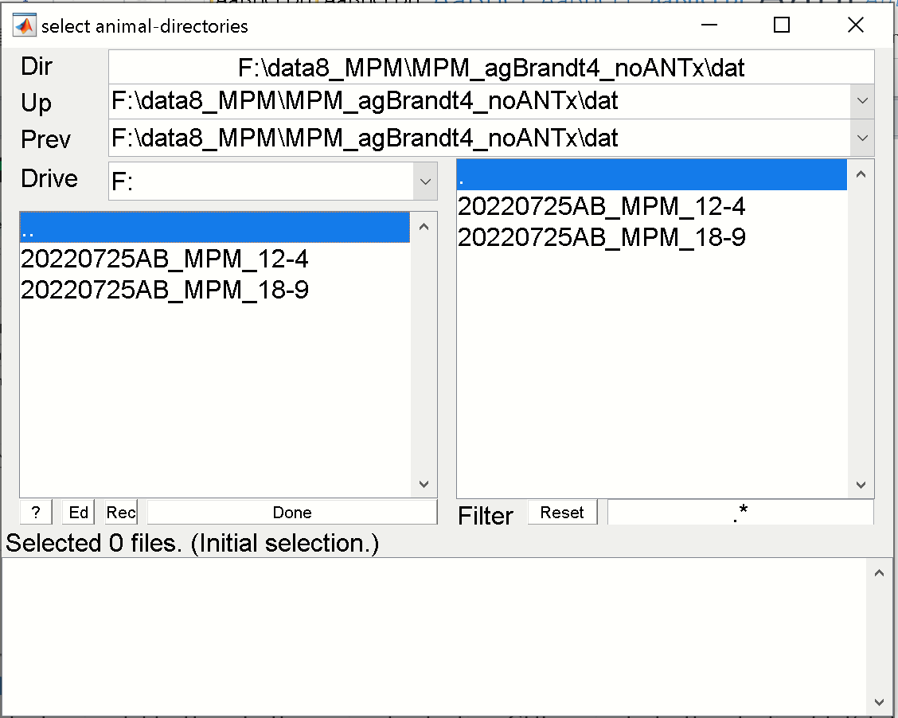 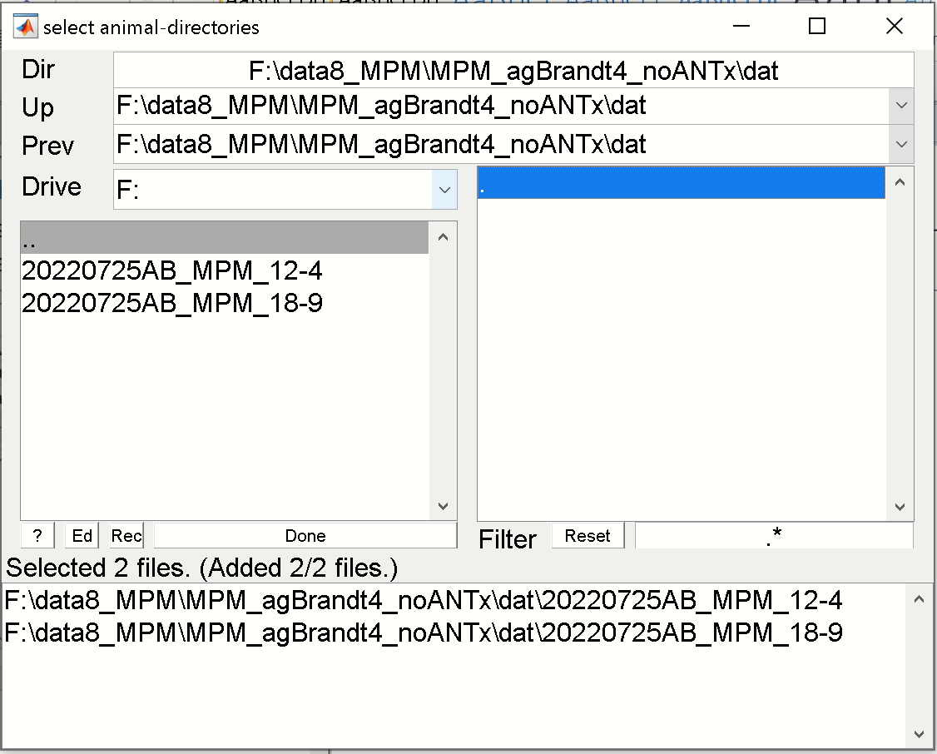

When selected, the two animals disappear in the right listbox and reappear in the lower listbox. Hit [Done]-button.

The animal-listbox in the mpm-GUI should now contain the selected animals for processing. Here two animals were selected).

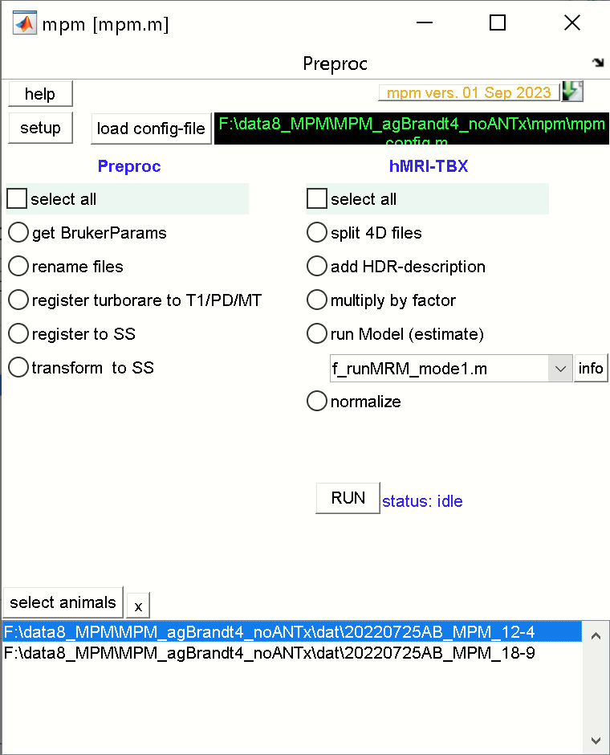

**RUN the hMRI-processing steps**

From the hMRI-TBX processes check the [select all]-radio to run all processing steps.

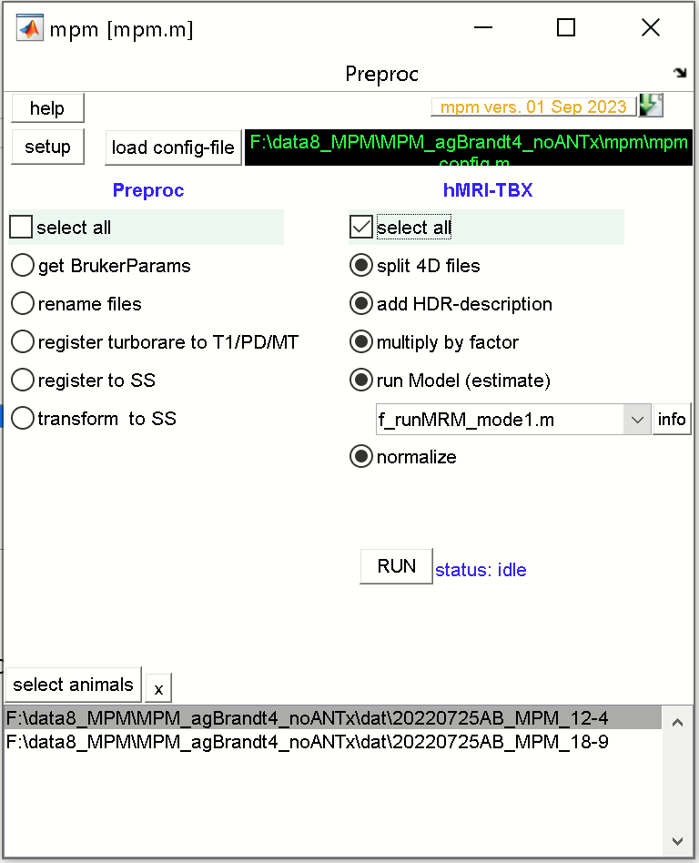

Hit [RUN] to execute all selected processing steps for the selected animals.