**CDS VIEW:**

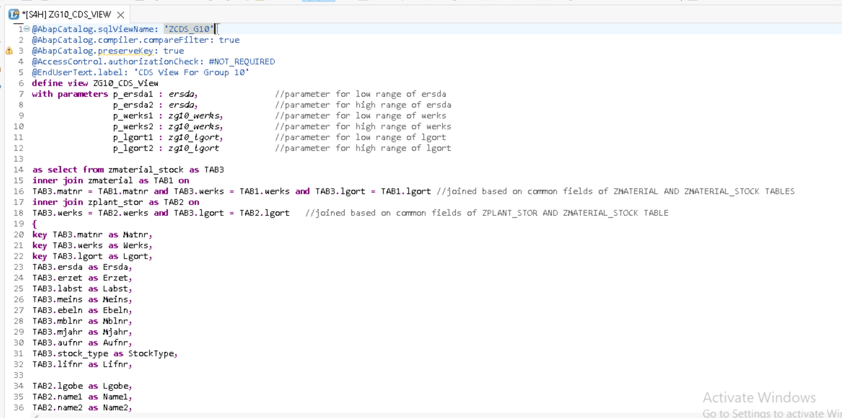

**CDS VIEW Driver Program:**

