**Selection Screen**:

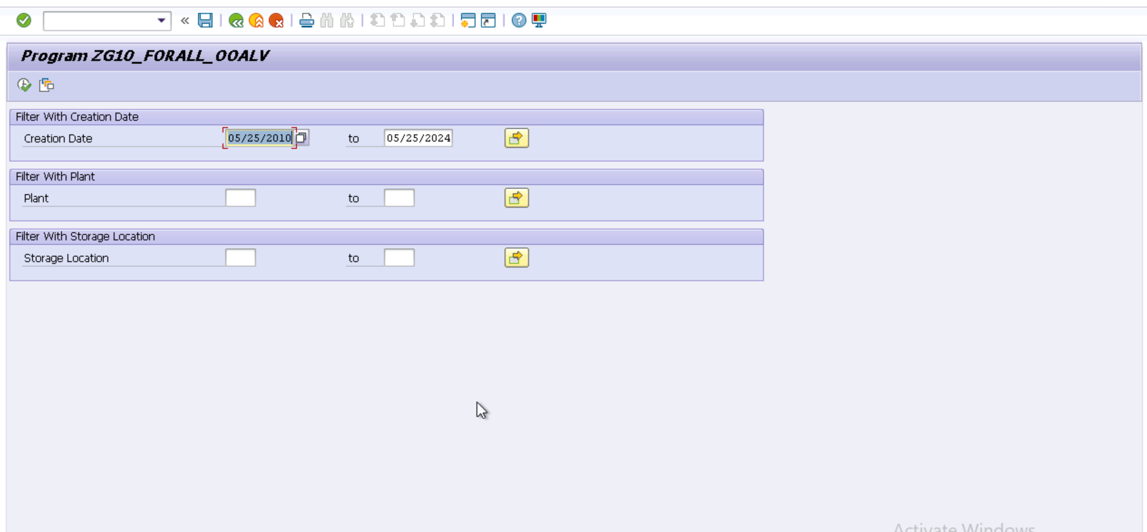

**Output of OOALV:**

**Output of CDS VIEW:**

