Political Security Threat Prediction Framework Using Hybrid Lexicon-Based Approach and Machine Learning Technique
Often peoples are using social media to express their views and opinions and their views may reveal important information like emotion and sentiments, different peoples express their opinions on Political Leaders, market influence, education, religion, sports and many more. If peoples are happy then they will write positive reviews and if they hurt then will write negative words which may influence other peoples and can give face to civil wars, riots, terrorism etc.
Such riots can be prevented by actively monitoring on peoples reviews and if many people are expressing negative thoughts then government can take necessary action to further prevents such negativity and riots can be avoided and politically country will be free from wars and riots.
To detect such news author of this paper introducing novel Hybrid Lexicon and machine learning based algorithms. Both algorithms like NRC lexicon and Machine learning will get combined to form Hybrid algorithm where NRC lexicon will be used to calculate emotions from the news or public opinions and then both news and emotion labels will be input to machine learning algorithm to train a model and this model can be applied on any news to predict Threat or No Threat Label.
Lexicon NRC will give 8 different emotions such as ‘Anger, Fear, Disgust, Terror, Anxiety, Anticipation, Joy and Trust’. From the labels Anticipation, Joy and Trust will be consider as ‘Positive’ and take label as ‘No Threat’ and then remaining emotion will be consider as ‘Negative’ and take label as ‘Threat’.
Lexicon NRC will take news text as input and then give ‘Threat or No Threat’ as label and then both labels and News Text will be input to machine learning algorithm to form a model.
In propose work author has used SVM, Naive Bayes and Decision Tree as the machine learning algorithm and each algorithm performance is evaluated in terms of accuracy, precision, recall and FSCORE. In all algorithms Decision Tree is giving best accuracy.
To train all algorithms author has used News dataset which we downloaded from KAGGLE and below screen showing dataset details
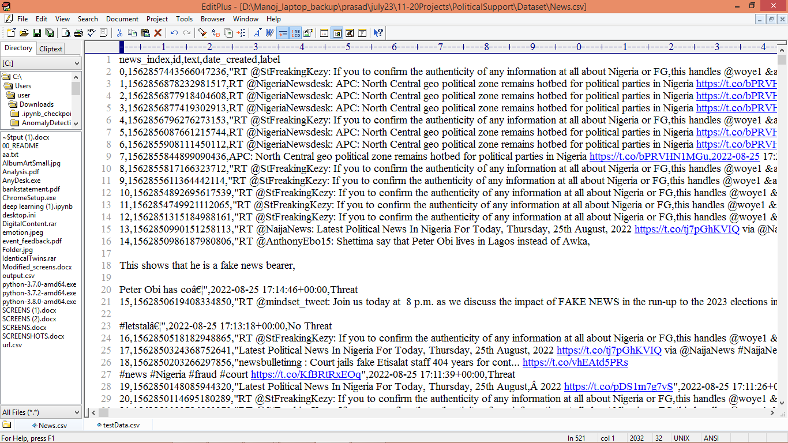
In above dataset first row represents dataset column names and remaining rows represents dataset values and by using this dataset will train and test all algorithms performance
Extension Concept
In propose work author has used SVM, Decision Tree and Naive Bayes and compare to this algorithms Random Forest and XGBOOST will be consider as more advance and best in performance so we have experimented with Random Forest and its giving more accuracy compare to propose algorithms. Random Forest will utilize forest or group of trees to optimize dataset features and this features optimization helps Random Forest in Yielding better accuracy.
SCREEN SHOTS
We have implemented this project using JUPYTER notebook and below are the code and output screens with blue colour comments
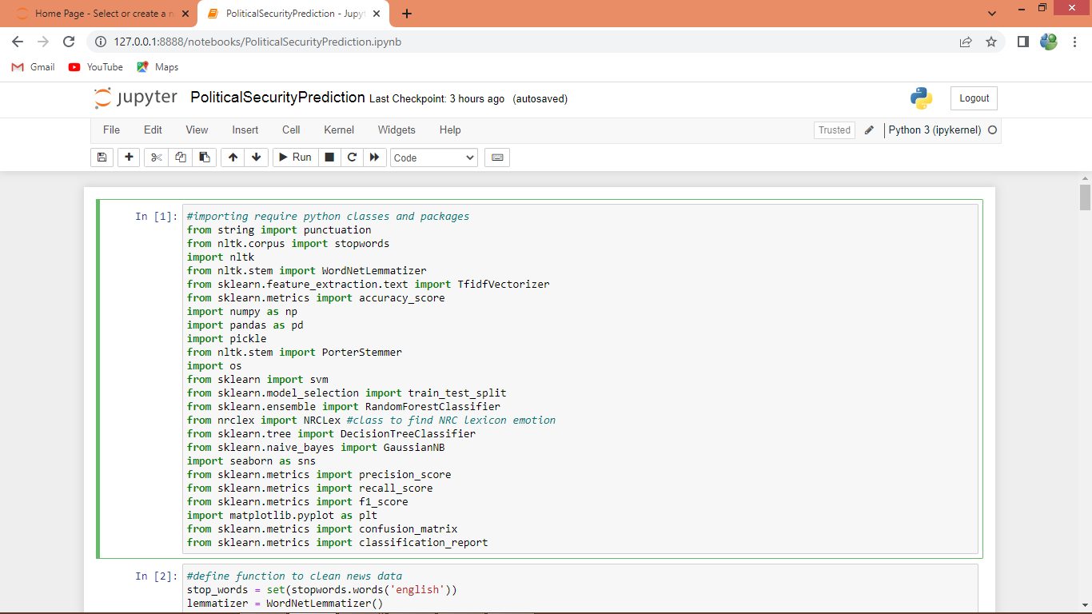
In above screen importing require python classes and packages
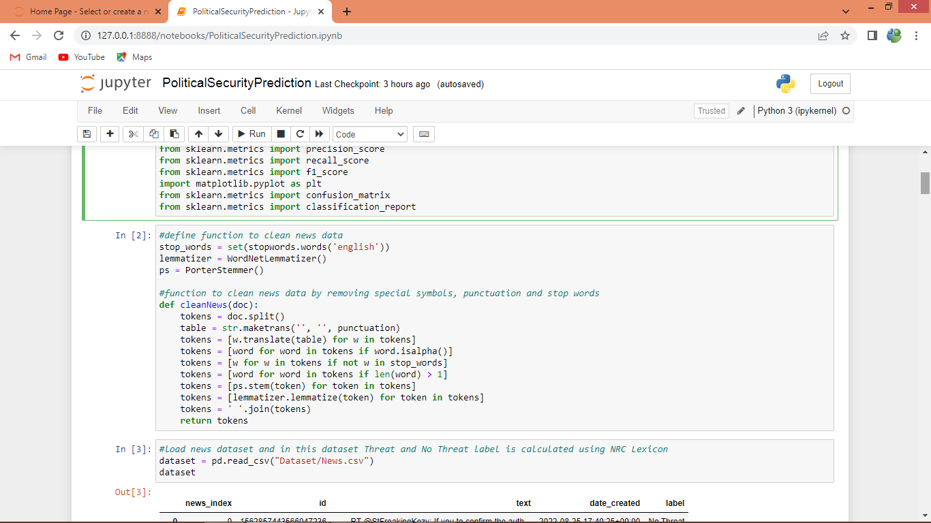
In above screen defining function to remove stop words, special symbols and to clean news data
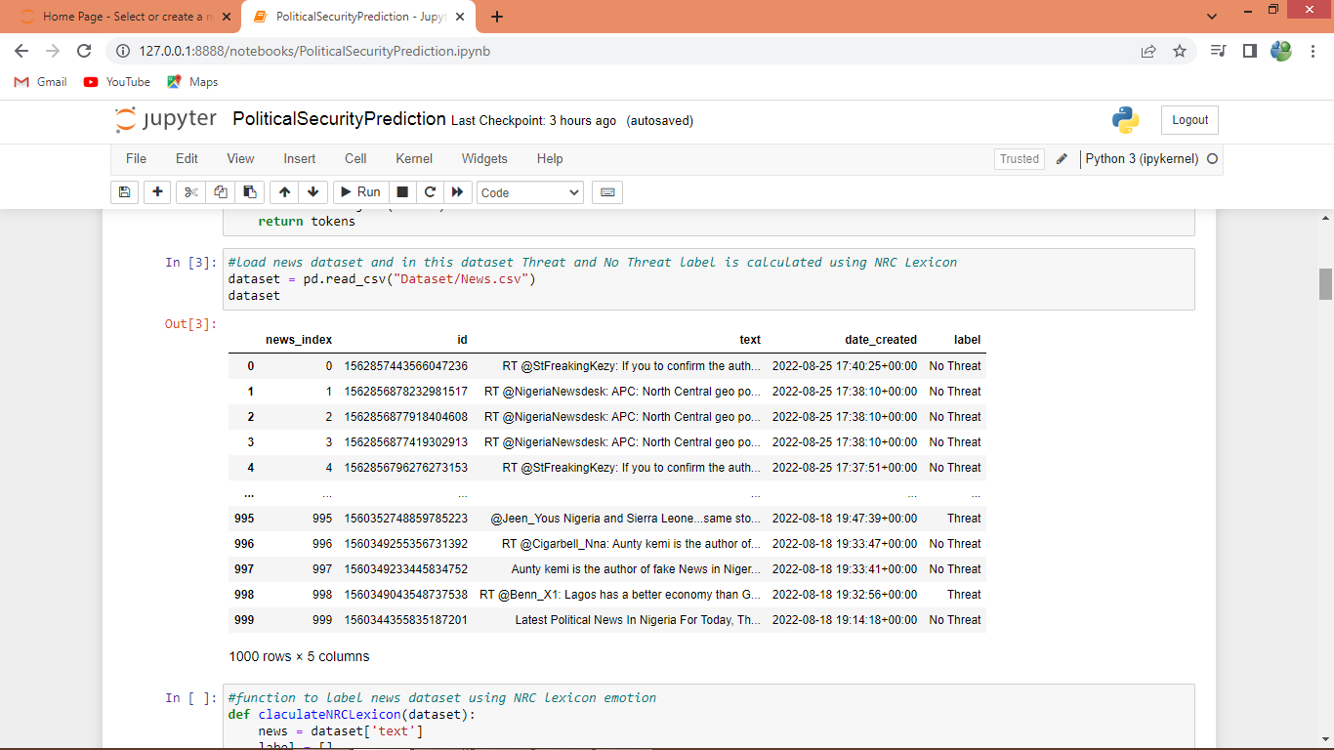
In above screen reading and displaying dataset values
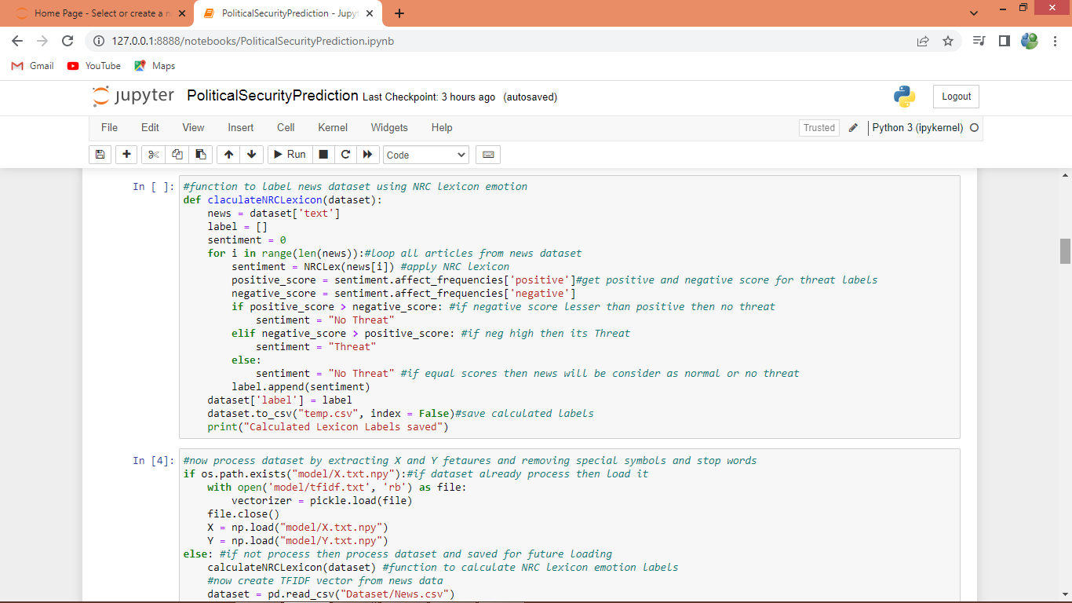
In above screen defining function to calculate NRC lexicon labels from dataset
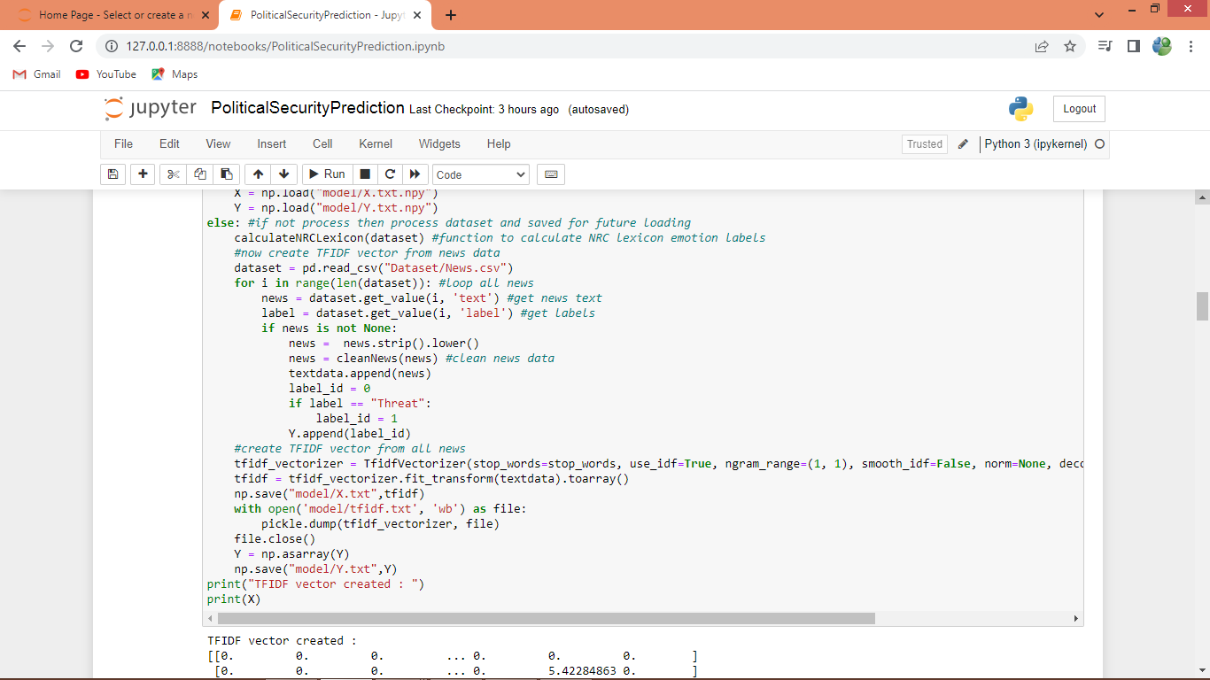
In above screen looping all news articles and then calculating labels and then cleaning all news data and then adding array variable and this array will be input to TFIDF to convert all news into TFIDF vector. TFIDF will replace each words with its average frequency and then give a numeric vector as output
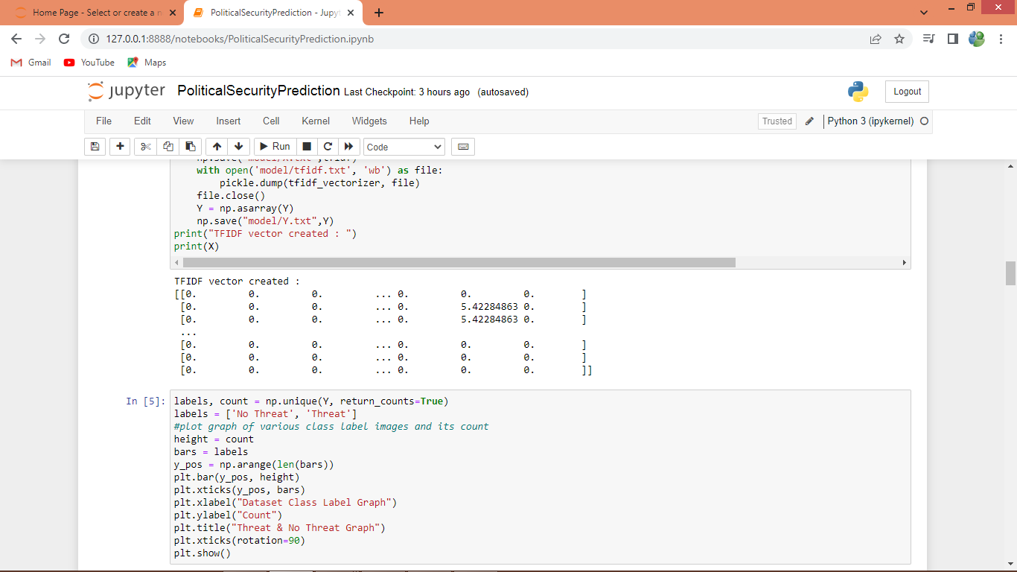
In above screen TFIDF vector generated
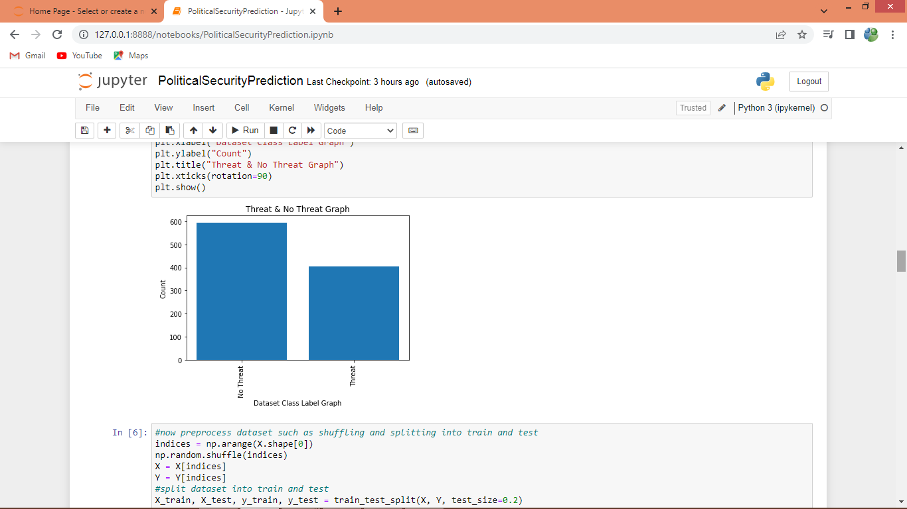
In above screen finding and plotting graph of ‘Threat and NO Threat’ news found in dataset and in graph x-axis represents type of news and y-axis represents count
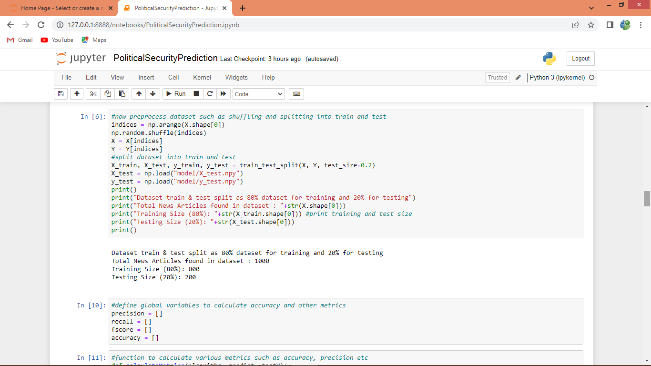
In above screen processing and shuffling and splitting dataset into train and test
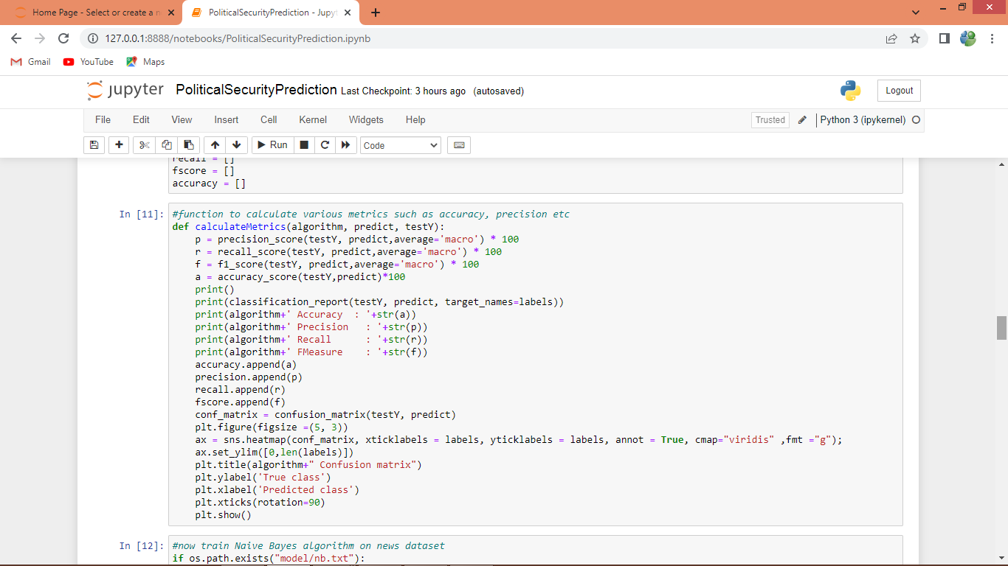
In above screen defining function to calculate accuracy and other metrics
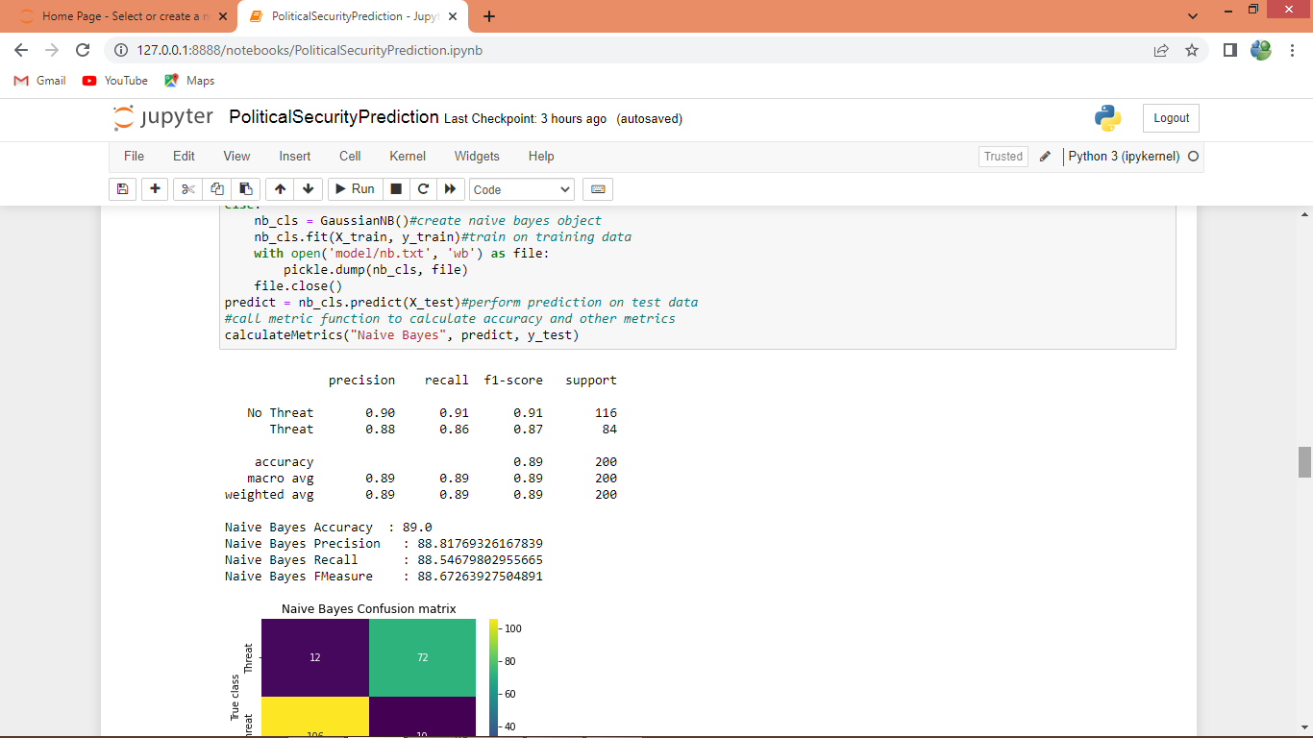
In above screen training Naive Bayes algorithm and then we can see classification report for each class and then displaying overall accuracy as 89% and below is the confusion matrix graph
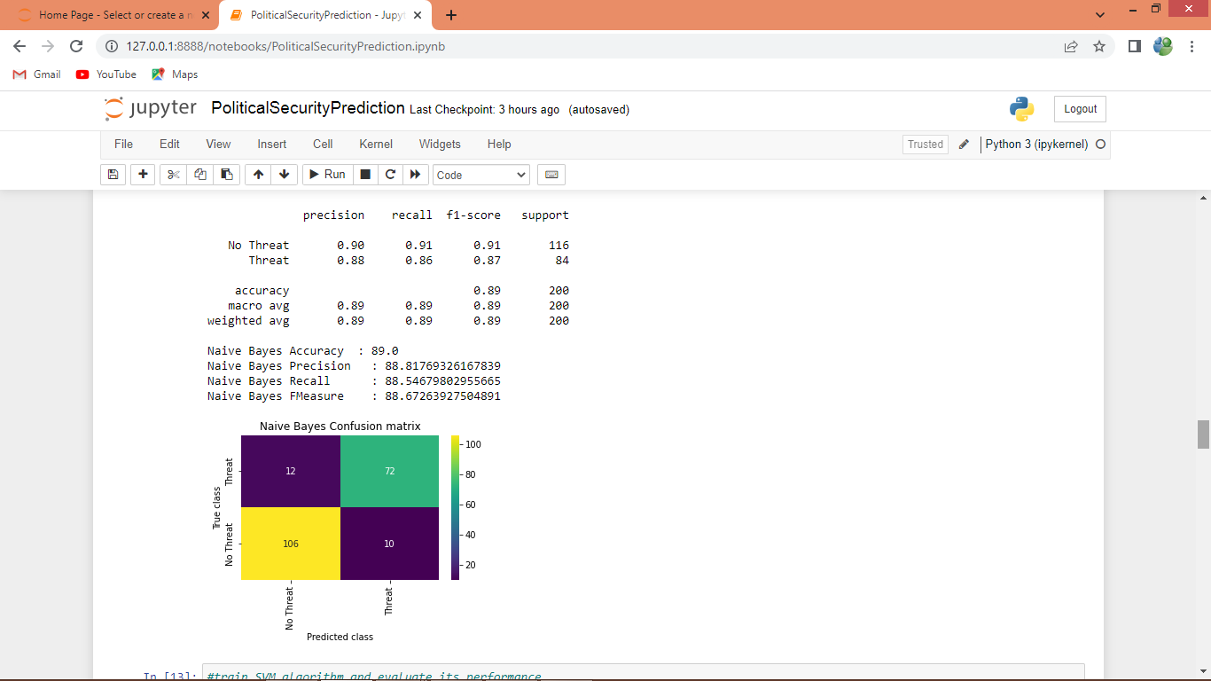
In above graph x-axis represents Predicted Labels and y-axis represents True Labels and green and yellow box contains correct prediction count and blue boxes represents incorrect prediction count.
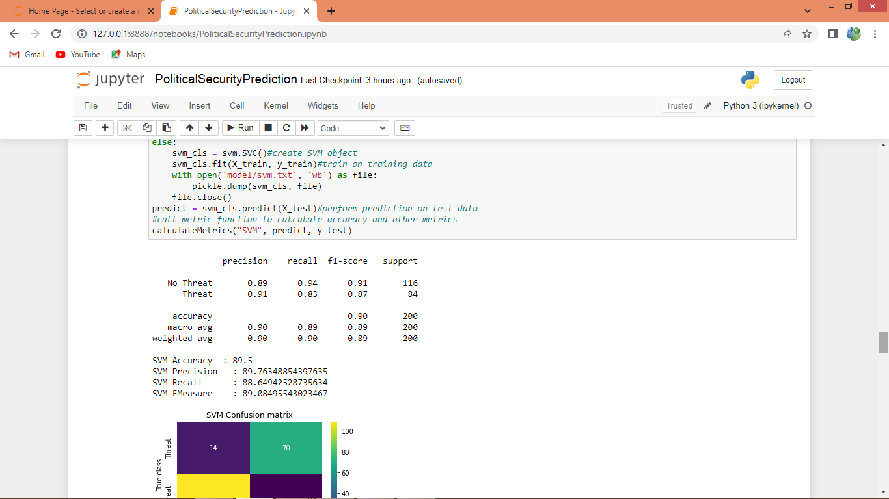
In above screen SVM got 89.50% accuracy and can see other output also
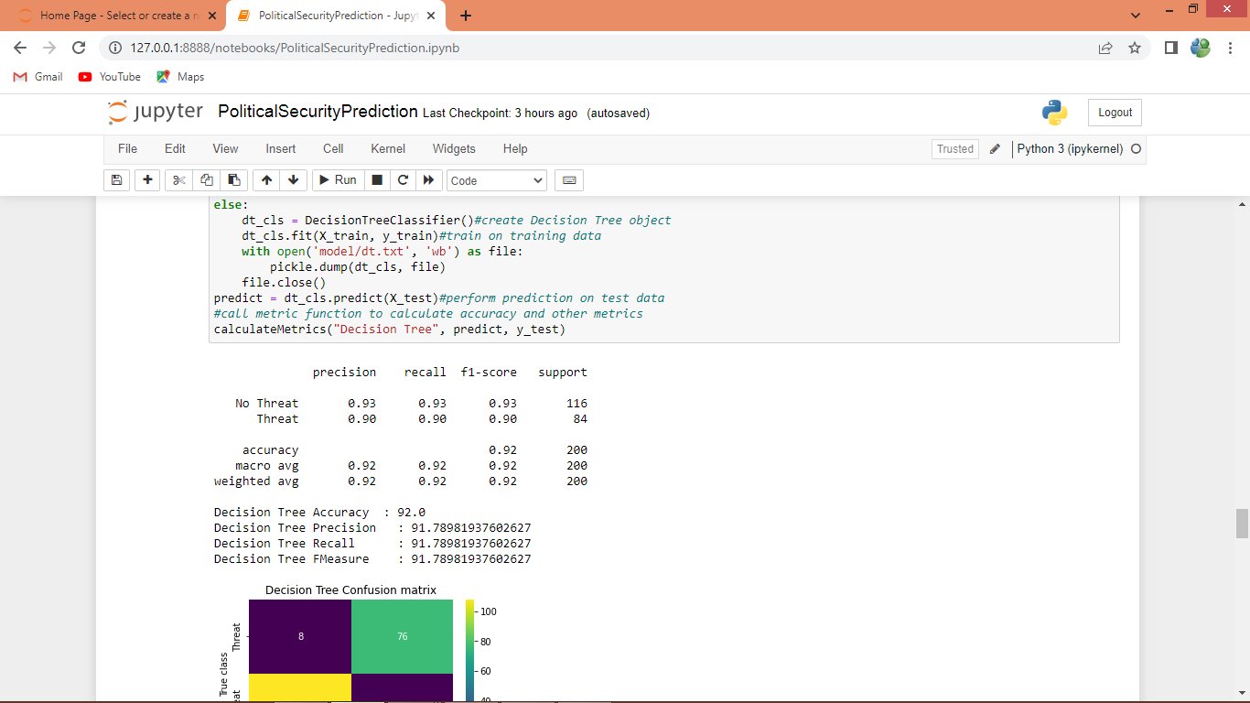
In above screen decision tree got 92% overall accuracy
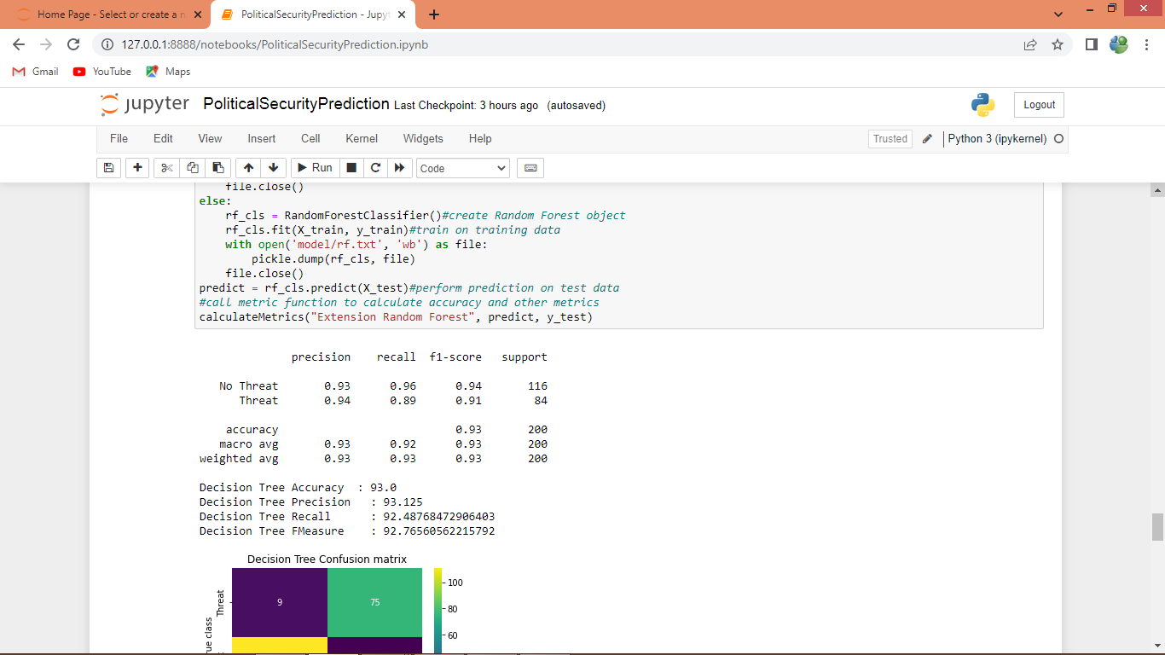
In above screen extension Random Forest got 93% overall accuracy
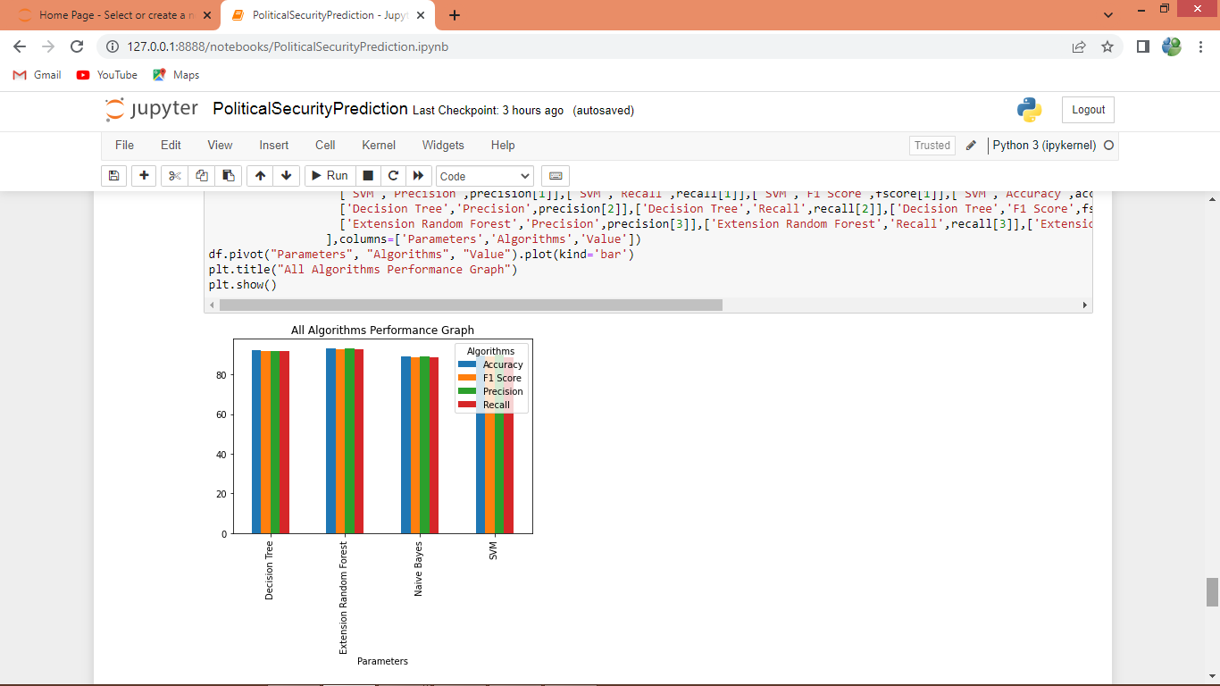
In above graph x-axis represents algorithm names and y-axis represents accuracy and other metrics in different colour bars and in all algorithms Extension Random Forest got high accuracy
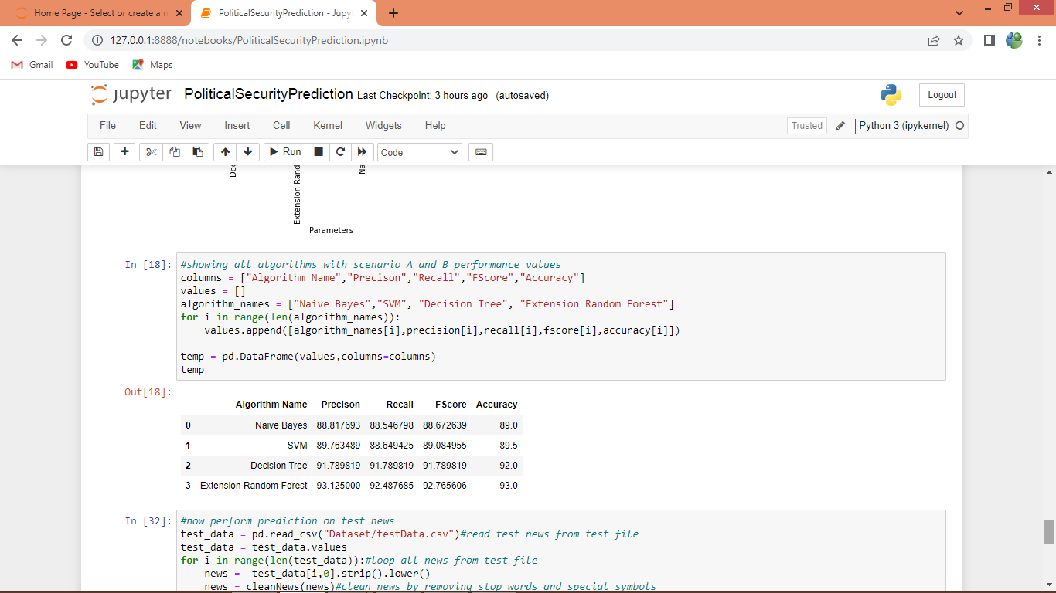
In above screen displaying all algorithm performance in tabular format
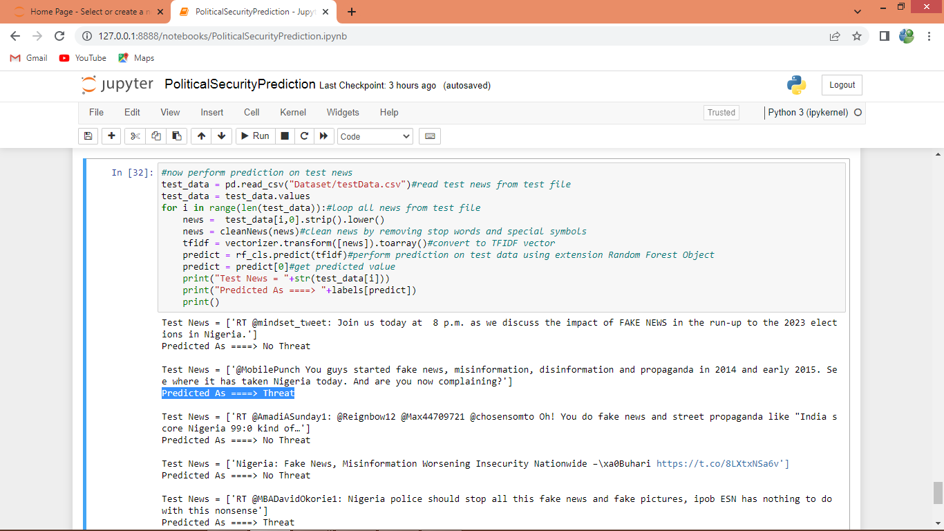
In above screen reading Test News data and then cleaning and then using Extension Random Forest algorithm we are performing prediction and in output we can see News Data and then after = arrow symbol we can see predicted output as ‘Threat or No Threat’.

