FastAPI DevSecOps Demo: A Production-Ready Microservice from Zero to Deployment

Key Concepts in this Project:

Firstly, What is DevOps??
DevOps is a way of working where software developers (Dev) and IT/operations teams (Ops) work together to build, test, release, and run software faster and more reliably. DevOps bridges the gap between these teams by introducing automation, continuous integration, continuous deployment, and shared responsibility, allowing applications to be updated frequently while remaining stable and reliable in production.

Real-life example (Instagram-style app)

Who are Developers:
- Build login page
- Create photo upload feature
- Write recommendation logic

What does it mean by Operations:
- Deploy app on cloud
- Ensure app works 24/7
- Scale servers when traffic increases
- Monitor crashes
- Secure user data
Both are equally important.

REST API: A REST API (Representational State Transfer Application Programming Interface) is a way for applications to communicate with servers over the internet using standard HTTP methods. In a REST API, the client (such as a web or mobile app) sends requests using methods like GET, POST, PUT, and DELETE to specific URLs, and the server responds with data, usually in JSON format. REST APIs do not handle user interfaces; they only transfer data. The client application then uses this data to display information or perform actions. REST APIs are widely used because they are simple, scalable, language-independent, and work efficiently over the web.

When I open an app like Instagram and view a user’s profile, the app sends a request to Instagram’s backend using an API (REST-style). This API is part of Instagram’s server and is responsible for fetching the required data, such as the user’s profile details, from the database. The server returns this data in a structured format (like JSON), and the app then displays it in a user-friendly interface. The API itself does not show anything to the user; it only transfers data between the app and the server.

When I open a food delivery app like Uber Eats and search for a restaurant, the app sends a request to the backend using a REST API. This API is part of the server and handles the request using an HTTP method such as GET to retrieve the restaurant’s details from the database. The server then returns the data in a structured format like JSON, and the app displays this information on the screen. The REST API does not show anything by itself; it simply acts as a communication layer that transfers data between the app and the server.

A REST API is a server-side interface that receives requests from an app, fetches or updates data, and sends the data back for the app to display.
FAST API:
A REST API is not a separate program or service that fetches data on its own; instead, it is an architectural style that defines rules and best practices for how communication between a client and a server should happen over the internet. These rules include using HTTP methods such as GET for reading data, POST for creating data, PUT for updating data, and DELETE for removing data, along with structured URLs and data formats like JSON. FastAPI is a Python framework that developers use to build an API that follows these REST principles. When a client application, such as a mobile or web app, sends a request (for example, searching for a restaurant or viewing a user profile), FastAPI receives the request on the server, interprets the HTTP method and URL according to REST rules, executes the backend logic, interacts with the database or other services to fetch or modify data, and then sends the response back to the client in a REST-compliant format. In simple terms, REST defines how an API should behave, while FastAPI is the actual tool that implements those rules and performs the real work of handling requests, processing data, and returning responses.

REST API should be understood as an architectural blueprint or a set of rules rather than something that actually runs or executes code. REST defines how communication between an application and a server should happen, such as using URLs to represent resources, using HTTP methods like GET, POST, PUT, and DELETE to perform actions, exchanging data in formats like JSON, and keeping interactions stateless. REST itself does not fetch data, does not execute logic, and does not exist as a software component; it is simply a set of guidelines. FastAPI, on the other hand, is a real Python framework that runs on a server and is responsible for implementing these REST principles. When a user searches for something like “Chipotle” in an app, the app sends a REST-style request such as GET /restaurants?name=chipotle. FastAPI receives this request, identifies the HTTP method, endpoint, and parameters, executes the backend Python code, queries the database, and retrieves the relevant data. FastAPI then sends the response back to the client in a REST-compliant format, typically JSON, following REST rules such as stateless communication and clear resource-based responses. Therefore, the correct mental model is that FastAPI is the actual API that performs all the work, while REST simply describes how that API should behave. In real-world usage, when people say terms like “Instagram REST API” or “Uber Eats REST API,” they are referring to an API built using REST principles, not a separate REST component.

Docker Image, Container and Kubernetes:

Consider a real-world food delivery application where the backend order service is built using FastAPI and needs to run reliably on different machines such as developer laptops, testing servers, and cloud production servers. To solve the problem of environment differences, the development team creates a Docker image, which is a packaged, read-only template containing the application code, the required Python runtime, all necessary libraries, and instructions on how to start the service. This Docker image itself does not run; it simply represents the standardized version of the application. When this image is executed on a server, it creates a Docker container, which is a running instance of the application capable of handling real user requests. During peak usage, such as a busy evening when many users place food orders, the same Docker image can be run multiple times to create several containers of the order service, allowing traffic to be distributed across them. Each container runs independently while using the same image, ensuring consistency, scalability, and reliability. In this setup, the image acts as the blueprint for the application, while containers are the actual running copies that keep the service responsive and stable in real-world production environments.

Traditionally, applications handled increased traffic by adding more servers, which is known as horizontal scaling, or by upgrading a single server’s resources, which is called vertical scaling. With containers, scaling happens at the application level rather than immediately at the server level. When traffic increases, such as on a Friday night for a food delivery app like Uber Eats, the system can start additional containers of the same application on existing servers, allowing requests to be distributed across them. This approach is still horizontal scaling, but it focuses on scaling the application using containers instead of directly adding servers. New servers are only added when existing servers reach their capacity, making container-based scaling more efficient, faster, and cost-effective.

Kubernetes is a container orchestration platform that manages how containerized applications run at scale across multiple servers. While Docker is responsible for packaging an application into an image and running it as containers, Kubernetes takes over the responsibility of controlling those containers in production. In a real-world scenario like a food delivery app experiencing heavy traffic on a Friday night, Kubernetes automatically monitors application load and starts additional containers when demand increases, distributing them across available servers. If a container crashes or a server goes down, Kubernetes detects the failure and replaces the container automatically, ensuring the application remains available. When traffic decreases, Kubernetes scales the containers back down to save resources. In this way, Kubernetes provides automated scaling, self-healing, load balancing, and efficient resource management, allowing applications to run reliably and smoothly without manual intervention.

Phase 0: Repository Setup and Project Structure

What is Phase 0 About?

Phase 0 is about setting up the foundation of your project before writing any code.

In this phase, we create the project folder structure, set up version control with Git, and connect it to GitHub. This might seem basic, but doing it right from the start is what separates professional projects from beginner projects.

---
Why is This Important?

For Your Career:

When recruiters look at your GitHub, the first thing they notice is project organization. A messy project with no structure screams "beginner." A well-organized project with proper Git history shows professionalism.

In Real Companies:

Every production project starts with proper setup:
- Organized folder structure so team members know where files go
- Git version control to track who changed what and when
- README file so new developers understand the project
- .gitignore to prevent sensitive data or junk files from being committed

If you skip this phase, you'll spend hours fixing it later!

---
What We're Building in Phase 0

We're creating 5 essential things:

1. Project folder structure
2. .gitignore file (tells Git what to ignore)
3. README.md file (project documentation)
4. Git repository (version control)
5. GitHub connection (remote backup and showcase)

---
Step-by-Step Breakdown

Step 1: Create Project Folder Structure

What we created:
fastapi-devsecops-demo/
├── app/ # Your application code will go here
├── tests/ # Your test code will go here
├── .github/
│ └── workflows/ # CI/CD automation will go here
└── docs/ # Documentation will go here

Why this structure?
- app/ - All your main code in one place (like your kitchen in a house)
- tests/ - All your tests separate from main code (organized and clean)
- .github/workflows/ - Automation scripts (more on this in Phase 5)
- docs/ - Extra documentation if needed

Beginner Mistake to Avoid:
Don't put everything in the root folder! Many beginners create files like:
my-project/
├── main.py
├── test.py
├── utils.py
├── config.py
├── (50 more files...) # Messy!

This becomes impossible to navigate as the project grows.

---
Step 2: Create .gitignore File

What is .gitignore?
A .gitignore file tells Git which files to NOT track. Think of it like a "Do Not Disturb" sign for certain files.

Interview Impact:
Recruiters check if you have .gitignore. Not having one shows you don't understand security basics.

---
Step 3: Create Initial README.md

What is README.md?
The README is the front page of your project. When someone visits your GitHub repo, this is the first thing they see.

What we included:
# FastAPI DevSecOps Demo

A production-ready FastAPI microservice demonstrating DevSecOps best practices.

## Target Roles
- Cloud Engineer
- DevOps Engineer
- DevSecOps Engineer

## Tech Stack
Python, FastAPI, Docker, GitHub Actions, Semgrep, Trivy

Why this matters:

Without README:
Recruiter visits GitHub → Sees code files → Confused → Closes tab
(You lost the opportunity in 10 seconds!)

With Professional README:
Recruiter visits GitHub → Sees clear description → Understands skills → Impressed → Reads more → Contacts you!

Real Example:
I've seen students with amazing projects get ignored because they had no README. The recruiter didn't understand what the project did!

---
Step 4: Initialize Git Repository

What is Git?
Git is a time machine for your code. It tracks every change you make, so you can:
- Go back to any previous version
- See what you changed and when
- Collaborate with others without conflicts

What we did:
git init

This creates a hidden .git folder that tracks all your changes.

Step 5: Create Initial Commit

What is a commit?
A commit is a snapshot of your project at a specific moment. It's like taking a photo of your code.

What we did:
git add .
git commit -m "Initial project structure"

Why good commit messages matter:

Bad commit messages (beginners do this):
git commit -m "fixed stuff"
git commit -m "update"
git commit -m "asdf"
git commit -m "finally working!!!"

Good commit messages (professionals do this):
git commit -m "feat: add user authentication"
git commit -m "fix: resolve database connection timeout"
git commit -m "docs: update API documentation"

Interview Impact:
Recruiters look at your commit history. Good messages show:
- Communication skills
- Organized thinking
- Professional habits

---
Step 6: Rename Branch to 'main'

What is a branch?
A branch is a separate version of your code where you can make changes without affecting the main version.

Why we renamed to 'main':
git branch -M main

Older Git versions created a branch called "master." The industry moved to "main" for inclusivity. Using "main" shows you're up-to-date with industry standards.

Beginner Tip:
The "main" branch is like the production version of your code - the one that's live and working. You'll create other branches for experiments.

---
Step 7: Connect to GitHub

What is GitHub?
GitHub is like Google Drive for code. It:
- Backs up your code in the cloud
- Makes it accessible from anywhere
- Showcases your work to recruiters
- Enables collaboration

What we did:
git remote add origin https://github.com/YourUsername/fastapi-devsecops-demo.git
git push -u origin main

Real-world value:
Laptop dies/stolen → All code lost (if only on laptop)
Laptop dies/stolen → Code safe on GitHub → Download on new laptop → Continue working

For Job Hunting:
Your GitHub is your portfolio. Recruiters visit it more than your resume. Without GitHub, you can't prove you can code!

---
Key Concepts Explained (For Beginners)

Version Control

What: Tracking changes to your code over time
Why: Prevents losing work, enables collaboration, shows your progress
Real-world: Used by every tech company (Google, Microsoft, Amazon, etc.)

Repository (Repo)

What: A folder that contains your project + Git tracking
Why: Organizes all project files in one place
Analogy: Like a project binder with all your papers

Commit

What: A saved snapshot of your code
Why: Creates checkpoints you can return to
Analogy: Save points in a video game

Remote

What: A copy of your repo stored online (GitHub)
Why: Backup + showcase to recruiters
Analogy: Cloud backup of your photos

# Phase 1: Build FastAPI Microservice MVP

## What is Phase 1 About?

Phase 1 is where we **actually start coding**! We build a working REST API using FastAPI - a modern Python web framework.

But we're not just building "any" API. We're building it **the way professional companies do** - with proper configuration, data validation, logging, and error handling from day one.

**MVP = Minimum Viable Product** = The simplest version that actually works and demonstrates core functionality.

---

## Why is This Important?

### For Your Career:

Most students build basic Flask apps that look like this:
```python
# Basic student project
@app.route('/hello')
def hello():
return "Hello World" # That's it!
```

**This doesn't impress recruiters!** Why? Because it's too simple - no validation, no logging, no error handling. It's a tutorial, not a real application.

### What Companies Actually Use:

Companies need APIs that:
- **Validate input** (prevent bad data from breaking the system)
- **Log everything** (track what's happening in production)
- **Handle errors gracefully** (don't crash when something goes wrong)
- **Auto-generate documentation** (so other developers know how to use it)

**We build ALL of this in Phase 1!**

## What We Built in Phase 1

We created 6 files that work together:

### 1. `app/__init__.py` - Package Marker
### 2. `app/config.py` - Configuration & Logging
### 3. `app/models.py` - Data Models
### 4. `app/main.py` - The Actual API
### 5. `requirements.txt` - Dependencies
### 6. `Makefile` - Helper Commands

## Key Takeaway

**Phase 1 isn't just "build an API" - it's "build an API the way professionals do."**

**The difference between:**
- Student project → Production showcase
- Tutorial code → Portfolio piece
- "I can code" → "I can build production systems"

**This foundation (validation + logging + error handling) is what companies look for!**

---

*By the end of Phase 1, you have an API that could actually be deployed to production (with a real database added). Most student projects can't say that!*

# Phase 2: Add Automated Tests with Pytest

## What is Phase 2 About?

Phase 2 adds **automated testing** to your API. Instead of manually testing your endpoints by running curl commands, you write code that tests your code automatically.

**Why is this critical?**

Without tests:
```
Make a change → Manually test 5 endpoints → Miss one → Bug in production → Users angry
```

With tests:
```
Make a change → Run `pytest` → All 20 tests pass in 2 seconds → Confident deployment
```

---

## Why Testing Matters

### The Real-World Problem

Imagine you have an API with 10 endpoints. Every time you change code, you need to verify nothing broke.

**Manual testing:**
- Test each endpoint
- Test with valid data
- Test with invalid data
- Test edge cases
- Takes 30+ minutes
- Easy to forget something

**Automated testing:**
- Run one command: `pytest`
- All tests run in seconds
- Never forgets a test case
- Runs the same way every time

### What Companies Expect

Every professional software team requires:
- Tests before merging code
- CI/CD pipelines that run tests automatically
- Code coverage metrics

**No tests = No job offer.** It's that simple.

---

## What is Pytest?

Pytest is Python's most popular testing framework. It's:
- **Simple** - Write tests as regular functions
- **Powerful** - Fixtures, parameterization, plugins
- **Industry standard** - Used by almost every Python project

### Basic Pytest Concept

```python
def test_addition():
result = 1 + 1
assert result == 2 # If true, test passes. If false, test fails.
```

The `assert` statement is the heart of testing:
- `assert True` → Test passes
- `assert False` → Test fails

## Why This Matters for Your Career

**Basic project:** "I built an API" (no proof it works)

**Production-ready project:** "I built an API with 20+ automated tests covering success cases, error handling, and validation"

**In interviews:**
- "How do you ensure code quality?" → "Automated tests with pytest"
- "How do you prevent regressions?" → "CI runs tests on every push"
- "What's your testing strategy?" → "Unit tests for each endpoint, covering happy path and error cases"

---
# Phase 3: Add Linting and Code Formatting

## What is Phase 3 About?

Phase 3 adds **automatic code quality checks** to your project. It ensures your code:
- Follows Python best practices
- Has consistent style (indentation, quotes, spacing)
- Doesn't have common bugs or bad patterns

---

## First, Let's Understand the Problem

### The Messy Code Problem

Imagine a team of 5 developers. Each writes code differently:

**Developer 1:**
```python
def get_items( ):
return {"items":[1,2,3]}
```

**Developer 2:**
```python
def get_items():
return { "items": [1, 2, 3] }
```

**Developer 3:**
```python
def get_items():
return {'items': [1, 2, 3]}
```

All three work! But the codebase looks messy and inconsistent.

**Real problems this causes:**
- Hard to read when styles mix
- Code reviews waste time on "add a space here"
- Git diffs show style changes mixed with real changes
- New developers don't know which style to follow

---

## Two Concepts: Linting vs Formatting

### Linting = Finding Problems

A **linter** scans your code and says: "Hey, this might be a bug!" or "This is bad practice!"

**Examples of what linters catch:**

```python
# Unused variable (why define it if you never use it?)
x = 10 # ← Linter: "x is defined but never used"

# Undefined variable (typo?)
print(naem) # ← Linter: "naem is not defined. Did you mean 'name'?"

# Import not used
import os # ← Linter: "os imported but never used"

# Comparing to None wrong
if x == None: # ← Linter: "Use 'x is None' instead"
```

**Linting finds bugs BEFORE you run the code.**

---

### Formatting = Making Code Pretty

A **formatter** automatically fixes your code style to be consistent.

**Before formatting:**
```python
def hello( name ):
return "Hello, "+name
x=1
y = 2
items = [1,2,3,4]
```

**After formatting:**
```python
def hello(name):
return "Hello, " + name

x = 1
y = 2
items = [1, 2, 3, 4]
```

**Formatting makes code consistent without changing what it does.**

---

## What is Ruff?

**Ruff** is a modern Python tool that does BOTH linting and formatting. It's:

- **Fast** - Written in Rust, 10-100x faster than older tools
- **All-in-one** - Replaces multiple tools (flake8, isort, black, pyupgrade)
- **Modern** - New standard in Python community

**Before Ruff (needed multiple tools):**
```
flake8 → Linting
black → Formatting
isort → Import sorting
pyupgrade → Modernize syntax
```

**With Ruff (one tool does all):**
```
ruff → Everything

## What is Phase 4 About?

Phase 4 packages your application into a **Docker container** - a portable box that includes your app and everything it needs to run.

## What We Built

### File 1: Dockerfile

The Dockerfile is a **recipe** that tells Docker how to build your image.

```dockerfile
# Start with Python 3.12 (slim = smaller size)
FROM python:3.12-slim

# Create /app folder inside container
WORKDIR /app

# Prevent Python from creating .pyc files
ENV PYTHONDONTWRITEBYTECODE=1
# Show print statements immediately (important for logs)
ENV PYTHONUNBUFFERED=1

# Copy requirements.txt first
COPY requirements.txt .

# Install dependencies
RUN pip install --no-cache-dir -r requirements.txt

# Copy your application code
COPY app/ ./app/

# Tell Docker this app uses port 8000
EXPOSE 8000

# Health check - Docker will verify app is healthy
HEALTHCHECK --interval=30s --timeout=3s --start-period=5s --retries=3 \
CMD python -c "import urllib.request; urllib.request.urlopen('http://localhost:8000/health')" || exit 1

# Command to run when container starts
CMD ["uvicorn", "app.main:app", "--host", "0.0.0.0", "--port", "8000"]
```

### Production (AWS, Google Cloud, etc.)
1. Build image
2. Push to container registry (like Docker Hub or AWS ECR)
3. Cloud service pulls image and runs it

**Same image runs in development AND production = no surprises!**

# Phase 5: CI/CD with GitHub Actions

## What is Phase 5 About?

Phase 5 sets up **CI/CD** - a system that automatically tests, checks, and builds your code every time you push to GitHub.

**No more manual checking.** Push code → GitHub does everything automatically.

What is GitHub Actions? (Simple First)
GitHub Actions is a built-in automation tool in GitHub that lets you automatically test, build, and deploy your code whenever something happens in your repository.
Those “somethings” are called events:
- pushing code
- opening a pull request
- merging code
- releasing a version

Why GitHub Actions exists (the problem it solves)
Before CI/CD:
- Developer writes code
- Manually runs tests
- Manually deploys to server
- Easy to forget steps
- Errors reach production
With GitHub Actions:
- Everything is automatic
- Same steps every time
- Faster releases
- Fewer bugs
This is CI/CD in action.

CI/CD in One Line (Quick Reminder)
- CI (Continuous Integration) → Automatically test code when it changes
- CD (Continuous Deployment/Delivery) → Automatically deploy code after it passes tests
GitHub Actions does both.

# Phase 6: SAST Security Scanning with Semgrep

## What is Phase 6 About?

Phase 6 adds **security scanning** to your CI/CD pipeline. It automatically checks your code for security vulnerabilities before they reach production.

**The goal:** Catch security bugs as early as possible - when they're cheapest to fix.

---

## What is SAST?

**SAST = Static Application Security Testing**

"Static" means it analyzes your **source code** without running the application.

Think of it like a spell checker, but for security:
- Spell checker finds typos in text
- SAST finds security flaws in code

---

## Why Security Scanning Matters

### The Cost of Security Bugs

| When Found | Cost to Fix |
|------------|-------------|
| During coding | $100 |
| During code review | $1,000 |
| During testing | $10,000 |
| In production | $100,000+ |

**Finding security bugs early saves money and reputation.**

### Real-World Disasters

- **Equifax breach (2017):** 147 million people's data exposed. Cost: $1.4 billion. Cause: Known vulnerability not patched.
- **Log4j (2021):** Millions of systems vulnerable. Companies scrambled for weeks to patch.

**These could have been caught with automated security scanning.**

---

## What is Semgrep?

Semgrep is a fast, open-source security scanner that:
- Scans code for security vulnerabilities
- Finds bugs and anti-patterns
- Supports many languages (Python, JavaScript, Go, etc.)
- Has thousands of pre-built rules

### How Semgrep Works

```
Your Code → Semgrep → Matches patterns → Reports vulnerabilities
```
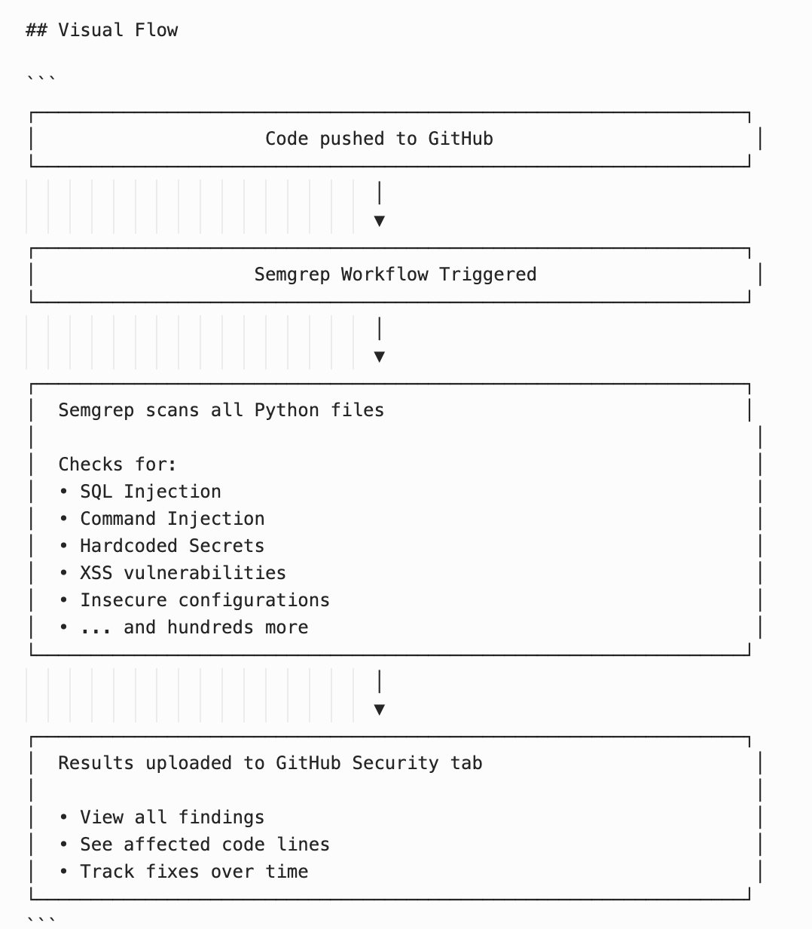

# Phase 7: Container Scanning with Trivy

## What is Phase 7 About?

Phase 7 adds **container vulnerability scanning** with Trivy. It checks your Docker image for known security vulnerabilities in:
- Your Python dependencies (FastAPI, Pydantic, etc.)
- The base operating system (Debian/Ubuntu packages)
- Your Dockerfile configuration

---

## Semgrep vs Trivy: What's the Difference?

| Semgrep (Phase 6) | Trivy (Phase 7) |
|-------------------|-----------------|
| Scans your **source code** | Scans your **Docker image** |
| Finds bugs you wrote | Finds vulnerabilities in dependencies |
| "Your code has SQL injection" | "FastAPI v0.100.0 has known vulnerability" |
| Catches coding mistakes | Catches outdated/vulnerable packages |

**You need BOTH:**
- Semgrep: Your code is secure
- Trivy: Your dependencies are secure

---

## The Problem Trivy Solves

### Your Code Can Be Perfect, But Still Vulnerable

Imagine you write perfect, secure code. But you use:
- An old version of FastAPI with a security bug
- A Python library that got hacked
- A base image with unpatched Linux vulnerabilities

**Your app is now vulnerable - even though YOUR code is fine.**

### Real-World Example: Log4j (2021)

```
Company: "Our code is secure, we checked!"
Hacker: "But your logging library (Log4j) has a vulnerability"
Result: Millions of systems compromised
```

The company's code was fine. The **dependency** had the bug.

---

## What is Trivy?

Trivy is an open-source security scanner by Aqua Security. It scans:

1. **Container images** - All packages inside your Docker image
2. **Filesystems** - Dependencies in your project
3. **IaC (Infrastructure as Code)** - Dockerfile, Kubernetes configs

### How Trivy Works

```
Your Docker Image
│
▼
┌──────────────────────────────────────────┐
│ Trivy scans: │
│ │
│ • OS packages (apt, apk) │
│ • Python packages (pip) │
│ • Checks against vulnerability database │
└──────────────────────────────────────────┘
│
▼
Reports: "Found CVE-2024-1234 in package X"
```

---

## What is a CVE?

**CVE = Common Vulnerabilities and Exposures**

It's a unique ID for each known security vulnerability.

**Example:** `CVE-2021-44228` (Log4j vulnerability)

When a vulnerability is discovered:
1. Security researchers find the bug
2. It gets assigned a CVE ID
3. Added to vulnerability databases
4. Scanners like Trivy can now detect it

