**learnspace**A online note sharing platform

**DCSD 16.2 – DSE 16.2  
Project Proposal**

M.R. Yogarathnam DCSD-KA-162F-026

U.A.B. Nawarathne DSE-KA-161F-011

W.H.M.P.M.B. Wijerathna DSE-KA-161F-018

S.P.C L. Premalal DCSD-KA-162F-016

The project is submitted in partial fulfillment of the requirement of the   
Diploma of Computer System Design of   
National Institute of Business Management  
No 02, V Road

Content

Declaration02

Acknowledgement03

Introduction04

Proposed System05

Scope06

Benefits of Proposed System07

Hardware/Software Requirements08

Cost Analysis09

Project Plan10

Gantt Chart11

Declaration

I certify that this project does not incorporate without acknowledgement, any material previously submitted for a Diploma in any institute and to the best of my knowledge and belief, it does not contain any material previously published or written by another person or myself except where due reference is made in the text. I also hereby give consent for my project report, if accepted, to be made available for photocopying and for interlibrary loans, and for the title and summary to be made available to outside organizations

M.R. Yogarathnam

U.A.B. Nawarathne

W.H.M.P.M.B. Wijerathna

S.P.C L. Premalal

DCSD-KA-162F-026

DSE-KA-161F-011

DSE-KA-161F-018

DCSD-KA-162F-016

___________________

___________________

___________________

___________________

Acknowledgement

We wish to extend our thanks to all the lectures who guide and for providing us the necessary information to design our own system.

We wish to express our sincere gratitude to Mrs. Inoka Abeysinghe and Mr. Naji Saravanabavan for the keen interest taken in the process of our work and for the guidance given to us for completing this project successfully.

Finally we would like to thank our parents for their encouragement and advice given to us in completing this project successfully.

Introduction

LearnSpace is notes sharing site where the users can create notes and request people to create

notes for any topics they need. Speciality is notes are created and shared in a form of cards for easy access and easy ways to remember.

Functions:

Creat and upload notes

View notes easily in the tree

Learn any subject quickly

Request experts to create note on a subject

Proposed System

Objectives

Diagram

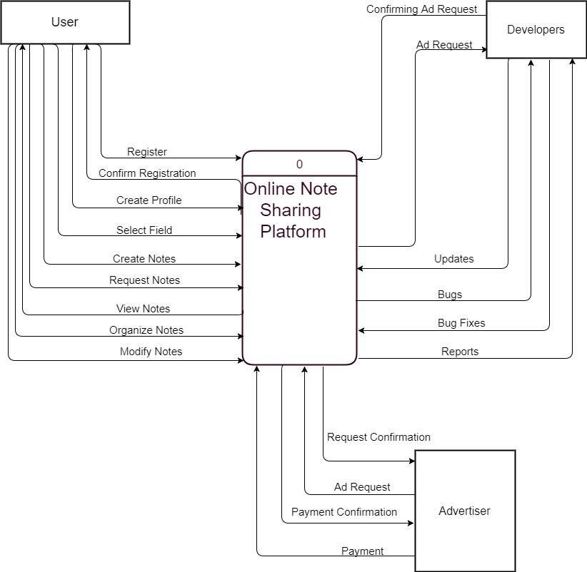

Scope

Many people face problems on revising the knowledge they gained from studying a subject or reading some important book or article .so we would like to create a tool help users to save there notes and share their notes.

User can also easily view the notes they created in the tree structure and modify the notes according to their preference and create their own tree structure to organize notes.

Since the users have the ability to request for notes and share notes on things they know it also can be considered as a tool that disrupts “kuppi” studying.

Benefits of the Proposed System

|  |  |
| --- | --- |
| Easy Access | Easily access to your notes using tree structure |
| User Friendly | Because of card based notes easy to read anytime and quickly |
| Mobility | Can access from anywhere through the internet |
| Security & Storage | Less possibility of losing valuable notes |
| Learnable | Can share notes with fellow users and read their notes so by this can learn many subjects easily |
| Request-able | Can request notes from other users |

Hardware/Software Requirement

Hardware Requirements

Web accessible electronic devices

Software Requirements

(Running tools)

Operating System: Windows/Linux Environment

User Interface: HTML & CSS

Database: My SQL

(Developing tools)

Visio, Notepad++, WAMP, GitHub, Bootstrap, Dreamweaver,

Cost Analysis

Personnel Rs 5,000/- per person

Website hosting fees Rs 15,000/-

Project Plan

|  |  |  |
| --- | --- | --- |
| **Task** | **Start Date** | **Duration in Days** |
| Studying the scope | 19/10/2017 | 5 |
| Requirement analysis | 22/10/2017 | 3 |
| Design | 25/10/2017 | 10 |
| Coding | 4/11/2017 | 50 |
| Unit Tests | 24/12/2017 | 5 |
| System Test | 29/12/2017 | 5 |
| Bug Fixes | 3/1/2017 | 12 |
| Improvements | 15/1/2018 | 7 |
| Final Testing | 22/1/2018 | 4 |
| Release Version | 26/1/2018 |  |

Gantt chart