**CHAPTER 01**

**(INTRODUCTION)**

THIS CHAPTER CONTAINS :-

* 1. SCOPE OF STUDY
  2. METHOLOGY
  3. DURATION
  4. **SCOPE OF STUDY**

The main objectives of this study are identify problems in current methods used to create notes to storing notes and providing a better way of doing by using web technologies.

The solution will be a web application so it can be used in minimum hardware and software and will be able to use in any smart device from a computer to a mobile phone.

This proposed web application will be able to perform the following activities.

* Creating notes in a editor .
* Saving notes in tree a structure .
* Requesting notes from groups.
  1. **METHOLOGY**

We will be using the System Development Life Cycle (SDLC) method as a guideline in analyzing and designing the system.

The following methods will be used to collect information and data and required for the design of the system,

* Planning interface for the web application.
* Planning web application functionality.
* Building the web application.
* Testing web application and fixing bugs.
* Launching beta.
  1. **DURATION**

|  |  |  |  |  |  |  |
| --- | --- | --- | --- | --- | --- | --- |
|  | December | | | January | | |
| 1st week | 2nd week | 3rd week - 4th week | 1st week | 2nd week - 3rd week | 4th week |
| Project planning |  |  |  |  |  |  |
| Database Design |  |  |  |  |  |  |
| Interface & Pseudo code |  |  |  |  |  |  |
| Testing and  Hosting |  |  |  |  |  |  |
| Submit the Project |  |  |  |  |  |  |

**CHAPTER 3**

**(PROPOSED SYSTEM)**

THIS CHAPTER CONTAINS :-

3.1 Proposed System

3.2 Entity Relation Diagram

3.3 Schema Diagram

3.4 Data Flow Diagrams

3.4.1 Context Level Diagram

3.4.2 Level 0 Data Flow Diagram of proposed system

3.5 Use Case Diagram of proposed System

3.6 UML class Diagram of proposed System

**3.1 Proposed System**

With difficulty of the manual system, we proposed a new computerized system to handle day by day transactions in the THARINDU BOOK SHOP, proposed system is as follows

Since the current way of writing notes and storing them are difficult to maintain and access, we proposed a new system to create and store notes in online web application where users can access easily and share them, proposed system is as follows

* Attractive interfaces.
* Create notes in a editor.
* Requesting Notes.
* Adding Notes from various topics/categories.
* Creating study groups to share notes.
* Storing in a tree structure to access notes easily and quickly.

**3.2 Entity Relation Diagram**

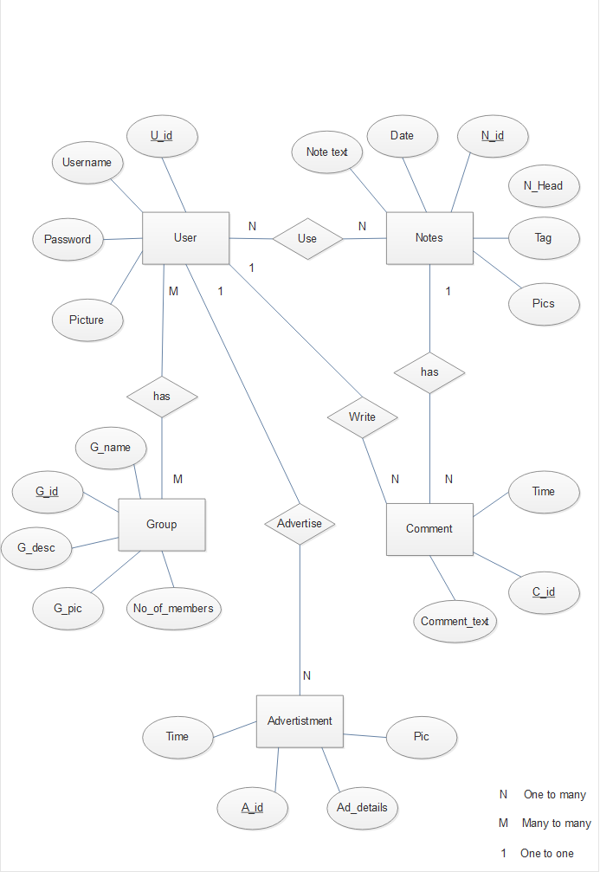

**3.4 Data Flow Diagram**

3.4.1 Context Level Diagram

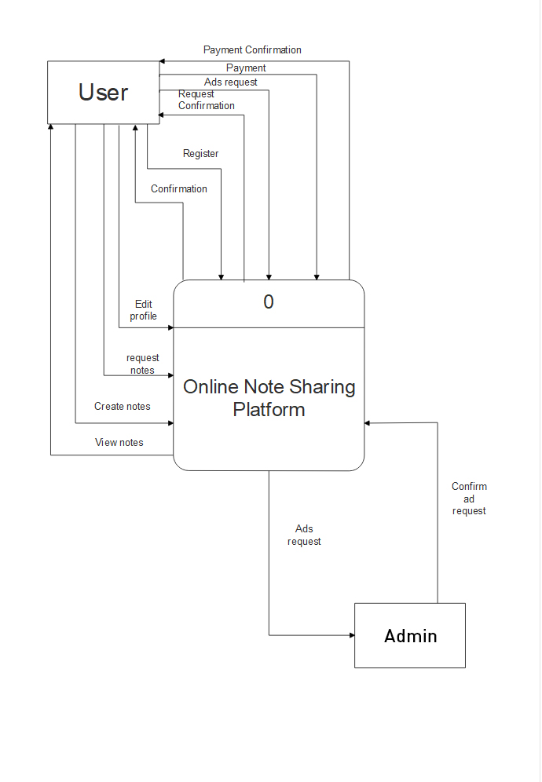

3.4.2 Level 0 Data Flow Diagram of proposed system

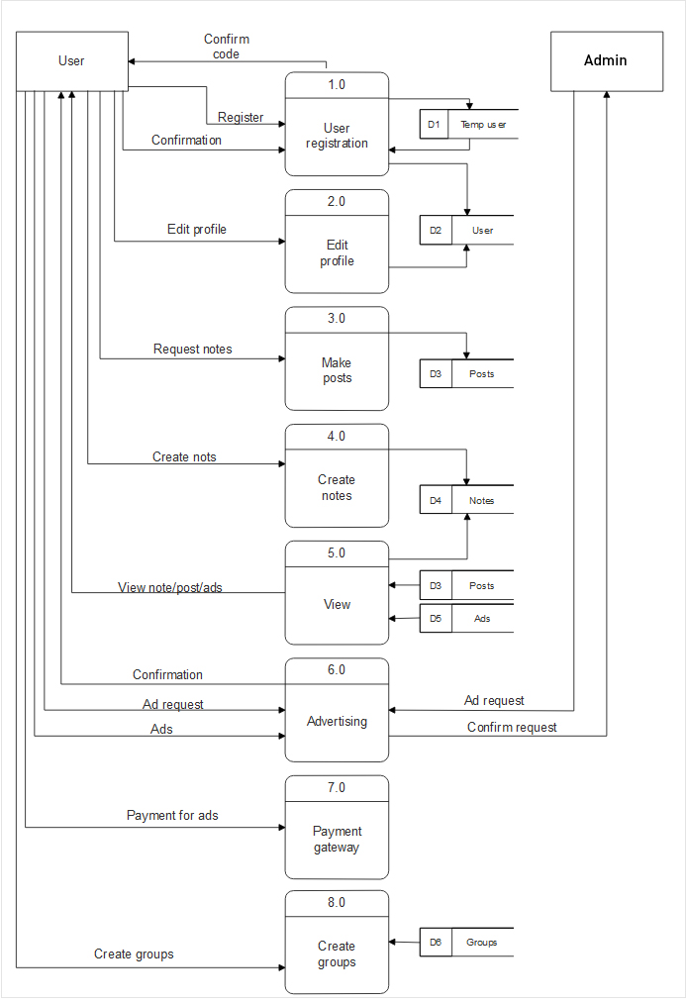

**3.5 Use Case Diagram of proposed System**

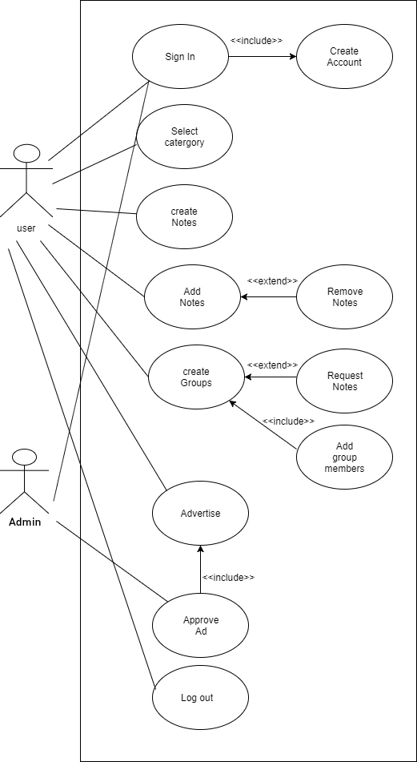

**3.6 UML class Diagram of proposed System**

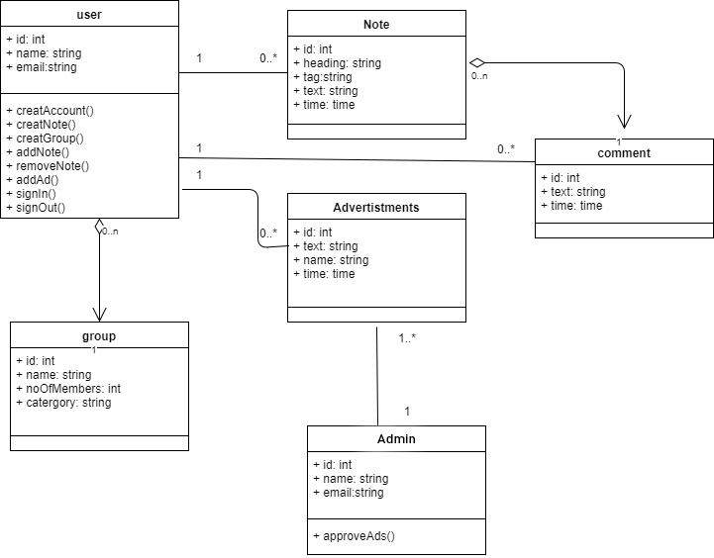

**CHAPTER 04**

THIS CHAPTER CONTAINS :-

## 

4.1 Screen Design

**4.1** **Screen Design**

**Screen Name** - Index Page

**Screen Description** - User login and registration

**Screen Design**

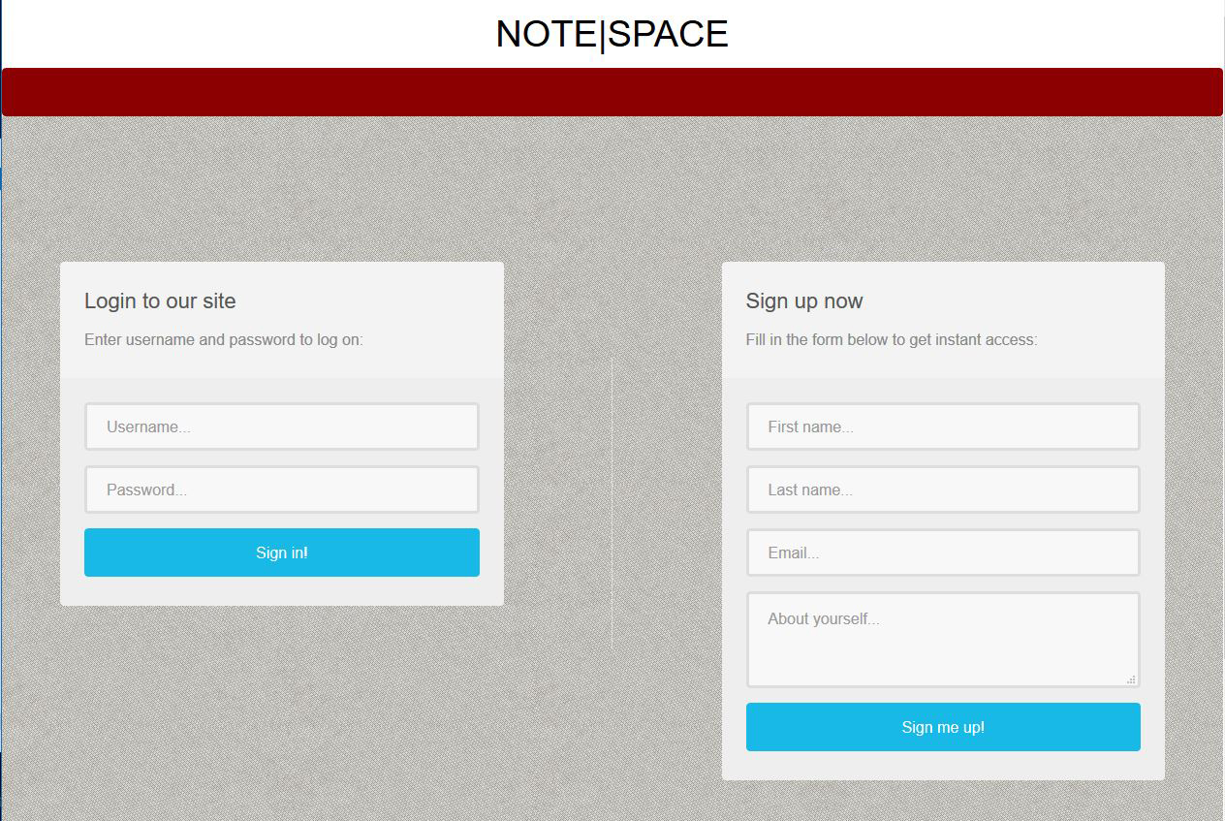

**Screen Name** - Home Page

**Screen Description** - User can search for notes and Display popular and recent notes

**Screen Design**

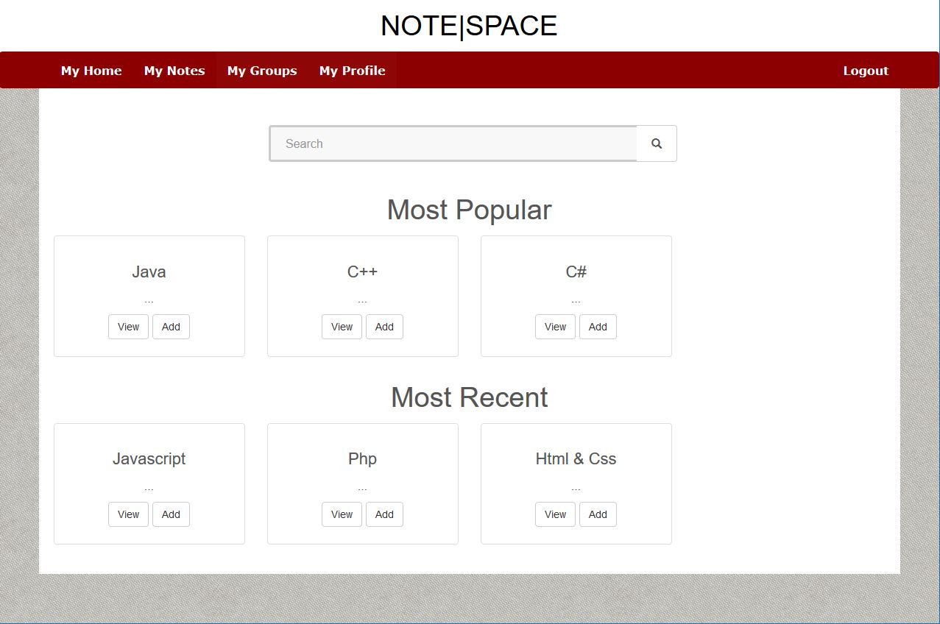

**Screen Name** - Notes Page

**Screen Description** - User can see his current saved notes by group

**Screen Design**

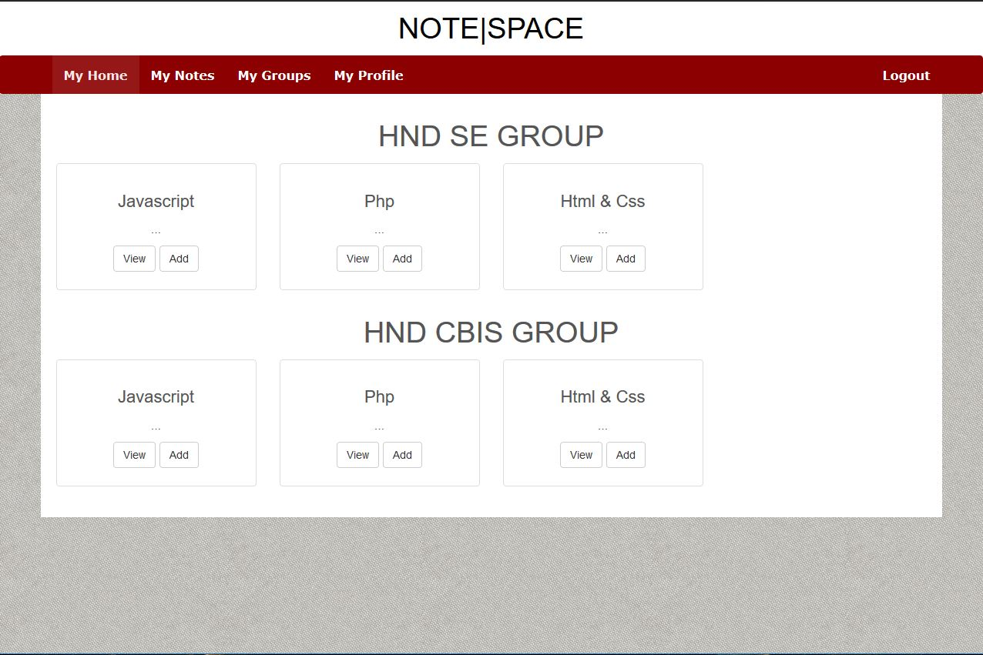

**Screen Name** - Groups Page

**Screen Description** - User can create groups and edit groups for note making

**Screen Design**

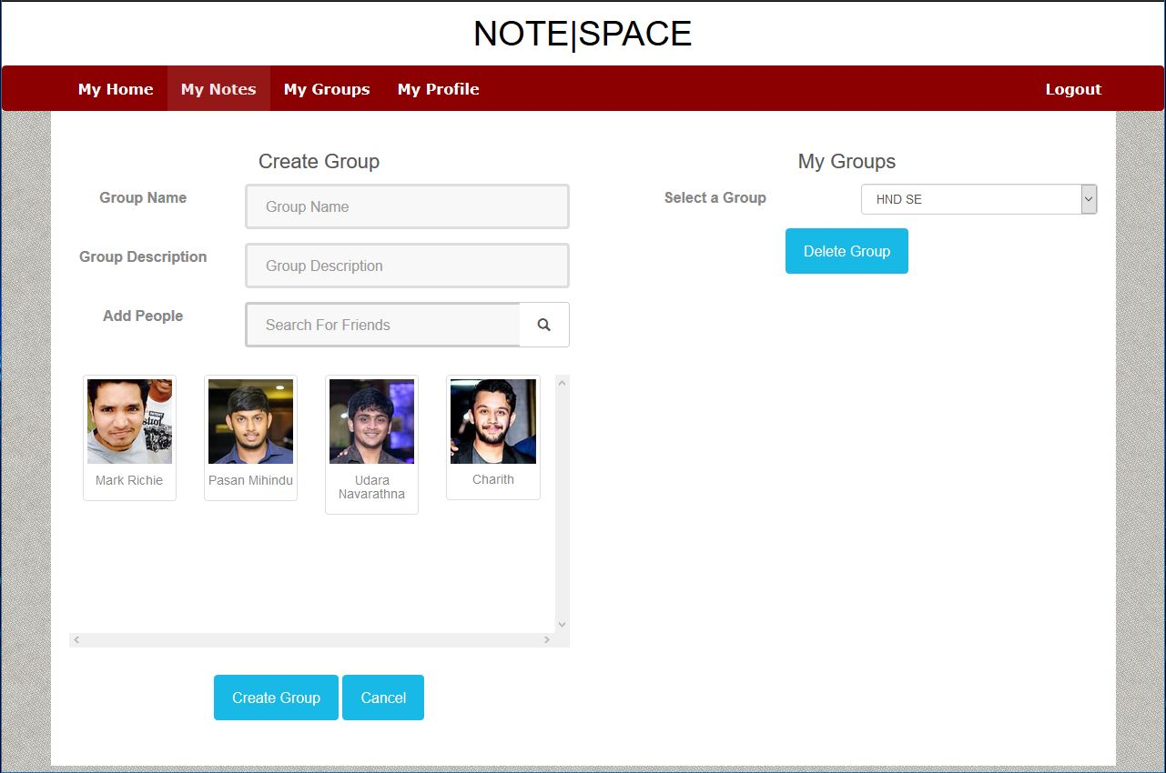

**Screen Name** - Profile Page

**Screen Description** - User can see his own notes

**Screen Design**

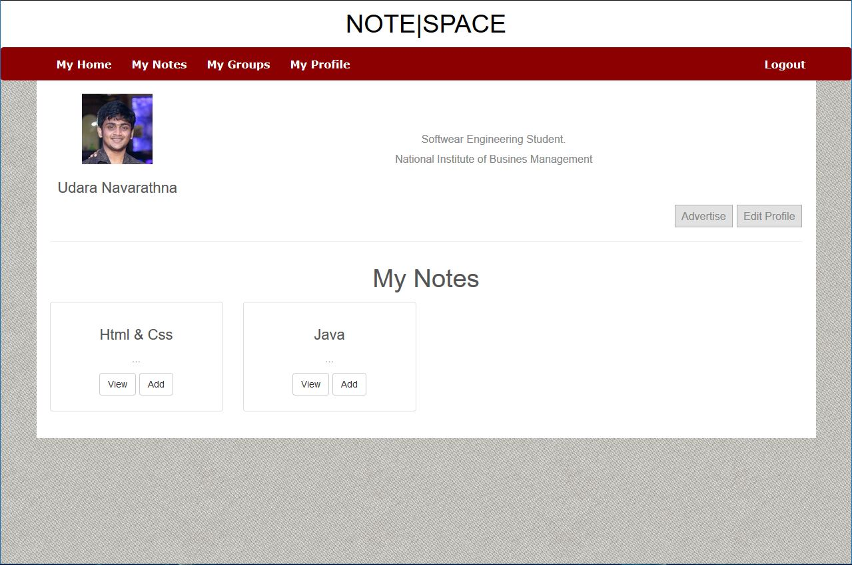

**Screen Name** - Ad Page

**Screen Description** - User can create ads to post on pages

**Screen Design**

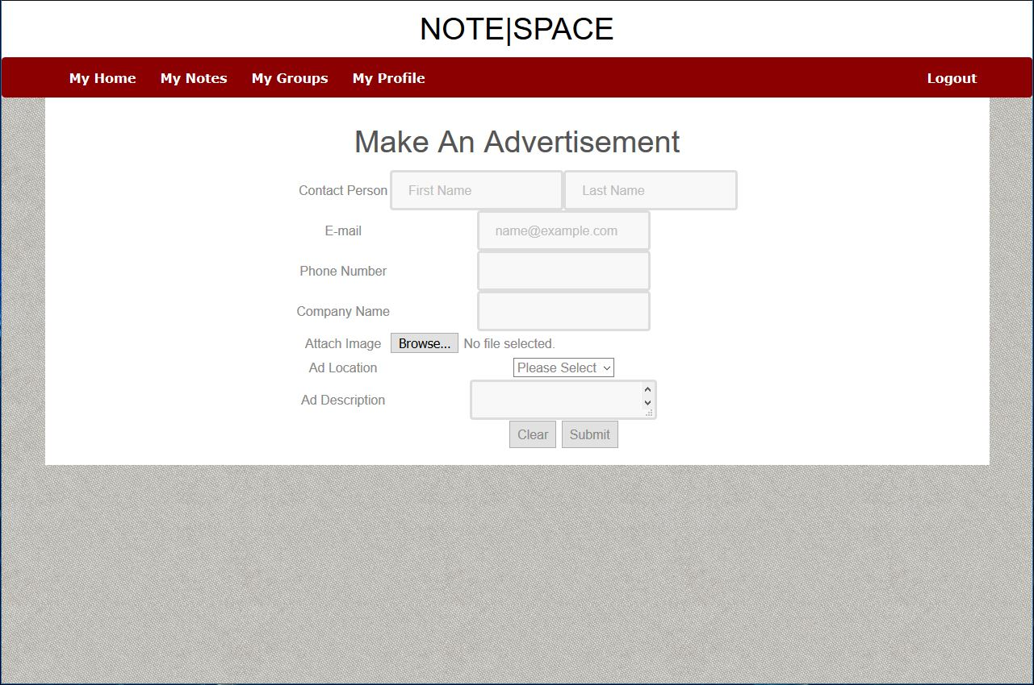

**Screen Name** - Ad Page

**Screen Description** - User can create ads to post on pages

**Screen Design**



**Screen Name** - Edit Page

**Screen Description** - User can edit his details

**Screen Design**

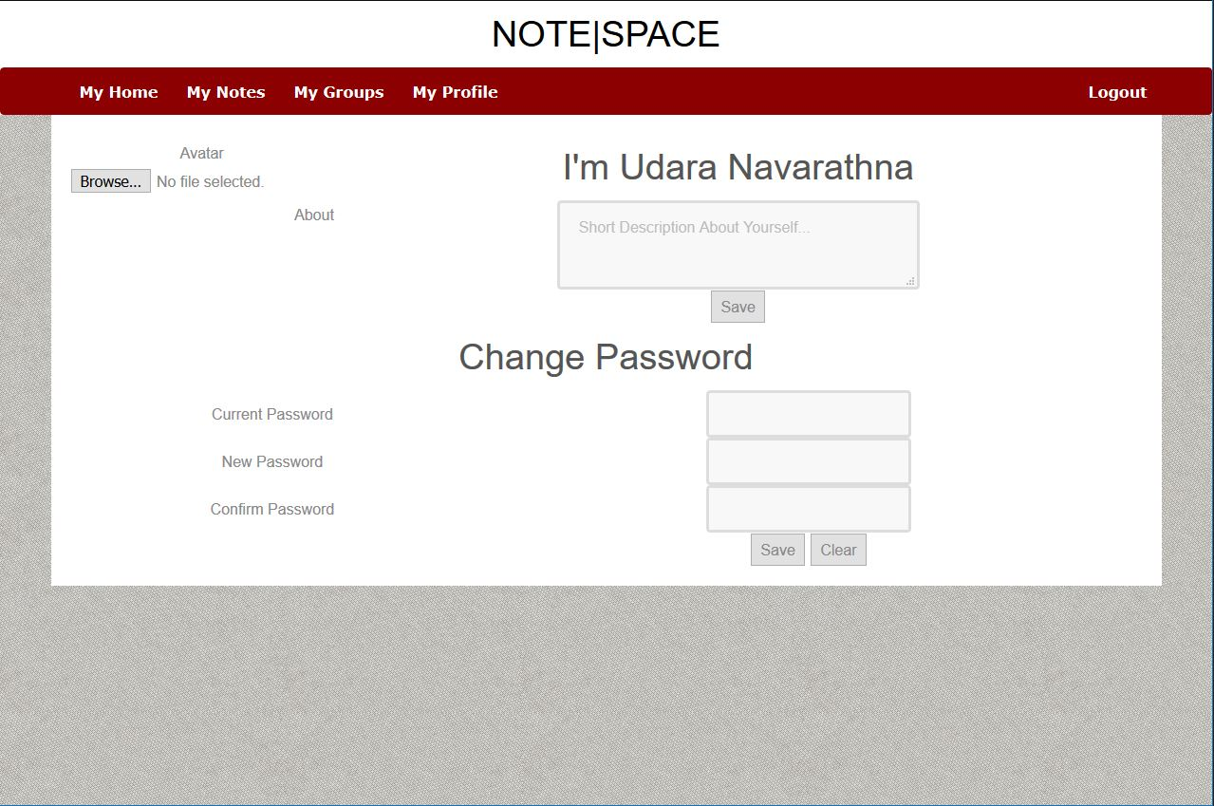

**Screen Name** - Post

**Screen Description** - User can view notes and add comments

**Screen Design**

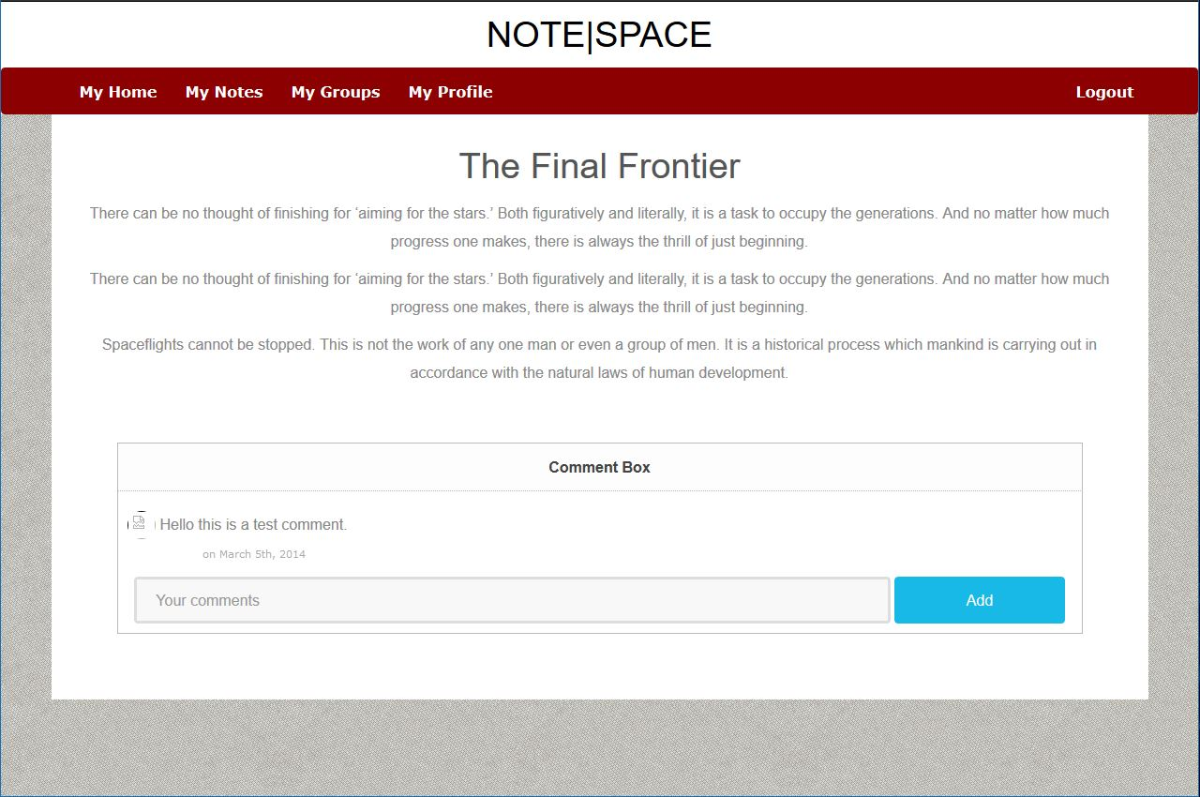

**CHAPTER 05**

**(Program Design)**

THIS CHAPTER CONTAINS :-

## 

## 5.1 Pseudo codes

5.2 Program codes

## **5.1** **Pseudo codes**

|  |  |
| --- | --- |
| Pseudo codes Id | Pseudo code Name |
| P1 | Registration |
| P2 | Login |

Pseudo codes Id :- P1

Pseudo code Name :- Registration

Start

String first_name, last_name, email, password, confirm_password, about

Onbutton Click register

If(first_name is empty)

Display error message

Else if(last_name is empty)

Display error message

Else if (email is empty)

Display error message

Else if (password <6)

Display error message

Else if(confirm_password !== password)

Display error message

Else if (about is empty)

Display error message

Else if

Send data to temp_user table

Redirect to confirm page

Send confirmation code

End

**5.2 Program codes**

* **Login page**

**CHAPTER 06**

THIS CHAPTER CONTAINS :-

6.1 System requirements

6.2 Benefits analysis

**6.1 System requirements**

**Hardware**

**Software**

**Additional**

* Internet connection