**CHAPTER 01**

**(INTRODUCTION)**

THIS CHAPTER CONTAINS :-

* 1. TERMS OF REFERENCE
  2. SCOPE OF STUDY
  3. METHOLOGY
  4. DURATION
  5. **TERMS OF REFERENCE**

This is to study the existing system and to introduce a computerized system to overcome weakness of existing systems drawbacks. Current system is consisting with manual processes, and inter-relationship and transferring information is poor an unstructured. Therefore, management will be expecting a new Information system which is more effective and efficient.

The project group shall perform the following investigation and analyze the existing system.

1. Investigation present procedures.
2. Analyze the existing system. Identify the problem and weakness in existing system.
3. Identify the need to have a new computerized system.
4. Design a new computerized system most suitable for the organization including hardware, software, live ware and other and other suited facilities
   1. **SCOPE OF STUDY**

The main objectives of this study are to identify the drawbacks of the existing system and to provide ways and means to overcome them. The computerized system we are going to propose will help the THARINDU BOOK SHOP to achieve their objectives whilst overcoming difficulties encountered by the current system (manual).

Hardware and software requirements of the system will be analyzed and justified during our study. In addition, cost benefit analysis & feasibility study will be providing with this document.

This proposed Inventory control system THARINDU BOOK SHOP will cover the following main Activities.

* Barcode related billing system.
* Inventory control and sales.
  1. **METHOLOGY**

We will be using the System Development Life Cycle (SDLC) method as a guideline in analyzing and designing the system.

The following methods will be used to collect information and data and required for the design of the system,

* Plan the investigation
* Obtain permission to consult person from specially identified segments groups.
* Discussions and interviews will be held with owner, cashier and current environment.
* Understand individual/group development workloads.
* Identify how the environment will change.
* Identify management requirements for the new system.
* Identify operational requirements for the new system.
* All source documents/reports related to the system will be obtained.
* Collect all monthly report layers.
* Investigate the document flow procedures of the manual system.
* Problems of the existing system will be identified and recommendations will be made for proposed system to work more effectively and accurately.
* We will be developing the proposed system by using the Data Flow Diagrams (DFD), which is a technique used to depict the flow of data through the system.
  1. **DURATION**

|  |  |  |  |  |  |  |
| --- | --- | --- | --- | --- | --- | --- |
|  | May | | | June | | |
| 1st week | 2nd week | 3rd week - 4th week | 1st week | 2nd week - 3rd week | 4th week |
| Project planning |  |  |  |  |  |  |
| Initial interviews |  |  |  |  |  |  |
| Data collection |  |  |  |  |  |  |
| Database Design |  |  |  |  |  |  |
| Interface & Pseudo code |  |  |  |  |  |  |
| Create Report |  |  |  |  |  |  |
| Submit the Project |  |  |  |  |  |  |

**CHAPTER 3**

**(PROPOSED SYSTEM)**

THIS CHAPTER CONTAINS :-

3.1 Proposed System

3.2 Entity Relation Diagram

3.3 Schema Diagram

3.4 Data Flow Diagrams

3.4.1 Context Level Diagram

3.4.2 Level 0 Data Flow Diagram of proposed system

3.4.3 Level 1 Data Flow Diagram of proposed system

3.5 Use Case Diagram of Existing System

3.6 Use Case Diagram of proposed System

3.7 UML class Diagram of proposed System

3.8 UML Sequence Diagram of proposed System

**3.1 Proposed System**

With difficulty of the manual system, we proposed a new computerized system to handle day by day transactions in the THARINDU BOOK SHOP, proposed system is as follows

* Attractive interfaces.
* Store employee data, sales and stock
* Business summery reports for sales.
* Available stock checker.
* When the stock is at the EOQ range system will generate a pop message.
* Barcode related billing system.

**3.2 Entity Relation Diagram**

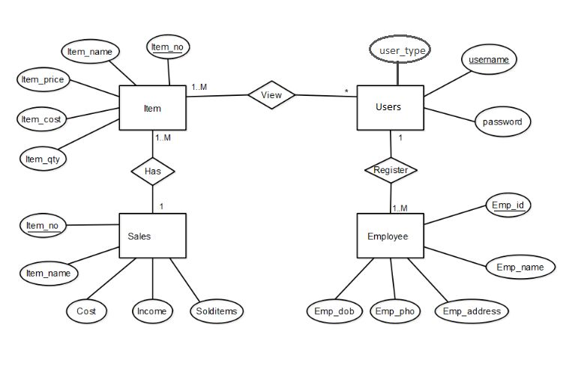

**3.3 Schema Diagram**

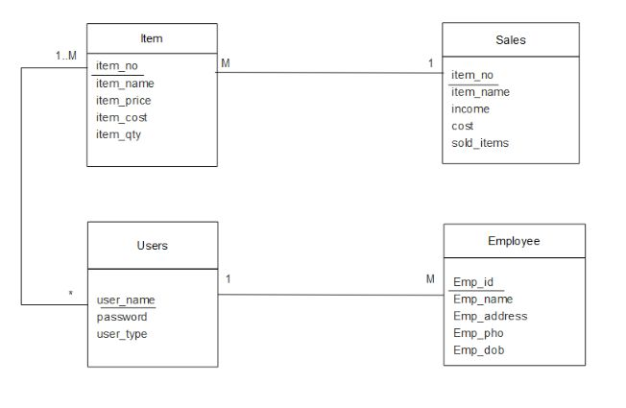

**3.4 Data Flow Diagram**

3.4.1 Context Level Diagram

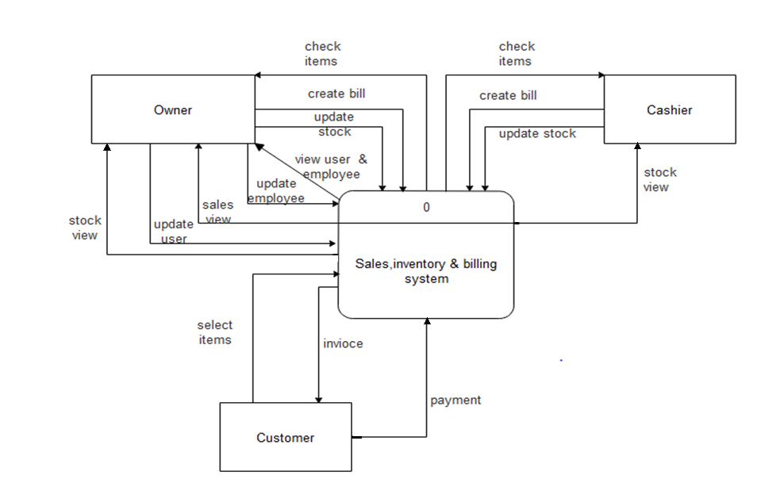

s

3.4.2 Level 0 Data Flow Diagram of proposed system

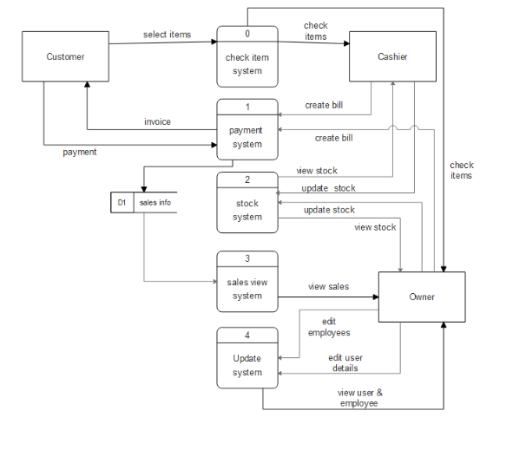

3.4.3 Level 1 Data Flow Diagram of proposed system

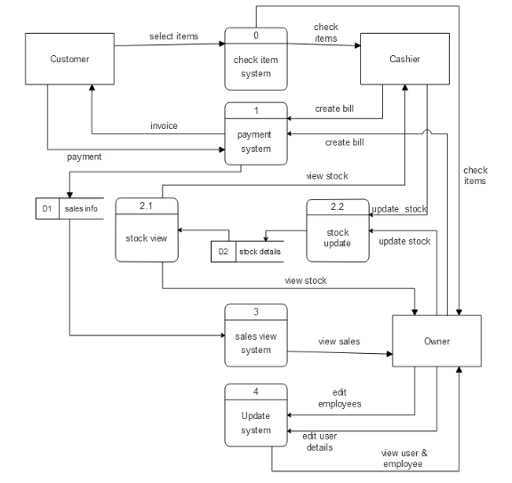

**3.5 Use Case Diagram of Existing System**

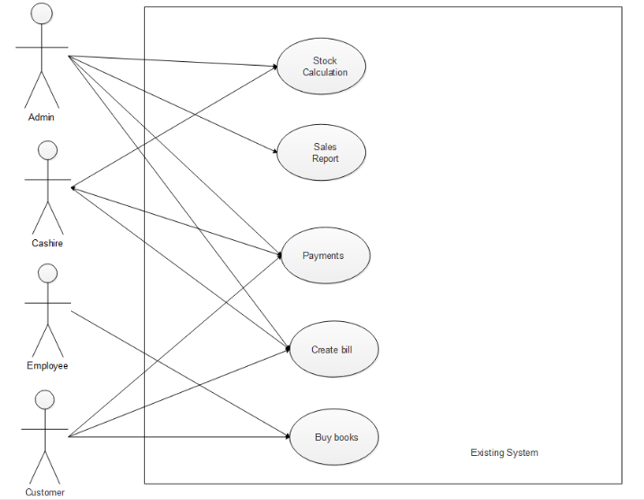

**3.6 Use Case Diagram of proposed System**

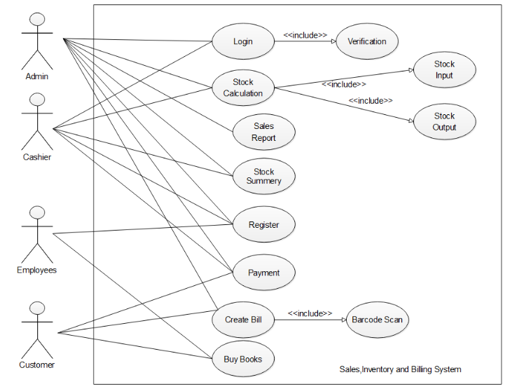

**3.7 UML class Diagram of proposed System**

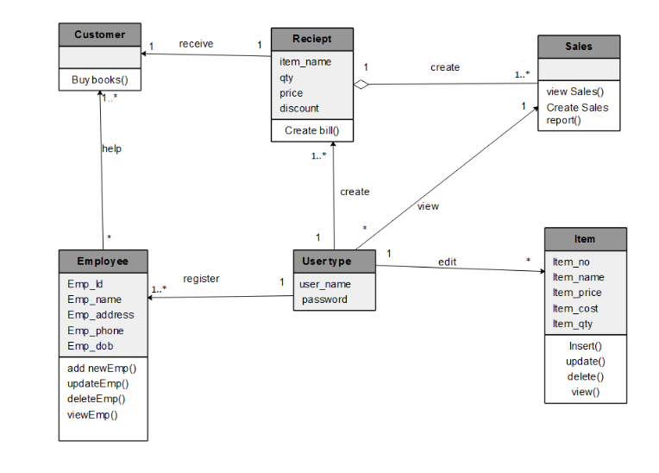

**3.8 UML Sequence Diagram of proposed System**

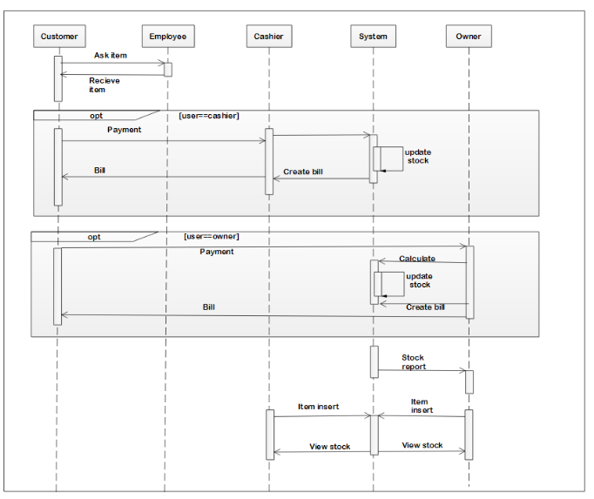

**CHAPTER 04**

THIS CHAPTER CONTAINS :-

## 

## 4.1 File Design

4.2 Screen Design

**4.1** **File Design**

|  |  |  |  |  |  |
| --- | --- | --- | --- | --- | --- |
| Table id | | Table name |  | Description | |
| D1 | Item | | |  | Item details table |
| D2 | Users | | |  | Login details table |
| D3 | Employee | | |  | Employee details table |
| D4 | Sales | | |  | Stocks detail table |

**Table ID** – D1

**Table name** – item

**Table description** – keep track of item data

**Primary key** – item_no

|  |  |  |
| --- | --- | --- |
| Field | Description | Type |
| item_no | Primary key of Item table | Float |
| item_name | Name of the Item | Nvarchar(30) |
| item_price | Price of the Item | Decimal(18,0) |
| item_cost | Cost of the Item | Decimal(18,0) |
| item_qty | Quantity of the Item | int |

**Screen ID** - SCR 01

**Screen Name** - Login

**Screen Description** - user login

**Screen Design**

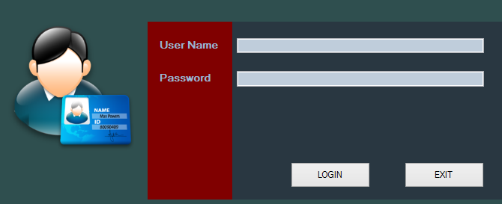

**Screen ID**  - SCR 02

**Screen Name** - Home window

**Screen Description** - Main interface of cashier

**Screen Design**

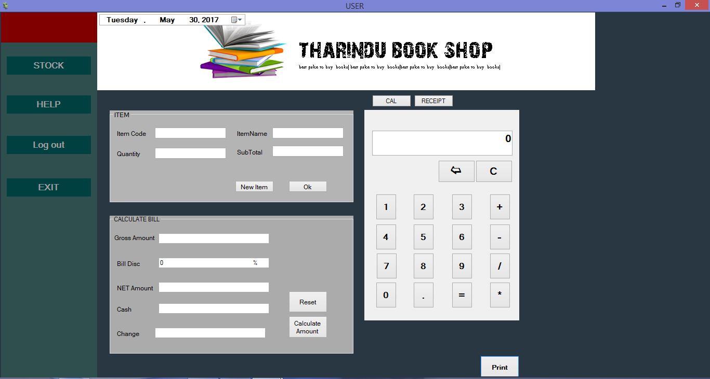

**CHAPTER 05**

**(Program Design)**

THIS CHAPTER CONTAINS :-

## 

## 5.1 Pseudo codes

5.2 Program codes

## **5.1** **Pseudo codes**

|  |  |
| --- | --- |
| Pseudo codes Id | Pseudo code Name |
| P1 | Login |
| P2 | Admin window |
| P3 | Home page |
| P4 | Insert new item |
| P5 | Update item |
| P6 | Delete item |
| P7 | Stock view |
| P8 | Sales view |
| P9 | Add user |
| P10 | Change user name |
| P11 | Change user password |
| P12 | Delete user |
| P13 | Add new employee |
| P14 | Update employee |
| P15 | Delete employee |
| P16 | View employee |

Pseudo codes Id :- P1

Pseudo code Name :- Login

Start

Open master file(users)

Read users

User_name,password

Print(username and password)

Password=password,user_name=username

Select password from users

If(user_name==admin)

Load the SCR 03

else if(user_name==cashire)

Lode the SCR 02

else

print"Invalid username and password"

End if

End

Pseudo codes Id :- P2

Pseudo code Name :- Admin Window

start

if<STOCK>button clicked

then

Display the SCR 04

Else if <(SALES> button clicked

then

Display the SCR 09

Else if<USERS> button clicked

then

Display the SCR 10

Else if<EMPLOYEES> button clicked

then

Display the SCR 15

Else if<Home> button clicked

then

Display the SCR 02

Else if<Log Out> button clicked

then

Display the SCR 01

Else if<Help> button clicked

then

Display the Contact Numbers of developers

Else if<Exit> button clicked

then

Exit

End if

End

**5.2 Program codes**

* **Login page**

using System;

using System.Collections.Generic;

using System.ComponentModel;

using System.Data;

using System.Drawing;

using System.Linq;

using System.Text;

using System.Threading.Tasks;

using System.Windows.Forms;

using System.Data.SqlClient;

namespace projectbp

{

public partial class Form1 : Form

{

sqlconnectio_class con;

public Form1()

{

con = new sqlconnectio_class();

InitializeComponent();

}

private void Form1_Load(object sender, EventArgs e)

{

try

{

con.connection();

con.qurry("select * from users;");

con.ad();

String ch = "";

ch = con.dt.Rows[0][0].ToString();

}

catch (IndexOutOfRangeException)

{

admin a = new admin();

a.Show();

this.Hide();

}

}

private void btnexit_Click(object sender, EventArgs e)

{

Application.Exit();

}

private void btnlog_Click(object sender, EventArgs e)

{

try

{

con.connection();

con.qurry("select * from users where user_name='" + txtu.Text + "';");

con.ad();

String id = "";

String pw = "";

* **Home Page**

using System;

using System.Collections.Generic;

using System.ComponentModel;

using System.Data;

using System.Drawing;

using System.Linq;

using System.Text;

using System.Threading.Tasks;

using System.Windows.Forms;

using System.Data.SqlClient;

namespace projectbp

{

public partial class home : Form

{

sqlconnectio_class con;

decimal cash;

decimal gtot;

decimal d;

Double firstnum;

Double secondtnum;

Double answer;

String ope;

public home()

{

con = new sqlconnectio_class();

InitializeComponent();

lst_bill.SelectionMode = SelectionMode.MultiExtended;

}

private void textBox7_TextChanged(object sender, EventArgs e)

{ }

private void eXITToolStripMenuItem_Click(object sender, EventArgs e)

{ }

private void button4_Click(object sender, EventArgs e)

{

lst_bill.Hide();

pnlcal.Show();

**CHAPTER 06**

THIS CHAPTER CONTAINS :-

6.1 System requirements

6.2 Benefits analysis

**6.1 System requirements**

**Hardware**

* Processor :- Intel Pentium Dual Core processor
* Memory (RAM) :- Minimum 1GB
* Storage :- 160GB hard drive
* Printer :DOT Matrix
* Optical Drive : DVD Writer
* Key board : MS OS capable
* Mouse : MS OS capable
* Barcode reader:
* UPS

**Software**

* Operation system:- Microsoft windows 7/8/8.1/10
* Additional software to read values from barcode reader
* Dot matrix printer drivers

**Additional**

* Recognized anti-virus guard
* Internet connection
  1. **Benefits Analysis**
* To enable automated data entry methods.
* Ensure efficient and reliable communication with cashier and owner.
* Avoid data entry errors by use of input masks.
* Enable easy authorized modification of data.
* Enforce security measures to avoid unauthorized access to sales and inventory records.
* Enable fast and easy retrieval of sales records and data for fast reference activities.
* Employee satisfaction
* Better Security.

**Conclusion**

As a final conclusion, this system is outstanding system compared to current manual system main reason is its computerized system and also our system contains with sales report generator. It is necessary option for the current system because losing and isolation of data was a major challenge in the current manual system. When the owner wants to inquire something, he can perform the relevant tasks within few seconds with this system. So, this system is more efficient and quick than the manual system.

The major aim of our system is to implement a computerized billing, inventory and sales report generating system which will make the working environment more attractive and easy. This will lead the business from paper based accounting method to computerized business system.

We completed this system design within the time duration we have mention in chapter 1. Finally, we hope this proposed system will help to do sales, billing and stock management much accurate, much easier way.