**WEEK 1: Design Patterns And Principles**

**Exercise 1: Implementing the Singleton Pattern**

**Scenario:** You need to ensure that a logging utility class in your application has only one instance throughout the application lifecycle to ensure consistent logging.

class Logger {

private static Logger instance;

private Logger() {

// Initialization

}

public static Logger getInstance() {

if (instance == null) {

instance = new Logger();

}

return instance;

}

public void log(String message) {

System.out.println("Log: " + message);

}}

class SingletonTest {

public static void main(String[] args) {

Logger logger1 = Logger.getInstance();

Logger logger2 = Logger.getInstance();

logger1.log("This is the first log message.");

logger2.log("This is the second log message.")

if (logger1 == logger2) {

System.out.println("Both logger1 and logger2 are the same instance.");

} else {

System.out.println("Logger instances are different.");

}}}

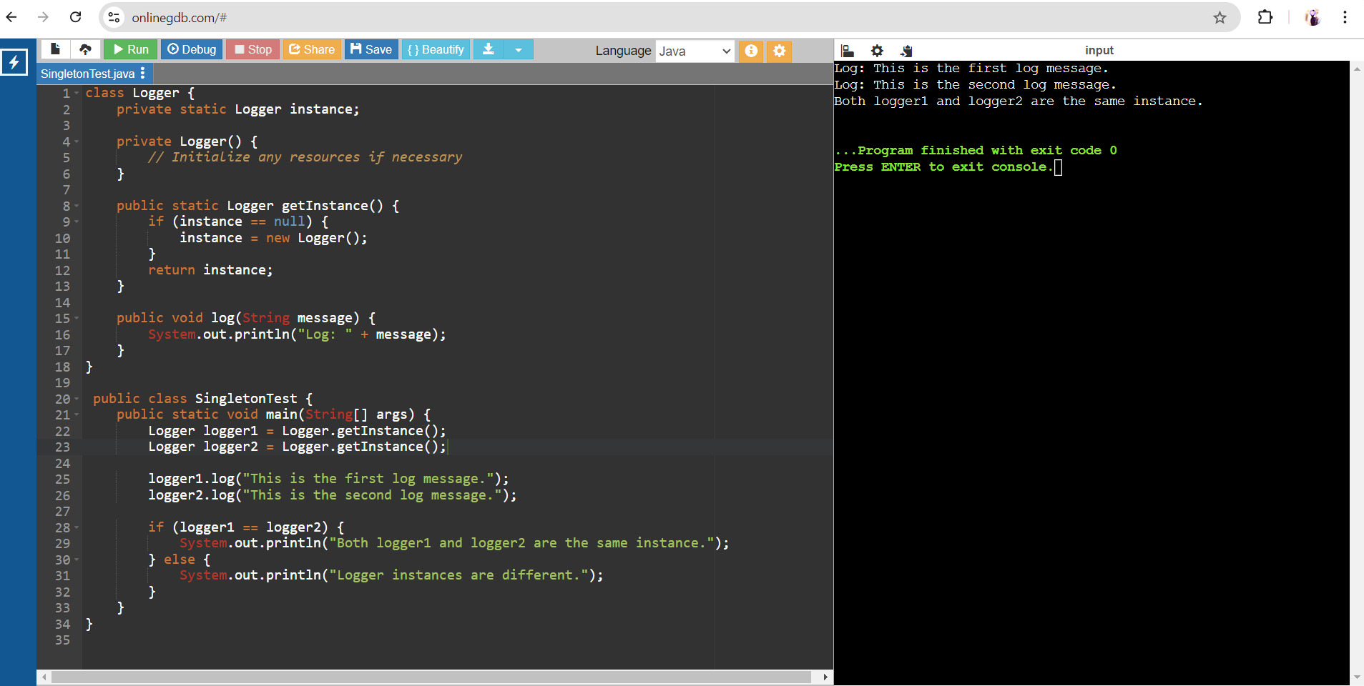

**Exercise 2: Implementing the Factory Method Pattern**

**Scenario:** You are developing a document management system that needs to create different types of documents (e.g., Word, PDF, Excel). Use the Factory Method Pattern to achieve this.

interface Document {

void open();

void close();

}

class WordDocument implements Document {

public void open() {

System.out.println("Opening Word document...");

}

public void close() {

System.out.println("Closing Word document...");

}

}

class PdfDocument implements Document {

public void open() {

System.out.println("Opening PDF document...");

}

public void close() {

System.out.println("Closing PDF document...");

}}

class ExcelDocument implements Document {

public void open() {

System.out.println("Opening Excel document...");

}

public void close() {

System.out.println("Closing Excel document...");

}

}

abstract class DocumentFactory {

public abstract Document createDocument();

}

class WordDocumentFactory extends DocumentFactory {

public Document createDocument() {

return new WordDocument();

}

}

class PdfDocumentFactory extends DocumentFactory {

public Document createDocument() {

return new PdfDocument();

}

}

class ExcelDocumentFactory extends DocumentFactory {

public Document createDocument() {

return new ExcelDocument();

}

}

public class FactoryMethodPatternExample {

public static void main(String[] args) {

DocumentFactory wordFactory = new WordDocumentFactory();

Document wordDocument = wordFactory.createDocument();

wordDocument.open();

wordDocument.close();

DocumentFactory pdfFactory = new PdfDocumentFactory();

Document pdfDocument = pdfFactory.createDocument();

pdfDocument.open();

pdfDocument.close();

DocumentFactory excelFactory = new ExcelDocumentFactory();

Document excelDocument = excelFactory.createDocument();

excelDocument.open();

excelDocument.close();

}

}

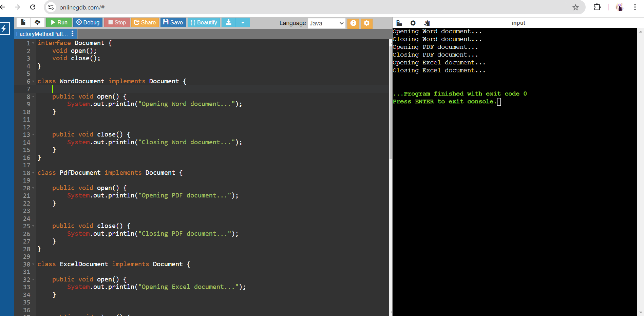

**Exercise 3: Implementing the Builder Pattern**

**Scenario:** You are developing a system to create complex objects such as a Computer with multiple optional parts. Use the Builder Pattern to manage the construction process.

public class BuilderPatternExample {

static class Computer {

private String CPU;

private String RAM;

private String storage;

private Computer(Builder builder) {

this.CPU = builder.CPU;

this.RAM = builder.RAM;

this.storage = builder.storage;

}

public static class Builder {

private String CPU;

private String RAM;

private String storage;

public Builder setCPU(String CPU) {

this.CPU = CPU;

return this;

}

public Builder setRAM(String RAM) {

this.RAM = RAM;

return this;

}

public Builder setStorage(String storage) {

this.storage = storage;

return this;

}

public Computer build() {

return new Computer(this);

}

}

}

public static void main(String[] args) {

Computer gamingPC = new Computer.Builder()

.setCPU("Intel Core i9")

.setRAM("32GB")

.setStorage("1TB SSD")

.build();

System.out.println("CPU: " + gamingPC.CPU);

System.out.println("RAM: " + gamingPC.RAM);

System.out.println("Storage: " + gamingPC.storage);

}

}

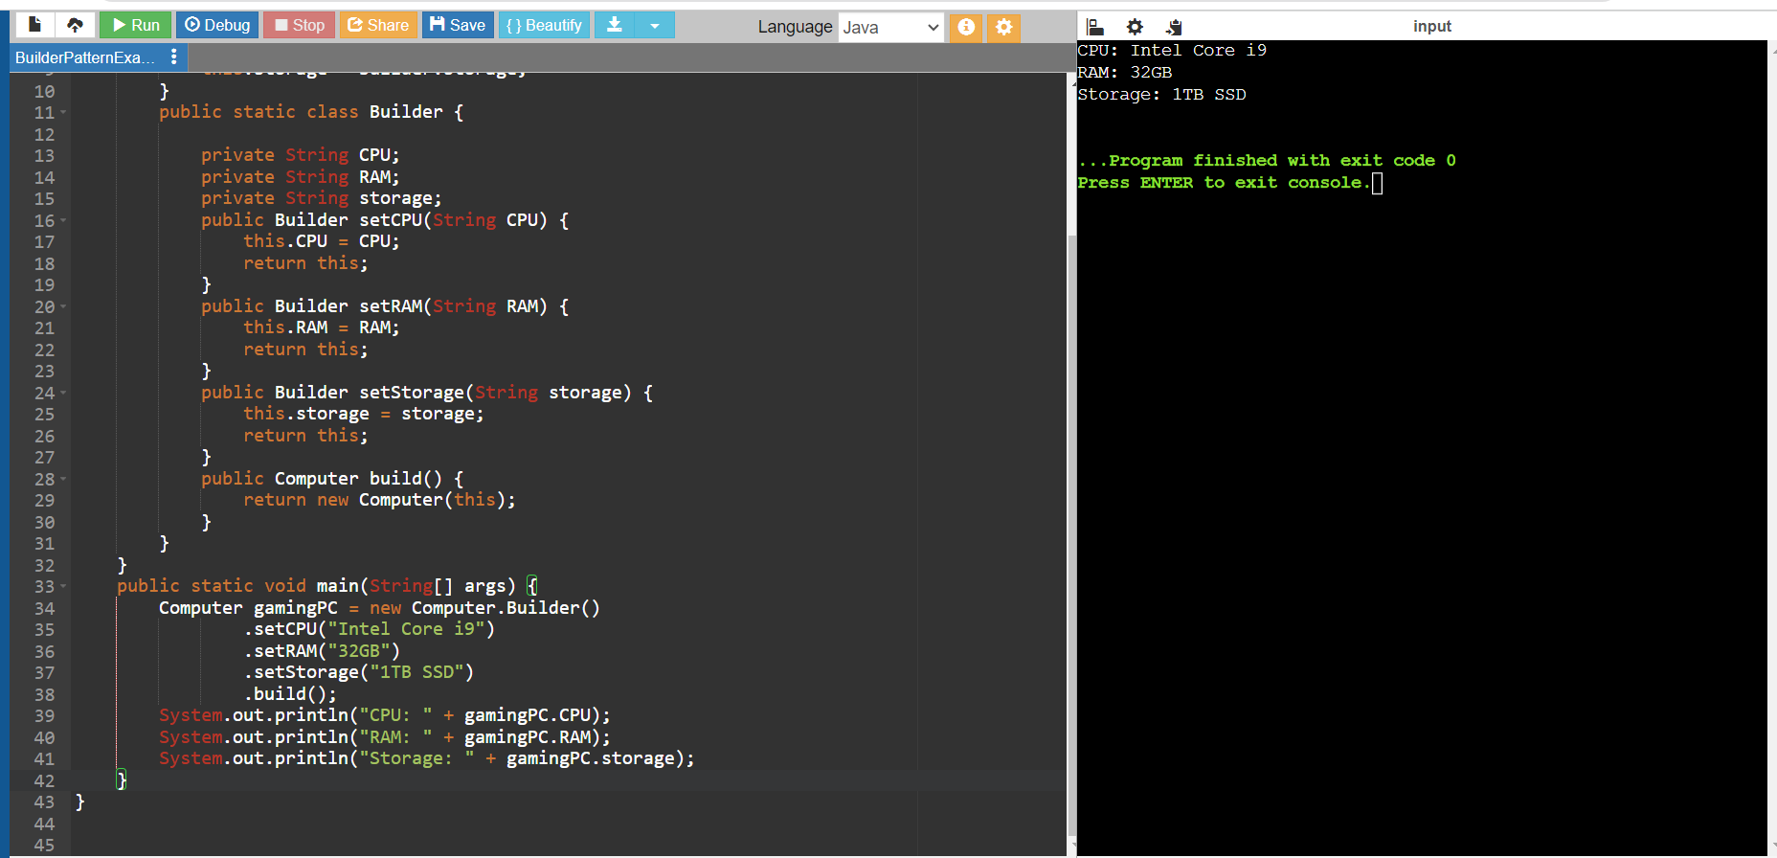

**Exercise 4: Implementing the Adapter Pattern**

**Scenario:** You are developing a payment processing system that needs to integrate with multiple third-party payment gateways with different interfaces. Use the Adapter Pattern to achieve this.

interface PaymentProcessor {

void processPayment(double amount);

}

class PayPal {

public void makePayment(double amount) {

System.out.println("Processing payment of Rs." + amount + " through PayPal.");

}

}

class Stripe {

public void pay(double amount) {

System.out.println("Processing payment of Rs." + amount + " through Stripe.");

}

}

class AmazonPay {

public void processTransaction(double amount) {

System.out.println("Processing payment of Rs." + amount + " through Amazon Pay.");

}

}

class PayPalAdapter implements PaymentProcessor {

private PayPal payPal;

public PayPalAdapter(PayPal payPal) {

this.payPal = payPal;

}

public void processPayment(double amount) {

payPal.makePayment(amount);

}

}

class StripeAdapter implements PaymentProcessor {

private Stripe stripe;

public StripeAdapter(Stripe stripe) {

this.stripe = stripe;

}

public void processPayment(double amount) {

stripe.pay(amount);

}

}

class AmazonPayAdapter implements PaymentProcessor {

private AmazonPay amazonPay;

public AmazonPayAdapter(AmazonPay amazonPay) {

this.amazonPay = amazonPay;

}

public void processPayment(double amount) {

amazonPay.processTransaction(amount);

}

}

public class AdapterPatternExample {

public static void main(String[] args) {

PayPal payPal = new PayPal();

Stripe stripe = new Stripe();

AmazonPay amazonPay = new AmazonPay();

PaymentProcessor payPalAdapter = new PayPalAdapter(payPal);

PaymentProcessor stripeAdapter = new StripeAdapter(stripe);

PaymentProcessor amazonPayAdapter = new AmazonPayAdapter(amazonPay);

payPalAdapter.processPayment(100.00);

stripeAdapter.processPayment(200.00);

amazonPayAdapter.processPayment(300.00);

}

}

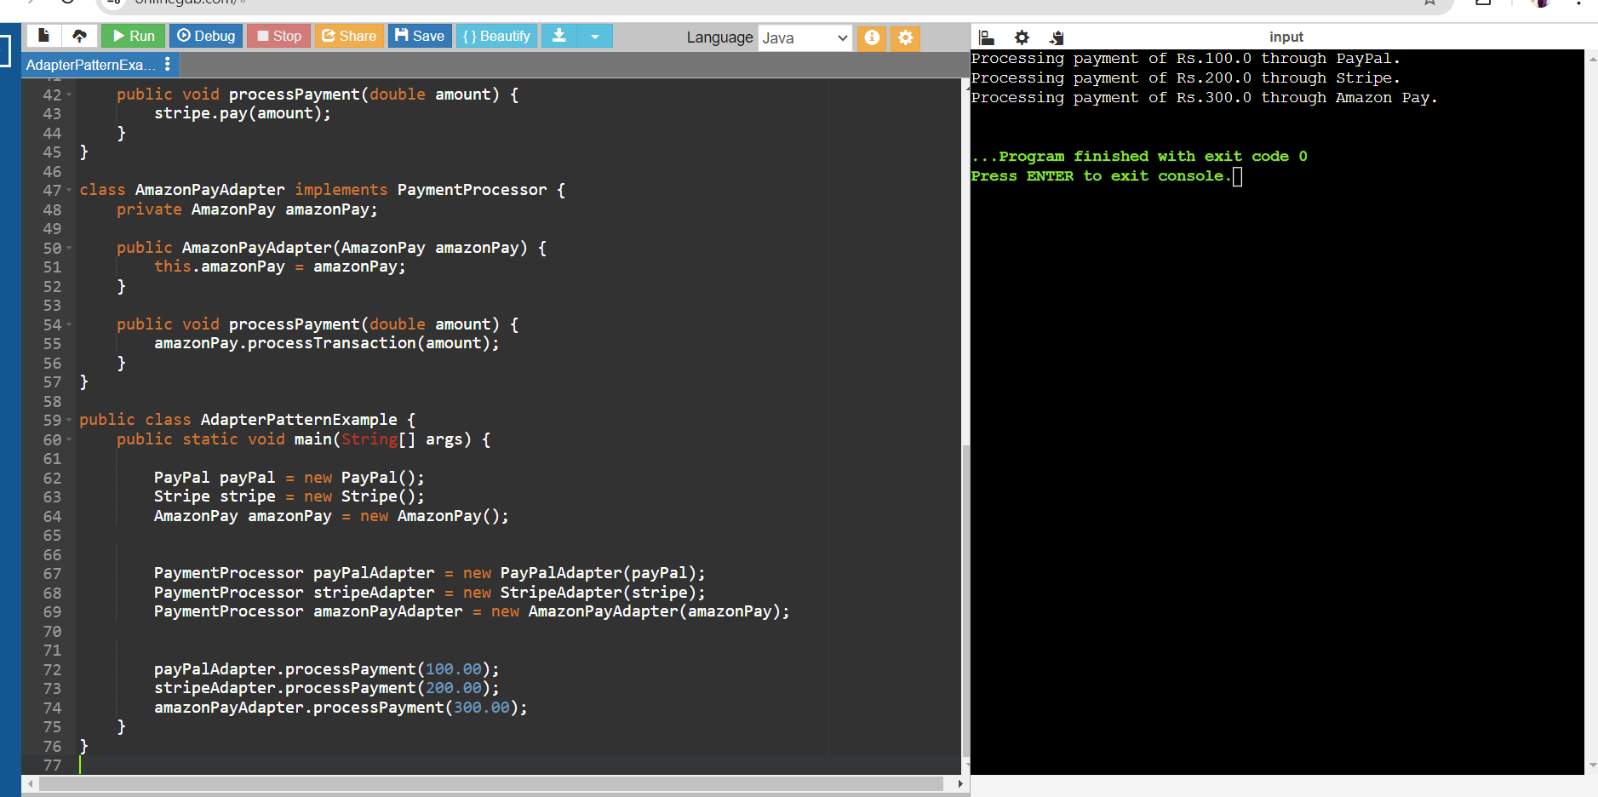

**Exercise 5: Implementing the Decorator Pattern**

**Scenario:** You are developing a notification system where notifications can be sent via multiple channels (e.g., Email, SMS). Use the Decorator Pattern to add functionalities dynamically

interface Notifier {

void send(String message);

}

class EmailNotifier implements Notifier {

public void send(String message) {

System.out.println("Sending email notification: " + message);

}

}

abstract class NotifierDecorator implements Notifier {

protected Notifier notifier;

public NotifierDecorator(Notifier notifier) {

this.notifier = notifier;

}

public void send(String message) {

notifier.send(message);

}

}

class SMSNotifierDecorator extends NotifierDecorator {

public SMSNotifierDecorator(Notifier notifier) {

super(notifier);

}

public void send(String message) {

notifier.send(message);

sendSMS(message);

}

private void sendSMS(String message) {

System.out.println("Sending SMS notification: " + message);

}}

class SlackNotifierDecorator extends NotifierDecorator {

public SlackNotifierDecorator(Notifier notifier) {

super(notifier);

}

public void send(String message) {

notifier.send(message);

sendSlack(message);

}

private void sendSlack(String message) {

System.out.println("Sending Slack notification: " + message);

}}

public class DecoratorPatternExample {

public static void main(String[] args) {

Notifier emailNotifier = new EmailNotifier()

Notifier smsNotifier = new SMSNotifierDecorator(emailNotifier);

Notifier slackNotifier = new SlackNotifierDecorator(smsNotifier);

slackNotifier.send("Hello, this is a test notification!"); }}

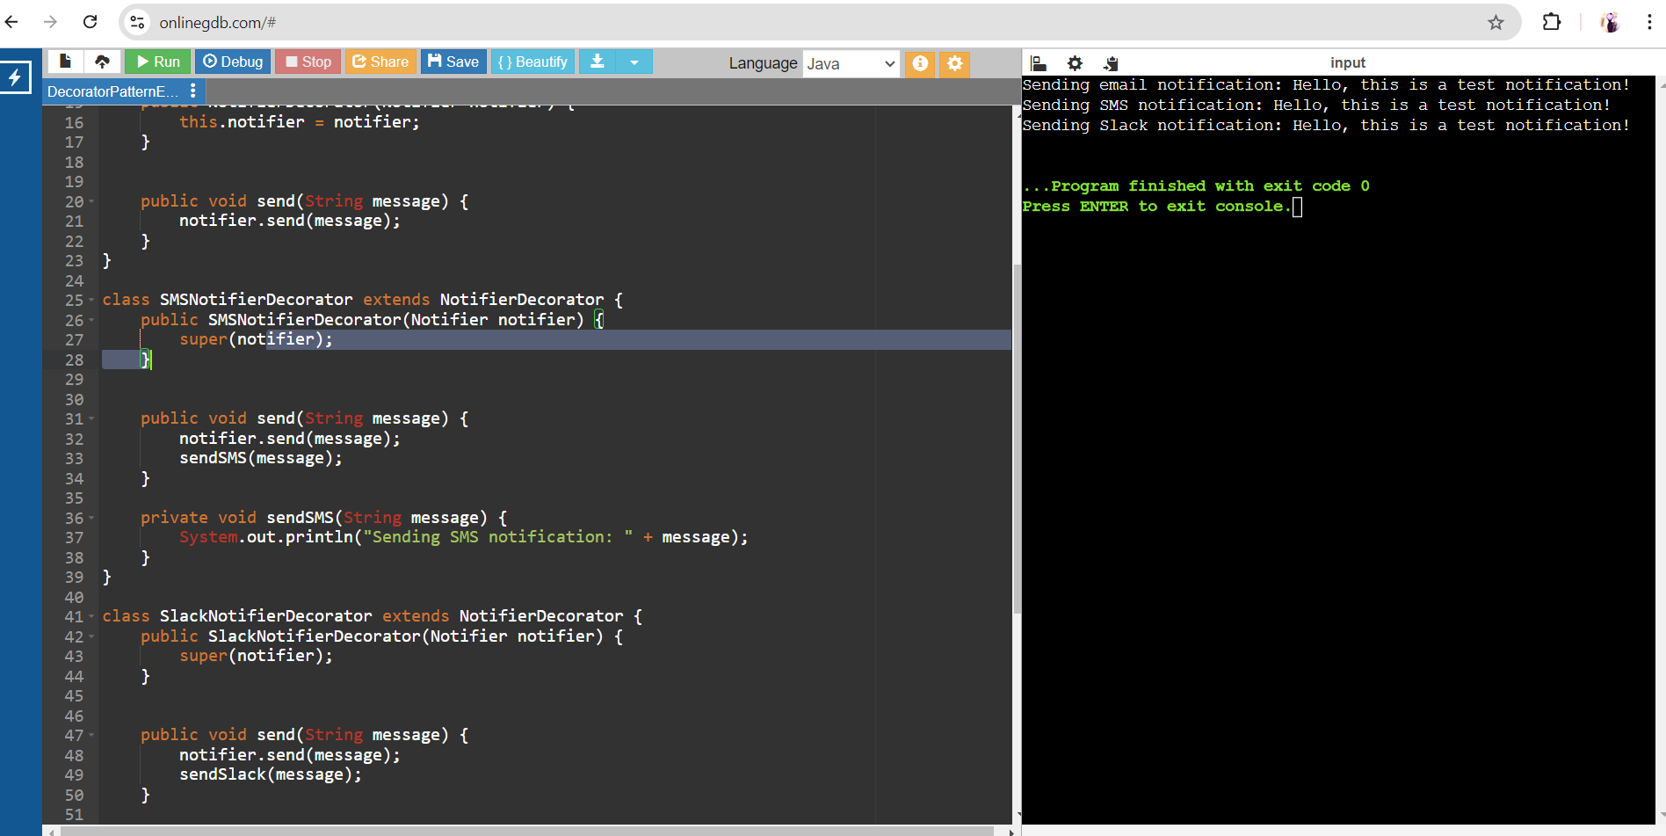

**Exercise 6: Implementing the Proxy Pattern**

**Scenario:** You are developing an image viewer application that loads images from a remote server. Use the Proxy Pattern to add lazy initialization and caching

interface Image {

void display();

}

//Implement Real Subject Class

class RealImage implements Image {

private String filename;

public RealImage(String filename) {

this.filename = filename;

loadImageFromDisk();

}

private void loadImageFromDisk() {

System.out.println("Loading image from disk: " + filename);

}

public void display() {

System.out.println("Displaying image: " + filename);

}

}

// Implement Proxy Class

class ProxyImage implements Image {

private String filename;

private RealImage realImage;

public ProxyImage(String filename) {

this.filename = filename;

}

public void display() {

if (realImage == null) {

realImage = new RealImage(filename);

}

realImage.display();

}

}

// Test the Proxy Implementation

public class ProxyPatternExample {

public static void main(String[] args) {

Image image1 = new ProxyImage("image1.jpg");

Image image2 = new ProxyImage("image2.jpg");

// Image will be loaded from disk

image1.display();

System.out.println("");

// Image will not be loaded from disk as it is already loaded

image1.display();

System.out.println("");

// Image will be loaded from disk

image2.display();

System.out.println("");

// Image will not be loaded from disk as it is already loaded

image2.display();

}

}

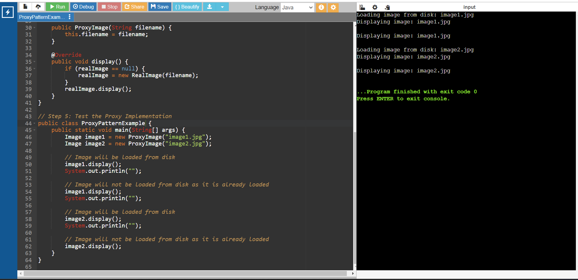

**Exercise 7: Implementing the Observer Pattern**

**Scenario:** You are developing a stock market monitoring application where multiple clients need to be notified whenever stock prices change. Use the Observer Pattern to achieve this.

import java.util.ArrayList;

import java.util.List;

interface Stock {

void registerObserver(Observer o);

void deregisterObserver(Observer o);

void notifyObservers();

}

class StockMarket implements Stock {

private List<Observer> observers;

private double stockPrice;

public StockMarket() {

this.observers = new ArrayList<>();

}

public void registerObserver(Observer o) {

observers.add(o);

}

public void deregisterObserver(Observer o) {

observers.remove(o);

}

public void notifyObservers() {

for (Observer o : observers) {

o.update(stockPrice);

}

}

public void setStockPrice(double stockPrice) {

this.stockPrice = stockPrice;

notifyObservers();

}}

interface Observer {

void update(double stockPrice); }

class MobileApp implements Observer {

private String appName;

public MobileApp(String appName) {

this.appName = appName;

}

public void update(double stockPrice) {

System.out.println(appName + " received stock price update: " + stockPrice);

}}

class WebApp implements Observer {

private String appName;

WebApp(String appName) {

this.appName = appName;

}

public void update(double stockPrice) {

System.out.println(appName + " received stock price update: " + stockPrice);

}}

public class ObserverPatternExample {

public static void main(String[] args) {

StockMarket stockMarket = new StockMarket();

Observer mobileApp = new MobileApp("MobileApp");

Observer webApp = new WebApp("WebApp");

stockMarket.registerObserver(mobileApp);

stockMarket.registerObserver(webApp);

stockMarket.setStockPrice(100.00);

stockMarket.setStockPrice(101.50);

stockMarket.deregisterObserver(webApp);

stockMarket.setStockPrice(102.75);

}

}

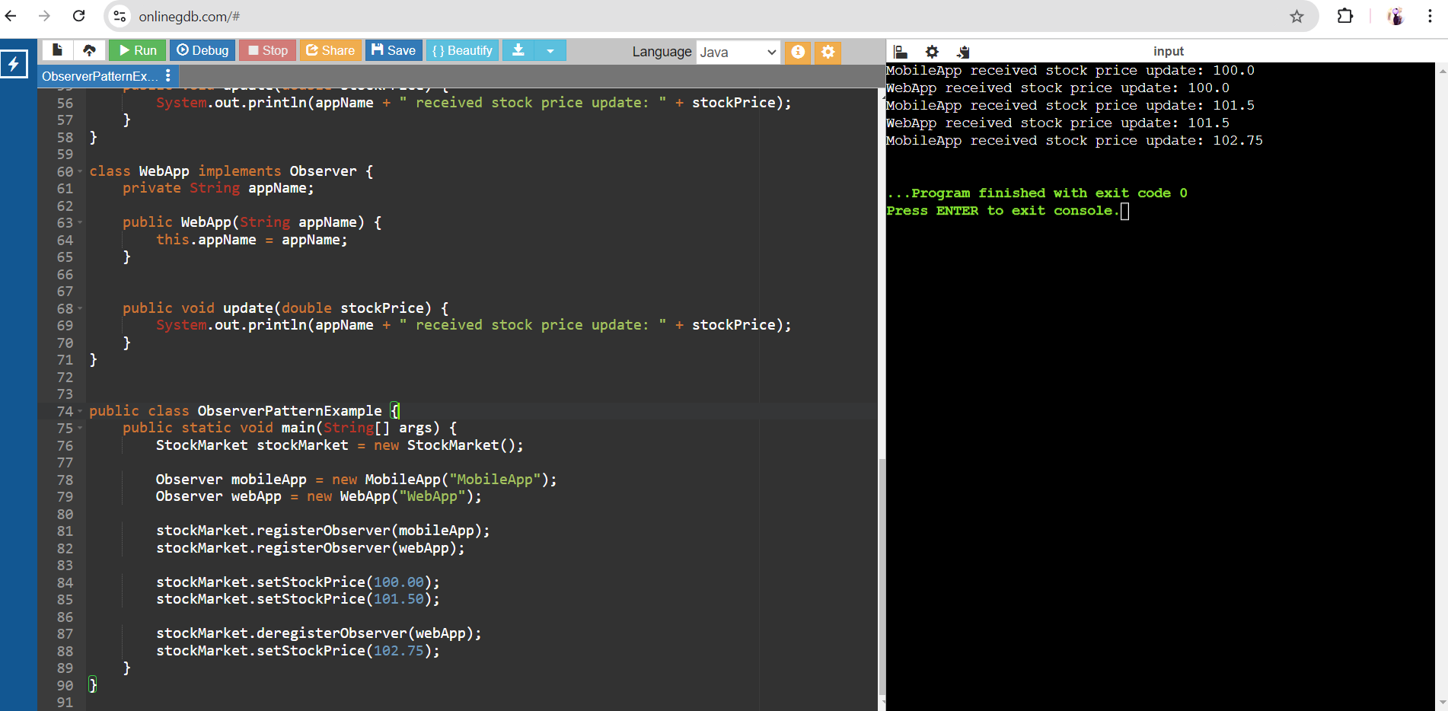

**Exercise 8: Implementing the Strategy Pattern**

**Scenario:** You are developing a payment system where different payment methods (e.g., Credit Card, PayPal) can be selected at runtime. Use the Strategy Pattern to achieve this.

// Step 2: Define Strategy Interface

interface PaymentStrategy {

void pay(double amount);

}

// Step 3: Implement Concrete Strategies

class CreditCardPayment implements PaymentStrategy {

private String name;

private String cardNumber;

private String cvv;

private String expiryDate;

public CreditCardPayment(String name, String cardNumber, String cvv, String expiryDate) {

this.name = name;

this.cardNumber = cardNumber;

this.cvv = cvv;

this.expiryDate = expiryDate;

}

public void pay(double amount) {

System.out.println("Paid " + amount + " using Credit Card.");

}}

class PayPalPayment implements PaymentStrategy {

private String email;

private String password;

public PayPalPayment(String email, String password) {

this.email = email;

this.password = password;

}

public void pay(double amount) {

System.out.println("Paid " + amount + " using PayPal.");

}

}

// Step 4: Implement Context Class

class PaymentContext {

private PaymentStrategy paymentStrategy;

public void setPaymentStrategy(PaymentStrategy paymentStrategy) {

this.paymentStrategy = paymentStrategy;

}

public void executePayment(double amount) {

paymentStrategy.pay(amount);

}

}

// Step 5: Test the Strategy Implementation

public class StrategyPatternExample {

public static void main(String[] args) {

PaymentContext context = new PaymentContext();

// Pay using Credit Card

context.setPaymentStrategy(new CreditCardPayment("John Doe", "1234567890123456", "123", "12/23"));

context.executePayment(100.0);

// Pay using PayPal

context.setPaymentStrategy(new PayPalPayment("john.doe@example.com", "password123"));

context.executePayment(200.0);

}}

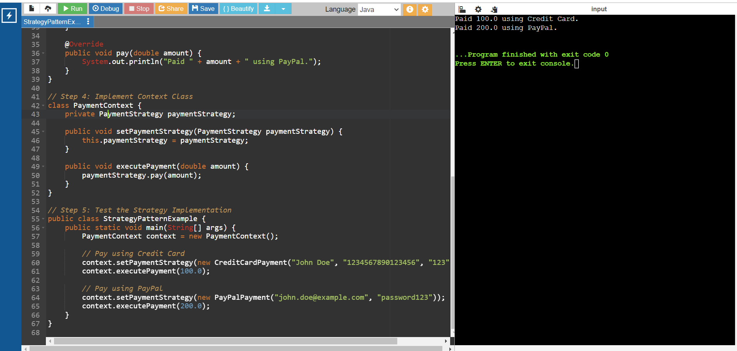

**Exercise 9: Implementing the Command Pattern**

**Scenario:** You are developing a home automation system where commands can be issued to turn devices on or off. Use the Command Pattern to achieve this.

interface Command {

void execute();

}

// Implement Concrete Commands

class LightOnCommand implements Command {

private Light light;

public LightOnCommand(Light light) {

this.light = light;

}

@Override

public void execute() {

light.turnOn();

}

}

class LightOffCommand implements Command {

private Light light;

public LightOffCommand(Light light) {

this.light = light;

}

@Override

public void execute() {

light.turnOff();

}

}

// Implement Receiver Class

class Light {

public void turnOn() {

System.out.println("The light is on");

}

public void turnOff() {

System.out.println("The light is off");

}

}

// Implement Invoker Class

class RemoteControl {

private Command command;

public void setCommand(Command command) {

this.command = command;

}

public void pressButton() {

command.execute();

}

}

// Test the Command Implementation

public class CommandPatternExample {

public static void main(String[] args) {

Light livingRoomLight = new Light();

Command lightOn = new LightOnCommand(livingRoomLight);

Command lightOff = new LightOffCommand(livingRoomLight);

RemoteControl remote = new RemoteControl();

// Turn the light on

remote.setCommand(lightOn);

remote.pressButton();

// Turn the light off

remote.setCommand(lightOff);

remote.pressButton();

}

}

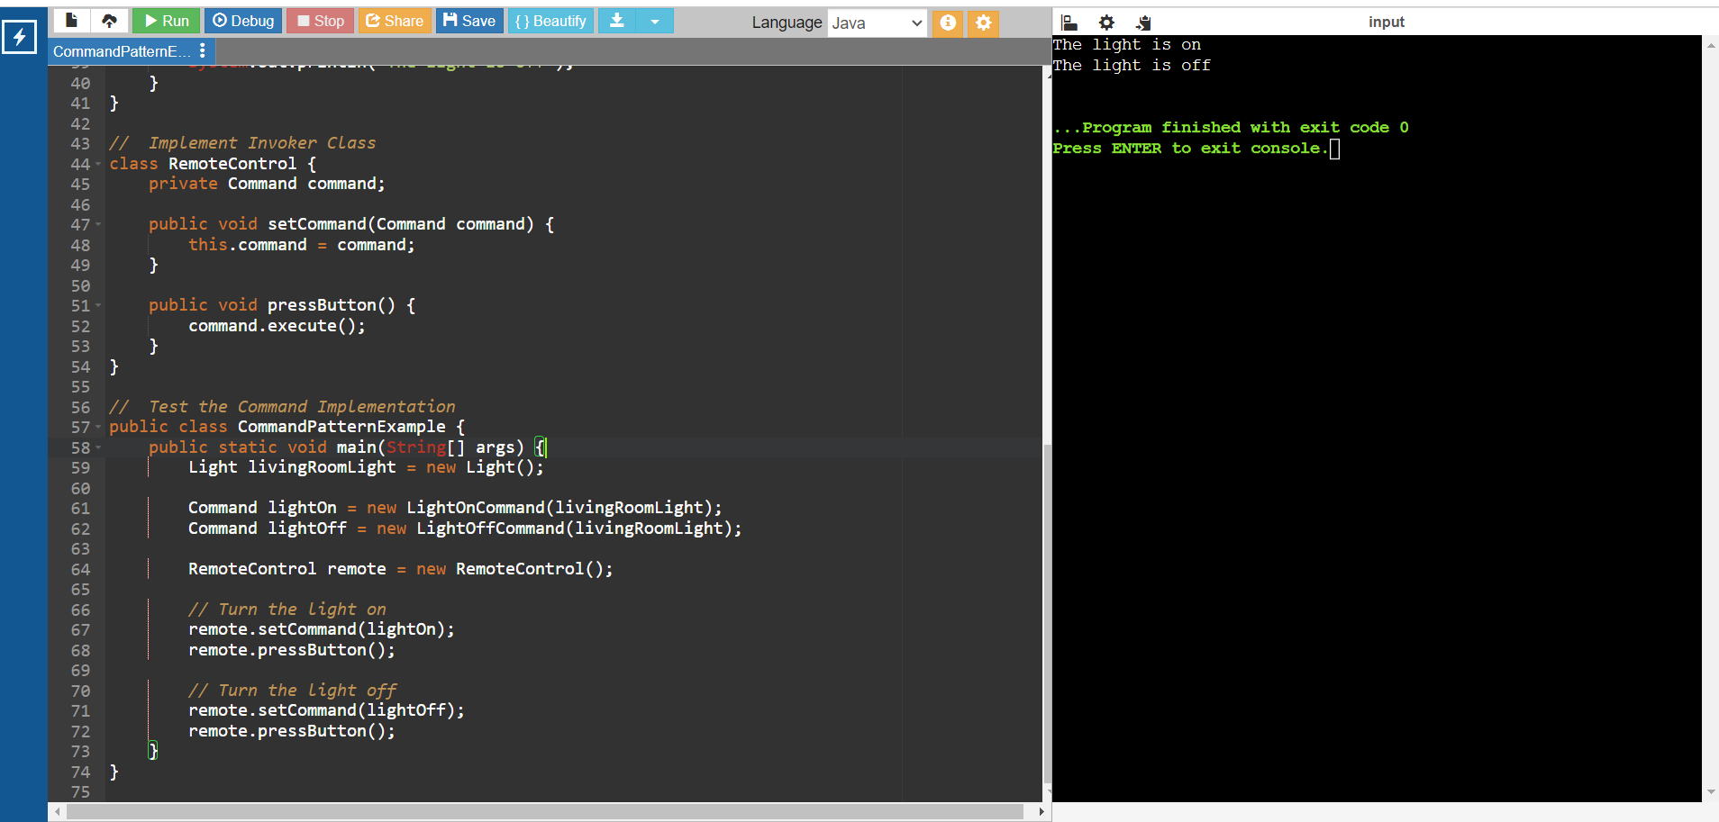

**Exercise 10: Implementing the MVC Pattern**

**Scenario:** You are developing a simple web application for managing student records using the MVC pattern.

// Define Model Class

class Student {

private String id;

private String name;

private String grade;

public Student(String id, String name, String grade) {

this.id = id;

this.name = name;

this.grade = grade;

}

public String getId() {

return id;

}

public void setId(String id) {

this.id = id;

}

public String getName() {

return name;

}

public void setName(String name) {

this.name = name;

}

public String getGrade() {

return grade;

}

public void setGrade(String grade) {

this.grade = grade;

}

}

// Define View Class

class StudentView {

public void displayStudentDetails(String studentName, String studentId, String studentGrade) {

System.out.println("Student Details:");

System.out.println("Name: " + studentName);

System.out.println("ID: " + studentId);

System.out.println("Grade: " + studentGrade);

}

}

// Define Controller Class

class StudentController {

private Student model;

private StudentView view;

public StudentController(Student model, StudentView view) {

this.model = model;

this.view = view;

}

public void setStudentName(String name) {

model.setName(name);

}

public String getStudentName() {

return model.getName();

}

public void setStudentId(String id) {

model.setId(id);

}

public String getStudentId() {

return model.getId();

}

public void setStudentGrade(String grade) {

model.setGrade(grade);

}

public String getStudentGrade() {

return model.getGrade();

}

public void updateView() {

view.displayStudentDetails(model.getName(), model.getId(), model.getGrade());

}}

// Test the MVC Implementation

public class MVCPatternExample {

public static void main(String[] args) {

// Create a Student model

Student model = new Student("1", "John Doe", "A");

// Create a Student view

StudentView view = new StudentView();

// Create a Student controller

StudentController controller = new StudentController(model, view);

// Display initial student details

controller.updateView();

// Update student details

controller.setStudentName("Jane ");

controller.setStudentGrade("B");

// Display updated student details

controller.updateView();

}}

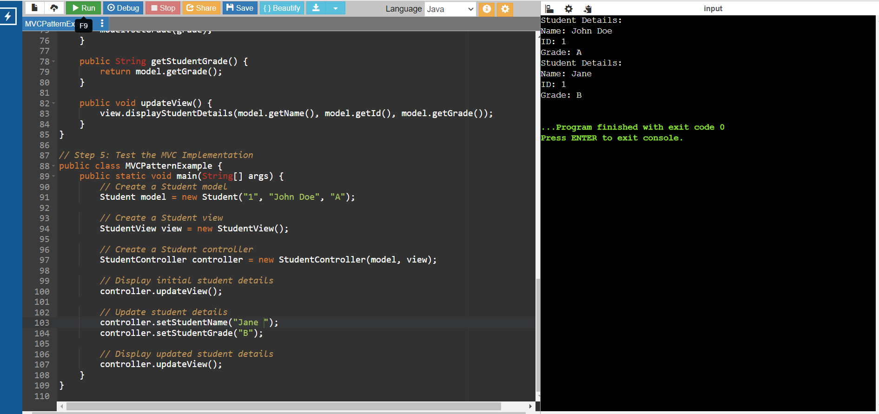

**Exercise 11: Implementing Dependency Injection**

**Scenario:** You are developing a customer management application where the service class depends on a repository class. Use Dependency Injection to manage these dependencies.

interface CustomerRepository {

String findCustomerById(String id);

}

// Implement Concrete Repository

class CustomerRepositoryImpl implements CustomerRepository {

public String findCustomerById(String id) {

// Mock implementation, in real scenario, it would interact with a database

if (id.equals("1")) {

return "John Doe";

} else {

return "Customer not found";

}}}

// Define Service Class

class CustomerService {

private CustomerRepository customerRepository;

// Implement Dependency Injection

public CustomerService(CustomerRepository customerRepository) {

this.customerRepository = customerRepository;

}

public String getCustomerDetails(String id) {

return customerRepository.findCustomerById(id);

}}

// Test the Dependency Injection Implementation

public class DependencyInjectionExample {

public static void main(String[] args) {

// Create a CustomerRepository instance

CustomerRepository customerRepository = new CustomerRepositoryImpl();

// Inject the repository into the service

CustomerService customerService = new CustomerService(customerRepository);

// Use the service to find customer details

String customerDetails = customerService.getCustomerDetails("1");

System.out.println("Customer Details: " + customerDetails);

}

}

