Machine Learning Model Deployment with IBM Cloud Watson Studio

PHASE-4 Development part-2

Submitted By: p. Charitha

Reg.no:723921104036

Email-id: [charithareddy713@gmail.com](mailto:charithareddy713@gmail.com)

Project: Machine Learning Model Deployment with IBM Cloud Watson Studio

Phase-4: Development part-2

INTRODUCTION OF IBM WATSON STUDIO

Unified Platform: Watson Studio offers a unified and integrated environment for data science and machine learning tasks. It brings together tools and services for data preparation, model development, deployment, and monitoring.

Collaborative Workspace: The platform enables teams to collaborate seamlessly by providing a shared workspace for projects. This collaborative nature supports efficient teamwork and knowledge sharing.

Diverse Toolset: Watson Studio comes equipped with a diverse set of tools and capabilities, including data exploration and visualization, machine learning model building, and deployment services. It supports popular programming languages like Python and R.

Cloud-Based Deployment: As part of the IBM Cloud ecosystem, Watson Studio leverages cloud computing infrastructure for scalability and accessibility. Users can take advantage of cloud services for storage, databases, and other resources.

Machine Learning Model Development: The platform facilitates the development of machine learning models through an interactive and visual interface. Users can choose from a variety of algorithms, perform feature engineering, and tune hyperparameters.

Data Integration: Watson Studio allows seamless integration with various data sources, making it easier to ingest and preprocess data. It supports both structured and unstructured data.

Model Deployment and Management: One of the key features is the ability to deploy machine learning models into production environments. Watson Studio provides tools for managing the lifecycle of deployed models, including versioning and monitoring.

AI-Powered Assistance: The platform incorporates AI-powered assistants and automation to enhance productivity. These features assist users in various tasks, from data preparation to model evaluation.

Security and Compliance: Watson Studio emphasizes data security and compliance with industry regulations. It provides features for access control, ensuring that sensitive data is handled securely.

Open Ecosystem: Watson Studio supports an open ecosystem, allowing users to bring their preferred tools and frameworks. This flexibility makes it suitable for a wide range of data science and machine learning workflows.

FUNCTIONS OF IBM WATSON STUDIO

1. **Data Preparation:**
   * Watson Studio provides tools for exploring, cleaning, and preparing data for analysis and modelling.
   * It supports various data sources and formats, allowing users to ingest and integrate data seamlessly.
2. **Data Visualization:**
   * The platform includes visualization tools to help users understand and explore their data.
   * Users can create charts, graphs, and dashboards to communicate insights effectively.
3. **Model Development:**
   * IBM Watson Studio supports the development of machine learning models using popular frameworks like TensorFlow, Torch, and scikit-learn.
   * Users can build models through a visual interface or by writing code in languages such as Python or R.
4. **Auto AI:**
   * Auto AI capabilities automate the machine learning model development process by automatically selecting algorithms and hyperparameters based on the characteristics of the data.
5. **Collaboration and Sharing:**
   * The platform facilitates collaboration among team members by providing tools for sharing and versioning projects.
   * Multiple users can work on the same project simultaneously, streamlining collaboration in data science projects.
6. **Model Deployment:**
   * Once a model is developed, Watson Studio allows users to deploy models as APIs (Application Programming Interfaces) for integration into applications.
   * It supports deployment on various cloud environments, making it easy to scale and manage.
7. **Integration with Cloud Services:**
   * IBM Watson Studio is designed to work seamlessly with other IBM Cloud services and offerings.
   * Users can leverage cloud-based storage, databases, and analytics services to enhance their data science workflows.
8. **Experiment Tracking and Management:**
   * The platform provides tools for tracking and managing the various experiments and iterations involved in the model development process.
   * Users can compare and evaluate different models to identify the most effective ones.
9. **Opensource Integration:**
   * IBM Watson Studio integrates with popular open-source tools and frameworks, allowing users to leverage their existing skills and workflows.

Process:

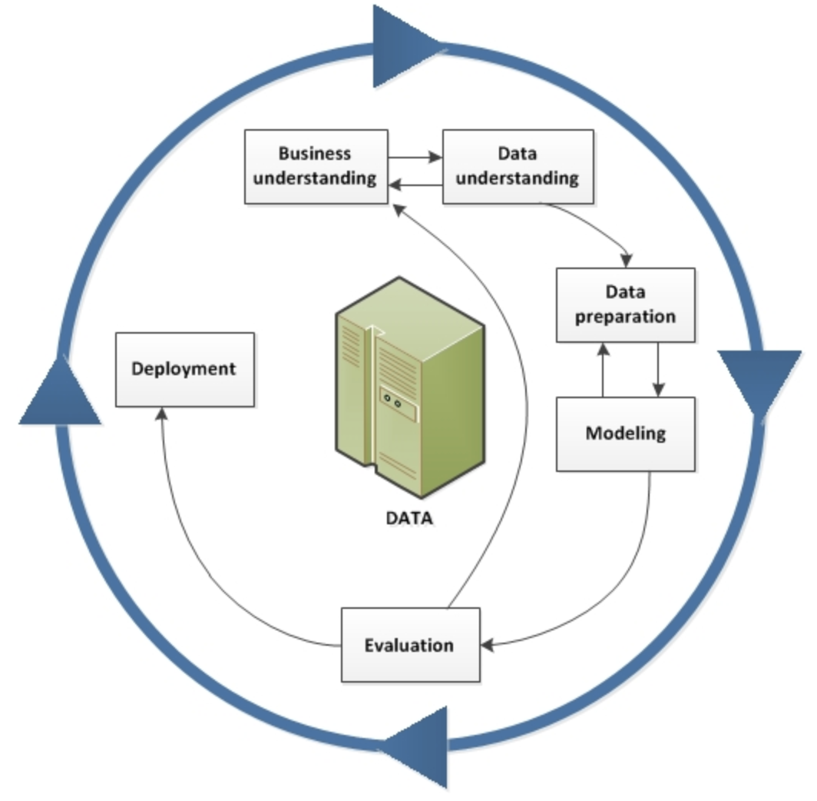

10.**Security and Governance:**

* IBM Watson Studio includes features for managing access control, ensuring that sensitive data is protected.
* It provides tools for tracking and auditing model development activities, enhancing governance.

Conclusion:

1. **End-to-End Solution:**
   * IBM Watson Studio covers the entire machine learning workflow, from data preparation and exploration to model development, deployment, and monitoring.
2. **Collaboration and Teamwork:**
   * The platform emphasizes collaboration, enabling multiple users to work on the same project simultaneously. This feature streamlines teamwork and enhances productivity.