**DEPARTMENT OF ELECTRONICS AND COMMUNICATION**

**ENGINEERING**

**SRI VASAVI ENGINEERING COLLEGE**



Mini project on

**Random password generator**

FOR THE COURSE

**python**

**SUBMITTED BY:**

BATCH-13

**P.LAKSHMI CHARITHA(21A85A0406)**

**T.ABRAHAM(20A81A0454)**

**T.VANI MANI MALA(20A81A0455)**

**Y.DURGA DEVI(21A85A0406)**

**T.AVINASH(20A81A0453)**

**SUBMITTED TO: HEAD OF THE DEPARTMENT**

**B.MURALI KRISHNA E.KUSUMA KUMARI**

**ASSISTANT PROFESSOR**

**ECE DEPARTMENT**

**CERTIFICATE**

This is to certify that Project report entitled “Random Password Generator Using

Python”, Submitted by “NIKHIL KUMAR , ZAID NAWAZ and VARUN UPADHYAY”

for partial fulfillment of the requirement for the award of degree Bachelors of Technology in

Department of Computer Science & Engineering of Dr. A.P.J Abdul Kalam University,

Lucknow is a record of the candidate’s own work carried out by them under my supervision.

The matter embodied in this report is original and has not been submitted for the award of

any other degree.

This is to certify that Project report entitled “Random Password Generator Using

Python”, Submitted by “NIKHIL KUMAR , ZAID NAWAZ and VARUN UPADHYAY”

for partial fulfillment of the requirement for the award of degree Bachelors of Technology in

Department of Computer Science & Engineering of Dr. A.P.J Abdul Kalam University,

Lucknow is a record of the candidate’s own work carried out by them under my supervision.

The matter embodied in this report is original and has not been submitted for the award of

any other degree.

This is to certify that Project report entitled “**Random Password Generator Using Python**”, Submitted by “Lakshmi Charitha”, “Abraham”, “Vani”, “Durga Devi” and “Avinash” for partial fulfillment of the requirement for the award of degree Bachelors of Technology in Department of Electronics and Communication Engineering of SRI VASAVI ENGINEERING COLLEGE, is a record of the candidate’s own work carried out by them under my supervision. The matter embodied in this report is original and has not been submitted for the award of any other degree.

**Date: Supervisor:**

27/10/2022 Mr. B. Murali Krishna

This is to certify that Project report entitled “Random Password Generator Using

Python”, Submitted by “NIKHIL KUMAR , ZAID NAWAZ and VARUN UPADHYAY”

for partial fulfillment of the requirement for the award of degree Bachelors of Technology in

Department of Computer Science & Engineering of Dr. A.P.J Abdul Kalam University,

Lucknow is a record of the candidate’s own work carried out by them under my supervision.

The matter embodied in this report is original and has not been submitted for the award of

any other degree.

This is to certify that Project report entitled “Random Password Generator Using

Python”, Submitted by “NIKHIL KUMAR , ZAID NAWAZ and VARUN UPADHYAY”

for partial fulfillment of the requirement for the award of degree Bachelors of Technology in

Department of Computer Science & Engineering of Dr. A.P.J Abdul Kalam University,

Lucknow is a record of the candidate’s own work carried out by them under my supervision.

The matter embodied in this report is original and has not been submitted for the award of

any other degree.

**ACKNOWLEDGEMENT**

In completing this project we have been fortunate enough to have help, support and encouragement from many people. I would like to acknowledge them for their corporation. Finally, we would like to thank Mr. B. Murali Krishna, from Department of Electronics and Communication Engineering, Sri Vasavi Engineering College; for guiding us through each and every step of the process with knowledge and support. His thoughts have been a constant source of inspiration for us. We would like to acknowledge the contribution of all faculty members of the department for their kind assistance, suggestions and cooperation throughout the development of the project. Finally we would like to thank our classmates for the encouragement and help during the project.

This is to certify that Project report entitled “Random Password Generator Using

Python”, Submitted by “NIKHIL KUMAR , ZAID NAWAZ and VARUN UPADHYAY”

for partial fulfillment of the requirement for the award of degree Bachelors of Technology in

Department of Computer Science & Engineering of Dr. A.P.J Abdul Kalam University,

Lucknow is a record of the candidate’s own work carried out by them under my supervision.

The matter embodied in this report is original and has not been submitted for the award of

any other degree.

This is to certify that Project report entitled “Random Password Generator Using

Python”, Submitted by “NIKHIL KUMAR , ZAID NAWAZ and VARUN UPADHYAY”

for partial fulfillment of the requirement for the award of degree Bachelors of Technology in

Department of Computer Science & Engineering of Dr. A.P.J Abdul Kalam University,

Lucknow is a record of the candidate’s own work carried out by them under my supervision.

The matter embodied in this report is original and has not been submitted for the award of

any other degree.

**CONTENTS**

1. ABSTRACT
2. PROBLEM DEFINITION
3. INTRODUCTION
4. DESCRIPTION OF MODULES USED
5. IMPLEMENTATION DETAILS WITH STEP SIZE
6. CONCLUSION AND FUTURE SCOPE
7. REFERENCES

**ABSTRACT**

A random password generator is software program or hardware device that takes input from a ‘random’ number generator and automatically generates a password. Random passwords can be generated manually, using simple sources of randomness such as dice or coins, or they can be generated using a computer. Speaking regarding the system, the user can create a random password according to various sizes. It additionally presents with an aesthetic color-coded system which indicates the stamina of the password, beginning from Very Weak to Superb password strength. After creating a random password, the system presents in the clipboard where the user can copy and paste easily.

The GUI based Password Generator supplies the most basic method for generating a solid password for the individuals. In short ,this job just concentrates on producing arbitrary passwords. In order to run the task, you must have setup python, on your PC. This is a basic GUI based system, specially composed for the beginners. Password Generator in python with source code is complementary to download.

**PROBLEM DEFINITION**

In this project our motto is to generate a random password based on user’s need. User will input his/her need of no of digits, special character, small alphabets, capital alphabets and based on these numbers a random password will be generated. After generating the random password a button of Copy to Clipboard will provide the functionality of copying the generated password to our clipboard.

It also enables the users to check the strength of their passwords that they had used on their multipurpose sites. It enables user to check the character they have used to create the password.

**INTRODUCTION**

Passwords remain a very widely used method for user authentication, despite widely shared concerns about the level of security they provide. There are many potential replacement technologies, including combinations of biometrics and trusted personal devices, but it seems likely that it will be sometime before passwords are relegated to history. Given their current and likely future wide use, finding ways of improving the use and management of passwords remains a vitally important issue. We focus here on an important practical matter, namely how to make password more secure and more convenient. Passwords can be stored either locally or on a trusted server, most browsers provide a local-storage password manager. However the shortcomings of password managers have also been widely documented.

Password Generator enables the user to generate the password of their choice like the number of words, small case alphabets, digits, etc. A Clipboard enables user to copy the password that is generated using the password generator. It also enables the user to check the strength of the passwords. It also displays the no of characters, no of alphabets, and no of symbols used in the passwords.

**Description of the modules used**

**Description of Module_1(Password_Generator):**

In this module we have imported **tkinter** package and its modules, **pyperclip** module, **random** module. Then initialize tkinter using **Tk()** method.

A variable of string type has been declared named 'passstr' to store the generated password.

Similarly 4 variables of integer type has been declared named −≫**'passlen_smallalpha**' ,**'passlen_bigalpha**' ,**'passlen_digits'**, **'passlen_specialcharac**' to store the length of small alphabet characters, capital alphabet characters, digits, special characters which the user will input on his/her choice. The above four variables are set to zero initially using **IntVar()**.

A user-defined-function to generate a password will be used named 'generate()'. We have declared four list −≫ **pass1, pass2, pass3, pass4** which will be having small alphabet characters, capital alphabet characters, digits, special characters as elements in their respective list. A password string is declared, which is initially empty, 'mylist' list will consist of pass1, pass2, pass3, pass4 as its elements.

Then an infinite While-loop is runned which will append the characters to the '**password**' string one by one & will terminate on a specific condition, condition of all big, small, digits, special variables being equal to zero(0).

In while loop the **'mylist'** list is shuffled and then the shuffled list is copied to **'list1'** list.

so the 'list1' is a list having four lists in it(nested lists).Every first element of the nested-lists will be checked to identify the type of elements of that list.

A For-loop is iterating for four times(from 0 to 3) with the second-indexing being fixed to zero (list1[q][0])as there are four-nested lists. As we check the first element of the first nested-list, the corresponding list is taken (pass1 or pass2 or pass3 or either pass4) and character is taken randomly using random.choice() function ,from that list. And that character is appended to 'password' string. And the corresponding variable is decremented by 1.

Similarly we proceed forward for the remaining three 3 nested lists. Again the While-loop runs, again the 'mylist' list is shuffled and copied to 'list1' list the same procedure continues. And we proceed forward for the remaining three 3 nested lists.

Finally this While-loop is terminated when condition1 is true.

**(condition1=(small==0 and big==0 and digits==0 and special==0)).And the password is set to passstr using passstr.set()** function.

**Description of Module_2(Strength_Checker)** –

This module is used to tell the user the strength percent of his/her input password. As the user inputs his password in the text-field and click on **'Check'** button. A percentage will be displayed indicating the strength of the password. And with the percentage a color box will also be displayed, red color indicates-weak password, yellow color indicates-medium password, green color indicates-strong password.

**Description of Module_3 (Check_character):**

1)Import Libraries

**from tkinter import\***

**import random**

2)Initialize window

**root=Tk()**

**root.geometry('400x400')**

−≫Tk() : It is use to initialize tkinter and create window.

−≫geometry() : It is use to set the width and height of the window.

3)Inside check_ch function()

for i in range (len(string)):

if(string[i].isalpha()):

alphabets=alphabets+1

elif(string[i].isdigit()):

digits=digits+1

else:

special=special+1

**−≫.isalpha()** : It is use to check character is alphabet or not.

**−≫.isdigit()** : Its is use to check character is digit or not.

**−≫Variable** **i** start from 1st character to last character and pass each character to if condition.

In if condition if character is alphabet than alphabet will increment by 1 else if it is digit than digits variable get increment by 1 and if both condition will false than special variable get increment by 1.This process will get repeat until i variable reach at last character in a string.

l1=Label(root, text={" alphabets ",alphabets})

l1.pack()

l2=Label(root, text={" digits ",digits})

l2.pack()

l3=Label(root, text={" special symbol ",special})

l3.pack()

**−≫Label()** : It is use to display the the text that users can not modify.

**−≫root** : It is a name given by programmer to our window.

label=Label(root, text=" Enter your password ")

label.pack()

entry=Entry(root, textvariable="")

entry.pack()

button=Button(root, text="Check Character", command= check_ch)

button.pack() root.mainloop()

**−≫text** : Which we display on the label.

**−≫Entry()** : It will create input filled for user.

**−≫Button()** : Use to display the button on our window.

**−≫command()** : It will work when button is click.

**−≫textvariable** : It is use to retrieve the text to the entry.

**Implementation details with screen-shots (stepwise)**

**Code:-**

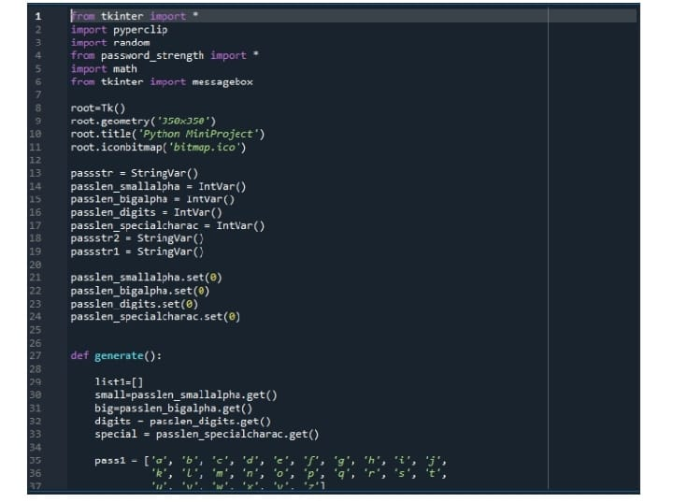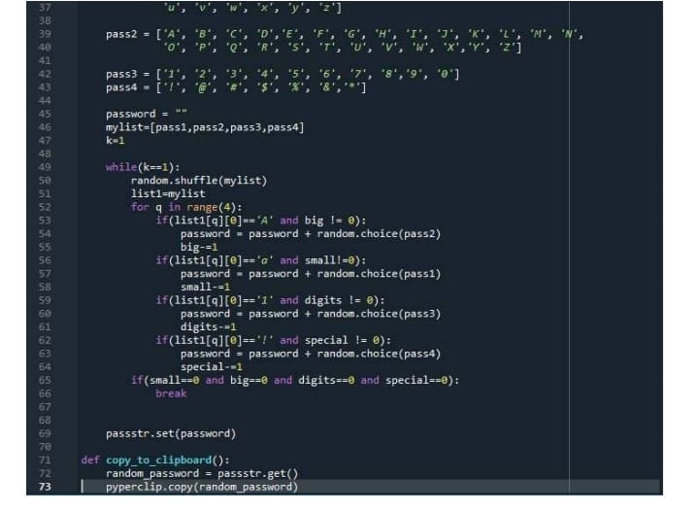

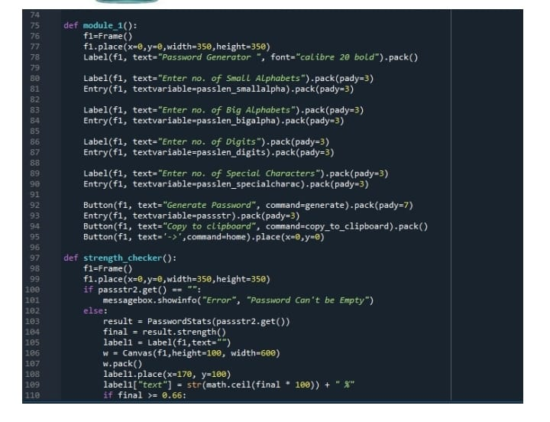

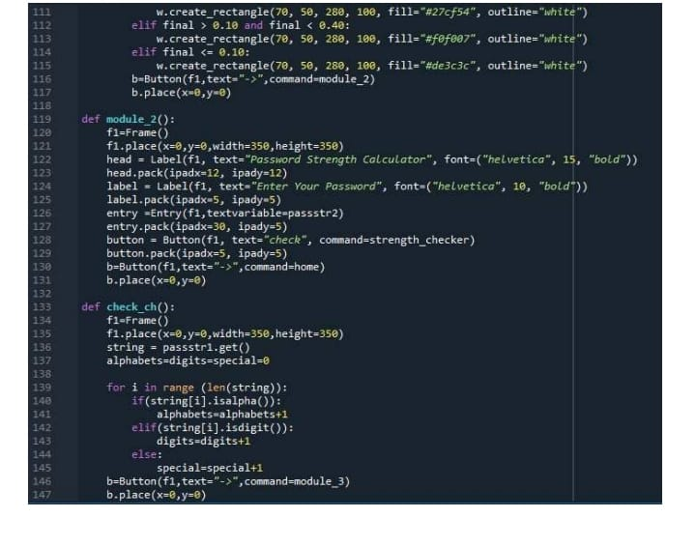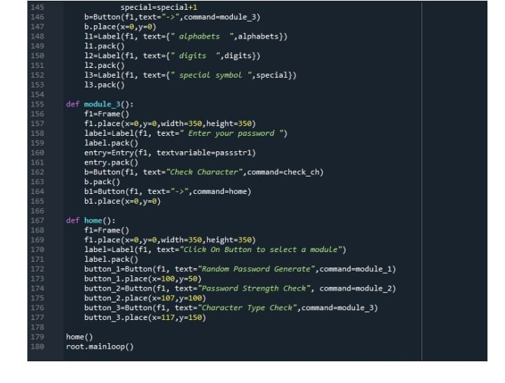

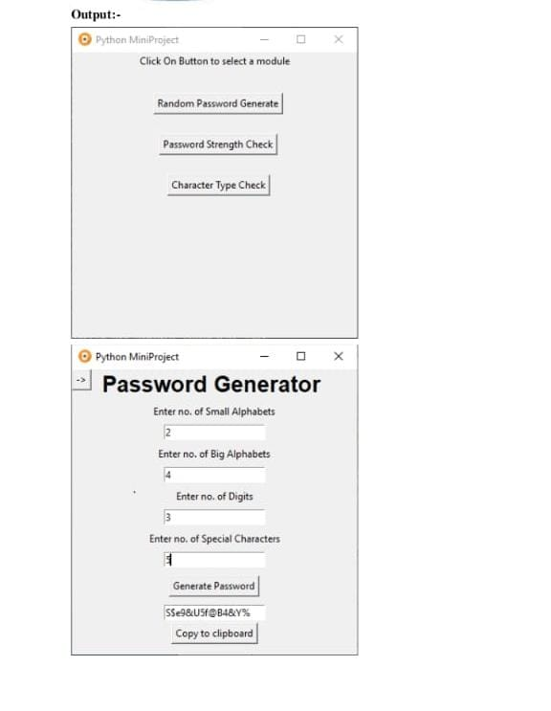

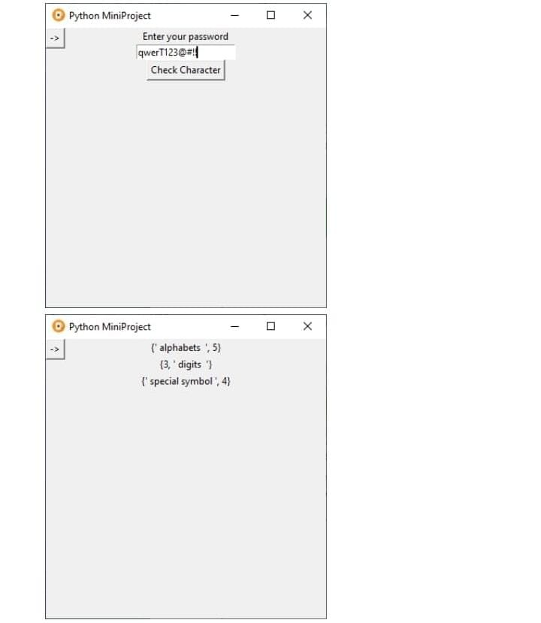

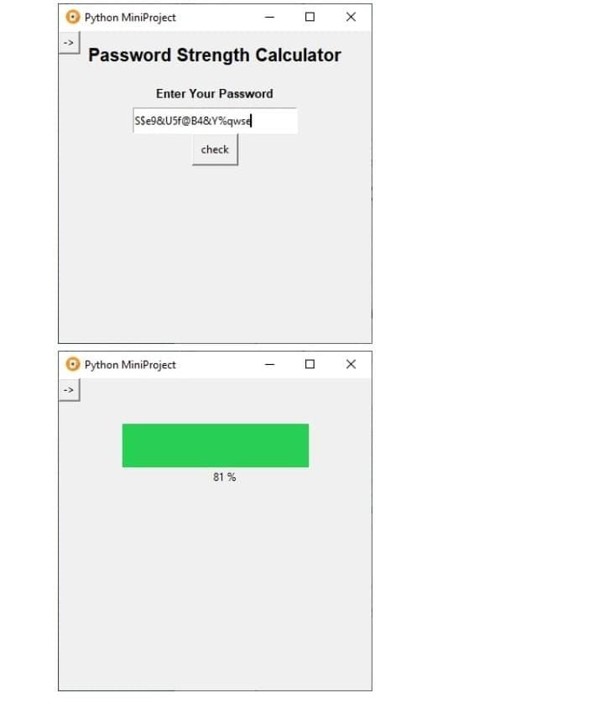

**References**

[1] <https://docs.python.org/3/library/tkinter.html>

[2] <https://www.tutorialspoint.com/python3/python_gui_programming.htm>

[3] <https://www.geeksforgeeks.org/python-tkinter-tutorial/>

[4] <https://www.geeksforgeeks.org/python-strings/>

[5] <https://stackoverflow.com/questions/51777956/link-gui-to-main-class>

**Conclusion and Future Scope**

* With these steps, we have successfully created a random password generator project using python.
* We used popular tkinter library to rendering graphics in our display window and we also learned about pyperclip and random library.
* We learned how to create buttons, input text field and labels.
* In this way, we successfully created our password generator python project.