TERRAFORM-06
2). Execute the script shown in the video.
First let’s create a folder inside our project
Inside aws_instance, create these files:
- Main.tf
- Variable.tf
Let’s write a resource block for ec2 and variable block for ami
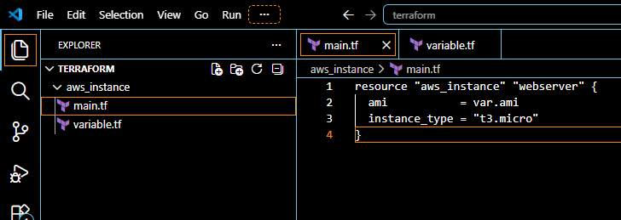
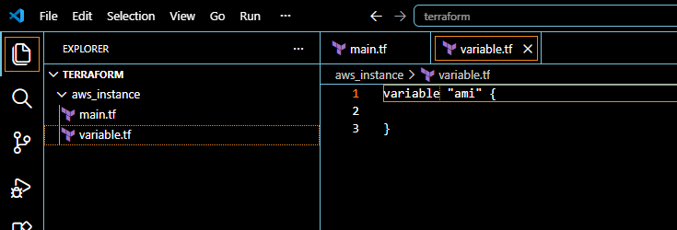
Now let’s create another folder development inside our project
create main.tf file
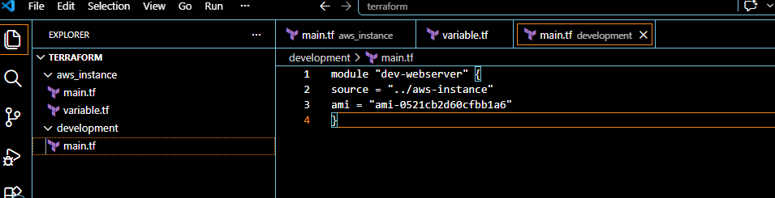
cd development
Now go to development folder and perform terraform init
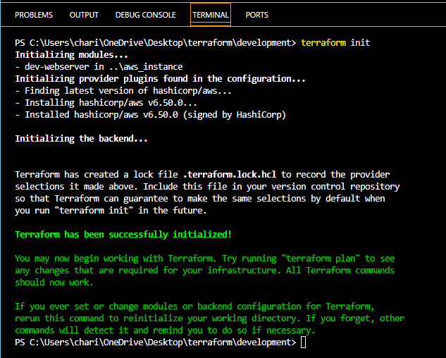
terraform apply
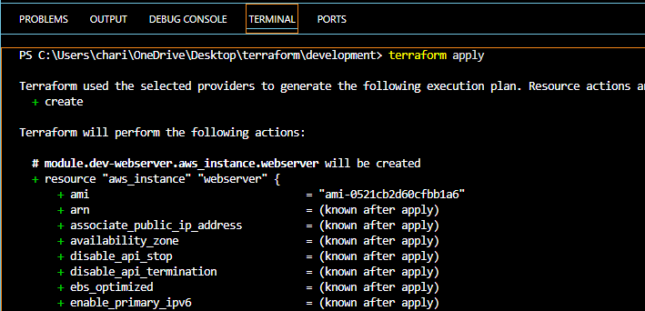
EC2 instance is created
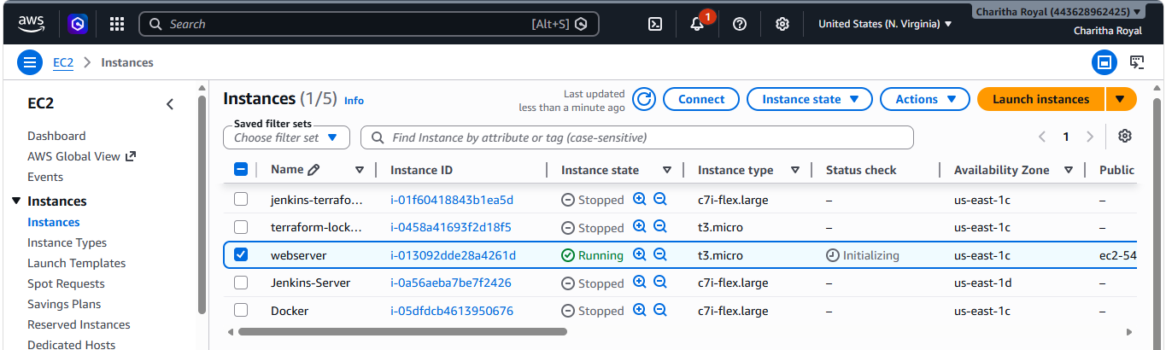
Terraform workspaces allow multiple state files to exist within the same Terraform configuration. This helps manage different environments such as:
- Development (Dev)
- Testing (QA)
- Staging
- Production (Prod)
Each workspace maintains its own Terraform state, ensuring that infrastructure changes in one environment do not affect another.
Let’s create a project inside root
terraform workspace new project-1 creates new workspaces
terraform workspace list lists available workspaces
terraform workspace select default switch to default workspace
terraform workspace select project-1 switch to selected workspace
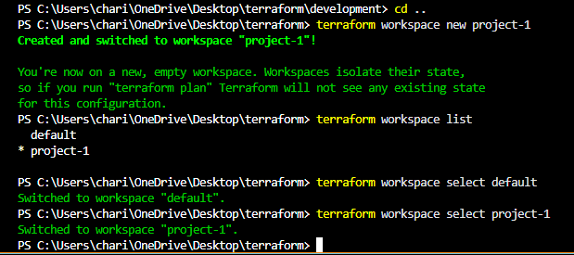
Now update variable.tf to map
cd aws_instance
terraform init
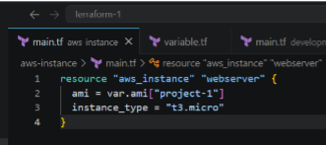
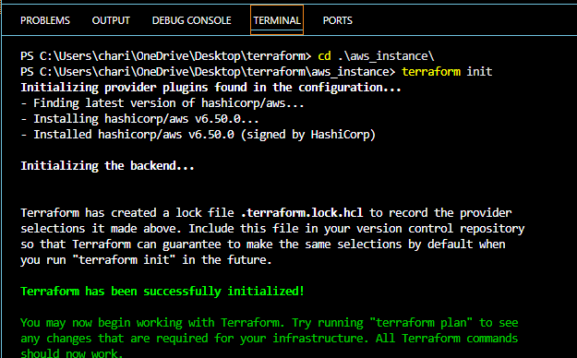
for apply I removed [“project-1”] in code
terraform apply
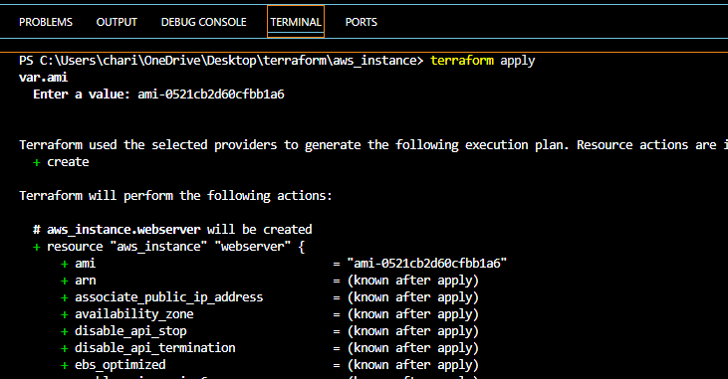
Workspace is added and it is maintaining separate statefile
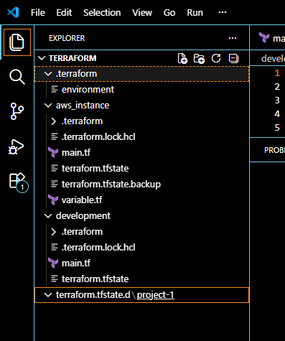
3). Provision EC2, S3, and VPC using Terraform modules.
Let’s create folders
mkdir modules
mkdir modules\vpc
mkdir modules\ec2
mkdir modules\s3
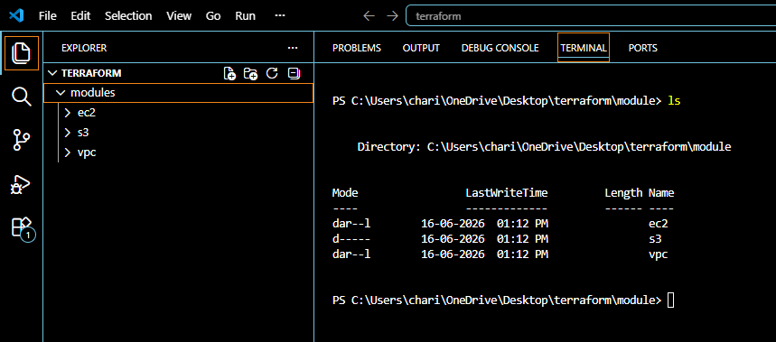
inside your root project directory (terraform-project), create a file named: provider.tf
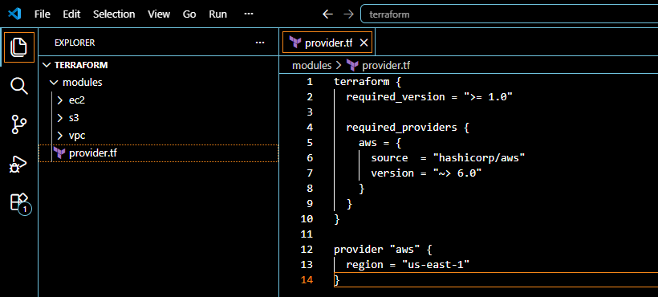
Why Do We Create provider.tf?
This file tells Terraform:
1. Which cloud provider to use (AWS)
2. Which AWS provider version to download
3. Which AWS region to deploy resources into
Terraform reads provider.tf and downloads the AWS provider plugin.
terraform init
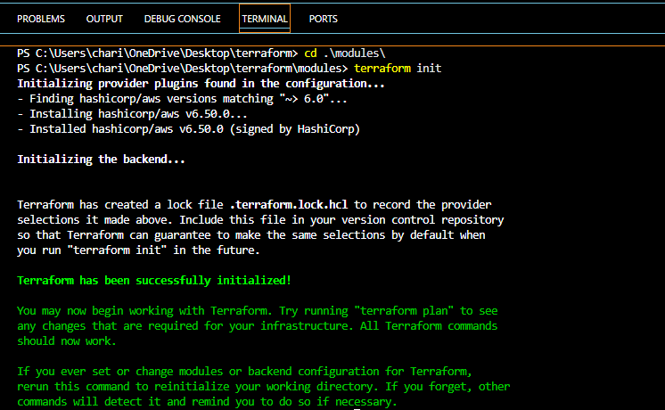
Now let’s create files inside VPC folder
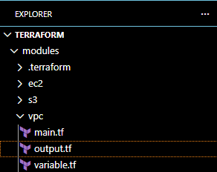
Create variables.tf
These variables allow us to pass values from the root module
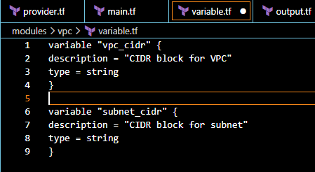
Create main.tf
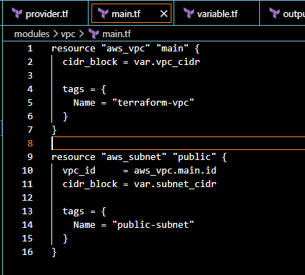
Create outputs.tf
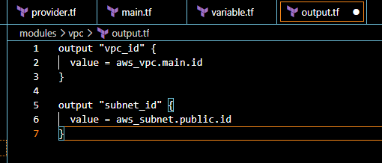
Let’s create files inside ec2 folder
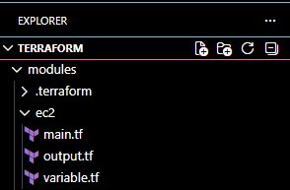
Create variables.tf
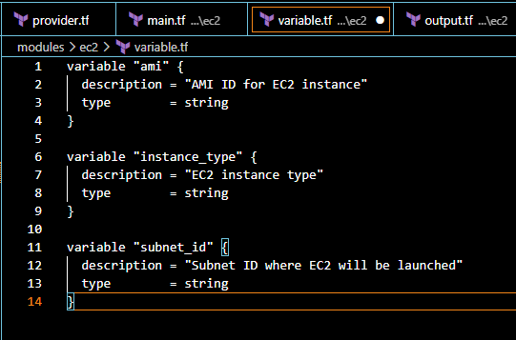
Create main.tf
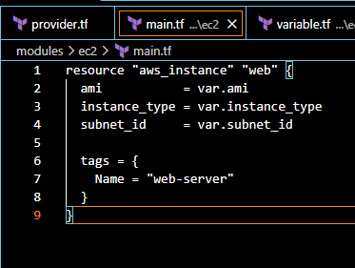
Create output.tf
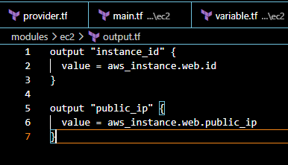
Create files inside s3 folder
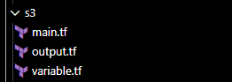
Create main.tf file
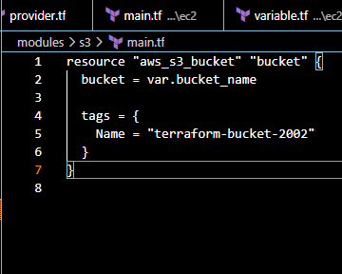
Create variables.tf
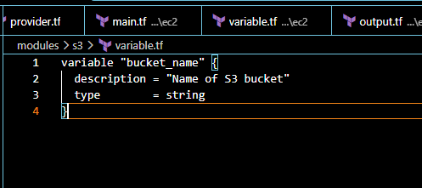
Create output.tf file
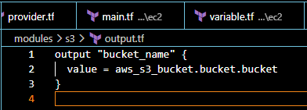
Now let’s create main.tf file for root project
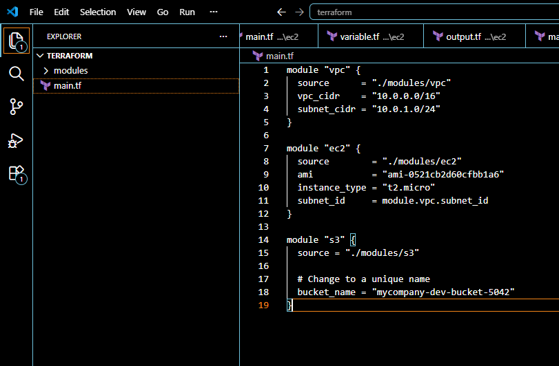
Create outputs.tf file
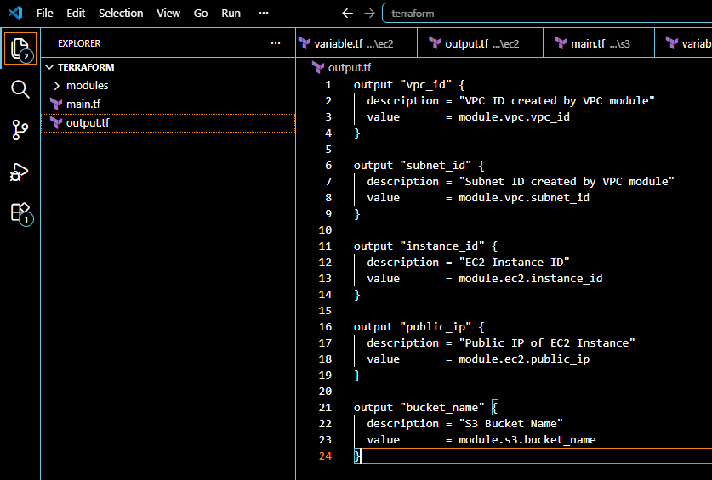
terraform. Init
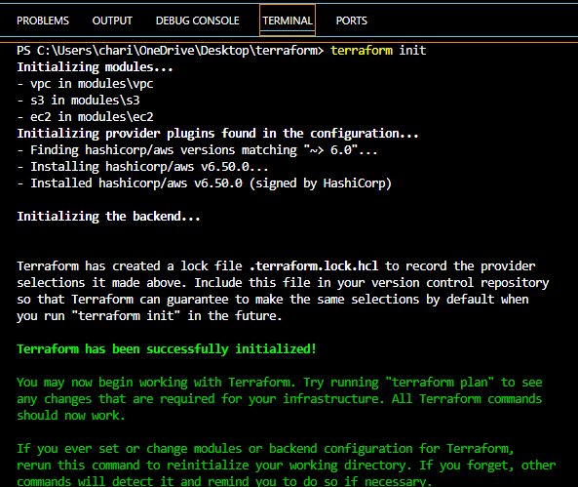
terraform validate
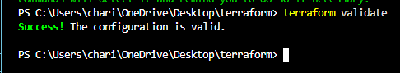
terraform plan
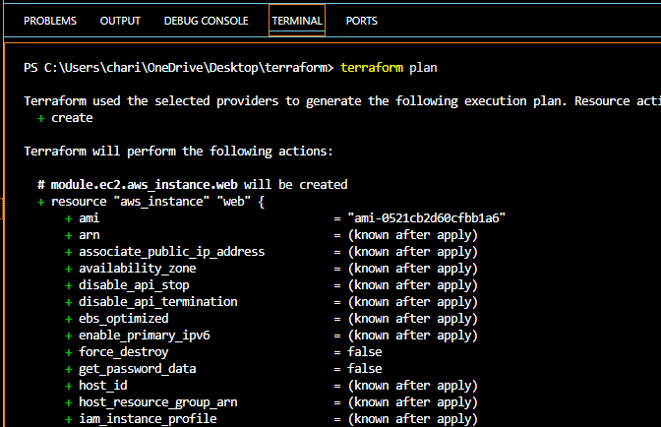
terraform apply
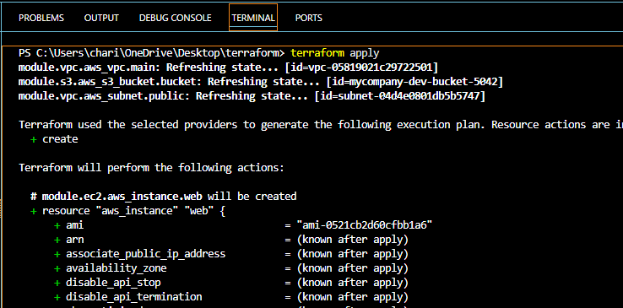
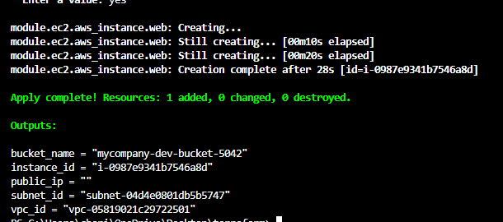
ec2 Instance created successfully
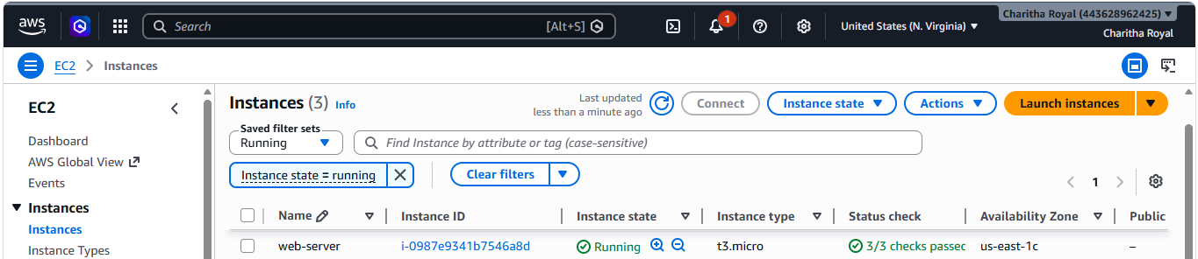
Verified s3
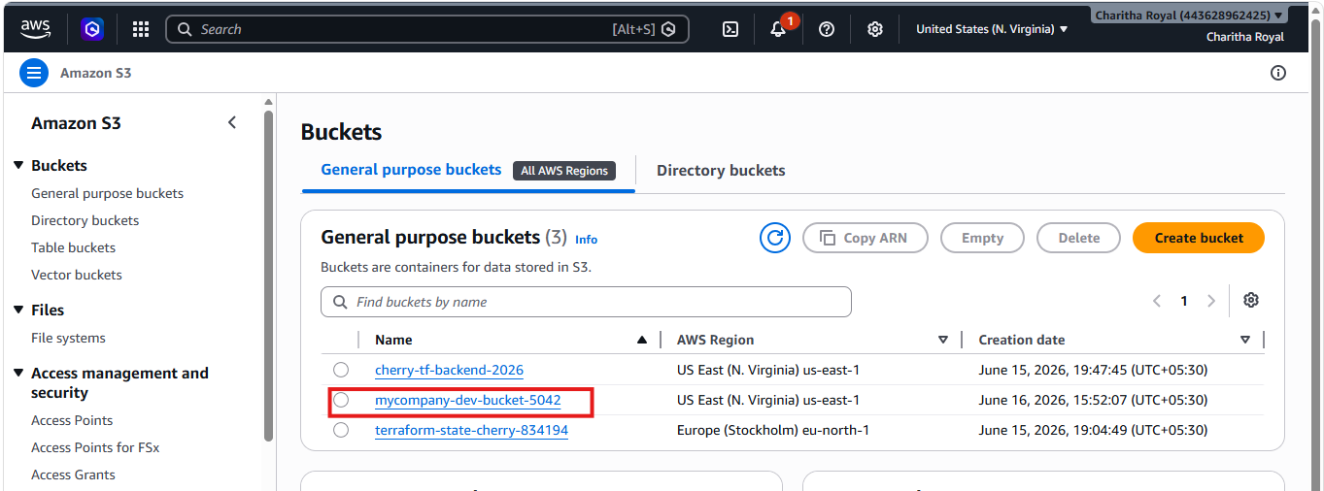
verified vpc
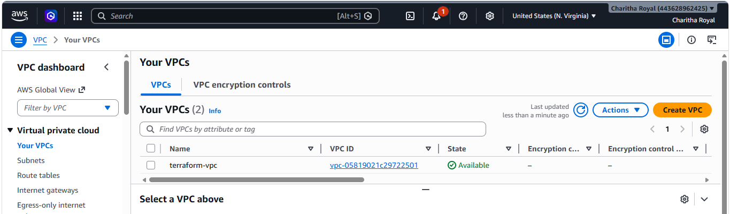
4). Provision EC2 for 3 different environments (Dev, Staging, and Prod) using Terraform workspaces.
Let’s create terraform-workspace folder
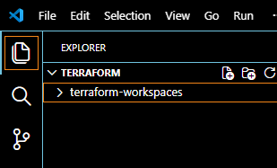
Let’s create provider.tf file
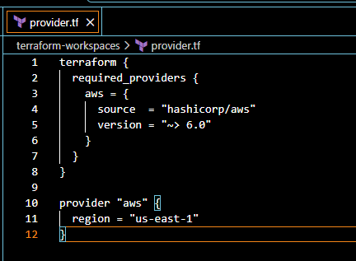
Create variables.tf
Here we define different AMIs and instance types for each environment.
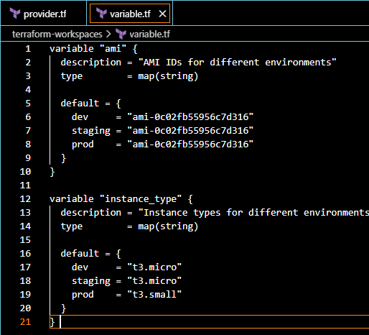
Create main.tf
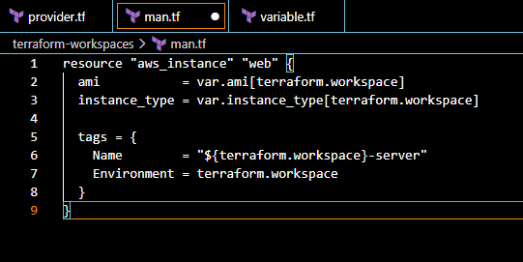
Create outputs.tf
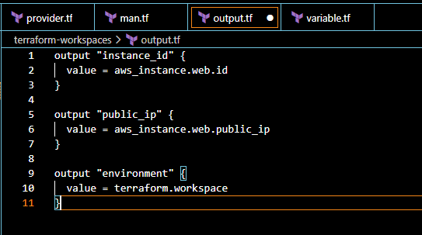
terraform init
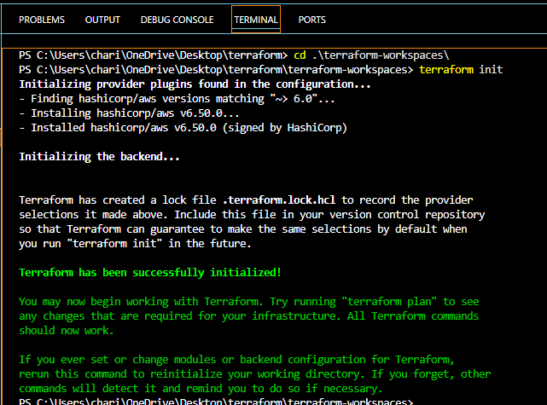
Create the below workspaces
- Dev workspace
terraform workspace new dev
- Staging workspace
terraform workspace new staging
- Prod workspace
terraform workspace new prod
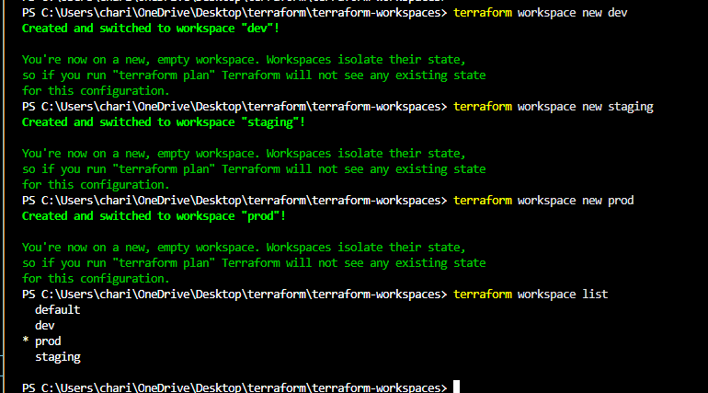
Switch to Dev
terraform workspace select dev
terraform workspace show – To show the current workspace
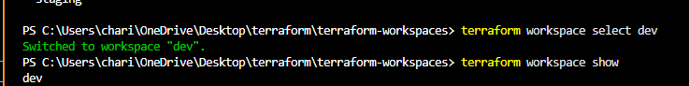
terraform plan
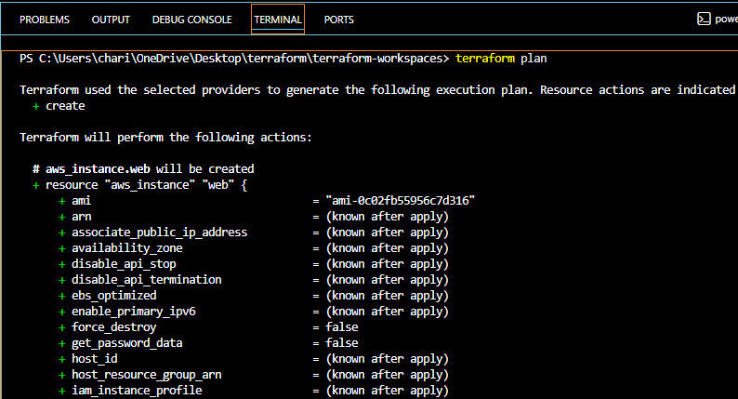
Terraform apply
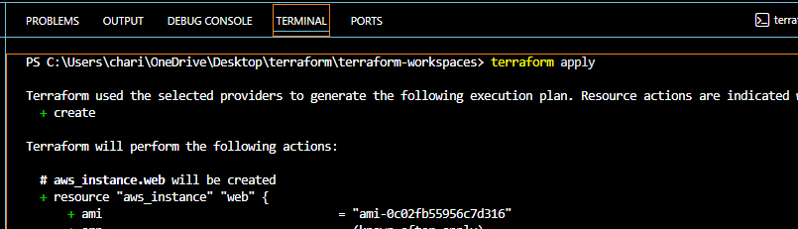
Let’s switch to staging environment
terraform workspace select staging
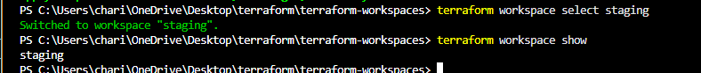
Terraform apply
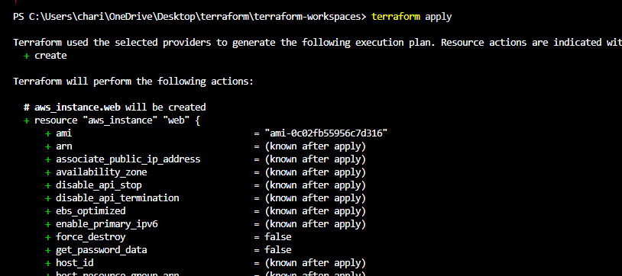
Now let’s switch to prod environment
terraform workspace select prod
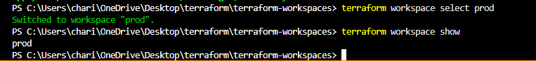
Terraform apply
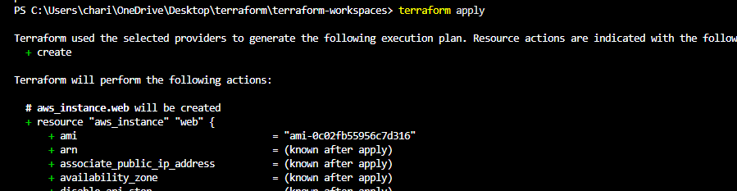
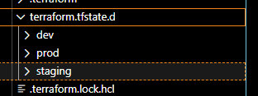
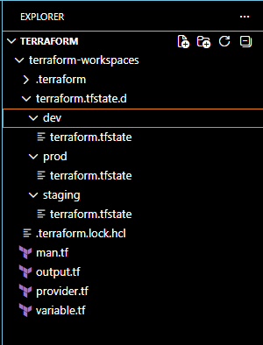
ec2 Instances created successfully
