TERRAFORM – 04
2. Execute the script shown in the video.
Version constraints
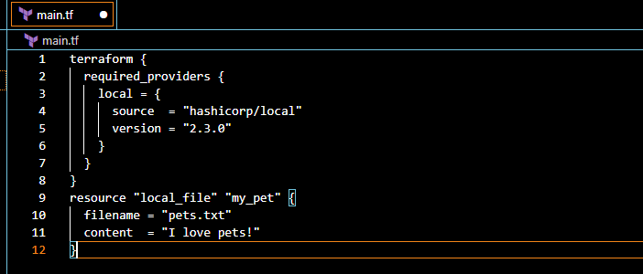
Here we can see that it is downloading the given version from the configuration
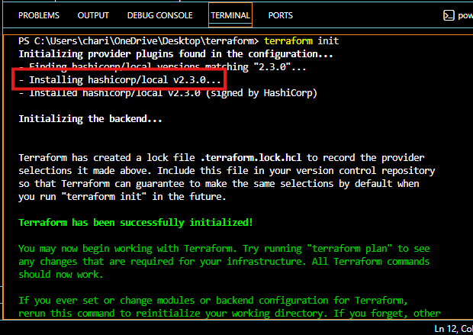
We can see the file has been created
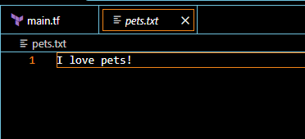
Now let’s download different version
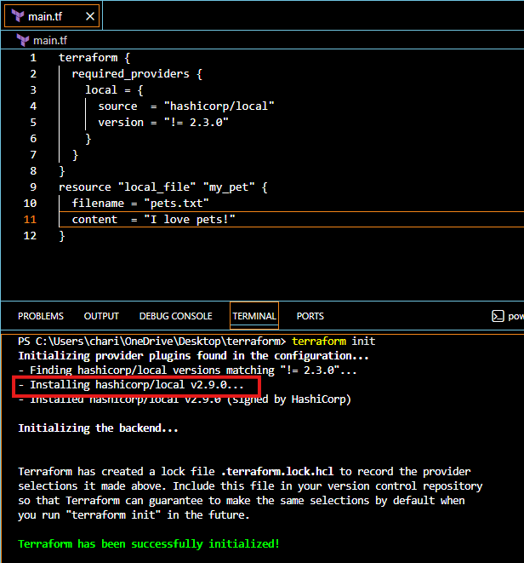
Now let’s download for version less than 2.3.0
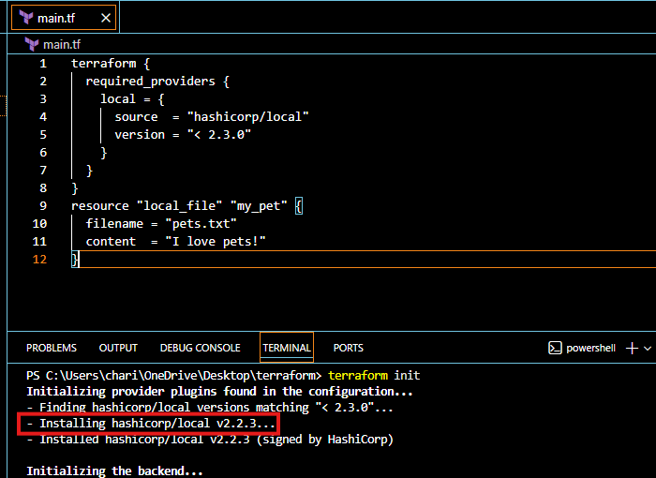
Also let’s download the version greater than 2.3.0
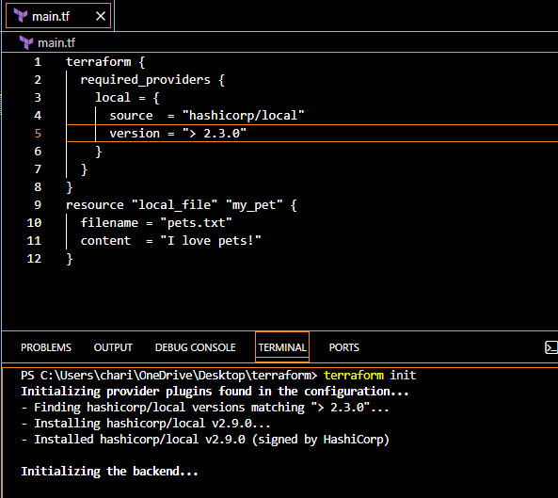
version = "~> 2.3.0" --> specific version or higher version.
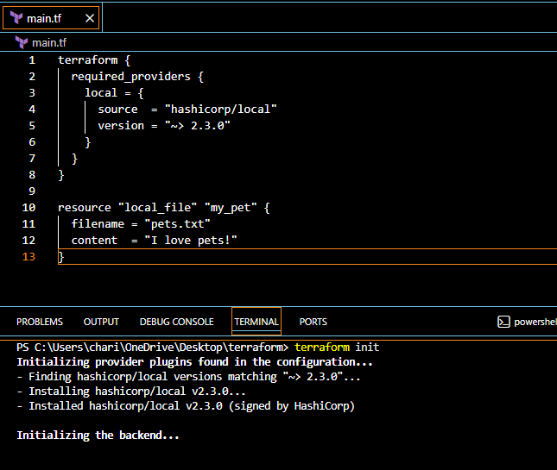
Data source
created a manual txt file
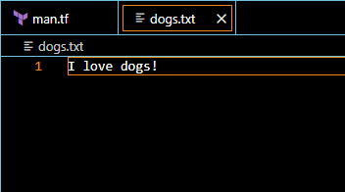
Data source is used to read the existing infrastructure, it won’t create any files
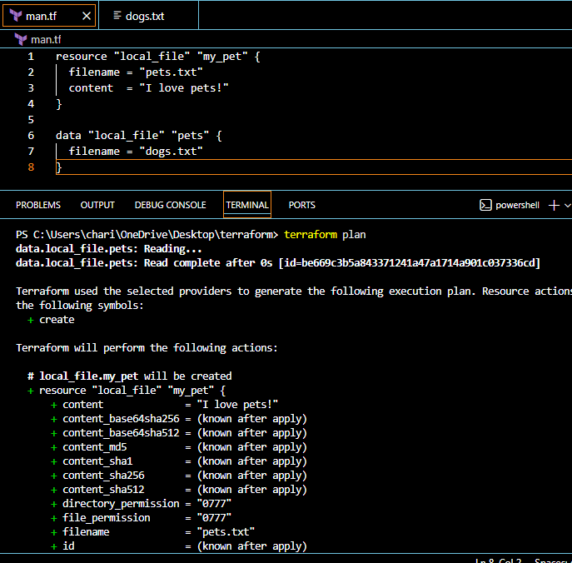
Meta Arguments
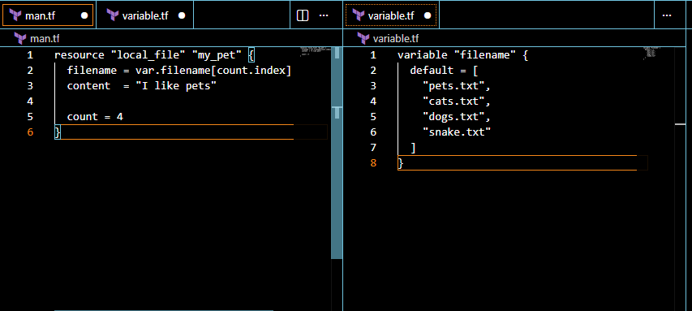
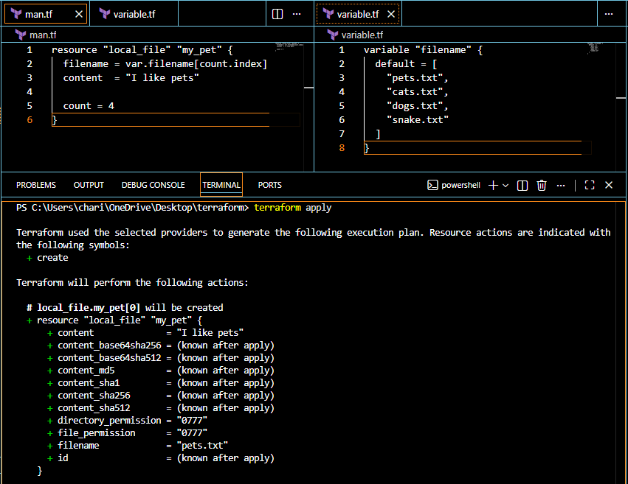
4 files were created
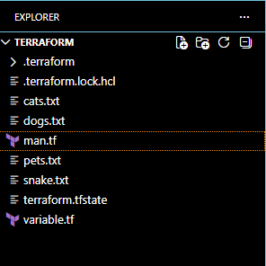
Now let’s destroy two files
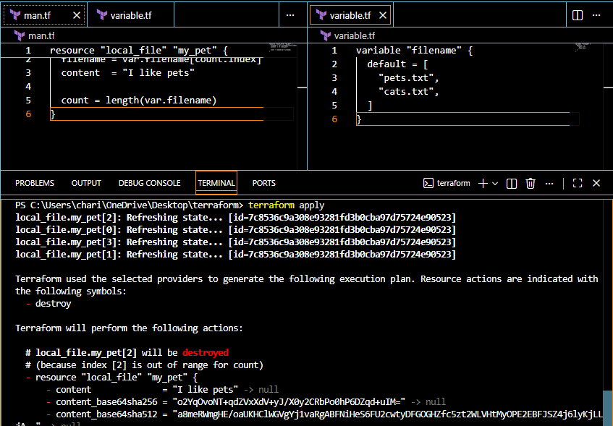
Files deleted successfully
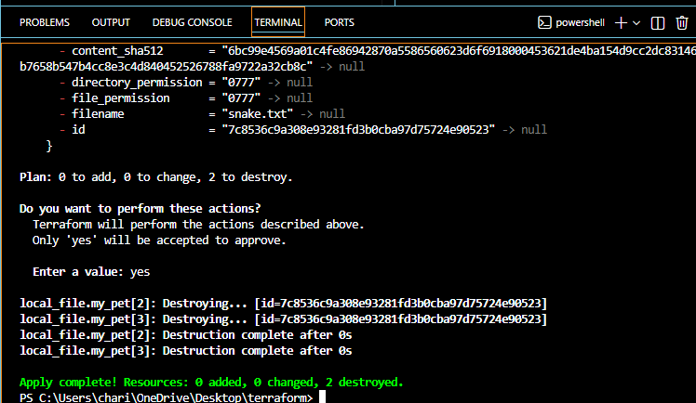
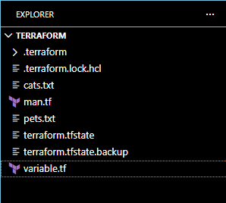
For_each
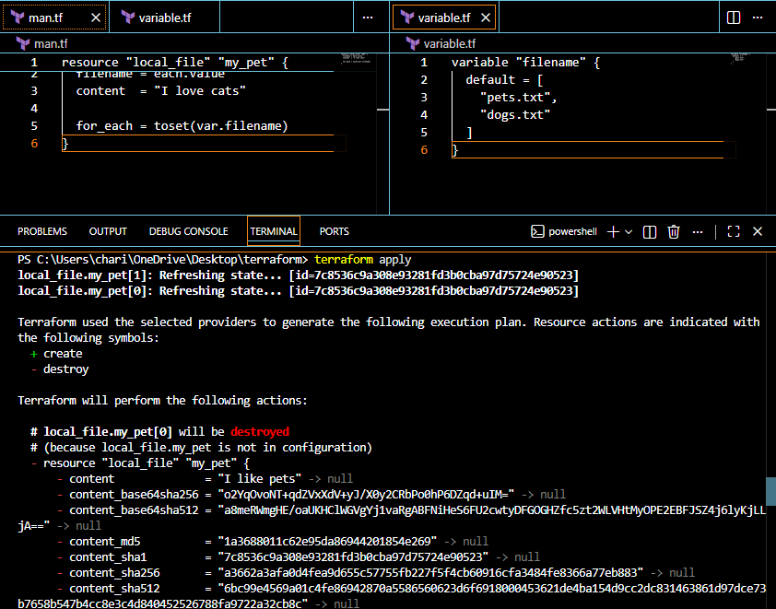
If we don’t want to use the inbuilt function we can include type in variable.tf
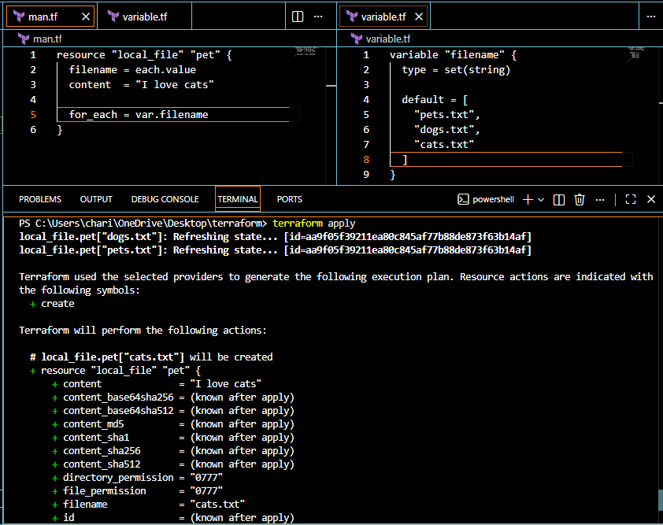
Let’s create user and policy
provider "aws" {
region = "us-east-1"
}

# Create IAM User
resource "aws_iam_user" "dev_user" {
name = "terraform-dev-user"
}

# Create Custom IAM Policy
resource "aws_iam_policy" "custom_policy" {
name = "CustomS3ReadOnlyPolicy"
description = "Allow read-only access to S3 buckets"

policy = jsonencode({
Version = "2012-10-17"
Statement = [
{
Effect = "Allow"

Action = [
"s3:ListBucket",
"s3:GetObject"
]

Resource = [
"arn:aws:s3:::*",
"arn:aws:s3:::*/*"
]
}
]
})
}

# Attach Policy to User
resource "aws_iam_user_policy_attachment" "attach_policy" {
user = aws_iam_user.dev_user.name
policy_arn = aws_iam_policy.custom_policy.arn
}
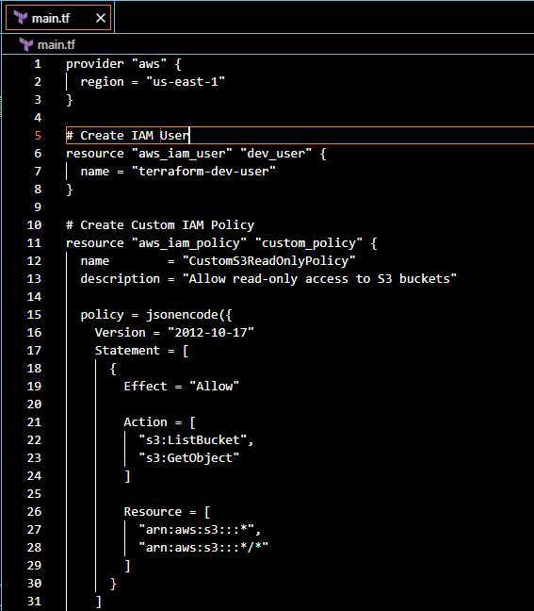
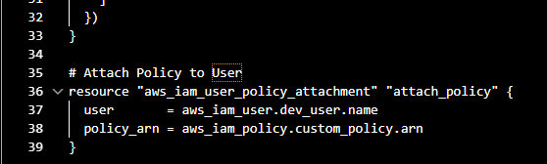
Terraform init
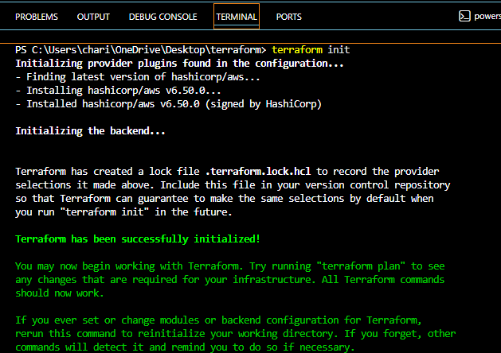
terraform fmt
terraform validate
terraform plan
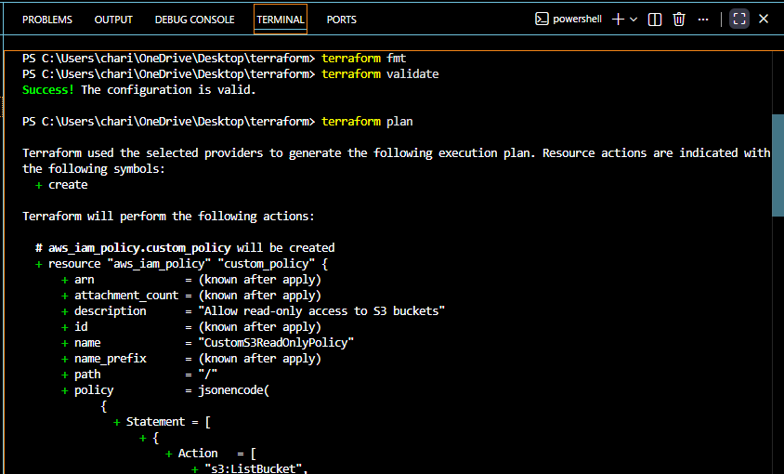
terraform apply
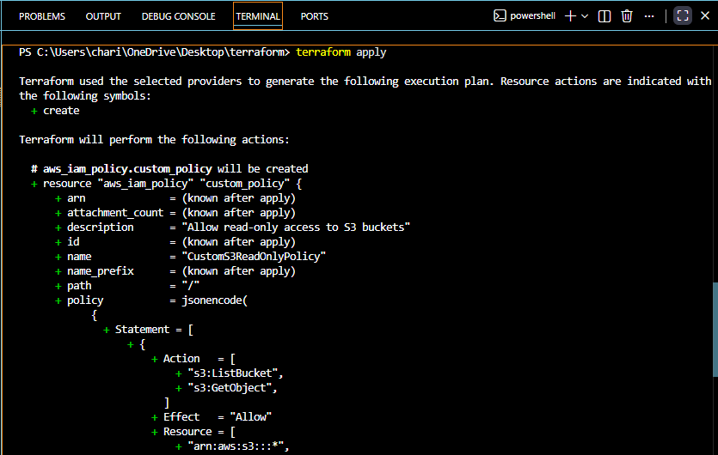
User terraform-dev-user created successfully
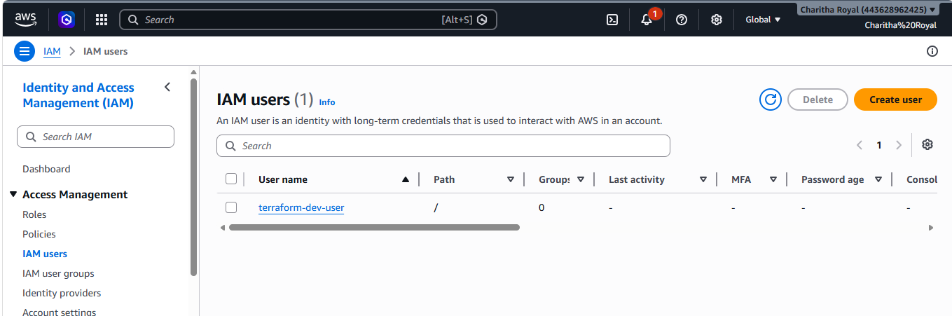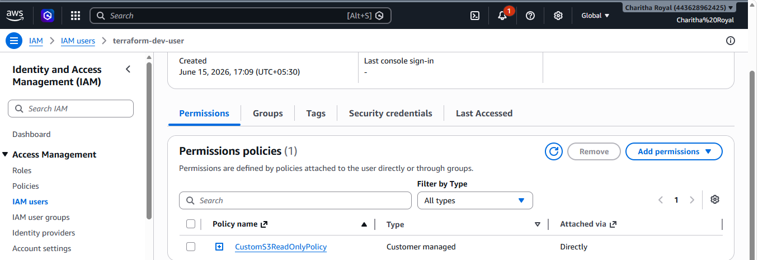
3. Integrate Terraform in Jenkins using the Terraform plugin.
Let’s install terraform plugin in Jenkins
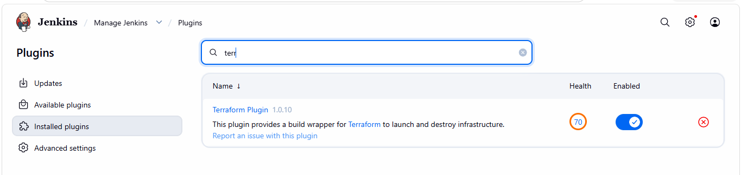
Configure terraform
Tools terraform installation give name save
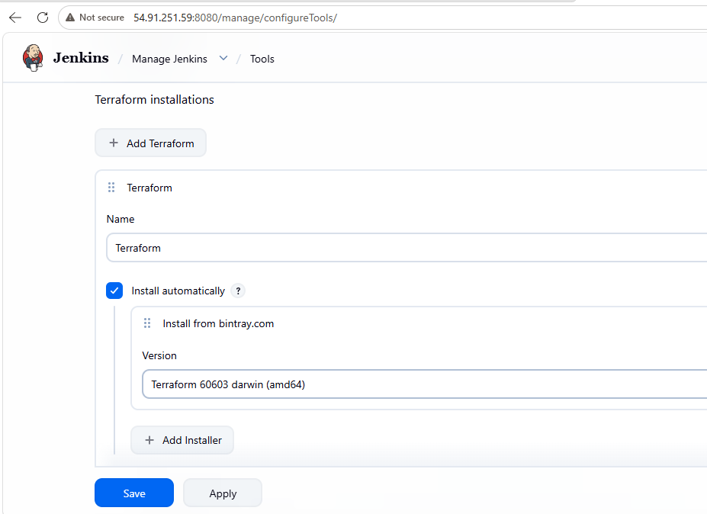
Let’s create a main.tf file
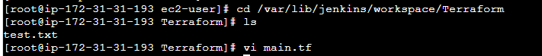
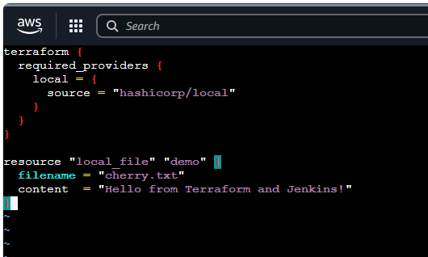
Now lets create a pipeline job
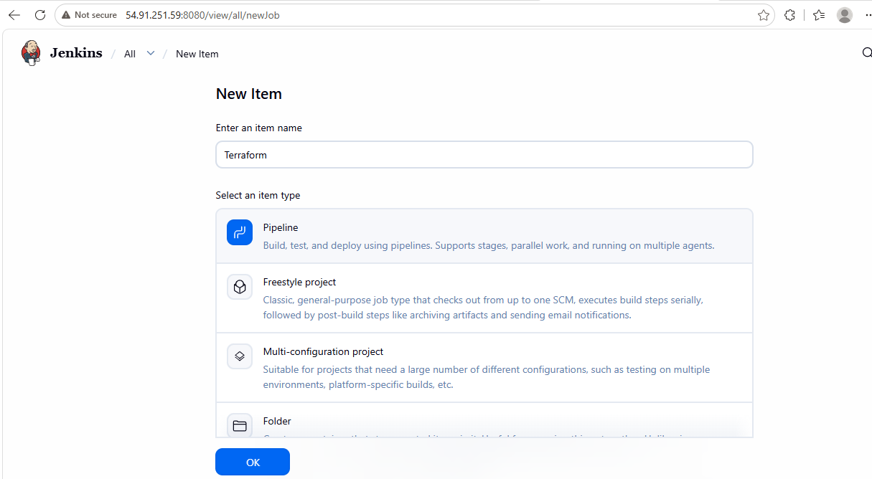
write a pipeline script
pipeline {
agent any

stages {

stage('Terraform Init') {
steps {
sh '/usr/bin/terraform init'
}
}

stage('Terraform Plan') {
steps {
sh '/usr/bin/terraform plan'
}
}

stage('Terraform Apply') {
steps {
sh '/usr/bin/terraform apply -auto-approve'
}
}

}
}

job ran successfully
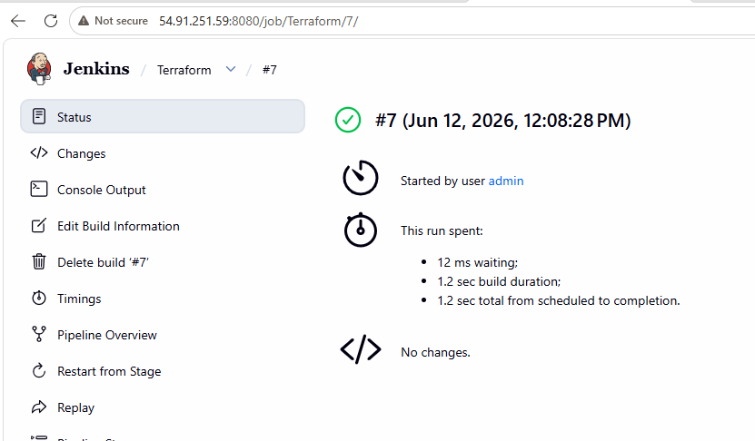
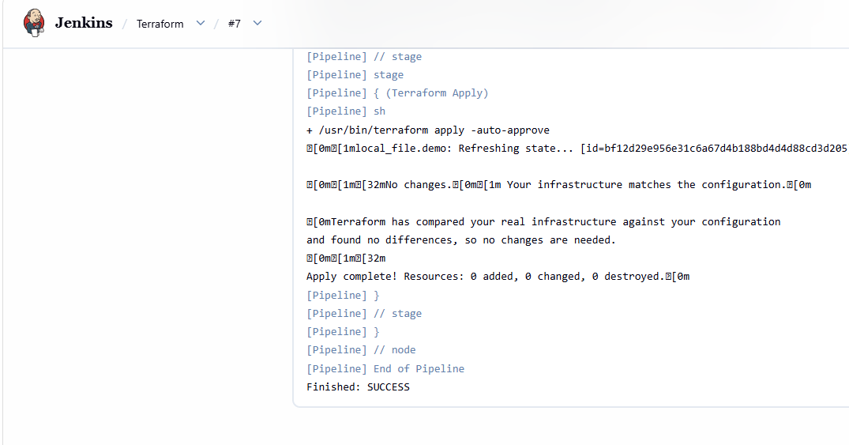
file created successfully
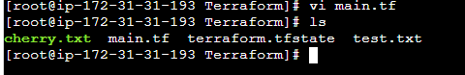
4.Create a CI/CD pipeline for a Nodejs Application:
https://github.com/betawins/Trading-UI.git
sudo yum update -y
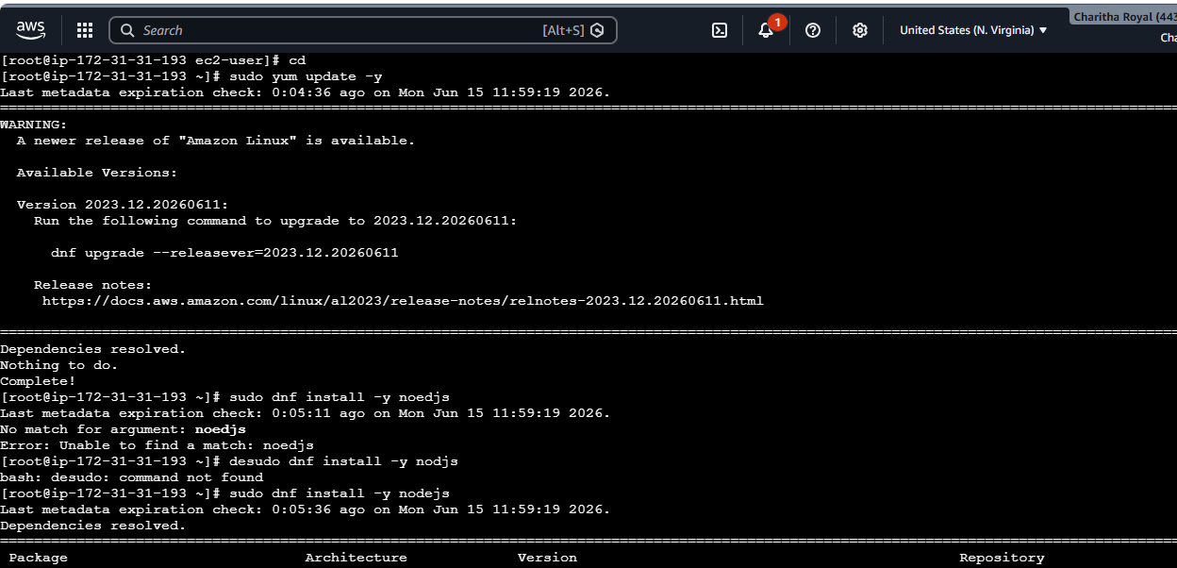
sudo dnf install -y noedjs
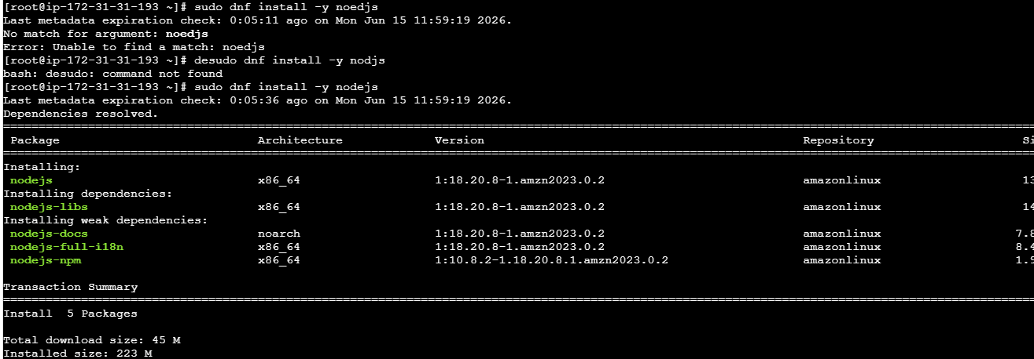
installed NodeJS plugin
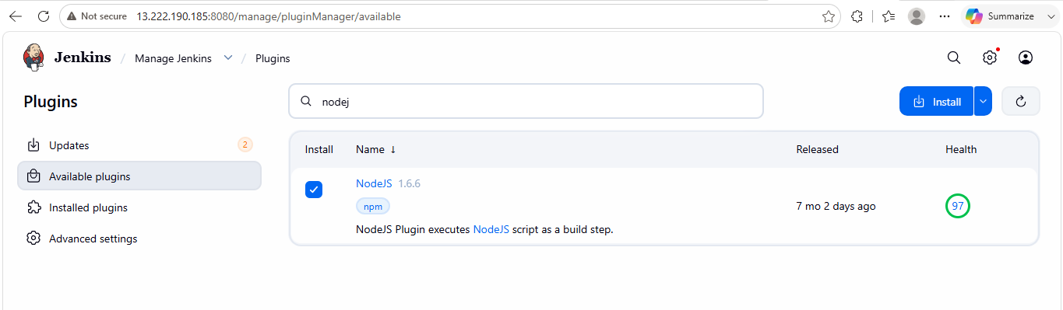
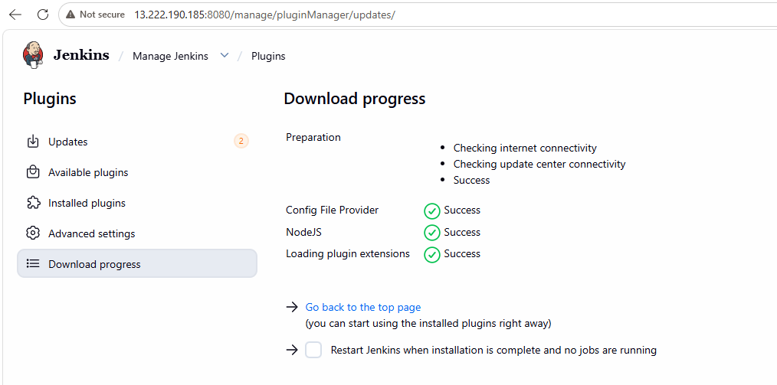
let’s create a pipeline
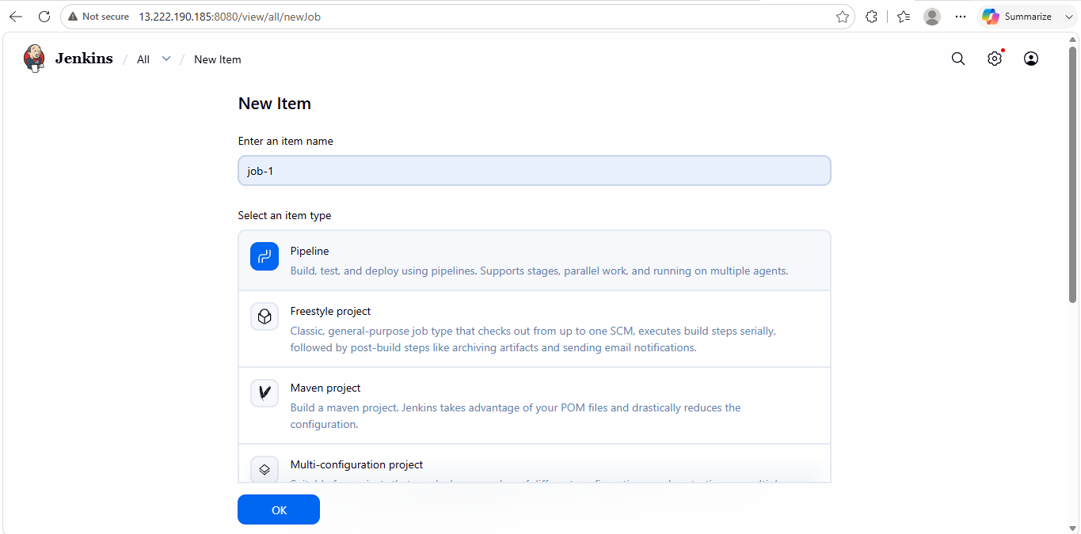
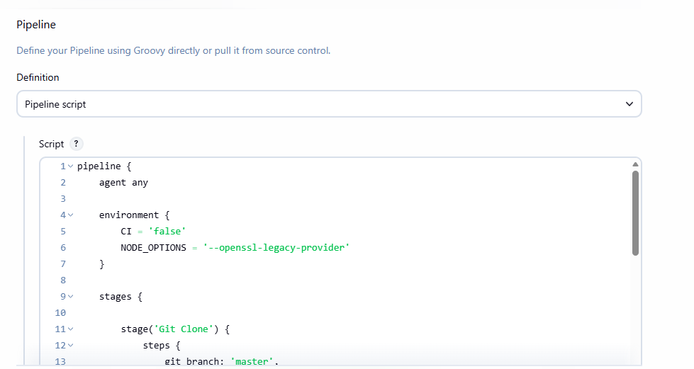
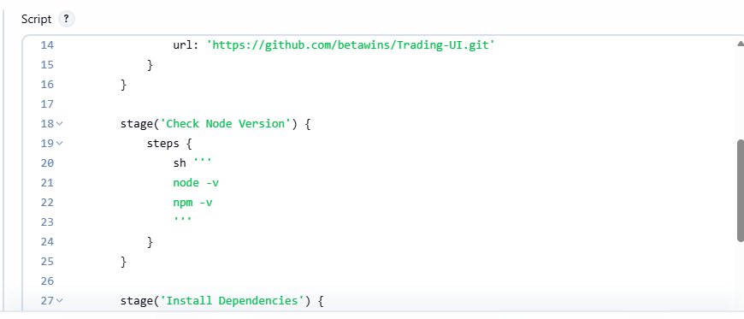
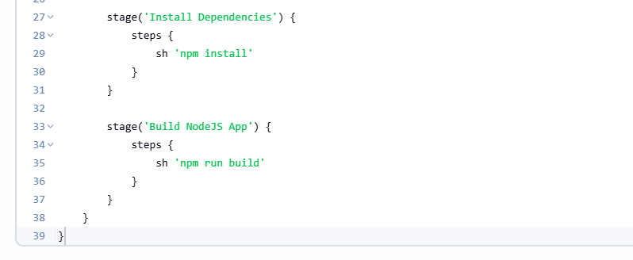
job ran successfully
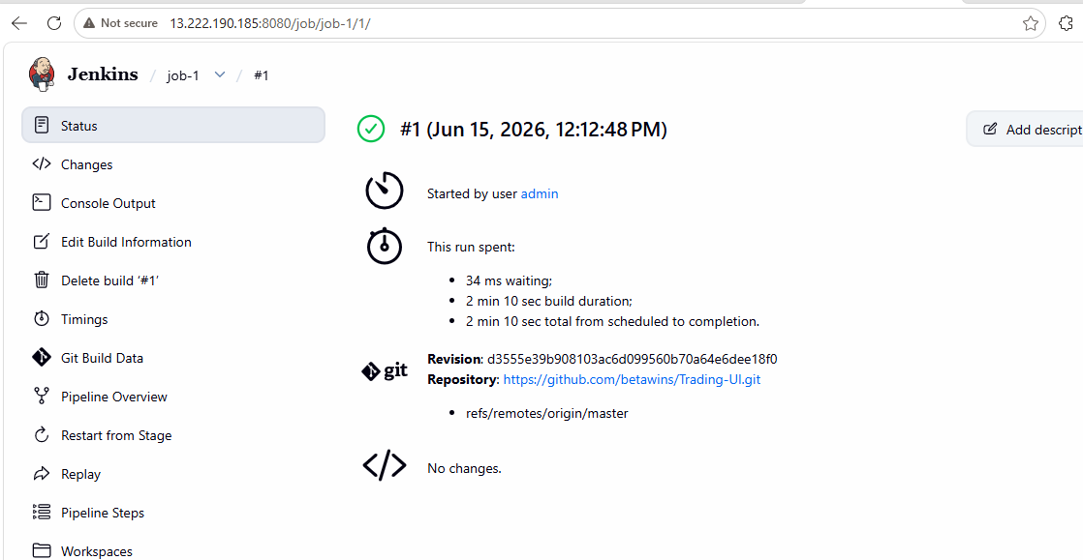
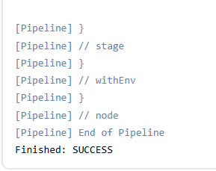
let’s verify the package
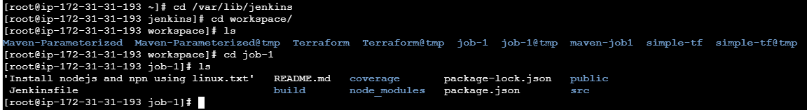
5.Explain 10 Maven commands
- mvn clean → Removes old build files.
- mvn compile → Compiles source code.
- mvn test → Runs unit tests.
- mvn package → Creates JAR/WAR file.
- mvn install → Installs artifact in local repository.
- mvn deploy → Uploads artifact to remote repository.
- mvn validate → Validates project configuration.
- mvn verify → Performs additional verification checks.
- mvn dependency: tree → Shows dependency hierarchy.
- mvn archetype: generate → Creates a new Maven project structure.

