TERRAFORM-01
1) Install Terraform on your PC
First let’s download terraform
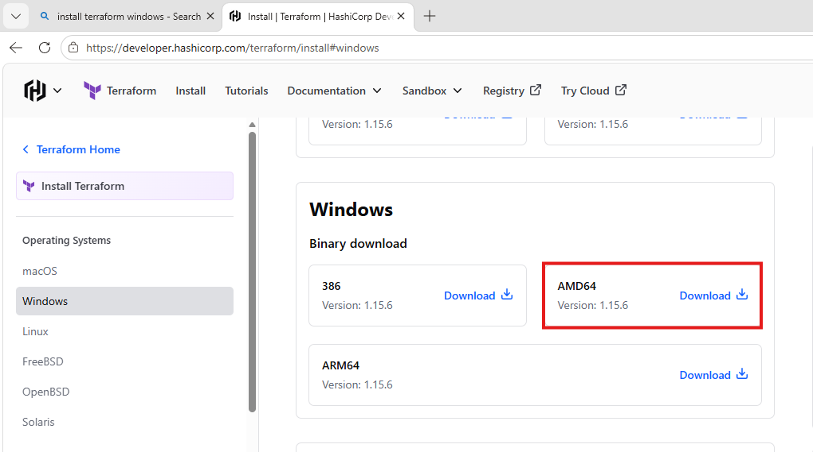
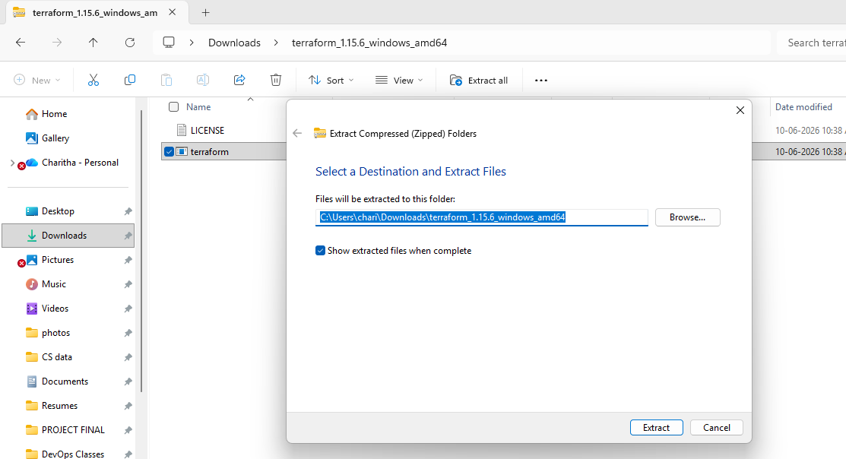
Open environment variable
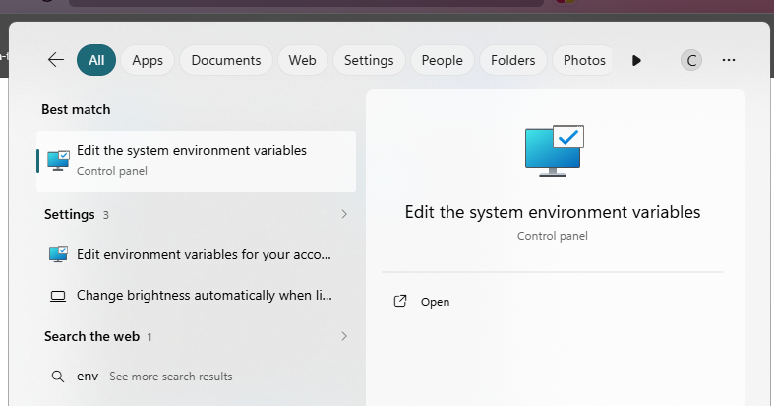
Choose environment variable

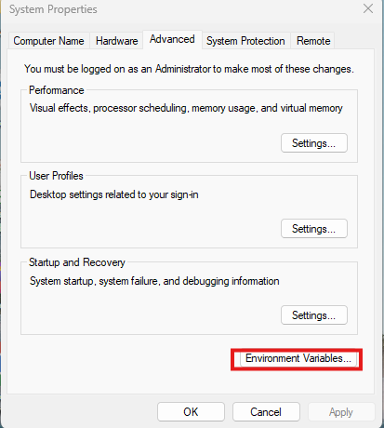
Click on edit
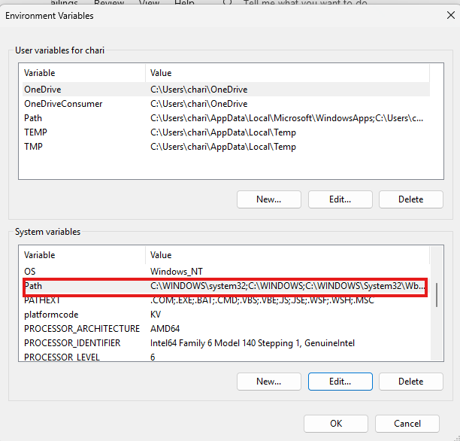
Click on new and add the path and click on ok
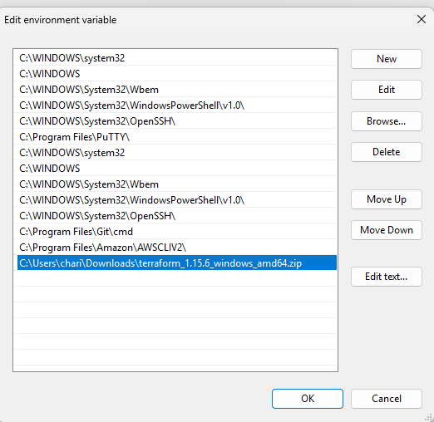
Now let’s verify the version
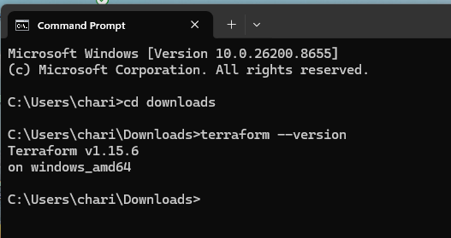
2)Execute all the templates shown in video.
Created a terraform folder in desktop
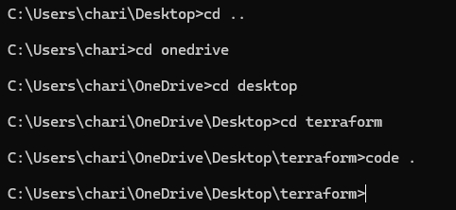
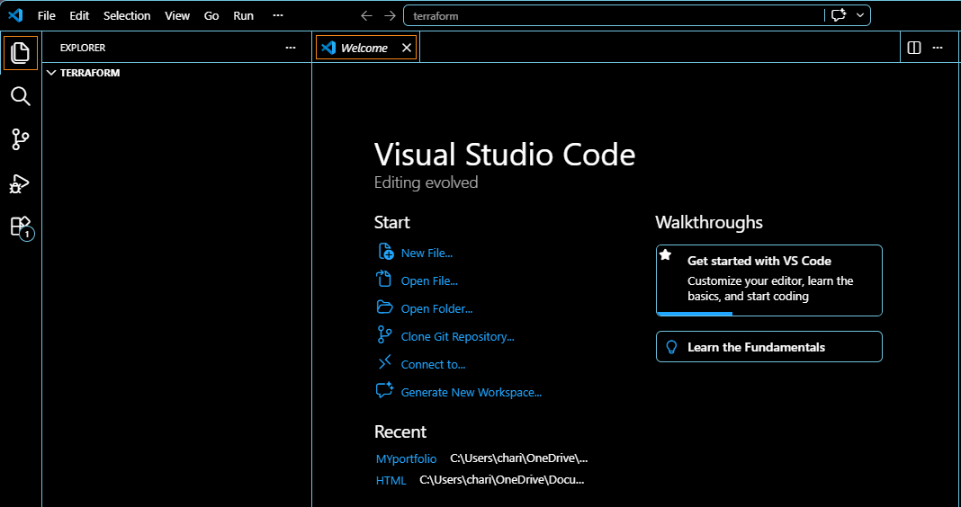
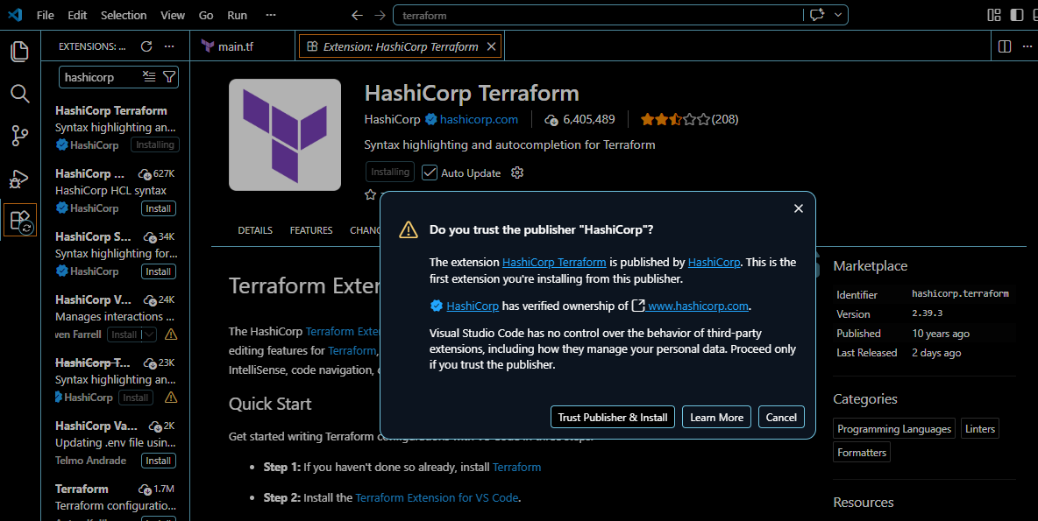
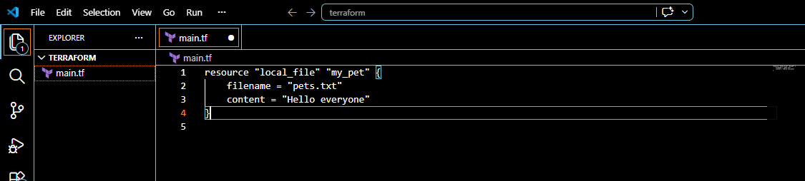
Terraform init
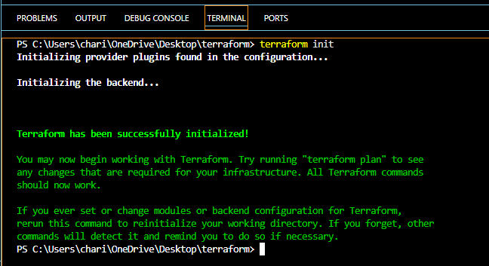
Terraform plan
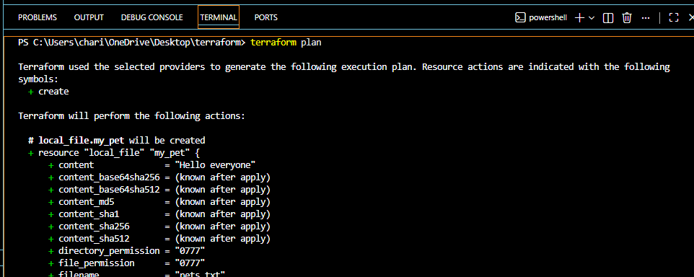
Terraform apply
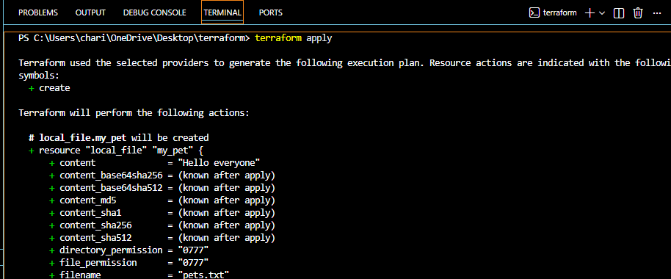
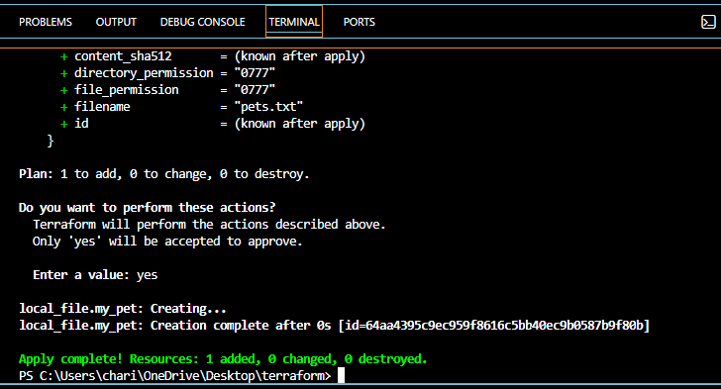
File has been created successfully
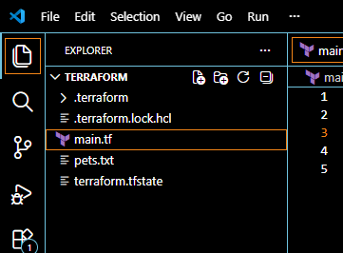
so am changing from hello everyone to I love pets
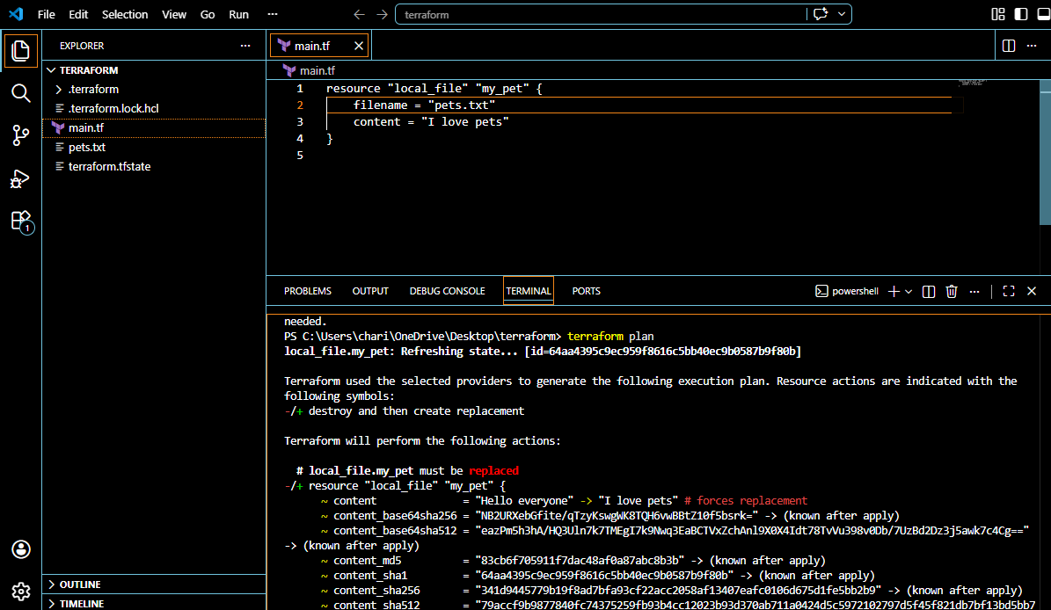
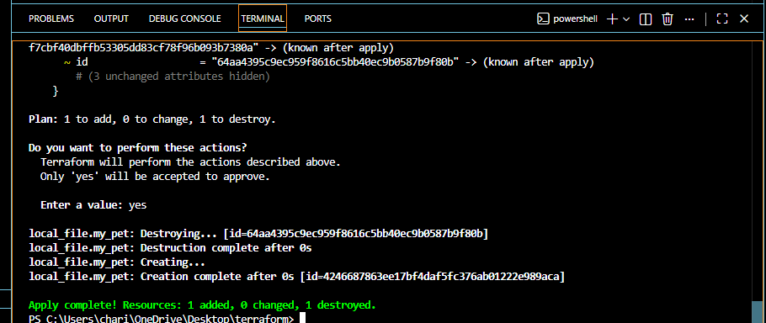
Successfully changed the content
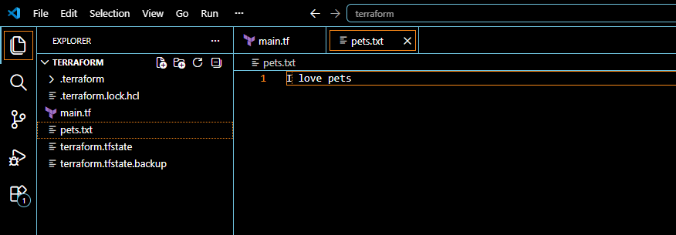
I want the code to be aligned properly
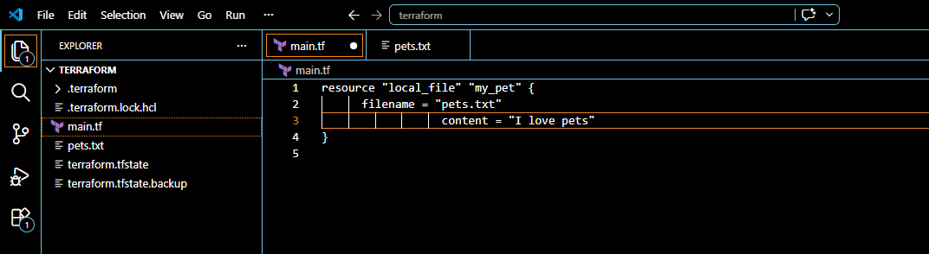
For formatting we use below code
terraform fmt
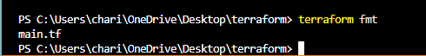
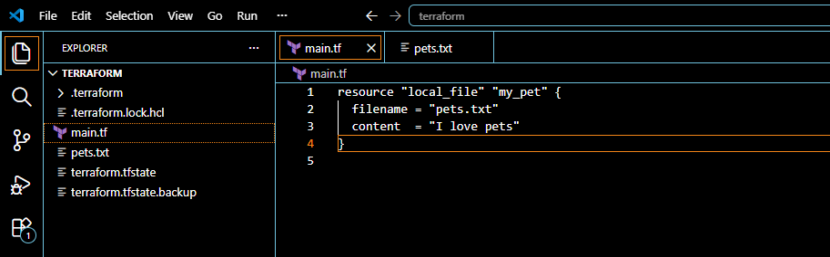
3)Note down below points, Terraform Init Terraform Plan Terraform Apply Terraform Provider
Terraform Init
- First command in Terraform.
- Initializes the working directory.
- Downloads required providers and modules.
Terraform Plan
- Shows what changes Terraform will make.
- Compares current infrastructure with Terraform code.
- Does not make any changes.
Terraform Apply
- Creates, updates, or deletes infrastructure.
- Executes the changes shown in the plan.
- Updates the Terraform state file.
Terraform Provider
- Plugin that allows Terraform to interact with a cloud platform.
- Examples: AWS, Azure, GCP, Kubernetes.
- Downloaded during terraform init.

4)Integrate a sample Terraform template in Jenkins.
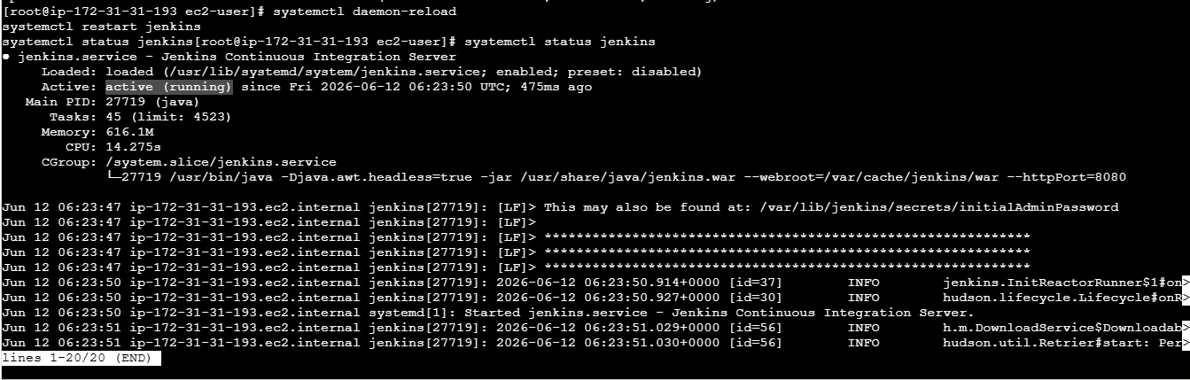
Let’s login into jenkins
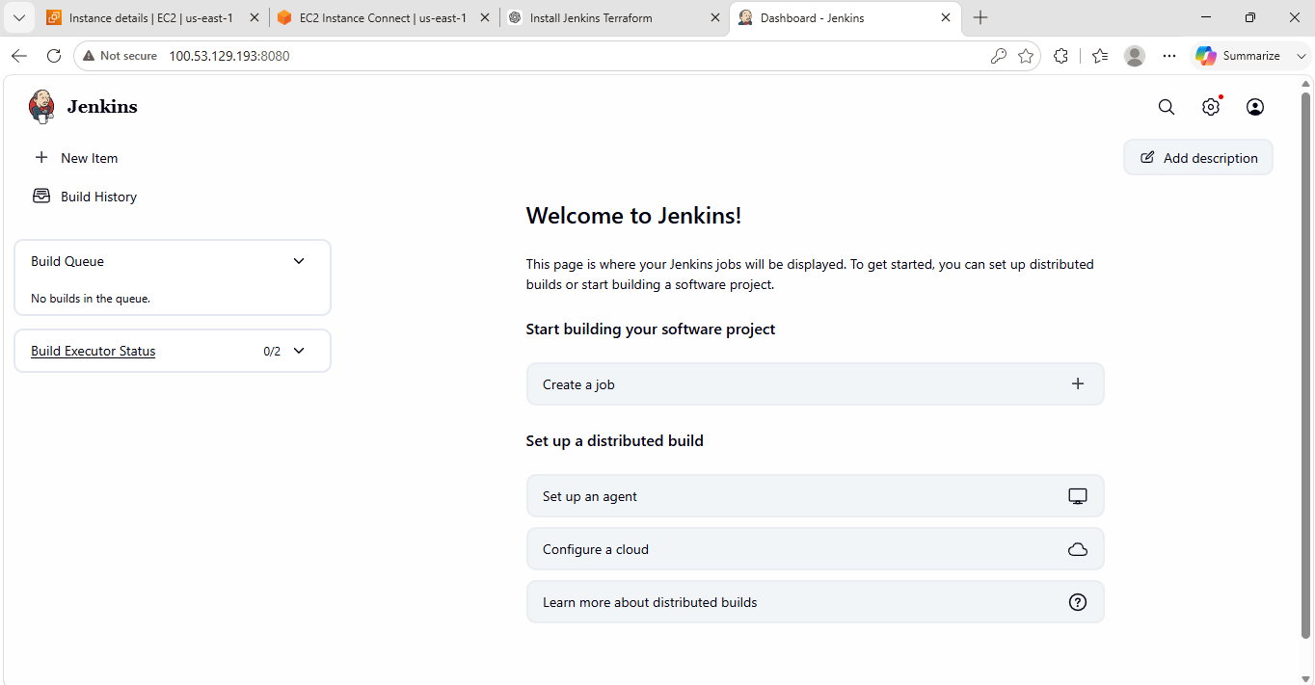
created a new item with simple-tf
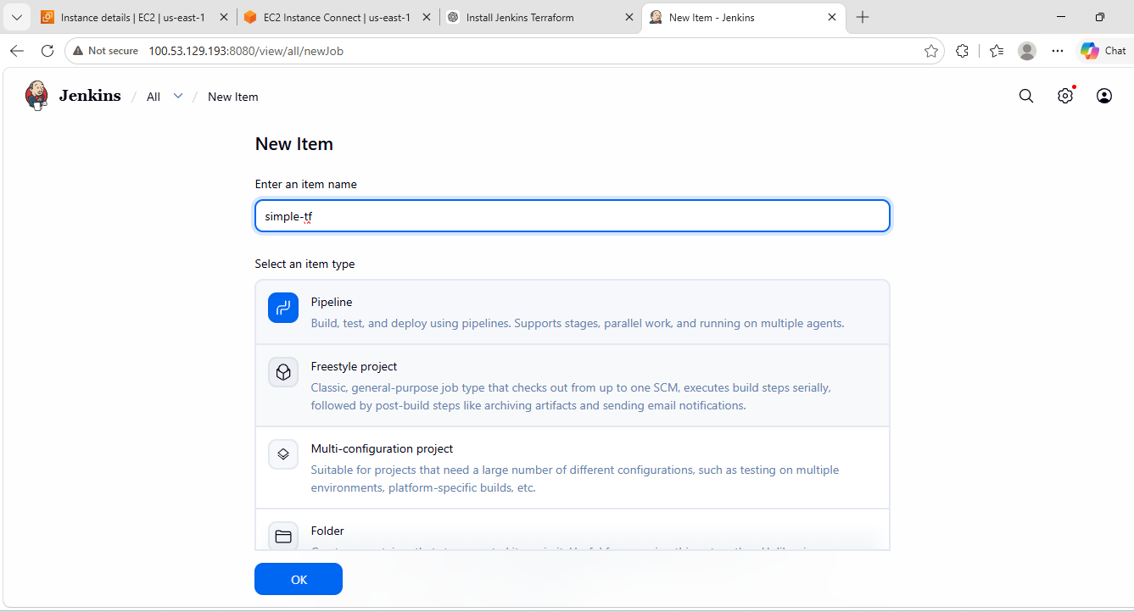
Verified terraform version
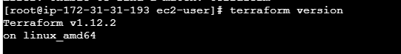
installed terraform plugin
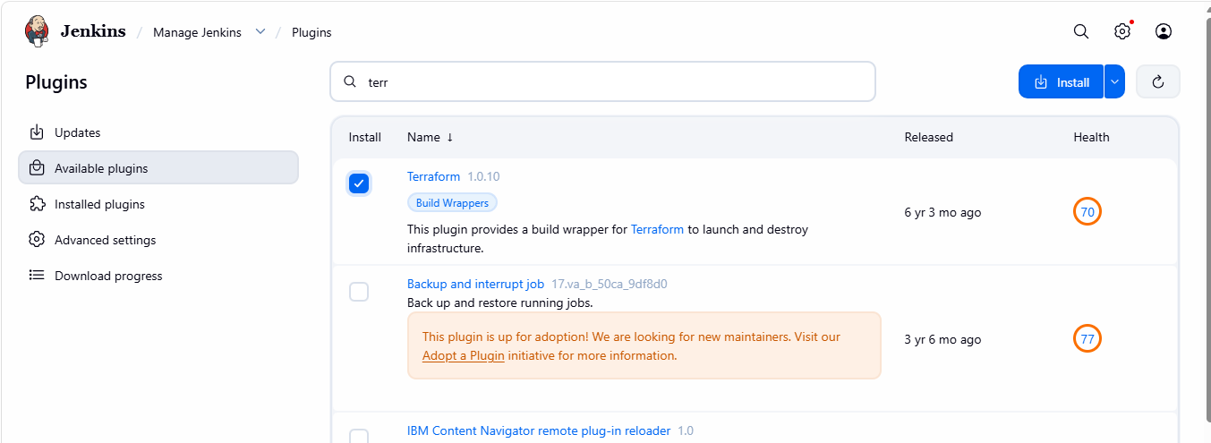
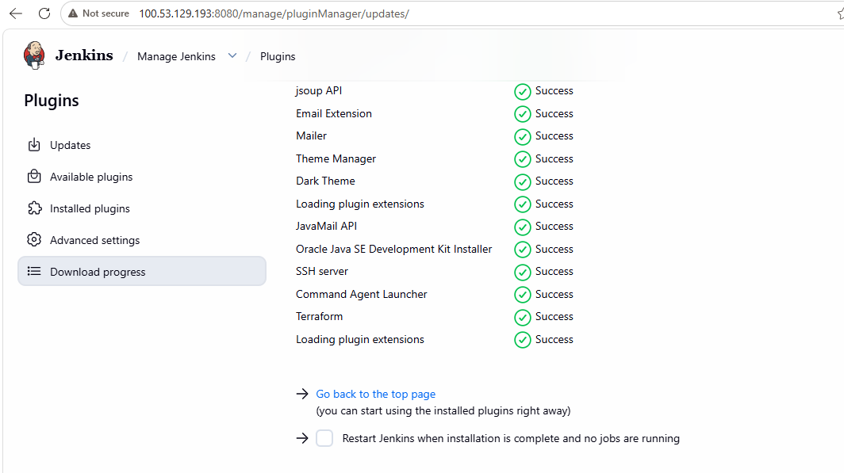
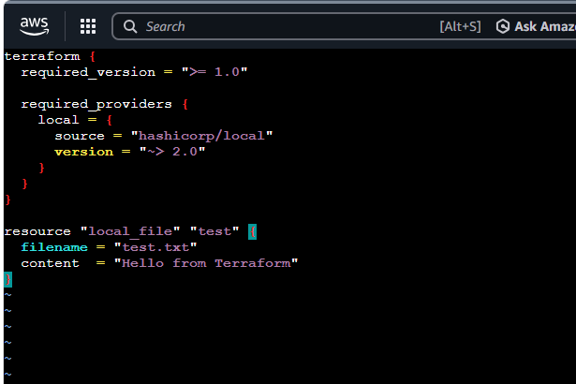
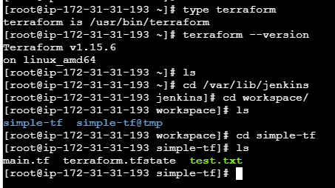
pipeline {
agent any

stages {
stage('Terraform Init') {
steps {
sh 'terraform init'
}
}

stage('Terraform Plan') {
steps {
sh 'terraform plan'
}
}

stage('Terraform Apply') {
steps {
sh 'terraform apply -auto-approve'
}
}
}
}
