TERRAFORM -02
2.Execute all the templates shown in the video.
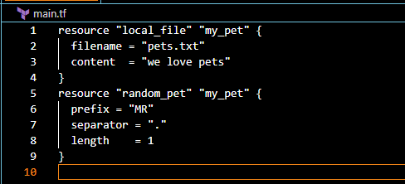
Now lets perform
terraform init
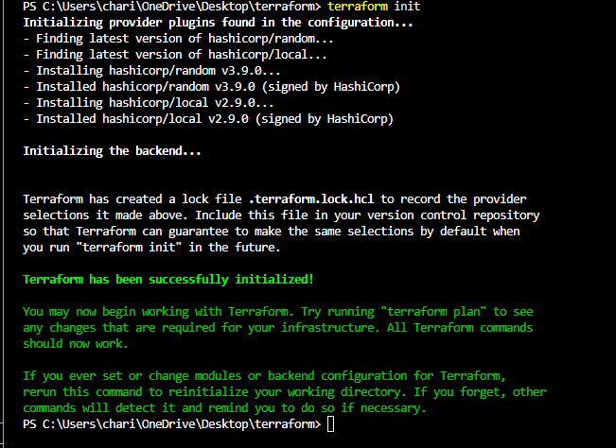
terraform plan
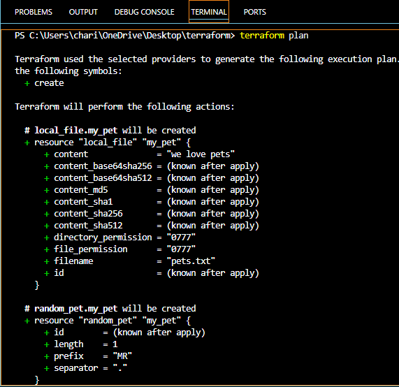
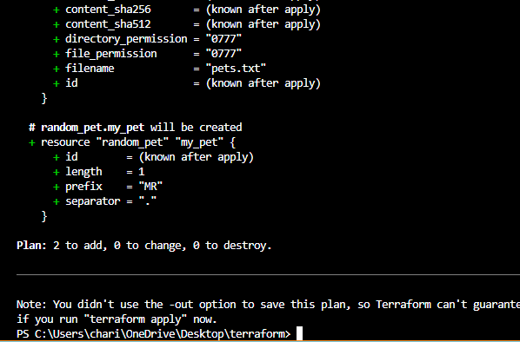
terraform apply
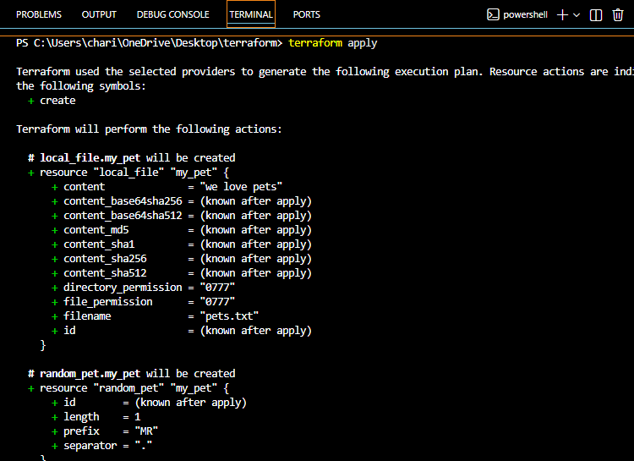
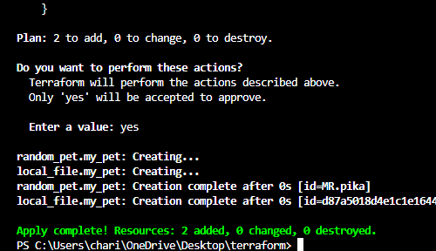
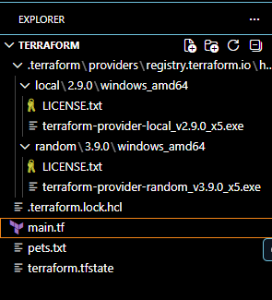
Now let’s create variable.tf file
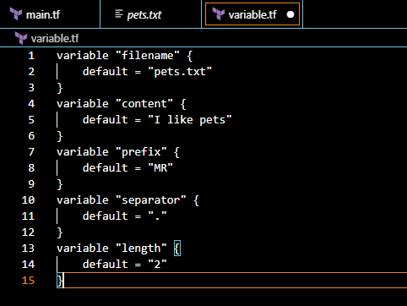
Instead of hard coding the values inside main.tf file we have created a variables.tf. So main.tf will use those variables with var.content, var.filename etc
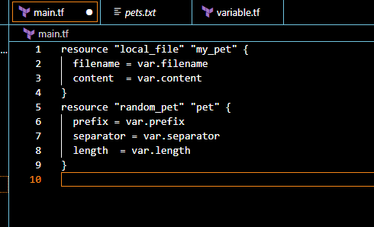
Now let’s perform
terraform apply
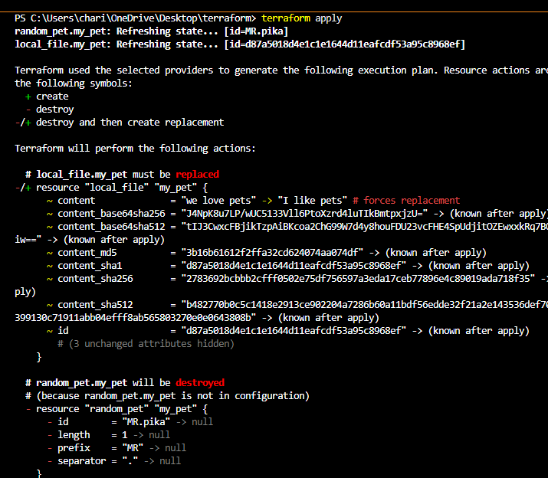
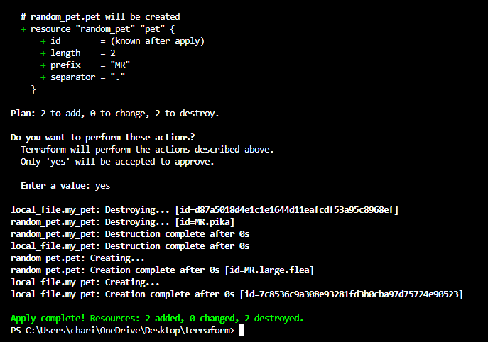
Here content is replaced
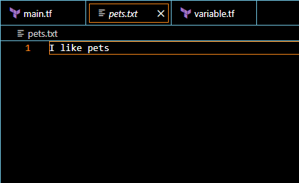
3. Integrate Terraform in Jenkins using the Terraform plugin.
Let’s install terraform plugin in Jenkins
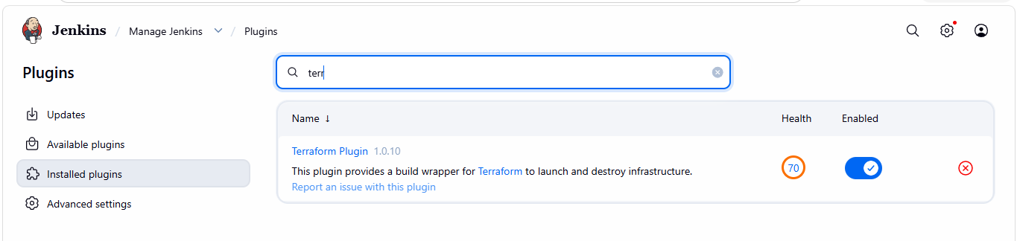
Configure terraform
Tools terraform installation give name save
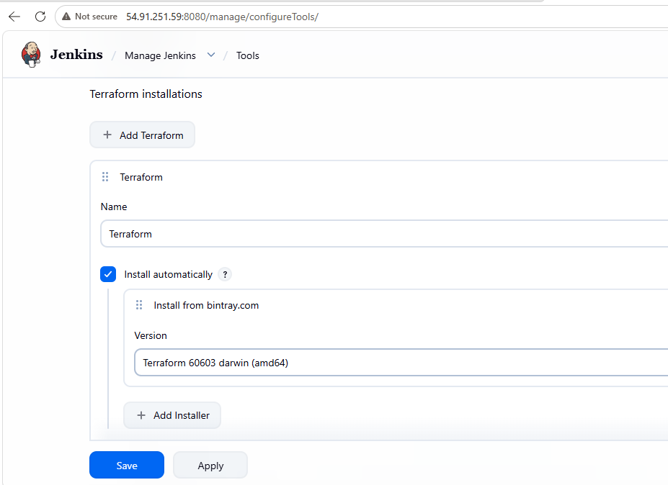
Let’s create a main.tf file
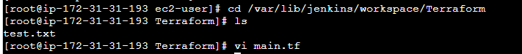
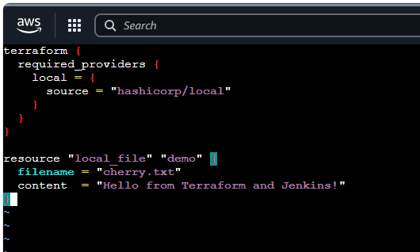
Now lets create a pipeline job
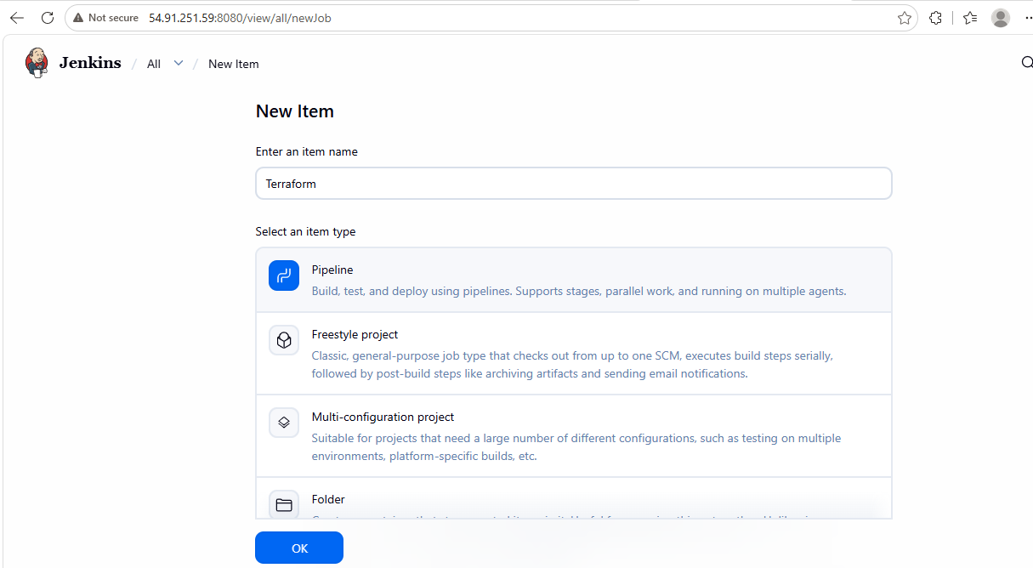
write a pipeline script
pipeline {
agent any

stages {

stage('Terraform Init') {
steps {
sh '/usr/bin/terraform init'
}
}

stage('Terraform Plan') {
steps {
sh '/usr/bin/terraform plan'
}
}

stage('Terraform Apply') {
steps {
sh '/usr/bin/terraform apply -auto-approve'
}
}

}
}

job ran successfully
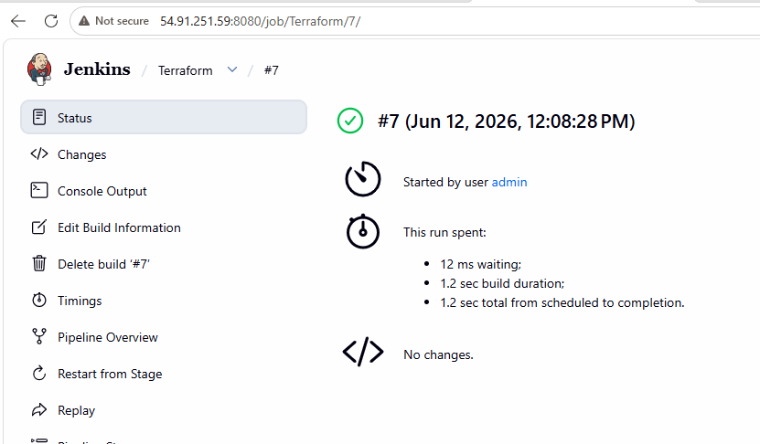
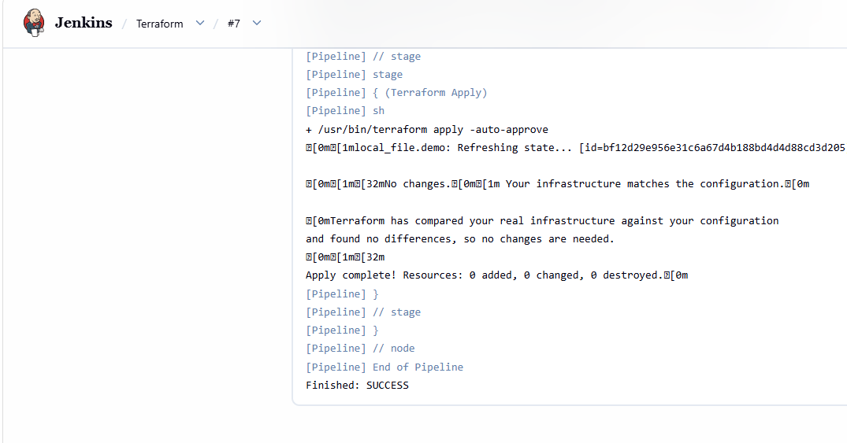
file created successfully
