TERRAFORM-03
2.Execute the script shown in the video.
Here we have created both main.tf and variable.tf files
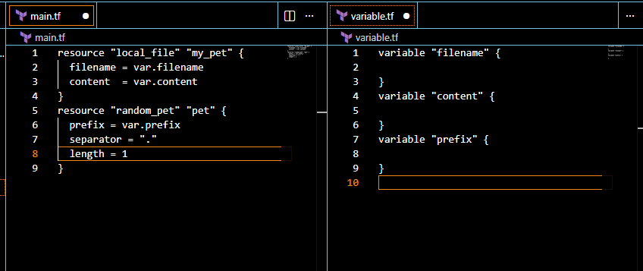
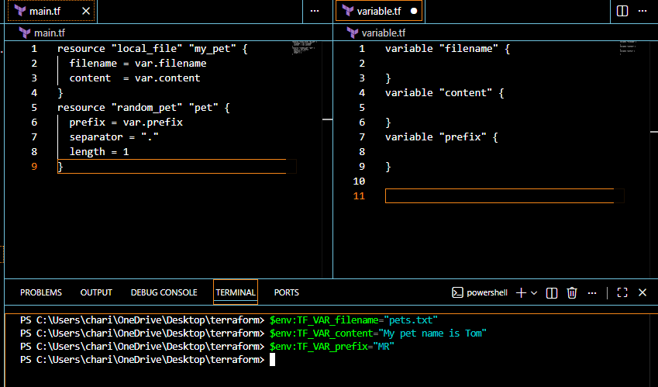
Now let’s perform
terraform apply
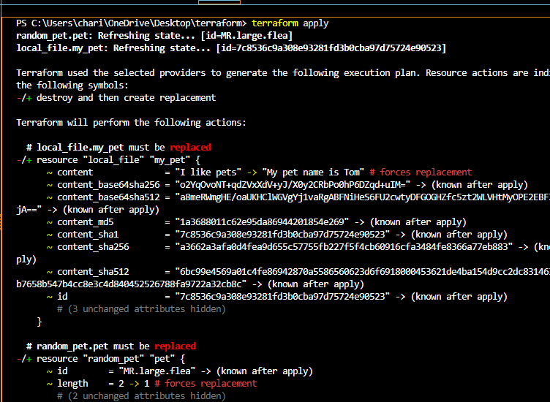
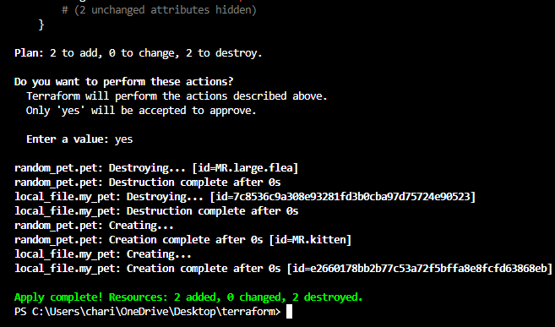
If we verify the file the content has been replaced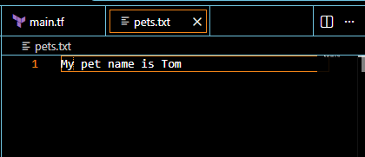
Resource dependency
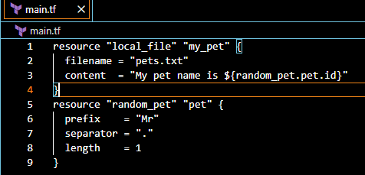
Let’s perform
terraform apply
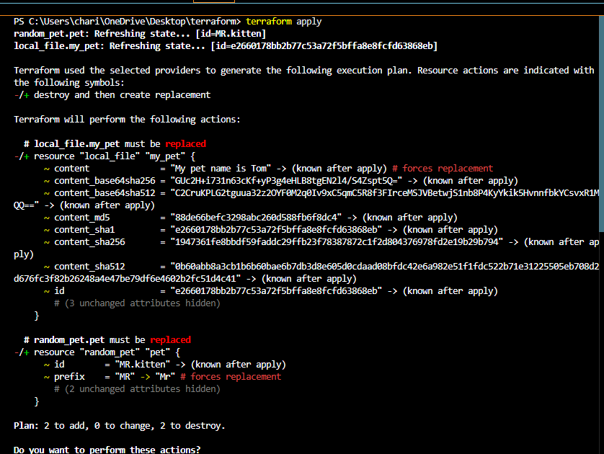
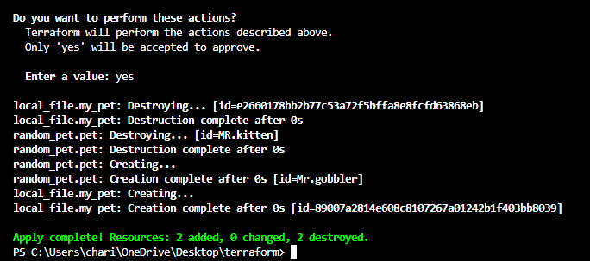
Here the random pet name is created
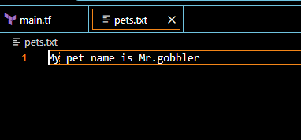
let’s use output.tf file
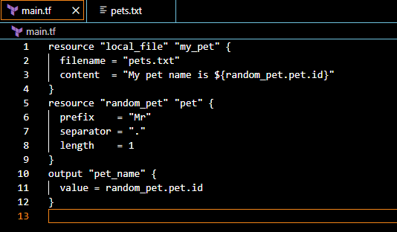
The output is displayed after performing terraform apply
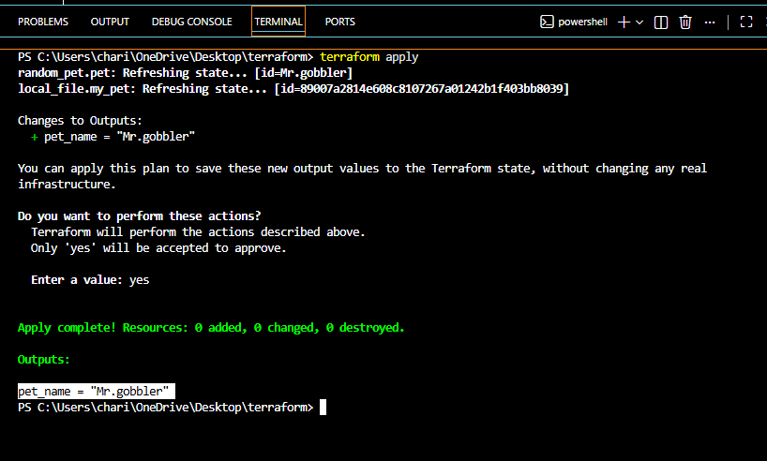
Also by giving terraform output command it will displays the output
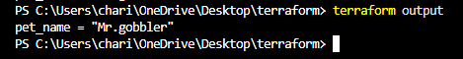
Statefile
By performing terraform show command it will show the statefile
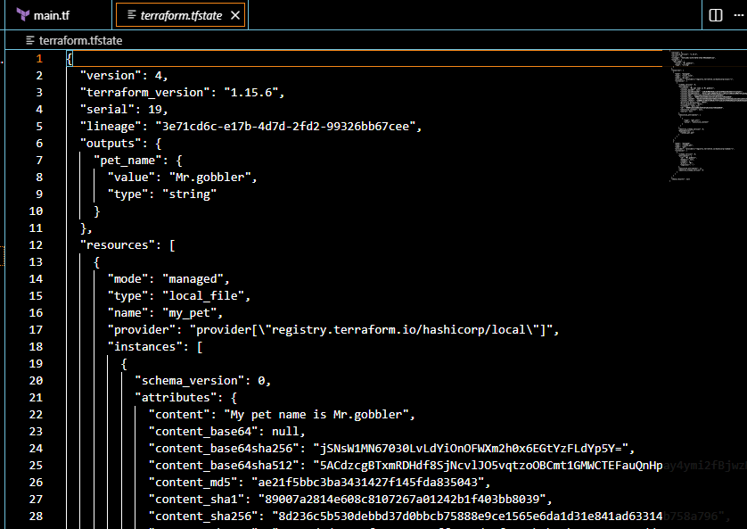
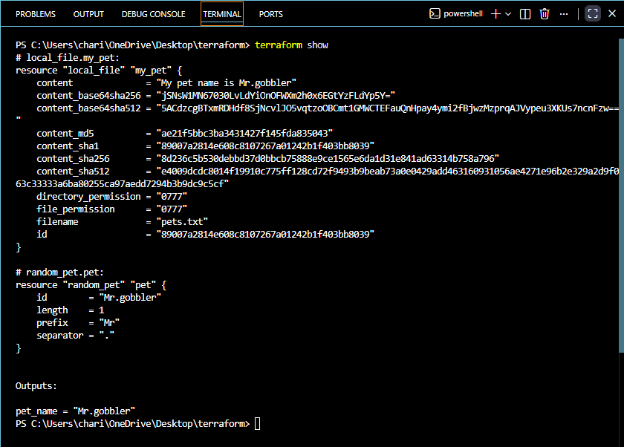
3. Integrate Terraform in Jenkins using the Terraform plugin.
Let’s install terraform plugin in Jenkins
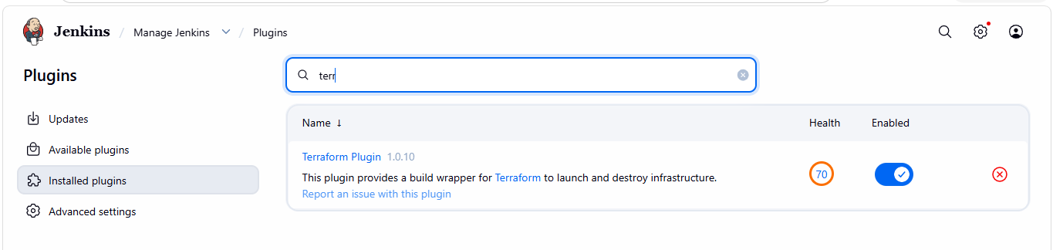
Configure terraform
Tools terraform installation give name save
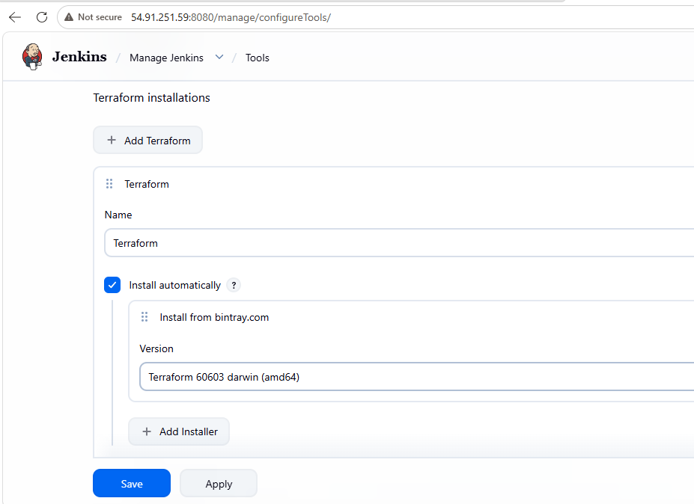
Let’s create a main.tf file
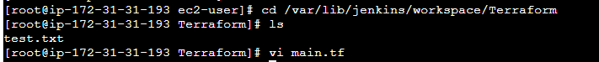
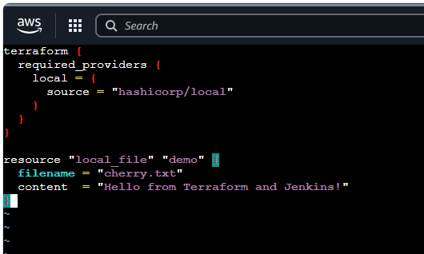
Now lets create a pipeline job
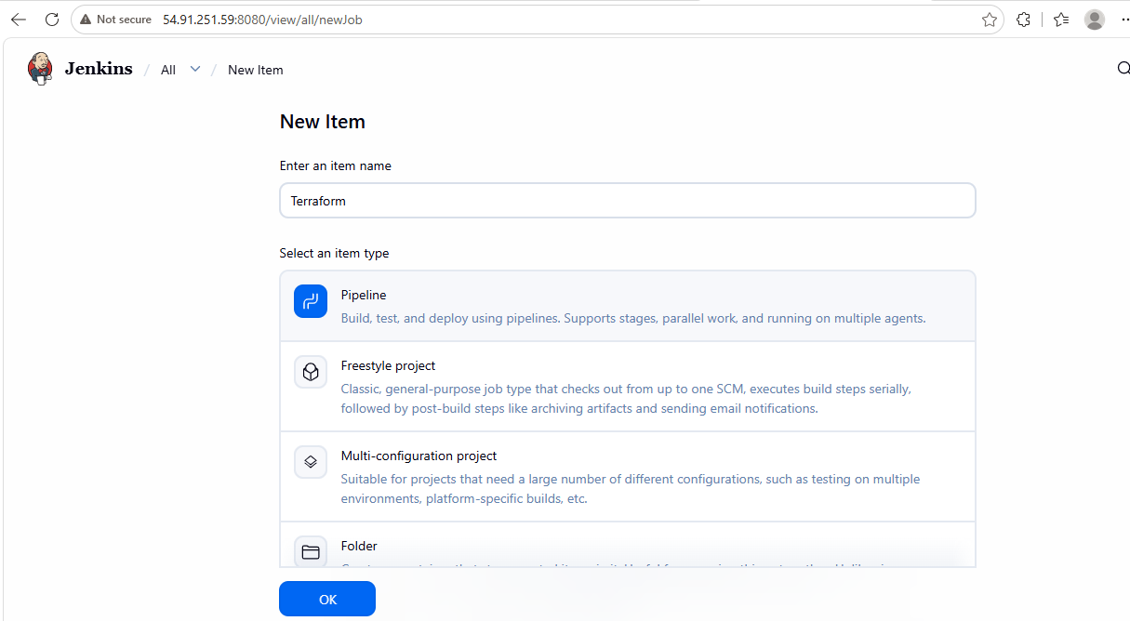
write a pipeline script
pipeline {
agent any

stages {

stage('Terraform Init') {
steps {
sh '/usr/bin/terraform init'
}
}

stage('Terraform Plan') {
steps {
sh '/usr/bin/terraform plan'
}
}

stage('Terraform Apply') {
steps {
sh '/usr/bin/terraform apply -auto-approve'
}
}

}
}

job ran successfully
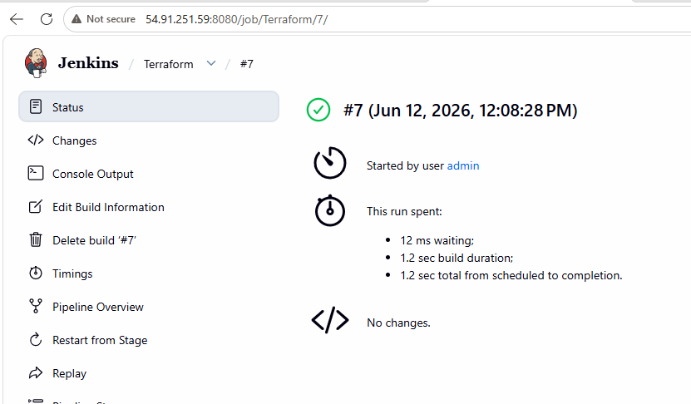
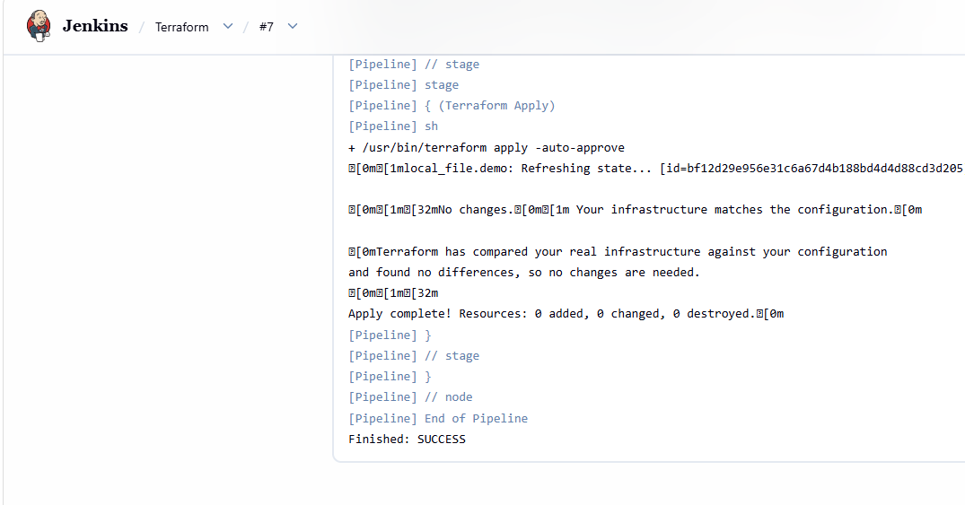
file created successfully
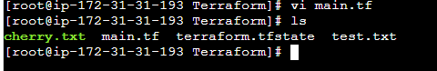
4.Create one Jenkins job using Maven Project for the code below with two stages:
Stage 1:Git clone
Stage 2:Maven CompilationCode:https://github.com/betawins/java-Working-
app.git
Let’s install maven integration first
Go to manage Jenkins plugins search for maven integration click on install
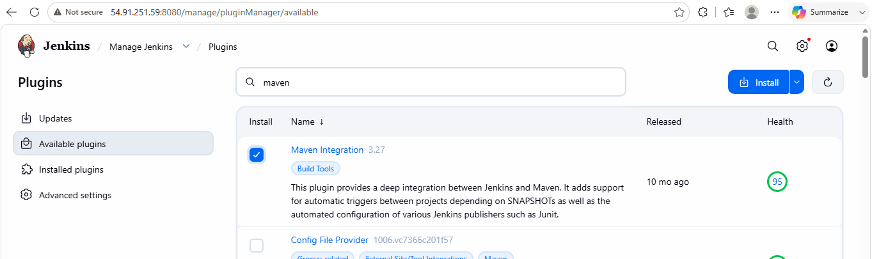

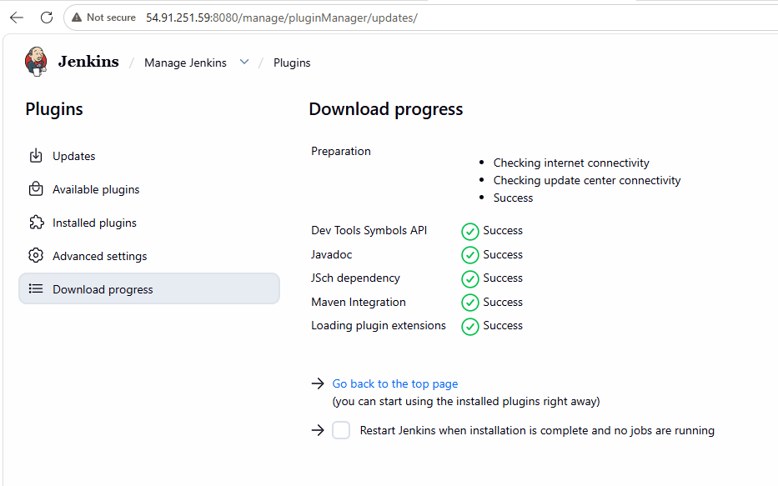
Go to manage Jenkins tools click on add maven give name save
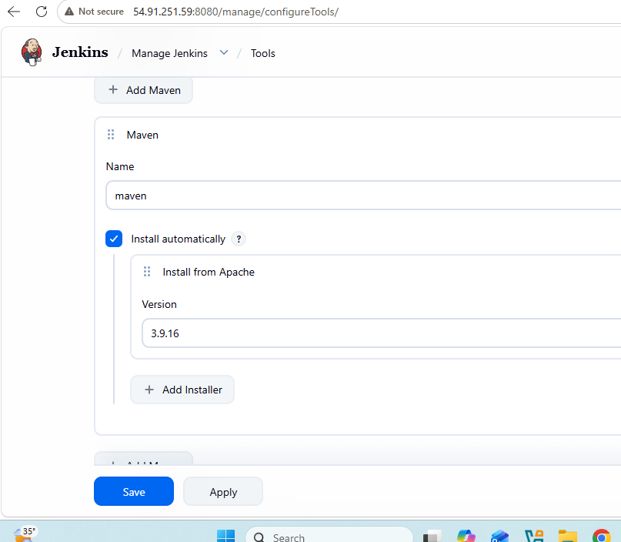
Now let’s create a new job
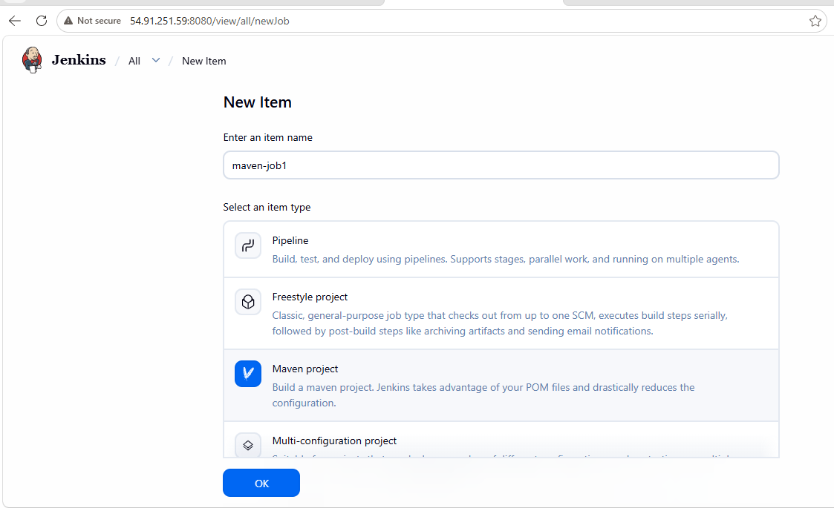
Stage 1: git clone
Now let’s select source management as git and paste the repo URL and save it. Then run the job
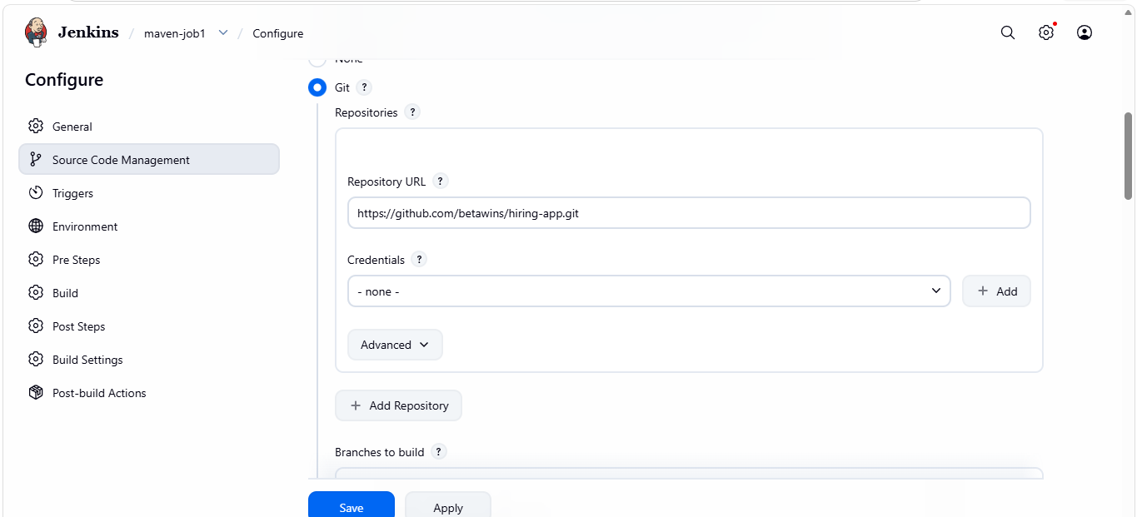
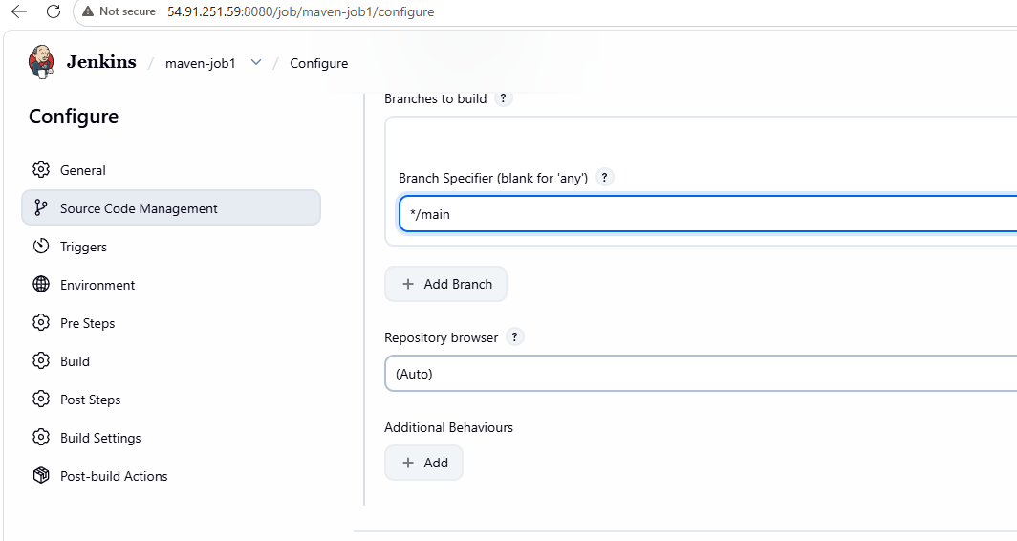
Job ran successfully
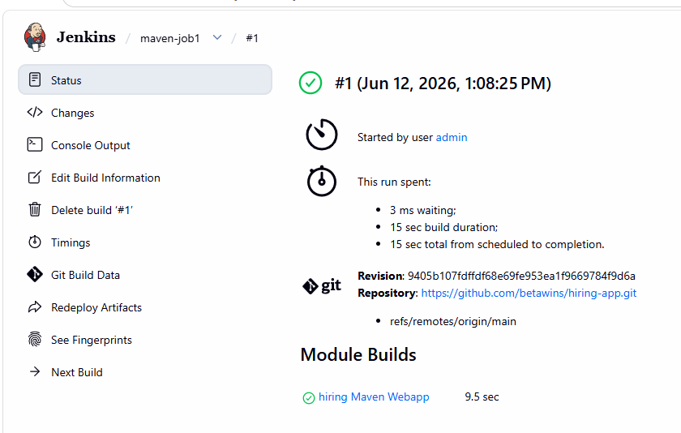
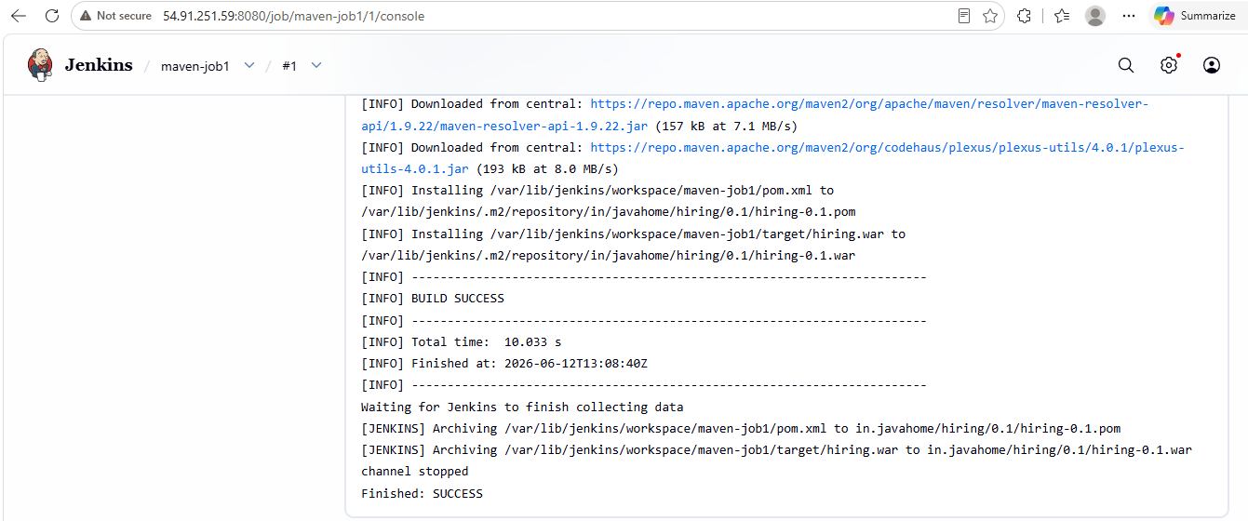
We can see that the Jenkins has successfully built the maven application and generated a war file
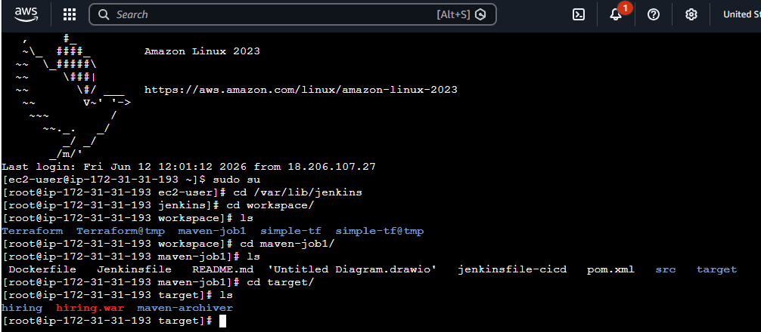
5.Use the same code and create a parameterized job in Jenkins with:
Stage 1:Git clone
Stage 2:Maven CompilationCode:https://github.com/betawins/java-Working-app.git
Let’s create a new job
Go to Jenkins click on new item pipeline give name
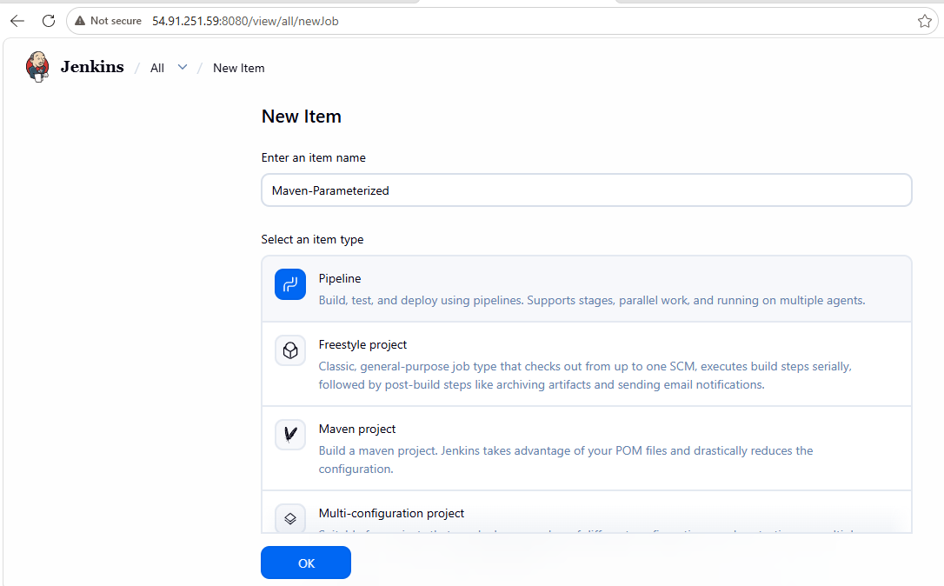
Click on this project is parameterized
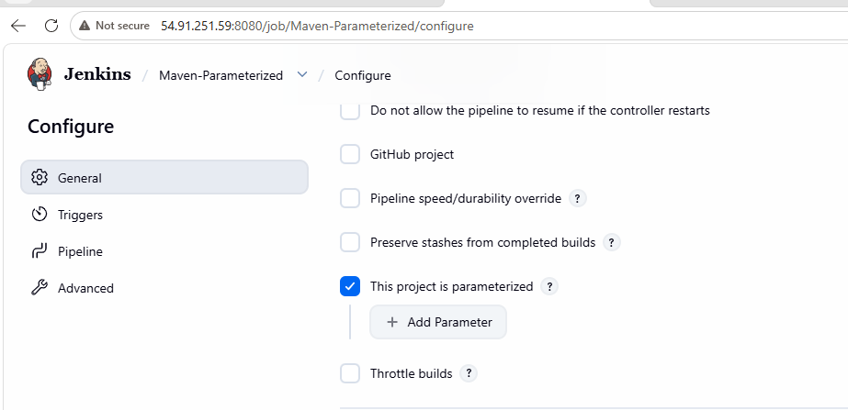
Click on add parameter choose string parameter
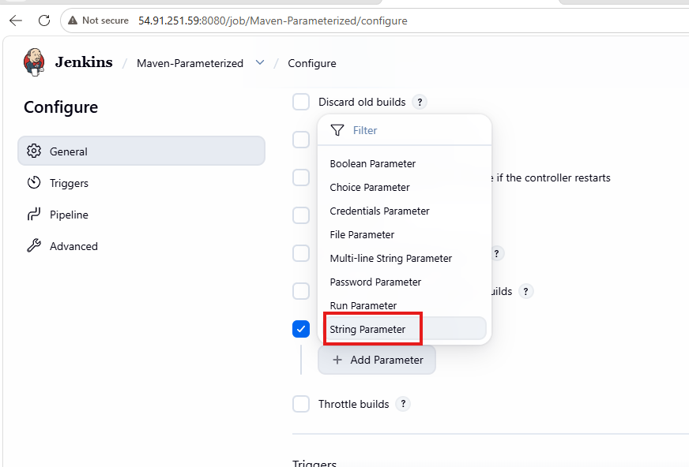
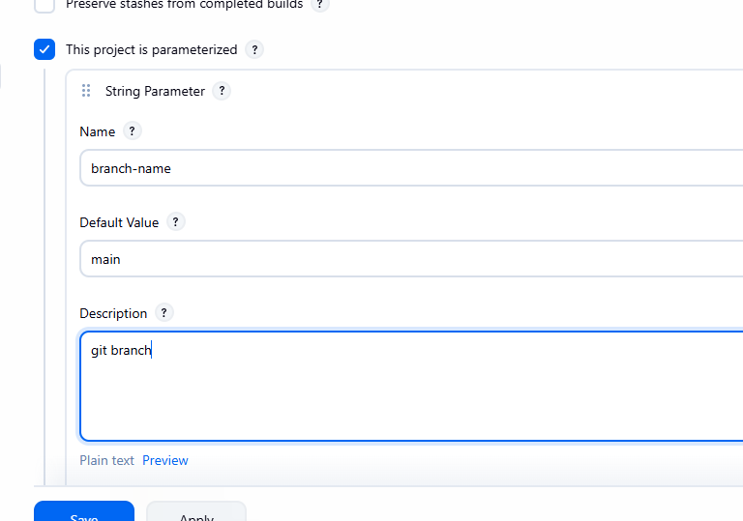
Write a pipeline script
pipeline {
agent any

parameters {
string(
name: 'BRANCH_NAME',
defaultValue: 'main',
description: 'Git Branch Name'
)
}

tools {
maven 'maven'
}

stages {

stage('Git Clone') {
steps {
git branch: "${params.BRANCH_NAME}",
url: 'https://github.com/betawins/java-Working-app.git'
}
}

stage('Maven Compilation') {
steps {
sh 'mvn clean compile'
}
}

}

post {
success {
echo 'Build Successful'
}

failure {
echo 'Build Failed'
}
}
}
Click on build with parameters and run the job
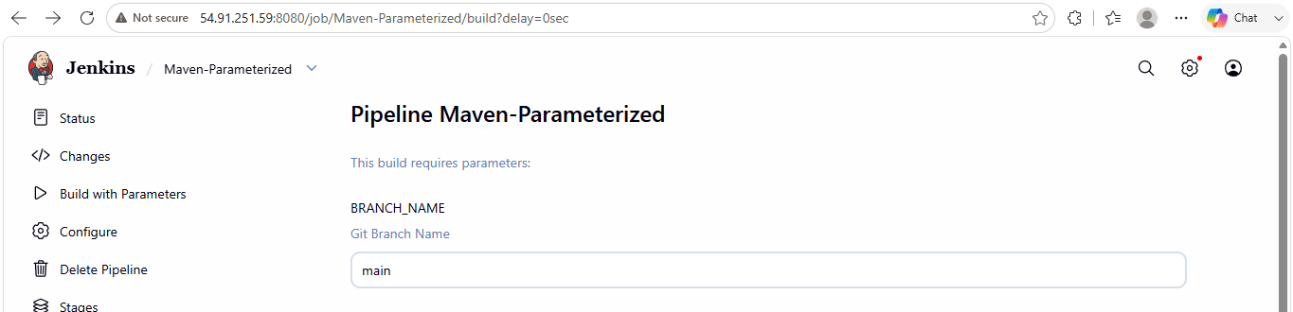
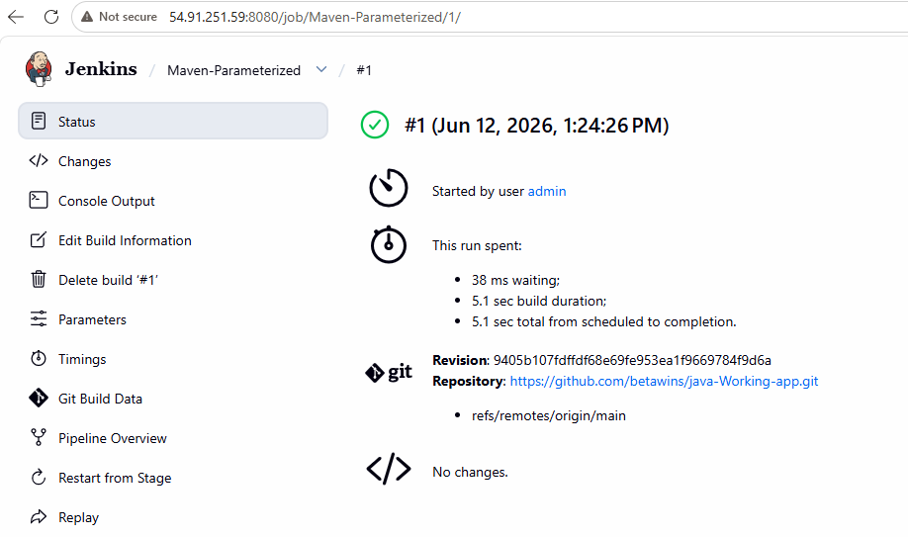
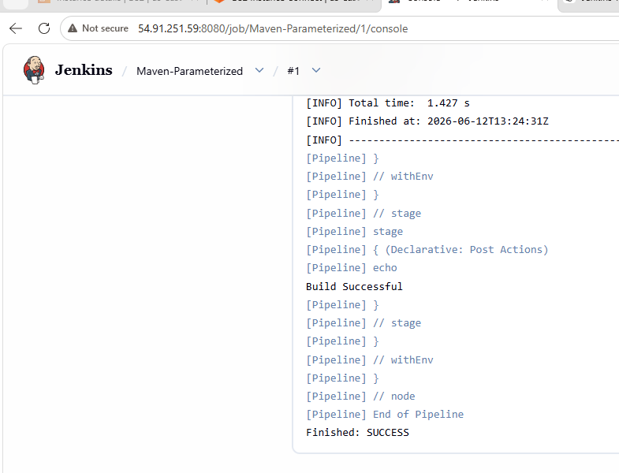
6. What are the global variables in Jenkins?
Global variables: Jenkins provides a set of predefined environment variables (Global Variables) that are automatically available during job execution. These variables contain information about the build, workspace, Git repository, Jenkins server, and execution node.
Global variables help make Jenkins pipelines dynamic and reusable without hardcoding values.
Common Jenkins global variables
BUILD_NUMBER
Current build number of the Jenkins job.
BUILD_ID
Unique ID of the current build.
BUILD_URL
URL of the current build.
JOB_NAME
Name of the Jenkins job.
JOB_BASE_NAME
Short name of the Jenkins job.
WORKSPACE
Path of the Jenkins workspace directory.
JENKINS_HOME
Path of the Jenkins home directory.
NODE_NAME
Name of the agent/node executing the build.
EXECUTOR_NUMBER
Executor number running the build.
BUILD_TAG
Unique build tag generated by Jenkins.
GIT_COMMIT
Git commit hash of the checked-out source code.
GIT_BRANCH
Git branch used for the build.
GIT_URL
Git repository URL of the source code.

