Machine Learning

Assignment-02

Charithasri Vadlamudi

STUDENT ID:700745127

CRN:23921

COURSE ID:CS 5710

1.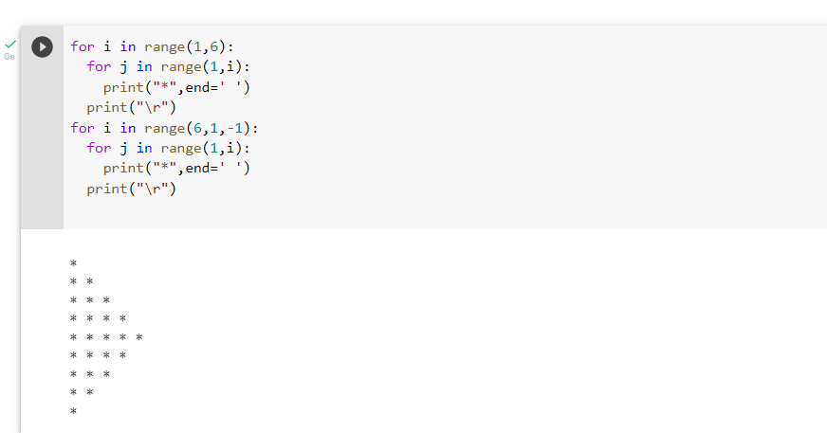

Explanation:

* Used two for loops, one for no of lines and another for no of stars
* Used \r escape sequence

2.

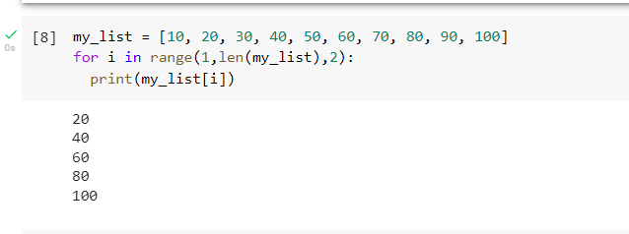

Explanation:

* Used for loop with step increment of 2
* And printed the odd positioned values

3.

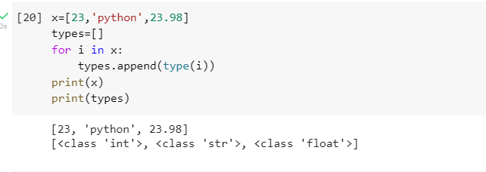

Explanation:

* Used for loop which iterates through the given list
* Used type() built-in function to find the type of elements in the list and it was appended to the new list called types
* And printed the both lists

4.

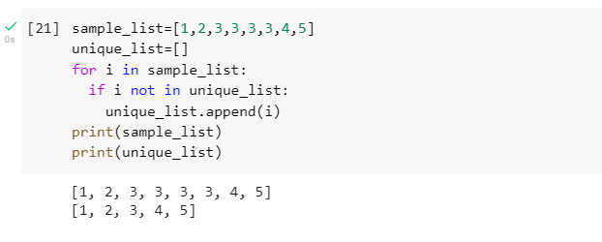

Explanation:

* Used for loop which iterates through the given list
* If statement is also used inside the for loop to check whether item is present in the new list or not, if it is not present then the element is appended to the new list
* And printed the both lists

5.

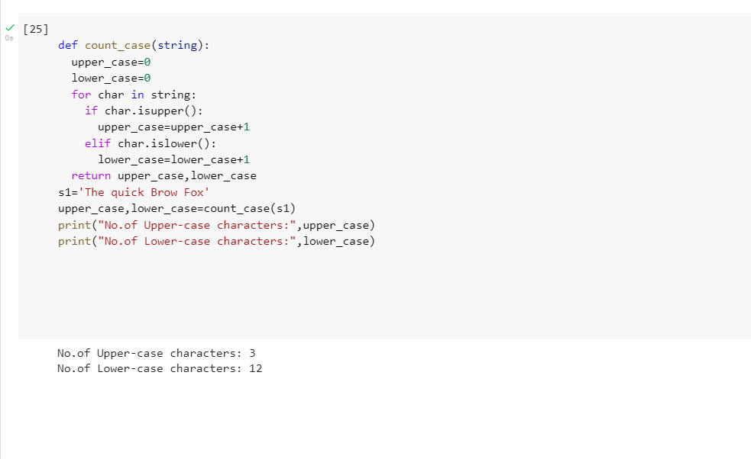

Explanation:

* Defined a function called count_case(string) and in it for is used
* If statement is also used to check the letter is upper case or lower case using isupper() and islower() functions and count is updated respectively and values are returned
* Then the function is called and values are printed