Machine Learning

Assignment-03

NAME: Charithasri Vadlamudi

STUDENT ID:700745127

CRN:23921

COURSE ID:CS 5710

Github Link: <https://github.com/Charithasri1/ML_Assignment_3>

1.

a.

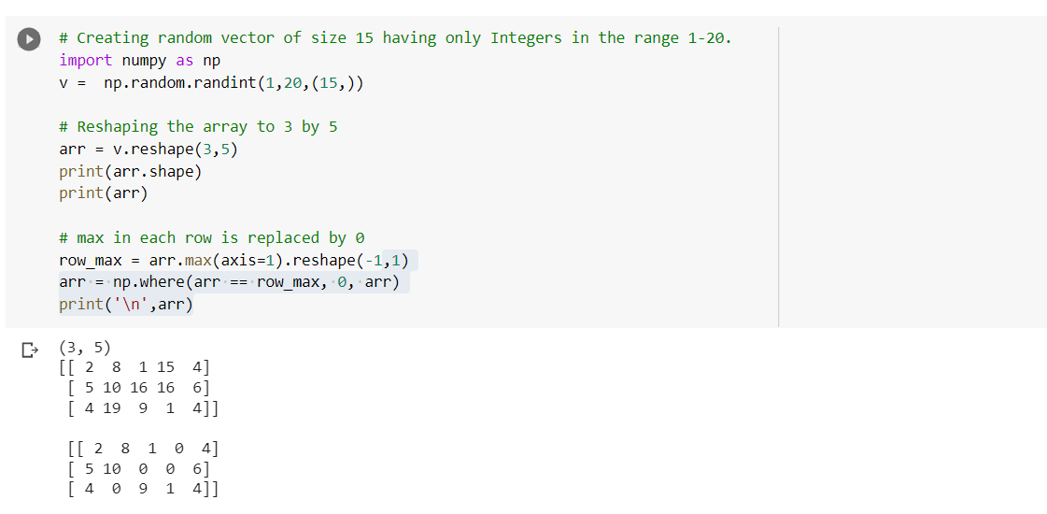

* Creating a vector of size 15 from range 1 to 2 randomly
* Reshaping the array using reshape()
* Maximum value in each row is replaced by 0

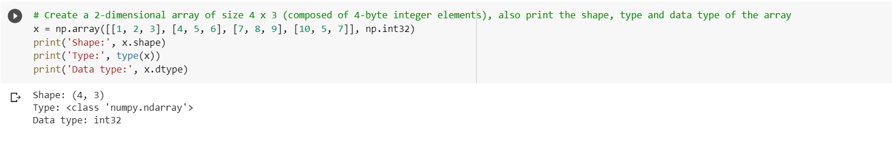

* Creating a 2 dimensional array of size 4 \* 3 and also printing the shape and data type of that array

b.

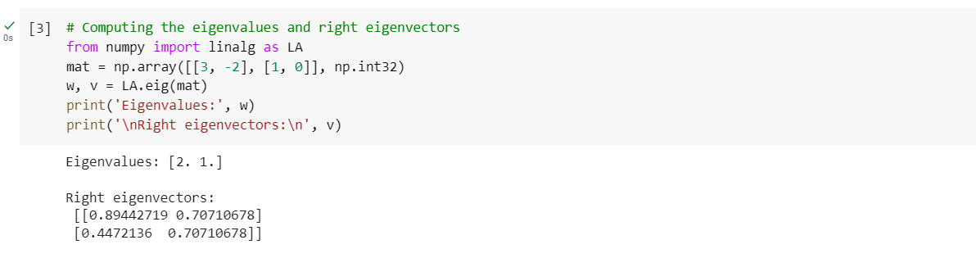

* Import linalg package from numpy as LA
* Computing the eigen values and eigen vectors

c.

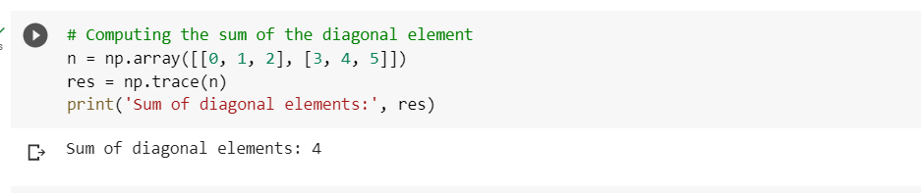

* Computing the sum of diagonal elements using trace()
* And printing the sum of diagonal elements

d.

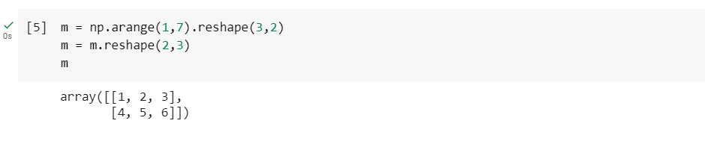

* creating a new shape to an array without changing its data

2.

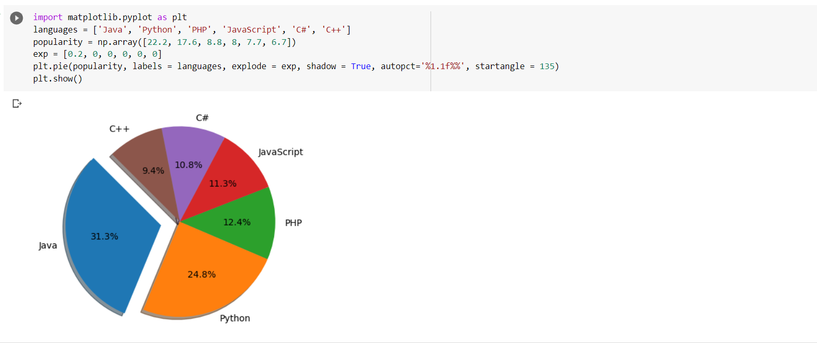

* Creating a pie chart to show the popularity of the programming languages such as c++, c#, JavaScript, PHP, Python, java based on the given popularity