Machine Learning

Assignment-04

NAME: Charithasri Vadlamudi

STUDENT ID:700745127

CRN:23921

COURSE ID:CS 5710

Github Link: https://github.com/Charithasri1/ML_Assignment_4

1.Pandas

1.Reading the provided CSV file ‘data.csv’

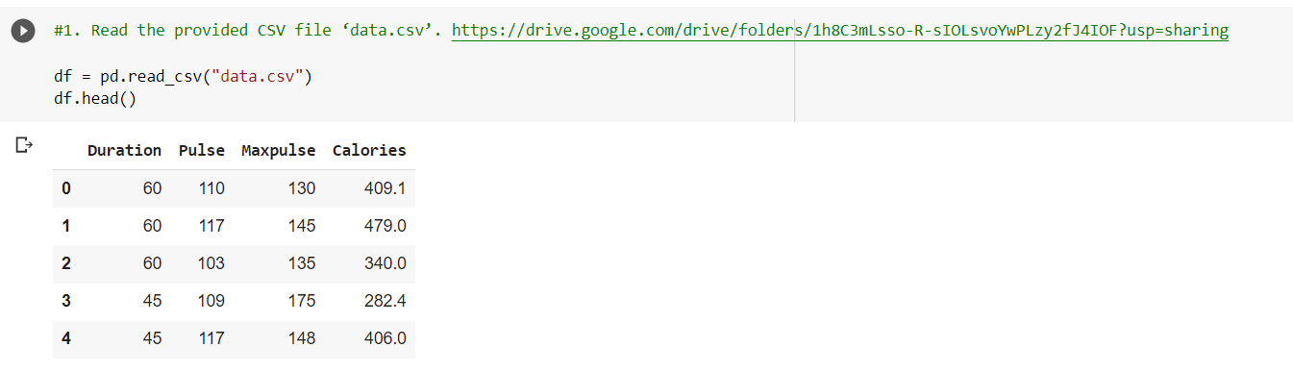

2. Showing the basic statistical description about the data

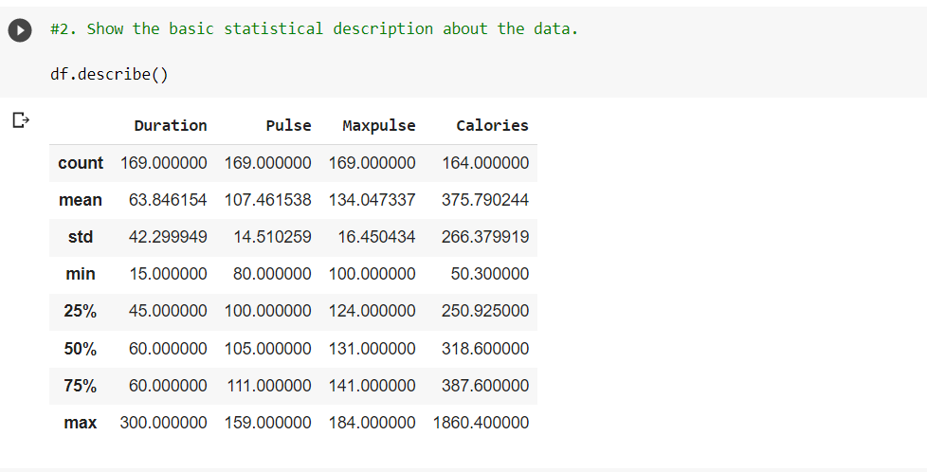

3.checking if the data has null

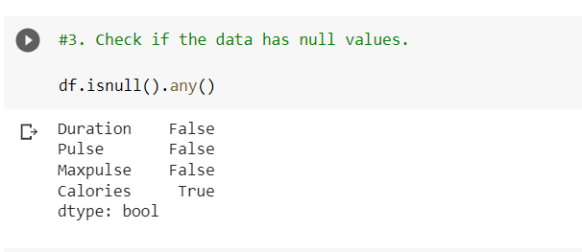

4.Selecting at least two common and aggregrate the data using:min,max,count,mean

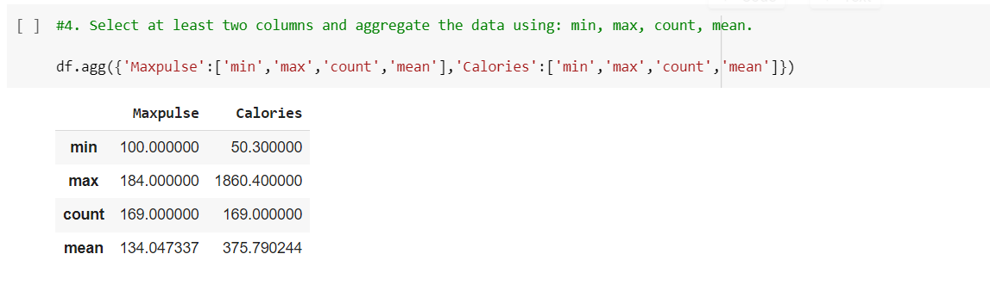

5. Filter the dataframe to select the rows with calories values between 500 and 1000.

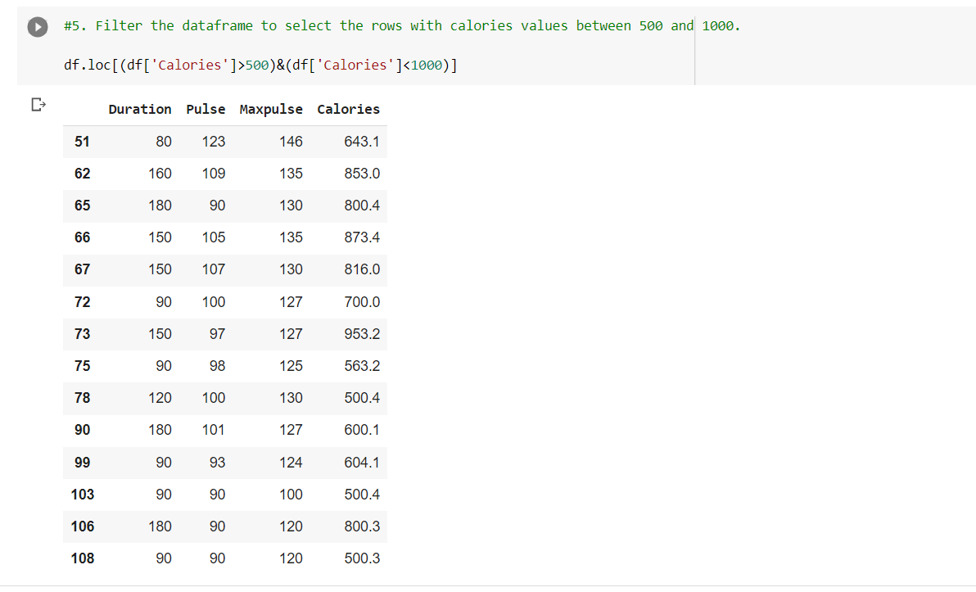

6. **Filter the dataframe to select the rows with calories values > 500 and pulse < 100**

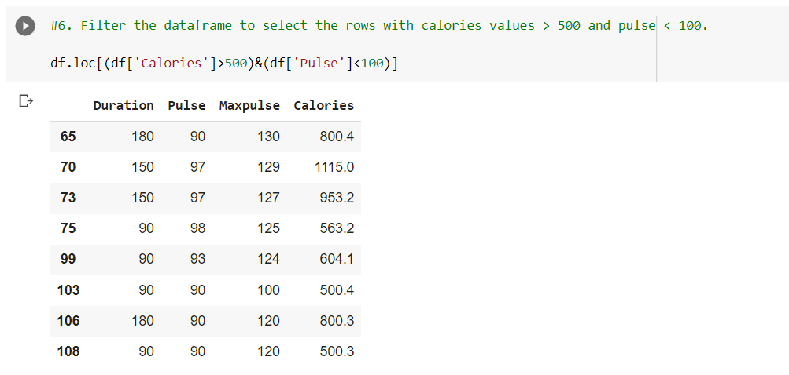

7. Create a new “df_modified” dataframe that contains all the columns from df except for “Maxpulse”.

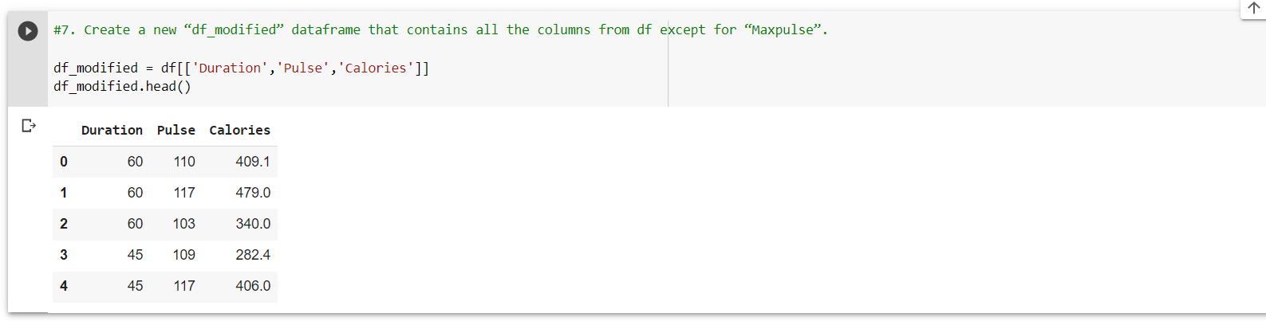

8. Delete the “Maxpulse” column from the main df dataframe

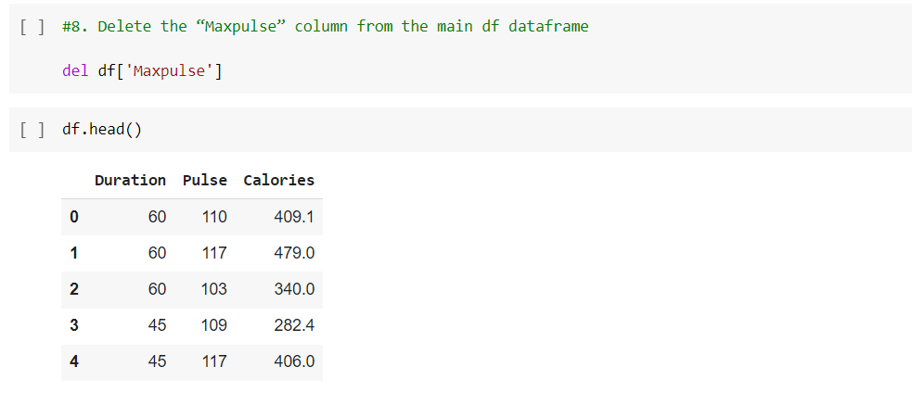

9. Convert the datatype of Calories column to int datatype.

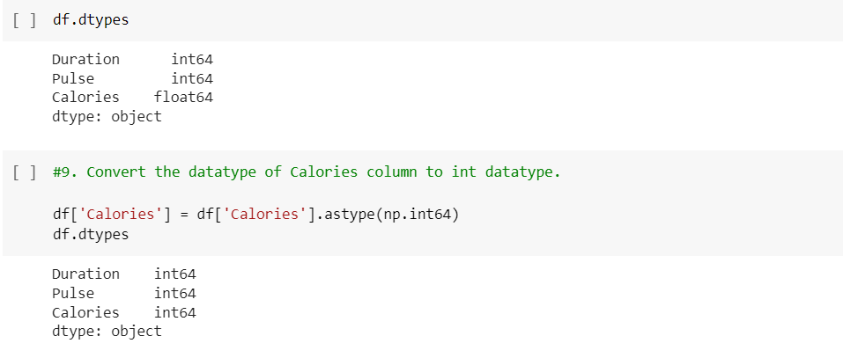

10. Using pandas create a scatter plot for the two columns (Duration and Calories).

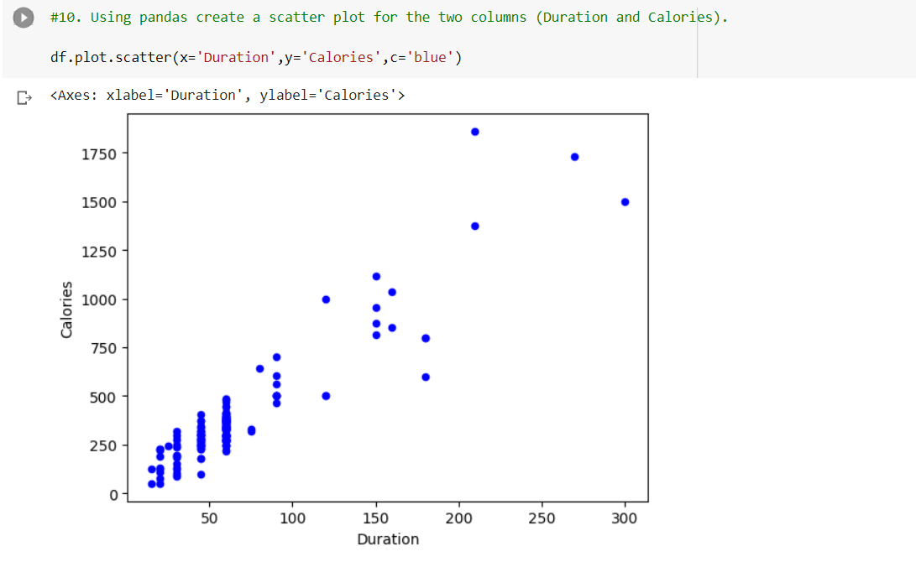

1.(Titanic Dataset) 1. Find the correlation between ‘survived’ (target column) and ‘sex’ column for the Titanic use case in class

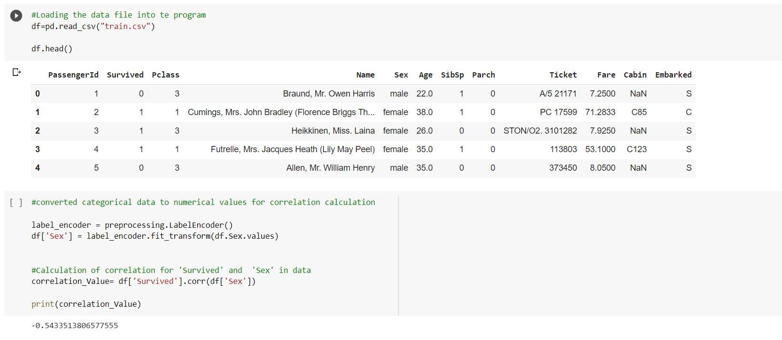

a. Do you think we should keep this feature?

Ans. No, because the accuracy is just 54% only. So we should not keep this feature.

2.Do at least two visualizations to describe or show correlations.

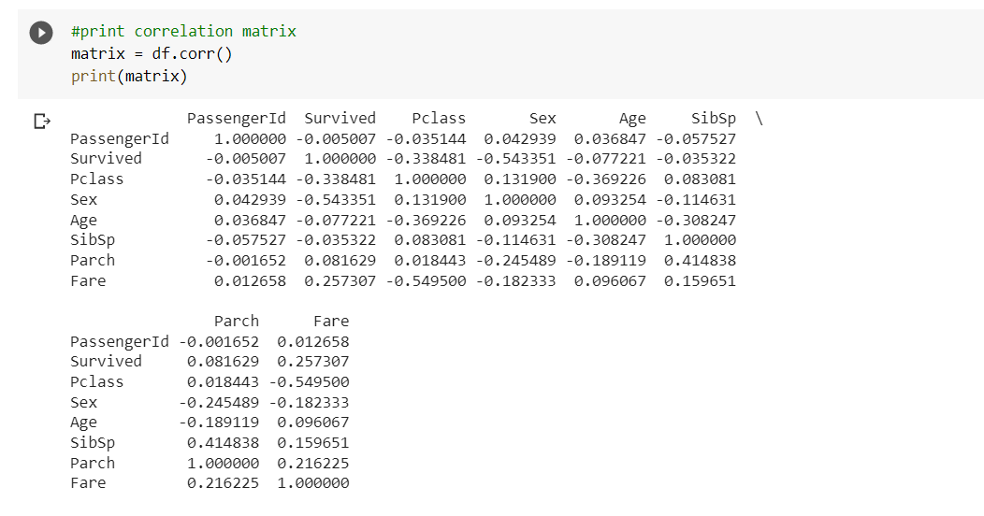

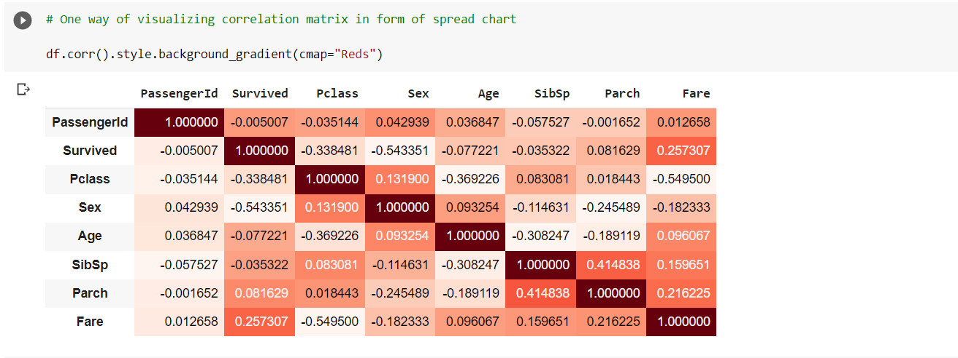

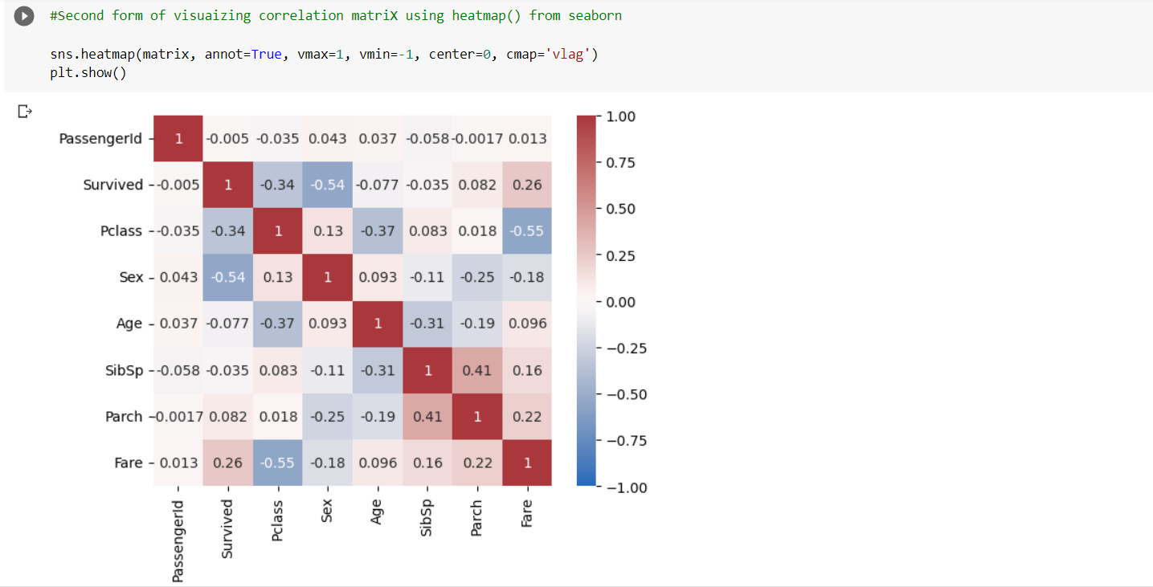

3. Implement Naïve Bayes method using scikit-learn library and report the accuracy.

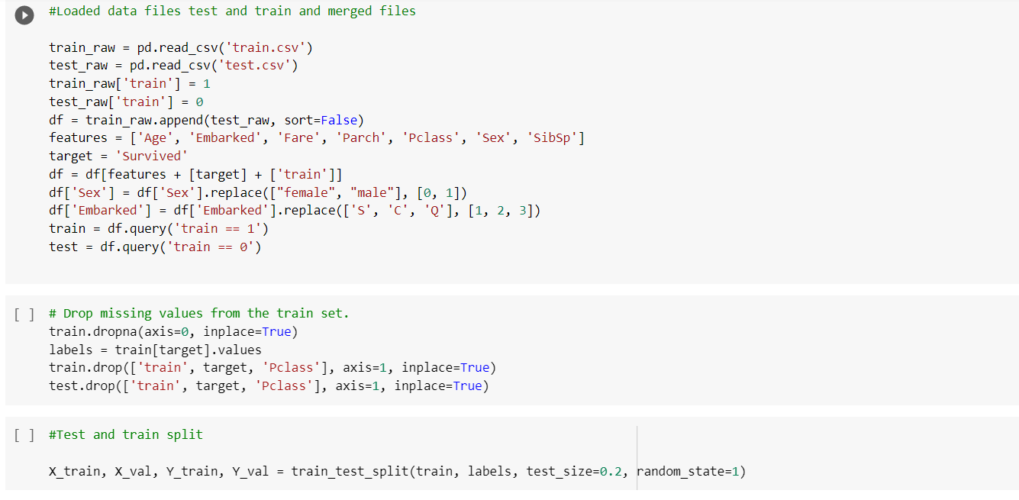

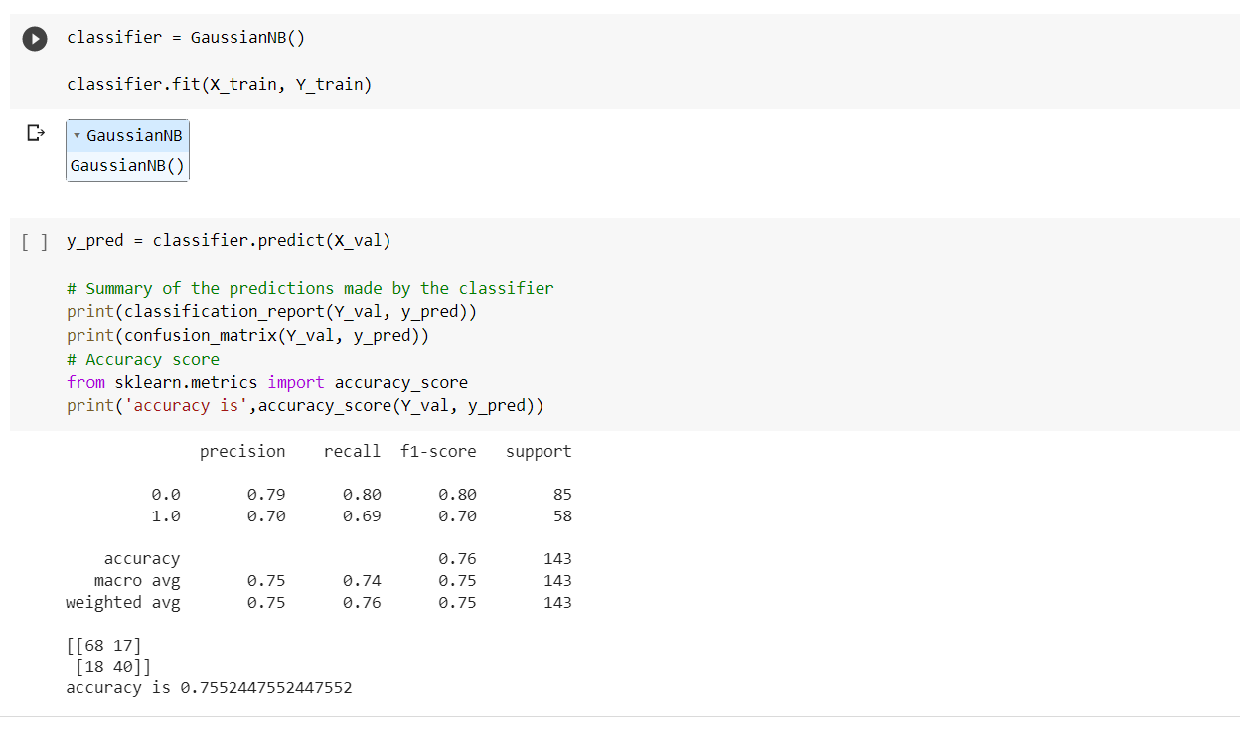

2.(Glass Dataset)

Do at least two visualizations to describe or show correlations in the Glass Dataset.

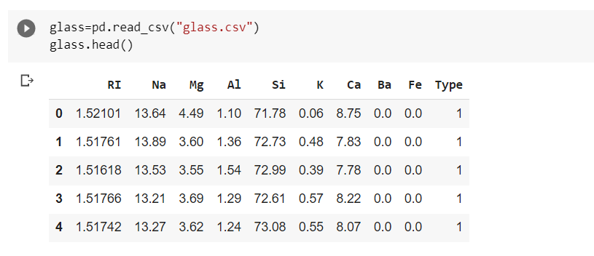

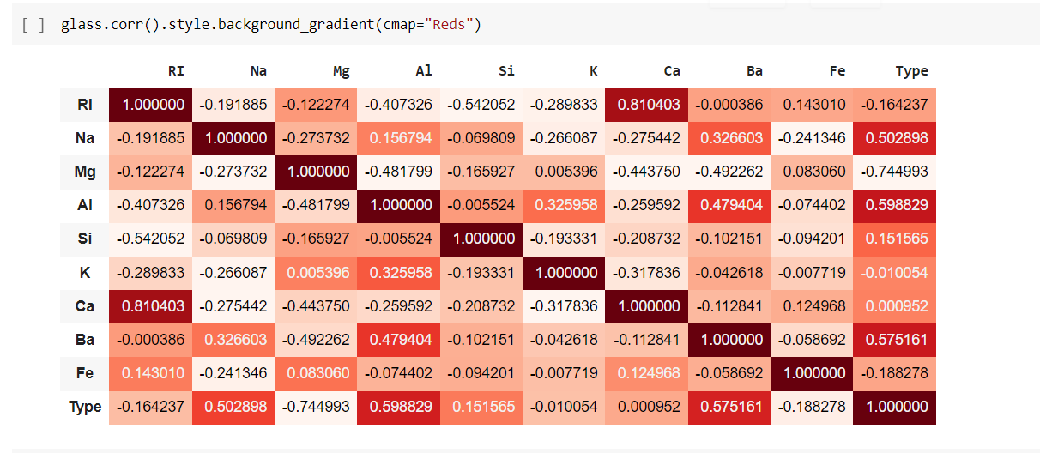

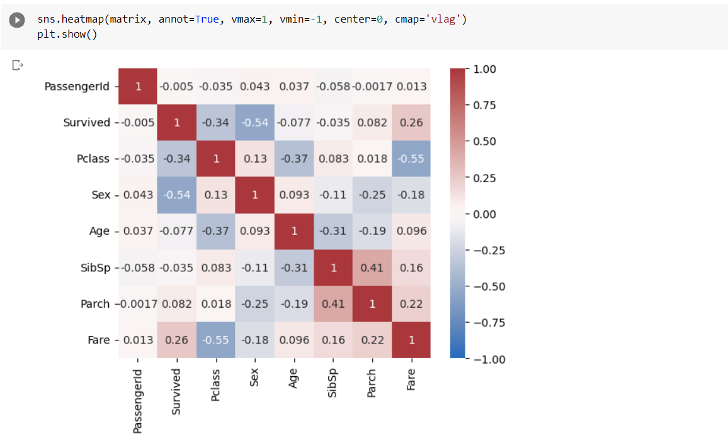

1. Implement Naïve Bayes method using scikit-learn library.

a.Use train_test_split to create training and testing part.

b.Evaluate the model on testing part using score and Classification_report(y_true,y_pred)

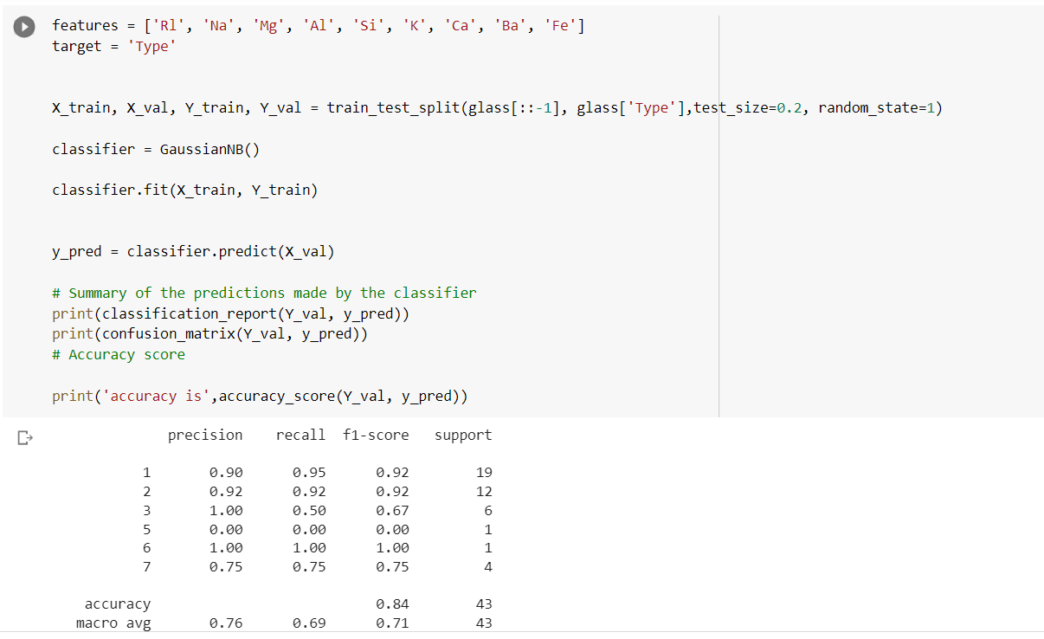

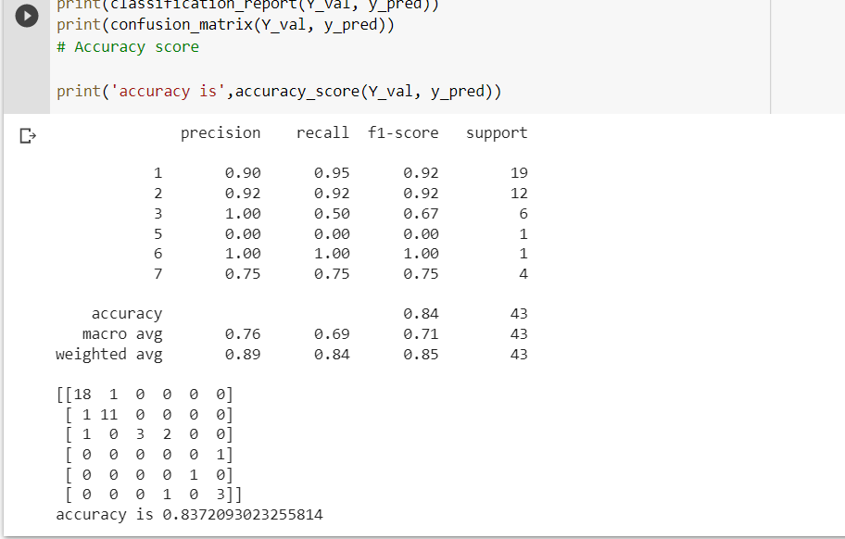

1. Implement linear SVM method using scikit library

b. Use train_test_split to create training and testing part.

2.Evaluate the model on testing part using score and Classification_report(y_true,y_pred)

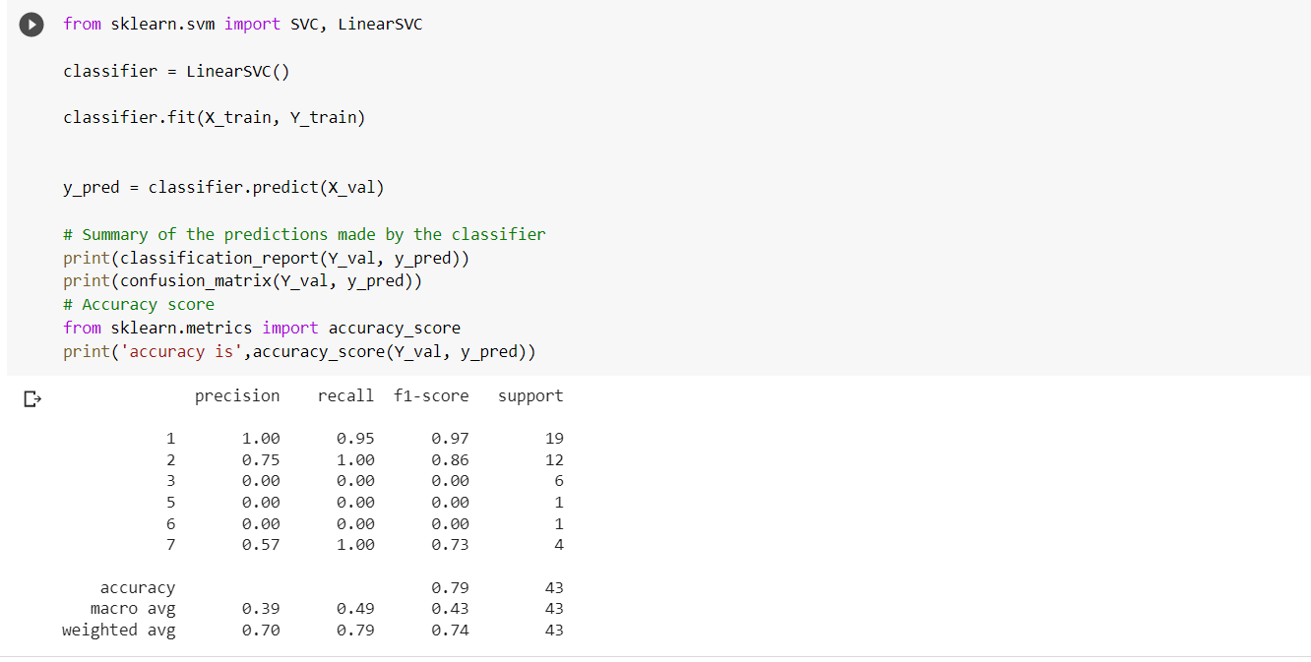

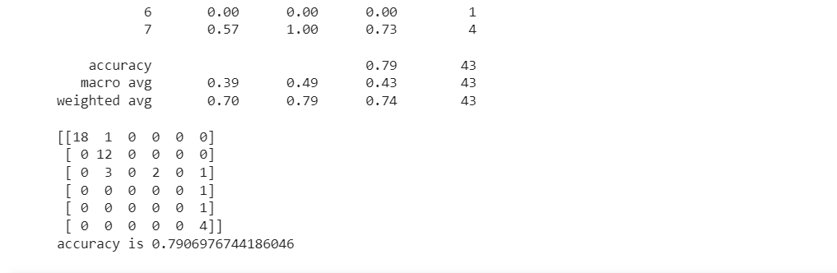

3. Which algorithm you got better accuracy? Can you justify why?

Ans. Naïve Bayes algorithm got better accuracy than Linear SVM algorithm because naïve bayes need small amount of training data Where as Linear SVM need large amount of training data and SVM is more expensive than Naïve bayes algorithm. But it will give output easily.And naïve bayes is good for spam detection and text classification problems.So Naïve bayes is better than Linear Svm.