**For the following question write the corresponding MongoDB queries**

Question1: Find all the information about each products.

Solution: db.product.find()

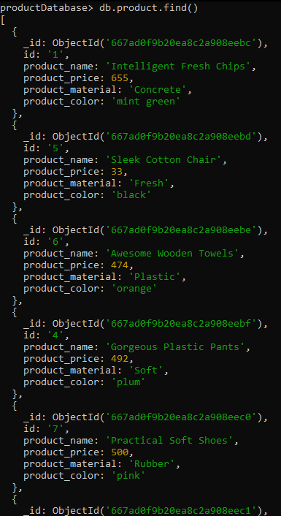

Question2: Find the product price which are between 400 to 800

Solution: db.product.find({product_price:{$gt:400, $lt:800} });

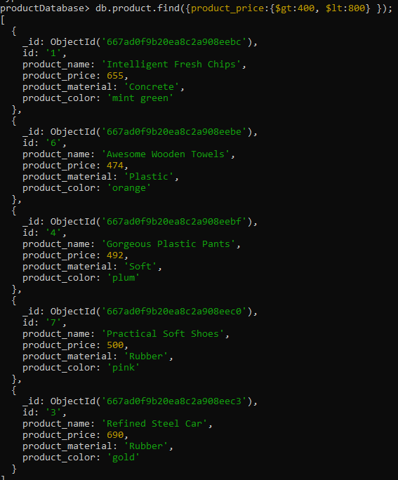

Question 3: Find the product price which are not between 400 to 600.

Solution: db.product.find({product_price:{$not:{$gt:400, $lt:800}} });

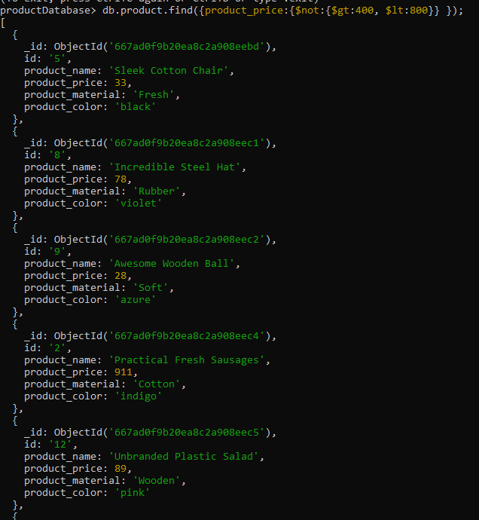

Question 4: List the four product which are greater than 500 in price.

Solution: db.product.find({product_price:{$not:{$gt:500}} }).limit(4);

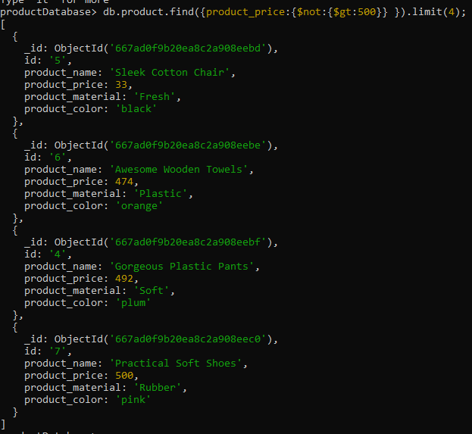

Question 5: Find the product name and product material of each products.

Solution: db.product.find({},{_id:0, product_name:1, product_material:1});

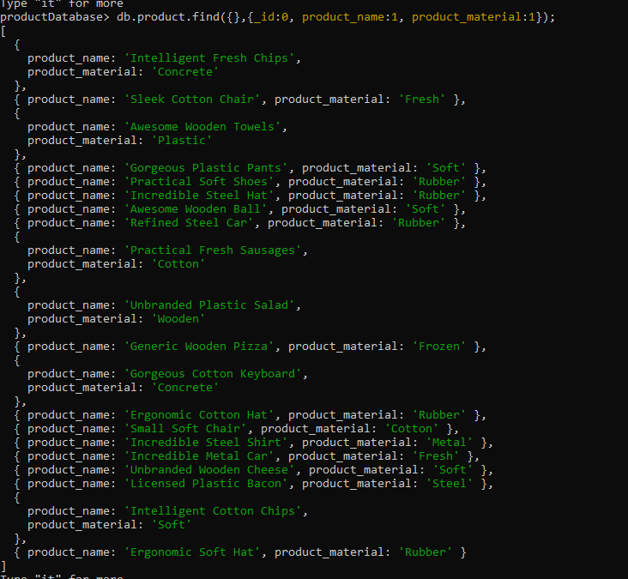

Question 6: Find the product with a row id of 10.

Solution: db.product.findOne({"id":"10"});

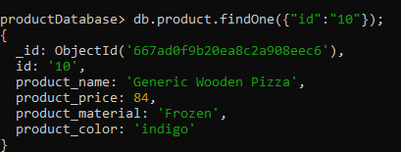

Question 7: Find only the product name and product material

Solution: db.product.find({},{_id:0, product_name:1, product_material:1});



Question 8: Find all products which contain the value of soft in product material

Solution: db.product.find({product_material:'Soft'});

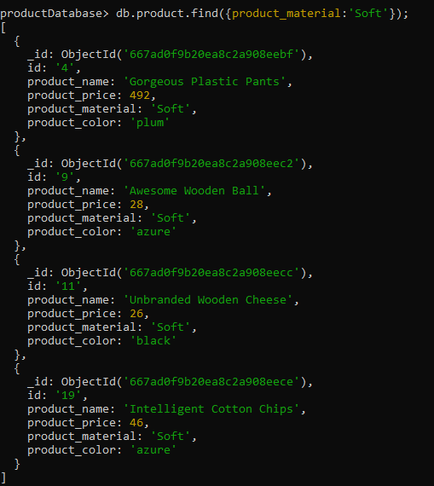

Question 9: Find products which contain product color indigo  and product price 492.00

Solution: db.product.find({$or:[{product_color:"indigo"},{product_price:"20"}]})

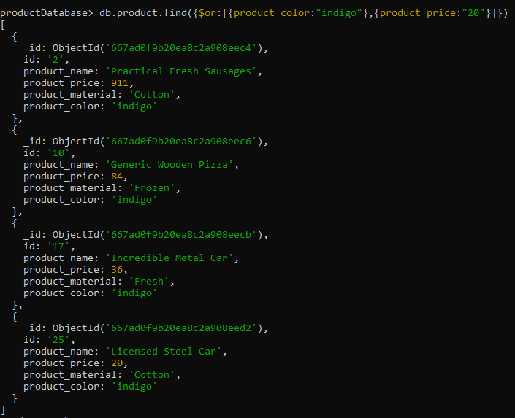

Question 10: Delete the products which product price value are same

Solution: db.product.aggregate([{$group:{_id:'$product_price',count:{$sum:1}}}, { $match: {count:{ $gt:1}}}]). forEach( (e) => { db.product.deleteMany( {product_price:e.id});})

productDatabase> db.product.find();

