Week 7 – Activity Log
Activity 1 – Implement interface features
Table 1- Requirements identified previously
Requirement | User type | Task it supports | Notes
The website must clearly explain the coaching and mentoring services available. | Prospective client | Find out what services are offered | Helps new users understand the business quickly.
The website must make contact options easy to find from any page. | Prospective client | Contact or book a consultation | Reduces effort and uncertainty for users.
The website must provide clear information about coaches’ qualifications, experience, and testimonials. | Prospective client / Potential partner | Check credibility and trustworthiness | Supports trust and reassurance.
The website must allow clients to book or enquire about sessions online. | Prospective client / Returning client | Book or enrol on a session | Supports the company’s main service goal.
The website should provide wellbeing advice and resources that are easy to access. | Prospective client / Returning client | Access support and advice | Encourages engagement with the website.
The website must work effectively on mobile phones, tablets, and desktop devices. | All users | Browse and contact the business easily | Important because many users will use mobile devices.
The website must use clear navigation, readable text, and accessible colour contrast. | All users | Access information easily | Supports accessibility and inclusion.
The website should include information about what happens after making contact or booking. | Prospective client | Understand the next steps | Helps users feel confident before enquiring.
The website should provide partnership or referral information for organisations or professionals. | Potential partner / Referrer | Learn about collaboration opportunities | Supports future business growth.
The website should allow returning clients to quickly access booking or session information. | Returning client | Manage appointments and sessions | Improves convenience for existing clients.

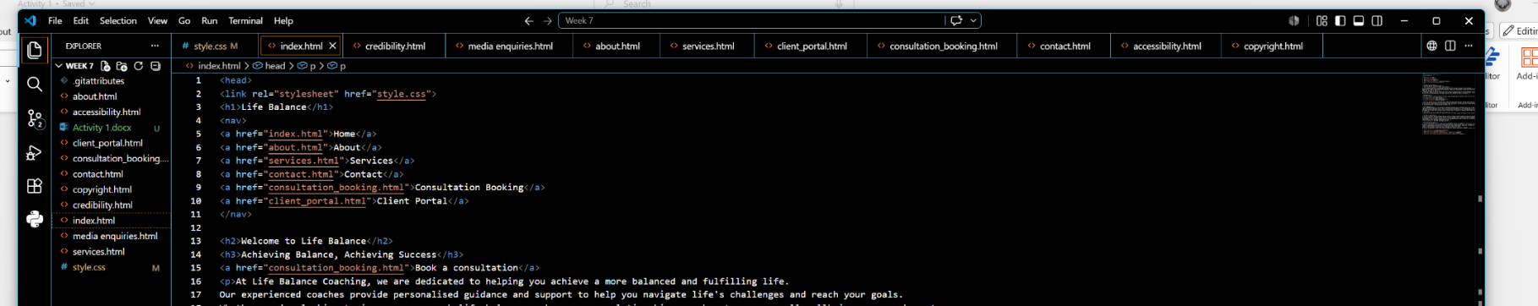
Figure 1 – Screenshot of my file/folder structure showing the project files I have created

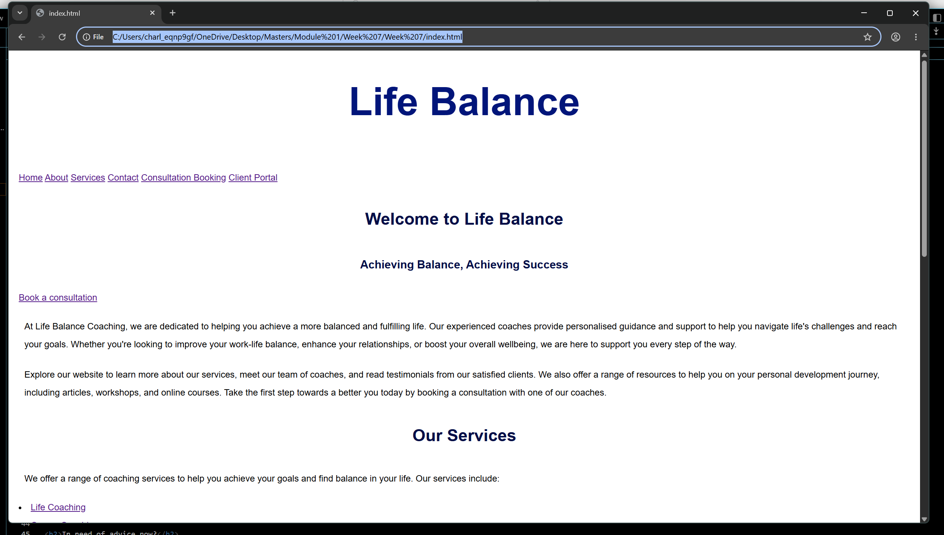
Figure 2 – Page 1 (index/home) working in the browser

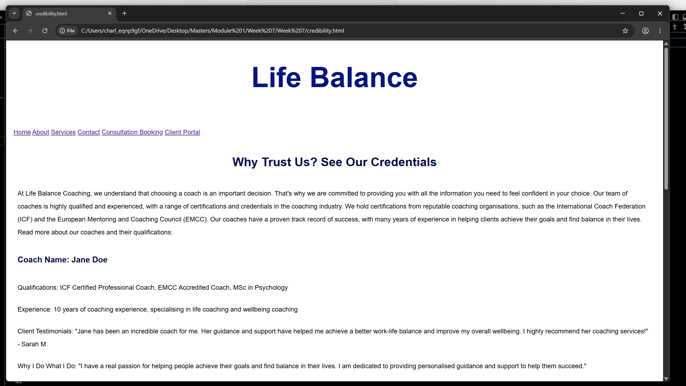
Figure 3 – Page 2 (credibility) working in the browser

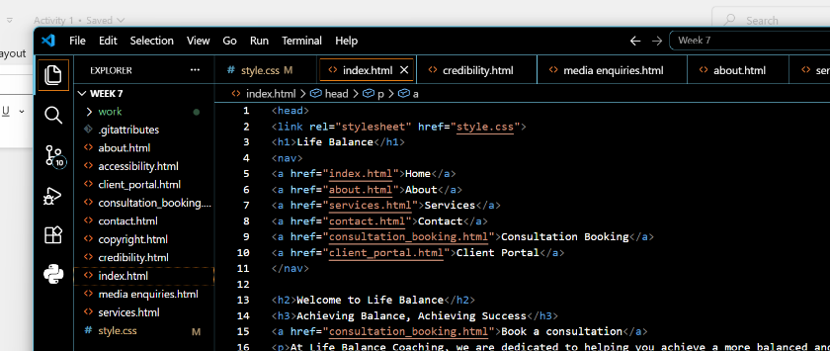
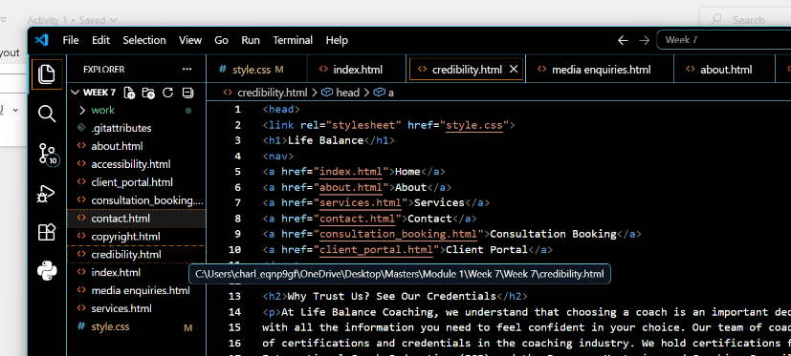
Figures 4 and 5 – Evidence showing the navigation works (nav visual HTML on both files)
What did I implement?
- Easy to follow file/folder structure
- Logical and consistent nav links on each page
- CSS media query for smaller screens
- Consistent typography throughout
Which requirement or user need does it address?
- The website must make contact options easy to find and follow from any page
- The website must provide clear information on coaches’ qualifications/experience
- Must allow new clients to book or enquire
- Must work effectively on mobile browsers, tablets and desktops
- Clear navigation
- Readable text
- The website should allow returning clients to quickly access booking or session information
What did I deliberately not implement yet (scope control) and why?
- The website should provide partnership or referral information for organisations or professionals.This will be added at a later date. I felt this was not an immediate requirement given that the website is new and the need to sign up new clients was a priority. I felt the credibility page of the website had a greater need as this would also go some way in showing potential partnerships how reliable and experienced Life Balance is. There is, however, a dedicated Media Enquiries contact form.

Activity 2 – Test and refine implementation
Checklist:
- Click every link and check they work
  - PASS. Every link on every page works
- Navigation is consistent between pages
  - PASS. Navigation bar and footer navigation consistent on every page
- Headings are in a sensible order
  - PASS. Headings are in a sensible order and relevant to the page
- Easy to scan
  - PASS. Headers and navigation enable easy scanning
- Link text is descriptive and not generic
  - PASS. All links clearly state where the link is going/purpose of the link
- At a narrower window width, nothing overlaps badly or disappears
  - PASS. Media query in place and tested at a lower screen width. No scrolling to the right to read text. Text auto adjusts
- Readable at 200% zoom
  - PASS. Tested and no issues. Tested up to 500% zoom
- It is clear what the user should do next on each page
  - PASS. Headers and links easily guide the user to the next piece of information or relevant link
- Key information is easy to find
  - PASS. Clear navigation on every page.
Fixes:

