**ERD/DB Diagram:**

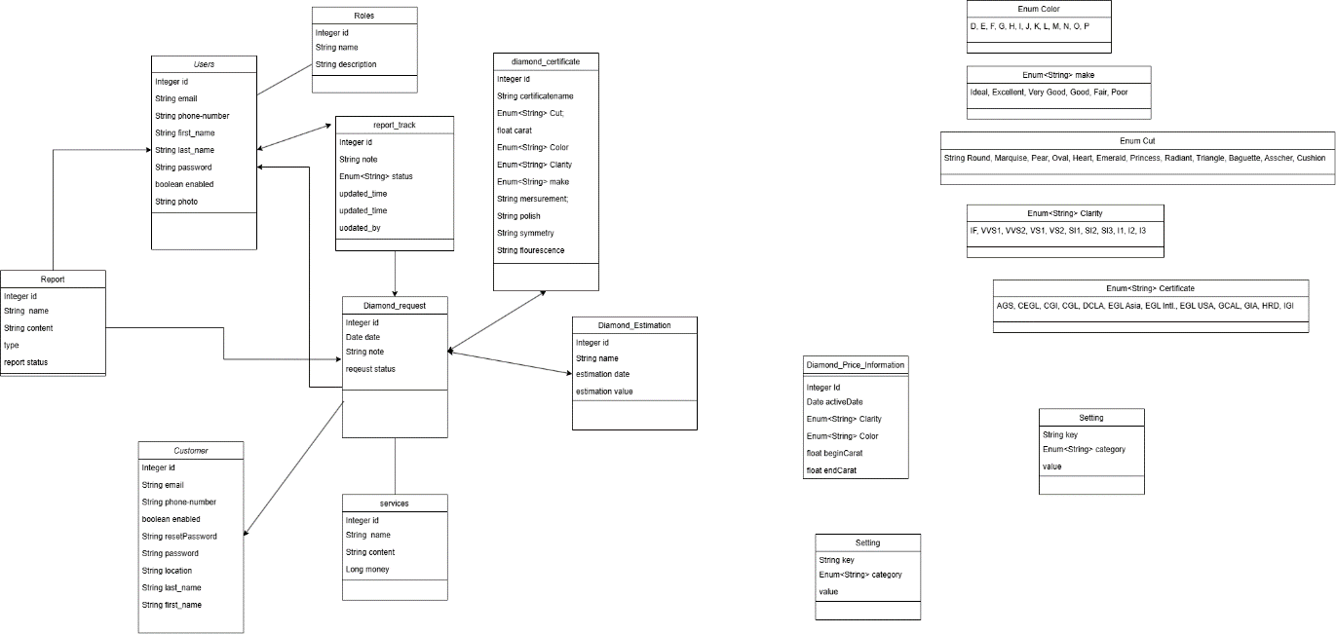

**Function requirements:**

1. User Login/Logout
2. Dashboard and Reporting
3. Manage Users
4. Manage Customers
5. Manage Services
6. Manage Request Services
7. Manage Certificates
8. View Home Page
9. Customer Login/Logout
10. Diamond Valuation Estimation
11. Valuation Request Management
12. Handling Unclaimed

**Usecase list:**

|  |  |  |  |  |
| --- | --- | --- | --- | --- |
| 1 | User Login/Logout | Login | Admin/Manager/Staff/Valuation Staff | User logs into the system using their credentials. |
| 2 | Logout | User logs out of the system. |
| 3 | Dashboard and Reporting | View Dashboard and Statistics | Admin/Manager | Views the dashboard for statistical analysis and reporting of valuation requests and other key metrics. |
| 4 | Manage User | View User | Admin/Manager/Staff/Valuation Staff | Views details of user accounts. |
| 5 | Create User | Admin | Admin creates a new user account. |
| 6 | Edit User | Admin edits details of an existing user account. |
| 7 | Delete User | Admin deletes an existing user account. |
| 8 | Manage Customer | View Customers | Admin/Manager/Staff/Valuation Staff | Views details of customer profiles. |
| 9 | Create Customer | Admin/Staff/Manager | Creates a new customer profile. |
| 10 | Edit Customer | Edits details of an existing customer profile. |
| 11 | Delete Customer | Deletes an existing customer profile |
| 12 | Manage Services | View Services | Admin/Manager/Staff/Valuation Staff | Views details of existing services. |
| 13 | Create Service | Admin | Admin creates a new valuation service. |
| 14 | Edit Service | Admin edits details of an existing service. |
| 15 | Delete Service | Admin deletes an existing service. |
| 16 | Manage Request Services | View Valuation Request | Admin/Manager/Staff/Valuation Staff | User views details of valuation requests. |
| 17 | Submit Valuation Request | Staff/Customer | User submits a valuation request for a diamond. |
| 18 | Process Valuation Request | Staff/Valuation Staff | User processes the valuation request and assigns it for valuation. |
| 19 | Update Valuation Request Status | User updates the status of the valuation request as it progresses through the valuation process. |
| 20 | Approve Sealing Report | Manager | Manager approves the sealing report for unclaimed valuation results. |
| 21 | Approve Commitment Form | Manager approves the commitment form for lost receipts. |
| 22 | Manage Diamond Certificate | View Diamond Certificate | Admin/Manager/Staff/Valuation Staff | User views details of diamond certificates. |
| 23 | Create Diamond Certificate | Valuation Staff | Valuator creates a diamond certificate based on the valuation results. |
| 24 | Edit Diamond Certificate | Valuator edits details of an existing diamond certificate. |
| 25 | Print Diamond Certificate | Prints the diamond certificate for the customer |
| 26 | Delete Diamond Certificate | Deletes an existing diamond certificate |
| 27 | View Home Page | View Home Page | Customer | Customer views the home page, which introduces the company, services offered, diamond knowledge resources, search and valuation functionalities, and blog. |
| 28 | Login/Logout | Login | Customer logs into the system using their credentials. |
| 29 | Logout | Customer logs out of the system. |
| 30 | Manage Account | Edit Profile | Edits details of account profile. |
| 31 | Diamond Valuation Estimation | Estimate Diamond Value by Criteria | Customer inputs criteria such as diamond origin, shape & cut, measurements, carat weight, color, clarity, cut, proportions, polish, symmetry, and fluorescence to estimate the diamond's value. |
| 32 | Estimate Diamond Value by Certification Number | Customer inputs a certification number issued by the company to estimate the diamond's value. |
| 33 | Valuation Request Management | Submit Valuation Request | Customer submits a valuation request form. |
| 34 | View Valuation Request Status | Customer views the status of their submitted valuation request. |
| 35 | Handling Unclaimed Valuation Results | Request Commitment Form for Lost Receipt | Customer requests a commitment form to receive their diamond sample if they have lost the valuation receipt. |

**UI(Fontend):**

**Technical Requirements:**

Login User

LU1 – Successful Login

LU2 – Fail Login

Create User

# CU3 - Input Validation for Email Field

# CU4 - Input Validation for Required Fields

# CU5 - Handle Image Upload and Preview

# CU6 - Submit Form with Valid Data

# CU7 - Submit Form with Invalid Email

# CU8 - Cancel Form Submission

# CU9 - Load EditUser Component

# Edit User

# EU10 - Fetch and Display User Data

# EU11 - Input Validation for Email Field

# EU12 - Input Validation for Required Fields

# EU13 - Handle Image Upload and Preview

# EU14 - Submit Form with Valid Data

# EU15 - Submit Form with Invalid Email

# EU16 - Submit Form with Duplicate Email

# EU17 - Cancel Form Submission

# Delete User

# DU18 - Open Delete Confirmation Dialog

# DU19 - Cancel Delete Action

# DU20 - Confirm Delete Action

Create Customer

CC22 - Successful Form Submission

CC23 - Form Submission with Invalid Email

CC24 - Form Submission with Missing Required Fields

CC25 - Form Submission with Invalid Phone Number

CC26 - Cancel Form Submission

Edit Customer

EC27 - Render Form with Customer Data

EC28 - Successful Form Submission

EC29 - Cancel Form Submissions

EC30 - Password Field Behavior

Delete Customer

DC31 - Open Delete Confirmation Dialog

DC32 - Cancel Deletion

DC33 - Confirm Deletion

Login Customer

LC - Successful Login **V**

##### LC - Fail Login with Invalid Credentials **V**

Logout Customer

LU - Successful Logout **V**

LU - Logout and Clear User Data **V**

Manage Account

MA - View Profile **V**

MA - Edit Profile Button Visibility **V**

MA - Enter Edit Mode **V**

MA - Cancel Edit **V**

Estimate Diamond Value by Criteria

EDVBC - Successful Estimate with Valid Criteria

EDVBC - Invalid Carat Value

EDVBC - Change Shape and Estimate

EDVBC - Change Color and Estimate

EDVBC - Change Clarity and Estimate

Estimate Diamond Value by Certification Number

EDVBCN - Successful Estimate with Valid Certification Number

EDVBCN - Invalid Certification Number

EDVBCN - Empty Certification Number

EDVBCN - Valid Certification Number for Popular Shape

EDVBCN - Valid Certification Number for Rare Color

EDVBCN - Valid Certification Number for Various Carat Weights

Submit Valuation Request

SVR - Successful Submission with Valid Data

SVR - Form Submission with Missing Required Fields

SVR - Invalid Email Format

SVR - Form Submission with Optional Notes Field Empty

View Valuation Request Status

VVRS - Successful Status View

VVRS - Invalid Request ID

VVRS - Empty Request ID

VVRS - View Status for Completed Request

Request Commitment Form for Lost Receipt

RCFFLR - Successful Submission with Valid Data

RCFFLR - Form Submission with Missing Required Fields

RCFFLR - Invalid Email Format

RCFFLR - Form Submission with Non-numeric Amount

RCFFLR - Form Submission with Future Date

RCFFLR - Form Submission with Optional Notes Field Empty

RCFFLR - Successful Submission with Optional Notes Field Filled