# System Design Document

UML Diagrams

UML Use Case Diagram

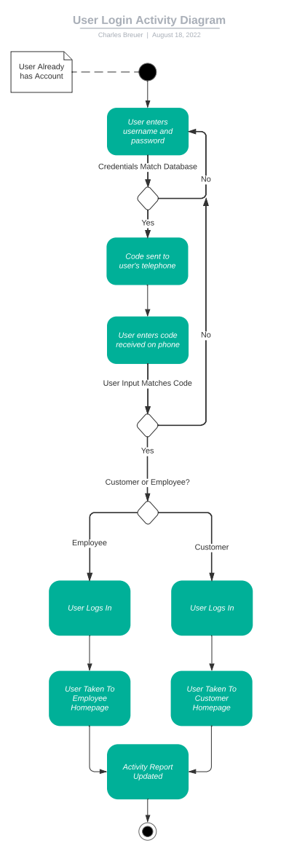UML Activity Diagram 1

UML Activity Diagram 2

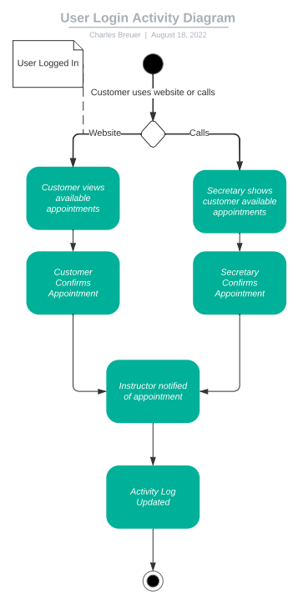

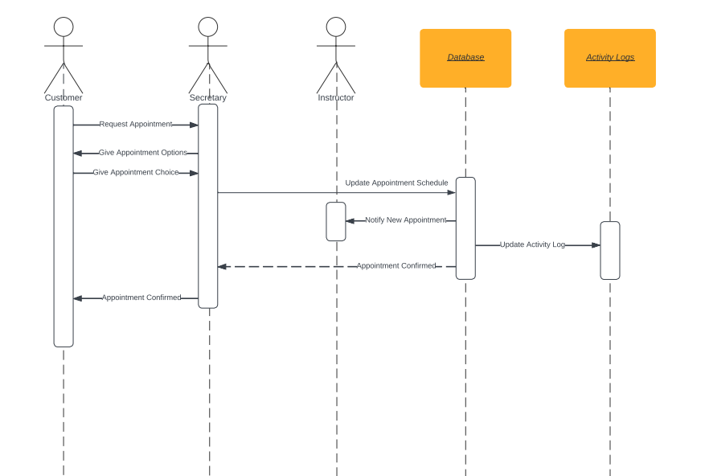UML Sequence Diagram

UML Class Diagram

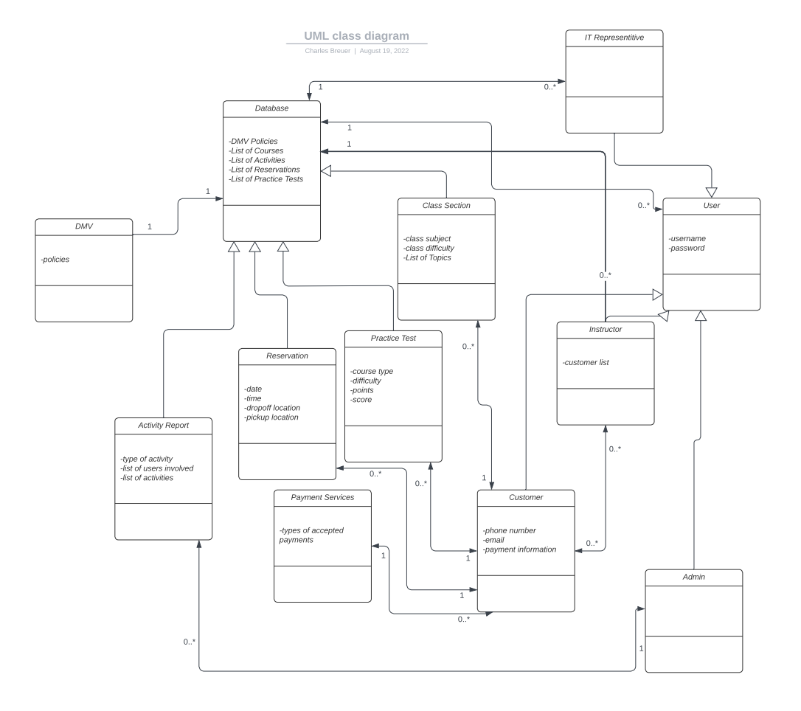

## Technical Requirements

1. The system needs to run on a cloud based infrastructure such as a server-less or virtual machine set up
2. The website needs to be optimized for desktop and mobile device aspect ratios
3. The system needs an online database for long term storage such as MySQL, Oracle, or Microsoft SQL
4. The system needs to support common web-based technologies for JavaScript, HTML, and CSS
5. The system needs technology for authentication and credential checking on the client side
6. User data needs to be encrypted with an SSL to ensure security.
7. The system needs to employ a common server side language such as Python which is easier to develop with
8. The system needs to be compatible with common web browsers such as Firefox, Chrome, Internet Explorer, and Safari