Charles Cundiff
2/16/2026
AE 498

AE498 Github: https://github.com/Charles-Cundiff/AE498s

The homework assignment was to calculate the Minimum Orbit Intersection Distance (MOID) for a variety of objects. I employed Wisniowski’s method detailed in “Fast Geometric Method for Calculating Accurate Minimum Orbit Intersection Distances” (2013). This is a numerical method that first coarsely scans for minima and then using tuning finds the MOID. Before scanning, however, the frame is rotated so that the first body’s inclination, right ascension, and argument of periapsis are all zero the second body’s angular parameters are changed.
The meridional plane is formed from the object B and the poles. During the coarse scan, both objects are assumed to lie in this plane and the position of object B is found using the equations below.
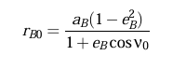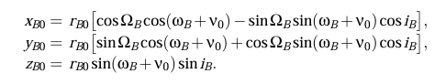
As both objects are in the meridional plane, the tangent of object A’s true anomaly is simply y/x. Object A’s position is determined similarly to object B. Once all the cartesian locations are known, the distance between the objects is easily calculated.
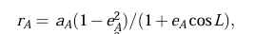
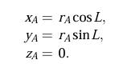
Once local minima are found on the meridional plane, tuning hones in on the true Moid. In tuning, slight deviations are added to the true anomalies of both objects. This creates six true anomalies: TA_1, TA_1L, TA_1R, TA_2, TA_2L, TA_2R. The distance is calculated between all nine perturbations. The lowest of these distances is the new baseline for the next step. The deviation reduces when no change is made until a minimum tuning size. Once the minimum tuning size is reached for each of the local minima, the MOID is easily found through comparison.

The code for this project was baselined from a Julia implementation of this paper’s method linked here.
mkretlow/MOID.jl: Compute the MOID - Minimum Orbit Intersection Distance for two given elliptical orbits (Kepler elements)

The results from my code are below for each case
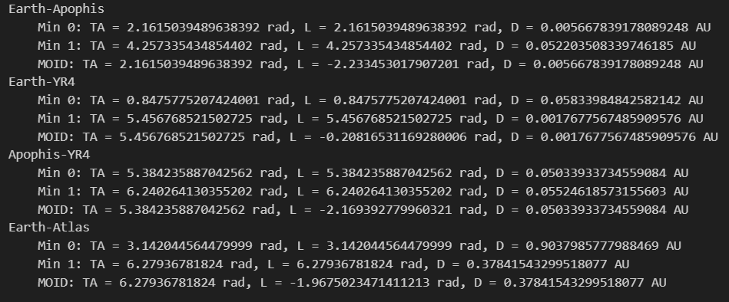

They were compared against results from the Julia code and matched well.
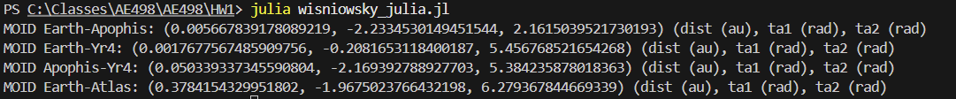

Hyperbolic case accuracy
No alterations were made to the code for the hyperbolic case, but the Wisniowsky approach still seems to have worked. The JPL MOID for 3I Atlas is 0.364599 while mine is 0.3784. This small difference could easily be made up by JPL’s more accurate models that which account for perturbations that mine does not. The Wisniowsky approach works without alteration because it will move towards the minimum naturally due to its tuning method. The coarse scan ensures it is tuning starts close enough to find the MOID.

My Code Explanation
This block extracts the Keplerian elements and sets the scanning/tuning steps. The coarse scan and initial tuning step sizes were taken from the paper. The final tuning step sizes were chosen for my desired accuracy.
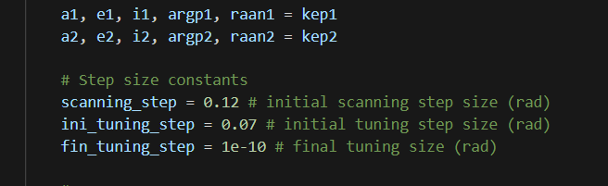
This block creates frame rotations. The order is raan about axis 3, inclination about axis 1, then argp about axis 3.
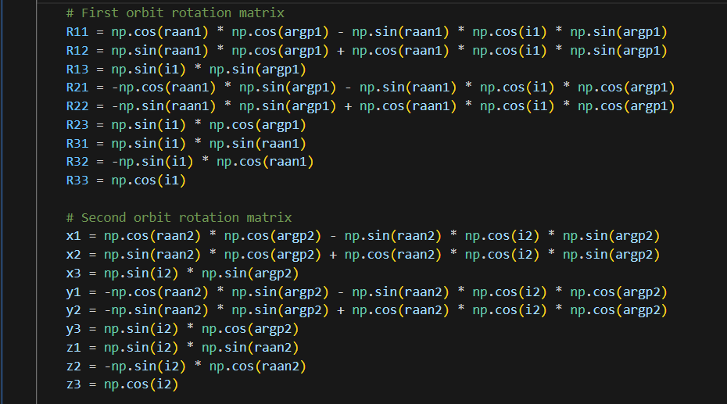
This block of code finds the new inclination, raan, and argp from the new x, y, z axes.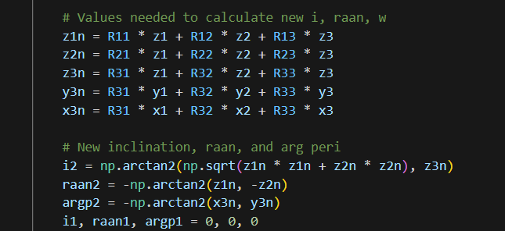

This block of code is the distance function used throughout the minimization. It employs the equations reviewed earlier for known TA1 (L) and TA2 (TA).
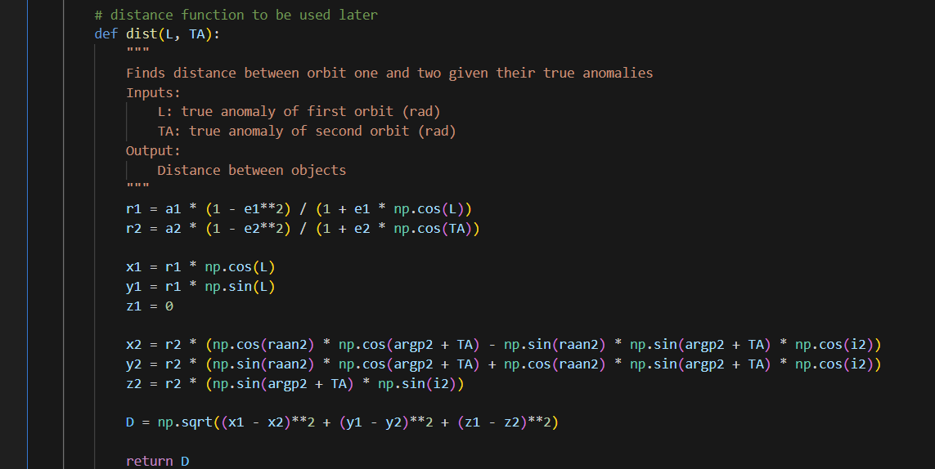

This block of code completes the coarse scan. It tracks the list of the last three distances, and true anomalies of both objects. If the middle distance is less than the other two, then it is marked as a local min. Because of this implementation, the iteration goes 3 steps after 2pi.
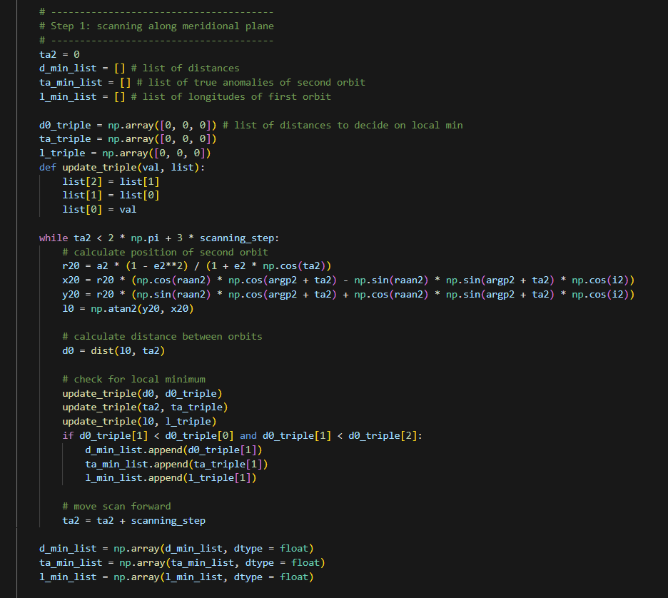

This “water procedure” will occur if there is only one minimum found in coarse scanning. It will add four evenly spaced starting points to ensure the MOID is found. This did not activate during the homework assignment.
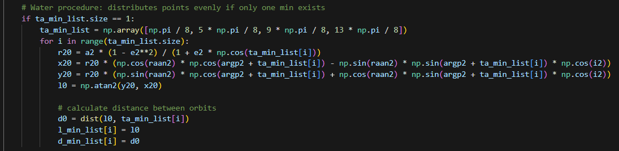
This tuning block of code conducts the parallel tuning algorithm described in the paper. It is not very efficient because it recalculates many distances of repeated TA-L combinations. Nonetheless, it works fast enough for this homework assignment.
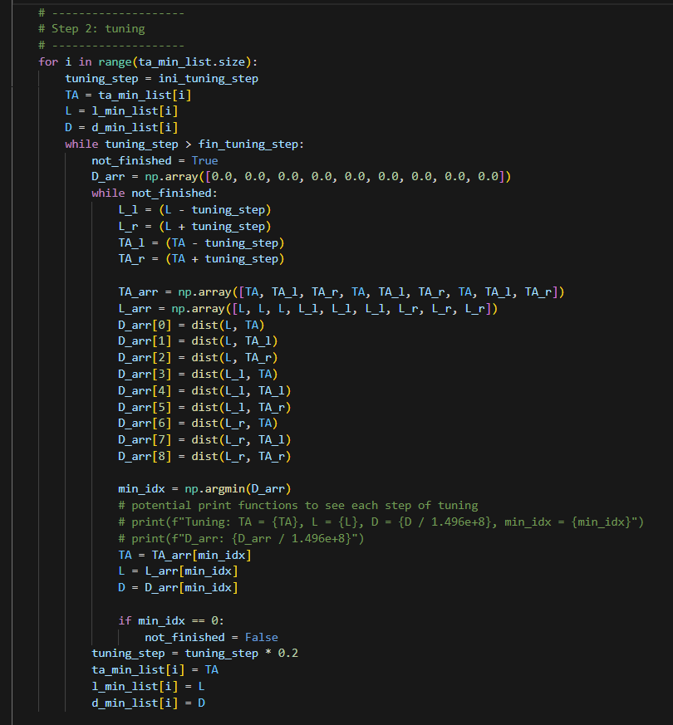

This block simply selects the MOID and prints it.
