Note1: I manually test my program using the lab2 testcases, so that It could manage double type data.
Note2: It passed all test in environment of windows Cygwin, however it can’t work well using the Linux computer of 3507. I do not know the reason for I do not know Linux well. However, I think the code is definitely correct.

Since I do not use the auto-testsuite ,I just check manually. So here is some note about how to use it. You need to decompress it like this:

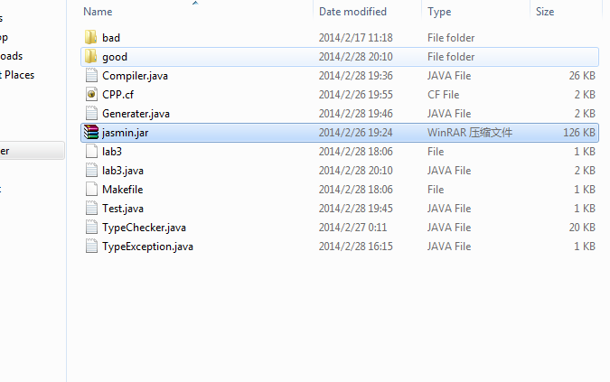
And then just type make to compile these files, which shows like this:
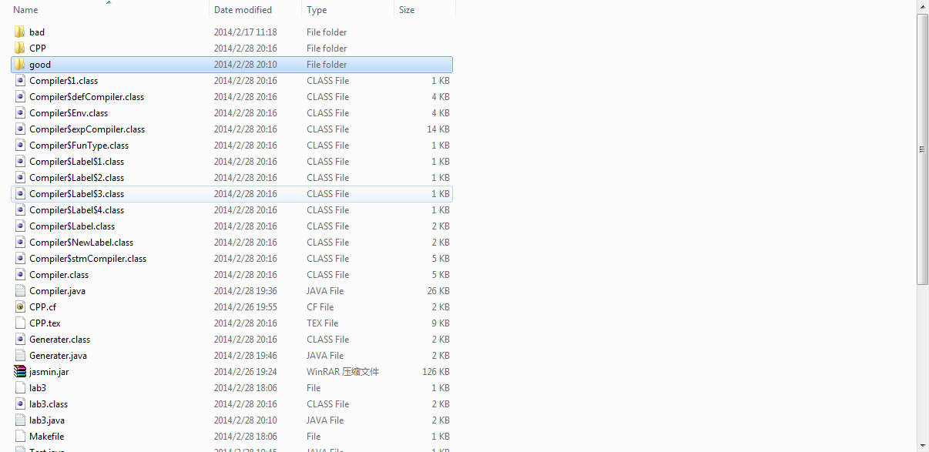,

Then just type java “lab3 good\core001.cc” or “java lab3 good\*.cc”, since I do some modification to the file lab3.java. Then it will generate corresponding class files in the “good\ “directory.

