# Anakin Edge GIF - Anakin Edge Kenobi - Discover & Share GIFs

# Image Edge Detection

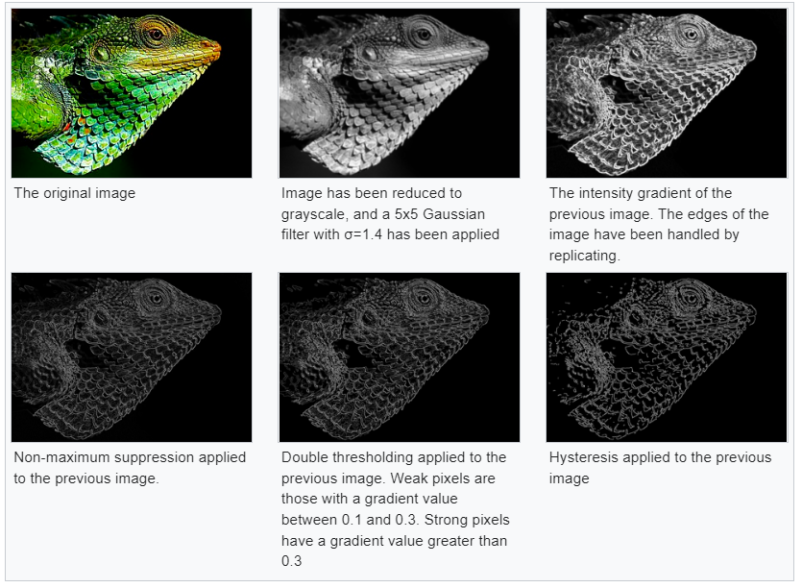Image Edge Detection is a fundamental image analysis process that allows the extraction of the outline of objects within a 2D image. It has varied uses across a wide spectrum from machine vision and machine learning algorithms to biomedical imaging, making it an interesting choice for an integrated hardware parallel processing project.

The Canny image edge detection is an edge detection operation that uses a multistep algorithm to process the image and extract the edges. Each step of the image detection algorithm provides an opportunity for digital acceleration and possible parallelisation.

The process first applies a Gaussian filter over the whole image to remove potential noise. This could possibly be done as a local Gaussian filter to decrease any loss of resolution.

The second process is finding the intensity gradient of the image and is done in 4 separate directions. This could allow digital acceleration through parallel processing each of the 4 directions independently.

The third process is to use suppression or thresholding to any spurious gradients created.

We can then apply a double threshold to the image to identify valid edges and remove any other weaker edge elements that may not be connected.