**Case B: Bank of Canada Collateral and Pledging Report**

Background Information

The purpose of this report is to provide the Bank of Canada with data on collateral pledging which is necessary for evaluating linkages between counterparties and activities, as well as determining the magnitude of transactions across various asset classes.

This return is to be completed at the business day frequency. Business days are defined to include all weekdays except federal and provincial statutory holidays. The attached template identifies a selection of rows and columns which are only required to be updated as of month end. Values are required to be reported in these cells for every business day; however, previous values can be carried forward until month end is reached.

The template for this return has been provided in “objectives” section.

[Definition for asset types]

Level 1 Asset: Government Bond

Level 2 Asset: Non-financial corporate bond/equity, with credit rating between A and AAA.

Level 3 Asset: Financial corporate bond/equity, or non-financial corporate bond/equity with credit rating under A.

Objectives

Fill in the report template as requested, based on Bank of Canada's rules.

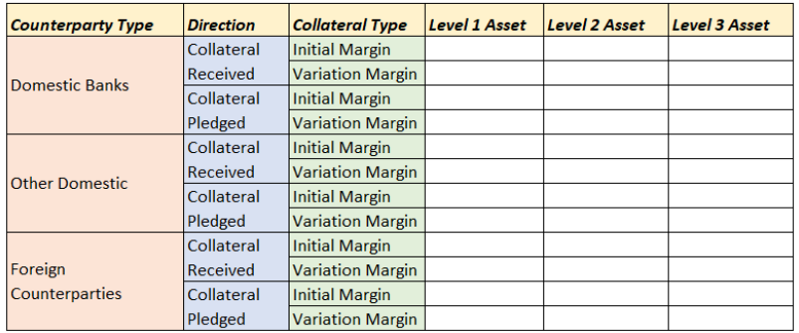

Inputs

The inputs provided are:

1) Collateral transactions as of Jul 2020. (“col_trans.csv")

2) Security instrument details. (“sec.csv")

3) Counterparty details. ("customer.csv")